RAJALAKSHMI ENGINEERING COLLEGE
An Autonomous Institution, Affiliated to Anna University
Rajalakshmi Nagar, Thandalam – 602 105

Web Technology And Mobile Application

Experiment 4

2026-2027

By

NAVDEEP.N
B.Tech-AIML
241501127

AIM:

To create a simple web application that includes a form to accept a user&#39;s name and age, and then use a Servlet to process the submitted data. The Servlet will retrieve the form data, process it, and display the values back on the browser.

ALGORITHM:

1. Input:
• The user fills out a web form with their name and age and submits it.

2. Form Handling and Servlet Processing:
1. Create the Web Form:
o Create an HTML form with two input fields: one for the user&#39;s name and one for the user&#39;s age.
o Add a submit button to the form.
o Set the form&#39;s action attribute to the URL of the Servlet and the method to POST (or GET).
- Create the Servlet Class:
o Write a Servlet that processes the form data submitted by the user.
o The Servlet will override the doPost() (or doGet() depending on the form method) to handle form submissions.
o The Servlet will retrieve the name and age parameters from the request object using request.getParameter(&quot;name&quot;) and request.getParameter(&quot;age&quot;).

3. Process the Data in the Servlet:
o Extract the name and age values submitted from the form.
o Validate the input (e.g., check if the age is a valid number).
o Prepare a response that will display the user&#39;s name and age back on the browser.

4. Send Response to the Browser:
o The Servlet will send a response to the browser containing a message like: &quot;Hello, [name]! You are [age] years old.&quot;
o The response will be displayed to the user in the browser.

5. Deploy the Servlet:
o Compile the Servlet and deploy it to a Servlet container (like Apache
Tomcat).
o Ensure the web.xml file or Servlet annotations are used to map the Servlet to the URL defined in the form&#39;s action attribute.

6. Test the Application:
o Open the web browser, fill in the form with the name and age, and submit it.
o The Servlet will process the data and display the message back to the user in the browser.

CODE:

Html Code:

<!DOCTYPE html>
<html lang="en">
<head>
<meta charset="UTF-8" />
<title>Railway Reservation</title>
<style>
* { margin: 0; padding: 0; box-sizing: border-box; }

body {
font-family: 'Segoe UI', sans-serif;
min-height: 100vh;
background: linear-gradient(135deg, #0f2027, #203a43, #2c5364);
display: flex;
flex-direction: column;
align-items: center;
justify-content: center;
}

.header {
text-align: center;
color: #fff;
margin-bottom: 28px;
}

.header .logo { font-size: 2.8rem; }

.header h1 {
font-size: 1.5rem;
font-weight: 600;
margin-top: 8px;
letter-spacing: 1px;
}

.card {
background: #fff;
border-radius: 14px;
padding: 2rem 2rem;
width: 360px;
box-shadow: 0 16px 48px rgba(0,0,0,0.4);
}

label {
display: block;
font-size: 0.82rem;
font-weight: 600;
color: #555;
margin-bottom: 6px;
text-transform: uppercase;
letter-spacing: 0.4px;
}

input {
width: 100%;
padding: 10px 12px;
border: 1.5px solid #ddd;
border-radius: 7px;
font-size: 0.95rem;
color: #333;
background: #fafafa;
margin-bottom: 1.2rem;
}

input:focus {
outline: none;
border-color: #1565c0;
background: #fff;
}

button {
width: 100%;
padding: 11px;
background: #1565c0;
color: #fff;
border: none;
border-radius: 7px;
font-size: 0.97rem;
font-weight: 600;
cursor: pointer;
margin-top: 4px;
}

button:hover { background: #0d47a1; }
</style>
</head>
<body>

<div class="header">
<div class="logo">🚆</div>
<h1>Indian Railway Reservation</h1>
</div>

<div class="card">
<form action="exp4" method="POST">

<label for="username"></label>
<input type="text" id="username" name="username"
placeholder="Passenger Name" required />

<label for="age"></label>
<input type="number" id="age" name="age"
placeholder="Age" min="1" max="120" required />

<button type="submit">Book Ticket</button>

</form>
</div>

</body>
</html>

Servlet code:

package WTMA;

import jakarta.servlet.ServletException;
import jakarta.servlet.annotation.WebServlet;
import jakarta.servlet.http.HttpServlet;
import jakarta.servlet.http.HttpServletRequest;
import jakarta.servlet.http.HttpServletResponse;
import java.io.IOException;
import java.io.PrintWriter;

@WebServlet("/exp4")
public class exp4 extends HttpServlet {

private static final long serialVersionUID = 1L;

protected void doPost(HttpServletRequest request, HttpServletResponse response)
throws ServletException, IOException {

response.setContentType("text/html");
PrintWriter pw = response.getWriter();

String name = request.getParameter("username");
String age = request.getParameter("age");

pw.println("<!DOCTYPE html>");
pw.println("<html lang='en'><head>");
pw.println("<meta charset='UTF-8'/>");
pw.println("<title>Railway Reservation</title>");
pw.println("<style>");
pw.println(" * { margin:0; padding:0; box-sizing:border-box; }");
pw.println(" body { font-family:'Segoe UI',sans-serif; min-height:100vh;");
pw.println(" background:linear-gradient(135deg,#0f2027,#203a43,#2c5364);");
pw.println(" display:flex; flex-direction:column;");
pw.println(" align-items:center; justify-content:center; }");
pw.println(" .header { text-align:center; color:#fff; margin-bottom:28px; }");
pw.println(" .header .logo { font-size:2.8rem; }");
pw.println(" .header h1 { font-size:1.5rem; font-weight:600; margin-top:8px; letter-spacing:1px; }");
pw.println(" .card { background:#fff; border-radius:14px; padding:2rem;");
pw.println(" width:360px; box-shadow:0 16px 48px rgba(0,0,0,0.4); }");
pw.println(" .row { display:flex; justify-content:space-between;");
pw.println(" padding:10px 0; border-bottom:1px solid #f0f0f0; font-size:0.9rem; }");
pw.println(" .row:last-of-type { border-bottom:none; }");
pw.println(" .key { color:#888; }");
pw.println(" .val { font-weight:600; color:#222; }");
pw.println("</style></head><body>");

pw.println("<div class='header'>");
pw.println(" <div class='logo'>🚆</div>");
pw.println(" <h1>Booked Ticket</h1>");
pw.println("</div>");

pw.println("<div class='card'>");
pw.println(" <div class='row'><span class='key'>Passenger Name</span><span class='val'>" + name + "</span></div>");
pw.println(" <div class='row'><span class='key'>Age</span><span class='val'>" + age + " years</span></div>");
pw.println("</div>");

pw.println("</body></html>");
}
}

OUTPUT: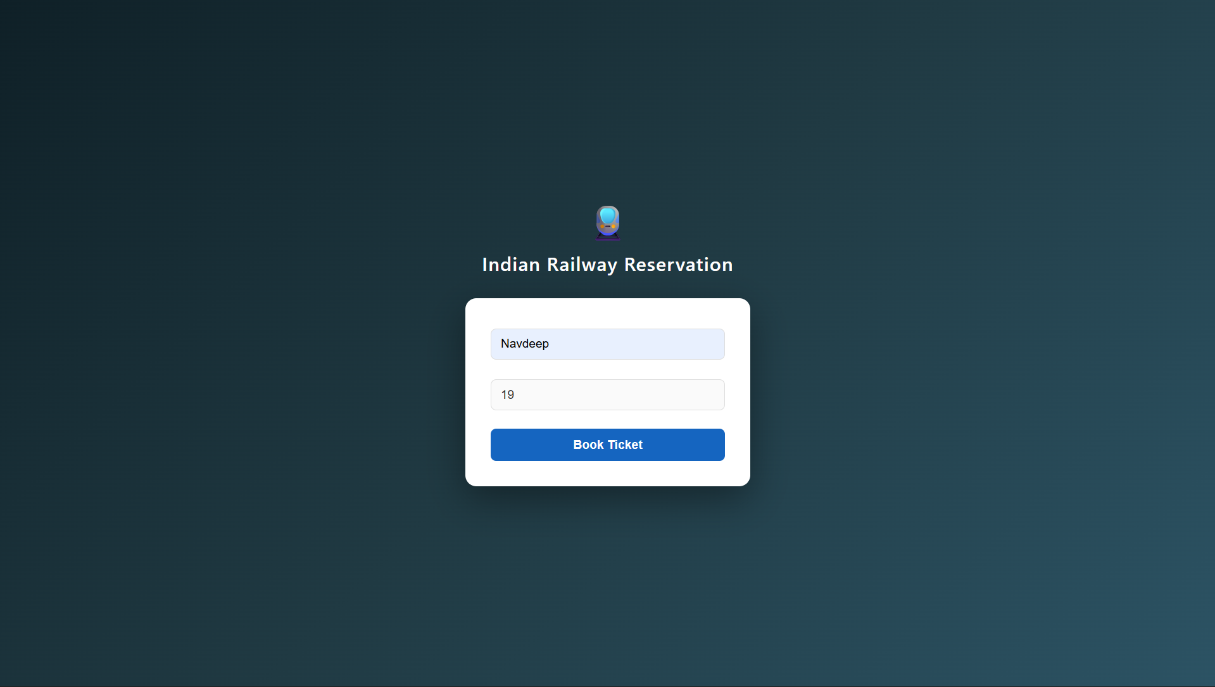
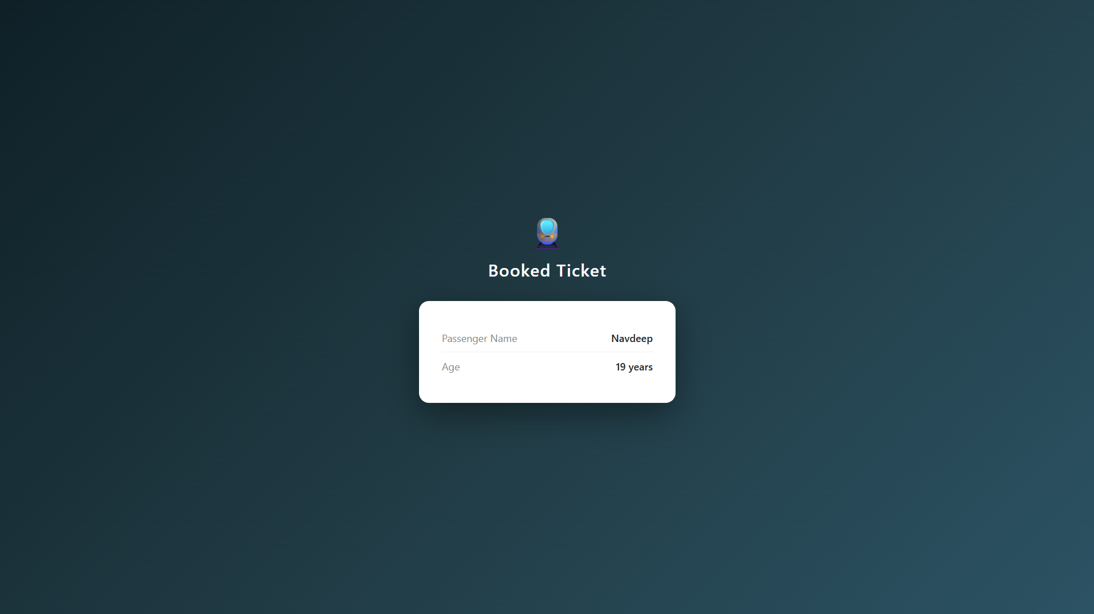

RESULT:

The browser will display the message &quot;Hello, World!&quot; returned by the Servlet.

