RAJALAKSHMI ENGINEERING COLLEGE
An Autonomous Institution, Affiliated to Anna University
Rajalakshmi Nagar, Thandalam – 602 105

Web Technology And Mobile Application

Experiment 5

2026-2027

By

NAVDEEP.N
B.Tech-AIML
241501127

AIM:

To demonstrate the difference between the HTTP GET and POST methods by creating a form in an HTML page and handling the form submissions using two different HTTP methods in a Java Servlet.

ALGORITHM:

1. Input:
• The user fills out a web form with their name and email.
• The form will use both GET and POST methods for data submission.

2. Steps for Creating and Handling the HTTP GET and POST Requests:
1. Create an HTML Form:
o Design an HTML form with two input fields: one for the name and one for the email.
o Create two buttons to allow the user to submit the form using GET or POST methods.
o Use the action attribute to define the Servlet URL and specify the form
method (either GET or POST).

2. Create the Servlet to Handle GET and POST Requests:
o Write a Java Servlet class that will handle both GET and POST requests.
o The servlet will have two methods:
▪ doGet() to handle the GET requests.
▪ doPost() to handle the POST requests.
o In both methods, retrieve the form data using request.getParameter().
o In the doGet() method, process and display the data in the URL.
o In the doPost() method, process and display the data in the HTTP request body.

3. Handle GET Requests in the Servlet:
o In the doGet() method, use request.getParameter() to retrieve the name and
email submitted via GET.
o Output the data as a response, including the name and email in the URL
(visible to the user).

4. Handle POST Requests in the Servlet:
o In the doPost() method, use request.getParameter() to retrieve the name and email submitted via POST.
o Output the data as a response, displaying the name and email without
exposing them in the URL (more secure).

5. Return the Output:
o The Servlet should return an HTML page displaying the name and email
entered by the user.
o For the GET method, the output should be visible in the URL.
o For the POST method, the output should be visible in the response body, not
the URL.

6. Deploy and Test the Servlet:
o Compile the Servlet class and deploy it to a Servlet container (like Apache
Tomcat).
o Test the form using GET and POST methods to see the difference in data
submission.

7. Observe and Compare GET and POST Results:
o Test the GET method: The form data is sent in the URL.
o Test the POST method: The form data is sent in the HTTP request body, not
visible in the URL.

CODE:

Html Code:

<!DOCTYPE html>
<html>
<head>
<title>Railway Reservation</title>
<style>
body {
font-family: Georgia, serif;
background-color: #0d1117;
margin: 0;
padding: 20px;
}

h2 {
background-color: #1f6feb;
color: white;
padding: 15px;
text-align: center;
border-radius: 8px;
letter-spacing: 2px;
}

h3 {
color: #58a6ff;
border-left: 5px solid #f0a500;
padding-left: 10px;
}

.container {
max-width: 500px;
margin: 0 auto;
}

form {
background-color: #161b22;
padding: 25px;
border-radius: 10px;
box-shadow: 0 4px 15px rgba(0,0,0,0.5);
margin-bottom: 25px;
border: 1px solid #30363d;
}

input[type="text"] {
padding: 10px 12px;
border: 1px solid #30363d;
border-radius: 5px;
width: 100%;
font-size: 14px;
margin-bottom: 14px;
box-sizing: border-box;
background-color: #0d1117;
color: #c9d1d9;
}

input[type="text"]::placeholder {
color: #6e7681;
}

input[type="text"]:focus {
outline: none;
border-color: #1f6feb;
}

input[type="submit"] {
margin-top: 5px;
padding: 10px 25px;
background-color: #1f6feb;
color: white;
border: none;
border-radius: 6px;
font-size: 15px;
cursor: pointer;
width: 100%;
}

input[type="submit"]:hover {
background-color: #f0a500;
color: #0d1117;
}

hr {
border: none;
border-top: 1px solid #30363d;
margin: 20px 0;
}
</style>
</head>
<body>

<div class="container">

<h2>🚆 Online Railway Reservation System</h2>

<!-- GET Form - Search Train -->
<h3>Search Train (GET)</h3>
<form action="exp5" method="get">
<input type="text" name="from" placeholder="From Station (e.g. Chennai)" />
<input type="text" name="to" placeholder="To Station (e.g. Mumbai)" />
<input type="submit" value="Search Train" />
</form>

<hr/>

<!-- POST Form - Book Ticket -->
<h3>Book Ticket (POST)</h3>
<form action="exp5" method="post">
<input type="text" name="name" placeholder="Passenger Name" />
<input type="text" name="trainNo" placeholder="Train Number (e.g. 12163)" />
<input type="submit" value="Book Ticket" />
</form>

</div>

</body>
</html>

Servlet code:

package WTMA;

import jakarta.servlet.ServletException;
import jakarta.servlet.annotation.WebServlet;
import jakarta.servlet.http.HttpServlet;
import jakarta.servlet.http.HttpServletRequest;
import jakarta.servlet.http.HttpServletResponse;
import java.io.IOException;
import java.io.PrintWriter;

@WebServlet("/exp5")
public class exp5 extends HttpServlet {

private static final long serialVersionUID = 1L;

public exp5() {
super();
}

private String getStyle() {
return "<style>"
+ "body { font-family: Georgia, serif; background-color: #0d1117; padding: 30px; color: #c9d1d9; }"
+ "h2 { background-color: #1f6feb; color: white; padding: 15px;"
+ " text-align: center; border-radius: 8px; letter-spacing: 2px; }"
+ ".card { background: #161b22; max-width: 450px; margin: 20px auto; padding: 25px;"
+ " border-radius: 10px; box-shadow: 0 4px 15px rgba(0,0,0,0.5);"
+ " border: 1px solid #30363d; }"
+ "h3 { color: #58a6ff; border-left: 5px solid #f0a500; padding-left: 10px; }"
+ "p { font-size: 16px; color: #c9d1d9; border-bottom: 1px solid #21262d; padding: 8px 0; }"
+ "span { font-weight: bold; color: #58a6ff; }"
+ ".success { color: #3fb950; font-size: 18px; text-align: center; font-weight: bold; }"
+ ".back-btn { display: block; text-align: center; margin-top: 15px; padding: 10px;"
+ " background-color: #1f6feb; color: white; text-decoration: none;"
+ " border-radius: 6px; font-size: 15px; }"
+ ".back-btn:hover { background-color: #f0a500; color: #0d1117; }"
+ "</style>";
}

protected void doGet(HttpServletRequest request, HttpServletResponse response)
throws ServletException, IOException {

response.setContentType("text/html");
PrintWriter pw = response.getWriter();

String from = request.getParameter("from");
String to = request.getParameter("to");
String contextPath = request.getContextPath();

pw.println(getStyle());
pw.println("<h2>🚆 Online Railway Reservation System</h2>");
pw.println("<div class='card'>");
pw.println("<h3>Data Received Using GET Method</h3>");
pw.println("<p>From Station : <span>" + from + "</span></p>");
pw.println("<p>To Station : <span>" + to + "</span></p>");
pw.println("<p>Available Train : <span>Chennai Express (12163)</span></p>");
pw.println("<p>Fare : <span>Rs. 850</span></p>");
pw.println("<a class='back-btn' href='" + contextPath + "/index.html'>⬅ Go Back</a>");
pw.println("</div>");
}

protected void doPost(HttpServletRequest request, HttpServletResponse response)
throws ServletException, IOException {

response.setContentType("text/html");
PrintWriter pw = response.getWriter();

String name = request.getParameter("name");
String trainNo = request.getParameter("trainNo");
String contextPath = request.getContextPath();

pw.println(getStyle());
pw.println("<h2>🚆 Online Railway Reservation System</h2>");
pw.println("<div class='card'>");
pw.println("<h3>Data Received Using POST Method</h3>");
pw.println("<p>Passenger Name : <span>" + name + "</span></p>");
pw.println("<p>Train Number : <span>" + trainNo + "</span></p>");
pw.println("<p class='success'>✅ Ticket Booked Successfully!</p>");
pw.println("<a class='back-btn' href='" + contextPath + "/index.html'>⬅ Go Back</a>");
pw.println("</div>");
}
}

OUTPUT:

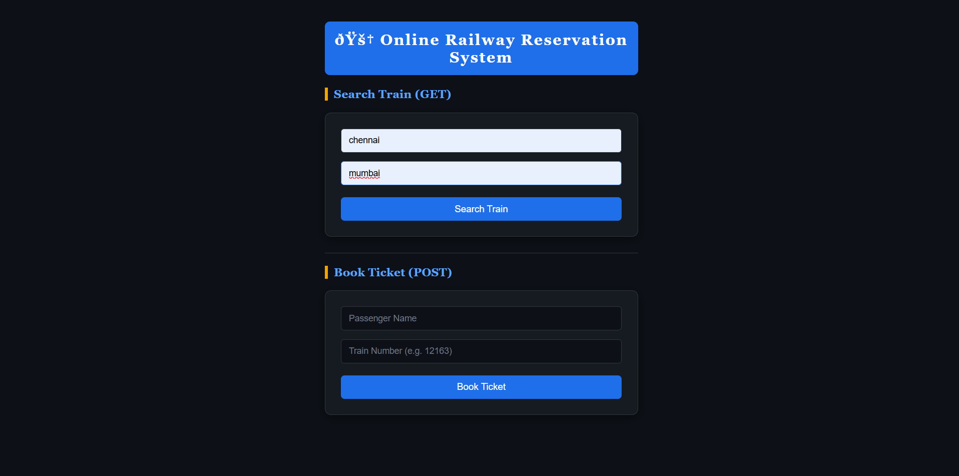

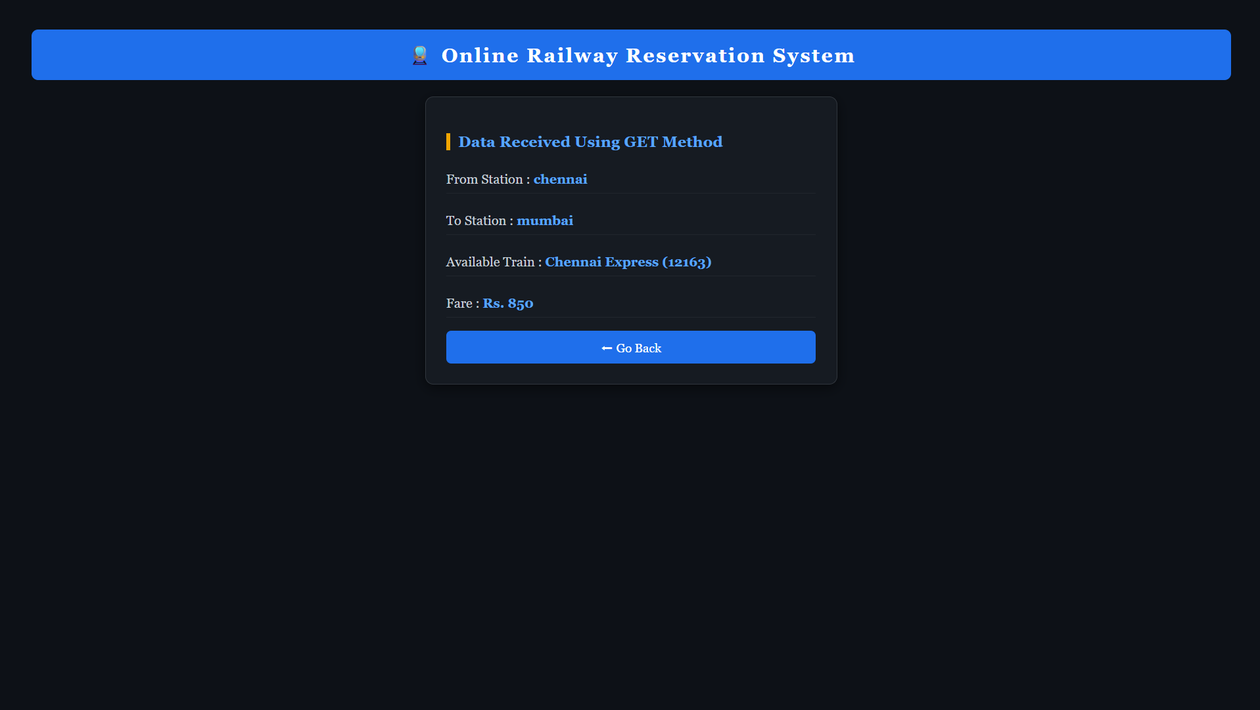

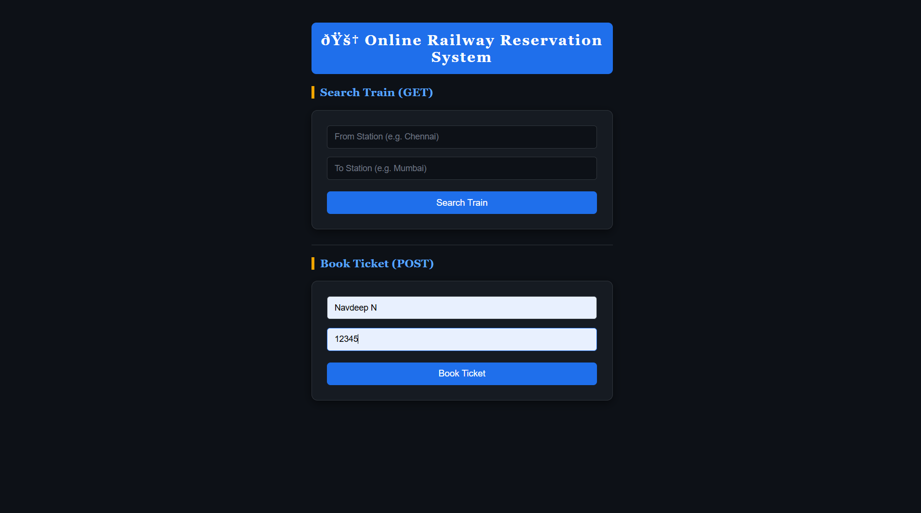

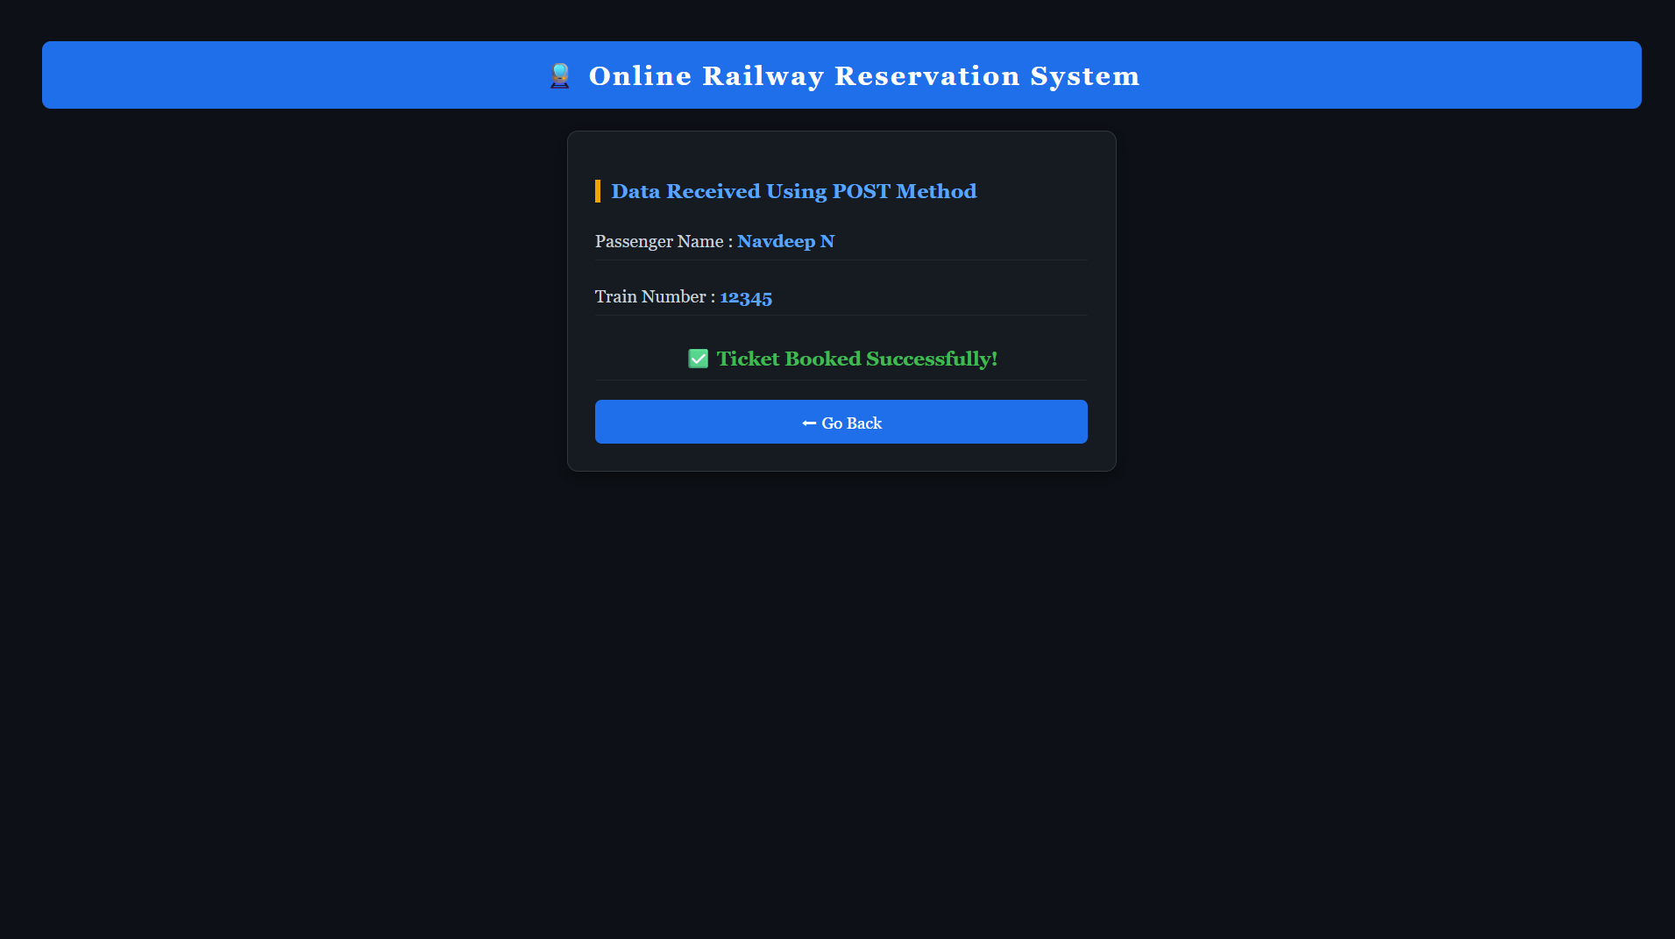

RESULT:

The browser will display the message &quot;Hello, World!&quot; returned by the Servlet.

