**Time Series Forecast Model for Inventory Management**

**Approach:**

The given data contains historical demand of auto parts (Part No) on weekly basis. Thus, to create a time series forecast model, this ‘week’ attribute needs to be converted into a date format such that it indicates the demand of a part at start of a week.

The data needs to be un-pivoted (i.e. the part demand needs to transposed from rows to column).

Post feature engineering and data processing, different time series models can be employed to make predictions. Models such as ARIMA, LSTM, and Prophet has been used to make future demand forecasts.

**EDA Analysis:**

There are 190 different unique parts, there will be a different demand pattern for each of the parts. In this analysis, analysis and forecast has been shown for part no 29032636, same logic can be replicated for rest of the parts.

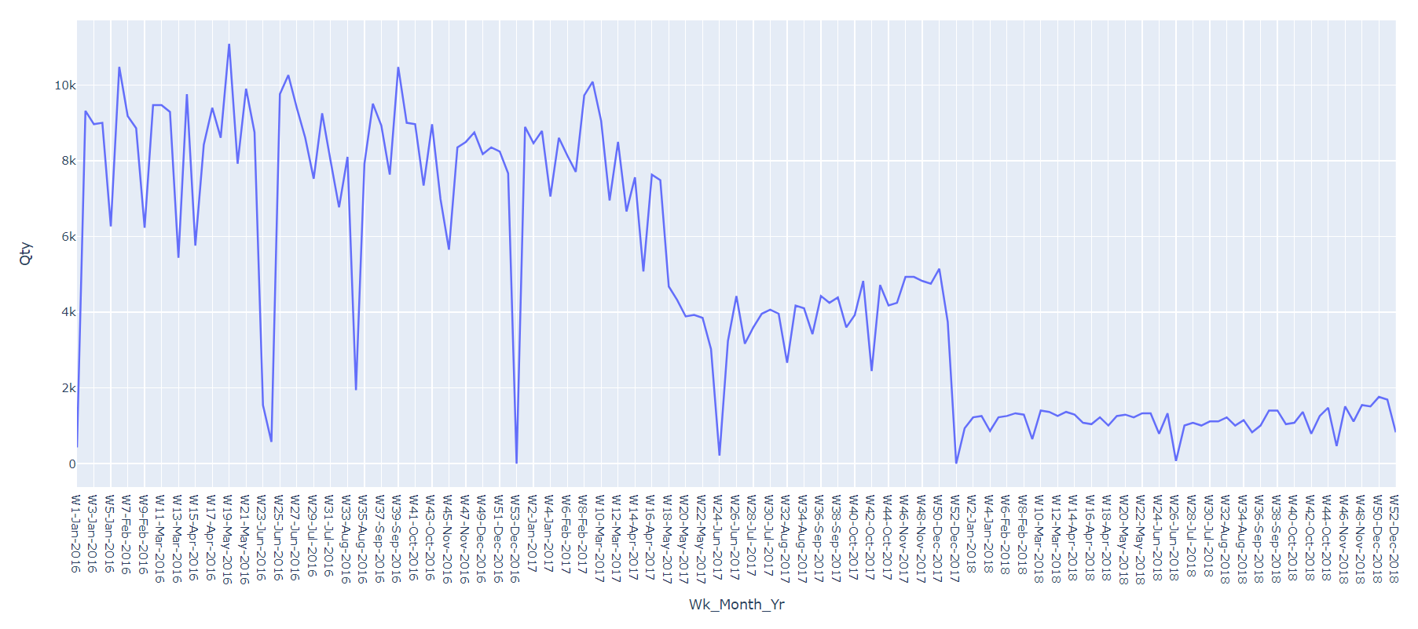From below plot, we can see for part no 29032636 there is high fluctuation in the inventory demand and there is drop in the demand as we move from year 2016 to 2018. We can find stable time series in 2018 only, thus it will be a good idea to train model only on 2018 data to make future forecasts.

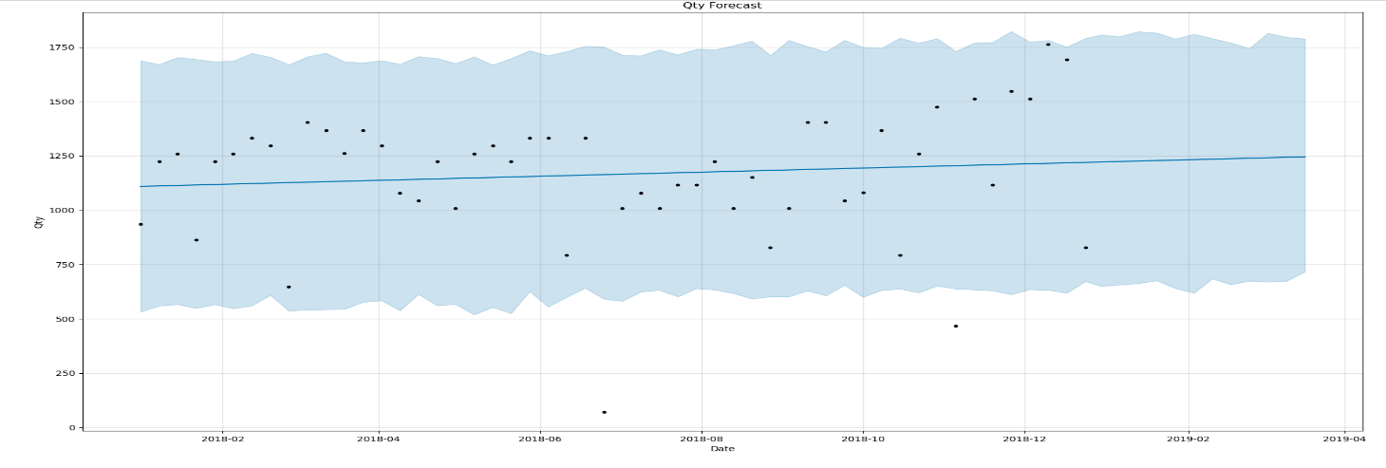**Prophet Model 12 Week Forecast Plot:**

**ARIMA Model 12 Week Forecast Plot:**

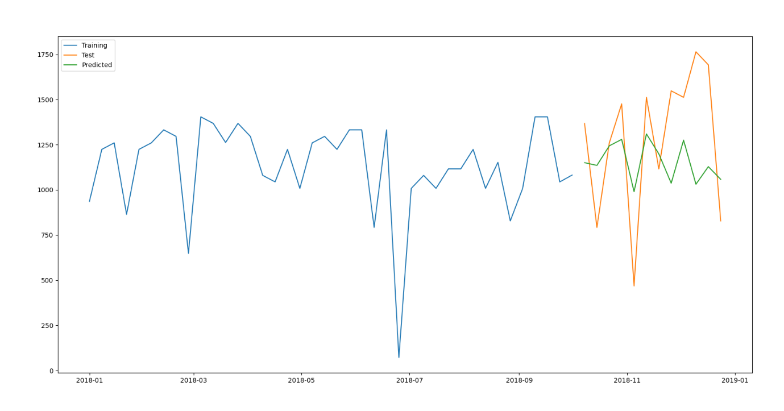

**LSTM Model Forecast:**

