Product Design
Team | Micro-Content Powered Transit M-Commerce (Team 45)  Team Members:  Naga Sai Ritvik Modumudi  Keshava Kishore Nanda Veerapuneni  Navdha Bansal  Paridhi Jain  Venishetty Hari Chandana

Design Model
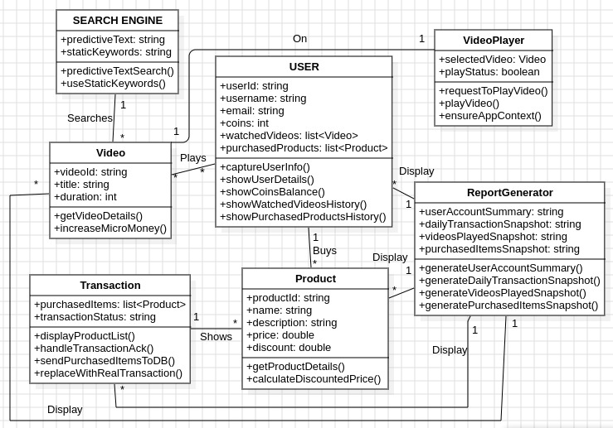

User | Class state:  1. user_Id: string  2. username: string  3. email: string  4. coins: int  5. watched_Videos: list<Video>  6. purchased_Products: list<Product>  Class behavior:  1. capture_User_Info() : Captures basic user information  2. show_User_Details() : Displays user details  3. show_Coins_Balance():Displays the balance of coins owned by the user.  4. show_Watched_Videos_History(): Displays the history of videos watched by the user.  5. show_Purchased_Products_History(): Displays the history of products purchased by the user.
Video | Class state:  1.video_Id: string  2.title: string  3.duration: int  Class behavior:  1. get_Video_Details(): Retrieves details of a specific video  2. Micromoney_earned(): Calculates and returns the amount of micro money earned by the user.
Search Engine | Class state:  1. predictive_Text: string[]  2. static_Keywords: string[]  Class behavior:  1. predictive_Text_Search(): Performs a search using predictive text to find relevant results  2. use_Static_Keywords(): Utilizes static keywords generated from user profile parameters to show recommended content
Video Player | Class state:  1. selected_Video: Video  2. play_Status: boolean  Class behavior:  1. request_To_Play_Video(): Sends a request to play a selected video  2. play_Video(): Plays the requested YouTube video  3. ensure_App_Context(): Ensures that the video is played within the application context.
Transaction | Class state:  1. purchased_Items: list<Product>  2. transaction_Status: string  Class behavior:  1. display_Product_List(): Shows a list of products with pictures, descriptions, prices, and discounts  2. handle_Transaction_Ack(): Handles acknowledgements after a successful transaction  3. send_Purchased_Items_To_DB(): Sends information about purchased items to a database.  4. replace_With_Real_Transaction(): Replaces the transaction process with a real one.
Product | Class state:  1. product_Id: string  2. name: string  3. description: string  4. price: double  5. discount: double  Class behavior:  1. get_Product_Details(): Retrieves details of a product such as its name, description, price, and discount.  2. calculate_Discounted_Price(): Calculates the discounted price of a product based on the micro-money of the user
Report Generator | Class state:  1. user_Account_Summary: string  2. daily_Transaction_Snapshot: string  3. videos_Played_Snapshot: string  4. purchased_Items_Snapshot: string  Class behavior:  1.generate_User_Account_Summary(): Generates a summary of the user's account, including their basic information and current balance.  2.generate_Daily_Transaction_Snapshot(): Creates a snapshot of the daily transactions, summarizing the activities and transactions that occurred within a day.  3.generate_Videos_Played_Snapshot(): Generates a snapshot of the videos played by the user, capturing details such as the titles and durations of the videos.  4.generate_Purchased_Items_Snapshot(): Creates a snapshot of the items purchased by the user, including details like product names, descriptions, prices, and discounts.
.

Sequence Diagram(s)
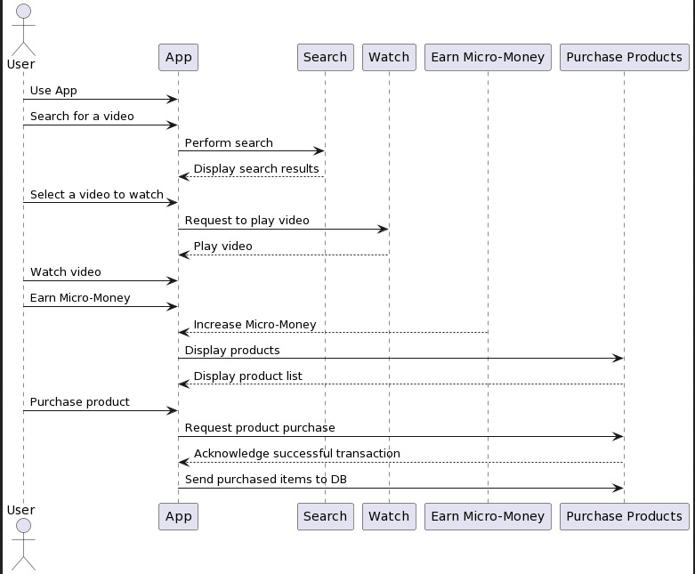

Design Rationale
Landing Page Design:
- Issue: Initially, we attempted to design the landing page using Figma to emulate the layout and functionality of the IRCTC page. However, we encountered a problem with the lack of user interactivity in the imported design.
- Rejected solution: We initially tried to import the design directly from Figma into Android Studio, but the lack of user interactivity hindered the usability of the landing page.
- Strengths of chosen approach: While Figma offers excellent design capabilities, it lacks the interactive elements required for a functional landing page. Moving forward, we're exploring alternative design tools or directly implementing the landing page within Android Studio to ensure user interactivity and a seamless user experience.
Video Player Placement:
- Issue: Initially, the video player and search results were integrated into a single page. However, we decided to move the video player to a separate page within the app.
- Rejected solution: We attempted to design the separate page for the video player using Figma, but encountered similar issues with user interactivity.
- Strengths of chosen approach: Separating the video player into its own page allows for better organization and navigation within the app. While Figma provides a robust platform for designing UI elements, it may not fully support the level of interactivity required for complex app features like video playback. We're now considering alternatives such as direct implementation within Android Studio or exploring other design tools better suited for interactive elements.
E-commerce UI Enhancement:
- Issue: We encountered issues with the UI representation of user coins in the e-commerce section, finding the display unattractive and unappealing.
We are currently working on it.

