**Software Requirements Specification (SRS) Document**

|  |  |
| --- | --- |
|  | Micro-Content Powered Transit M-Commerce (Team 45)  Team Members:  Naga Sai Ritvik Modumudi  Keshava Kishore Nanda Veerapuneni  Navdha Bansal  Paridhi Jain  Venishetty Hari Chandana |

# **Brief problem statement**

The challenge at hand is to seamlessly integrate a Transit provider's mobile app with an E-Commerce platform, enabling users to earn micro-money incentives by watching YouTube videos within the Transit app. These incentives are then utilized to purchase discounted purchases across various products and services offered on the E-Commerce app. Ensuring consistent and accurate transactional accounting across all User interactions is crucial, necessitating a system that maintains integrity and reliability throughout the process.

# **System requirements**

The system must be compatible with Android 9 operating system or later versions.

Technologies, languages and libraries:

1. FrontEnd

* Java and Kotlin
* Figma (for UI/UX designs)
* Android Studio

1. BackEnd

* JavaScript/Python
* Firebase
* Visual Studio Code

1. Collaboration Tools

* GitHub

# **Users profile**

1. INTEGRATED APP USER-

* Primarily uses the Transit app for commuting.
* Engages in Video Watching during Transit and earns Micro-money.
* Utilizes earned Micro-money to make discounted purchases from the integrated E-Commerce app.

1. ADMINISTRATORS/DEVELOPERS-

* Individuals responsible for maintaining, updating and overseeing the entire App ecosystem.
* They ensure the consistency of transactional accounting and summary bookkeeping across the system.

# Feature requirements (described using use cases)

|  |  |  |  |
| --- | --- | --- | --- |
| **No.** | **Use Case Name** | **Description** | **Release** |
|  | User-Onboarding | Captures basic user info | R1 |
|  | Search | 1. User Searches the video he wants to watch - with predictive text. 2. If there is no search keyword, we use static keywords generated from other parameters from the user profile to show the recommended system. 3. A request to play the Selected video is sent. | R1 (2,3 - R2) |
|  | Watch | 1. Plays the requested YT Video 2. Should not migrate out of app context. | R1 |
|  | Earn Micro-Money | Increase Micro-Money based on duration watched. | R1 |
|  | Purchase products | 1. It will be in the app only. 2. Able to purchase products (Real transaction is not handled, just as a POC) 3. A list of products each with pic, description, price, and discount is displayed. Discount is based on the earned micro-money. 4. Sends acknowledgements after a successful transaction. 5. Needs to send what items a user purchased to a DB. 6. Must be easily replaceable with a real app. | R1 |
|  | User Profile | 1. Show the Coins the user earned. 2. Show the User details. 3. History of videos the user watched. 4. History of products purchased. |  |
|  | Reports | 1. User account summary 2. Snapshot of daily transitions 3. Snapshot of all videos played and their duration. 4. All items purchased | R2 |
|  |  |  |  |

**Use case diagram:**

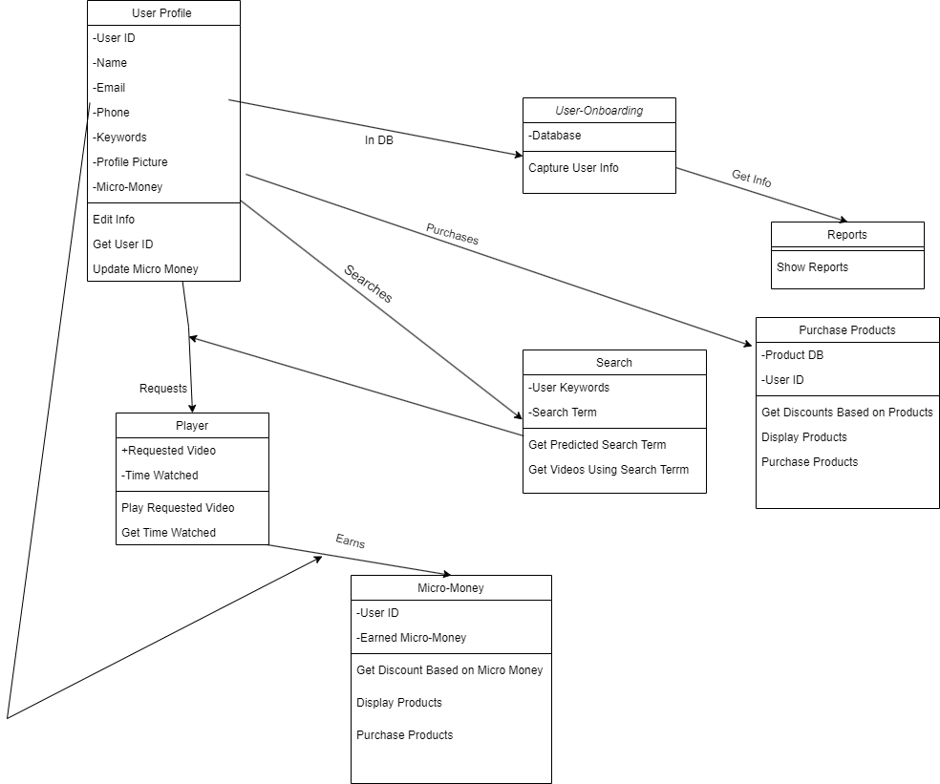

**Use case description:**

**Main-Flow: 1-2-3-4-7,1-5-7,1-6**

|  |  |
| --- | --- |
| **Use Case Number:** | UC-01 |
| **Use Case Name:** | User On-Boarding |
| **Overview:** | Captures basic user info |
| **Actors:** | User |
| **Precondition:** | No predecessor for it |
| **Flow:** | Main (success) Flow: 1-2-3-4-7 |
|  | Alternate Flows: 1-6-7, 1-5-7  Conditions:   1. Data of the user is stored in the database and the user wants to view his profile. 2. Data of the user is stored in the database and the user wants to buy a product. |
| **Post Condition:** | Data of the user stored in the database |

|  |  |
| --- | --- |
| **Use Case Number:** | UC-02 |
| **Use Case Name:** | Search |
| **Overview:** | 1. The User Searches for the video he wants to watch - with predictive text. 2. If there is no search keyword, we use static keywords generated from other parameters from the user profile to show the recommended system. 3. A request to play the Selected video is sent. |
| **Actors:** | User |
| **Precondition:** | 1(User details should be stored in database) |
| **Flow:** | Main (success) Flow: 1-2-3-4-7 |
|  |  |
| **Post Condition:** | Videos related to search/keywords should be displayed |

|  |  |
| --- | --- |
| **Use Case Number:** | UC-03 |
| **Use Case Name:** | Watch |
| **Overview:** | 1. Plays the requested YT Video 2. Should not migrate out of app context. |
| **Actors:** | User |
| **Precondition:** | Videos related to search/keywords should be displayed |
| **Flow:** | Main (success) Flow: 1-2-3-4-7 |
|  |  |
| **Post Condition:** | Video will play in the video player present in the app itself.  Stores the duration of videos watched.  Stores the videos watched. |

|  |  |
| --- | --- |
| **Use Case Number:** | UC-04 |
| **Use Case Name:** | Earn Micro-Money |
| **Overview:** | 1. Increase Micro-Money based on duration watched. |
| **Actors:** | User |
| **Precondition:** | Stores the duration of videos watched. |
| **Flow:** | Main (success) Flow: 1-2-3-4-7 |
|  |  |
| **Post Condition:** | The number of Coins you have earned should be Updated.  Store the info of the videos watched by the user. |

|  |  |
| --- | --- |
| **Use Case Number:** | UC-05 |
| **Use Case Name:** | Purchase Products |
| **Overview:** | 1. It will be in the app only. 2. Able to purchase products (Real transaction is not handled, just as a POC) 3. A list of products each with pic, description, price, and discount is displayed. Discount is based on the earned micro-money. 4. Sends acknowledgements after a successful transaction. 5. Needs to send what items a user purchased to a DB. 6. Must be easily replaceable with a real app. |
| **Actors:** | User |
| **Precondition:** | User details should be stored along with the updated number of Coins and user should invoke the e-commerce app |
| **Flow:** | Main (success) Flow: 1-5-7 |
|  |  |
| **Post Condition:** | Update the database after the coins have been used.  Store the purchase done by the User. |

|  |  |
| --- | --- |
| **Use Case Number:** | UC-06 |
| **Use Case Name:** | User profile |
| **Overview:** | 1. Show the Coins the user earned. 2. Show the User details. 3. History of videos the user watched. 4. History of products *purchased.* |
| **Actors:** | User |
| **Precondition:** | User details should be stored in a database along with an updated number of coins, products purchased, and videos watched |
| **Flow:** | Main (success) Flow: 1-6-7 |
|  |  |
| **Post Condition:** | Display all the details on the screen for user analysis. |

|  |  |
| --- | --- |
| **Use Case Number:** | UC-07 |
| **Use Case Name:** | Reports |
| **Overview:** | 1. User account summary 2. Snapshot of daily transitions 3. Snapshot of all videos played and their duration. 4. All items purchased |
| **Actors:** | Client |
| **Precondition:** | User details should be stored in the database along with an updated number of coins, products purchased, and videos watched.  Details of products purchased in a day-wise manner.  Details of videos watched in a day-wise manner. |
| **Flow:** | Main (success) Flow: 1-2-3-4-7,1-5-7 |
|  | Alternate Flows:. |
| **Post Condition:** | A report should be displayed to the client |