**Software Requirements Specification (SRS) Document**

|  |  |
| --- | --- |
|  | Micro-Content Powered Transit M-Commerce (Team 45)  Team Members:  Naga Sai Ritvik Modumudi  Keshava Kishore Nanda Veerapuneni  Navdha Bansal  Paridhi Jain  Venishetty Hari Chandana |

# **Brief problem statement**

The challenge at hand is to seamlessly integrate a Transit provider's mobile app with an E-Commerce platform, enabling users to earn micro-money incentives by watching YouTube videos within the Transit app. These incentives are then utilized to purchase discounted purchases across various products and services offered on the E-Commerce app. Ensuring consistent and accurate transactional accounting across all User interactions is crucial, necessitating a system that maintains integrity and reliability throughout the process.

# **System requirements**

The system must be compatible with Android 9 operating system or later versions.

Technologies, languages and libraries:

1. FrontEnd

* Java and Kotlin
* Android Studio

1. BackEnd

* JavaScript/Python
* Firebase
* Visual Studio Code

1. Collaboration Tools

* GitHub

# **Users profile**

1. INTEGRATED APP USER-

* Primarily uses the Transit app for commuting.
* Engages in Video Watching during Transit and earns Micro-money.
* Utilizes earned Micro-money to make discounted purchases from the integrated E-Commerce app.

1. ADMINISTRATORS/DEVELOPERS-

* Individuals responsible for maintaining, updating and overseeing the entire App ecosystem.
* They ensure the consistency of transactional accounting and summary bookkeeping across the system.

# Feature requirements (described using use cases)

|  |  |  |  |
| --- | --- | --- | --- |
| **No.** | **Use Case Name** | **Description** | **Release** |
|  | Search | 1. User Searches the video he wants to watch - with predictive text. 2. If there is no search keyword, we use static keywords generated from other parameters from the user profile to show the recommended system. 3. A request to play the Selected video is sent. | R1 (2 - R2) |
|  | Watch | 1. Plays the requested YT Video 2. Should not migrate out of app context. | R1 |
|  | Earn Micro-Money | 1.Increase in Micro-Money.  2.Increase in micro-money based on duration watched. | R1(2-R2) |
|  | Purchase products | 1. It will be in the app only. 2. Able to purchase products (Real transaction is not handled, just as a POC) 3. A list of products each with pic, description, price, and discount is displayed. 4. Discount is based on the earned micro-money. 5. Sends acknowledgements after a successful transaction. 6. Needs to send what items a user purchased to a DB. 7. Must be easily replaceable with a real app. | R1(4-R2) |
|  | User Profile | 1. Show the Coins the user earned. 2. Show the User details. 3. History of videos the user watched. 4. History of products purchased. | R1(2-R2) |
|  | Reports | 1. User account summary 2. Snapshot of daily transitions 3. Snapshot of all videos played and their duration. 4. All items purchased | R2 |

**Use case diagram:**

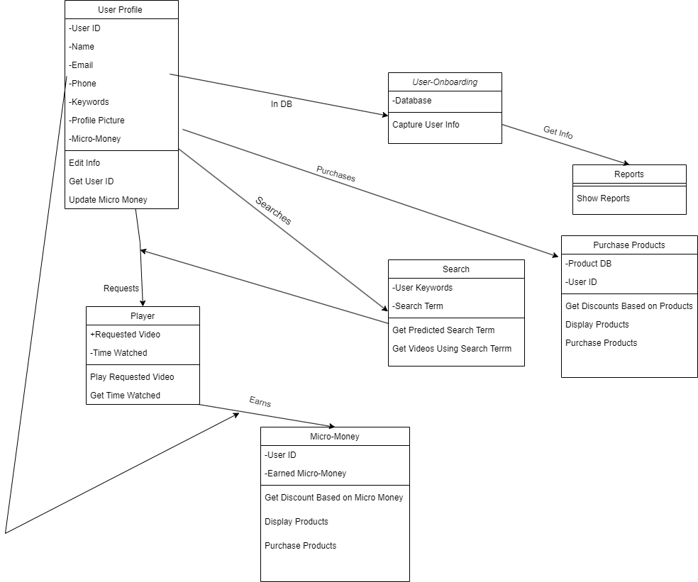

**Use case description:**

**Main-Flow: 1-2-3-6,4-6**

|  |  |
| --- | --- |
| **Use Case Number:** | UC-01 |
| **Use Case Name:** | Search |
| **Overview:** | 1. The User Searches for the video he wants to watch - with predictive text. 2. If there is no search keyword, we use static keywords generated from other parameters from the user profile to show the recommended system. 3. A request to play the Selected video is sent. |
| **Actors:** | User |
| **Precondition:** | 1(User details should be stored in database) |
| **Flow:** | Main (success) Flow: 1-2-3-6 |
|  |  |
| **Post Condition:** | Videos related to search/keywords should be displayed |

|  |  |
| --- | --- |
| **Use Case Number:** | UC-02 |
| **Use Case Name:** | Watch |
| **Overview:** | 1. Plays the requested YT Video 2. Should not migrate out of app context. |
| **Actors:** | User |
| **Precondition:** | Videos related to search/keywords should be displayed |
| **Flow:** | Main (success) Flow: 1-2-3-6 |
|  |  |
| **Post Condition:** | Video will play in the video player present in the app itself.  Stores the duration of videos watched.  Stores the videos watched. |

|  |  |
| --- | --- |
| **Use Case Number:** | UC-03 |
| **Use Case Name:** | Earn Micro-Money |
| **Overview:** | 1. Increase Micro-Money based on duration watched. |
| **Actors:** | User |
| **Precondition:** | Stores the duration of videos watched. |
| **Flow:** | Main (success) Flow: 1-2-3-6 |
|  |  |
| **Post Condition:** | The number of Coins you have earned should be Updated.  Store the info of the videos watched by the user. |

|  |  |
| --- | --- |
| **Use Case Number:** | UC-04 |
| **Use Case Name:** | Purchase Products |
| **Overview:** | 1. It will be in the app only. 2. Able to purchase products (Real transaction is not handled, just as a POC) 3. A list of products each with pic, description, price, and discount is displayed. Discount is based on the earned micro-money. 4. Sends acknowledgements after a successful transaction. 5. Needs to send what items a user purchased to a DB. 6. Must be easily replaceable with a real app. |
| **Actors:** | User |
| **Precondition:** | User details should be stored along with the updated number of Coins and user should invoke the e-commerce app |
| **Flow:** | Main (success) Flow: 4-6 |
|  |  |
| **Post Condition:** | Update the database after the coins have been used.  Store the purchase done by the User. |

|  |  |
| --- | --- |
| **Use Case Number:** | UC-05 |
| **Use Case Name:** | User profile |
| **Overview:** | 1. Show the Coins the user earned. 2. Show the User details. 3. History of videos the user watched. 4. History of products *purchased.* |
| **Actors:** | User |
| **Precondition:** | User details should be stored in a database along with an updated number of coins, products purchased, and videos watched |
| **Flow:** | Main (success) Flow: 5-6 |
|  |  |
| **Post Condition:** | Display all the details on the screen for user analysis. |

|  |  |
| --- | --- |
| **Use Case Number:** | UC-06 |
| **Use Case Name:** | Reports |
| **Overview:** | 1. User account summary 2. Snapshot of daily transitions 3. Snapshot of all videos played and their duration. 4. All items purchased |
| **Actors:** | Client |
| **Precondition:** | User details should be stored in the database along with an updated number of coins, products purchased, and videos watched.  Details of products purchased in a day-wise manner.  Details of videos watched in a day-wise manner. |
| **Flow:** | Main (success) Flow: 1-2-3-6,4-6 |
|  | Alternate Flows:. |
| **Post Condition:** | A report should be displayed to the client |