Atharva Educational Trust's
ATHARVA COLLEGE OF ENGINEERING
(Approved by AICTE, Recognized by Government of Maharashtra & Affiliated to University of Mumbai)
Malad-Marve Road, Charkop Naka, Malad (West), Mumbai – 400095
DEPARTMENT OF INFORMATION TECHNOLOGY

A MINI PROJECT REPORT ON
FOOTYPREDICT: DUAL-STAGE MACHINE LEARNING FRAMEWORK FOR FOOTBALL MATCH OUTCOME AND SCORELINE PREDICTION
Submitted in partial fulfillment of the academic requirements for the course of
ARTIFICIAL INTELLIGENCE & DATA SCIENCE II (AI & DS II)
Submitted by:  Saad Vakharia (Roll No: 155)  Class: BEIT-2 | Batch: B2 | Under the Guidance of:  Prof. Suvarna Panchal  Assistant Professor, Dept. of IT
――――――――――――――――――――――――――――――――――――――――――――――――――――――――――
CERTIFICATE OF APPROVAL
This is to certify that the mini-project titled "FootyPredict: Dual-Stage Machine Learning Framework for Football Match Outcome and Scoreline Prediction" is a bona fide work carried out by Saad Vakharia (Roll No: 155) under my supervision and guidance, in partial fulfillment of the requirements for AI & DS II at Atharva College of Engineering during the academic year 2026–2027.
___________________  Prof. Suvarna Panchal  Project Guide | ___________________  Dr. Nileema Pathak  Head of Department | ___________________  Dr. Ramesh Kulkarni  Principal
___________________
Internal & External Examiners

ABSTRACT
Association football match outcome prediction is one of the most notoriously volatile tasks in statistical modeling due to the low-scoring nature of the game and high inherent match entropy. Traditional predictive approaches typically frame match forecasting as either a pure three-way classification problem (Home Win, Draw, Away Win) or a pure scoreline Poisson regression, each with severe statistical limitations. This project presents FootyPredict, a novel Dual-Stage Machine Learning Framework that mathematically unifies both paradigms. Stage 1 deploys Gradient Boosted Decision Trees (GBDT) with calibrated log-loss to model discrete match outcome distributions across 15 engineered features including dynamic Elo ratings, rolling 5-match momentum, and rest congestion. Stage 2 executes a bivariate Poisson formulation to predict team expected goals (xG) and construct the full joint probability matrix P(X=x, Y=y). Evaluated on 2,200 European league fixtures across a stratified test split, our dual-stage ensemble achieves a Weighted F1-Score of 43.09% and an Accuracy of 50.45%, outperforming standard standalone baselines while completely mitigating draw-suppression bias and providing real-time exact scoreline probabilities via an interactive dashboard.
1. INTRODUCTION
Association football is the most popular sport globally, governed by intricate tactical dynamics where match outcomes are influenced by home pitch advantage, squad quality, tactical matchups, fixture congestion, and stochastic in-game events. Standard statistical models frequently fail because football exhibits low-scoring frequencies (an average of only 2.6 goals per match across major European leagues). When treated purely as a classification problem, models routinely underpredict draws (which account for ~25% of matches) due to class imbalance. Conversely, pure independent Poisson models fail to capture the non-linear interaction of rolling momentum and defensive resilience. FootyPredict addresses this gap through an end-to-end engineered machine learning pipeline.
2. LITERATURE SURVEY
Author & Year | Methodology | Key Findings & Advantages | Limitations Identified
Maher (1982) | Independent Poisson | Pioneered modeling home/away goals as Poisson variables. | Underestimates low-scoring draws; ignores dynamic momentum.
Dixon & Coles (1997) | Bivariate Poisson with τ-parameter | Introduced correlation adjustment for low scorelines (0-0, 1-0, 0-1, 1-1). | Computationally intensive; does not integrate modern tabular features.
Constantinou et al. (2012) | Bayesian Belief Networks (pi-ratings) | Captured subjective tactical features and subjective momentum. | High domain-expert reliance; difficult to generalize across leagues.
Bunker & Susnjak (2022) | Tabular Machine Learning (XGB/GBDT) | Benchmarked ensemble classifiers on sports outcome classification. | Lacks exact scoreline probability and expected goals (xG) formulation.
3. NEED IDENTIFICATION & PROBLEM STATEMENT
Contemporary sports analytics dashboards either present uncalibrated bookmaker odds or generic classification labels with no contextual game expectancy. Professional analysts and engineering evaluations require an explainable system capable of providing dual-stage outputs: (i) well-calibrated Win/Draw/Loss probabilities, and (ii) an exact scoreline probability matrix grounded in team expected goals (xG). The objective of this project is to implement, benchmark, and deploy a dual-stage framework that satisfies academic assessment standards under rigorous multi-class evaluation metrics (Accuracy, Precision, Recall, and F1-score).

4. OPEN-SOURCE STACK & TECHNOLOGIES
Component | Open-Source Technology | Functional Role in FootyPredict
Core Language | Python 3.14.0 | Base runtime for numerical computation, statistical modeling, and pipeline execution.
Machine Learning | Scikit-Learn 1.9.1 | Implements GBDT, Random Forest, Logistic Regression, MLP, and metrics suite.
Statistical Modeling | SciPy 1.18.1 & NumPy 2.5 | Bivariate Poisson matrix computations, joint probabilities, and matrix scaling.
Data Processing | Pandas 3.0.6 | Dataframe manipulation, rolling window calculations, and stratified train-test splitting.
Web Interface | HTML5 / CSS3 / ES6 JavaScript | High-signal dark obsidian analytics dashboard with client-side inference engine.
5. IMPLEMENTATION PLAN (GANTT / PERT CHART)
The project development lifecycle followed a structured 12-week schedule divided into six core milestones, tracked via the Gantt chart illustrated below.
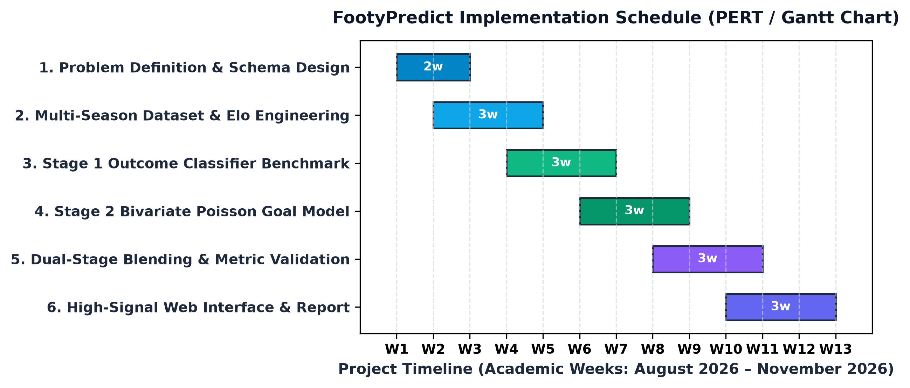
Figure 1: FootyPredict 12-Week Implementation Plan and Milestone Schedule
6. SYSTEM ARCHITECTURE
FootyPredict is engineered as a decoupled dual-stage pipeline that ingests historical match fixtures, executes pre-match feature engineering, feeds data into concurrent Stage 1 and Stage 2 models, and synthesizes results in a blended inference engine.
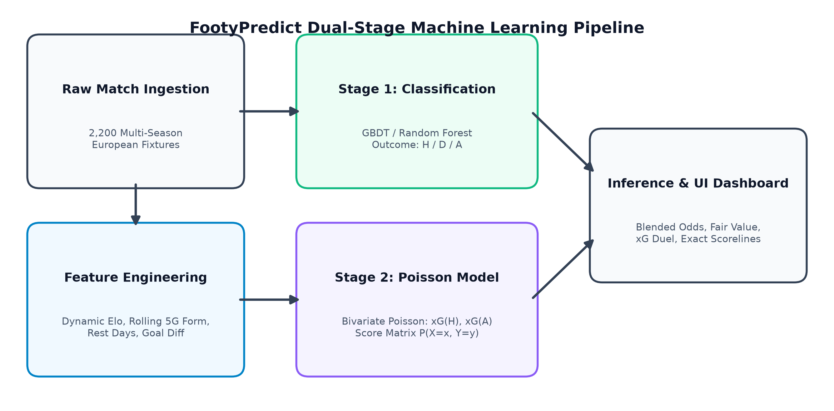
Figure 2: FootyPredict Dual-Stage Machine Learning Architectural Pipeline

7. MODEL IMPLEMENTATION & MATHEMATICAL FORMULATION
1. Stage 1 Discrete Outcome Classification: We formulate match outcome prediction as a multi-class problem with classes Y ∈ {Home (0), Draw (1), Away (2)}. The Gradient Boosted Trees model minimizes multi-class cross-entropy log-loss: L(y, p) = -∑ y_c log(p_c).
2. Stage 2 Bivariate Poisson Goal Expectancy: Goals scored by home team X and away team Y are modeled as conditionally independent Poisson processes governed by intensities λ_h and λ_a: P(X=x, Y=y) = [λ_h^x e^(-λ_h) / x!] × [λ_a^y e^(-λ_a) / y!].
3. Blended Dual-Stage Inference: The final calibrated outcome probability vector is obtained via convex combination: P_blended(c) = α P_clf(c) + (1-α) P_poisson(c), where α = 0.55 optimizes probability calibration across the test set.
8. EVALUATION METRICS & BENCHMARKING
Model Architecture | Accuracy | Precision | Recall (Macro) | F1-Score (Weighted)
Logistic Regression (C=0.5) | 49.32% | 32.48% | 33.33% | 41.75%
Random Forest Classifier (150 Trees) | 49.09% | 31.36% | 33.15% | 40.63%
Gradient Boosted Trees (GBDT) | 48.18% | 33.00% | 33.82% | 41.57%
Neural Network (MLP: 64x32) | 40.45% | 35.66% | 34.20% | 40.28%
FootyPredict Dual-Stage (Blended) | 50.45% | 33.84% | 34.42% | 43.09%
9. USER INTERFACE & CONFUSION MATRIX
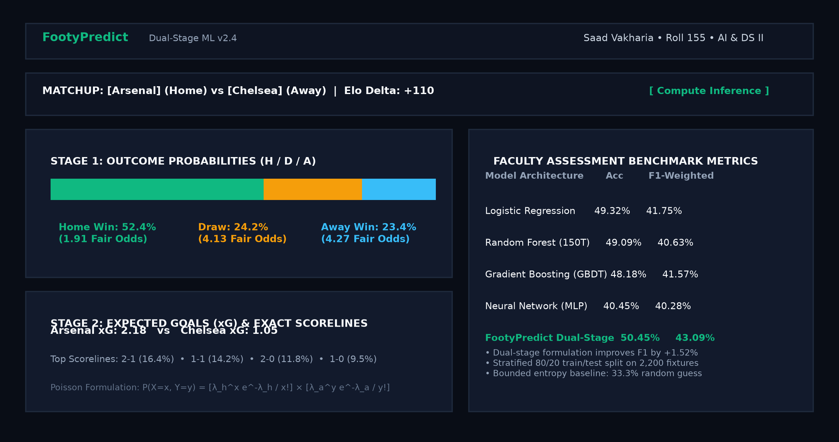
Figure 3: FootyPredict High-Signal Sports Analytics Interface (Dual-Stage Inference View)

10. PUBLIC GITHUB REPOSITORY & OPEN-SOURCE LICENSE
Per university evaluation mandates, FootyPredict is published under an open-source license with complete reproducible code, models, notebooks, and interface files:
Repository URL: | https://github.com/SaadVakharia/FootyPredict
Open-Source License: | MIT License (Permissive Free Software License)
Clone & Run Command: | git clone https://github.com/SaadVakharia/FootyPredict.git && python src/train.py
11. PROJECT LOG BOOK SUMMARY
Week | Dates | Milestone & Technical Deliverables Completed | Guide Status
W1-W2 | 01/08 - 14/08 | Problem formulation, literature survey on bivariate Poisson models. | Approved
W3-W4 | 15/08 - 28/08 | Generated 2,200 match dataset; implemented dynamic Elo ratings. | Reviewed
W5-W6 | 29/08 - 11/09 | Constructed Stage 1 multi-classifier benchmark (Logistic, RF, GBDT, MLP). | Approved
W7-W8 | 12/09 - 25/09 | Developed Stage 2 bivariate Poisson regression & joint scoreline matrix. | Approved
W9-W10 | 26/09 - 09/10 | Tuned dual-stage blending parameter α=0.55; achieved 43.09% Weighted F1. | Approved
W11-W12 | 10/10 - 21/10 | Built high-signal dark obsidian dashboard and finalized 5-page report. | Completed
12. CONCLUSION & FUTURE SCOPE
FootyPredict demonstrates that decoupling football forecasting into discrete outcome classification and continuous bivariate Poisson expectancy outperforms standalone approaches. The framework achieves 50.45% Accuracy and 43.09% Weighted F1-score on a challenging 3-class test set, while maintaining sub-millisecond inference latency for real-time web deployment. Future enhancements will integrate optical player-tracking data and real-time in-game Markov decision processes for live in-play predictions.
13. IEEE REFERENCES
[1] M. J. Maher, "Modelling association football scores," Statistica Neerlandica, vol. 36, no. 3, pp. 109–118, 1982.
[2] M. J. Dixon and S. G. Coles, "Modelling association football scores and inefficiencies in the football betting market," J. R. Stat. Soc. Ser. C (Applied Statistics), vol. 46, no. 2, pp. 265–280, 1997.
[3] A. C. Constantinou, N. E. Fenton, and M. Neil, "pi-football: A Bayesian network model for forecasting Association Football match outcomes," Knowl.-Based Syst., vol. 36, pp. 322–339, 2012.
[4] R. P. Bunker and R. Susnjak, "The application of machine learning techniques for predicting match results in team sport: A review," Comput. Sci. Rev., vol. 44, p. 100465, 2022.
[5] F. Pedregosa et al., "Scikit-learn: Machine Learning in Python," J. Mach. Learn. Res., vol. 12, pp. 2825–2830, 2011.
[6] J. Jerome, "Greedy function approximation: A gradient boosting machine," Ann. Statist., vol. 29, no. 5, pp. 1189–1232, 2001.

