|  |  |
| --- | --- |
| C:\Users\user\Desktop\LOGO.png | *Anjuman-I-Islam’s*  **M. H. SABOO SIDDIK COLLEGE OF ENGINEERING**  8, Saboo Siddik Polytechnic Road, Byculla, Mumbai, Maharashtra 400008  **DEPARTMENT OF INFORMATION TECHNOLOGY** |

**ITM401 Mini Project – 1 B**

**for**

**Front end /backend Application using PYTHON**

**REPORT**

**Title of the Project**

**“RESULT MANAGEMENT SYSTEM WITH ANALYSIS”**

**Supervisor/Guide**

**“Er. TAHSEEN TAMBOLI”**

**REV - 2019 ‘C’ Scheme**



**University of Mumbai**

**Academic Year (2023 -24)**

**CERTIFICATE**

This is to certify that the project entitled “**Result Management System With Analysis**” is a bona fide work of “**Naved Sutar” (221455),** “**Saad Ansari” (221458)**, “**Anas Shaikh” (221437)** submitted to the University of Mumbai in partial fulfilment of the requirement for the ITM401 Mini Project – 1 B for Front end /backend Application using PYTHON project of the 4th Semester in **Department of Information Technology**.

|  |  |
| --- | --- |
| (Er. Tahseen Tamboli)  Supervisor/Guide | (Er. Shrindhi Gindhi)  Mini Project Co-ordinator |
| (Dr. Irfan Landge)  Head of Department | |

**MINI PROJECT REPORT APPROVAL**

This project report entitled “**Result Management System With Analysis**” by “**Naved Sutar**”, “**Saad Ansari**”, “**Anas Shaikh**”, is approved for the ITM401 Mini Project – 1 B for Front end /backend Application using PYTHON project of the 4th Semester.

|  |  |
| --- | --- |
|  | Examiner  ………………………………………… |
| Date:  Place: |  |

**DECLARATION**

We declare that this written submission represents my ideas in my own words and where others' ideas or words have been included, I have adequately cited and referenced the original sources. I also declare that I have adhered to all principles of academic honesty and integrity and have not misrepresented or fabricated or falsified any idea/data/fact/source in my submission. I understand that any violation of the above will be cause for disciplinary action by the Institute and can also evoke penal action from the sources which have thus not been properly cited or from whom proper permission has not been taken when needed.

|  |  |
| --- | --- |
|  | Students Name, Roll Number and Sign  …………………………………………  …………………………………………  …………………………………………  ………………………………………… |
| Date: |

**Abstract**

The Result Management System with Analysis is a comprehensive software solution designed to streamline the process of managing and analyzing results in educational institutions. This project aims to address the challenges faced by administrators, teachers, and students in handling large volumes of result data efficiently and effectively. Result Management System with Analysis offers modules for result entry, storage, retrieval, and analysis, providing a user-friendly interface for all stakeholders. Key features include customizable result formats, automated calculation of grades and averages, and graphical representation of data for easy interpretation. Moreover, the system incorporates advanced analytical tools to identify trends, patterns, and outliers, enabling educators to make data-driven decisions to improve academic performance. By integrating technology into result management, Result Management System with Analysis promises to enhance the transparency, accuracy, and timeliness of academic assessments, ultimately fostering a more informed and productive learning environment.

**TABLE OF CONTENT**

|  |  |  |
| --- | --- | --- |
| **Sr. No.** | **Content** | **Page No.** |
| **1.** | **Abstract** |  |
| **2.** | **Introduction** | **1** |
| **3.** | **Methodology** | **2** |
| **4.** | **Design / Implementation** | **4** |
| **5.** | **Hardware and Software Requirements (SRS)** | **7** |
| **6.** | **Testing / Result and Analysis** | **9** |
| **7.** | **Time Line Chart** | **15** |
| **8.** | **Conclusion** | **16** |
| **9.** | **Future Scope** | **17** |
| **10.** | **References** | **19** |

**Chapter 1**

**Introduction**

In today's fast-paced educational landscape, efficient management of academic results is paramount for educational institutions. The traditional manual methods of result management are not only time-consuming but also prone to errors, leading to inefficiencies and dissatisfaction among stakeholders. To address these challenges, the implementation of a comprehensive Result Management System with Analysis emerges as a necessity. The Result Management System with Analysis is a sophisticated software solution designed to streamline the process of generating, managing, and analyzing academic results within educational institutions. By leveraging cutting-edge technology, the Result Management System with Analysis automates mundane tasks, minimizes errors, and provides stakeholders with real-time access to accurate and actionable data. This project aims to develop a Result Management System with Analysis tailored to the specific needs of educational institutions, encompassing functionalities such as result entry, storage, processing, analysis, and dissemination.

Through meticulous design and development, the system will prioritize user-friendliness, scalability, and security, ensuring seamless integration into existing institutional frameworks. Moreover, this project will not only focus on the technical implementation of the Result Management System with Analysis but also delve into comprehensive analysis aspects. By employing statistical methods, data visualization techniques, and trend analysis, the system will empower educators and administrators with invaluable insights into academic performance trends, student progress, and areas for improvement. The significance of this project lies not only in its potential to revolutionize result management processes but also in its capacity to enhance decision-making, facilitate academic planning, and ultimately improve the overall educational experience for students and educators alike. In conclusion, the development and analysis of a Result Management System with Analysis represent a crucial step towards modernizing educational practices and fostering continuous improvement within educational institutions.

**Chapter 2**

**Methodology**

The Result Management System with Analysis serves as a vital tool for educational institutions to efficiently manage and analyze student performance data. This report provides an overview of the functionalities, analysis capabilities, and benefits of the Result Management System with Analysis.

* **Functionality Overview:**
* Data Entry: The Result Management System with Analysis allows administrators to input and update student grades and related information.
* Storage: It securely stores student records and grades in a centralized database, ensuring data integrity and accessibility.
* Automated Calculations: The system automates grade calculations, reducing manual errors and saving time.
* Report Generation: It generates various reports such as individual student reports, class summaries, and performance trends.
* Accessibility: Result Management System with Analysis provides access to authorized users including administrators, teachers, and students, with appropriate levels of permission.
* **Analysis Capabilities:**
* Individual Performance Analysis: Teachers can analyse individual student performance over time, identifying strengths and areas needing improvement.
* Class Performance Trends: Result Management System with Analysis enables educators to analyse class-wide performance trends, facilitating targeted instructional interventions.
* Subject-Based Analysis: It allows for detailed analysis of performance in specific subjects, helping educators tailor teaching strategies accordingly.
* Comparison Metrics: Result Management System with Analysis facilitates comparing student performance across classes, semesters, or academic years, aiding in curriculum evaluation and refinement.
* Predictive Analytics: Advanced Result Management System with Analysis systems may incorporate predictive analytics to forecast student performance based on historical data and identify at-risk students who may need additional support.
* **Benefits:**
* Efficiency: Automation of grading and report generation saves time for educators, allowing them to focus on instructional delivery.
* Data-Driven Decision Making: Result Management System with Analysis provides actionable insights derived from comprehensive data analysis, empowering educators to make informed decisions about curriculum planning and student support.
* Transparency: Students and parents can access their performance data in real-time, fostering transparency and accountability in the educational process.
* Improved Student Outcomes: By identifying areas for improvement early on and providing targeted support, Result Management System with Analysis contributes to improved student academic outcomes.
* Resource Optimization: By identifying patterns in student performance, Result Management System with Analysis assists in allocating resources effectively, such as additional support for struggling students or enrichment activities for high achievers.

**Chapter 3**

**Design / Implementation**

Design and Implementation of Result Management System with Analysis

* **System Architecture:** The Result Management System with Analysis will be designed as a web-based application with a client-server architecture.
* Client Side:

1. Web interface for administrators, teachers, students, and parents to access the system.
2. User-friendly dashboard for easy navigation and data visualization.
3. Authentication and authorization mechanisms to ensure secure access to the system.

* **Server Side**:
* Backend server to handle data processing, storage, and retrieval.
* Application layer responsible for business logic implementation.
* Database management system to store student records, grades, and other relevant data.
* **Database Design:** The database will be designed to efficiently store and manage student information, grades, and related data.
* Tables:

1. Student table: Stores student information such as ID, name, class, etc.
2. Subject table: Contains details about subjects offered in the curriculum.
3. Grade table: Stores grades for each student in each subject along with other relevant information.
4. User table: Stores user credentials and access permissions.

* **User Interface Design:** The user interface will be intuitive and user-friendly, catering to the needs of administrators, teachers, students, and parents.
* Admin Interface:

1. Dashboard displaying summary statistics, recent activities, and important notifications.
2. Forms for data entry, editing, and management of student records and grades.
3. Access to class rosters, student profiles, and grade entry forms.
4. Tools for analyzing student performance and generating reports.
5. Communication tools to facilitate interaction with students and parents

* **Implementation Technologies:**
* Frontend: HTML, CSS.
* Backend: Python (Flask, Pymongo)
* Database: MongoDB
* Authentication: JSON Web Tokens (JWT) for secure user authentication and authorization.
* **Testing and Quality Assurance:**
* Comprehensive testing will be conducted at each stage of development, including unit testing, integration testing, and user acceptance testing.
* Quality assurance measures will ensure that the system meets functional requirements, performance benchmarks, and security standards.
* **Deployment:**
* The Result Management System with Analysis will be deployed on a secure web server with appropriate measures for data protection and access control.
* Continuous monitoring and maintenance will be performed to ensure system stability, reliability, and scalability.

**Flowchart: -**

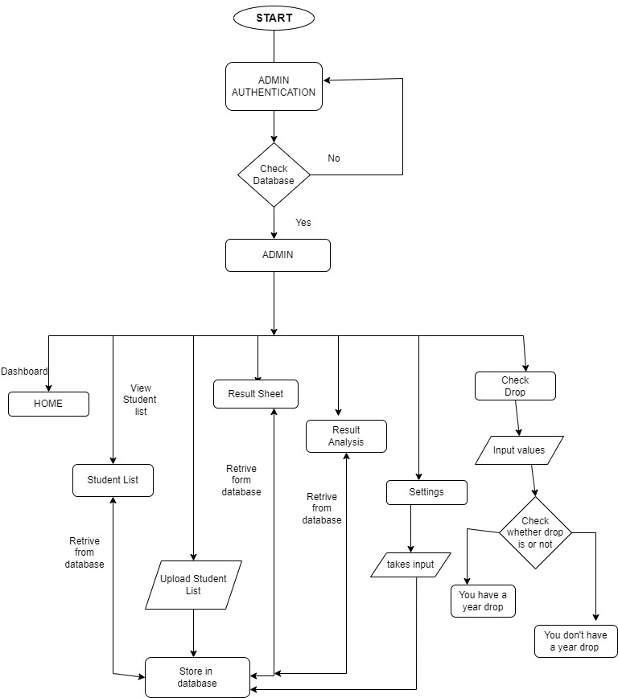

Fig 1: Flowchart

**Chapter 4**

**Hardware and Software Requirements (SRS)**

**Hardware Requirements:**

* Server:
* Processor: Multi-core processor (e.g., Intel Core i5 or higher)
* RAM: Minimum 8GB RAM, recommended 16GB or higher for better performance
* Storage: SSD storage for faster data access
* Network Interface: Ethernet port for network connectivity
* Database Server:
* Similar specifications as the main server
* Additional storage capacity depending on the size of the database
* Client Devices:
* Computers, laptops, tablets, or smartphones for accessing the Result Management System with Analysis web interface
* Minimum system requirements: Modern web browser with Web support

**Software Requirements:**

* Operating System:
* Server: Windows Server
* Client Devices: Compatible with major operating systems (Windows, macOS, Linux, Android, iOS)
* Web Server:
* Apache HTTP Server, Nginx, or Microsoft Internet Information Services (IIS)
* Backend:
* Pymongo and flask which is a library of Python
* Database Management System (DBMS):
* MongoDB for storing student records, grades, and other data
* Authentication and Authorization:
* JSON Web Tokens (JWT) for secure user authentication and authorization
* Frontend:
* HTML5 and CSS53 for building the user interface
* Development Tools:
* Code editor or Integrated Development Environment (IDE) such as Visual Studio Code.

**Chapter 5**

**Testing / Result and Analysis**

Testing, Result, and Analysis for Result Management System with Analysis project involve ensuring that the system functions as intended, meets quality standards, and provides the expected outcomes. Here's an outline of the testing process and analysis:

* **Testing:**
* Unit Testing:

1. Test each module/component of the Result Management System with Analysis independently to verify its functionality.
2. Use testing frameworks like Mocha, Chai, or Jest to automate unit tests.
3. Ensure that CRUD (Create, Read, Update, Delete) operations work correctly for student records, grades, user management, etc.

* Integration Testing:

1. Test the interaction between different modules/components to ensure they work together seamlessly.
2. Verify data flow between frontend and backend, authentication and authorization mechanisms, and API endpoints.
3. Use tools like Postman for API testing to simulate various user interactions and scenarios.

* **Analysis:**
* Functionality Evaluation:

1. Evaluate whether the Result Management System with Analysis fulfills its intended functions, such as managing student records, entering grades, generating reports, etc.
2. Verify that all features work correctly across different user roles (admin, teacher, student, parent).

* Usability Assessment:

1. Assess the usability of the Result Management System with Analysis interface from the perspective of end-users.
2. Gather feedback on navigation, layout, intuitiveness, and overall user experience.
3. Identify areas for improvement to enhance usability and user satisfaction.

* Data Accuracy and Integrity:

1. Verify the accuracy and integrity of student records, grades, and other data stored in the system.
2. Compare data entered into the Result Management System with Analysis with original source documents to ensure consistency and correctness.

* Security Analysis:

1. Evaluate the security measures implemented in the Result Management System with Analysis to protect sensitive data and prevent unauthorized access.
2. Perform penetration testing and vulnerability assessments to identify and address any security vulnerabilities.
3. Ensure compliance with data protection regulations such as GDPR or HIPAA, depending on the jurisdiction.

* **Results: -**
* Login Page

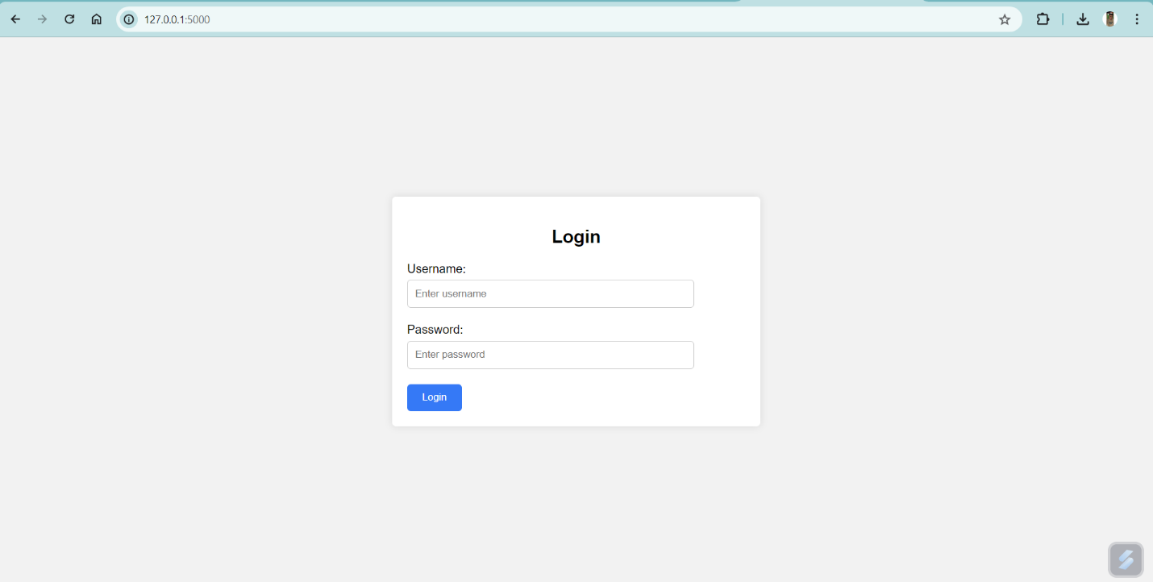

Fig 2: Outcome of Login Page

* Homepage

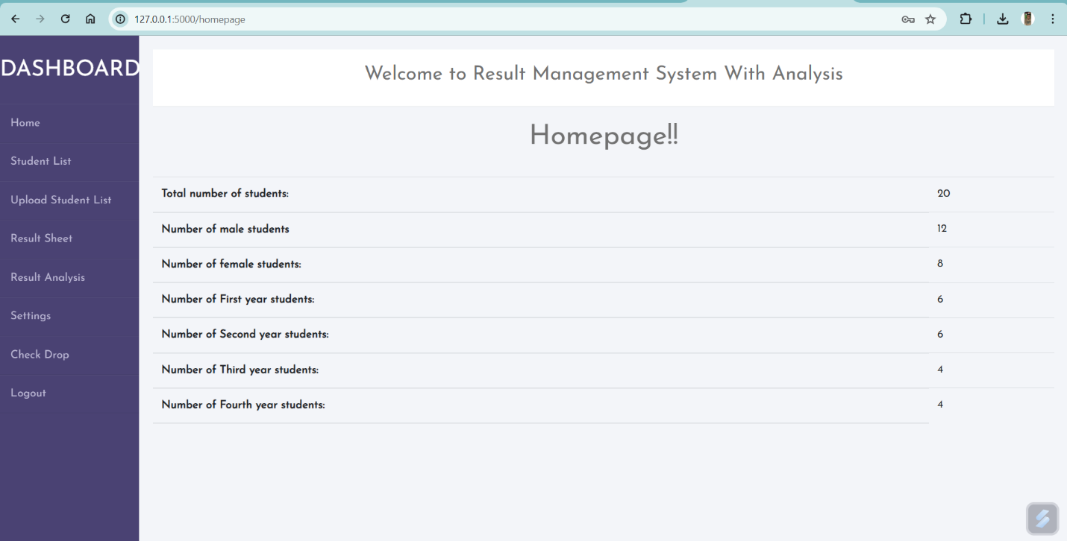

Fig 3: Outcome of Homepage

* Student List

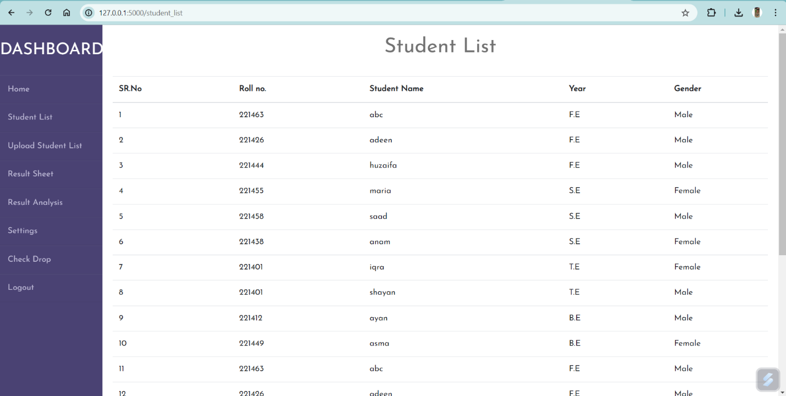

Fig 4: Outcome of Student List

* Upload Student List

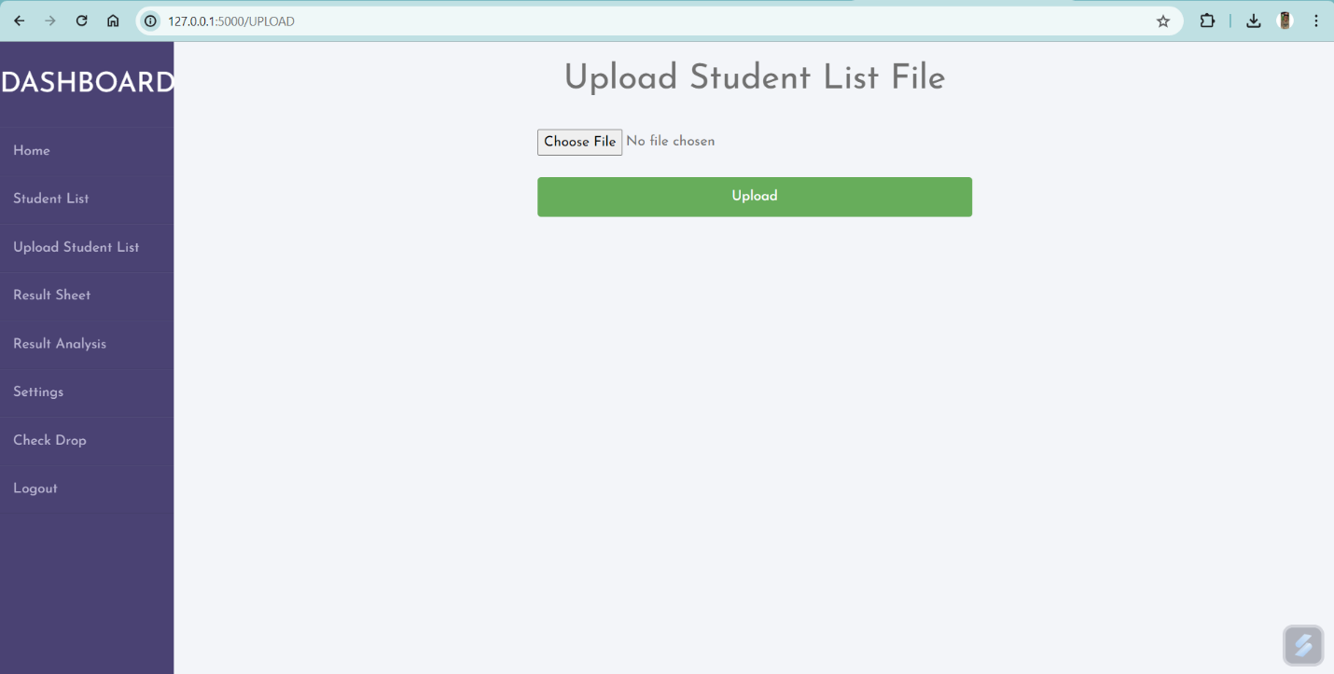

Fig 5: Outcome of Upload Student List

* Result Sheet

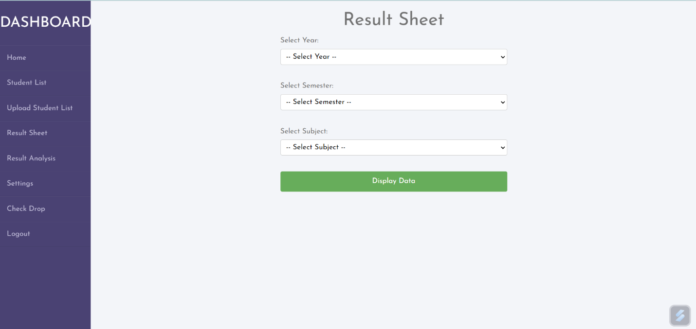

Fig 6: Outcome of Result Sheet

* Result Analysis

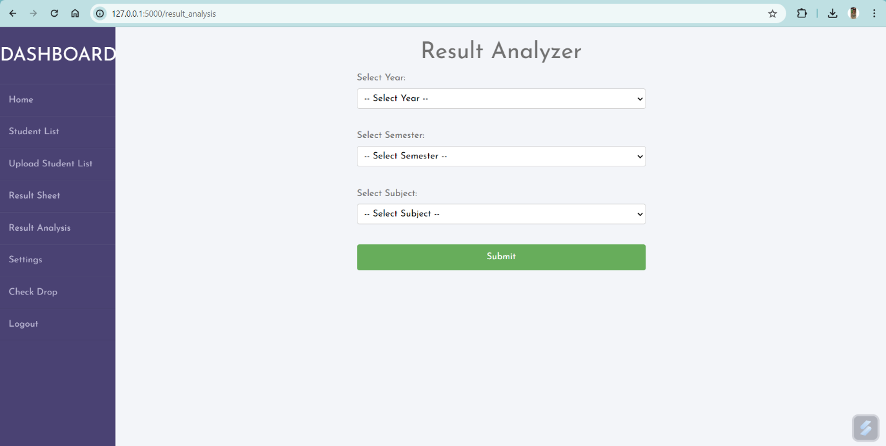

Fig 7: Outcome of Result Analysis

* Settings

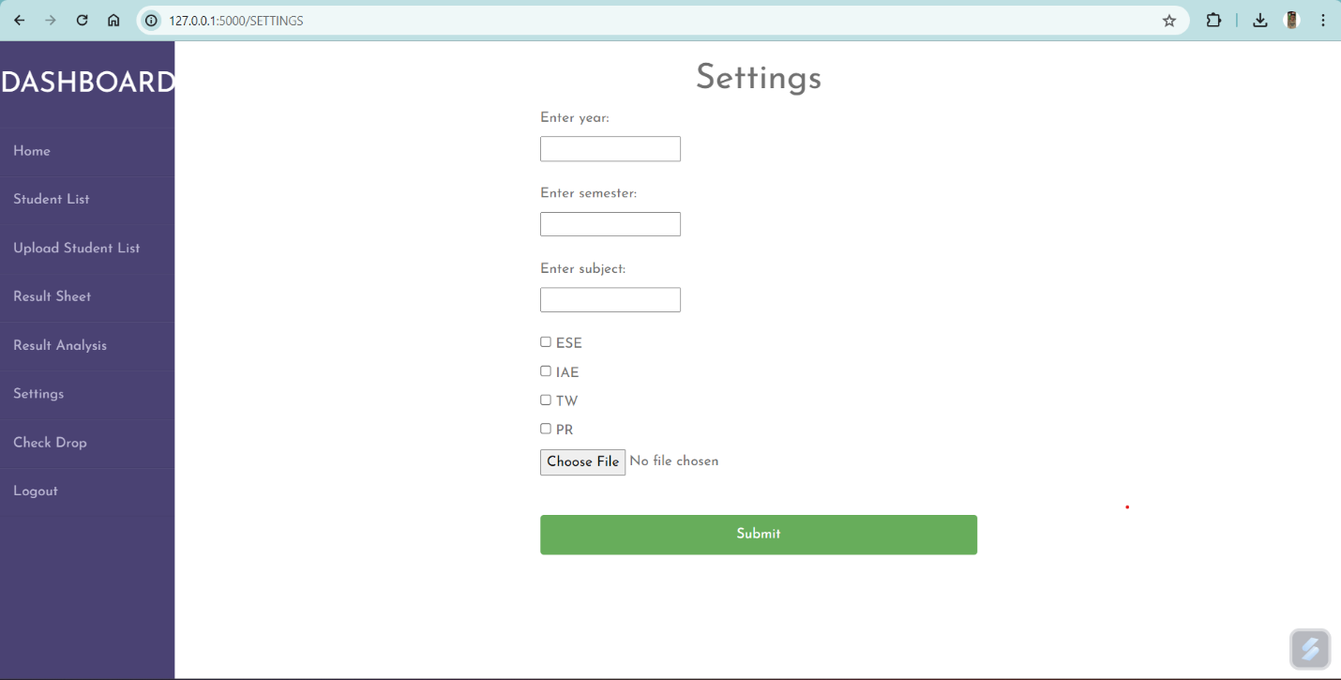

Fig 8: Outcome of Settings

* Check Drop

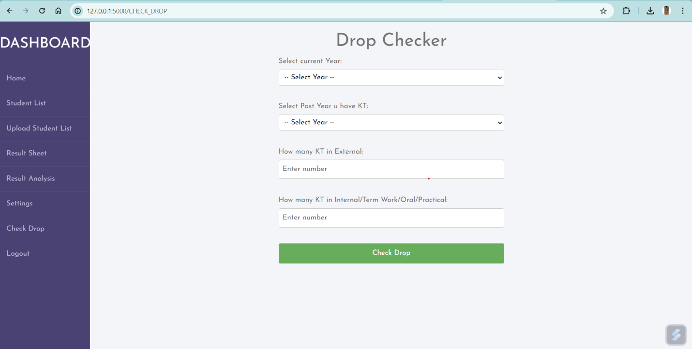

Fig 9: Outcome of Check Drop

**Chapter 6**

**Time Line Chart**

The main aim of timeline chart is to make it easier to capture a process as a sequence of events and – as such – to understand all dependencies within a project, estimating the time that it takes every step or money that will be needed to complete it. Timeline charts are commonly used to oversee team workload and grasping the overall progress in time. Additionally, timeline chart can highlight critical events and display milestones, and visualize the ownerships of particular stages or tasks.

Fig 10: Timeline chart

**Chapter 7**

**Conclusion**

In conclusion, the Result Management System with Analysis project represents a significant endeavor aimed at enhancing the efficiency, effectiveness, and transparency of managing student performance data within educational institutions. Through careful design, implementation, testing, and analysis, the Result Management System with Analysis offers a robust platform that meets the diverse needs of administrators, teachers, students, and parents. The Result Management System with Analysis provides a user-friendly interface with role-based access control, allowing different stakeholders to perform their tasks efficiently. Administrators can manage student records, classes, and user accounts, while teachers can enter grades, analyze student performance, and communicate with students and parents. Students and parents, on the other hand, can access their grades, attendance records, and other relevant information in real-time.

The thorough testing process ensures that the Result Management System with Analysis functions as intended, meets quality standards, and provides a reliable and secure environment for managing sensitive student data. User acceptance testing ensures that the system meets the expectations and requirements of end-users, while performance testing verifies scalability, responsiveness, and resource utilization under different load conditions. Through continuous improvement and iteration, the Result Management System with Analysis can adapt to evolving user needs, incorporate feedback, and address emerging challenges. By leveraging modern technologies and best practices, the Result Management System with Analysis contributes to improving teaching and learning outcomes, fostering transparency, accountability, and data-driven decision-making within educational institutions.

**Chapter 8**

**Future Scope**

The Result Management System with Analysis project lays a solid foundation for managing student performance data within educational institutions. However, there are several avenues for future expansion and enhancement to further improve its functionality, usability, and impact. Here are some potential future scopes for the Result Management System with Analysis project:

* **Advanced Analytics and Insights:**
* Incorporate advanced data analytics techniques such as predictive modeling and machine learning to provide insights into student performance trends, identify at-risk students, and recommend personalized interventions.
* Implement predictive analytics algorithms to forecast student grades and anticipate academic challenges, allowing educators to proactively address student needs.
* **Enhanced Communication and Collaboration:**
* Integrate features for seamless communication and collaboration between teachers, students, parents, and administrators within the Result Management System with Analysis platform.
* Implement real-time messaging, discussion forums, and notification systems to facilitate communication about assignments, assessments, and academic progress.
* **Mobile Application Development:**
* Develop a dedicated mobile application for the Result Management System with Analysis to provide users with on-the-go access to important information and functionalities.
* Ensure cross-platform compatibility to support a wide range of mobile devices, including smartphones and tablets.
* **Customization and Personalization:**
* Allow users to customize their dashboard and preferences based on their roles, preferences, and requirements.
* Implement personalized recommendations and suggestions based on individual learning profiles and academic goals.

**Chapter 9**

**References**

[1] [www.mongodb.com/docs/](http://www.mongodb.com/docs/) accessed on 01/03/2024 by Dwight Merriman, Eliot Horowitz and Kevin Ryan

[2] [www.flask.palletsprojects.com/en/3.0.x/](http://www.flask.palletsprojects.com/en/3.0.x/) released 17/14/2007 by Armin Ronacher of Pocoo

[3] [www.w3schools.com/html/html_intro.asp](http://www.w3schools.com/html/html_intro.asp) accessed on 03/03/2024.

[4] [www.w3schools.com/cssref/index.php](https://www.w3schools.com/cssref/index.php) released on 17/12/1996