When does machine learning recover the physics? A synthetic-benchmark tutorial for structure–property modelling of metal-crosslinked carrageenan hydrogels
Target journal: Digital Discovery (RSC), Paper or Tutorial Review format.
Authors: [Author names], [Affiliations], [Corresponding author email]. To be confirmed by the team.
Data declaration: No laboratory experiments were performed for this study. Every dataset was generated synthetically from the physical models and assumed parameters given in Section 2. Ionic radii and hydration Gibbs energies are literature constants, used only to give the six virtual ion classes realistic descriptors. No result should be read as a measured property of any real material.

Abstract
Machine-learning models of hydrogel structure–property data are usually trained on 10–50 formulations measured in replicate. In this regime, validation design can matter more than the model itself. We present an open synthetic benchmark in which the ground truth is known. A data-generating process combines affine rubber elasticity, Flory-type swelling and Langmuir ion binding with literature descriptors for six divalent ions, producing metal-crosslinked carrageenan hydrogel datasets with controlled replicate noise. All data are synthetic.
On 24 formulations (120 samples, 4% noise), under leakage-free grouped cross-validation, a physics-based grey-box model reached Q² = 0.979 against a noise ceiling of 0.981 and recovered its true parameters within 5%. Gaussian process regression reached Q² = 0.956, but its 95% intervals covered only 87% of held-out values, and grouped recalibration raised this only to 90%. Random forests (Q² = 0.36) and small neural networks (0.25) failed. The neural network stayed at 0.25 even with 480 samples. Splitting replicates at random inflated random-forest Q² from 0.36 to 0.97. At a fixed budget of 120 samples, 24 formulations in five replicates gave GPR Q² = 0.98 against the true function, whereas 6 formulations in 20 replicates gave 0.03. A misspecified physical model still predicted well (Q² = 0.94) while biasing its key parameter by 43%. Feature attribution ranked the three causal descriptors above all non-causal ones. Ion-class identification reached 45% accuracy (chance 17%), limited by the physics rather than the model. In a degradation scenario, logistic fitting recovered an imposed 180 h lifetime shift (179.8 ± 1.9 h), whereas a second-derivative method gave 82 ± 34 h. Point-wise tests on pooled time points produced false-positive rates of up to 31%. We give design and validation guidance for experimental groups and release all code and data.
Keywords: machine learning; synthetic benchmark; data leakage; grouped cross-validation; hydrogels; carrageenan; Gaussian process; physics-informed modelling

1. Introduction
Machine learning (ML) is now routinely applied to hydrogel and soft-matter datasets. These datasets are small, typically 10–50 formulations, each measured in a few replicates. In this regime, the reported accuracy depends heavily on how the data are split, which model is chosen and how uncertainty is reported. With experimental data alone, a reader cannot tell whether a high R² reflects learned structure–property physics or an artefact of validation design.
Data leakage is a documented cause of irreproducible ML results across many fields (Kapoor & Narayanan, 2023). In formulation science, the commonest form is replicate leakage. When replicates of one formulation fall in both the training and test folds, the model is scored on samples it has effectively already seen. Grouped cross-validation is the standard remedy for clustered data (Roberts et al., 2017). The time-series counterpart is pseudoreplication: treating repeated readings from one sample as independent observations inflates significance by orders of magnitude (Hurlbert, 1984; Lazic, 2010).
Simulation studies with a known ground truth are the accepted way to evaluate statistical methods before they are applied to real data (Morris et al., 2019). Here we build such a benchmark for metal-crosslinked carrageenan hydrogels, a system in which divalent ions bridge sulfate groups to form ionic crosslinks. The synthetic data-generating process combines textbook physics (affine rubber elasticity, Flory-type swelling and Langmuir site occupancy) with literature ion descriptors and controlled measurement noise. Because every true parameter and causal driver is known, each modelling step can be scored on whether it recovers the physics, not only on whether it fits.
This tutorial makes four contributions:
- A documented, open data-generating process for six virtual divalent-ion classes, with every equation and parameter stated, so the benchmark can be reproduced and extended.
- A head-to-head comparison of linear, kernel, tree-based, neural and physics-based (grey-box) models under leakage-free grouped cross-validation, including uncertainty calibration and extrapolation to unseen ions.
- Quantified failure modes: replicate leakage, too few formulations, poor allocation of replicates, noise ceilings, misspecified physics, spurious feature attribution and pseudoreplicated time-series statistics.
- Practical guidance for experimentalists on how many formulations to make, how to spend a fixed experimental budget, which validation scheme to use and which results to trust.

2. Methods

2.1 Study design and data declaration
This is a computational tutorial. All data were generated synthetically by the open-source module dgp.py, and no experiments were performed. The design follows the ADEMP structure for simulation studies (aims, data-generating mechanisms, estimands, methods, performance measures; Morris et al., 2019).

2.2 Virtual formulation space
Six divalent ion classes were defined: Cu²⁺, Zn²⁺, Co²⁺, Fe²⁺, Cd²⁺ and Hg²⁺. Each was described by two literature constants: its ionic radius r_{ion} (CN = 6; Shannon, 1976) and its hydration Gibbs energy ΔG_{hyd} (Marcus, 1991). For each ion, n_{f} virtual formulations were drawn by Latin hypercube sampling (McKay et al., 1979) over polymer fraction c = 1–3 wt% and ion:sulfate molar ratio R = 0.2–1.0. Each formulation received five virtual replicates. The default design was n_{f} = 4, giving 24 formulations and 120 samples. Four nuisance descriptors, drawn from N(0, 1) per formulation, had no causal effect and served as negative controls for feature attribution.
Table 1. Ion descriptors (literature constants).
Ion | r_{ion} (Å) | ΔG_{hyd} (kJ mol⁻¹)
Cu²⁺ | 0.73 | −2010
Zn²⁺ | 0.74 | −1955
Co²⁺ | 0.745 | −1915
Fe²⁺ | 0.78 | −1840
Cd²⁺ | 0.95 | −1755
Hg²⁺ | 1.02 | −1760

2.3 Ground-truth property model
The effective ion–sulfate binding energy was assumed proportional to the hydration energy. Site occupancy followed a Langmuir isotherm:
$$\left|E_{bind}\right|=κ \left|ΔG_{hyd}\right|, K=K_{0}exp\left[\frac{b_{K} \left(\left|E_{bind}\right|−150\right)}{RT}\right], θ=\frac{KR}{1+KR}$$
Crosslink density, storage modulus (affine rubber elasticity; Treloar, 1975), equilibrium swelling (Flory-type scaling; Flory & Rehner, 1943), ionic conductivity and network lifetime were then:
$$ρ_{x}=ρ_{max} \frac{c}{3} θ, G′=ρ_{x}k_{B}T, Q=Q_{ref} ρ_{x}^{−3/5}$$
$$σ=s_{0} c \left(1−0.5 θ\right), TTF_{50}=Aexp\left(\frac{α \left|E_{bind}\right|}{RT}\right)ρ_{x}^{β}$$
with T = 298.15 K. The assumed parameters were κ = 0.08, K₀ = 2.0, b_{K} = 0.10, ρ_{max} = 2.0 × 10²⁴ m⁻³, Q_{ref} = 20, s₀ = 1.6 mS cm⁻¹ per wt%, A = 7.0 d, α = 0.05 and β = 0.50. These give G′ = 1.2–5.0 kPa, Q = 17–44 and TTF₅₀ = 63–205 d, ranges typical of ionic polysaccharide gels. The true causal drivers of every property are c, R and ΔG_{hyd}. r_{ion} is correlated with ΔG_{hyd} across ions but has no causal role.

2.4 Noise model
Each observed property was the ground truth multiplied by exp(ε_{batch} + ε_{rep}). ε_{batch} ~ N(0, CV_{batch}) was shared by all replicates of a formulation and mimics batch-to-batch variation; ε_{rep} ~ N(0, CV) was drawn per replicate. The defaults were CV = 4% and CV_{batch} = 2%. In the sensitivity sweep, CV took the values 1, 4, 10 and 20% with CV_{batch} = CV/2. The noise ceiling, the Q² achieved by the noise-free truth itself, was reported for every dataset as the upper bound on any model’s performance.

2.5 Degradation scenario
The fraction of intact crosslinks decayed logistically over 0–300 h, p(t) = 1/[1 + exp(k(t − t₅₀))] with k = 0.06 h⁻¹. Hourly observables were G′(t) = 40 kPa · p(t), σ(t) = 2.0 + 1.8[1 − p(t)] mS cm⁻¹ and CN(t) = 2.4 + 2.9 p(t). Each received 3% lognormal observation noise, and each trajectory’s t₅₀ had a 3 h jitter. The control group had t₅₀ = 105 h. A “stabilized” group had t₅₀ shifted by an input Δt = +180 h. The estimand was this known shift. 200 independent virtual studies were run, each with five trajectories per group. To measure false-positive rates, a null scenario (true Δt = 0) was run 500 times at a trajectory jitter of 3 h and of 15 h. Each null study was analysed with a point-wise Welch test pooling all hourly readings and with a replicate-level Welch test on the per-trajectory t₅₀ estimates.

2.6 Models
The target was log TTF₅₀, or log G′. The inputs were the eight descriptors (c, R, r_{ion}, ΔG_{hyd} and four nuisance variables), z-scored within each training fold. The models were:
- Ridge regression, with λ chosen by internal cross-validation over 10⁻³–10³.
- Random forest (RF; Breiman, 2001): 300 trees, minimum leaf size 2.
- Support vector regression (SVR, RBF kernel), with C, γ and ε tuned by inner GroupKFold.
- Multilayer perceptron (MLP, 8–8–4–1 with ReLU), with the L2 penalty tuned by inner GroupKFold.
- Gaussian process regression (GPR) with a Matérn-5/2 ARD kernel plus white noise (Rasmussen & Williams, 2006).
- A physics-based grey-box model: the functional form of TTF₅₀ from Section 2.3 with A, α, β and K₀ unknown, fitted by bounded nonlinear least squares on the log scale.
Feature attribution used LASSO (Tibshirani, 1996) and GPR permutation importance, with 20 permutations per held-out fold. Ion-class identification used linear discriminant analysis (LDA; Fisher, 1936) on c, R and four observed properties. Degradation t₅₀ was estimated per trajectory in two ways: by fitting the logistic model, and by the extremum of a five-point second derivative of the raw signal, a common naive approach.

2.7 Validation and performance measures
Predictive performance was scored by 5-fold GroupKFold with the formulation as the group, so that no formulation contributed replicates to both training and test folds. SVR and MLP hyperparameters were tuned in an inner GroupKFold, giving nested cross-validation (Varma & Simon, 2006). Leakage was demonstrated by repeating the analysis with shuffled KFold on individual samples. The performance measures were:
- out-of-fold Q², RMSE and MAPE
- empirical 95% interval coverage (GPR)
- bias of the recovered parameters against their true values (grey-box)
- classification accuracy (LDA)
- for Δt: bias, SD and the coverage of 95% bootstrap (2,000 resamples of trajectories) and Welch intervals across the 200 studies
The sensitivity sweep crossed four noise levels with three design sizes (n_{f} = 2, 4, 8 per ion; N = 60, 120, 240), with 10 independent datasets per cell.
Additional benchmarks. Five further analyses were run:
- Leave-one-ion-out cross-validation (6 folds, one ion class held out per fold), to test extrapolation to an unseen metal.
- Misspecified grey-box forms: one ignoring Langmuir saturation (θ = R) and one omitting the binding-energy term (α = 0), each fitted and scored like the correct form.
- A fixed budget of 120 samples divided as 6 × 20, 12 × 10, 24 × 5, 30 × 4, 60 × 2 or 120 × 1 (formulations × replicates), 10 datasets each. Out-of-fold predictions were scored against the noise-free truth, so that designs with different replicate numbers are comparable.
- GPR interval calibration: empirical coverage at nominal levels of 50–95%, before and after rescaling the predictive SD by the factor that made 95% of inner-fold grouped residuals fall within ±1.96 SD (nested inside the outer folds).
- An extended learning curve to N = 480 (96 formulations) at CV = 4%, five datasets per size, including the MLP.

2.8 Software and reproducibility
Python 3 with NumPy, SciPy, pandas, scikit-learn (Pedregosa et al., 2011) and Matplotlib. All random seeds are fixed. dgp.py generates the data, models.py holds the shared model code, analysis.py and extra_analysis.py run the benchmarks, null_test.py runs the null scenario and figures.py draws every figure. The full pipeline runs in about 40 minutes on a two-core CPU without a GPU.

3. Results

3.1 Ground truth and model performance
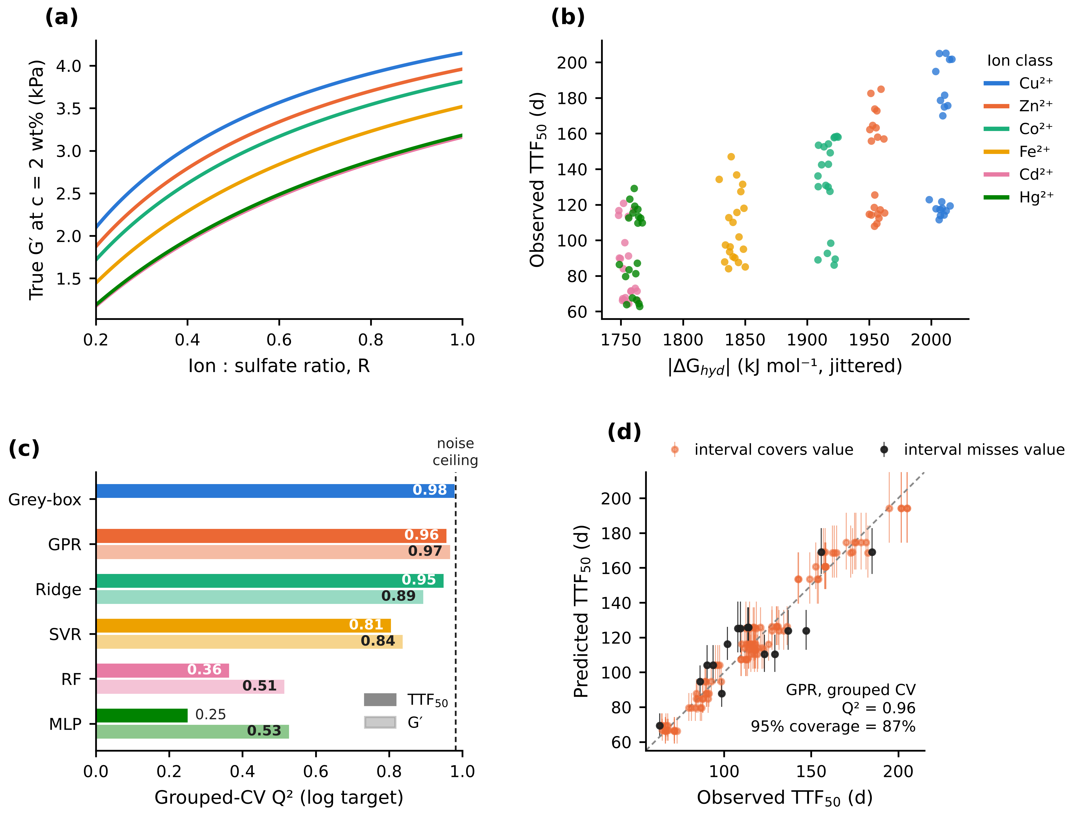
Figure 1. Ground truth and model performance. (a) True storage modulus against ion:sulfate ratio at c = 2 wt% for the six ion classes. (b) Observed (noisy) TTF₅₀ against |ΔG_{hyd}| for all 120 synthetic samples. (c) Grouped-CV Q² on the log-scale target for TTF₅₀ (dark bars) and G′ (light bars); the dashed line marks the TTF₅₀ noise ceiling. (d) GPR out-of-fold predictions of TTF₅₀ with 95% prediction intervals; black points are samples whose interval misses the observed value.
The data-generating process produced G′ = 1.2–5.0 kPa and TTF₅₀ = 63–205 d across 24 formulations (Figure 1a–b). All properties depend on the ion only through ΔG_{hyd}, so Cd²⁺ and Hg²⁺, whose hydration energies differ by 5 kJ mol⁻¹, are physically indistinguishable by design.
Under grouped cross-validation at 4% noise, the grey-box model came closest to the noise ceiling for TTF₅₀ (Q² = 0.979 against 0.981; RMSE = 5.5 d). It was followed by GPR (0.956; 7.5 d) and ridge regression (0.949; 7.7 d), with SVR at 0.805 (Figure 1c). The random forest (0.364; RMSE 29.4 d) and the MLP (0.251; 34.0 d) failed. For G′, GPR was best (Q² = 0.966 against a ceiling of 0.990), with RF and MLP near 0.5. The full grey-box fit recovered the true parameters closely: A = 7.07 (true 7.0), α = 0.0500 (0.05), β = 0.501 (0.50) and K₀ = 1.91 (2.0).
GPR’s nominal 95% intervals covered the observed value in only 86.7% of out-of-fold predictions (Figure 1d), so its uncertainty was overconfident on unseen formulations (see Section 3.2).

3.2 Validation design
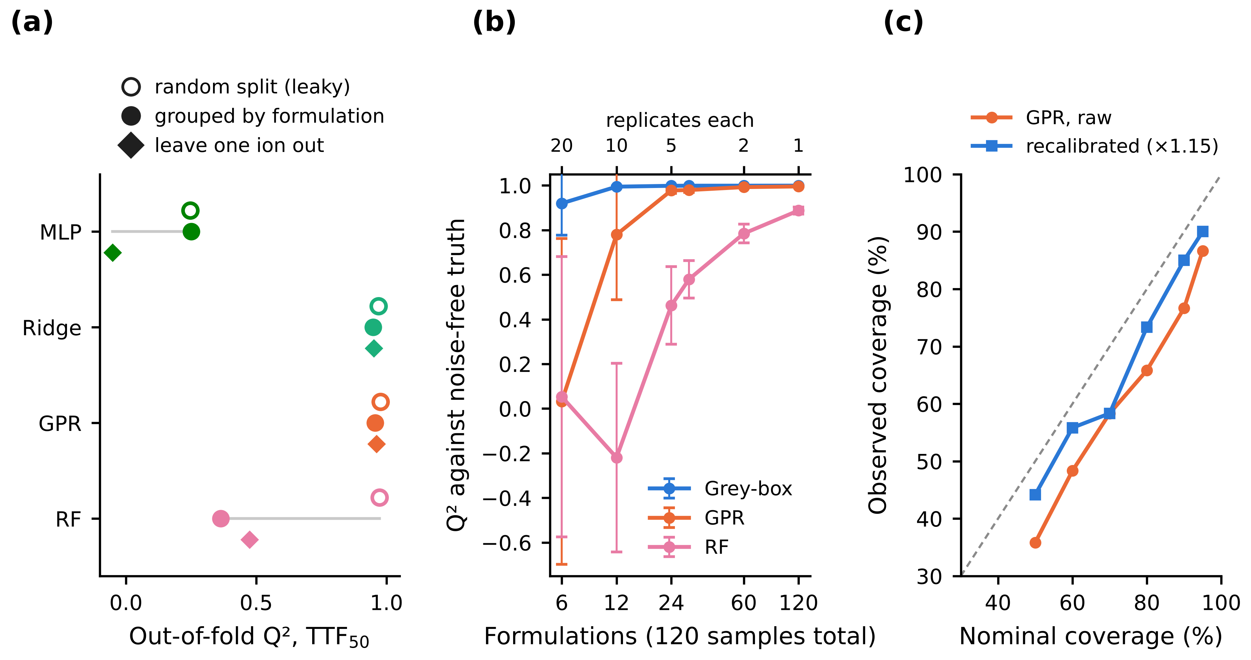
Figure 2. Validation design. (a) Out-of-fold Q² for TTF₅₀ under three splits: random KFold on samples (open circles; replicates leak across folds), GroupKFold by formulation (filled circles) and leave-one-ion-out (diamonds). (b) Accuracy against the noise-free truth when a fixed budget of 120 samples is split between formulations and replicates; mean ± SD over 10 datasets; top axis gives replicates per formulation. (c) Calibration of GPR prediction intervals before and after grouped recalibration; dashed line: perfect calibration.
Replicate leakage. Splitting samples at random let replicates of a formulation appear in both training and test folds. This raised random-forest Q² from 0.36 to 0.97 (Figure 2a), enough to rank it level with the best models when it is the second worst. Smoother models were inflated less: GPR from 0.96 to 0.98 and ridge from 0.95 to 0.97. The MLP scored 0.25 under both schemes, so its failure comes from too few formulations, not from leakage.
Unseen ions. Leaving out one ion class at a time tests extrapolation to a metal the model has never seen. Models with smooth, monotone structure held up: grey-box 0.980, GPR 0.962, ridge 0.951 and SVR 0.783. The random forest (0.475) cannot extrapolate beyond the range of its training targets, and the MLP failed (−0.05).
Formulations versus replicates. With the total budget fixed at 120 samples, spreading it across more formulations was always better than repeating fewer (Figure 2b). Six formulations with 20 replicates each gave GPR a Q² of 0.03 ± 0.73 against the true function. Twenty-four formulations with five replicates gave 0.977 ± 0.013, and 120 single-replicate formulations gave 0.995. The random forest needed the full 120 formulations to reach 0.887. The grey-box model was already at 0.92 with six formulations, because its form supplies the structure the data cannot.
Interval calibration. GPR intervals were too narrow at every nominal level: 36% observed coverage at 50% nominal and 87% at 95% (Figure 2c). Rescaling the predictive SD with a factor estimated by inner grouped cross-validation (mean ×1.15) improved coverage to 44% and 90%, but did not close the gap. Uncertainty estimates from GPR on fewer than about 30 formulations should therefore be treated as lower bounds.

3.3 Data requirements and physics recovery
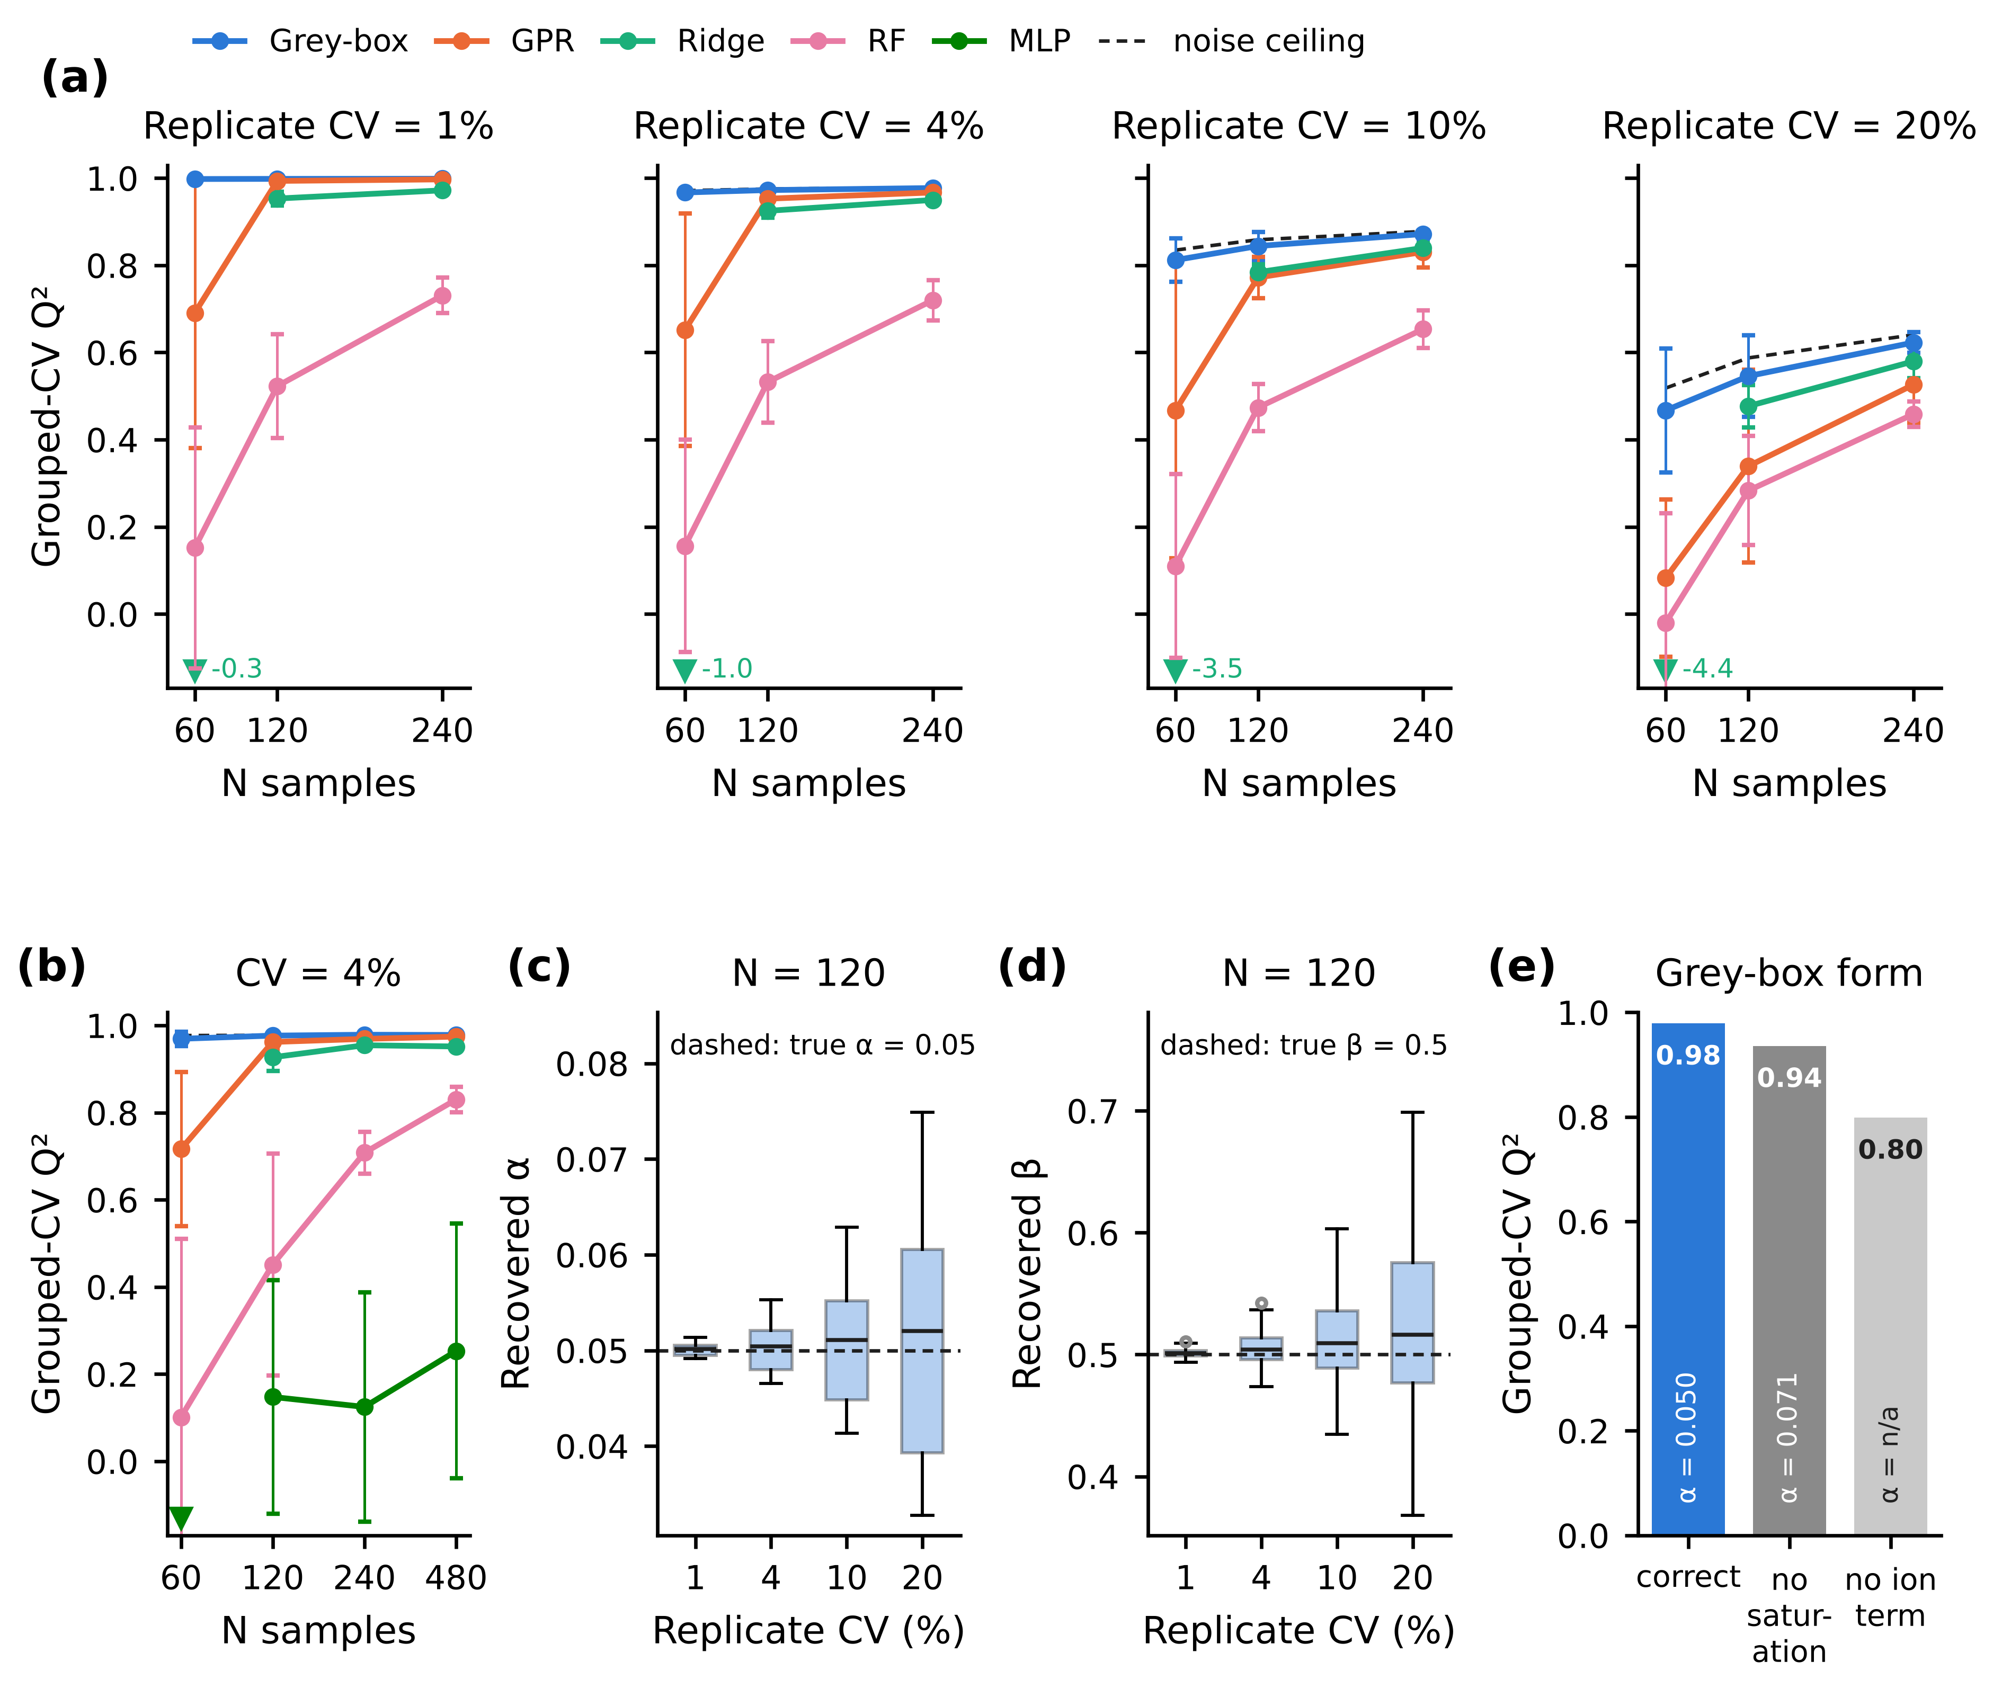
Figure 3. Data requirements and physics recovery. (a) Grouped-CV Q² for TTF₅₀ against design size (N = 60, 120, 240; 12, 24 and 48 formulations) at four replicate-noise levels; mean ± SD over 10 datasets; dashed: noise ceiling; down-triangles: ridge means below the axis, with values. (b) Extended learning curve to N = 480 at 4% noise (5 datasets per size). (c, d) Grey-box estimates of α and β at N = 120 across noise levels. (e) Grouped-CV Q² of the correct grey-box form and two misspecified forms, with the recovered α printed inside each bar.
Noise sets the ceiling. The noise ceiling fell from 0.998 at CV = 1% to 0.52–0.64 at CV = 20% (Figure 3a). No model can exceed it, so a reported Q² above the ceiling signals leakage or an error. The grey-box model stayed within 0.03 of the ceiling at every design size up to CV = 10%. GPR needed about 24 formulations to approach the ceiling: at 4% noise its Q² rose from 0.65 ± 0.27 at N = 60 to 0.95 at N = 120.
Hidden leakage in tuning. Ridge regression collapsed at N = 60 (mean Q² between −0.3 and −4.4). Its internal λ selection uses leave-one-sample-out cross-validation, which leaks replicates and chooses too little regularization when only 12 formulations exist. Leakage can hide inside a model’s own tuning step even when the outer validation is correctly grouped.
More data does not rescue every model. Extending the design to 480 samples (96 formulations) raised the random forest to 0.83 ± 0.03, still well below what GPR (0.962) and the grey-box model (0.977) achieved with only 120 samples; the noise ceiling was 0.979 (Figure 3b). The MLP stayed at 0.25 ± 0.29 even at N = 480, so this small architecture is unsuitable at any realistic hydrogel dataset size.
Parameter recovery. At N = 120 the estimate of α stayed unbiased at every noise level, with its spread growing from ±0.001 at 1% noise to ±0.014 at 20% (Figure 3c). β drifted slightly upward, to 0.533 ± 0.101 at 20% noise (Figure 3d). With only 12 formulations and 20% noise the model became unidentifiable: A = 75 ± 106 against a true value of 7, and K₀ = 11.7 ± 31 against 2.0. Meaningful parameter estimates need far more data than good predictions do.
Good predictions from the wrong physics. A grey-box model that ignored Langmuir saturation (θ = R) still predicted well, with Q² = 0.936 (Figure 3e). However, it recovered α = 0.071 against a true 0.050 (+43%) and β = 0.35 against 0.50 (−30%). Dropping the ion-binding term altogether lowered Q² to 0.80. A high Q² therefore does not validate a mechanism: an incomplete model can absorb the missing physics into biased parameters.

3.4 Interpretation: feature attribution and ion classification
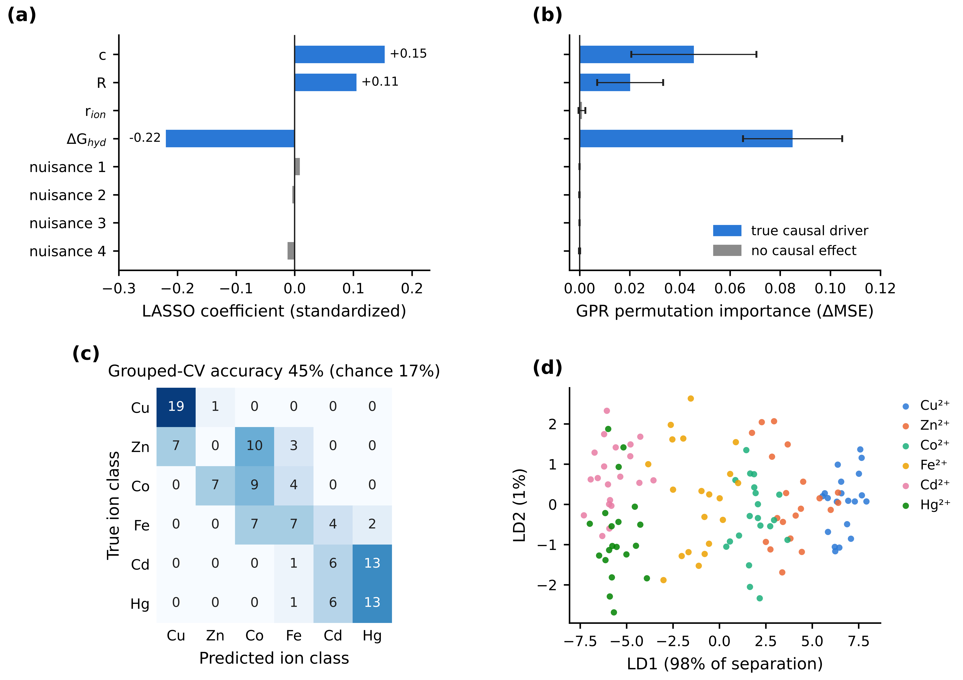
Figure 4. Interpretation. (a) Standardized LASSO coefficients for log TTF₅₀. (b) GPR permutation importance (increase in held-out MSE; mean ± SD over five folds). Blue: true causal drivers; grey: no causal effect. (c) Grouped-CV confusion matrix for LDA identification of the ion class. (d) Discriminant scores; LD1 carries 98% of the between-class separation.
Both attribution methods ranked the three true drivers first: ΔG_{hyd} (LASSO −0.22), then c (+0.15), then R (+0.11) (Figure 4a–b). LASSO set the coefficient of r_{ion} exactly to zero, even though r_{ion} is strongly correlated with ΔG_{hyd} across ions, and every nuisance coefficient was 0.012 or smaller. Here LASSO kept the causal descriptor. That is not guaranteed in general, because LASSO chooses arbitrarily among collinear predictors.
LDA identified the ion class with 45% grouped-CV accuracy, against 17% by chance (Figure 4c). Cu²⁺, the ion with the strongest hydration energy, was recognized in 19 of 20 cases. Cd²⁺ and Hg²⁺ were confused with each other, and Zn²⁺ was never identified correctly. One discriminant axis carried 98% of the separation (Figure 4d), matching the single latent variable |E_{bind}| in the data-generating process. This is the physically correct result: properties that depend only on hydration energy cannot distinguish ions with the same hydration energy. A reported accuracy of 100% on such data is a warning sign, not an achievement.

3.5 Degradation and time-series statistics
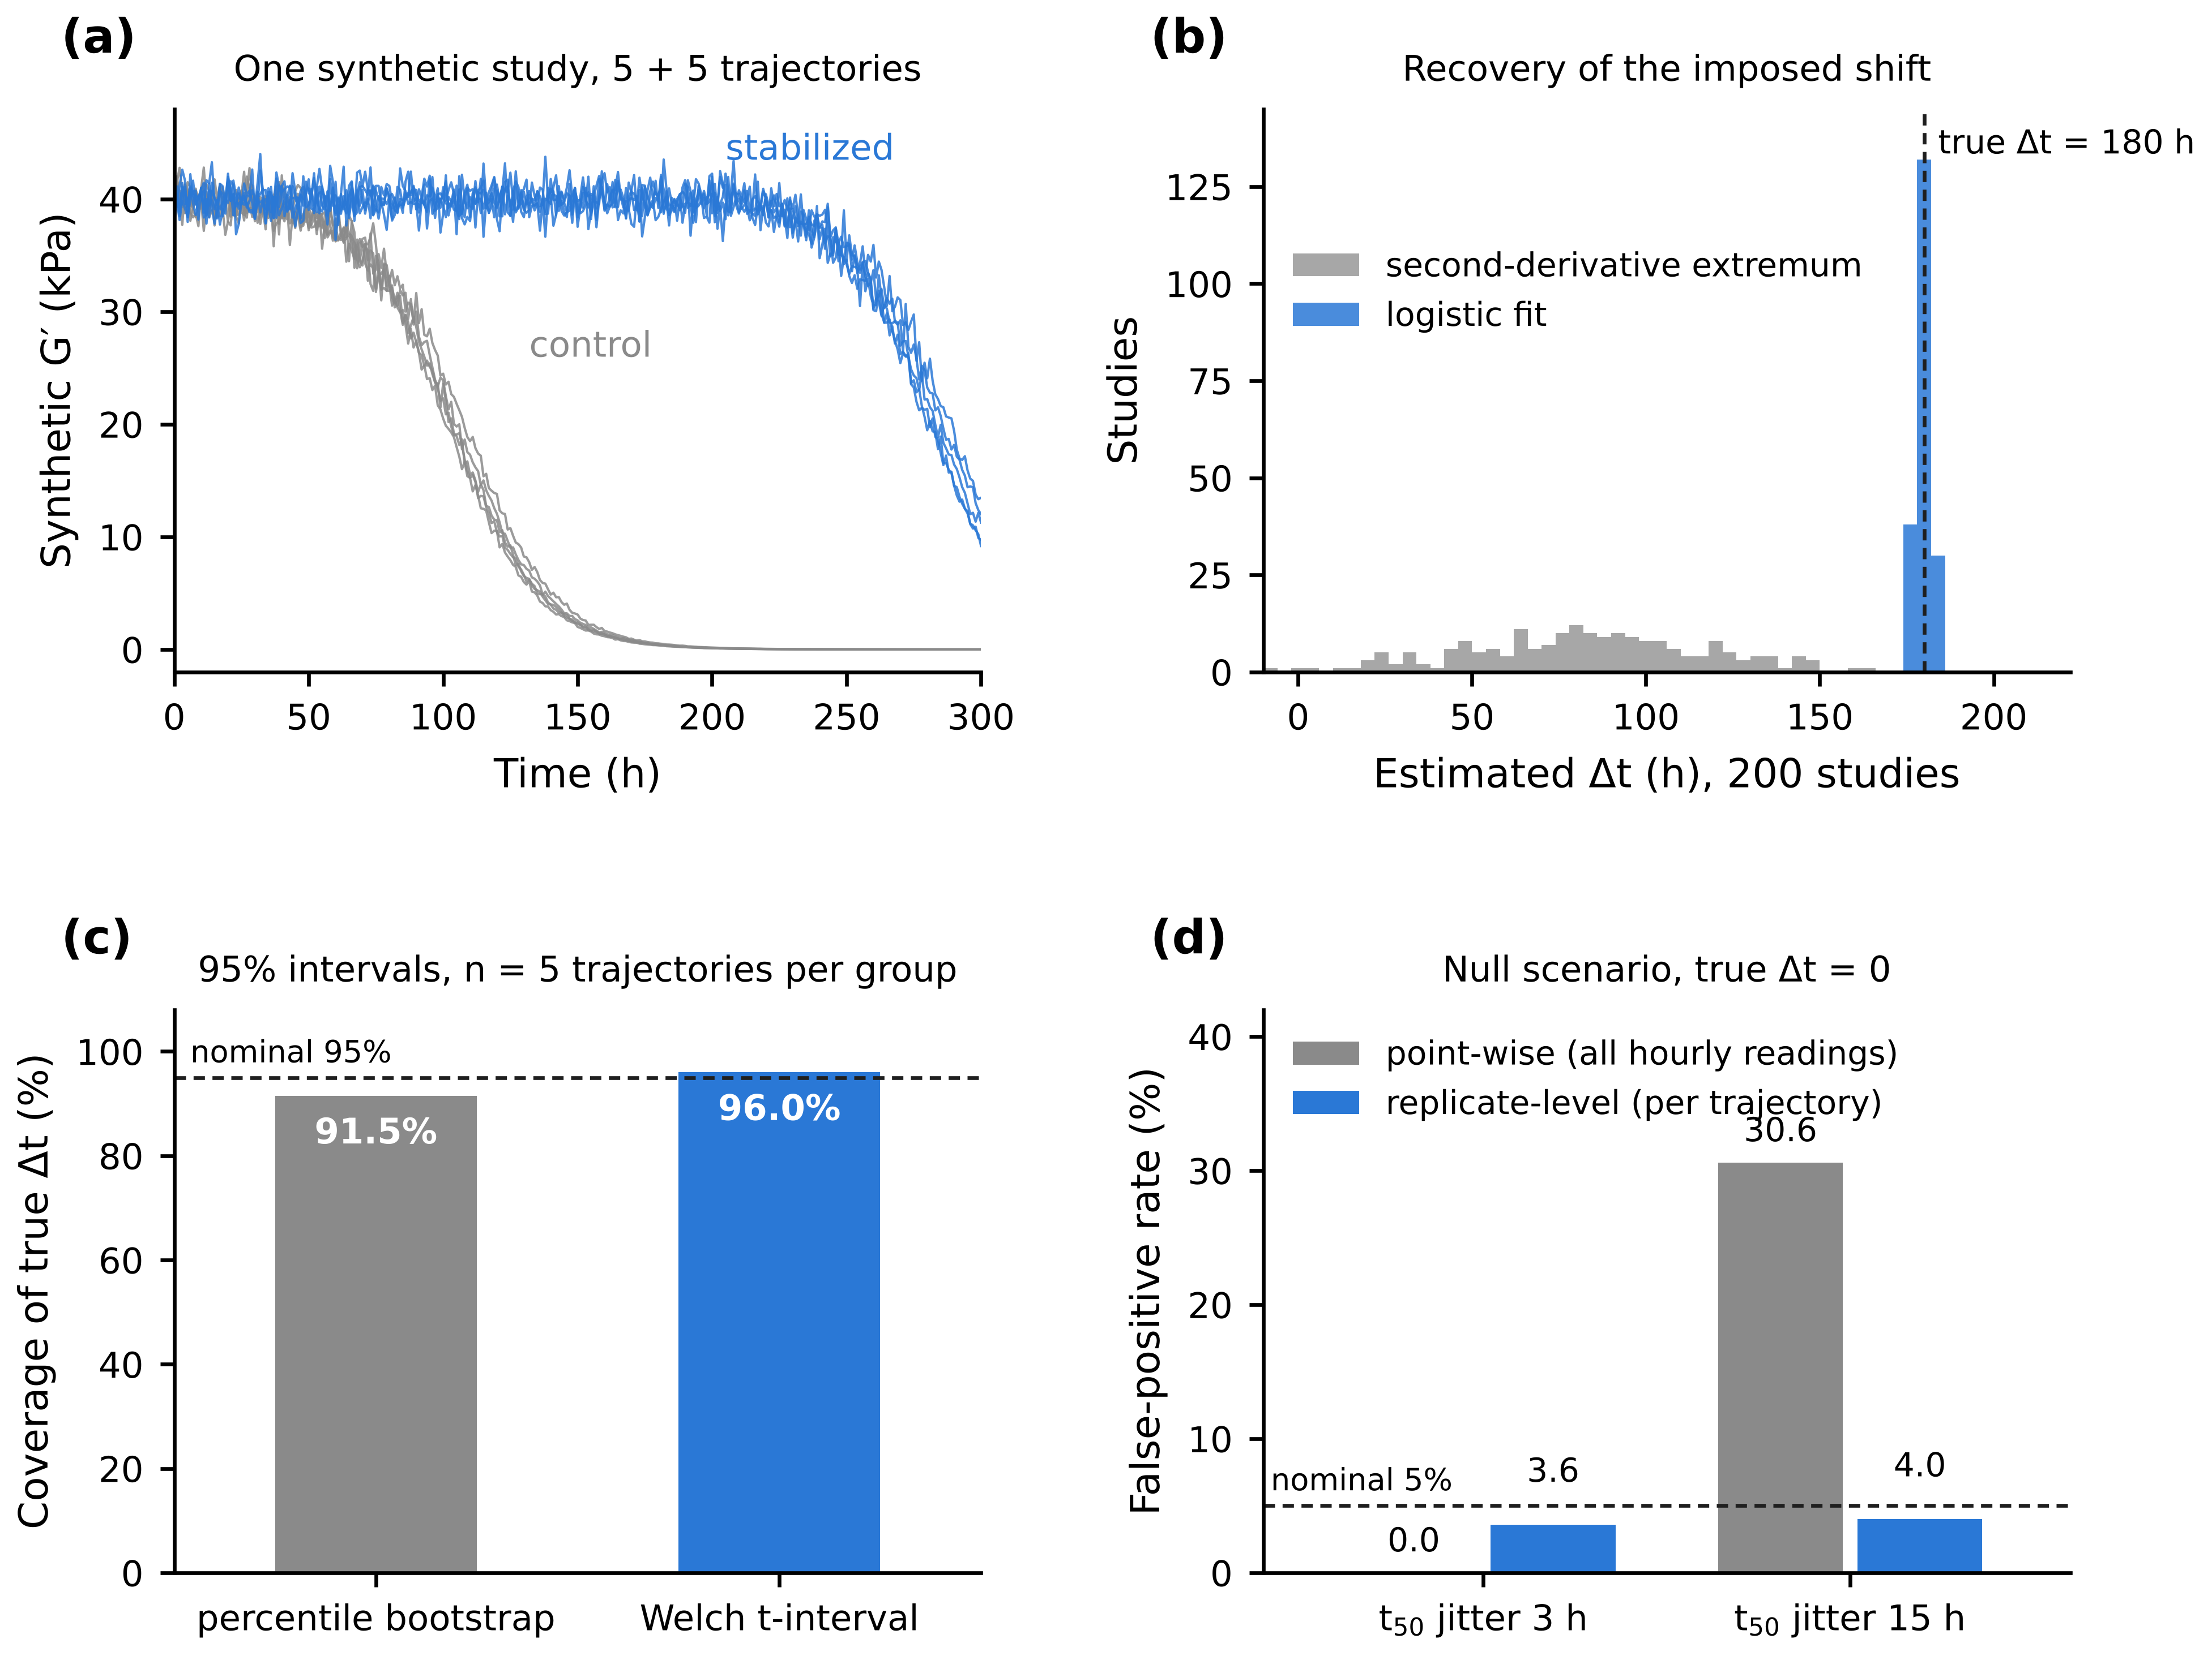
Figure 5. Degradation scenario. (a) One synthetic study: five control and five stabilized G′(t) trajectories. (b) Estimated Δt across 200 studies by logistic fitting and by the second-derivative extremum; dashed line: true Δt = 180 h. (c) Coverage of the true Δt by 95% percentile-bootstrap and Welch intervals; dashed line: nominal 95%. (d) False-positive rates under a null scenario (true Δt = 0) for a point-wise test on all hourly readings and a replicate-level test on per-trajectory t₅₀ estimates; dashed line: nominal 5%.
Logistic fitting recovered the imposed shift almost exactly: Δt = 179.8 ± 1.9 h across 200 studies, with a per-trajectory t₅₀ bias of −0.01 h (Figure 5b). The second-derivative method applied to the raw signal locked onto noise spikes, giving Δt = 82.2 ± 34.2 h and a t₅₀ bias of −67.5 h. With five trajectories per group the percentile bootstrap undercovered (91.5%), while the Welch t-interval was close to nominal (96.0%; Figure 5c).
With no true effect, a replicate-level t-test kept its false-positive rate at 3.6–4.0% (Figure 5d). A point-wise test that treated all 1,505 hourly readings per group as independent was badly miscalibrated. It never rejected at 3 h trajectory jitter, but falsely detected an effect in 30.6% of studies at 15 h jitter. Point-wise p-values from pooled time series, including values such as 10⁻¹⁰⁰, carry no evidential weight.

4. Discussion
The benchmark shows that on hydrogel-scale datasets, what decides whether ML recovers the physics is validation design and prior structure, not model complexity. When the functional form was known, a four-parameter grey-box model matched or beat every flexible learner at every design size. Of the flexible models, GPR was the most reliable, but it needed about 24 formulations and its intervals were overconfident. Random forests and small neural networks, two of the most popular choices in the materials literature, were the least reliable at these sample sizes. Their apparent success under random splits came entirely from replicate leakage.

4.1 Practical guidance for experimentalists
Table 2. Design and validation recommendations from this benchmark.
Decision | Recommendation
Validation split | Group by formulation (GroupKFold); never split replicates at random. Check that hyperparameter tuning is grouped as well.
Design size | At 4% replicate noise, plan for at least 20–25 distinct formulations for flexible models; 12 is enough only with a physics-based model. Spend a fixed budget on more formulations rather than more replicates: 2–5 replicates each is enough.
Sanity check on Q² | Estimate the noise ceiling from replicate variance; a Q² above it indicates leakage or an error.
Model choice | Start with a physics-based or linear model; use GPR when the form is unknown; treat RF/MLP results on fewer than 50 formulations with suspicion. To predict new chemistries, validate with leave-one-class-out; tree models cannot extrapolate.
Uncertainty | Check interval coverage on held-out formulations. Expect GPR intervals to be too narrow below about 30 formulations, even after recalibration.
Mechanistic claims | Report parameter confidence intervals; do not interpret parameters fitted to fewer than 15 formulations at high noise. A high Q² does not validate a mechanism: compare alternative physical forms.
Feature importance | Include deliberate nuisance descriptors as negative controls; importance at or below theirs means no evidence of an effect.
Classification | Ask whether the classes differ in the physics that drives the measured properties; perfect accuracy on overlapping classes is a red flag.
Time series | Fit a model to each trajectory, then test across replicate trajectories; never compute p-values over pooled time points.

4.2 Limitations
The ground-truth models are deliberately simple. Real carrageenan networks show helix aggregation, ion-specific coordination, viscoelastic relaxation and ageing, none of which is represented here. The grey-box advantage is an upper bound, because the true functional form was available to it; on real data, structural misspecification will erode that advantage, as Section 3.3 shows. The results quantify how the methods behave under controlled conditions. They do not predict any property of a real material and must not be cited as such.

5. Conclusions
A synthetic benchmark with known ground truth separates ML results that reflect structure–property physics from those that reflect validation artefacts. For metal-crosslinked carrageenan hydrogels at realistic scale (24 formulations, 4% noise), physics-based and GP models approached the noise ceiling (Q² ≈ 0.96–0.98), while random forests and small neural networks did not (Q² ≈ 0.25–0.36). Replicate leakage alone inflated random-forest Q² from 0.36 to 0.97. Pooling time points produced false-positive rates up to 31%. At a fixed experimental budget, more formulations beat more replicates, and a good fit from an incomplete physical model can still return badly biased parameters. The open data-generating process and pipeline allow any group to test its own workflow against a known answer before applying it to experimental data.

Data and code availability
All code (dgp.py, models.py, analysis.py, extra_analysis.py, null_test.py, figures.py) and all generated data will be deposited on GitHub and archived on Zenodo under the MIT licence [DOI to be added]. All data are synthetic; running the code regenerates every number and figure in this paper.

Author contributions
[To be completed using CRediT roles.]

Conflicts of interest
There are no conflicts to declare.

References
Check every entry against the original source before submission.
- Breiman, L. (2001). Random forests. Machine Learning, 45, 5–32.
- Fisher, R. A. (1936). The use of multiple measurements in taxonomic problems. Annals of Eugenics, 7, 179–188.
- Flory, P. J., & Rehner, J. (1943). Statistical mechanics of cross-linked polymer networks II. Swelling. Journal of Chemical Physics, 11, 521–526.
- Hurlbert, S. H. (1984). Pseudoreplication and the design of ecological field experiments. Ecological Monographs, 54, 187–211.
- Kapoor, S., & Narayanan, A. (2023). Leakage and the reproducibility crisis in machine-learning-based science. Patterns, 4, 100804.
- Lazic, S. E. (2010). The problem of pseudoreplication in neuroscientific studies: is it affecting your analysis? BMC Neuroscience, 11, 5.
- Marcus, Y. (1991). Thermodynamics of solvation of ions. Part 5. Gibbs free energy of hydration at 298.15 K. Journal of the Chemical Society, Faraday Transactions, 87, 2995–2999.
- McKay, M. D., Beckman, R. J., & Conover, W. J. (1979). A comparison of three methods for selecting values of input variables in the analysis of output from a computer code. Technometrics, 21, 239–245.
- Morris, T. P., White, I. R., & Crowther, M. J. (2019). Using simulation studies to evaluate statistical methods. Statistics in Medicine, 38, 2074–2102.
- Pedregosa, F., et al. (2011). Scikit-learn: Machine learning in Python. Journal of Machine Learning Research, 12, 2825–2830.
- Rasmussen, C. E., & Williams, C. K. I. (2006). Gaussian Processes for Machine Learning. MIT Press.
- Roberts, D. R., et al. (2017). Cross-validation strategies for data with temporal, spatial, hierarchical, or phylogenetic structure. Ecography, 40, 913–929.
- Shannon, R. D. (1976). Revised effective ionic radii and systematic studies of interatomic distances in halides and chalcogenides. Acta Crystallographica A, 32, 751–767.
- Tibshirani, R. (1996). Regression shrinkage and selection via the lasso. Journal of the Royal Statistical Society B, 58, 267–288.
- Treloar, L. R. G. (1975). The Physics of Rubber Elasticity (3rd ed.). Oxford University Press.
- Varma, S., & Simon, R. (2006). Bias in error estimation when using cross-validation for model selection. BMC Bioinformatics, 7, 91.

