**Lab Task 05**

**Q1 Write a C++ program which inputs two numbers from the user, and display the maximum of them.**

**For sample output, the first number is the last two digits of your registration number, whereas the second number is the reverse of the first number.**

Source code

**#include <iostream>**

**using namespace std;**

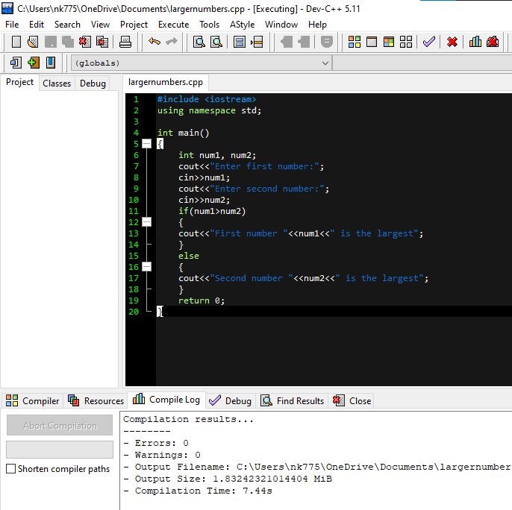

**int main()**

**{**

**int num1, num2;**

**cout<<"Enter first number:";**

**cin>>num1;**

**cout<<"Enter second number:";**

**cin>>num2;**

**if(num1>num2)**

**{**

**cout<<"First number "<<num1<<" is the largest";**

**}**

**else**

**{**

**cout<<"Second number "<<num2<<" is the largest";**

**}**

**return 0;**

**}**

**Out Put**

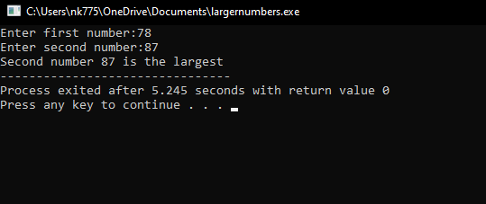

**Q2. Write a C++ program which inputs a number from the user, and classify it as even or odd.**

**For sample output, use the last two digits of your registration number**.

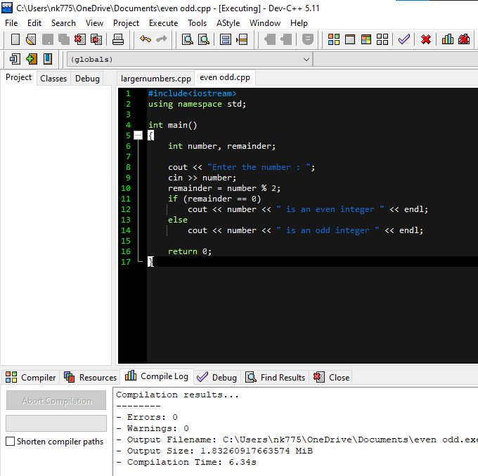Source code

**#include<iostream>**

**using namespace std;**

**int main()**

**{**

**int number, remainder;**

**cout << "Enter the number : ";**

**cin >> number;**

**remainder = number % 2;**

**if (remainder == 0)**

**cout << number << " is an even integer " << endl;**

**else**

**cout << number << " is an odd integer " << endl;**

**return 0;**

**}**

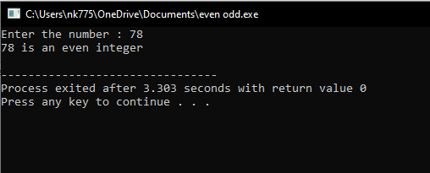**Out put**

**Q3. Write a C++ program which inputs a number and check if it is divisible by 5 and 11.For sample output, use the last two digits of your registration number.**

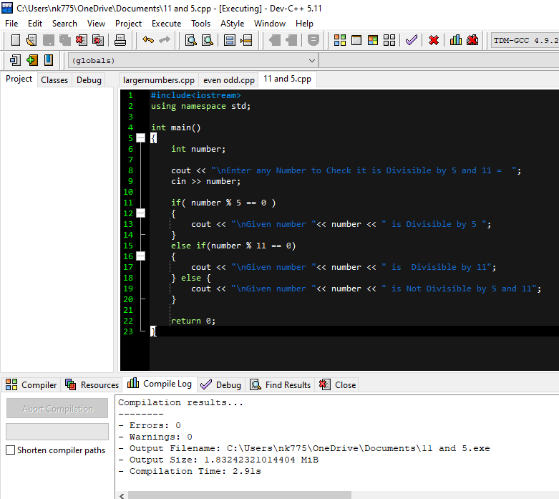

**Source code**

**#include<iostream>**

**using namespace std;**

**int main()**

**{**

**int number;**

**cout << "\nEnter any Number to Check it is Divisible by 5 and 11 = ";**

**cin >> number;**

**if( number % 5 == 0 )**

**{**

**cout << "\nGiven number "<< number << " is Divisible by 5 ";**

**}**

**else if(number % 11 == 0)**

**{**

**cout << "\nGiven number "<< number << " is Divisible by 11";**

**} else {**

**cout << "\nGiven number "<< number << " is Not Divisible by 5 and 11";**

**}**

**return 0;**

**}**

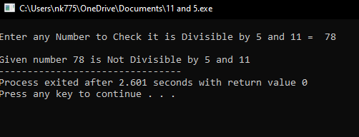**Out put**

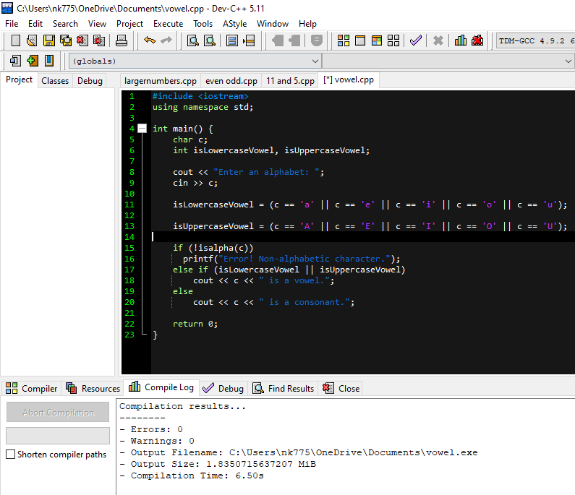**Q.4 Write a C++ program which inputs a character and check if it is vowel or consonant. For sample input, use the 3rd letter of your name.**

Source Code

#include <iostream>

using namespace std;

int main() {

char c;

int isLowercaseVowel, isUppercaseVowel;

cout << "Enter an alphabet: ";

cin >> c;

isLowercaseVowel = (c == 'a' || c == 'e' || c == 'i' || c == 'o' || c == 'u');

isUppercaseVowel = (c == 'A' || c == 'E' || c == 'I' || c == 'O' || c == 'U');

if (!isalpha(c))

printf("Error! Non-alphabetic character.");

else if (isLowercaseVowel || isUppercaseVowel)

cout << c << " is a vowel.";

else

cout << c << " is a consonant.";

return 0;

}

**Out Put**

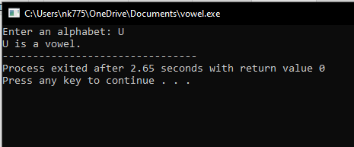

**Q.5 Write a C++ program which inputs a year and check if it is leap year.**

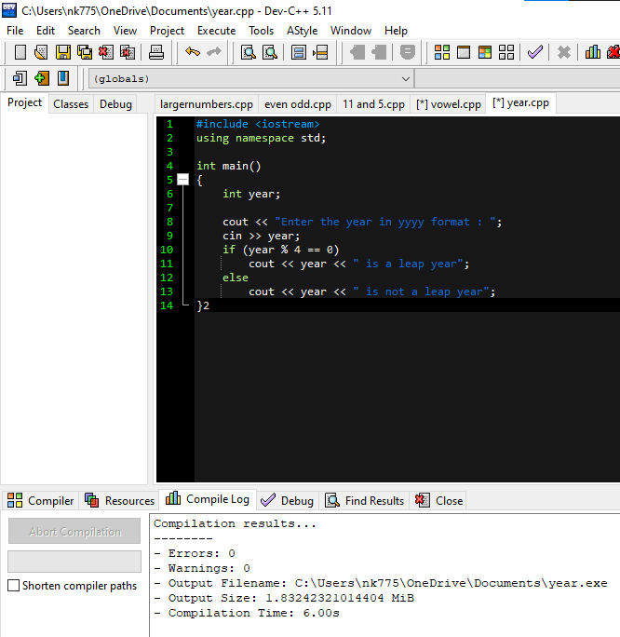

**Source code**

**#include <iostream>**

**using namespace std;**

**int main()**

**{**

**int year;**

**cout << "Enter the year in yyyy format : ";**

**cin >> year;**

**if (year % 4 == 0)**

**cout << year << " is a leap year";**

**else**

**cout << year << " is not a leap year";**

**}**

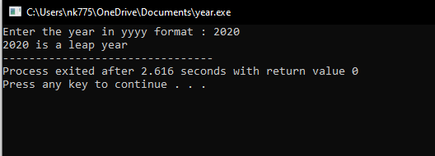**Out put**

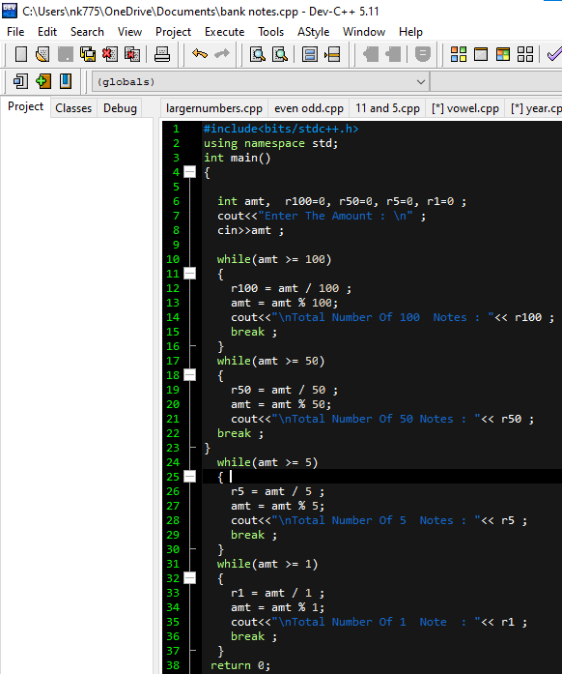**Q6. A bank teller has money available in the form of 4 denominations of 1, 5, 50, and 100. Whenever a customer demands some amount, the teller attempts to minimize the use of notes by distributing the highest value denomination notes, followed by the lesser value notes. The objective is to minimize the minimum number of notes disbursement. For example, to disburse Rs. 319/-, the teller will provide 3 notes of 100, 0 notes of fifty, 3 notes of five, and 4 notes of one. You task is to design a computer program which will input the required amount, and will display the number of notes required for each denomination**

**Source Code**

**#include<bits/stdc++.h>**

**using namespace std;**

**int main()**

**{**

**int amt, r100=0, r50=0, r5=0, r1=0 ;**

**cout<<"Enter The Amount : \n" ;**

**cin>>amt ;**

**while(amt >= 100)**

**{**

**r100 = amt / 100 ;**

**amt = amt % 100;**

**cout<<"\nTotal Number Of 100 Notes : "<< r100 ;**

**break ;**

**}**

**while(amt >= 50)**

**{**

**r50 = amt / 50 ;**

**amt = amt % 50;**

**cout<<"\nTotal Number Of 50 Notes : "<< r50 ;**

**break ;**

**}**

**while(amt >= 5)**

**{**

**r5 = amt / 5 ;**

**amt = amt % 5;**

**cout<<"\nTotal Number Of 5 Notes : "<< r5 ;**

**break ;**

**}**

**while(amt >= 1)**

**{**

**r1 = amt / 1 ;**

**amt = amt % 1;**

**cout<<"\nTotal Number Of 1 Note : "<< r1 ;**

**break ;**

**}**

**return 0;**

**}**

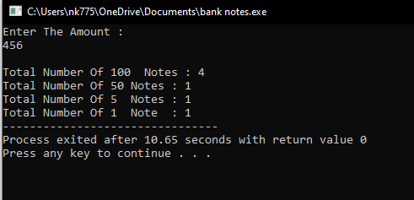**Out put**