import java.util.Scanner;

class Employee{

    private int salary;

    private int NOH;

    public void getinfo(int salary,int NOH) {

        this.salary=salary;

        this.NOH=NOH;

    }

    public void Addsal(int extended) {

       if (salary<500) {

        salary+=extended;

       }

    }

    public void Addwork(int overtime) {

        if (NOH>6) {

         salary+=overtime;

        }

     }

     public void  print() {

         // TODO Auto-generated method stub

       System.out.println(salary+"\n"+NOH);

     }

}

public class task1 {

    public static void main(String[] args) {

        Scanner sc=new Scanner(System.in);

        // int salary=sc.nextInt();

        // int noh=sc.nextInt();

    Employee em=new Employee();

    em.getinfo(4000,7);

    em.Addsal(10);

    em.Addwork(500);

  em.print();

    }

}

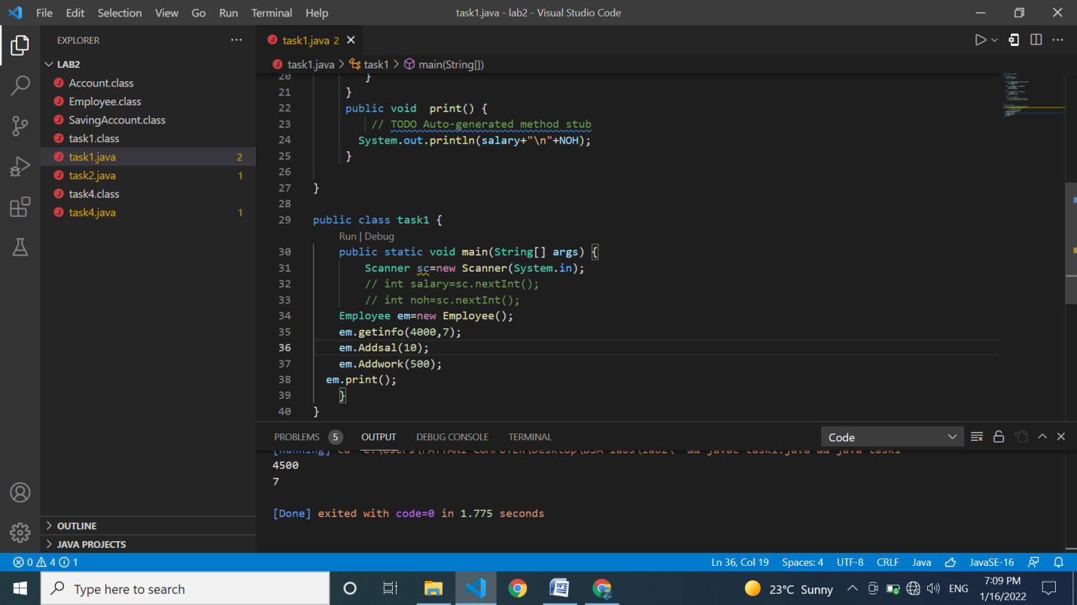

import java.util.Scanner;

class Area{

    private int length;

    private int breadth;

    public void setDim(int length,int breadth) {

        this.length=length;

        this.breadth=breadth;

    }

    public int getArea() {

        return length\*breadth;

     }

}

class task2{

    public static void main(String[] args) {

    Scanner sc=new Scanner(System.in);

    System.out.println("Enter length");

    int length=sc.nextInt();

    System.out.println("Enter breadth");

    int breadth=sc.nextInt();

    Area ar= new Area();

    ar.setDim(length, breadth);

    ar.getArea();

    }

}

class Account{

    protected Double balance=0.0;

    public void deposit(Double amount) {

        balance+=amount;

    }

    public void withdraw(double draw) {

    balance-=draw;

    }

}

class SavingAccount extends Account{

    private double interestRate=2.5;

    public void SetdefaultInterestRate(double rate) {

        balance+=rate;

    }

    public void checkbalance() {

        System.out.println(balance);

    }

}

public class task4 {

    public static void main(String[] args) {

    SavingAccount acc=new SavingAccount();

    acc.deposit(40.0);

    acc.SetdefaultInterestRate(20.0);

        acc.checkbalance();

        acc.withdraw(20.0);

    }

}