**LINE PLOT**

In [1]: import matplotlib as mp

In [**2**]: import matplotlib.pyplot as plt

In [**3**]: plt.plot([1,2,3,4])

Out[**3**]: [<matplotlib.lines.Line2D at 0x61b7170>]

In [**4**]: plt.show()

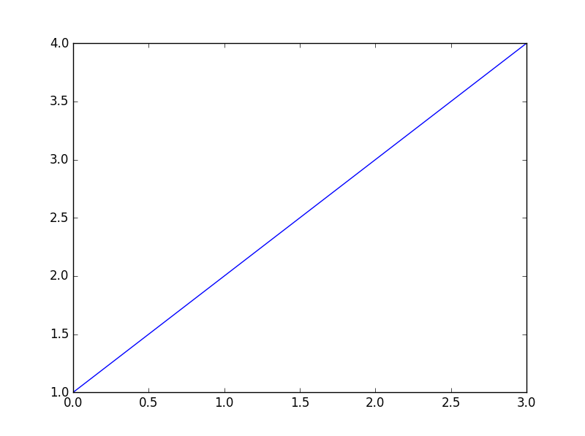

In [**5**]: plt.plot([1,2,3,4], [2,5,8,15])

Out[**5**]: [<matplotlib.lines.Line2D at 0x63cce70>]

In [**6**]: plt.show()

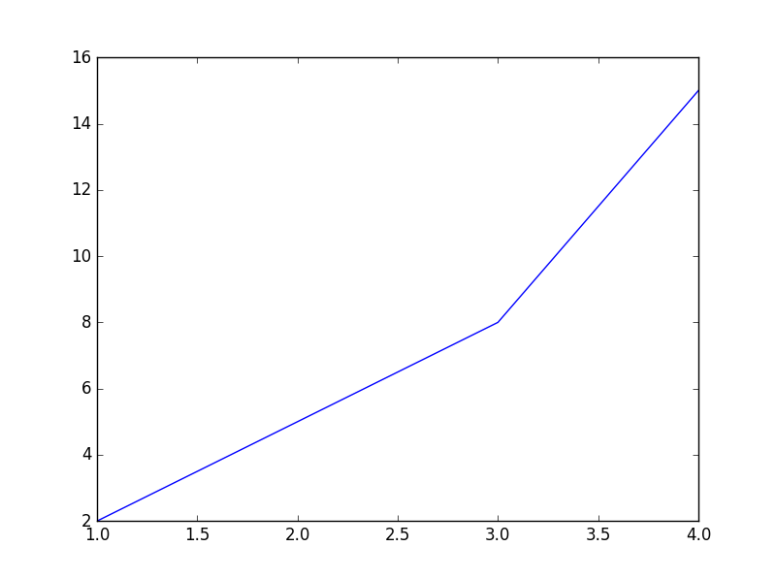

**PLOTTING VALUES WITH DOTS**

In [**7**]: plt.plot([1,2,3,4], [2,5,8,15], 'ro')

Out[**7**]: [<matplotlib.lines.Line2D at 0x64fc670>]

In [**8**]: plt.axis([0,6,0,20])

Out[**8**]: [0, 6, 0, 20]

In [**9**]: plt.show()

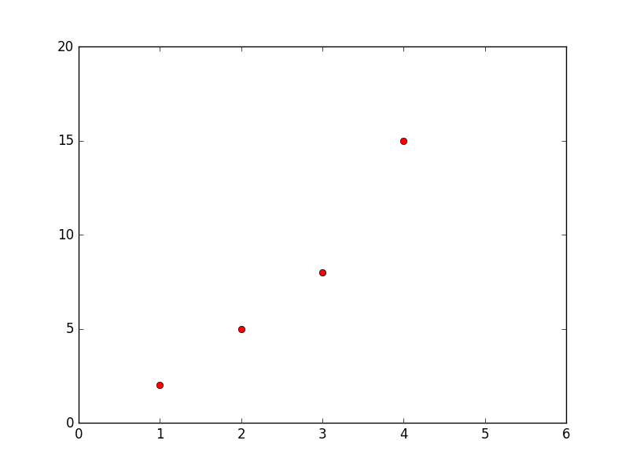

**PLOTTING SEVERAL LINES WITH DIFFERENT FORMAT STYLE**

In [**11**]: import numpy as np

In [**12**]: t = np.arange(0., 5., 0.2)

In [**13**]: plt.plot(t, t, 'r--', t, t**2, 'bs', t, t**3, 'g^')

Out[**13**]:

[<matplotlib.lines.Line2D at 0x65a90b0>,

<matplotlib.lines.Line2D at 0x65a91b0>,

<matplotlib.lines.Line2D at 0x65a9570>]

In [**14**]: plt.show()

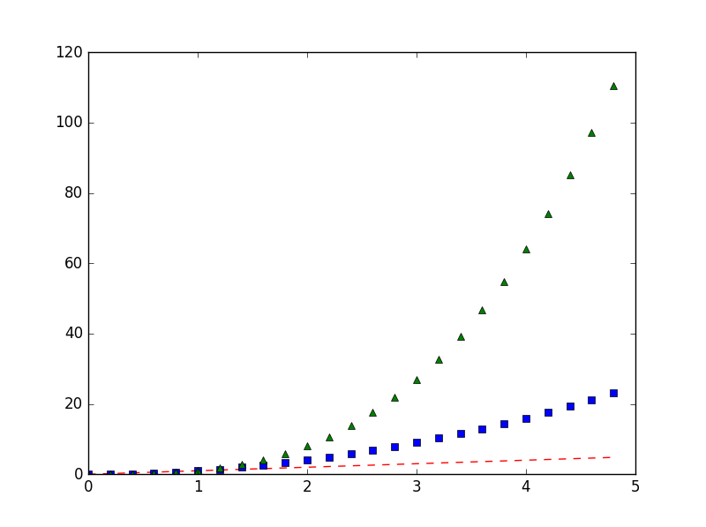

**SIMPLE PLOT**

In [**16**]: x = np.arange(0, 3*np.pi, 0.1)

In [**17**]: y = np.sin(x)

In [**18**]: plt.plot(x,y)

Out[**18**]: [<matplotlib.lines.Line2D at 0x66a7d30>]

In [**19**]: plt.show()

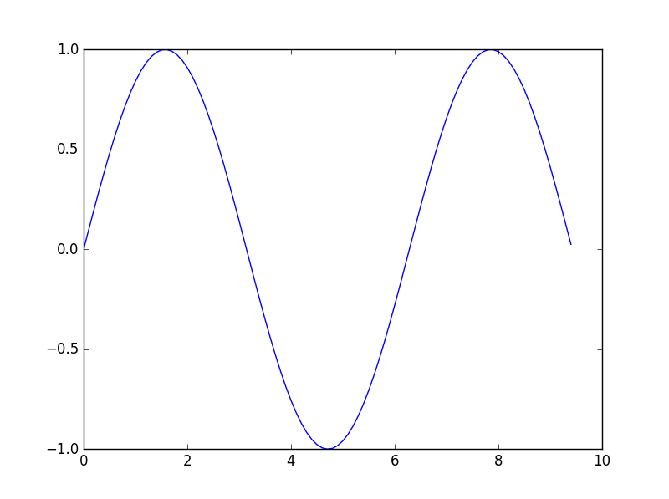

**SINE AND COSINE PLOT**

In [**20**]: x = np.arange(0, 3 * np.pi, 0.1)

In [**22**]: y_sin = np.sin(x)

In [**23**]: y_cos = np.cos(x)

In [**24**]: plt.plot(x, y_sin)

Out[**24**]: [<matplotlib.lines.Line2D at 0x673bcf0>]

In [**25**]: plt.plot(x, y_cos)

Out[**25**]: [<matplotlib.lines.Line2D at 0x678c230>]

In [**26**]: plt.xlabel('x axis label')

Out[**26**]: <matplotlib.text.Text at 0x65dc530>

In [**27**]: plt.ylabel('y axis label')

Out[**27**]: <matplotlib.text.Text at 0x651c250>

In [**28**]: plt.title ('Sine and Cosine')

Out[**28**]: <matplotlib.text.Text at 0x6720b10>

In [**29**]: plt.legend(['Sine', 'Cosine'])

Out[**29**]: <matplotlib.legend.Legend at 0x678c510>

In [**30**]: plt.show()

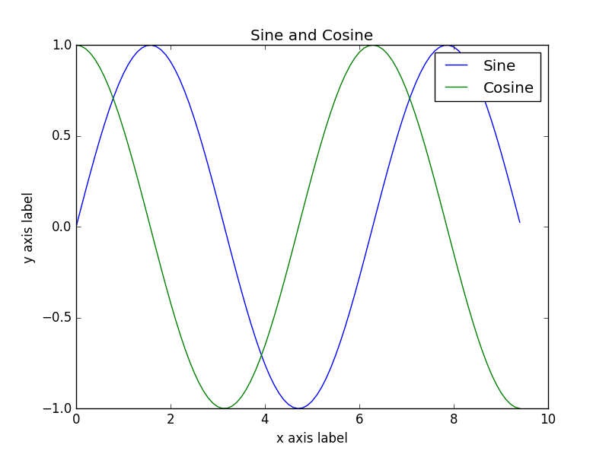

**SUBPLOTS**

In [**31**]: x = np.arange(0, 3 * np.pi, 0.1)

In [**32**]: y_sin = np.sin(x)

In [**33**]: y_cos = np.cos(x)

In [**34**]: plt.subplot(2,1,1)

Out[**34**]: <matplotlib.axes._subplots.AxesSubplot at 0x65d4330>

In [**35**]: plt.plot(x, y_sin)

Out[**35**]: [<matplotlib.lines.Line2D at 0x684f650>]

In [**36**]: plt.title('Sine')

Out[**36**]: <matplotlib.text.Text at 0x68353d0>

In [**37**]: plt.subplot(2,1,2)

Out[**37**]: <matplotlib.axes._subplots.AxesSubplot at 0x684f630>

In [**38**]: plt.plot(x, y_cos)

Out[**38**]: [<matplotlib.lines.Line2D at 0x68ed150>]

In [**39**]: plt.title('Cosine')

Out[**39**]: <matplotlib.text.Text at 0x68ce510>

In [**40**]: plt.show()

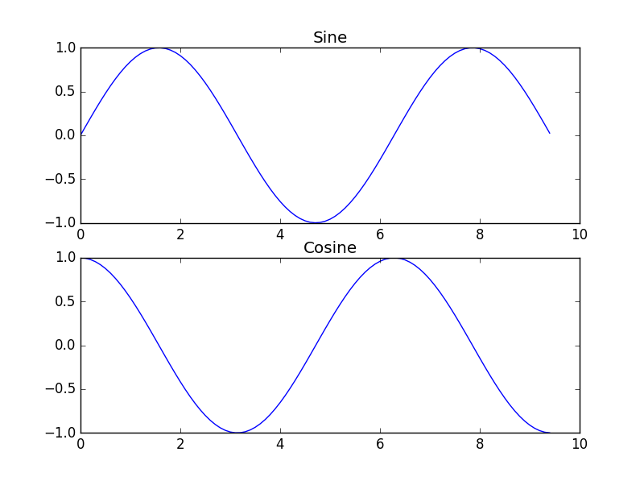

**HISTOGRAM**

data = np.random.normal(5.0, 3.0, 1000)

In [**12**]: plt.hist(data)

Out[**12**]:

(array([ 2., 12., 44., 100., 200., 249., 214., 123., 43., 13.]),

array([ -5.6815256 , -3.7794175 , -1.8773094 , 0.02479871,

1.92690681, 3.82901491, 5.73112301, 7.63323111,

9.53533921, 11.43744731, 13.33955541]),

<a list of 10 Patch objects>)

In [**13**]: plt.xlabel('data')

Out[**13**]: <matplotlib.text.Text at 0x74b7250>

In [**14**]: plt.show()

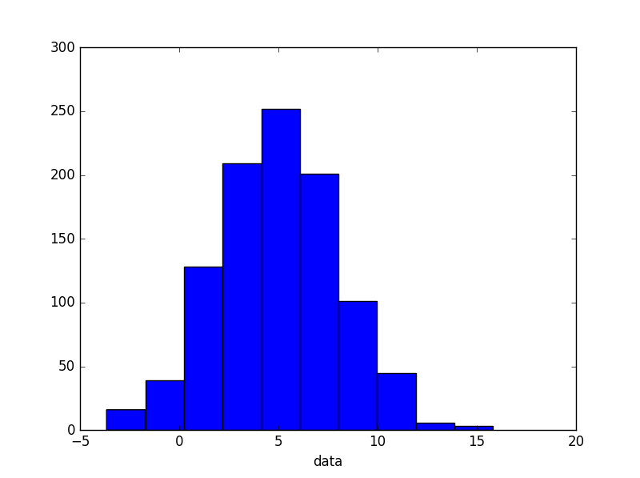

In [**15**]: bins = np.arange(-5., 16., 1.)

In [**16**]: plt.hist(data, bins)

Out[**16**]:

(array([ 0., 5., 8., 13., 31., 33., 74., 104., 110.,

138., 120., 113., 103., 74., 25., 27., 13., 5.,

3., 0.]),

array([ -5., -4., -3., -2., -1., 0., 1., 2., 3., 4., 5.,

6., 7., 8., 9., 10., 11., 12., 13., 14., 15.]),

<a list of 20 Patch objects>)

In [**17**]: plt.show()

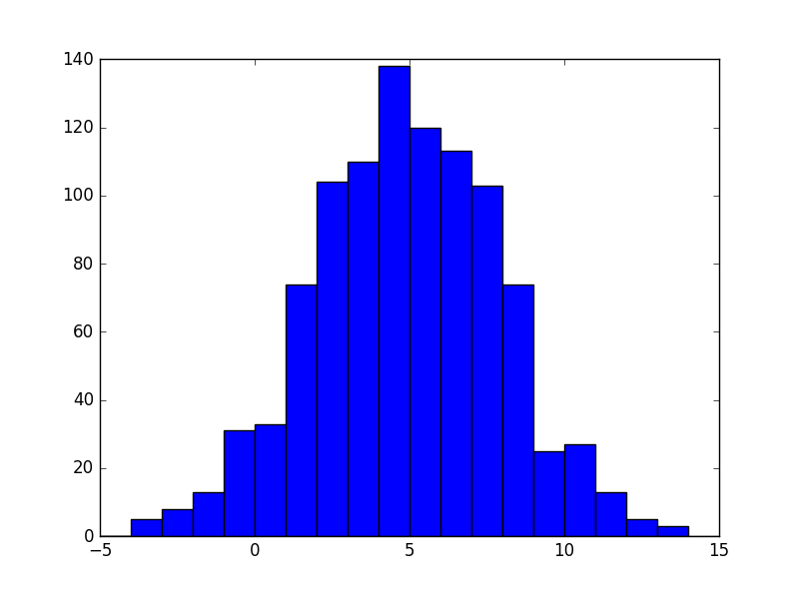

**BAR CHART**

In [**3**]: year = (2011, 2012, 2013, 2014, 2015)

In [**4**]: score = (83, 78, 99, 60, 80)

In [**13**]: plt.xlabel('year')

Out[**13**]: <matplotlib.text.Text at 0x6bc5f10>

In [**14**]: plt.ylabel('score')

Out[**14**]: <matplotlib.text.Text at 0x6d16930>

In [**15**]: plt.bar(year, score)

Out[**15**]: <Container object of 5 artists>

In [**16**]: plt.show()

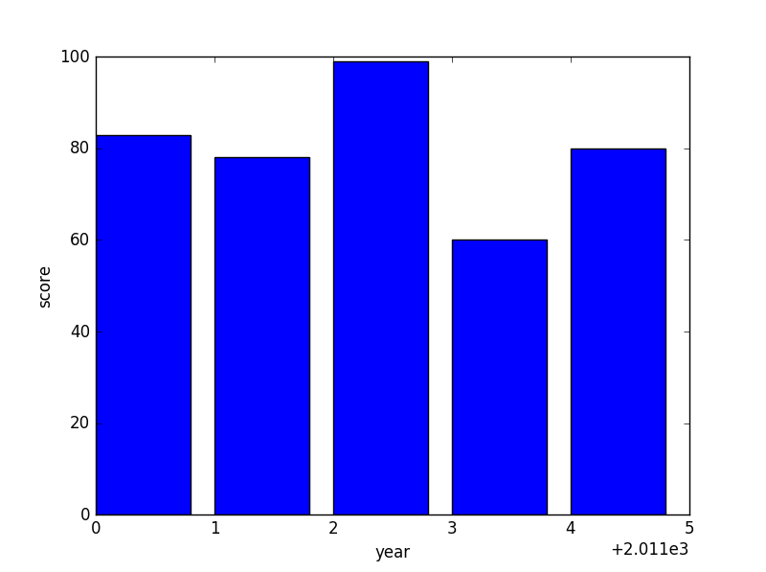

**SCATTER PLOT**

In [**14**]: year = (2011, 2012, 2013, 2014, 2015)

In [**15**]: score = (83, 78, 99, 60, 80)

In [**16**]: plt.scatter(year, score)

Out[**16**]: <matplotlib.collections.PathCollection at 0x6a5b430>

In [**17**]: plt.xlabel(year)

Out[**17**]: <matplotlib.text.Text at 0x6753ff0>

In [**18**]: plt.ylabel(score)

Out[**18**]: <matplotlib.text.Text at 0x69bdb10>

In [**19**]: plt.show()

