EXPERIMENT – 10 FIRST FIT AND BEST FIT
NAME: NAVEED SHERIFF J
REG NO: 240701348

FIRST FIT:
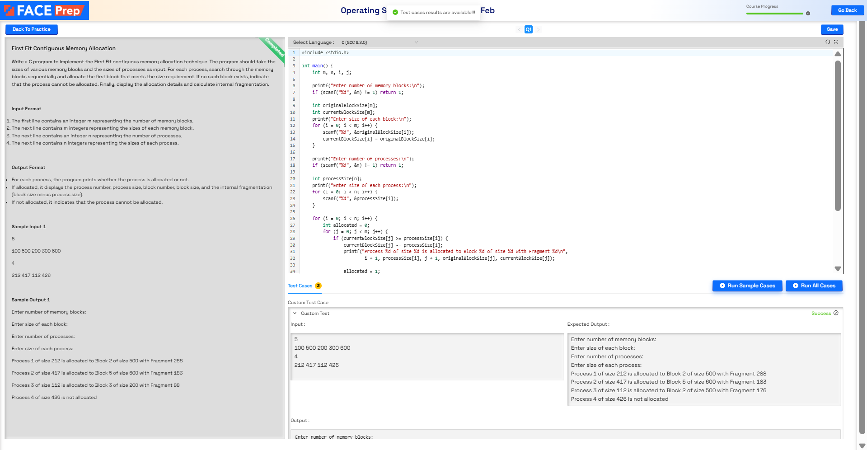

BEST FIT:
