EXPERIMENT – 11 PAGE REPLACEMENT ALGORITHMS
NAME: NAVEED SHERIFF J
REG NO: 240701348

FIFO PAGE REPLACEMENT :
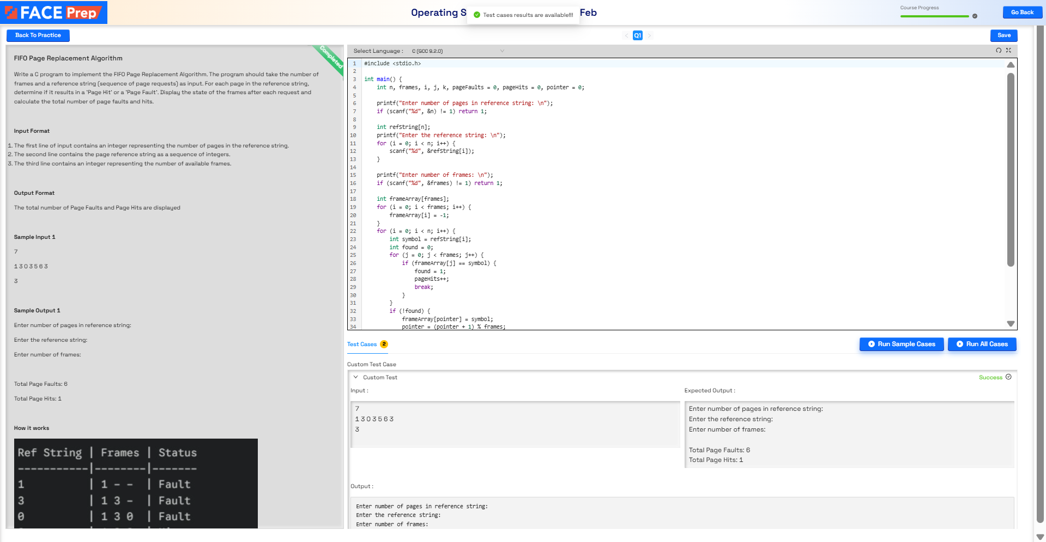

LRU PAGE REPLACEMENT:
