DESIGN AND IMPLEMENTATION OF A CAMPUS SPORTS MANAGEMENT AND EVENT TICKETING PLATFORM (CAMPUSARENA)
A PROJECT REPORT
Submitted in partial fulfillment of the requirements for the award of the degree of
BACHELOR OF COMPUTER APPLICATIONS (BCA)
SUBMITTED BY
MUBARAK IDREES
H.T.NO: 280123861075
UNDER THE GUIDANCE OF
PROF. MOHAMMED ILYAS
DEPARTMENT OF BCA
ST. JOSEPH’S DEGREE COLLEGE
SUBMITTED TO

AFFILIATED TO OSMANIA UNIVERSITY
PILLAR NO.187 UPPARPALLY ATTAPUR, HYDERABAD
2023-2026



ST. JOSEPH’S DEGREE & P.G COLLEGE
(Affiliated to Osmania university)
BOSTON TOWERS, PILLAR NO. 187, UPPERPALLY,
RAJENDRANAGAR, R.R DIST.
PH. 04024018619 & 9619, 8125301483 & 86

CERTIFICATE
This is to certify that the project titled "DESIGN AND IMPLEMENTATION OF A CAMPUS SPORTS MANAGEMENT AND EVENT TICKETING PLATFORM (CAMPUSARENA)" is a record of original and bonafide work done by,
Student Details
Mubarak idrees
H.T. No. 280123861039
BCA· St. Joseph's Degree College
The project is being submitted in partial fulfillment towards the requirement of the award of the degree of Bachelor of Computer Applications (BCA) from Osmania University during the period of 2023–2026.

Principal Mrs. Jyothi Lakshmi



ST. JOSEPH’S DEGREE & P.G COLLEGE
(Affiliated to Osmania university)
BOSTON TOWERS, PILLAR NO. 187, UPPERPALLY,
RAJENDRANAGAR, R.R DIST.
PH. 04024018619 & 9619, 8125301483 & 86

CERTIFICATE
This is to certify that Mubarak idrees is a bona fide student of BCA III Year of this institution with Hall Ticket No: 280122861075 for the academic year 2023–2026.
This is to certify that Syed Sufi is a bona fide student of BCA III Year of this institution with Hall Ticket No: 280123861075 for the academic year 2023–2026.

He has successfully submitted the project titled "Design and Implementation of a Campus Sports Management and Event Ticketing Platform (CampusArena)" in partial fulfillment of the requirements for the award of the degree of Bachelor of Computer Applications (BCA)

Project Guide



ST. JOSEPH’S DEGREE & P.G COLLEGE
(Affiliated to Osmania university)
BOSTON TOWERS, PILLAR NO. 187, UPPERPALLY,
RAJENDRANAGAR, R.R DIST.
PH. 04024018619 & 9619, 8125301483 & 86

CERTIFICATE
This is to certify that Mubarak idrees is a bona fide student of BCA III Year of this institution with Hall Ticket No: 280123861075 for the academic year 2023–2026.
He has successfully submitted the project titled "Design and Implementation of a Campus Sports Management and Event Ticketing Platform (CampusArena)" in partial fulfillment of the requirements for the award of the degree of Bachelor of Computer Applications (BCA).

External Examiner Internal Examiner



ST. JOSEPH’S DEGREE & P.G COLLEGE
(Affiliated to Osmania university)
BOSTON TOWERS, PILLAR NO. 187, UPPERPALLY,
RAJENDRANAGAR, R.R DIST.
PH. 04024018619 & 9619, 8125301483 & 86

CERTIFICATE
This is to certify that Mubarak Idrees is a bona fide student of BCA III Year of this institution with Hall Ticket No: 280122861075 for the academic year 2023–2026.
This is to certify that Mubarak Idrees is a bona fide student of BCA III Year of this institution with Hall Ticket No: 280123861075 for the academic year 2023–2026.
He has successfully submitted the project titled "Design and Implementation of a Campus Sports Management and Event Ticketing Platform (CampusArena)" in partial fulfillment of the requirements for the award of the degree of Bachelor of Computer Applications (BCA).

HOD Signature
DECLARATION

I am a student of St. Joseph Degree College, Upper Pally, Hyderabad. I do hereby declare that the project report titled "Design and Implementation of a Campus Sports Management and Event Ticketing Platform (CampusArena)" is an original and bonafide work done by me. This is being submitted in partial fulfillment of the requirement for the award of Bachelor of Computer Applications (BCA).

Mubarak Idrees
H.T.NO: 280123861075

ACKNOWLEDGEMENT
I would like to express my sincere gratitude to our Principal and the Head of the Department of BCA for providing me the opportunity to complete this project. I would also like to thank my project guide and faculty members for their valuable guidance, support, and encouragement throughout the development of my project titled "Design and Implementation of a Campus Sports Management and Event Ticketing Platform (CampusArena)." I am thankful to my friends and classmates who helped me with their suggestions and support during the completion of this project. Finally, I would like to express my heartfelt thanks to my family for their continuous encouragement and support throughout my studies.
ABSTRACT
CampusArena is a comprehensive campus sports management and event ticketing platform designed to digitize and streamline the organization of inter-departmental athletic competitions and campus-wide events. It provides a centralized system where administrators can manage sports categories, schedule matches between approved student teams, track live scores, and oversee event registrations with manual payment verification. Students can register, complete verified academic profiles, form teams by adding members through hall ticket verification, and participate in matches and events. The platform also supports guest spectators who can register for events and matches without an account and retrieve their digital tickets using a unique booking reference code. Built using React 19 with Vite on the frontend and Node.js with Express on the backend, with MySQL as the database, CampusArena features a dynamic global leaderboard with an automated points-based ranking system, role-based access control using JWT authentication, and a modern dark-themed responsive user interface. Whether organizing a hackathon, scheduling a cricket tournament, or tracking the season's top-performing teams, CampusArena brings campus sports and events into one unified, accessible, and efficient digital platform. Conclusion CampusArena successfully simplifies the management of campus sports and events, offering administrators powerful tools for scheduling, team oversight, and registration tracking, while giving students and guests an intuitive interface to explore, register, and stay updated. It is a practical, scalable solution that brings transparency and efficiency to campus athletic operations.

TABLE OF CONTENT
CHAPTER 1 3
INTRODUCTION 3
1.1 Introduction 4
1.2 Problem Statement 4
1.3 Objectives 4
1.4 Methodology 5
1.4.1 Requirement Gathering and Analysis 5
1.4.2 System Design and Architecture 5
1.4.3 Development Phase (Module Implementation) 5
1.4.4 Testing and Quality Assurance 6
1.4.5 Deployment and Release 6
1.5 Manual Testing Procedure 6
1.5.2 Functional Testing 6
1.5.3 Usability & Performance Testing 7

CHAPTER 2 8
REQUIREMENTS AND SYSTEM ANALYSIS 8
2.1 Functional Requirements 9
2.2 Non-Functional Requirements 9
2.3 System Requirements 9
2.4 Security Considerations 10
2.5 Process Automation and Event Handling 10

CHAPTER 3 11
EXISTING SOLUTIONS AND LITERATURE REVIEW 11
3.1 Existing Solutions 12
3.2 Relevant Technologies 13
3.3 Literature Review 14

CHAPTER 4 15
SYSTEM DEVELOPMENT AND DESIGN 15
4.1 System Development 16
4.2 Analysis 16
4.3 Design of the Application 16
4.4 UML Diagrams 17
4.4.1 Class Diagram 17
4.4.2 Use Case Diagram 18
4.4.3 Activity Diagram 18
4.4.4 Deployment Diagram 19
4.5 Proposed Architecture 20
4.6 Data Storage and Management 21
4.7 Features 21
4.8 Structured File System 21
4.9 Database Schema Implementation 24

CHAPTER 5 31
IMPLEMENTATION AND DEPLOYMENT 31
5.1 Technologies Used 32
5.2 Frontend Implementation 32
5.3 Backend Implementation 33
5.4 Database Integration 33
5.5 Security and Middleware 34
5.6 Deployment Environment 34
5.7 System Interface and Screenshots 35
5.7.1 Public Landing Page and Hero Section 35
5.7.2 Authentication and Student Gateway 37
5.7.3 Public Sports Catalog 39
5.7.4 Match Schedule Interface 41
5.7.5 Match Results Archive 44
5.7.6 Global Leaderboard 46
5.7.7 Guest Ticket Lookup Modal 48
5.7.8 Comprehensive Administrative Dashboard 50
5.7.9 Admin Events Console 53
5.7.10 Admin Match Management 55
5.7.11 Student Dashboard 57
5.7.12 Campus Events Browser 60
5.7.13 Registration Modal 62
5.7.14 Student Team Formation 65
5.7.15 Admin Student Teams Management 67
5.7.16 Admin User & Profile Verification 69

CHAPTER 6 72
TESTING AND RESULTS 72
6.1 Unit Testing 73
6.2 Integration Testing 73
6.3 System Testing 74
6.4 Automated Background Process Testing 74
6.5 Usability and Interface Testing 74
6.6 Security and Performance Results 75

CHAPTER 7 76
CONCLUSION AND FUTURE SCOPE 76
7.1 Conclusion 77
7.2 Future Enhancements 77
7.3 Final Thoughts 78
7.4 Additional Future Enhancements 79

CHAPTER 8 80
APPENDICES 80
8.1 Appendix A: Acronyms and Abbreviations 81
8.2 Appendix B: Glossary 81
8.3 Appendix C: User Scenarios and Use Cases 82
8.4 Appendix D: Hardware and System Requirements 83
8.5 Appendix E: References (IEEE Format) 83

CHAPTER 1

INTRODUCTION

1.1 Introduction
Campus Arena is an advanced, full-stack web platform meticulously engineered to digitize, streamline, and elevate the management of college sports activities and inter-departmental tournaments. Operating under the guiding philosophy of bringing collegiate athletics under the stadium lights, the platform completely modernizes how campus sports are organized and consumed. The system utilizes a sophisticated dual-portal architecture that seamlessly separates public engagement from secure administrative and student-specific workflows. A highly responsive, dark-themed public interface allows visitors and guests to browse upcoming events, track live match scores, and monitor global team rankings. Simultaneously, a protected student dashboard empowers verified scholars to construct their athletic profiles, form competitive teams, and register for tournaments, while a comprehensive administrative console grants campus organizers total operational control over the entire sports ecosystem.

1.2 Problem Statement
Traditional campus sports management systems rely heavily on archaic, manual coordination methods that severely hinder student engagement and administrative efficiency. College athletic departments frequently depend on paper-based registration forms, fragmented physical notice boards, and scattered digital messaging groups to organize complex inter-departmental tournaments. This decentralized approach creates massive information asymmetry, where students struggle to discover upcoming events, form teams reliably, or track live match schedules. Furthermore, administrators are burdened with an operational nightmare, lacking the centralized digital tools necessary to verify student identities, manage dynamic tournament brackets, process guest registrations, or extract real-time analytical insights regarding overall campus athletic participation and revenue generation.

1.3 Objectives
The primary objective of the Campus Arena project is to architect a centralized, highly reliable digital ecosystem that completely unifies the management of campus sports. The platform is designed to deliver real-time athletic information, ensuring that students and public guests have instant access to live match scores, upcoming schedules, and comprehensive tournament results. A critical goal is the implementation of a robust, identity-verified team management engine, allowing students to form official rosters exclusively through academic hall ticket validation to ensure competitive integrity. The project also aims to equip platform administrators with powerful management tools to execute complex data operations across sports catalogs, event registrations, and match scheduling. Finally, the system is engineered to foster healthy competition through an automated, points-based global leaderboard, all wrapped within a premium, responsive graphical user interface that mimics the polish of professional sports broadcasting networks.

1.4 Methodology

1.4.1 Requirement Gathering and Analysis
The foundational phase of the project involved a deep analysis of the logistical bottlenecks experienced during collegiate sports festivals. The engineering team identified the absolute necessity for a strict role-based access control system to securely separate standard students, public guests, and platform administrators. Detailed data mapping was conducted to understand the complex relational dependencies between academic student profiles, sports categories, competitive teams, and individual match events. This phase also solidified the requirement for an asynchronous guest booking lookup system, ensuring that unregistered attendees could reliably track their event tickets using secure email and booking reference combinations.

1.4.2 System Design and Architecture
To accommodate the dynamic and data-heavy nature of live sports tracking, the application was designed utilizing a decoupled, three-tier architecture. The presentation layer was structured as a highly interactive single-page application utilizing the React library, designed to render complex analytical dashboards and live scorecards without disruptive page reloads. The business logic tier was formulated using a Node.js runtime environment and the Express framework, acting as the central authority for processing secure authentication requests and handling complex multipart file uploads. The underlying data tier was architected utilizing a strictly relational MySQL database, ensuring that cascading deletions and foreign key constraints maintained absolute data integrity across user profiles, team rosters, and historical match records.

1.4.3 Development Phase (Module Implementation)
During the development phase, backend engineers constructed a robust application programming interface featuring dozens of secure routing endpoints to handle everything from user credential verification to automated match score updates. The database interaction layer utilized connection pooling to ensure high-throughput execution of complex structured query language commands. Concurrently, the frontend team developed the visual interface using modern utility classes and accessible user interface primitives, creating a dark-themed, glassmorphic aesthetic. This phase also saw the integration of an automated background scheduling system, which was programmed to autonomously transition the status of sports matches from scheduled to live, and eventually to completed, based on the server clock.

1.4.4 Testing and Quality Assurance
Quality assurance protocols were rigorously applied across the entire technology stack to guarantee transactional reliability and data security. The development team executed extensive validation checks on the backend controllers to ensure that malformed data payloads or unauthorized access attempts were immediately rejected by the security middleware. The complex relational database schema was subjected to intense scrutiny, verifying that actions such as an administrator soft-deleting a specific sports category did not inadvertently corrupt the historical records of previously completed matches or existing student teams associated with that sport.

1.4.5 Deployment and Release
The transition from the local development environment to production required a sophisticated, multi-platform deployment strategy. The static frontend assets, compiled through a lightning-fast build tool, were deployed to a highly optimized edge network to guarantee minimal load times for users across different geographic regions. The central Node.js application programming interface was hosted on a dedicated cloud web service, configured with strict environment variables to securely process incoming requests. Finally, the relational MySQL database was deployed to a managed cloud infrastructure utilizing secure socket layer encryption, ensuring that all sensitive student data and financial registration records remained protected against unauthorized network interception.

1.5 Manual Testing Procedure
1.5.1 Test Environment Setup
Initializing the local testing environment required the meticulous orchestration of the backend application server alongside the relational database. Engineers utilized specialized database seeding scripts to automatically generate the required schema structures, establishing all necessary tables and complex foreign key constraints. Subsequent scripts were executed to inject foundational seed data into the system, automatically generating the primary administrative user account alongside a comprehensive catalog of default campus sports to provide a baseline testing environment.

1.5.2 Functional Testing
Functional evaluations focused on traversing the complete user journey from initial registration to live match participation. Testers simulated the student onboarding process, verifying that academic profiles were correctly suspended in a pending state until an administrator explicitly approved the submitted hall ticket and major details. The team then evaluated the team formation algorithms, ensuring that a student leader could only add verified peers to their roster and that the system accurately prevented identical players from joining multiple conflicting teams within the same sports category.

1.5.3 Usability & Performance Testing
Usability and performance audits were conducted to ensure the platform delivered a frictionless experience across diverse digital devices. Evaluators rigorously tested the responsive cascading stylesheets by simulating various mobile and tablet viewports, confirming that complex administrative data tables and interactive live scorecards adapted fluidly without obscuring critical information. Performance metrics were closely monitored during simulated high-traffic events, specifically ensuring that the backend connection pool efficiently handled rapid, concurrent requests to the guest booking lookup endpoints and the global leaderboard ranking algorithms without introducing noticeable interface latency.

CHAPTER 2

REQUIREMENTS AND SYSTEM ANALYSIS

2.1 Functional Requirements
The functional requirements of the Campus Arena platform dictate a highly interactive, multi-role ecosystem capable of managing complex collegiate sports data. The system must provide a public-facing portal where unregistered guests and casual visitors can seamlessly browse active sports catalogs, view scheduled and live matches, and register for events as spectators using a seamless booking reference system. For verified scholars, the platform must offer a protected student dashboard requiring secure authentication. Within this secure environment, students are required to complete academic profiles using their unique hall ticket numbers, which subsequently enables them to form competitive teams, manage rosters, and register for inter-departmental tournaments. Furthermore, the platform mandates a comprehensive administrative console. This privileged interface must empower campus organizers to perform complete data manipulation operations across sports, events, and match schedules, while also providing tools to approve or reject student profiles and team formations. A critical functional component is the automated global leaderboard, which must dynamically calculate and rank teams based on a strict point system derived from real-time match outcomes.

2.2 Non-Functional Requirements
Non-functional requirements focus on the operational quality, security, and performance of the platform. The application must deliver an exceptionally responsive user experience, utilizing modern rendering techniques to ensure that dynamic components like live scorecards and analytical dashboards update fluidly without requiring full page reloads. Performance optimization is paramount, necessitating the use of advanced compilers to automatically memoize interface components and maintain rapid load times. The system architecture must reliably manage concurrent user sessions, particularly during high-traffic event registrations, without degrading server response times. Additionally, the user interface must strictly adhere to a premium, dark-themed design language that incorporates sophisticated glassmorphic visual effects and highly accessible typography, ensuring complete visual responsiveness and a native feel across mobile, tablet, and desktop viewports.

2.3 System Requirements
The system requirements are logically partitioned into distinct client-side and server-side technical environments to support the decoupled three-tier architecture. End-users require only a standard, internet-connected mobile device or personal computer equipped with a modern web browser to access the fully responsive client application. The backend infrastructure, however, demands a robust server environment capable of executing a Node.js runtime to host the complex application programming interface. The data layer necessitates a highly reliable relational database management system, specifically MySQL, hosted on a managed cloud infrastructure to guarantee high availability and fault tolerance. The development and compilation of the software dictate the use of strict static type-checking methodologies and high-speed build tools to construct the optimized static assets required for seamless production deployment.

2.4 Security Considerations
Security considerations are deeply integrated into the fundamental architecture of the platform to protect sensitive academic data and administrative controls. User authentication is strictly governed by the generation and validation of secure, cryptographically signed access tokens, which persist user sessions seamlessly within the browser environment. All user passwords must be heavily hashed using advanced cryptographic algorithms with multiple salt rounds before being stored in the relational database, completely neutralizing the risk of plain-text data exposure. The system must also enforce rigorous role-based access control middleware, ensuring that standard students or public guests are explicitly blocked from executing administrative commands. To mitigate malicious file executions, the integrated upload system must enforce strict file type validation and size limitations for all incoming images, such as student avatars or event banners. Furthermore, all database interactions must utilize parameterized queries through a robust connection pool to proactively prevent injection attacks.

2.5 Process Automation and Event Handling
To maintain a real-time and accurate representation of the campus sports ecosystem, the platform requires sophisticated background automation. The system must feature scheduled background processes configured to evaluate the status of all registered matches continuously. These automated jobs are required to autonomously transition match states from scheduled to live exactly when the predefined start time is reached, and subsequently transition them to a completed state after a standard duration. This strict automation ensures that the public-facing schedules and live tracking features remain highly accurate without necessitating constant manual intervention from campus administrators, thereby significantly reducing the operational overhead required to manage large-scale athletic tournaments.

CHAPTER 3

EXISTING SOLUTIONS AND LITERATURE REVIEW

3.1 Existing Solutions
The contemporary environment of collegiate sports management is heavily reliant on fragmented and rudimentary digital tools that fail to provide a cohesive user experience. Traditionally, university athletic departments and student organizers coordinate complex tournaments by cobbling together generic software that was never intended for dedicated sports administration. These existing solutions suffer from significant functional deficits, primarily the complete absence of real-time data synchronization.
Commonly utilized legacy tools and their specific limitations include:
- Generic Spreadsheet Software (e.g., Microsoft Excel, Google Sheets): While useful for basic data entry, these tools entirely lack real-time synchronization across large user bases. They are highly susceptible to accidental data corruption, provide no automated ways to update live match scores, and cannot dynamically render tournament brackets or global leaderboards for public viewing.
- Basic Web Forms (e.g., Google Forms, Typeform): Often used for initial event registration, these isolated forms fail to integrate with user profiles or authentication systems. They cannot verify academic credentials—such as hall ticket numbers—in real-time, nor can they track payment statuses or generate unique, automated booking references for spectators.
- Informal Social Media Messaging (e.g., WhatsApp, Telegram Groups): Athletic departments frequently rely on decentralized messaging groups to broadcast schedule changes or match results. This unstructured approach leads to critical information getting buried under conversational noise, creating widespread confusion and severely delayed updates for the student body.
- Manual Identity Verification: Existing administrative methods require the manual, physical checking of university ID cards. This creates severe logistical bottlenecks during team formation and event entry, making it exceedingly difficult to enforce fair play and prevent non-students from participating in restricted inter-departmental tournaments.
The Campus Arena ecosystem directly addresses these pervasive shortcomings by providing a dedicated, centralized platform that seamlessly integrates live score tracking, rigorous identity verification, and automated global leaderboards into a single digital environment.

3.2 Relevant Technologies
The development of the Campus Arena platform relies on a highly sophisticated, multi-tiered technology stack carefully selected to balance high-performance user interactivity with robust relational data management. By decoupling the presentation layer from the business logic and database tiers, the system ensures maximum scalability and long-term maintainability.
The core technologies comprising this ecosystem include:
- React 19 and TypeScript: Utilized for the client-facing presentation layer, this combination leverages the latest concurrent rendering features and enforces strict static typing. This ensures a highly interactive, bug-resistant single-page application capable of rendering live scorecards and analytical dashboards without disruptive page reloads.
- Vite and Tailwind CSS v4: The frontend is bundled using the blazing-fast Vite build tool and styled exclusively with the Tailwind CSS utility framework. This modern styling approach guarantees a highly responsive, visually premium dark-themed aesthetic that seamlessly adapts to mobile, tablet, and desktop viewports.
- Shadcn UI and Framer Motion: To accelerate the development of accessible, complex interfaces, the project incorporates Shadcn components alongside Radix UI primitives. Concurrently, Framer Motion is utilized to execute fluid, declarative page transitions and tactile animations that mimic the polish of professional sports broadcasting networks.
- Node.js and Express 5: The central business logic tier operates on a Node.js runtime environment utilizing the robust Express web framework. This serves a secure Representational State Transfer (REST) application programming interface, efficiently handling complex multipart file uploads via Multer and orchestrating scheduled background automation via dedicated cron jobs.
- MySQL Database (Aiven Cloud): For reliable data persistence, the architecture eschews non-relational alternatives in favor of a highly relational MySQL database hosted on a managed cloud platform. The backend utilizes a promise-based connection driver to maintain a highly efficient connection pool, rapidly executing complex filtering queries while ensuring absolute referential integrity across sports catalogs, user profiles, and match registration records.

3.3 Literature Review
Academic literature surrounding educational technology consistently highlights the profound operational inefficiencies caused by decentralized administrative processes within university environments. As digital transformation initiatives gradually permeate higher education, the architectural focus of campus management has shifted heavily toward unified systems capable of delivering real-time information to the student body.
Key themes and consensus within current academic research include:
- Impact of Fragmented Communication: Researchers have extensively documented how the reliance on paper-based records and fragmented digital communication channels disproportionately limits student participation in extracurricular activities. This lack of centralized information creates unnecessary friction in the discovery and registration phases, ultimately lowering overall campus engagement.
- Necessity of Unified Cloud Ecosystems: Studies demonstrate that student satisfaction and participation metrics increase significantly when institutions deploy unified, cloud-based management systems. These platforms effectively eliminate information asymmetry by ensuring that all stakeholders—from athletes to administrative staff—have instantaneous access to the same synchronized schedules and results.
- Efficacy of Microservices Architecture: Contemporary computer science literature strongly advocates for the adoption of decoupled, three-tier microservices-inspired architectures for academic platforms. Research notes that physically separating the interactive client interface from the transactional database logic drastically improves system scalability under high concurrent user load, which is critical during massive traffic spikes associated with tournament registration deadlines or live championship matches.
The engineering philosophy behind the Campus Arena platform is deeply rooted in these modern academic findings. By synthesizing the theoretical foundations of scalable web architecture with a highly specialized feature set tailored specifically for collegiate athletics, the project effectively bridges the gap between theoretical software engineering principles and the practical, day-to-day operational requirements of university sports administration.

CHAPTER 4

SYSTEM DEVELOPMENT AND DESIGN

4.1 System Development
The development of the Campus Arena platform was executed utilizing a highly modular, decoupled engineering approach to ensure maximum scalability and long-term maintainability. The development lifecycle was distinctly partitioned into two parallel tracks focusing on the client-facing presentation layer and the transactional backend application programming interface. The frontend was constructed using React alongside the Vite build tool, allowing the engineering team to develop a highly responsive, single-page application capable of rendering complex live scorecards and analytical dashboards without requiring disruptive browser reloads. Concurrently, the backend infrastructure was developed using the Node.js runtime environment and the Express framework. This server-side development focused heavily on establishing secure routing protocols, implementing robust JSON Web Token authentication middleware, and engineering a highly efficient connection pool to manage concurrent data requests to the relational database.

4.2 Analysis
Prior to the commencement of active coding, a comprehensive architectural analysis was conducted to address the logistical complexities inherent in managing collegiate sports tournaments. The analysis identified that traditional, monolithic web applications would struggle to deliver the real-time performance required for live match tracking and rapid event registrations during high-traffic periods. Consequently, the analysis mandated the adoption of a stateless, microservices-inspired architecture where the frontend and backend operate entirely independently. Furthermore, evaluating the requirement for strict academic verification revealed the necessity of a highly relational database schema. To prevent unauthorized individuals from participating in restricted inter-departmental tournaments, the system analysis dictated that student profiles and team rosters must be securely bound by foreign key constraints tied to verified academic hall ticket numbers.

4.3 Design of the Application
The architectural design of the Campus Arena application prioritizes data clarity, intuitive navigation, and a premium visual aesthetic tailored to collegiate athletics. The user interface was meticulously engineered using the Tailwind CSS utility framework and Shadcn accessible components to establish a sophisticated, dark-themed design language characterized by glassmorphic overlays and tactile entrance animations. To accommodate diverse user roles, the application features a tiered layout design. Public visitors and guests interact with a clean, centralized landing page and discovery portals, while verified students and platform administrators are securely routed to protected, sidebar-driven dashboard layouts. This design ensures that complex administrative tools, such as the match scheduling interface and the team approval modules, remain completely isolated from the consumer-facing public ecosystem.

4.4 UML Diagrams

4.4.1 Class Diagram
This class diagram represents the core entities within the Campus Arena database ecosystem and their underlying relationships, highlighting how user accounts connect to academic profiles, athletic teams, and specific event registrations.
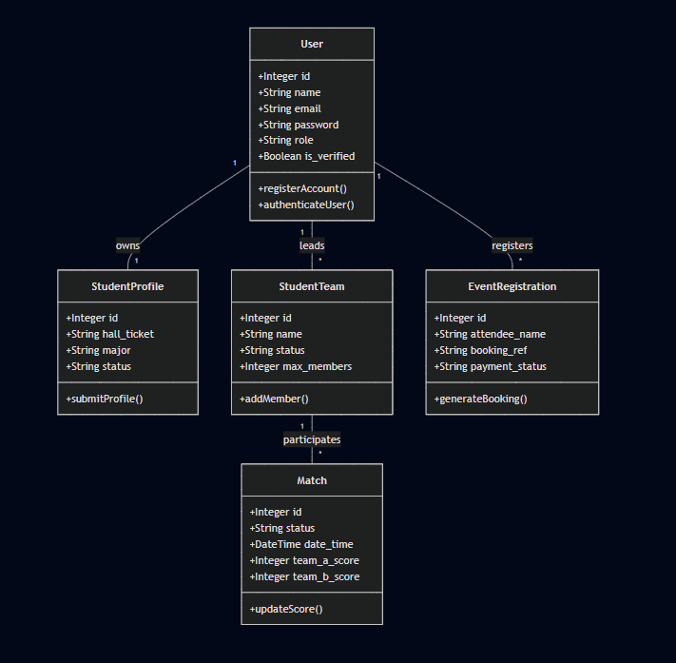
Figure 4.1: Class Diagram illustrating the relational mapping between Users, their verified Student Profiles, managed Student Teams, and Event Registrations.

4.4.2 Use Case Diagram
This use case diagram explicitly illustrates the strict separation of capabilities between public guests, verified scholars, and elevated platform administrators within the athletic ecosystem.
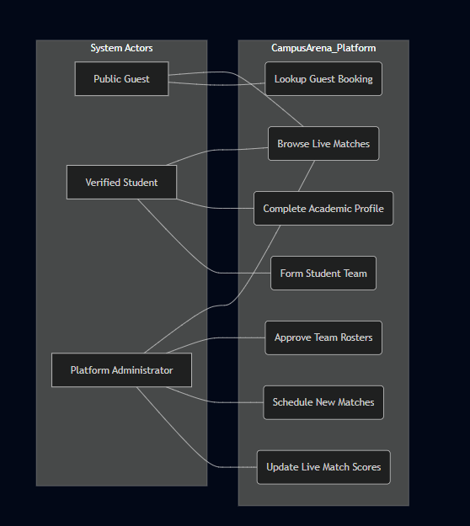
Figure 4.2: Use Case Diagram demonstrating the divergent access pathways, highlighting how students manage teams while administrators exclusively control tournament scheduling and score updating.

4.4.3 Activity Diagram
This activity diagram traces the specific, complex workflow of a student attempting to form a new competitive sports team and navigating the administrative approval process.
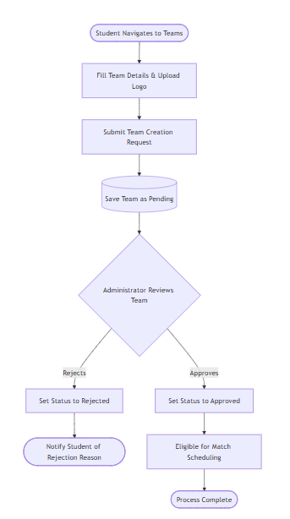
Figure 4.3: Activity Diagram detailing the strict administrative validation workflow required before a newly formed student team can participate in campus tournaments.

4.4.4 Deployment Diagram
This deployment diagram details the distributed cloud architecture necessary to support the dual-portal ecosystem, ensuring high availability and seamless data synchronization.
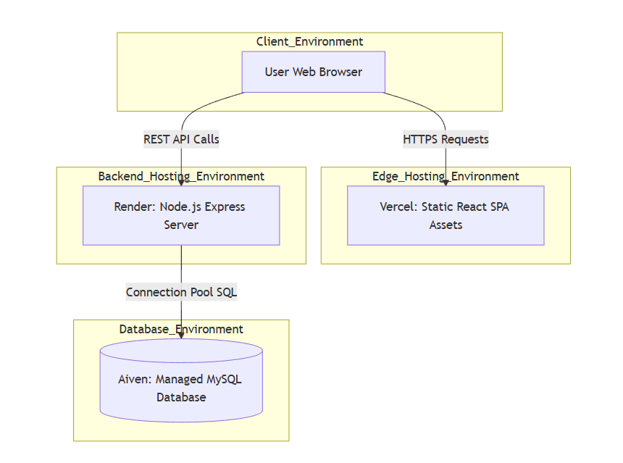Figure 4.4: Deployment Diagram depicting the microservices-inspired cloud architecture, showcasing the strict separation between the Vercel edge network, the Render application server, and the Aiven database environment.

4.5 Proposed Architecture
The proposed architecture transitions away from legacy administrative tools in favor of a highly resilient, three-tier ecosystem. The presentation tier operates entirely within the user's browser as a dynamic single-page application, assuming full responsibility for rendering the user interface, managing local component states, and validating form inputs prior to server transmission. The application logic tier is housed within a centralized Node.js server utilizing the Express framework. This server acts as the primary orchestrator, processing all incoming asynchronous requests, strictly enforcing role-based access controls through cryptographic token verification, and handling complex multipart file uploads for team logos and event banners. The data tier consists of a managed, highly relational MySQL database engineered to enforce strict data consistency and referential integrity across the entire platform, ensuring that the deletion of a sports category, for example, accurately cascades to update all associated active matches and registered student teams.

4.6 Data Storage and Management
Data persistence and management are orchestrated exclusively through a highly relational MySQL database hosted on the Aiven cloud platform. The database schema is meticulously structured utilizing normalized tables for user accounts, academic student profiles, sports catalogs, event registrations, and competitive matches. By employing a structured query language database, the system inherently enforces rigorous referential integrity through complex foreign key constraints. This ensures that a student team cannot be scheduled for a match in a sports category that does not exist, and that an individual user's event registrations remain securely linked to their primary account. Furthermore, the database utilizes an advanced connection pooling mechanism to ensure that the backend application programming interface can rapidly execute complex analytical queries, such as calculating the global leaderboard rankings based on historical match outcomes, without overwhelming the database server during peak usage hours.

4.7 Features
The platform boasts a comprehensive suite of features designed to serve public guests, verified scholars, and administrative personnel flawlessly. The core feature is the real-time match tracking engine, which allows users to view scheduled, live, and completed matches alongside dynamic global leaderboards calculated using a strict points-based algorithm. Verified students are empowered with a dedicated dashboard to manage their academic profiles, form competitive rosters, and securely add team members using an automated hall ticket validation system. For administrative efficiency, the platform includes a powerful management console featuring overarching key performance indicator analytics, comprehensive tools to orchestrate the entire lifecycle of events and matches, and interactive modules to quickly approve or reject pending student profiles and team submissions. To accommodate external participation, the system also features an asynchronous guest booking lookup tool, allowing non-registered attendees to retrieve event tickets using an automated alphanumeric booking reference generated upon successful registration.

4.8 Structured File System
The project source code is meticulously organized into a modern directory structure, creating clear physical boundaries between the interactive client interface and the transactional server environment to facilitate highly organized development and maintenance. The root directory branches into two primary environments encompassing the frontend and the backend. The frontend directory houses all React components, which are logically subdivided into sections for accessible user interface primitives, dedicated feature layouts for public and administrative views, comprehensive routing configurations, and centralized application programming interface service modules. The backend directory contains the complete Node.js environment, strictly organized into dedicated folders for structured query language database schemas, business logic controllers, secure routing definitions, upload middleware configurations, and the core server initialization scripts.
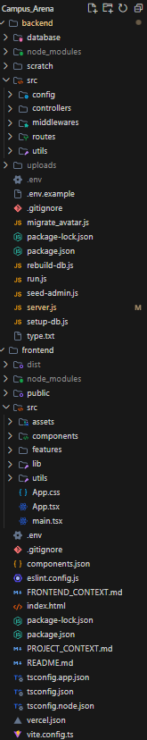

4.9 Database Schema Implementation
The following Structured Query Language (SQL) data definition statements represent the exact schema implemented within the Aiven managed MySQL database. These definitions enforce the strict relational integrity required by the platform, including foreign key constraints and cascading deletion rules.
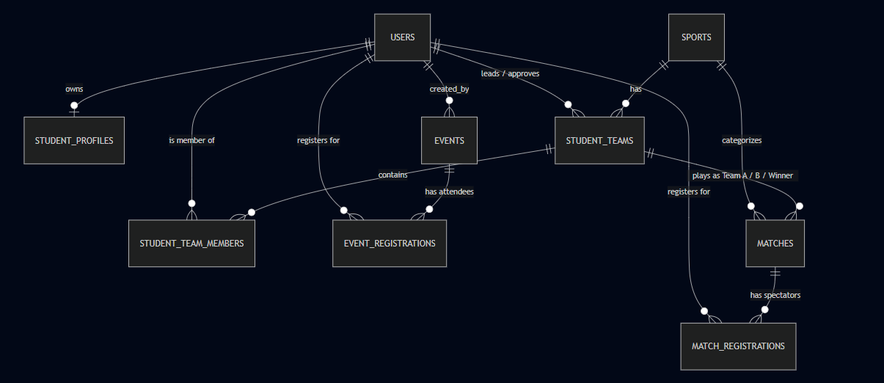
-- Table structure for table `event_registrations`
CREATE TABLE `event_registrations` (
`id` int unsigned NOT NULL AUTO_INCREMENT,
`event_id` int unsigned NOT NULL,
`user_id` int unsigned DEFAULT NULL,
`status` enum('pending','confirmed','cancelled') DEFAULT 'pending',
`created_at` timestamp NULL DEFAULT CURRENT_TIMESTAMP,
`attendee_name` varchar(255) NOT NULL,
`attendee_email` varchar(255) NOT NULL,
`attendee_phone` varchar(20) NOT NULL,
`payment_status` enum('pending','paid') DEFAULT 'pending',
`booking_ref` varchar(20) DEFAULT NULL,
PRIMARY KEY (`id`),
UNIQUE KEY `event_id` (`event_id`,`user_id`),
KEY `user_id` (`user_id`),
CONSTRAINT `event_registrations_ibfk_1` FOREIGN KEY (`event_id`) REFERENCES `events` (`id`) ON DELETE CASCADE,
CONSTRAINT `event_registrations_ibfk_2` FOREIGN KEY (`user_id`) REFERENCES `users` (`id`) ON DELETE CASCADE
) ENGINE=InnoDB DEFAULT CHARSET=utf8mb4 COLLATE=utf8mb4_0900_ai_ci;

-- Table structure for table `events`
CREATE TABLE `events` (
`id` int unsigned NOT NULL AUTO_INCREMENT,
`title` varchar(255) NOT NULL,
`description` text,
`event_type` enum('hackathon','workshop','sports','cultural','tech_fest','seminar','other') DEFAULT 'other',
`location` varchar(255) DEFAULT NULL,
`start_time` datetime NOT NULL,
`end_time` datetime DEFAULT NULL,
`price` int unsigned DEFAULT '0',
`status` enum('upcoming','ongoing','completed','cancelled') DEFAULT 'upcoming',
`max_capacity` int unsigned DEFAULT NULL,
`created_by` int unsigned DEFAULT NULL,
`banner_url` varchar(255) DEFAULT NULL,
`created_at` timestamp NULL DEFAULT CURRENT_TIMESTAMP,
`updated_at` timestamp NULL DEFAULT CURRENT_TIMESTAMP ON UPDATE CURRENT_TIMESTAMP,
PRIMARY KEY (`id`),
KEY `created_by` (`created_by`),
CONSTRAINT `events_ibfk_1` FOREIGN KEY (`created_by`) REFERENCES `users` (`id`) ON DELETE SET NULL
) ENGINE=InnoDB DEFAULT CHARSET=utf8mb4 COLLATE=utf8mb4_0900_ai_ci;

-- Table structure for table `match_registrations`
CREATE TABLE `match_registrations` (
`id` int unsigned NOT NULL AUTO_INCREMENT,
`match_id` int unsigned NOT NULL,
`user_id` int unsigned DEFAULT NULL,
`status` enum('pending','confirmed','cancelled') DEFAULT 'confirmed',
`created_at` timestamp NULL DEFAULT CURRENT_TIMESTAMP,
`attendee_name` varchar(255) NOT NULL,
`attendee_email` varchar(255) NOT NULL,
`attendee_phone` varchar(20) NOT NULL,
`payment_status` enum('pending','paid') DEFAULT 'pending',
`booking_ref` varchar(20) DEFAULT NULL,
PRIMARY KEY (`id`),
UNIQUE KEY `match_id` (`match_id`,`user_id`),
KEY `user_id` (`user_id`),
CONSTRAINT `match_registrations_ibfk_1` FOREIGN KEY (`match_id`) REFERENCES `matches` (`id`) ON DELETE CASCADE,
CONSTRAINT `match_registrations_ibfk_2` FOREIGN KEY (`user_id`) REFERENCES `users` (`id`) ON DELETE CASCADE
) ENGINE=InnoDB DEFAULT CHARSET=utf8mb4 COLLATE=utf8mb4_0900_ai_ci;

-- Table structure for table `matches`
CREATE TABLE `matches` (
`id` int unsigned NOT NULL AUTO_INCREMENT,
`sport_id` int unsigned NOT NULL,
`team_a_id` int unsigned NOT NULL,
`team_b_id` int unsigned NOT NULL,
`league` varchar(255) DEFAULT NULL,
`venue` varchar(255) DEFAULT NULL,
`date_time` datetime NOT NULL,
`price` int unsigned DEFAULT '0',
`status` enum('scheduled','live','completed','cancelled') DEFAULT 'scheduled',
`created_at` timestamp NULL DEFAULT CURRENT_TIMESTAMP,
`updated_at` timestamp NULL DEFAULT CURRENT_TIMESTAMP ON UPDATE CURRENT_TIMESTAMP,
`team_a_score` int DEFAULT NULL,
`team_b_score` int DEFAULT NULL,
`winner_id` int unsigned DEFAULT NULL,
PRIMARY KEY (`id`),
KEY `sport_id` (`sport_id`),
KEY `idx_matches_status` (`status`),
KEY `idx_matches_date_time` (`date_time`),
KEY `matches_team_a_fk` (`team_a_id`),
KEY `matches_team_b_fk` (`team_b_id`),
KEY `winner_id` (`winner_id`),
CONSTRAINT `matches_ibfk_1` FOREIGN KEY (`sport_id`) REFERENCES `sports` (`id`) ON DELETE CASCADE,
CONSTRAINT `matches_ibfk_2` FOREIGN KEY (`winner_id`) REFERENCES `student_teams` (`id`) ON DELETE SET NULL,
CONSTRAINT `matches_team_a_fk` FOREIGN KEY (`team_a_id`) REFERENCES `student_teams` (`id`) ON DELETE CASCADE,
CONSTRAINT `matches_team_b_fk` FOREIGN KEY (`team_b_id`) REFERENCES `student_teams` (`id`) ON DELETE CASCADE
) ENGINE=InnoDB DEFAULT CHARSET=utf8mb4 COLLATE=utf8mb4_0900_ai_ci;

-- Table structure for table `sports`
CREATE TABLE `sports` (
`id` int unsigned NOT NULL AUTO_INCREMENT,
`name` varchar(100) NOT NULL,
`icon` varchar(100) DEFAULT NULL,
`image_url` varchar(255) DEFAULT NULL,
`description` text,
`is_active` tinyint(1) DEFAULT '1',
`created_at` timestamp NULL DEFAULT CURRENT_TIMESTAMP,
`updated_at` timestamp NULL DEFAULT CURRENT_TIMESTAMP ON UPDATE CURRENT_TIMESTAMP,
PRIMARY KEY (`id`),
UNIQUE KEY `name` (`name`)
) ENGINE=InnoDB DEFAULT CHARSET=utf8mb4 COLLATE=utf8mb4_0900_ai_ci;

-- Table structure for table `student_profiles`
CREATE TABLE `student_profiles` (
`id` int NOT NULL AUTO_INCREMENT,
`user_id` int unsigned NOT NULL,
`hall_ticket` varchar(50) NOT NULL,
`graduation_batch` year NOT NULL,
`major` varchar(100) NOT NULL,
`college_email` varchar(255) NOT NULL,
`primary_sport` varchar(100) DEFAULT NULL,
`jersey_no` int DEFAULT NULL,
`phone` varchar(20) DEFAULT NULL,
`status` enum('pending','approved','rejected') DEFAULT 'pending',
`created_at` timestamp NULL DEFAULT CURRENT_TIMESTAMP,
`updated_at` timestamp NULL DEFAULT CURRENT_TIMESTAMP ON UPDATE CURRENT_TIMESTAMP,
`avatar_url` varchar(255) DEFAULT NULL,
PRIMARY KEY (`id`),
UNIQUE KEY `hall_ticket` (`hall_ticket`),
UNIQUE KEY `college_email` (`college_email`),
KEY `user_id` (`user_id`),
CONSTRAINT `student_profiles_ibfk_1` FOREIGN KEY (`user_id`) REFERENCES `users` (`id`) ON DELETE CASCADE
) ENGINE=InnoDB DEFAULT CHARSET=utf8mb4 COLLATE=utf8mb4_0900_ai_ci;

-- Table structure for table `student_team_members`
CREATE TABLE `student_team_members` (
`id` int unsigned NOT NULL AUTO_INCREMENT,
`student_team_id` int unsigned NOT NULL,
`user_id` int unsigned NOT NULL,
`hall_ticket` varchar(50) NOT NULL,
`jersey_no` int DEFAULT NULL,
`role` enum('leader','co-leader','member') DEFAULT 'member',
`joined_at` timestamp NULL DEFAULT CURRENT_TIMESTAMP,
PRIMARY KEY (`id`),
UNIQUE KEY `student_team_id` (`student_team_id`,`user_id`),
KEY `user_id` (`user_id`),
CONSTRAINT `student_team_members_ibfk_1` FOREIGN KEY (`student_team_id`) REFERENCES `student_teams` (`id`) ON DELETE CASCADE,
CONSTRAINT `student_team_members_ibfk_2` FOREIGN KEY (`user_id`) REFERENCES `users` (`id`) ON DELETE CASCADE
) ENGINE=InnoDB DEFAULT CHARSET=utf8mb4 COLLATE=utf8mb4_0900_ai_ci;

-- Table structure for table `student_teams`
CREATE TABLE `student_teams` (
`id` int unsigned NOT NULL AUTO_INCREMENT,
`name` varchar(255) NOT NULL,
`sport_id` int unsigned NOT NULL,
`leader_id` int unsigned NOT NULL,
`description` text,
`status` enum('pending','approved','rejected') DEFAULT 'pending',
`reason_if_rejected` text,
`max_members` int unsigned DEFAULT '11',
`approved_by` int unsigned DEFAULT NULL,
`approved_at` timestamp NULL DEFAULT NULL,
`created_at` timestamp NULL DEFAULT CURRENT_TIMESTAMP,
`updated_at` timestamp NULL DEFAULT CURRENT_TIMESTAMP ON UPDATE CURRENT_TIMESTAMP,
`logo_url` varchar(255) DEFAULT NULL,
PRIMARY KEY (`id`),
KEY `sport_id` (`sport_id`),
KEY `leader_id` (`leader_id`),
KEY `approved_by` (`approved_by`),
CONSTRAINT `student_teams_ibfk_1` FOREIGN KEY (`sport_id`) REFERENCES `sports` (`id`) ON DELETE CASCADE,
CONSTRAINT `student_teams_ibfk_2` FOREIGN KEY (`leader_id`) REFERENCES `users` (`id`) ON DELETE CASCADE,
CONSTRAINT `student_teams_ibfk_3` FOREIGN KEY (`approved_by`) REFERENCES `users` (`id`) ON DELETE SET NULL
) ENGINE=InnoDB DEFAULT CHARSET=utf8mb4 COLLATE=utf8mb4_0900_ai_ci;

-- Table structure for table `users`
CREATE TABLE `users` (
`id` int unsigned NOT NULL AUTO_INCREMENT,
`name` varchar(255) NOT NULL,
`email` varchar(255) NOT NULL,
`password` varchar(255) NOT NULL,
`role` enum('student','admin') DEFAULT 'student',
`is_verified` tinyint(1) DEFAULT '0',
`created_at` timestamp NULL DEFAULT CURRENT_TIMESTAMP,
`updated_at` timestamp NULL DEFAULT CURRENT_TIMESTAMP ON UPDATE CURRENT_TIMESTAMP,
PRIMARY KEY (`id`),
UNIQUE KEY `email` (`email`)
) ENGINE=InnoDB DEFAULT CHARSET=utf8mb4 COLLATE=utf8mb4_0900_ai_ci;

CHAPTER 5

IMPLEMENTATION AND DEPLOYMENT

5.1 Technologies Used
The implementation of the Campus Arena platform relies on a highly modernized, multi-tiered technology stack designed to balance high-speed user interactivity with rigorous data processing capabilities. By carefully selecting industry-standard tools, the platform ensures maximum performance and long-term maintainability.
The core technologies utilized include:
- Frontend Layer: Built using React version 19 and TypeScript to provide robust static type checking that significantly minimizes runtime errors.
- Build System: Bundled utilizing the Vite build tool, which ensures lightning-fast hot module replacement during development and highly optimized static assets for production.
- Styling Framework: Styled exclusively utilizing the Tailwind CSS utility framework alongside accessible component primitives from Shadcn, creating a cohesive, dark-themed visual language.
- Backend Application Logic: Powered by a Node.js runtime environment utilizing the Express web framework to expose a secure Representational State Transfer (REST) application programming interface.
- Data Persistence: Integrated with a highly relational MySQL database hosted on the Aiven cloud platform, seamlessly handling the complex relationships between student profiles, sports catalogs, and event registrations.

5.2 Frontend Implementation
The frontend architecture was implemented as a dynamic single-page application utilizing React Router to manage complex client-side navigation without ever requiring a full page reload.
Key frontend implementation details include:
- Decentralized Layouts: Structured using a multi-layered layout strategy to strictly separate public viewing areas from the secure, sidebar-driven student and administrative dashboards.
- API Service Layer: Implemented a centralized API service module utilizing the native browser fetch mechanism to manage all outbound network requests asynchronously and handle error responses gracefully.
- Session Management: Avoided heavy global state management libraries in favor of a highly efficient local storage session pattern to persist JSON Web Tokens and user profile metadata across browser sessions.
- Performance Optimization: Integrated an experimental React Compiler to automatically memoize components, ensuring that complex data visualizations, such as the global leaderboard and the interactive match schedule, render fluidly even when processing large volumes of athletic data.

5.3 Backend Implementation
The server-side implementation follows a strict, modular controller-based architecture designed to logically isolate business rules from network routing definitions. The Express application relies entirely on asynchronous JavaScript modules.
Key backend implementation details include:
- Modular Controllers: Utilized dedicated controller files to manage discrete platform features, explicitly separating the logic for user authentication, student team formation, and administrative analytics.
- File Upload Processing: Integrated the Multer library to handle complex multipart form data, securely processing incoming file uploads such as team logos, event banners, and student avatars directly to the local file system.
- Automated Job Scheduling: Incorporated a dedicated background scheduling module utilizing the node-cron package to manage the automated lifecycle of collegiate sports.
- Event Transitions: Configured background processes to execute automated structured query language commands every minute, seamlessly transitioning athletic matches from a scheduled state to a live state, and ultimately to a completed state, entirely without manual administrative intervention.

5.4 Database Integration
Data storage and retrieval were implemented using the promise-based MySQL2 driver, establishing a highly resilient connection pool to the managed Aiven cloud database.
Key database integration details include:
- Connection Pooling: Established a pool limit to maintain high throughput, allowing the server to instantly reuse established database connections rather than initiating a costly new connection for every incoming user request.
- Raw Query Optimization: Eschewed object-relational mapping (ORM) libraries in favor of raw, parameterized SQL queries embedded directly within the backend controllers to guarantee maximum query optimization and absolutely prevent malicious SQL injection attacks.
- Referential Integrity: Enforced strict database schema rules utilizing cascading deletion constraints to ensure that if an administrator removes a specific sports category, all associated matches and registered student teams are systematically purged, preventing application crashes caused by orphaned data records.

5.5 Security and Middleware
Platform security is rigorously enforced through a layered middleware architecture that intercepts and validates all incoming network requests before they reach the core business logic.
Key security implementations include:
- Stateless Authentication: Developed a custom authentication middleware that cryptographically verifies the signature of JSON Web Tokens (JWT) attached to the authorization headers of incoming requests, instantly rejecting expired or manipulated credentials.
- Role-Based Access Control (RBAC): Implemented secondary authorization checks for privileged operations, ensuring that standard students cannot execute commands restricted to campus administrators, such as creating new sports events or altering live match scores.
- Optional Authentication: Designed a specialized, non-blocking authentication middleware for specific ticketing endpoints, allowing the server to gracefully process event registrations for both verified students and anonymous public guests simultaneously.
- Password Encryption: Ensured all user passwords are encrypted using the bcrypt hashing algorithm with 10 salt rounds before database insertion.

5.6 Deployment Environment
The final deployment architecture is distributed across multiple specialized cloud environments to ensure global availability and absolute fault tolerance.
Key deployment details include:
- Edge Network Delivery: Deployed the compiled React frontend assets directly to the Vercel edge network, utilizing advanced routing rewrite rules to efficiently serve the single-page application to users across different geographic locations with minimal latency.
- Cloud Web Service: Hosted the Node.js transactional backend on the Render cloud platform as a dedicated web service, configured with hidden environment variables containing sensitive cryptographic secrets and database connection strings.
- Managed Cloud Database: Operated the MySQL database continuously on the Aiven managed cloud infrastructure, utilizing secure socket layer encryption to protect all transmitted data against network interception.
- Strict CORS Policies: Enforced strict Cross-Origin Resource Sharing (CORS) policies at the backend level, ensuring that the application programming interface exclusively accepts requests originating from the verified Vercel production domain or localized development servers.

5.7 System Interface and Screenshots

5.7.1 Public Landing Page and Hero Section
The public-facing landing page of the Campus Arena platform serves as the primary entry point for all users, delivering a highly immersive, sports-centric visual experience designed to immediately capture user attention.
- Features a dark-themed cinematic aesthetic with a prominent hero section drawing attention to live matches and global leaderboards.
- Employs bold, italicized typography alongside high-quality stadium imagery to establish a premium athletic brand identity.
- Incorporates direct call-to-action buttons facilitating immediate navigation to match exploration and ranking tables.
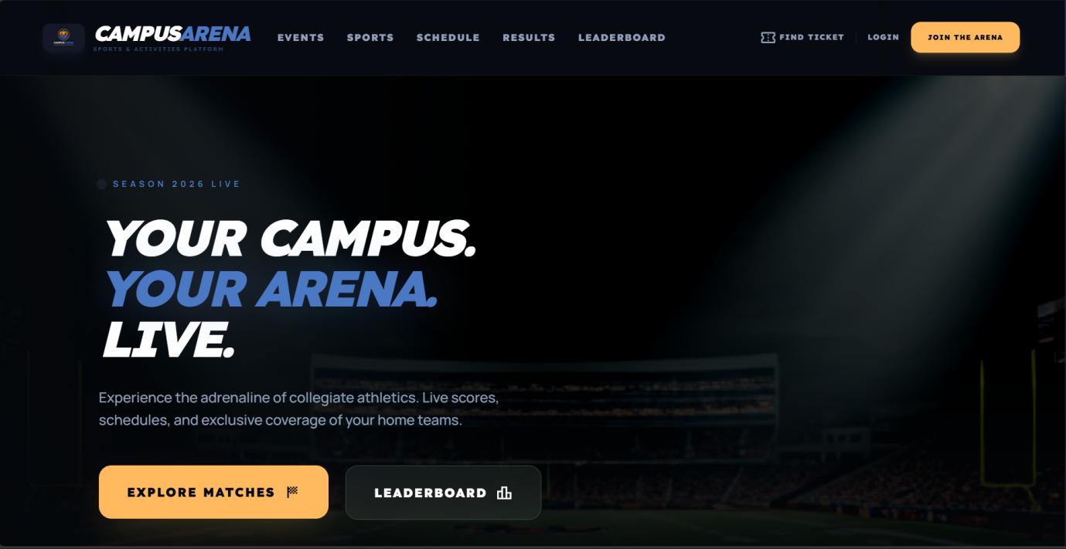
Figure 5.1: Screenshot of the Campus Arena public landing page featuring the dynamic hero section and primary navigation pathways.
Sample Code of Landing Page Component
// HeroSection.tsx — Landing page hero with staggered animations
export default function HeroSection() {
return (
<section className="relative min-h-[600px] lg:h-screen flex items-center overflow-hidden">
<div className="absolute inset-0 z-0">
<img className="w-full h-full object-cover brightness-[0.3]" src="..." alt="Stadium" />
<div className="absolute inset-0 bg-gradient-to-t from-[#05080c] via-transparent to-transparent" />
</div>
<div className="container mx-auto px-6 relative z-10">
<motion.div initial={{ opacity: 0, x: -20 }} animate={{ opacity: 1, x: 0 }} transition={{ delay: 0.2 }}>
<span className="bg-arena-primary w-2 h-2 rounded-full animate-ping" />
<span className="text-arena-primary text-xs font-black uppercase">Season 2026 Live</span>
</motion.div>
<motion.h1 initial={{ opacity: 0, y: 40 }} animate={{ opacity: 1, y: 0 }} transition={{ delay: 0.3 }}
className="text-7xl font-black font-headline uppercase italic text-white">
YOUR CAMPUS. <span className="text-arena-primary">YOUR ARENA.</span> LIVE.
</motion.h1>
<motion.div initial={{ opacity: 0, y: 20 }} animate={{ opacity: 1, y: 0 }} transition={{ delay: 0.7 }}
className="flex flex-col sm:flex-row gap-6">
<Link to="/sports">
<Button className="bg-arena-secondary text-[#05080c] px-10 py-6 h-auto rounded-2xl font-headline font-black uppercase tracking-widest hover:scale-110 transition-all duration-300">
Explore Matches <span className="material-symbols-outlined text-xl">sports_score</span>
</Button>
</Link>
<Link to="/leaderboard">
<Button variant="outline" className="bg-white/5 backdrop-blur-md border-white/10 text-white px-10 py-6 h-auto rounded-2xl font-headline font-black uppercase tracking-widest hover:bg-white/10">
Leaderboard <span className="material-symbols-outlined text-xl">leaderboard</span>
</Button>
</Link>
</motion.div>
</div>
</section>
)
}

5.7.2 Authentication and Student Gateway
The authentication interface provides a secure, streamlined portal for users to access personalized platform features and manage their athletic profiles.
- Integrates a seamless dual-role toggle, allowing both standard students and platform administrators to authenticate through a unified entry point.
- Utilizes clean, distraction-free input fields tailored for official college email addresses and secure security passes.
- Connects directly to the backend authentication middleware to securely generate and store JSON Web Tokens upon successful credential verification.
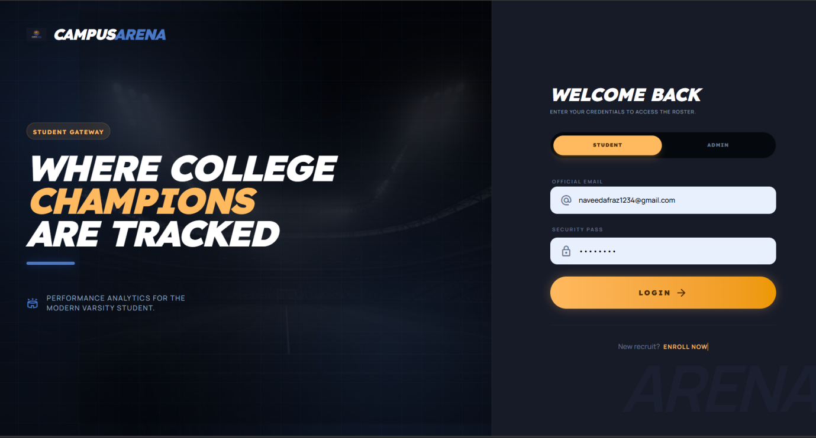Figure 5.2: Screenshot of the secure Student Gateway and authentication interface highlighting role-based login capabilities.
Sample Code of Authentication Component
// LoginPage.tsx — Role-based authentication with JWT storage
export default function LoginPage() {
const [role, setRole] = useState<'student' | 'admin'>('student')
const [email, setEmail] = useState('')
const [password, setPassword] = useState('')

const handleSubmit = async (e: React.FormEvent) => {
e.preventDefault()
const response = await authAPI.login(email, password, role);
if (!response.success) { toast.error(response.message || 'Invalid credentials'); return; }

localStorage.setItem('campusArenaUser', JSON.stringify({
token: response.data.token, role: response.data.user.role,
name: response.data.user.name, profile_status: response.data.user.profile_status
}));

if (response.data.user.role === 'admin') navigate('/admin')
else if (response.data.user.profile_status === 'approved') navigate('/student')
else navigate('/complete-profile')
}

return (
<main className="min-h-screen flex flex-col md:flex-row bg-surface-container-lowest">
{/* Left: Branding Panel (60%) with stadium imagery and grid effect */}
<section className="relative hidden md:flex md:w-7/12 lg:w-3/5 bg-[#03050a] overflow-hidden items-center px-24">
<div className="relative z-10 space-y-6 text-white">
<h1 className="text-7xl font-black font-headline leading-[0.9] uppercase italic">
WHERE COLLEGE <span className="text-arena-secondary">CHAMPIONS</span> ARE TRACKED
</h1>
</div>
</section>

{/* Right: Login Form (40%) */}
<section className="flex-1 flex flex-col justify-center px-8 sm:px-12 lg:px-20 py-12">
{/* Role Toggle */}
<div className="p-1.5 bg-surface-container-lowest rounded-full flex gap-1 border border-white/5">
<button onClick={() => setRole('student')}
className={`flex-1 py-3 rounded-full text-[10px] font-black tracking-widest ${role === 'student' ? 'bg-arena-secondary text-on-secondary shadow-lg' : 'text-slate-500'}`}>STUDENT</button>
<button onClick={() => setRole('admin')}
className={`flex-1 py-3 rounded-full text-[10px] font-black tracking-widest ${role === 'admin' ? 'bg-arena-primary text-white shadow-lg' : 'text-slate-500'}`}>ADMIN</button>
</div>
<form onSubmit={handleSubmit} className="space-y-6">
<Input type="email" value={email} onChange={(e) => setEmail(e.target.value)} placeholder="student@university.edu" />
<Input type="password" value={password} onChange={(e) => setPassword(e.target.value)} placeholder="••••••••" />
<Button type="submit" className="w-full py-5 h-auto rounded-full bg-gradient-to-r from-arena-secondary to-secondary-container text-on-secondary">
<span className="font-black font-headline tracking-[0.2em] uppercase">LOGIN</span>
</Button>
</form>
<footer className="pt-8 text-center border-t border-white/5">
<p className="text-sm text-slate-500">New recruit? <Link to="/register" className="text-arena-secondary font-black uppercase">Enroll Now</Link></p>
</footer>
</section>
</main>
)
}

5.7.3 Public Sports Catalog
The sports catalog serves as a comprehensive visual directory, allowing visitors and scholars to seamlessly discover and explore the diverse athletic departments supported by the university ecosystem.
- Renders an interactive grid of sport category cards, dynamically fetching data and imagery directly from the MySQL database.
- Features integrated search and filtering tools, enabling users to rapidly locate specific collegiate games or department leagues.
- Provides dedicated navigation pathways from each sport directly to its associated match schedules and historical results.
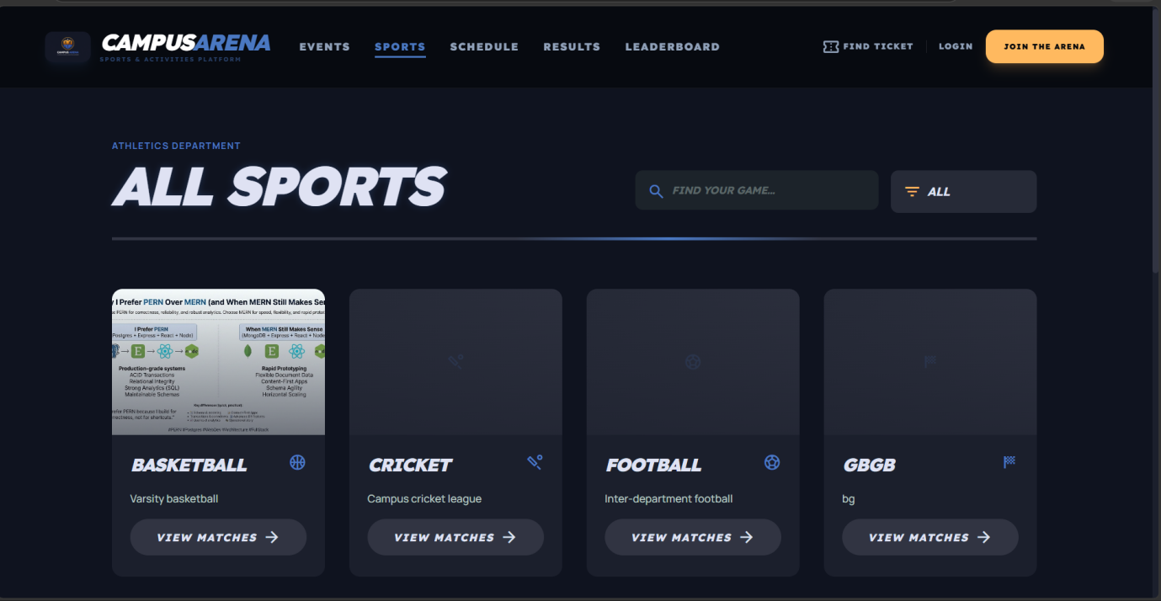
Figure 5.3: Screenshot of the interactive sports catalog displaying distinct athletic categories and integrated search filters.
Sample Code of Sports Catalog Component
// SportsPage.tsx — Memoized filtering with animated grid
export default function SportsPage() {
const [searchQuery, setSearchQuery] = useState('')
const [sports, setSports] = useState<any[]>([])

useEffect(() => {
const fetchSports = async () => {
const response = await sportsAPI.getAll()
setSports(response.data.sports || [])
}
fetchSports()
}, [])

const filteredSports = useMemo(() => {
return sports.filter((sport) =>
searchQuery === '' || sport.name.toLowerCase().includes(searchQuery.toLowerCase())
)
}, [searchQuery, sports])

return (
<div className="container mx-auto px-6 py-12 lg:py-20">
<header className="mb-16">
<motion.div initial={{ opacity: 0, x: -30 }} animate={{ opacity: 1, x: 0 }}>
<span className="text-arena-primary font-bold tracking-widest text-xs uppercase">Athletics Department</span>
<h1 className="font-headline text-5xl md:text-7xl font-black uppercase italic tracking-tighter">All Sports</h1>
</motion.div>
<SearchFilter searchQuery={searchQuery} onSearchChange={setSearchQuery} />
</header>
<div className="grid grid-cols-1 sm:grid-cols-2 lg:grid-cols-3 xl:grid-cols-4 gap-8">
{filteredSports.map((sport, index) => (
<motion.div key={sport.id} initial={{ opacity: 0, y: 30 }} animate={{ opacity: 1, y: 0 }}
transition={{ delay: index * 0.1, duration: 0.4 }}>
<SportCard name={sport.name} icon={sport.icon || 'sports'} image={sport.image_url}
description={sport.description || ''} />
</motion.div>
))}
</div>
{filteredSports.length === 0 && <EmptyState onClearFilters={() => setSearchQuery('')} />}
</div>
)
}

5.7.4 Match Schedule Interface
The match schedule interface is engineered to keep the student body continuously informed regarding all upcoming and active athletic engagements across the campus.
- Utilizes a highly organized tab system to logically segregate matches into "All," "Upcoming," "Live," and "Completed" categories.
- Displays critical logistical data for each fixture, including specific venue coordinates, precise kickoff times, and spectator entry fees.
- Integrates interactive buttons allowing standard users and public guests to securely reserve their spectator spots within the arena.
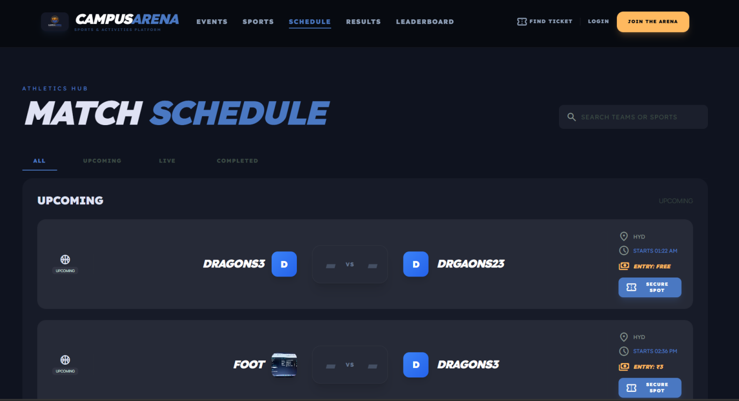Figure 5.4: Screenshot of the organized match schedule interface highlighting upcoming inter-departmental basketball fixtures.
Sample Code of Match Schedule Component
// SchedulePage.tsx — Tabbed match filtering with date grouping
const tabs = [
{ label: 'ALL', value: 'all' },
{ label: 'UPCOMING', value: 'upcoming' },
{ label: 'LIVE', value: 'live', dot: true },
{ label: 'COMPLETED', value: 'completed' },
]

export default function SchedulePage() {
const [matches, setMatches] = useState<ScheduleMatch[]>([])
const [activeTab, setActiveTab] = useState('all')

useEffect(() => {
const fetchMatches = async () => {
const response = await matchesAPI.getAll()
if (response.success) {
const transformed = response.data.matches.map((match: any) => ({
id: match.id.toString(), sport: match.sport_name,
teamA: { name: match.team_a_name, score: match.team_a_score },
teamB: { name: match.team_b_name, score: match.team_b_score },
venue: match.venue, status: match.status === 'scheduled' ? 'upcoming' : match.status,
date: new Date(match.date_time).toLocaleDateString('en-US', { month: 'short', day: 'numeric' }),
price: match.price
}))
setMatches(transformed)
}
}
fetchMatches()
}, [])

const filteredMatches = matches.filter((m) => activeTab === 'all' || m.status === activeTab)

return (
<div className="container mx-auto px-6 md:px-8 py-12 lg:py-20">
<motion.div initial={{ opacity: 0, x: -30 }} animate={{ opacity: 1, x: 0 }}>
<h1 className="text-5xl md:text-7xl font-black font-headline uppercase tracking-tighter italic">
MATCH <span className="text-arena-primary">SCHEDULE</span>
</h1>
</motion.div>
<div className="flex gap-8 mt-12 overflow-x-auto pb-4 border-b border-outline-variant/10">
{tabs.map((tab) => (
<button key={tab.value} onClick={() => setActiveTab(tab.value)}
className={`px-6 py-3 font-headline font-black text-xs uppercase tracking-widest border-b-2 transition-all ${
activeTab === tab.value ? 'text-arena-primary border-arena-primary' : 'text-outline-variant border-transparent'
}`}>
{tab.label} {tab.dot && <span className="w-2 h-2 bg-arena-primary rounded-full animate-pulse ml-2" />}
</button>
))}
</div>
<div className="grid grid-cols-1 gap-6 w-full mt-8">
{filteredMatches.map((match) => <ScheduleMatchCard match={match} key={match.id} />)}
</div>
</div>
)
}

5.7.5 Match Results Archive
The athletics archive provides a permanent, searchable historical record of all completed matches, fostering long-term community engagement and competitive tracking.
- Visualizes final match scores utilizing a clean, highly legible card layout that clearly distinguishes the victorious team.
- Implements horizontal sport-specific filters to allow users to isolate historical data, such as exclusively reviewing past football or cricket championships.
- Dynamically fetches data from the backend application programming interface, ensuring the archive updates instantaneously the moment a referee finalizes a match.
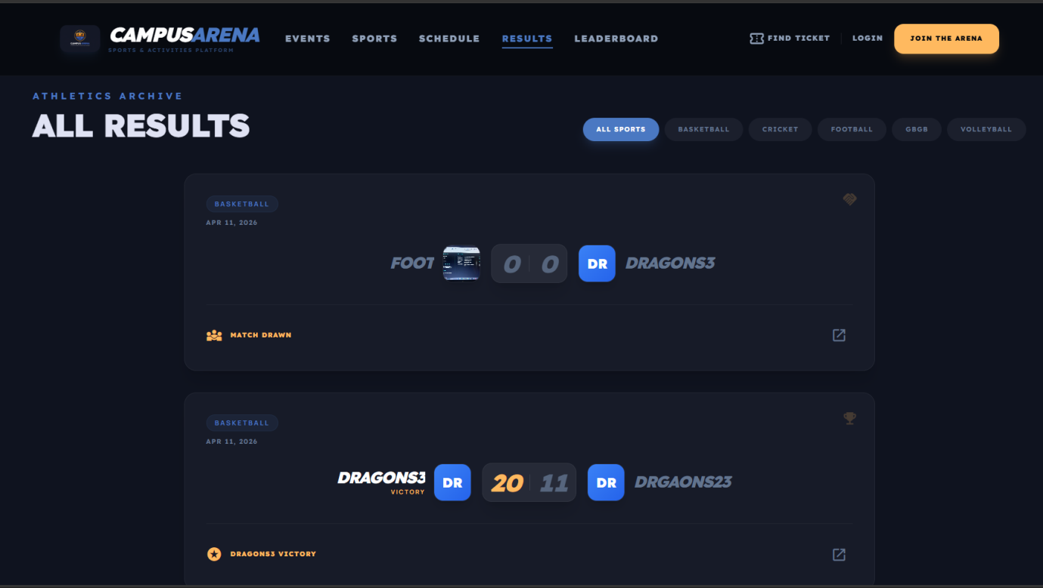Figure 5.5: Screenshot of the comprehensive match results archive displaying completed scores and sports-specific filtering options.
Sample Code of Match Results Component
// ResultsPage.tsx — Concurrent API fetching with load-more pagination
export default function ResultsPage() {
const [sportFilter, setSportFilter] = useState('All Sports')
const [results, setResults] = useState<any[]>([])
const [visibleCount, setVisibleCount] = useState(6)

useEffect(() => {
const fetchData = async () => {
const [matchesRes, sportsRes] = await Promise.all([
matchesAPI.getAll('completed'), sportsAPI.getAll()
])
if (matchesRes.success) {
const mapped = matchesRes.data.matches.map((m: any) => ({
id: m.id, sport: m.sport_name,
teamA: { name: m.team_a_name, score: m.team_a_score ?? 0 },
teamB: { name: m.team_b_name, score: m.team_b_score ?? 0 },
winner: m.winner_id === m.team_a_id ? 'A' : m.winner_id === m.team_b_id ? 'B' : 'Draw',
}))
setResults(mapped.reverse())
}
}
fetchData()
}, [])

const filtered = results.filter(r => sportFilter === 'All Sports' || r.sport === sportFilter)

return (
<div className="container mx-auto px-6 py-16">
{/* Sport filter tabs */}
{['All Sports', ...sports.map(s => s.name)].map((f) => (
<button key={f} onClick={() => setSportFilter(f)}
className={sportFilter === f ? 'bg-arena-primary text-on-primary' : 'bg-surface-container text-slate-500'}>
{f}
</button>
))}
{filtered.slice(0, visibleCount).map((result) => <ResultCard {...result} />)}
{filtered.length > visibleCount && (
<button onClick={() => setVisibleCount(prev => prev + 6)}>Load More History</button>
)}
</div>
)
}

5.7.6 Global Leaderboard
The automated global leaderboard is a central pillar of the platform's competitive ecosystem, utilizing a strict algorithmic points system to rank all approved student teams.
- Dynamically calculates team rankings based on a complex algorithm prioritizing total points (three per win, one per draw), followed by overall win rates.
- Displays progress bars mapping individual team win percentages alongside comprehensive win-loss records.
- Prominently highlights the number one overall "Varsity Target" to drive engagement and highlight top-performing athletic rosters.
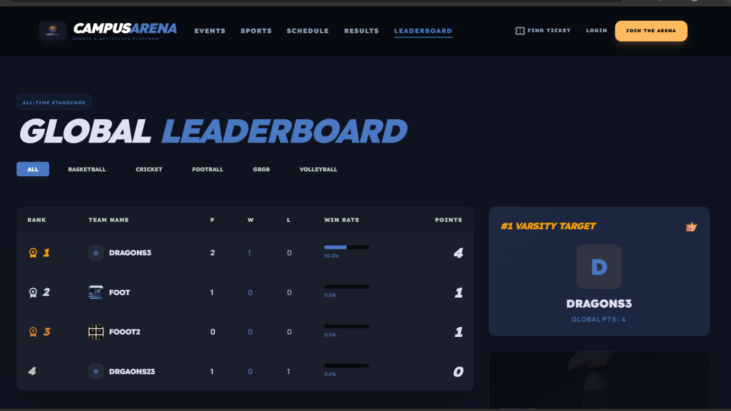Figure 5.6: Screenshot of the automated global leaderboard illustrating points-based rankings and specific team win rates.
Sample Code of Leaderboard Component
// SeasonLeaderboard.tsx — Reactive sport-based filtering
export default function SeasonLeaderboard() {
const [rankings, setRankings] = useState<any[]>([])
const [activeSportId, setActiveSportId] = useState<number | null>(null)

useEffect(() => { fetchLeaderboard() }, [activeSportId])

const fetchLeaderboard = async () => {
const resp = await leaderboardAPI.getGlobalRankings(activeSportId ?? undefined)
if (resp.success) setRankings(resp.data.leaderboard)
}

return (
<div className="container mx-auto px-6 py-12">
{/* Sport filter buttons */}
<table className="w-full text-left">
<thead>
<tr><th>Rank</th><th>Team</th><th>P</th><th>W</th><th>L</th><th>Win Rate</th><th>Points</th></tr>
</thead>
<tbody>
{rankings.map((r, i) => (
<motion.tr key={r.name} initial={{ opacity: 0, x: -20 }} animate={{ opacity: 1, x: 0 }}
transition={{ delay: i * 0.05 }}>
<td className={r.rank === 1 ? 'text-[#F59E0B]' : r.rank === 2 ? 'text-slate-300' : r.rank === 3 ? 'text-[#CD7F32]' : ''}>
{r.rank}
</td>
<td>{r.name}</td><td>{r.p}</td><td>{r.w}</td><td>{r.l}</td>
<td>
<div className="w-24 bg-surface-container-lowest h-2 rounded-full overflow-hidden">
<div className="bg-arena-primary h-full" style={{ width: `${r.rate}%` }} />
</div>
</td>
<td className="text-3xl font-black italic">{r.pts}</td>
</motion.tr>
))}
</tbody>
</table>
</div>
)
}

5.7.7 Guest Ticket Lookup Modal
To support external participants and streamline stadium entry, the platform features a highly efficient, asynchronous ticket retrieval system designed for public guests.
- Employs a focus-trapping modal interface that overlays the main application, minimizing navigational disruption.
- Requires the input of an email address alongside a unique alphanumeric booking reference (e.g., CA-XYZ123) for verification.
- Communicates directly with the backend to query both match and event registration tables simultaneously, returning the validated ticket instantly.
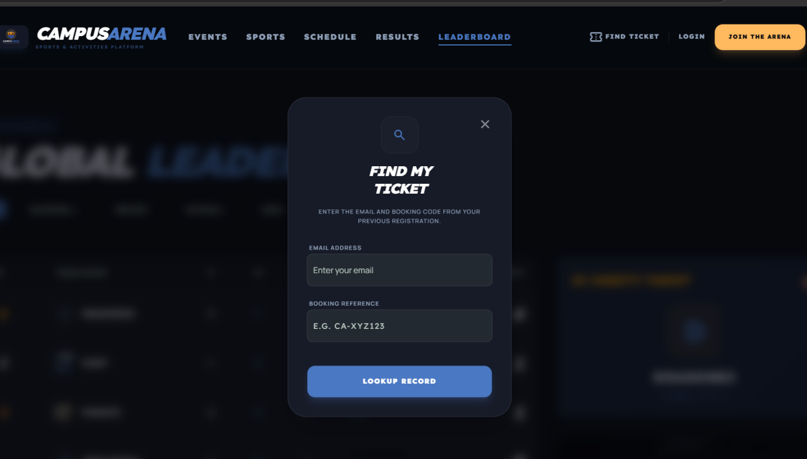Figure 5.7: Screenshot of the intuitive guest ticket lookup modal utilized for retrieving external spectator bookings.
Sample Code of Guest Lookup Component
// GuestLookupModal.tsx — Portal-based modal with dual-state UI
export default function GuestLookupModal({ isOpen, onClose }: GuestLookupModalProps) {
const [email, setEmail] = useState('')
const [bookingRef, setBookingRef] = useState('')
const [ticketData, setTicketData] = useState<any>(null)

const handleSubmit = async (e: React.FormEvent) => {
e.preventDefault()
const res = await guestAPI.lookup(email, bookingRef.toUpperCase())
if (res.success) { toast.success('Ticket found!'); setTicketData(res.data) }
else toast.error(res.message || 'No bookings found.')
}

return typeof document !== 'undefined' ? createPortal(
<AnimatePresence>
{isOpen && (
<motion.div initial={{ opacity: 0, scale: 0.95 }} animate={{ opacity: 1, scale: 1 }}
className="fixed left-1/2 top-1/2 -translate-x-1/2 -translate-y-1/2 max-w-sm bg-surface-container-low rounded-[32px] z-[100]">
{ticketData ? (
/* Digital Ticket View — shows event/match tickets with payment status */
<div>{ticketData.events?.map((ev: any) => <div>{ev.title} — {ev.payment_status}</div>)}</div>
) : (
/* Search Form */
<form onSubmit={handleSubmit}>
<Input placeholder="Email" value={email} onChange={(e) => setEmail(e.target.value)} />
<Input placeholder="e.g. CA-XYZ123" value={bookingRef} onChange={(e) => setBookingRef(e.target.value)} />
<Button type="submit">Lookup Record</Button>
</form>
)}
</motion.div>
)}
</AnimatePresence>, document.body
) : null
}

5.7.8 Comprehensive Administrative Dashboard
The core administrative dashboard equips campus organizers with an overarching, data-rich command center to monitor the real-time health and activity of the sports ecosystem.
- Features prominent key performance indicator modules displaying aggregate counts for total sports, live events, verified students, and active teams.
- Integrates a dedicated "Platform Feeds" sidebar, delivering an asynchronous, real-time stream of newly submitted user registrations and finalized match scores.
- Organizes pending administrative tasks logically, ensuring organizers can instantly access and manage critical upcoming schedules without navigating complex menus.
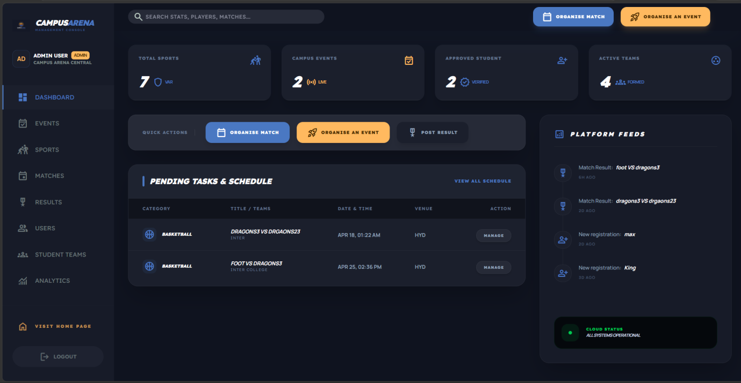Figure 5.8: Screenshot of the primary administrative dashboard highlighting overarching platform statistics and real-time activity feeds.
Sample Code of Admin Dashboard Component
// AdminDashboard.tsx — 12-column grid layout with KPI metrics
export default function AdminDashboard() {
const [stats, setStats] = useState<any>(null)
const [pendingMatches, setPendingMatches] = useState<any[]>([])
const [activityFeed, setActivityFeed] = useState<any[]>([])

useEffect(() => {
const fetch = async () => {
const res = await dashboardAPI.getAdminStats()
if (res.success) {
setStats(res.data.stats); setPendingMatches(res.data.pendingMatches)
setActivityFeed(res.data.activityFeed)
}
}; fetch()
}, [])

const kpiData = [
{ label: 'Total Sports', value: stats?.sports || '0', icon: 'sports_kabaddi' },
{ label: 'Campus Events', value: stats?.events || '0', icon: 'event_available' },
{ label: 'Approved Students', value: stats?.registrations || '0', icon: 'person_add' },
{ label: 'Active Teams', value: stats?.teams || '0', icon: 'group_work' },
]

return (
<div className="grid grid-cols-12 gap-8">
{/* KPI Row */}
<section className="col-span-12 grid grid-cols-1 md:grid-cols-4 gap-6">
{kpiData.map((kpi, i) => (
<motion.div key={kpi.label} initial={{ opacity: 0, y: 20 }} animate={{ opacity: 1, y: 0 }}
transition={{ delay: i * 0.1 }} className="bg-surface-container p-6 rounded-2xl relative overflow-hidden group shadow-xl">
<div className="flex justify-between items-start mb-4">
<span className="text-slate-500 text-[10px] font-black font-headline tracking-widest uppercase">{kpi.label}</span>
<span className="material-symbols-outlined text-arena-primary text-[22px]">{kpi.icon}</span>
</div>
<h2 className="font-headline font-black text-4xl text-white italic">{kpi.value}</h2>
<div className="absolute bottom-0 left-0 w-full h-1 bg-white/5">
<div className="h-full w-0 group-hover:w-full bg-arena-primary transition-all duration-700" />
</div>
</motion.div>
))}
</section>

{/* Main: Quick Actions + Pending Table (col-span-8) */}
<div className="col-span-12 lg:col-span-8 flex flex-col gap-8">
<div className="bg-surface-container-high p-4 rounded-2xl flex flex-wrap gap-4 items-center">
<Link to="/admin/matches" className="bg-arena-primary text-white px-6 py-3 rounded-xl text-[10px] font-black">ORGANISE MATCH</Link>
<Link to="/admin/events" className="bg-arena-secondary text-on-secondary px-6 py-3 rounded-xl text-[10px] font-black">ORGANISE AN EVENT</Link>
</div>
{/* Pending matches table */}
</div>

{/* Sidebar: Activity Feed (col-span-4) */}
<aside className="col-span-12 lg:col-span-4">
{/* Real-time platform feeds with relative timestamps */}
</aside>
</div>
)
}

5.7.9 Admin Events Console
The events console is a specialized administrative module dedicated entirely to the orchestration and financial monitoring of campus-wide activities and hackathons.
- Provides deep analytical insights into event performance, displaying real-time metrics for total registrations and projected overall revenue.
- Renders a highly detailed administrative table tracking specific event capacities, precise venue schedules, and categorical types.
- Empowers elevated users with absolute capabilities to create new events, instantly modify existing details, or permanently delete cancelled activities.
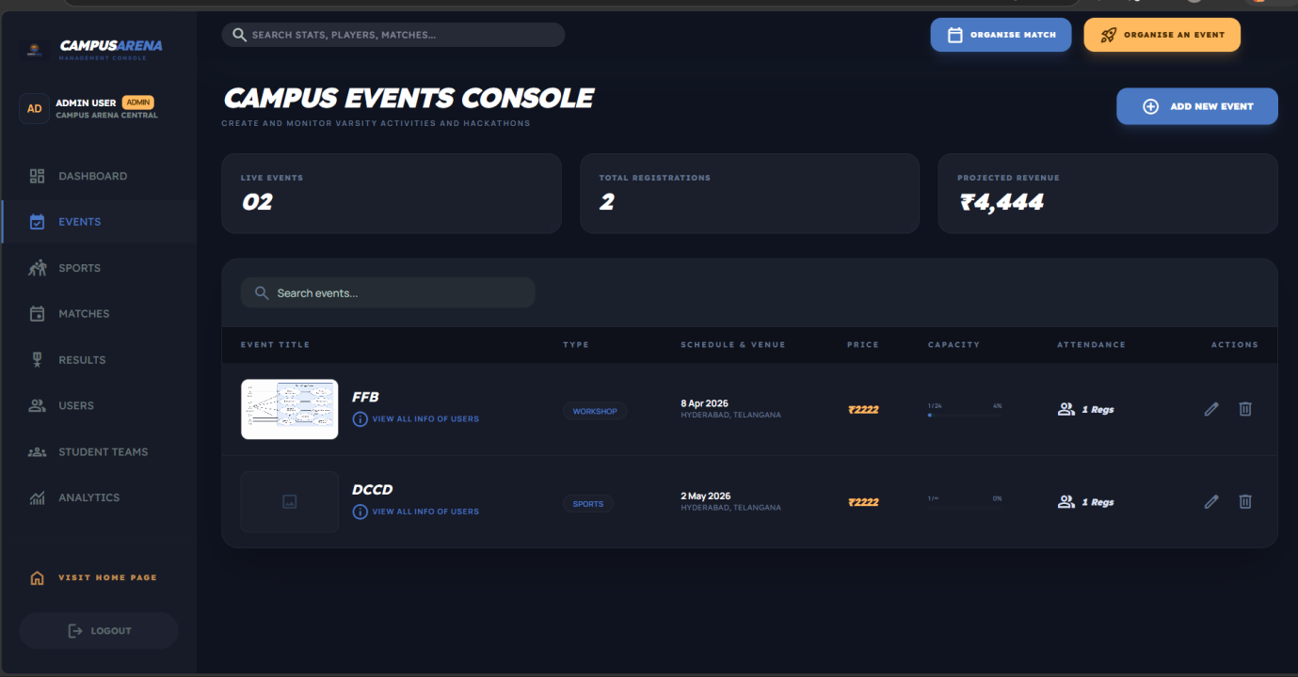Figure 5.9: Screenshot of the secure events console detailing current registration capacities, projected revenues, and event lifecycle management tools.
Sample Code of Admin Events Component
// AdminEvents.tsx — CRUD with computed stats and payment toggle
export default function AdminEvents() {
const [events, setEvents] = useState<Event[]>([])
const [isModalOpen, setIsModalOpen] = useState(false)
const [editingEvent, setEditingEvent] = useState<Event | null>(null)

const handleSave = async (e: React.FormEvent<HTMLFormElement>) => {
e.preventDefault()
const fd = new FormData(e.currentTarget)
const bannerFile = fd.get('banner') as File
if (!bannerFile || bannerFile.size === 0) fd.delete('banner')

const res = editingEvent
? await eventsAPI.update(editingEvent.id, Object.fromEntries(fd), bannerFile)
: await eventsAPI.create(Object.fromEntries(fd), bannerFile)
if (res.success) { toast.success(editingEvent ? 'Event updated' : 'Event published'); fetchEvents() }
}

// Manual payment toggle: pending ↔ paid
const handleTogglePayment = async (eventId: number, regId: number, currentStatus: string) => {
const newStatus = currentStatus === 'pending' ? 'paid' : 'pending';
const res = await eventsAPI.togglePaymentStatus(eventId, regId, newStatus);
if (res.success) toast.success(`Payment marked as ${newStatus.toUpperCase()}`);
}

return (
<div className="space-y-8 pb-20">
<header className="flex flex-col md:flex-row md:items-center justify-between gap-4">
<h1 className="text-4xl font-black font-headline text-white uppercase italic tracking-tighter">Campus Events Console</h1>
<Button onClick={() => { setEditingEvent(null); setIsModalOpen(true) }}
className="bg-arena-primary text-white font-black uppercase text-xs rounded-xl px-8 h-12">Add New Event</Button>
</header>
{/* Computed Stats: Live Events | Total Registrations | Projected Revenue (Σ price × participants) */}
<div className="grid grid-cols-1 md:grid-cols-3 gap-6">
{[
{ label: 'Live Events', value: String(events.length).padStart(2, '0') },
{ label: 'Total Registrations', value: events.reduce((s, e) => s + (e.participants || 0), 0).toLocaleString() },
{ label: 'Projected Revenue', value: `₹${events.reduce((s, e) => s + ((e.price || 0) * (e.participants || 0)), 0).toLocaleString()}` },
].map((stat, i) => (
<div key={i} className="bg-surface-container rounded-2xl p-6 border border-white/5">
<span className="text-[10px] font-headline font-extrabold uppercase text-slate-500">{stat.label}</span>
<span className="text-3xl font-black font-headline text-white italic">{stat.value}</span>
</div>
))}
</div>
{/* Events admin table with search, banner preview, type badge, capacity bar, edit/delete actions */}
{/* Registrants modal with payment toggle (pending ↔ paid) and booking ref display */}
</div>
)
}

5.7.10 Admin Match Management
The match management control center serves as the ultimate logistical tool for coordinating inter-departmental tournaments and updating real-time athletic data.
- Displays a dense, highly actionable grid of all scheduled, live, and completed matches across the entire sports catalog.
- Facilitates the rapid scheduling of new matches through an integrated interface that ensures only approved student teams can be pitted against each other.
- Includes dedicated quick-action buttons for administrators to instantly declare winners, finalize scores, or safely cancel matches directly from the primary table view.
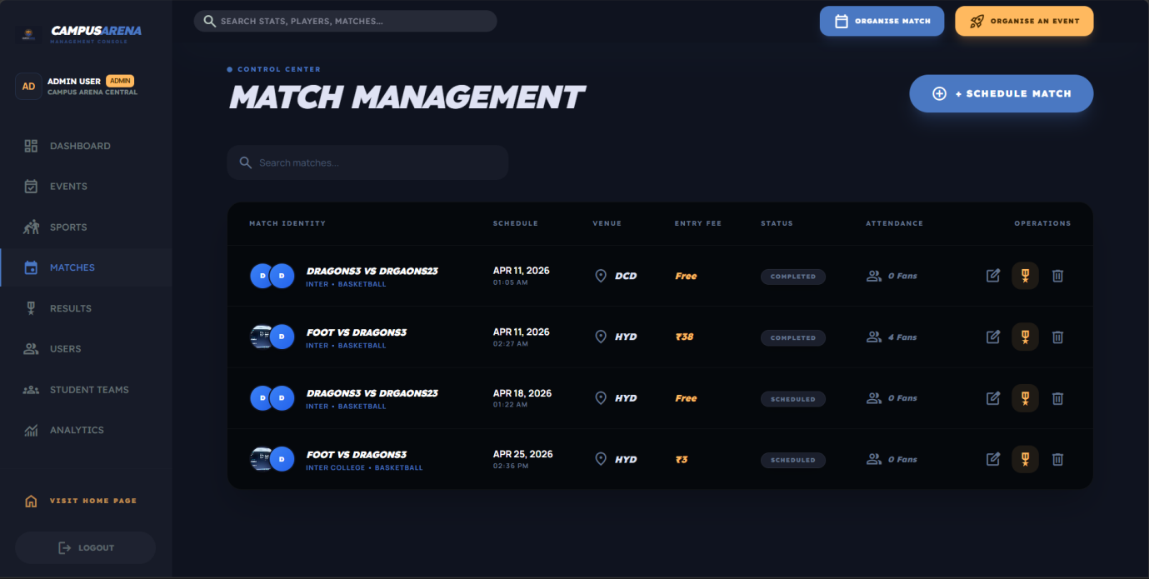Figure 5.10: Screenshot of the match management control center illustrating the comprehensive scheduling and score-updating administrative interface.
Sample Code of Match Management Component
// AdminMatches.tsx — Cascading dropdown with team validation
export default function AdminMatches() {
const [matches, setMatches] = useState<Match[]>([])
const [sports, setSports] = useState<any[]>([])
const [teams, setTeams] = useState<any[]>([])
const [filteredTeams, setFilteredTeams] = useState<any[]>([])

// Sport selection filters teams to only approved teams in that sport
const handleSportChange = (sportId: number) => {
const filtered = teams.filter((t) => String(t.sport_id) === String(sportId));
setFilteredTeams(filtered);
if (filtered.length === 0) toast.error('No approved teams found for this sport');
};

const handleSaveMatch = async () => {
if (editingMatch.teamAId === editingMatch.teamBId) {
toast.error("Team A and Team B must be different"); return;
}
const matchData = {
team_a_id: editingMatch.teamAId, team_b_id: editingMatch.teamBId,
sport_id: editingMatch.sportId, venue: editingMatch.venue,
date_time: `${editingMatch.date}T${editingMatch.time}`,
status: editingMatch.status?.toLowerCase(), price: editingMatch.entryFee || 0,
};
const response = editingMatch?.id
? await matchesAPI.update(parseInt(editingMatch.id), matchData)
: await matchesAPI.create(matchData);
if (response.success) toast.success('Match saved successfully');
};

return (
<div className="max-w-7xl mx-auto space-y-8">
<header className="flex justify-between items-end gap-6">
<h2 className="text-5xl font-black font-headline uppercase tracking-tighter italic">Match Management</h2>
<Button onClick={handleCreateMatch} className="bg-arena-primary text-white px-8 py-4 rounded-full font-black uppercase">+ Schedule Match</Button>
</header>
{/* Matches table with overlapping team logos (-space-x-3 avatars), status badges
(LIVE with animate-pulse dot / SCHEDULED / COMPLETED), entry fee in ₹,
attendance count, and edit/delete/post-result action buttons */}
</div>
)
}

5.7.11 Student Dashboard
The student dashboard provides personalized KPI cards (matches this week, win rate, team memberships), a horizontally scrolling upcoming matches carousel, and recent results with score comparison. It uses `Promise.all` for three parallel API calls and implements a `snap-x` touch-friendly carousel.
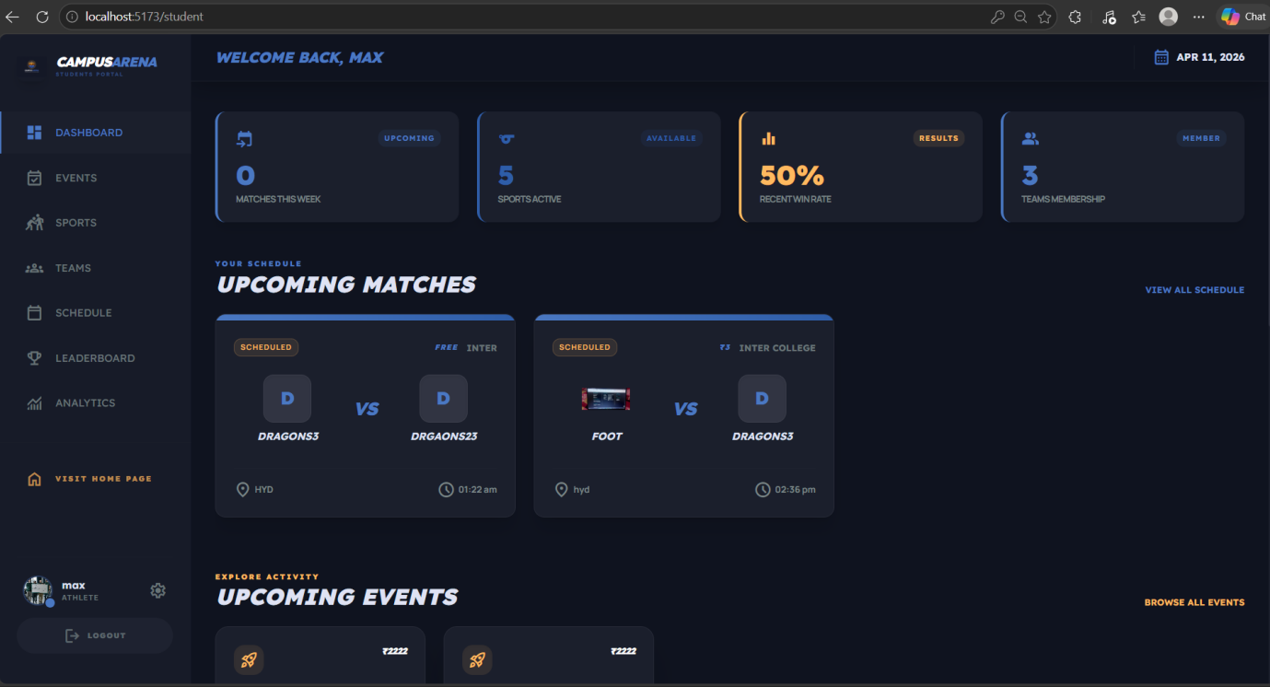
Figure 5.11: Student dashboard with personalized statistics.
Sample Code of Student Dashboard
// StudentDashboard.tsx — Parallel API fetching with snap-scroll carousel
export default function StudentDashboard() {
const [stats, setStats] = useState<any>(null)
const [upcomingMatches, setUpcomingMatches] = useState<any[]>([])
const [recentResults, setRecentResults] = useState<any[]>([])

useEffect(() => {
const fetchData = async () => {
const [dashRes, eventRes, sportRes] = await Promise.all([
dashboardAPI.getStudentStats(), eventsAPI.getAll(), sportsAPI.getAll()
])
if (dashRes.success) {
setStats(dashRes.data.stats)
setUpcomingMatches(dashRes.data.upcomingMatches)
setRecentResults(dashRes.data.recentResults)
}
}; fetchData()
}, [])

const kpiStats = [
{ label: 'Matches this Week', value: stats?.matchesThisWeek || '0', icon: 'event_upcoming', color: 'text-arena-primary', borderColor: 'border-arena-primary' },
{ label: 'Sports Active', value: stats?.activeSports || '0', icon: 'sports', color: 'text-primary-container', borderColor: 'border-primary-container' },
{ label: 'Recent Win Rate', value: stats?.winRate || '0%', icon: 'equalizer', color: 'text-arena-secondary', borderColor: 'border-arena-secondary' },
{ label: 'Teams Membership', value: stats?.followingTeams || '0', icon: 'group', color: 'text-arena-primary', borderColor: 'border-arena-primary' },
]

return (
<div className="space-y-12">
{/* KPI Cards with left color border accent */}
<section className="grid grid-cols-1 md:grid-cols-2 lg:grid-cols-4 gap-6">
{kpiStats.map((stat, i) => (
<motion.div key={stat.label} initial={{ opacity: 0, y: 20 }} animate={{ opacity: 1, y: 0 }}
transition={{ delay: i * 0.1 }}
className={`bg-surface-container p-6 rounded-xl border-l-4 ${stat.borderColor} shadow-lg`}>
<span className={`material-symbols-outlined ${stat.color} text-3xl`}>{stat.icon}</span>
<h3 className={`text-4xl font-headline font-black ${stat.color}`}>{stat.value}</h3>
<p className="text-xs font-bold text-on-surface-variant/60 uppercase">{stat.label}</p>
</motion.div>
))}
</section>
{/* Upcoming Matches: horizontal snap-x carousel with min-w-[400px] team-vs-team cards */}
{/* Recent Results: score display with conditional winner highlighting */}
</div>
)
}

5.7.12 Campus Events Browser
Students and guests can discover events through category filters (Hackathon, Workshop, Sports, Cultural, Tech Fest) and register via the `RegistrationModal` component.
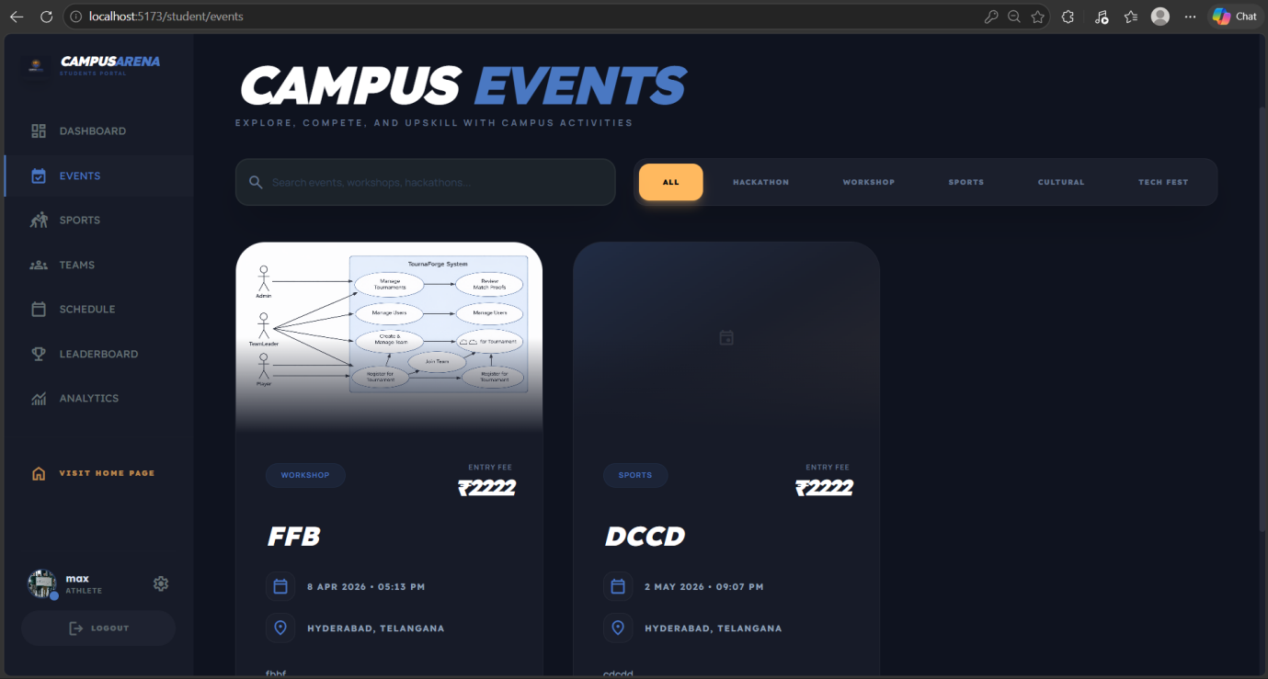
Figure 5.12: Campus events browser with registration.
Sample Code of Campus Event Component
// EventsPage.tsx — Category filtering with registration modal integration
const FILTERS = ['All', 'Hackathon', 'Workshop', 'Sports', 'Cultural', 'Tech Fest']

export default function EventsPage() {
const [events, setEvents] = useState<Event[]>([])
const [filter, setFilter] = useState('All')
const [modalOpen, setModalOpen] = useState(false)
const [selectedEvent, setSelectedEvent] = useState<Event | null>(null)

const filteredEvents = events.filter(ev => {
const matchesSearch = ev.title.toLowerCase().includes(search.toLowerCase())
const matchesFilter = filter === 'All' || ev.event_type === filter.toLowerCase().replace(' ', '_')
return matchesSearch && matchesFilter
})

return (
<div className="container mx-auto px-6 py-12 lg:py-20">
{/* Category filter pill tabs */}
<div className="flex flex-wrap gap-2 p-1.5 bg-surface-container rounded-2xl border border-white/5">
{FILTERS.map((f) => (
<button key={f} onClick={() => setFilter(f)}
className={`px-8 py-4 rounded-xl text-[10px] font-black tracking-widest ${filter === f ? 'bg-arena-secondary text-[#05080c] shadow-lg' : 'text-slate-500 hover:bg-white/5'}`}>
{f.toUpperCase()}
</button>
))}
</div>
{/* Event cards grid with banner image (16:10), type badge, pricing, date/venue, participant count */}
<div className="grid grid-cols-1 md:grid-cols-2 lg:grid-cols-3 gap-8">
{filteredEvents.map((ev, i) => (
<motion.div key={ev.id} initial={{ opacity: 0, y: 30 }} animate={{ opacity: 1, y: 0 }} transition={{ delay: i * 0.1 }}
className="bg-surface-container-low rounded-[40px] border border-white/5 overflow-hidden group hover:-translate-y-2 transition-all">
<div className="w-full" style={{ aspectRatio: '16/10' }}>
{ev.banner_url ? <img src={getImageUrl(ev.banner_url)} className="w-full h-full object-cover" /> : null}
</div>
<div className="p-10 space-y-8">
<h3 className="text-3xl font-black font-headline text-white uppercase italic">{ev.title}</h3>
<span className="text-3xl font-headline font-black italic">{Number(ev.price) > 0 ? `₹${ev.price}` : 'Free'}</span>
<Button disabled={ev.isRegistered} onClick={() => { setSelectedEvent(ev); setModalOpen(true) }}
className={ev.isRegistered ? 'bg-green-500/10 text-green-500' : 'bg-arena-secondary text-[#05080c] hover:scale-110'}>
{ev.isRegistered ? 'REGISTERED' : 'SECURE SPOT'}
</Button>
</div>
</motion.div>
))}
</div>
{selectedEvent && <RegistrationModal isOpen={modalOpen} onClose={() => setModalOpen(false)}
type="event" targetId={selectedEvent.id} title={selectedEvent.title} price={selectedEvent.price}
onSuccess={() => setEvents(events.map(e => e.id === selectedEvent.id ? { ...e, isRegistered: true } : e))} />}
</div>
)
}

5.7.13 Registration Modal
A shared portal-rendered modal supporting both student and guest registration flows with batch attendee booking (up to 5 members) and dynamic price calculation.
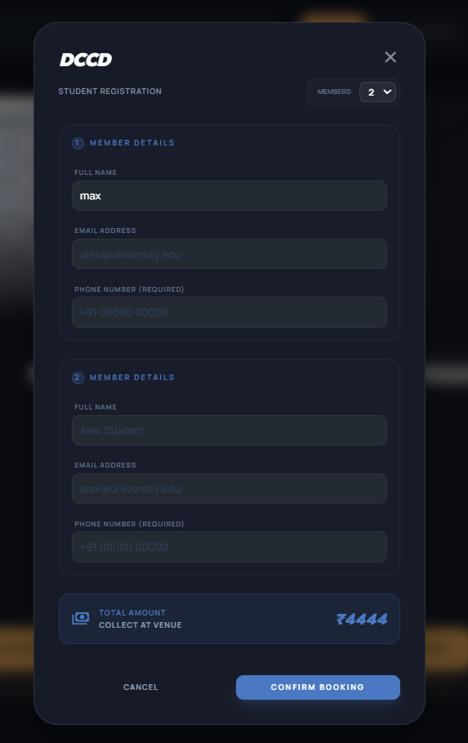
Figure 5.13: Registration modal with attendee form and pricing.
Sample Code of Registration Component
// RegistrationModal.tsx — Dual-mode registration with booking reference generation
export default function RegistrationModal({ isOpen, onClose, type, targetId, title, price, onSuccess }: Props) {
const [isLoggedIn, setIsLoggedIn] = useState(false)
const [isGuestMode, setIsGuestMode] = useState(false)
const [memberCount, setMemberCount] = useState(1)
const [attendees, setAttendees] = useState([{ attendee_name: '', attendee_email: '', attendee_phone: '' }])
const [successRef, setSuccessRef] = useState<string | null>(null)

useEffect(() => {
if (isOpen) {
const userStr = localStorage.getItem('campusArenaUser')
setIsLoggedIn(!!userStr)
}
}, [isOpen])

const handleSubmit = async (e: React.FormEvent) => {
e.preventDefault()
// Validate all attendee fields
for (let i = 0; i < attendees.length; i++) {
if (!attendees[i].attendee_name || !attendees[i].attendee_email || !attendees[i].attendee_phone) {
toast.error(`Please fill all details for Member ${i + 1}`); return;
}
}
let res = type === 'event'
? await eventsAPI.register(Number(targetId), attendees)
: await matchesAPI.register(Number(targetId), attendees)
if (res.success) {
toast.success(`Registered ${attendees.length} members for ${title}!`)
// Persist registration locally for "already registered" state tracking
const localData = JSON.parse(localStorage.getItem('guestRegistrations') || '{"events":[],"matches":[]}');
if (type === 'event') localData.events.push(targetId); else localData.matches.push(targetId);
localStorage.setItem('guestRegistrations', JSON.stringify(localData));
onSuccess()
if (res.data?.booking_ref) setSuccessRef(res.data.booking_ref) // Show booking confirmation
}
} const totalPrice = (Number(price) || 0) * memberCount
// Three UI states: (1) Type Selection → (2) Attendee Form → (3) Booking Confirmation
return createPortal(<AnimatePresence>{isOpen && <Modal>...</Modal>}</AnimatePresence>, document.body)
}

5.7.14 Student Team Formation
Students create teams by selecting a sport, uploading a logo, and adding members through hall ticket verification against the backend database.
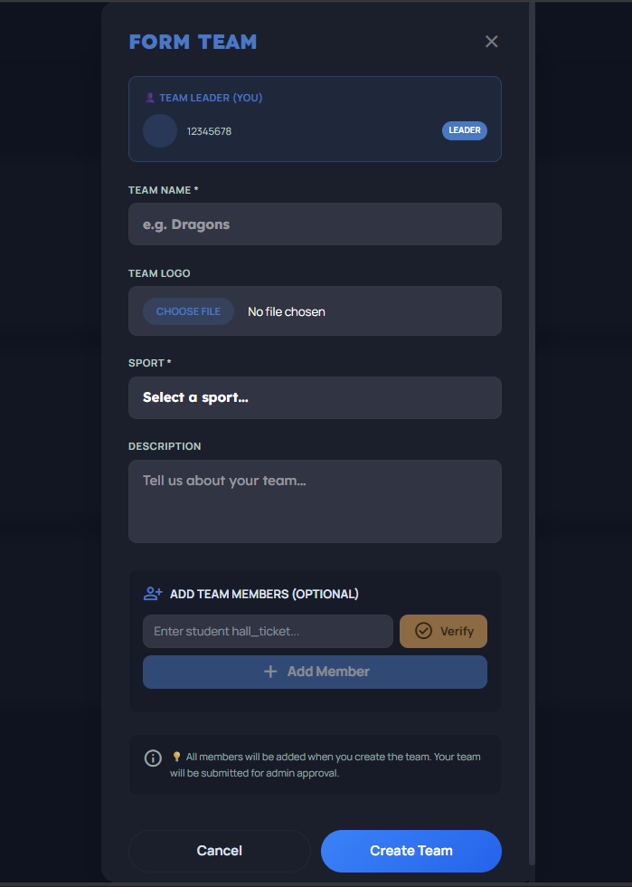
Figure 5.14: Student team formation with member verification.
Sample Code of StudentTeams Component
// StudentTeams.tsx — Hall ticket verification before member addition
export default function StudentTeams() {
const [hasProfile, setHasProfile] = useState(false)
const [newMember, setNewMember] = useState("")
const [verifiedMemberInfo, setVerifiedMemberInfo] = useState<any>(null)

const handleVerifyHallTicket = async () => {
const response = await usersAPI.verifyHallTicket(newMember);
if (response.success) {
setVerifiedMemberInfo({ hall_ticket: response.data.hall_ticket, name: response.data.name, verified: true });
toast.success(`Verified: ${response.data.name}`);
} else { toast.error("Hall ticket not found"); }
};

const handleCreateTeam = async () => {
const response = await studentTeamsAPI.createTeam(teamData, logo);
if (response.success) toast.success("Team created! Waiting for admin approval...");
};

// Status badge: pending → yellow, approved → green, rejected → red
const getStatusBadge = (status: string) => ({
pending: "bg-arena-secondary/10 text-arena-secondary",
approved: "bg-green-500/10 text-green-400",
rejected: "bg-arena-error/10 text-arena-error",
}[status])

return (
<div className="space-y-8">
<div className="flex justify-between items-center">
<h1 className="text-4xl font-black font-headline text-on-surface uppercase italic">MY TEAMS</h1>
<button onClick={() => setIsFormOpen(true)} disabled={!hasProfile}
className="kinetic-gradient text-on-primary font-black px-8 py-3 rounded-full disabled:opacity-50">FORM TEAM</button>
</div>
{!hasProfile && (
<div className="bg-arena-secondary/10 border border-arena-secondary/30 rounded-lg p-4">
<p className="font-bold text-arena-secondary">Complete Your Profile First</p>
<p className="text-sm">You need your hall_ticket before forming a team.</p>
<Link to="/student/complete-profile" className="bg-arena-secondary text-on-secondary font-bold px-4 py-2 rounded-lg">Complete Profile</Link>
</div>
)}
{/* Team cards with logo, sport name, member count (X/11), status badge (pending/approved/rejected),
rejection reason display, and edit/delete buttons visible only to team leaders */}
</div>
)
}

5.7.15 Admin Student Teams Management
Administrators review submitted teams with capabilities to approve (recording admin ID and timestamp), reject (with mandatory reason), and filter by status or sport category. The approval workflow updates the team's `status` field and records `approved_by` (admin user ID) and `approved_at` timestamps.

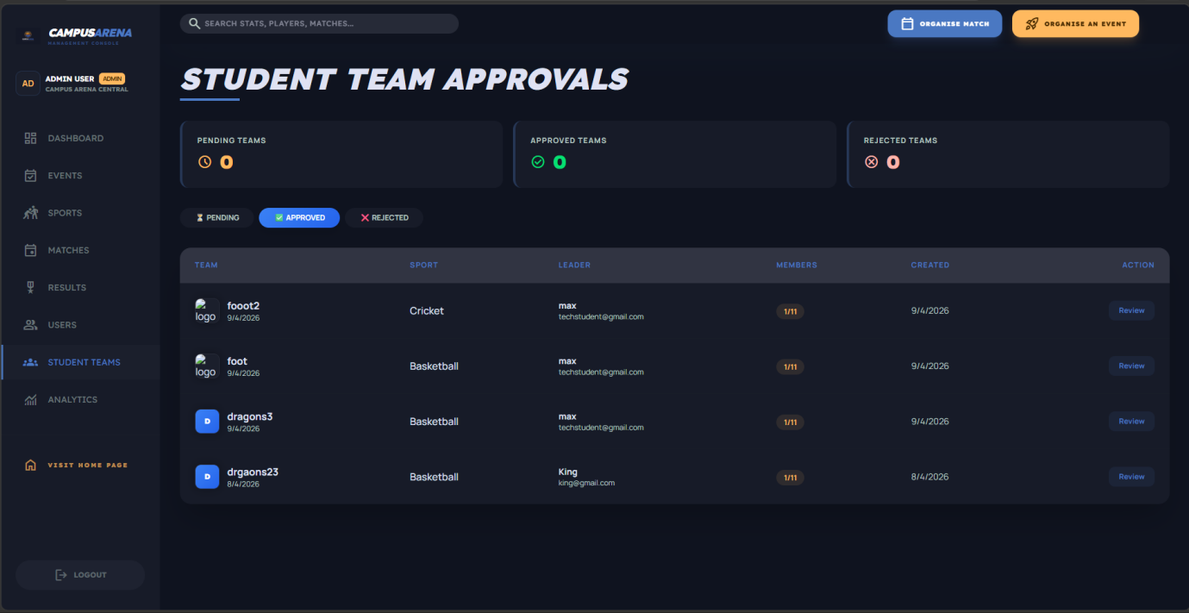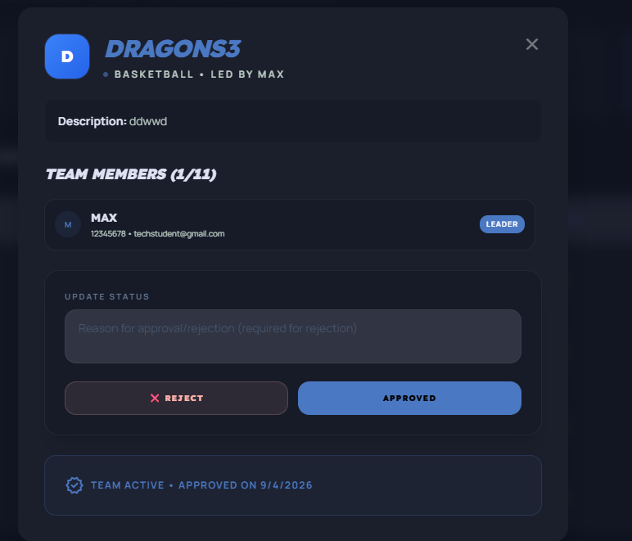
Figure 5.15: Admin team management with approval workflow.
Sample Code of AdminStudentTeams Component
// AdminStudentTeams.tsx — Team approval/rejection with status filtering
export default function AdminStudentTeams() {
const [teams, setTeams] = useState<any[]>([])
const [statusFilter, setStatusFilter] = useState('pending')

const handleApprove = async (teamId: number) => {
const res = await studentTeamsAPI.approveTeam(teamId)
if (res.success) { toast.success('Team approved'); fetchTeams() }
}

const handleReject = async (teamId: number) => {
const reason = prompt('Enter rejection reason:')
if (!reason) return
const res = await studentTeamsAPI.rejectTeam(teamId, reason)
if (res.success) { toast.success('Team rejected'); fetchTeams() }
}

return (
<div>
{/* Status filter tabs: Pending | Approved | Rejected */}
{/* Teams table with leader info, sport, member count, created date, approve/reject buttons */}
</div>
)
}

5.7.16 Admin User & Profile Verification
The user management module oversees the student lifecycle from registration through profile verification, with approve/reject/reset actions that set the `is_verified` flag in the users table. It displays comprehensive profile details including hall ticket, graduation batch, major, and college email.
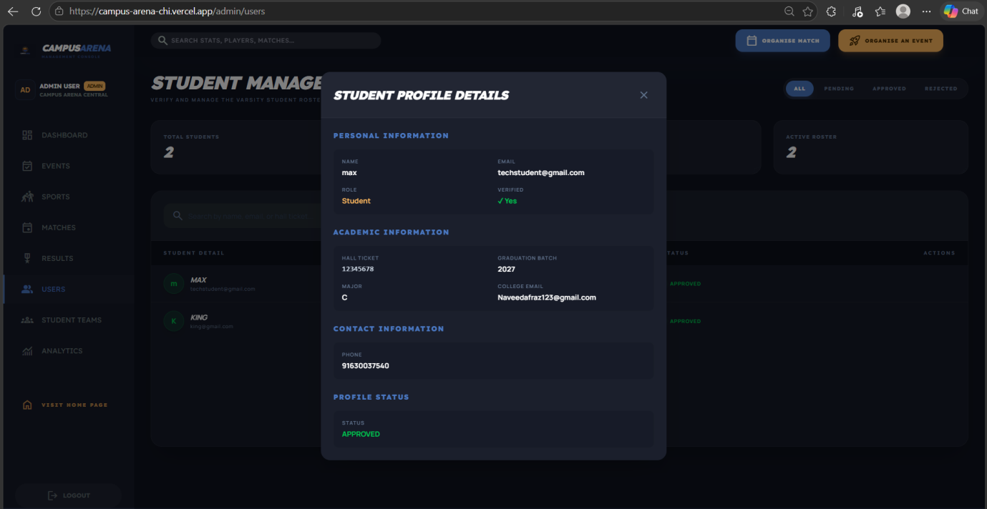
Figure 5.16: Admin user management with profile verification controls.
Sample Code of StudentTeams Component
// AdminUsers.tsx — Student profile verification with search filtering
export default function AdminUsers() {
const [users, setUsers] = useState<any[]>([])
const [searchTerm, setSearchTerm] = useState('')
const [statusFilter, setStatusFilter] = useState('all')

const handleApproveProfile = async (userId: number) => {
const res = await usersAPI.approveProfile(userId)
if (res.success) { toast.success('Profile approved — student is now verified'); fetchUsers() }
}

const handleRejectProfile = async (userId: number) => {
const reason = prompt('Enter rejection reason:')
if (!reason) return
const res = await usersAPI.rejectProfile(userId, reason)
if (res.success) { toast.success('Profile rejected'); fetchUsers() }
}

return (
<div>
{/* Search bar + status filter: All | Pending | Approved | Rejected */}
{/* Users table with avatar, name, email, hall_ticket, batch, major, profile_status, approve/reject actions */}
</div>
)
}

CHAPTER 6

TESTING AND RESULTS

Testing represents an absolutely critical phase in the development lifecycle of the Campus Arena platform, ensuring that the sophisticated dual-portal architecture operates securely, accurately, and reliably. Given the high-traffic nature of collegiate sports events and the necessity for strict academic data integrity, the testing protocols were designed to be exhaustive. This chapter provides a detailed exploration of the comprehensive manual testing and verification methodologies applied across the React frontend client, the Node.js transactional backend, and the highly relational MySQL database hosted on the Aiven cloud platform.

6.1 Unit Testing
The primary objective of unit testing was to evaluate individual algorithmic functions and isolated components of the Campus Arena ecosystem to guarantee that the foundational building blocks performed exactly as intended. On the backend, developers rigorously tested the individual Express controller functions responsible for critical operations such as user authentication, sports catalog management, and team formation. Evaluators specifically verified that data sanitization logic correctly rejected malformed payloads, such as missing hall ticket numbers or invalid event capacities, before they could interact with the database. Concurrently, frontend unit verification focused heavily on the isolated behavior of Shadcn user interface primitives and custom React components. Testing ensured that local state mutations, such as toggling the dynamic guest lookup modal or inputting data into the multipart event registration form, occurred predictably and provided immediate, accurate visual feedback to the user through the integrated Sonner toast notification system.

6.2 Integration Testing
Integration testing shifted the engineering focus toward verifying the seamless and secure communication between the distinctly decoupled layers of the platform's architecture. A major priority was validating the complex communication pipeline connecting the Vercel-hosted React application with the Render-hosted Node.js server. Tests were conducted to guarantee that cross-origin resource sharing policies successfully permitted authorized traffic while blocking malicious external requests. Furthermore, rigorous integration audits were performed to evaluate the custom authentication middleware. Evaluators confirmed that JSON Web Tokens generated during login were accurately attached to the authorization headers of subsequent requests, and that the backend successfully decoded these tokens to enforce strict role-based access controls. The multipart file upload system was also thoroughly tested to ensure that the Multer middleware correctly processed, renamed, and stored event banners and student avatars to the local file system without corrupting the media payloads.

6.3 System Testing
The objective of system testing was to evaluate the Campus Arena platform as a unified, holistic entity, ensuring that it successfully met all specified functional requirements under simulated real-world collegiate conditions. This phase involved executing complete, end-to-end user journeys to validate the interconnected workflows. For the standard student journey, testers registered a new account, navigated to the profile completion interface, submitted simulated academic details including a major and graduation batch, and awaited administrative approval. Once verified, the tester successfully formed a new athletic team, utilized the public application programming interface to add peers via hall ticket verification, and registered the completed roster for an upcoming tournament. Conversely, the administrative workflow was tested by logging into the secure management console, generating a new sports event, scheduling a match between two approved teams, and manually updating the live scores to verify that the global leaderboard instantly recalculated the algorithmic rankings based on the three-point victory system.

6.4 Automated Background Process Testing
A highly specialized phase of testing was dedicated to verifying the reliability of the background automation processes that govern the lifecycle of collegiate sports matches. The platform relies on scheduled tasks executed via the node-cron utility to autonomously manage match states without human intervention. Evaluators meticulously monitored the server logs to confirm that the scheduled jobs executed precisely every minute. Testing verified that the system successfully identified matches where the scheduled date and time matched the current server clock, automatically transitioning their database status from scheduled to live. Subsequently, evaluators confirmed the secondary automation rule, ensuring that matches active for over three hours were autonomously transitioned to a completed state. This rigorous testing guaranteed that the public-facing schedule and real-time live discovery feeds would remain highly accurate during active sports festivals.

6.5 Usability and Interface Testing
Usability and interface testing aimed to meticulously evaluate the visual responsiveness, accessibility, and interactive behavior of the frontend client across diverse hardware environments. Evaluators heavily scrutinized the responsive grid layouts and the dynamic sidebar navigation systems to ensure they adapted fluidly across simulated mobile, tablet, and high-resolution desktop viewports. The premium, dark-themed aesthetic, governed by the Tailwind CSS utility framework, was audited to guarantee that text contrast ratios remained legible and that glassmorphic background blurs rendered correctly on different browser engines. Furthermore, the declarative page transitions and tactile hover effects powered by Framer Motion were tested to ensure they executed smoothly at sixty frames per second without causing visual stuttering or layout shifts, ultimately confirming that the platform delivers a broadcast-quality visual experience.

6.6 Security and Performance Results
The final stage of the testing lifecycle involved an exhaustive audit of the platform's security protocols and computational performance benchmarks. Security testing was absolutely paramount given the inclusion of sensitive academic identifiers and administrative access controls. Evaluators verified that the bcrypt cryptographic hashing algorithm successfully obscured all user passwords with ten salt rounds, completely neutralizing the risk of plain-text data exposure. The platform was also subjected to rigorous access testing, confirming that unauthenticated users attempting to access protected routes were instantly redirected, and that standard students were systematically blocked from executing administrative capabilities. From a performance standpoint, the dedicated health check endpoint consistently reported optimal database connectivity. The MySQL connection pooling implementation, strictly limited to ten concurrent connections, demonstrated remarkable resilience, efficiently queuing and processing rapid, repetitive filtering queries across the active marketplace inventory without exhausting server memory or dropping client requests.

CHAPTER 7

CONCLUSION AND FUTURE SCOPE

7.1 Conclusion
The development and deployment of the Campus Arena platform mark a significant technological advancement in the administration and engagement of collegiate sports. By successfully engineering a highly scalable, decoupled architecture utilizing React, Node.js, Express, and a relational MySQL database, the project effectively dismantles the archaic, paper-based methodologies traditionally used to manage inter-departmental tournaments. The platform seamlessly bridges a public-facing discovery portal with secure, role-based dashboards, providing standard students with the tools to form verified athletic teams while simultaneously empowering administrators with a comprehensive command center. The strict enforcement of academic identity verification using hall ticket numbers ensures complete competitive integrity across all registered teams. Furthermore, the integration of automated background processes seamlessly transitions match states in real time, directly fueling an algorithmic global leaderboard that fosters healthy campus competition without requiring constant manual oversight. Ultimately, Campus Arena delivers a premium, broadcast-quality digital ecosystem that significantly enhances student participation and dramatically reduces administrative overhead.

7.2 Future Enhancements
While the current iteration of the Campus Arena platform delivers a highly robust athletic management ecosystem, several technical and functional avenues for future enhancement have been identified. To ensure the platform remains at the forefront of collegiate sports technology, the following expansions are proposed:
- Payment Gateway Integration: Implementing secure financial APIs, specifically Stripe or Razorpay, to autonomously process spectator ticketing fees and event registration costs, completely eliminating the current reliance on manual administrative payment tracking.
- Multi-College SaaS Expansion: Scaling the platform architecture into a fully multi-tenant Software-as-a-Service (SaaS) model, enabling multiple universities to host their own isolated environments while facilitating large-scale, cross-campus inter-collegiate tournaments.
- Advanced Tournament Management: Developing specialized administrative modules dedicated to automatically generating and managing complex, multi-stage tournament brackets, round-robin leagues, and playoff elimination trees.
- Real-Time Notification System: Leveraging persistent Socket.IO connections and dedicated email services to dispatch real-time push notifications, instantly alerting students to sudden schedule changes, impending registration deadlines, and live match results.
- Live Broadcast Capabilities: Integrating advanced WebRTC or WebSocket streaming protocols to allow users to stream active matches directly within the application, creating a virtual stadium experience for off-campus students and alumni.
- Expanded Student Analytics: Enhancing the student dashboard to provide individual athletes with granular, personalized performance metrics, win-loss records, and historical participation data to track their collegiate athletic careers comprehensively over time.
- Facilities and Merchandise Modules: Creating dedicated portals for secure campus facility reservations and establishing an official digital merchandise store to generate supplementary revenue for the university athletic department.
- Underlying Technical Optimizations: Implementing a global backend-driven search system to locate specific players or matches, introducing strict API rate-limiting middleware to defend against traffic spikes, and utilizing server-side image compression for user-uploaded logos and banners to accelerate page load times.

7.3 Final Thoughts
The successful realization of the Campus Arena platform emphatically demonstrates the profound impact that centralized, real-time web technologies can exert on university community engagement. By prioritizing architectural decoupling, rigorous data integrity, and a premium, responsive user interface styled with Tailwind CSS, the project transcends the severe limitations of fragmented messaging groups and static bulletin boards. Campus Arena establishes a new digital standard for higher education institutions, proving that complex athletic scheduling, team management, and public engagement can be democratized and presented in a highly accessible manner. This platform not only equips campus organizers with the objective data necessary to orchestrate large-scale sports festivals securely but also establishes a highly scalable technological blueprint for the future development of unified campus activity ecosystems.

7.4 Additional Future Enhancements
To ensure the Campus Arena platform continues to scale efficiently and meet the evolving operational demands of university athletics, the following supplementary technical enhancements are proposed:
- Comprehensive Automated Testing: Integrating robust end-to-end and unit testing frameworks to establish a Continuous Integration and Continuous Deployment (CI/CD) pipeline, ensuring flawless, zero-downtime updates as new features are released.
- Advanced Global Search Capabilities: Implementing a sophisticated, backend-driven search engine across the navigation bar, enabling students and administrators to instantly query specific athletes, historical match results, and complex sports statistics without navigating through multiple menus.
- Data Pagination and Infinite Scrolling: Expanding server-side pagination protocols across all remaining API endpoints, combined with fluid infinite scrolling on the frontend, to drastically reduce initial load times and database overhead as the platform's user base and match history grow.
- Dedicated Native Mobile Application: Transitioning the responsive web application into a fully native mobile experience utilizing React Native, providing students with seamless home screen access, biometric authentication, and hardware-integrated push notifications.
- Compliance and Legal Infrastructure: Developing automated cookie policy management, comprehensive terms of service tracking, and enhanced accessibility compliance to ensure the platform strictly adheres to institutional data privacy standards and inclusive design principles.

CHAPTER 8

APPENDICES

This chapter contains an extensive collection of supplementary information designed to provide deeper technical and operational context for the Campus Arena platform. It includes a comprehensive breakdown of technical acronyms, a detailed glossary of industry-specific terminology, practical user scenarios covering platform features, a record of hardware and system requirements, and a highly detailed bibliography of the technical references consulted during system development formatted according to IEEE standards.

8.1 Appendix A: Acronyms and Abbreviations
To ensure a thorough understanding of the underlying technical infrastructure, several key acronyms are defined within the specific context of the Campus Arena ecosystem:
- API: Application Programming Interface
- CORS: Cross-Origin Resource Sharing
- DOM: Document Object Model
- HMR: Hot Module Replacement
- HTTP: Hypertext Transfer Protocol
- JSON: JavaScript Object Notation
- JWT: JSON Web Token
- RBAC: Role-Based Access Control
- REST: Representational State Transfer
- SPA: Single Page Application
- SQL: Structured Query Language
- UI/UX: User Interface / User Experience

8.2 Appendix B: Glossary
The following terms are essential for navigating the specialized functionality and architectural philosophy of the Campus Arena marketplace:
- Connection Pooling: A database performance optimization technique utilized by the backend to instantly reuse established MySQL connections rather than initiating a costly new connection for every incoming user request.
- Cron Job: A time-based job scheduler in Unix-like computer operating systems. In this platform, node-cron is utilized to autonomously transition match states from scheduled to live, and ultimately to completed, without manual intervention.
- Glassmorphism: A user interface design trend characterized by semi-transparent backgrounds with a subtle blur effect (backdrop-blur), used extensively within the platform's dark-themed Tailwind CSS styling.
- JSON Web Token: An encrypted, self-contained string used to securely verify user identities and authorize access to protected student dashboards or administrative panels statelessly.
- Single Page Application (SPA): A web application implementation that loads a single HTML document and dynamically updates the body content via JavaScript (React) as the user navigates, preventing disruptive full-page reloads.

8.3 Appendix C: User Scenarios and Use Cases
The practical utility of the platform is demonstrated through several key user interactions and complex operational workflows:
- Student Onboarding and Team Formation: A newly enrolled student navigates to the registration portal and creates an account. Because their role is designated as a student, they are immediately prompted to complete their academic profile by submitting their hall ticket number and uploading an avatar. Once a platform administrator approves this profile, the student utilizes the dashboard to create a basketball team, adding their peers to the roster by securely looking up their verified hall ticket numbers.
- Guest Ticket Retrieval: An unregistered public guest purchases a spectator ticket for an upcoming inter-collegiate football match. They receive a unique booking reference (e.g., CA-XXXXXX). Upon arriving at the venue, the guest realizes they have misplaced their confirmation email. They access the Campus Arena landing page on their mobile device, open the "Find Ticket" modal, and input their email alongside the booking reference to instantly retrieve their digital entry pass.
- Automated Match Lifecycle Management: A campus administrator utilizes the secure dashboard to schedule a tennis match between two approved student teams for a specific date and time. Once scheduled, the administrator is no longer required to manage the event manually. The backend cron job autonomously monitors the server clock; when the precise start time arrives, the system automatically updates the match status to "Live" across all public leaderboards, and subsequently marks it as "Completed" after a standard three-hour duration.

8.4 Appendix D: Hardware and System Requirements
The deployment and continuous operation of the Campus Arena ecosystem demand robust system requirements and a cloud infrastructure capable of supporting high-concurrency web traffic.
- Client/End-User Requirements: The client application is hardware-agnostic and exceptionally lightweight. Users only require a standard mobile device, tablet, or desktop computer equipped with a modern internet browser (Google Chrome, Safari, Mozilla Firefox) and a stable 4G/5G or broadband network connection to flawlessly render the React application.
- Application Server Requirements: The backend environment must run on a scalable cloud container or virtual private server equipped with a multi-core processor and a minimum of 2GB of RAM to efficiently execute the Node.js runtime environment. The server must support background threading for concurrent Multer file uploads and active cron job scheduling.
- Database Server Requirements: The central relational database requires a managed cloud infrastructure (such as the Aiven cloud platform) running MySQL version 8.0 or higher. The instance requires optimized memory allocation and high-speed solid-state storage to handle rapid connection pooling requests and complex relational queries seamlessly.

8.5 Appendix E: References (IEEE Format)
[1] Meta Platforms, Inc., "React: The library for web and native user interfaces (Version 19.2)," React Documentation, 2024. [Online]. Available: https://react.dev/.
[2] OpenJS Foundation, "Node.js API Reference Documentation," Node.js, 2024. [Online]. Available: https://nodejs.org/en/docs/.
[3] OpenJS Foundation, "Express 5.x - Node.js web application framework," Express Documentation, 2024. [Online]. Available: https://expressjs.com/.
[4] Oracle Corporation, "MySQL 8.0 Reference Manual," MySQL Documentation, 2024. [Online]. Available: https://dev.mysql.com/doc/refman/8.0/en/.
[5] Tailwind Labs, "Tailwind CSS v4.0: Rapidly build modern websites without ever leaving your HTML," Tailwind CSS Documentation, 2024. [Online]. Available: https://tailwindcss.com/docs.
[6] Vite Developers, "Vite: Next Generation Frontend Tooling (Version 8.0)," Vite Documentation, 2024. [Online]. Available: https://vitejs.dev/guide/.
[7] Internet Engineering Task Force (IETF), "JSON Web Token (JWT) - RFC 7519," IETF Datatracker, 2015. [Online]. Available: https://datatracker.ietf.org/doc/html/rfc7519.

