AWS Identity and Access Management (IAM)
Trainer's Reference Material | Beginner Level | Suggested duration: 90–120 minutes
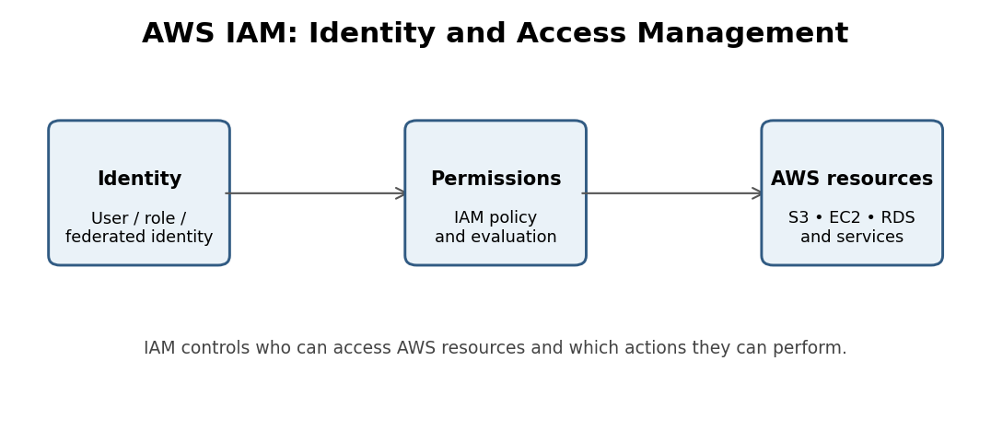
These notes are structured for classroom training. You can use the explanations directly while teaching students, including real-world examples, AWS terminology, practical demonstrations, interview questions, and hands-on exercises.

Module 1: Introduction to AWS IAM

1. What is IAM?
IAM stands for Identity and Access Management.
AWS IAM is a service that helps us securely control who can access our AWS account and what actions they are allowed to perform.
In simple words, IAM answers two important questions:
- Who are you?
- What are you allowed to do?
For example, imagine a company has an AWS account containing EC2 instances, S3 buckets, RDS databases, Lambda functions, and VPC networks. The company has different employees: Developers, Testers, DevOps engineers, Database administrators, and Security administrators.
Should every employee have permission to access everything? No. A developer might need access to EC2 and S3, while a database administrator might need access to RDS. IAM helps assign permissions according to job responsibilities.

2. Why Do We Need IAM?
Suppose a company has 50 employees working on an AWS project. If all 50 employees use the same AWS root account credentials, several problems can occur:
- Anyone can access sensitive resources.
- It becomes difficult to track who performed an action.
- Employees may accidentally delete important resources.
- Security risks increase.
- Removing access when an employee leaves becomes difficult.
IAM solves these problems by providing individual identities and controlled permissions.
Key benefits of IAM:
- Authentication – Verify user identity.
- Authorization – Control what users can access.
- Access control – Grant or deny permissions.
- Centralized permission management.
- Improved security.
- Accountability through individual identities and AWS logging services.

Module 2: Authentication vs Authorization

3. Understanding Authentication
Authentication means verifying the identity of a person or system.
In simple words: Authentication answers: Who are you?
Banking analogy: Imagine you visit a bank. The bank employee asks: What is your account number? Can you provide your PIN? Can you verify your identity? The bank verifies that you are the actual account holder. This process is called authentication.
In AWS, authentication can happen through:
- Username and password.
- Multi-Factor Authentication (MFA).
- Access keys for programmatic access.
- Temporary security credentials.
- Federated identity and Single Sign-On (SSO).

4. Understanding Authorization
Authorization means deciding what an authenticated identity is allowed to do.
In simple words: Authorization answers: What are you allowed to access?
Banking analogy: After verifying your identity, the bank checks your permissions. For example, you can withdraw money, check your account balance, and transfer money, but you cannot access another customer's account. This is authorization.
In AWS:
- A user may successfully log in.
- However, that user may not have permission to access S3.
- Another user may have permission to access EC2 but not RDS.

5. Authentication vs Authorization
Authentication | Authorization
Verifies identity | Verifies permissions
Who are you? | What can you do?
Username/password, MFA | IAM policies
Happens during identity verification | Evaluated when an action is requested

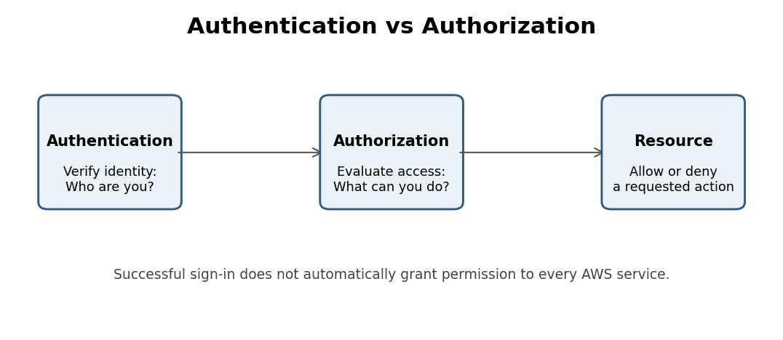
Trainer explanation: Tell students: “Logging into AWS successfully does not mean you have permission to access every AWS service.” This is one of the most important concepts in IAM.

Module 3: Core IAM Components
There are four major IAM components we need to understand: Users, Groups, Policies, and Roles.
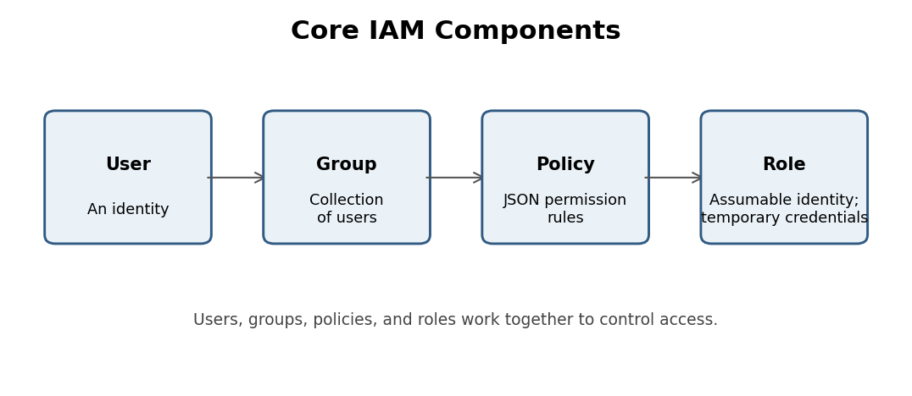

6. IAM Users
Definition: An IAM user is an identity created within an AWS account for a person or workload that needs access to AWS resources.
Example: Suppose your organization has three developers: Rahul, Amit, and Priya. You can create three separate IAM users. Each user can have their own access configuration and permissions.
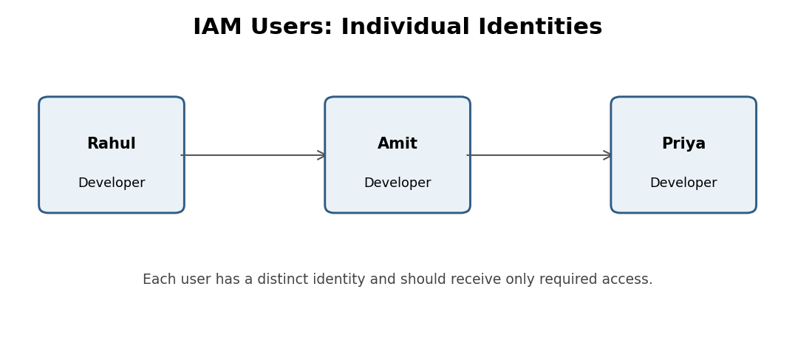
Important IAM user features:
- Each user has a unique identity within the AWS account.
- Console access can be configured using credentials.
- Programmatic access can use access keys when needed.
- Permissions can be assigned through policies directly or through groups.
- MFA can be configured for additional security.
Real-world example: Imagine Rahul is a developer. He needs to view EC2 instances, upload files to a specific S3 bucket, and view CloudWatch logs. He does not need permission to delete production databases. We can create a user for Rahul and assign only the permissions required for his work.
Important security point: AWS generally recommends using IAM Identity Center or federated identities for workforce access, with temporary credentials where possible, rather than creating long-term IAM user credentials for every employee.

7. IAM Policies
Definition: An IAM policy is a JSON document that defines permissions.
It specifies which actions are allowed or denied, which AWS resources those actions apply to, and under which conditions access is permitted.
In simple words: A policy tells AWS what an identity can and cannot do.
Example: Suppose a developer needs permission to view files in an S3 bucket. We can create a policy that allows only the required S3 read actions.
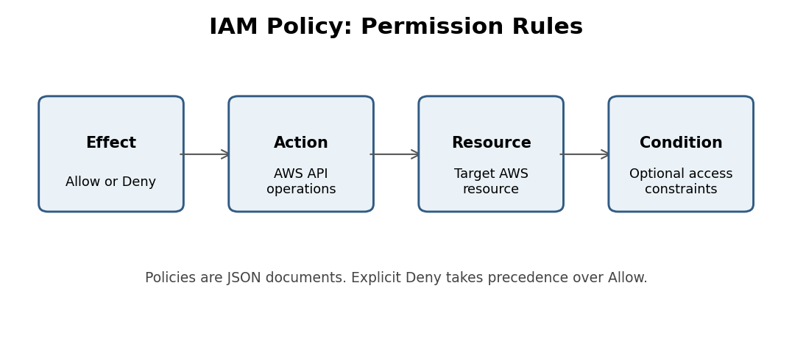
Understanding IAM Policy Structure:
Element | Meaning
Version | Policy language version
Statement | Defines permission rules
Effect | Allow or Deny
Action | AWS operations
Resource | AWS resources
Condition | Optional conditions for access

Example of an IAM policy: The following policy allows users to list the contents of an S3 bucket and download objects from that bucket.
{
"Version": "2012-10-17",
"Statement": [
{
"Effect": "Allow",
"Action": ["s3:ListBucket"],
"Resource": "arn:aws:s3:::training-demo-bucket"
},
{
"Effect": "Allow",
"Action": ["s3:GetObject"],
"Resource": "arn:aws:s3:::training-demo-bucket/*"
}
]
}
Explain this policy to students:
- Version: Identifies the IAM policy language version.
- Effect: Allow means permission is granted.
- Action: Specifies which operations are allowed.
- Resource: Specifies the bucket and objects.
- Condition: Can be used to apply additional restrictions.
Important IAM concepts: There are two common policy effects:
- Allow – Grants permission.
- Deny – Explicitly blocks permission.
An explicit Deny overrides an Allow.

8. Types of IAM Policies
Introduce these policy categories:
Policy type | Explanation
AWS Managed Policy | Created and maintained by AWS
Customer Managed Policy | Created and maintained by the customer
Inline Policy | Embedded directly in a single identity

Example: AWS provides a managed policy called AmazonS3FullAccess. This policy provides broad S3 permissions. Another example: AmazonEC2ReadOnlyAccess. This allows read-only access to supported EC2 resources.
Trainer warning: Avoid giving FullAccess policies to ordinary developers. Always follow the principle of least privilege.

9. IAM Groups
Definition: An IAM group is a collection of IAM users. Groups help us manage permissions for multiple users efficiently.
Example: Suppose an organization has 10 Developers, 5 QA Engineers, and 3 DevOps Engineers. Instead of attaching permissions separately to every user, we can create groups.
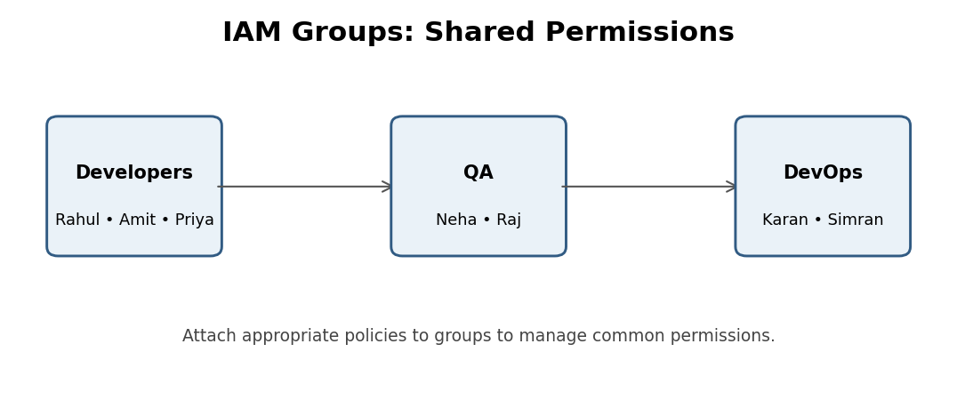
Example structure:
Group | Example members | Policy
Developers | Rahul, Amit, Priya | Developer policy
QA | Neha, Raj | QA policy
DevOps | Karan, Simran | DevOps policy

How does it work?
- Create an IAM group called Developers.
- Attach the required developer policy.
- Add developer IAM users to the group.
- All group members receive the permissions granted through the group.
Advantages of IAM Groups:
- Centralized permission management.
- Less manual work.
- Easier onboarding.
- Easier offboarding.
- Consistent permissions.
- Reduced administrative errors.
Important point: IAM groups contain IAM users, not other groups or IAM roles.

10. IAM Roles
Definition: An IAM role is an identity with a set of permissions that can be assumed by a trusted user, application, or AWS service.
Roles provide temporary security credentials rather than requiring long-term credentials to be embedded in applications.
Real-world example: Suppose you create an EC2 instance. That EC2 instance needs to access an S3 bucket. Should you store your AWS username and password inside the EC2 server? Absolutely not.
Instead:
- Create an IAM role.
- Attach an S3 access policy to the role.
- Configure the role to trust the EC2 service.
- Attach the role to the EC2 instance.
- The EC2 application can obtain temporary credentials and access the permitted S3 resources.
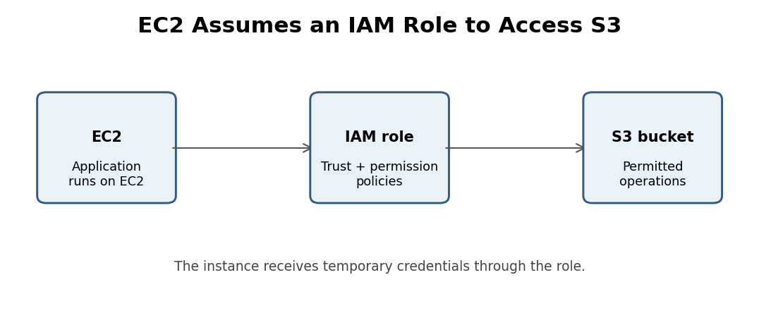
Common use cases of IAM Roles:
- EC2 accessing S3.
- Lambda accessing DynamoDB.
- Applications accessing AWS services.
- Cross-account access.
- Federated user access.

Difference between IAM User and IAM Role
IAM User | IAM Role
Long-term identity | Assumable identity
Can have long-term credentials | Uses temporary credentials
Often represents an individual or workload | Often represents a workload, service, or delegated access
Credentials may be configured for console or API access | Credentials are obtained when the role is assumed

11. Users vs Groups vs Policies vs Roles
Component | Purpose | Example
User | Identity | Rahul
Group | Collection of users | Developers
Policy | Permission rules | S3 Read Access
Role | Temporary permissions | EC2 accessing S3

Easy way to remember:
- User = Who?
- Group = Which team?
- Policy = What permissions?
- Role = What permissions can an identity temporarily assume?

Module 4: Practical Demonstration – Creating an IAM User
Hands-on AWS lab

12. Objective of the Practical
In this practical, students will learn how to:
- Open AWS IAM.
- Create an IAM user.
- Configure access.
- Understand default permissions.
- Attach an IAM policy.
- Give the user S3 access.
- Verify permissions.
Scenario: Imagine you are a DevOps engineer working in an organization. Your manager asks you to create an AWS user for a new developer named Rahul. Rahul needs access to Amazon S3. Your responsibility is to create his identity and provide the required permissions.

13. Step 1: Open the AWS Management Console
- Log in to your AWS Management Console.
- Search for IAM in the search bar.
- Click IAM.
- Open the IAM Dashboard.
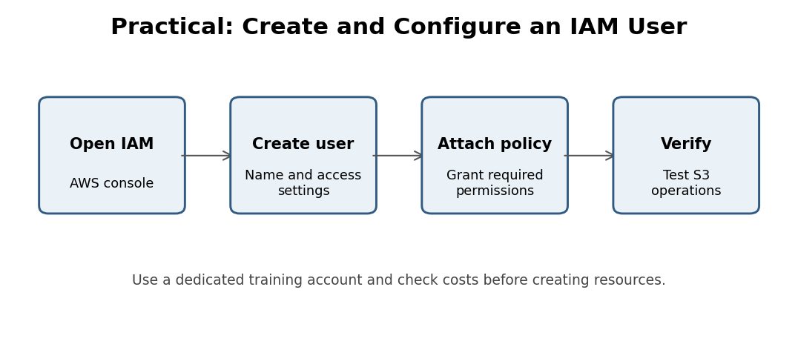
Official IAM console: https://console.aws.amazon.com/iam/

14. Step 2: Create an IAM User
- In the left navigation panel, click Users.
- Click Create user.
- Enter the username: rahul-developer.
- Configure console access if the user needs to log in through the AWS Management Console.
- Follow the current wizard to complete the user creation.
Explain to students: We are creating a separate identity for Rahul instead of sharing the root account credentials.

15. Step 3: Understand Default Permissions
This is a very important concept. By default, a newly created IAM user has no permissions to access AWS services unless permissions are granted through an applicable policy.
For example:
- Rahul can authenticate if console access is configured.
- Rahul does not automatically have S3 access.
- Rahul does not automatically have EC2 access.
- Rahul cannot automatically create AWS resources.
This is known as implicit deny.
Trainer explanation: “Creating an IAM user is not the same as granting permissions. Authentication and authorization are two separate things.”

16. Step 4: Attach an IAM Policy
Now we need to give Rahul access to Amazon S3.
- Open IAM.
- Click Users.
- Select rahul-developer.
- Open the Permissions tab.
- Click Add permissions.
- Select Attach policies directly, if using that option in the current console.
- Search for AmazonS3FullAccess.
- Select the policy.
- Review the permissions.
- Click Add permissions.
What happens now? Rahul receives the permissions granted by the AmazonS3FullAccess managed policy. He can perform a broad range of S3 operations, subject to other applicable access controls.
Important trainer warning: AmazonS3FullAccess is a broad permission policy. It is suitable for demonstrating how permissions work in a controlled training account, but it is not a recommended default for production developers. In production, grant access only to the specific buckets and operations required.

17. Step 5: Verify S3 Access
- Open a separate browser or private browsing window.
- Sign in using Rahul's IAM user credentials.
- Search for S3.
- Open the Amazon S3 dashboard.
- Explore the available S3 operations.
Explain: Before attaching the policy, Rahul had no S3 permissions. After attaching the policy, he can access the S3 operations allowed by the policy.
Important: S3 access can still be affected by bucket policies, permissions boundaries, organization policies, and other access controls. An IAM Allow does not guarantee access in every situation.

Module 5: Practical Demonstration – Creating IAM Groups

18. Why Do We Need IAM Groups?
Suppose your company hires 20 developers. You create 20 individual IAM users. All developers need similar permissions. Should you attach the same policy to all 20 users individually? That is not an efficient approach.
Instead, create one IAM group and attach the policy to the group. Whenever you add a new developer to the group, the developer receives the permissions granted through that group.
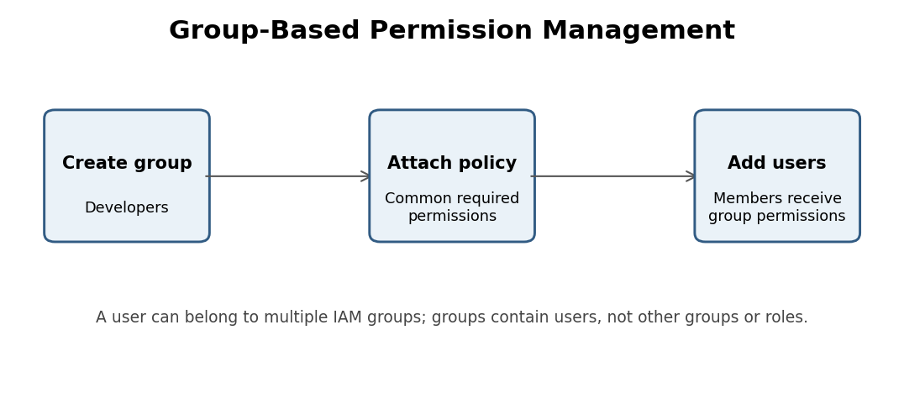

19. Step 1: Create a Developers Group
- Open the IAM Dashboard.
- Click User groups.
- Click Create group.
- Enter the group name: Developers.
- Select the users you want to add, if applicable.
- Attach the required policies.
- Click Create group.

20. Step 2: Attach a Policy to the Group
- Open the Developers group.
- Go to Permissions.
- Click Add permissions.
- Select Attach policies.
- Search for the required policy.
- Select the policy.
- Save the changes.
Example policy: AmazonS3FullAccess. Now all users in the Developers group receive the permissions granted through that group.

21. Step 3: Add Multiple Users to the Group
Suppose we have:
Username | Department
Rahul | Developer
Amit | Developer
Priya | Developer
Neha | QA
Raj | QA

Create two groups: Developers and QA. Add the respective users to their groups. Attach the appropriate policies to each group.
Trainer explanation: “When a new developer joins the organization, we simply create the required identity and add that user to the Developers group. We do not need to manually configure the same group permissions again.”

22. Important IAM Group Best Practices
- Organize users according to job responsibilities.
- Attach common policies to groups.
- Avoid assigning permissions individually when group-based management is appropriate.
- Review group membership regularly.
- Remove users from groups when their responsibilities change.
- Follow the principle of least privilege.
Remember: Users can belong to multiple IAM groups, and their effective permissions are evaluated across applicable policies and other AWS access controls.

Module 6: Principle of Least Privilege

23. What is the Principle of Least Privilege?
The principle of least privilege means giving an identity only the minimum permissions necessary to perform its assigned job.
Example: Suppose a developer needs to download files from an S3 bucket. Should we provide full S3 access? No. We should provide only the required read permissions on the required bucket.
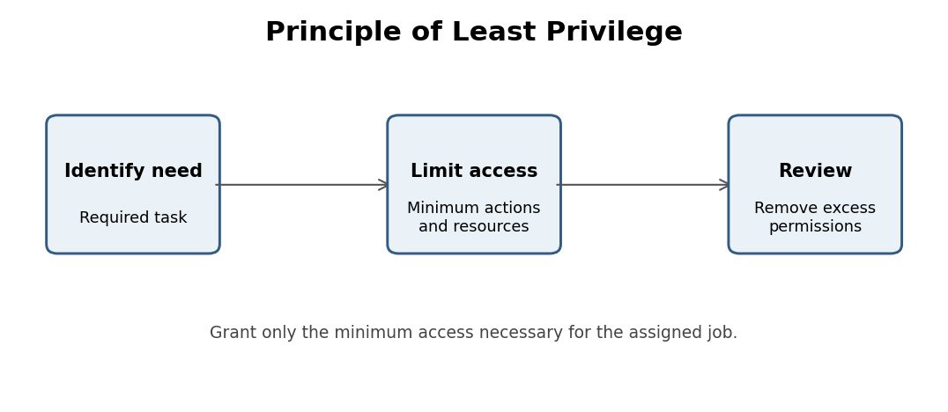
Employee | Required access
Developer | Required development resources
QA Engineer | Testing resources
DevOps Engineer | Infrastructure management resources
Database Administrator | Required database resources

Why is this important?
- Reduces security risks.
- Prevents accidental deletion.
- Limits unauthorized access.
- Reduces the impact of compromised credentials.
- Improves security compliance.

24. IAM Security Best Practices
Explain these points to students:
- Never share root account credentials.
- Enable MFA wherever supported.
- Avoid using root credentials for daily activities.
- Prefer temporary credentials and IAM roles.
- Avoid unnecessary long-term access keys.
- Use least-privilege permissions.
- Regularly review IAM users and policies.
- Remove unused access keys and credentials.
- Monitor activity using AWS CloudTrail.
- Use IAM Access Analyzer to identify potential access risks.

Module 7: Understanding How IAM Permissions Work

25. How Does AWS Evaluate Permissions?
Students should understand this basic flow:
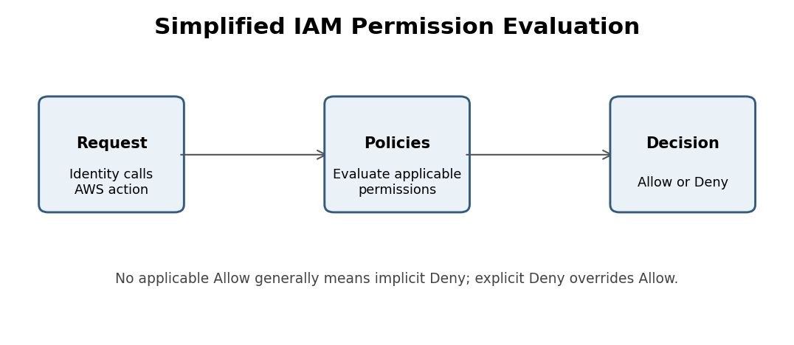
Consider three scenarios:

Scenario 1: No policy attached
- User tries to access S3.
- No applicable Allow permission exists.
- AWS denies the request.
Result: Access Denied.

Scenario 2: Allow policy attached
- User tries to access S3.
- An applicable policy allows the action.
- No overriding explicit Deny or other restriction applies.
Result: Access Allowed.

Scenario 3: Explicit Deny exists
- User has an Allow policy.
- Another applicable policy explicitly denies the requested action.
- Explicit Deny takes precedence.
Result: Access Denied.
Important technical point: AWS permission evaluation can also involve resource-based policies, permissions boundaries, service control policies (SCPs), session policies, and other controls. Students should learn these as they advance.

Module 8: Real-World DevOps Scenario

26. IAM in a DevOps Environment
Explain this scenario to your students. Imagine an organization has the following AWS environment:
- 5 Developers.
- 3 QA Engineers.
- 2 DevOps Engineers.
- 1 Database Administrator.
Team | AWS access requirement
Developers | Development EC2 and S3 resources
QA Engineers | Testing environments and application logs
DevOps Engineers | Infrastructure deployment and monitoring
DBA | Required RDS database operations

How should a DevOps engineer manage access?
- Create the required identities.
- Organize users into appropriate groups.
- Create permission policies based on job responsibilities.
- Attach policies to groups.
- Use IAM roles for AWS services and workloads.
- Enable MFA and monitor access.
- Review permissions periodically.
Ask students: “What would happen if an employee leaves the organization?” Expected answer: We should revoke that employee's access, disable or remove the relevant credentials, and remove their group memberships and other access paths.
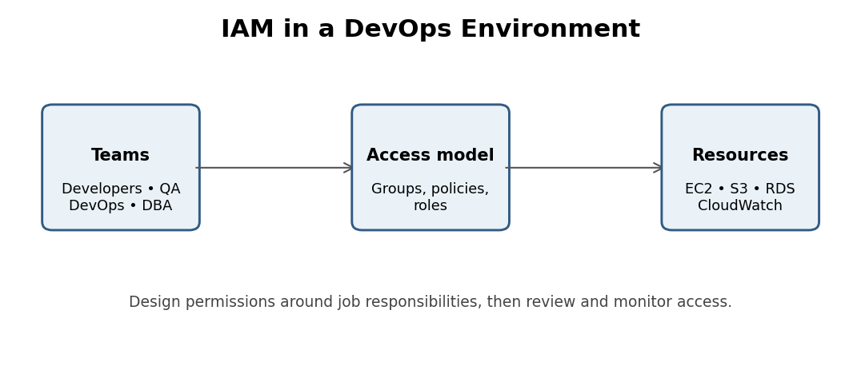

Module 9: Interview Questions and Answers
Q1. What is AWS IAM?
Answer: IAM is an AWS service used to manage identities and control access to AWS resources.
Q2. What is authentication?
Answer: Authentication is the process of verifying the identity of a user or system.
Q3. What is authorization?
Answer: Authorization determines what actions an authenticated identity is allowed to perform.
Q4. What is an IAM user?
Answer: An IAM user is an identity created within an AWS account.
Q5. What is an IAM policy?
Answer: An IAM policy is a JSON document that defines permissions.
Q6. What is an IAM group?
Answer: An IAM group is a collection of IAM users that can share common permissions.
Q7. What is an IAM role?
Answer: An IAM role is an identity that can be assumed by trusted users, applications, or AWS services to obtain temporary credentials.
Q8. What happens when an IAM user is created without permissions?
Answer: The user has no permissions by default, unless permissions are granted through another applicable access mechanism.
Q9. What is AmazonS3FullAccess?
Answer: It is an AWS-managed IAM policy that provides broad access to Amazon S3.
Q10. What is the difference between IAM user and IAM group?
Answer: An IAM user represents an identity, whereas an IAM group organizes multiple users for shared permission management.
Q11. Can an IAM user belong to multiple groups?
Answer: Yes. An IAM user can belong to multiple IAM groups.
Q12. Can we attach a policy to an IAM group?
Answer: Yes. Policies can be attached to IAM groups to grant common permissions to their members.
Q13. What is the principle of least privilege?
Answer: Giving users and services only the permissions necessary to perform their tasks.
Q14. Why do we use IAM roles with EC2?
Answer: To allow EC2 applications to securely access AWS resources using temporary credentials instead of storing long-term credentials on the server.
Q15. What is MFA?
Answer: Multi-Factor Authentication adds another verification factor to improve account security.

Module 10: Student Knowledge Assessment
Use this interactive test at the end of your class.
1. What does IAM stand for?
Answer: Identity and Access Management
2. Authentication means:
Answer: Verifying identity
3. Authorization means:
Answer: Deciding what actions are allowed
4. Which IAM component contains JSON permission rules?
Answer: Policy
5. What is an IAM group?
Answer: A collection of IAM users
6. Which IAM identity is commonly used by EC2 to access S3 securely?
Answer: IAM role
7. What happens to a new user with no applicable Allow permissions?
Answer: Access is implicitly denied
8. What does explicit Deny do?
Answer: Overrides Allow
9. What is the principle of least privilege?
Answer: Give only required permissions
10. Which AWS service can record account activity and API calls?
Answer: CloudTrail
Trainer option: You can present these questions as a verbal quiz or convert them into a classroom multiple-choice assessment.

Module 11: Suggested Training Agenda
Here is a suggested two-hour training schedule.
Topic | Duration
Introduction to IAM | 10 min
Authentication vs Authorization | 15 min
IAM Users and Policies | 20 min
IAM Groups | 15 min
IAM Roles | 15 min
Practical: Create IAM User | 15 min
Practical: Attach S3 Policy | 10 min
Practical: Create IAM Group | 10 min
Security Best Practices | 5 min
Interview Questions and Q&A | 5 min
Total | 120 min

Module 12: Hands-on Assignment for Students
Assignment: Build an IAM access management structure
Objective: Demonstrate practical understanding of IAM users, groups, and policies.
☐ Open the AWS IAM console.
☐ Create an IAM user named developer1.
☐ Create another IAM user named developer2.
☐ Create a group called Developers.
☐ Add both users to the Developers group.
☐ Attach an appropriate S3 policy to the group.
☐ Verify that the users receive the group's permissions.
☐ Explain the difference between authentication and authorization.
☐ Explain why IAM roles are used with EC2.
☐ Review and remove unnecessary permissions.
Important lab safety: Use a dedicated training AWS account, avoid production accounts, do not share credentials between students, and remove unnecessary users, credentials, and permissions after the exercise. Check billing and resource usage before and after the lab.

Final Trainer Summary
At the end of the training, students should be able to explain these concepts:
Concept | What students should remember
IAM | Manages AWS identities and permissions
Authentication | Verifies identity
Authorization | Determines access permissions
Users | Represent individual identities
Policies | Define permissions in JSON
Groups | Organize users with common permissions
Roles | Provide assumable identities and temporary credentials
MFA | Adds an extra authentication factor
Least Privilege | Grants only necessary permissions

My recommendation for your next AWS training session
Follow this learning sequence:
- IAM Fundamentals – Users, Groups, Policies, Roles, MFA.
- Amazon EC2 – Launch instances, key pairs, security groups, instance types.
- Amazon S3 – Buckets, objects, permissions, bucket policies.
- Amazon VPC – Networks, subnets, route tables, internet gateways.
- Amazon RDS – Managed databases and connectivity.
This sequence helps students understand how IAM security applies to actual AWS infrastructure rather than learning IAM as an isolated theoretical topic.

