Amazon EC2 – Training Notes

1. What is Amazon EC2?
EC2 (Elastic Compute Cloud) is an AWS service that provides virtual servers in the cloud.
These virtual servers are called EC2 Instances.
The word Elastic means we can increase or decrease computing resources according to our requirements.
Example: Suppose a company needs a server to host its website. Instead of purchasing a physical server, it can launch an EC2 instance on AWS and use it as a virtual server.
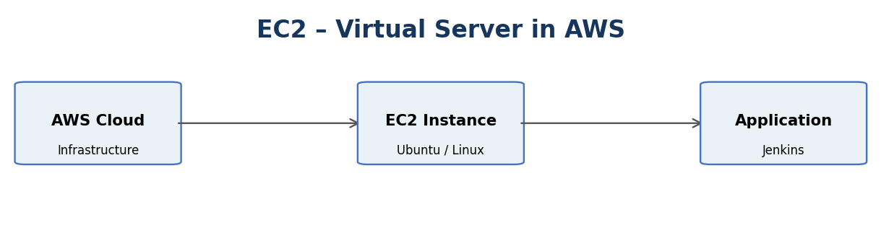

2. Why Do We Use EC2?
EC2 helps us run applications without purchasing and maintaining physical servers.
- No physical hardware: We do not need to purchase physical servers.
- Scalability: We can increase or decrease server resources when required.
- Pay-as-you-go: We pay for the resources we use, according to the pricing model.
- Flexibility: We can select different operating systems and instance types.
- Less infrastructure management: AWS manages the underlying physical infrastructure.
Example: If website traffic increases, we can launch a larger EC2 instance or add more instances to handle the traffic.
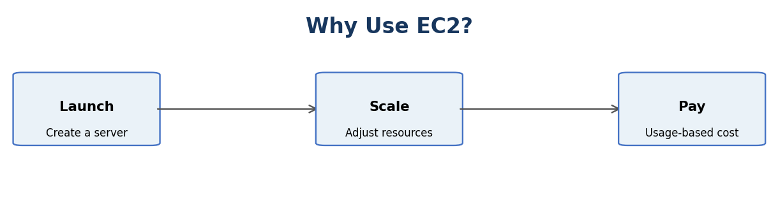

3. EC2 Instance Types
AWS provides different instance families based on application requirements.
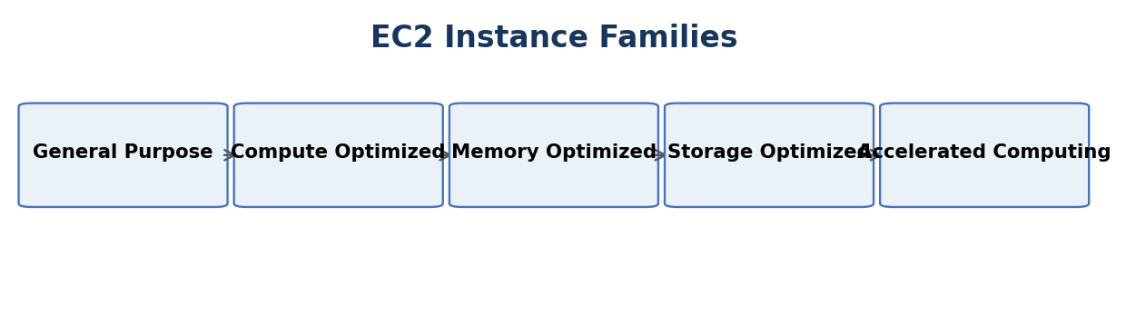
Instance Type | Purpose | Example Use
General Purpose | Balanced CPU, memory and networking | Web servers
Compute Optimized | High CPU performance | Data processing
Memory Optimized | High memory capacity | Databases
Storage Optimized | High storage performance | Large data workloads
Accelerated Computing | Uses GPUs or specialized hardware | Machine learning

4. AWS Regions and Availability Zones

Region
A Region is a separate geographical area where AWS operates its infrastructure.
Example: Mumbai (ap-south-1) is an AWS Region in India.

Availability Zone (AZ)
An Availability Zone is an isolated location within an AWS Region. A Region contains multiple Availability Zones.
Availability Zones help improve application availability and fault tolerance.
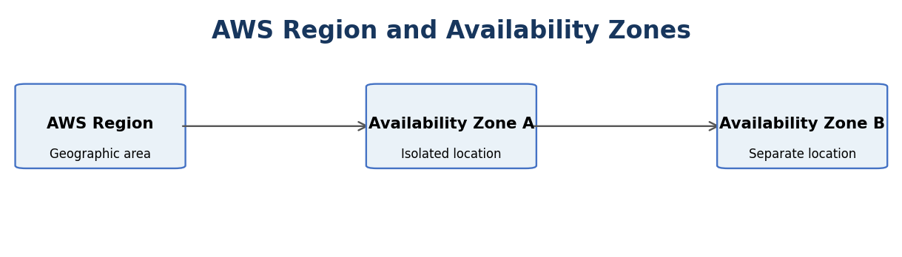
Example: If an application runs in two Availability Zones and one becomes unavailable, the application may continue running in the other, provided it is configured for failover.

5. Practical Project – Deploy Jenkins on an EC2 Instance
Project objective: Launch an Ubuntu EC2 instance, install Jenkins on it, and open the Jenkins dashboard using a web browser.
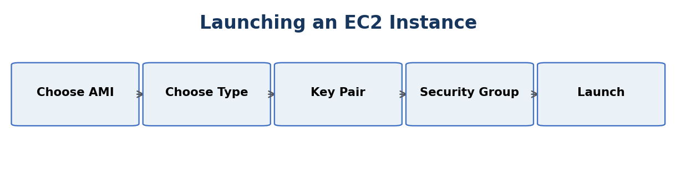

Step 1: Launch an EC2 Instance
- Sign in to the AWS Management Console.
- Search for EC2 and open the EC2 service.
- Select Instances from the left navigation panel.
- Click Launch instances.
- Enter the instance name: Jenkins-Server.
- Select Ubuntu as the Amazon Machine Image (AMI).
- Choose an instance type, such as t2.micro, if it is available and eligible for your account.
- Create or select a key pair.
- Configure the network settings and security group.
- Click Launch instance.

Step 2: Create a Key Pair
A key pair is used to securely connect to an EC2 instance.
- Public key: Stored on the EC2 instance.
- Private key: Downloaded and kept by the user, usually as a .pem file.
Example key pair name: jenkins-key
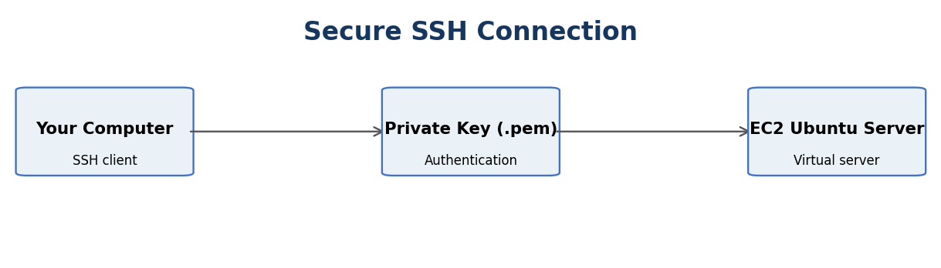

Step 3: Configure Security Groups
A Security Group acts as a virtual firewall for an EC2 instance. It controls inbound and outbound traffic.
Type | Port | Purpose
SSH | 22 | Connect to the Ubuntu server
Custom TCP | 8080 | Open the Jenkins dashboard
For SSH, select My IP as the source. For Jenkins, allow access only from the IP address or network that needs to use the dashboard.
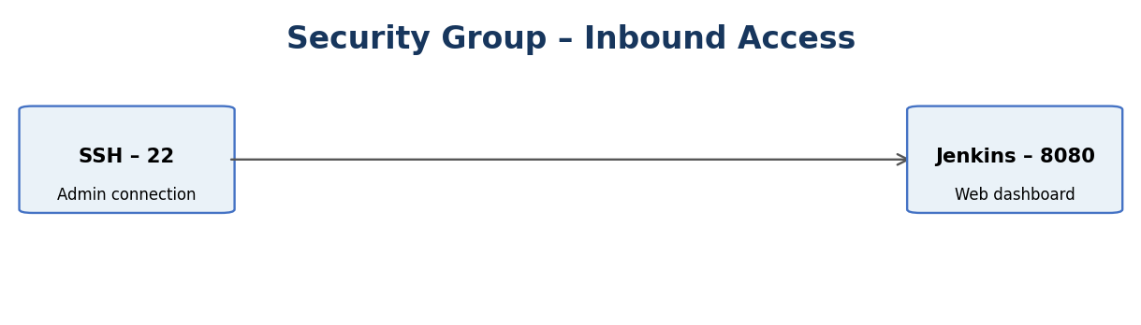

Step 4: Connect to the EC2 Instance
- Select the instance in the EC2 console.
- Copy its Public IPv4 address.
- Open a terminal on your computer.
- Go to the folder containing your .pem key file.
- Connect using SSH.
Example command:
chmod 400 jenkins-key.pem
ssh -i jenkins-key.pem ubuntu@<PUBLIC-IP>
Replace <PUBLIC-IP> with the public IPv4 address of your EC2 instance.
If the connection is successful, you will enter the Ubuntu server terminal.

Step 5: Update Ubuntu Packages
Run the following command after connecting to the instance:
sudo apt update
This updates the package information on the Ubuntu server.

Step 6: Install Java
Jenkins requires Java to run. Install Java 21:
sudo apt install -y fontconfig openjdk-21-jre
Check the Java installation:
java -version
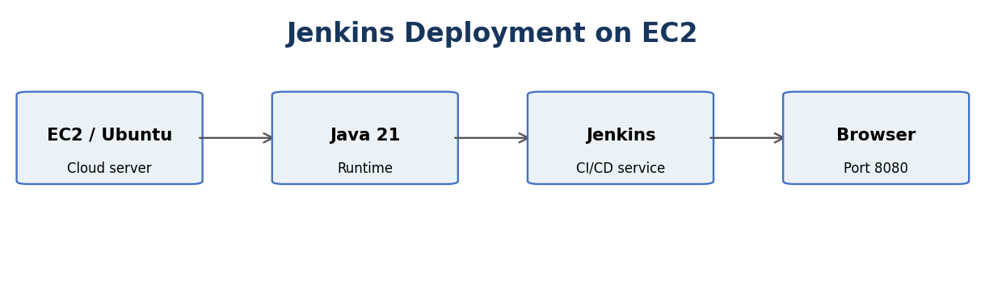

Step 7: Install Jenkins
Add the official Jenkins Long-Term Support repository:
sudo wget -O /etc/apt/keyrings/jenkins-keyring.asc \
https://pkg.jenkins.io/debian-stable/jenkins.io-2026.key
echo "deb [signed-by=/etc/apt/keyrings/jenkins-keyring.asc]" \
https://pkg.jenkins.io/debian-stable binary/ | \
sudo tee /etc/apt/sources.list.d/jenkins.list > /dev/null
Update the package list:
sudo apt update
Install Jenkins:
sudo apt install -y jenkins
These commands use the official Jenkins LTS installation instructions.

Step 8: Start Jenkins
Start the Jenkins service:
sudo systemctl start jenkins
Enable Jenkins to start automatically when the server restarts:
sudo systemctl enable jenkins
Check the Jenkins service status:
sudo systemctl status jenkins
If the installation is successful, the status should show:
Active: active (running)

Step 9: Open Jenkins in a Browser
- Go to the AWS EC2 console.
- Select your Jenkins instance.
- Copy its Public IPv4 address.
- Open a web browser.
- Enter the following address:
http://<PUBLIC-IP>:8080
Example:
http://13.201.XX.XX:8080
The Jenkins setup page should appear.

Step 10: Unlock Jenkins
Jenkins generates an initial administrator password during installation.
Run this command on your EC2 terminal:
sudo cat /var/lib/jenkins/secrets/initialAdminPassword
- Copy the password displayed in the terminal.
- Paste it into the Jenkins browser page.
- Click Continue.
- Select Install suggested plugins.
- Create your administrator username and password.
- Complete the Jenkins setup.

6. Final Project Result
Jenkins is now installed and running on an AWS EC2 instance.
The deployment flow is:
Final URL:
http://<PUBLIC-IP>:8080
End of Amazon EC2 Training Notes.

