

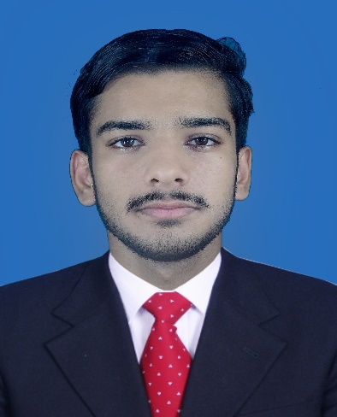Muhammad Ali akbar shahbaz

Mobile No: +92-300-8024321

E-Mail: cmranaali22@gmail.com

**Permanent Address: - House Of Rana Shahbaz Near Jamia Masjid Nor-ul-Masjid Mohallah Rasool Pura Chungi No.3, Farooqabad**

Career Objective:

I want to enhance my Professional career by working under your kind Control and in this Organization. Also want to groom my professional Skills.

Personal Profile:

Fathe`s Name :Shahbaz

CNIC : 35404-9620972-5

Date of Birth :03-10-2000

Gender : Male

Marital Status : Single

Nationality : Pakistani

Religion : Islam

Domicile : Sheikhupura

Education:

|  |  |  |  |  |  |
| --- | --- | --- | --- | --- | --- |
| Degree | Subjects | Obtain Marks | Total Marks | Passing Year | Board |
| Matriculation | Computer Science | 748 | 1100 | 2015 | BISE Lahore |
| Intermediate | ICS-Pyhsics | 791 | 1100 | 2017 | BISE Lahore |

Further Education:

|  |  |  |  |  |  |
| --- | --- | --- | --- | --- | --- |
| Degree | Department | CGPA/  Marks | Status/  Semster | Session | University |
| Graduation | BS-CS | 3.58 | 7 Semster | 2017-21 | University of Central Punjab |
| Bachelor | B.A | 214/400 | Cont.. | 2018-20 | Punjab University Lahore |

Computer Skills:

|  |
| --- |
|  |
| * Good Knowledge of MS-Office: MS Excel, Word and PowerPoint * Well-Known About the Hardware * Internet Explorer. * Proficient in using internet. |

Languages :

|  |
| --- |
|  |
| * English * Urdu * Punjabi |

Hobbies :

|  |
| --- |
|  |
| * Playing Cricket * Reading Books * Good Speakers and Debtor |

Experience:

* Fresh

Reference:

* Will be furnished in request.