**Analysis of Bank Marketing Campaign**

Problem Statement:

Data gathered and uploaded in the UCI Machine Learning Repository by the Portuguese Banking institution to produce an effective prediction model to make analysis of customer acquisition in the marketing campaign.

Data:

Data contains customer information like the age, job, marital status, education, loans etc. Together the data has 10 categorical variables, 9 Numerical variables and one output variable determining the customer interest in the campaign.

EDA:

Numerical Variables:

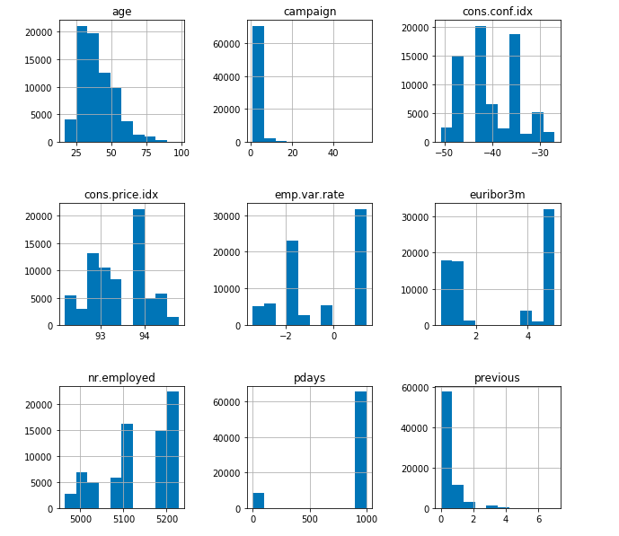

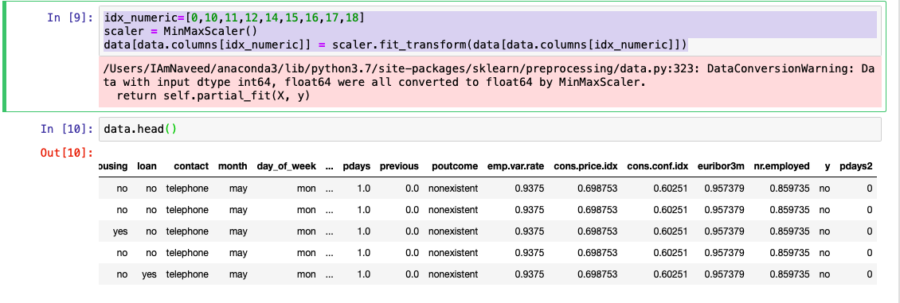

Categorical:

Nominal: Age, Campaign, education, contact, month, day_of_week.

Ordinal: poutcome, default, housing, loan.

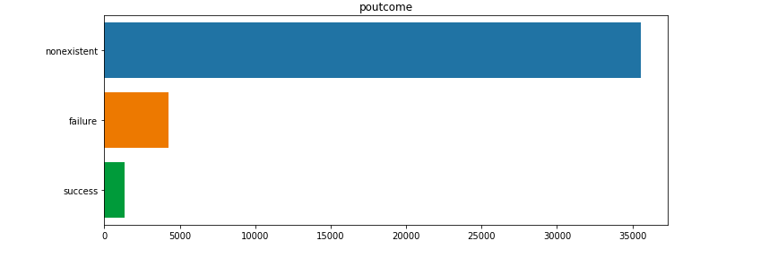

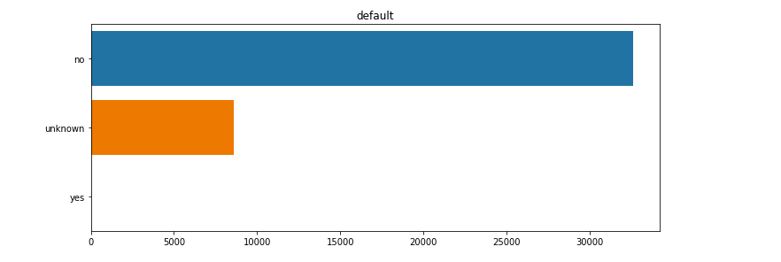

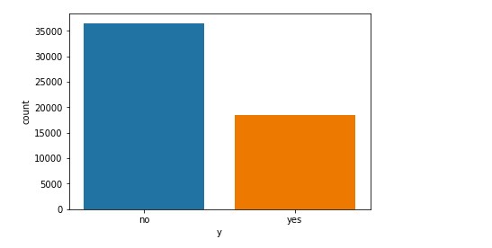

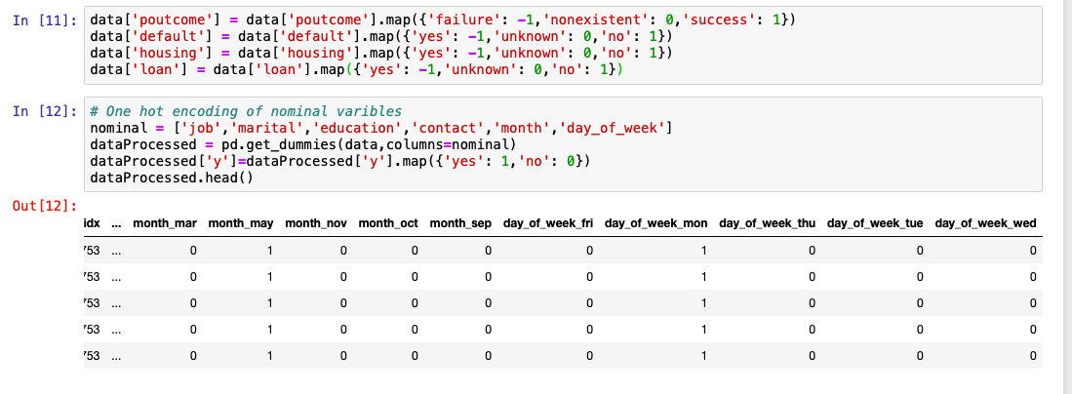

Expectation:

For the above processed data, I would like to try and execute different classification problems.