1. Create a folder NodeJS and open the command prompt there .
2. Type npm init command in it. This will create Package.JSON file in it.

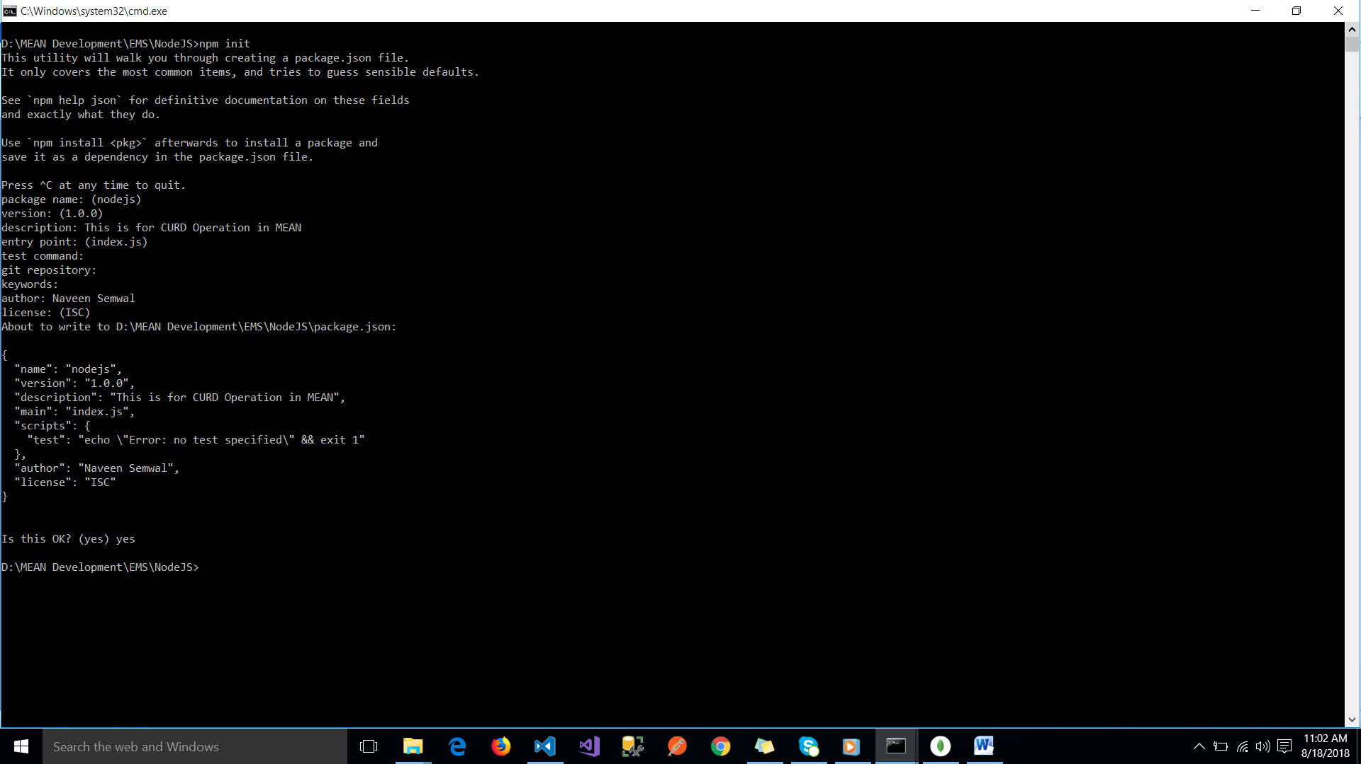

1. Now install express , mongoose, body-parser

Express.js, or simply Express, is a web application framework for Node.js

Mongoose : ORM for mongoDB

body-parser : It is used to parse the JSON body to Node.js api.

Below command will install all three and save configuration in Package.json file.

Command : **npm i express mongoose body-parser**

1. Create the db.js file which contains the connection .
2. To run db.js file write **node db.js** command

So any time you change the server you need to run command in the point 5. To avoid this install

**Npm install –g nodemon**

**Nodemon db.js**

1. **Index.js will be only the first file that will execute by framework first like Index.htm in Angular.**