**Exp:10**

**24.04.2025**

**Develop vector auto regression model for multivariate time series data forecasting**

**Aim:**

To develop a python program for Developing a vector auto regression model for multivariate time series data forecasting

**1. Importing Required Libraries**

import numpy as np

import pandas as pd

import matplotlib.pyplot as plt

from sklearn.metrics import mean_squared_error

**Explanation:**

We import numpy (np) is used for numerical operations, pandas (pd) for data manipulation, matplotlib.pyplot (plt) for plotting.

Adfuller for stationary check

**2. Loading the Dataset**

file_path = "/mnt/data/gold.csv"

df = pd.read_csv(file_path)

**Explanation:**

We use pd.read_csv() to load a CSV file containing Gold data.

**3. Display the first few rows to understand the structure**

print(data.head())

print(data.info())

**4.** **Preprocessing the data**

data = pd.read_csv('/content/gold (1).csv'

data['Date'] = pd.to_datetime(data['Date'])

data.set_index('Date', inplace=True)

### 5.Create lagged data

def create_lagged_features(data, lags):

    lagged_data = {}

    for lag in range(1, lags + 1):

        lagged_data[f"lag_{lag}"] = data.shift(lag)

    return pd.concat(lagged_data.values(), axis=1)

**6.Split data**

def create_lagged_features(data, lags):

    lagged_data = {}

    for lag in range(1, lags + 1):

        lagged_data[f"lag_{lag}"] = data.shift(lag)

    return pd.concat(lagged_data.values(), axis=1)

**7.** **Visualization**

plt.figure(figsize=(12, 8))

for i, col in enumerate(selected_columns):

    plt.subplot(len(selected_columns), 1, i + 1)

    plt.plot(y_test.iloc[:, i].values, label='Actual')

    plt.plot(y_pred[:, i], label='Predicted')

    plt.title(f"{col} - Actual vs Predicted")

    plt.legend()

plt.tight_layout()

plt.show()

**Outputs:**

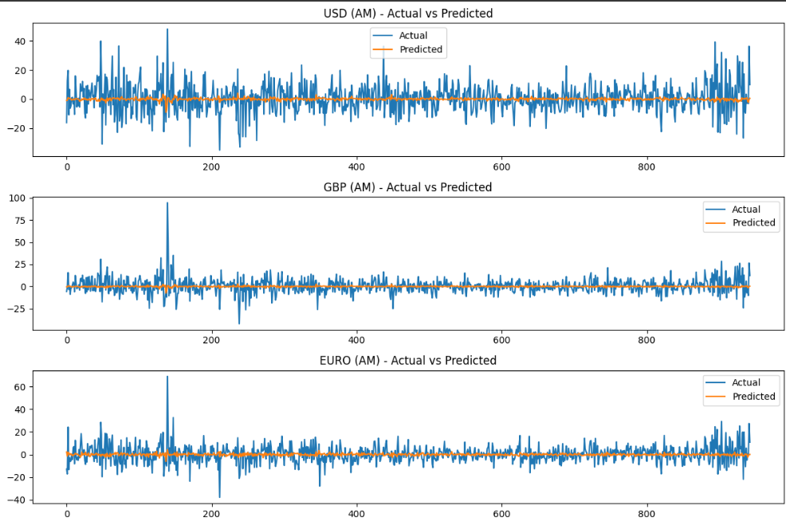

**Result:**

Thus the Program for developing a vector auto regression model for multivariate time series data forecasting