**Exp:7**

**10.04.2025**

**Implement program for decomposing time series data into trend and seasonality**

**Aim:**

To develop a python program for decomposing time series data into trend and seasonality

**1. Importing Required Libraries**

import pandas as pd

import numpy as np

import matplotlib.pyplot as plt

from statsmodels.tsa.seasonal import seasonal_decompose

**Explanation:**

We import numpy (np) is used for numerical operations, pandas (pd) for data manipulation, matplotlib.pyplot (plt) for plotting.

Adfuller for stationary check

**2. Loading the Dataset**

file_path = "/mnt/data/gold.csv"

df = pd.read_csv(file_path)

**Explanation:**

We use pd.read_csv() to load a CSV file containing Gold data.

**3. Display the first few rows to understand the structure**

df.head()

**4.** **Decomposition**

decomposition = seasonal_decompose(time_series, model='additive', period=365)

# Extract components

trend = decomposition.trend

seasonal = decomposition.seasonal

residual = decomposition.resid

**5.Components**

trend = decomposition.trend

seasonal = decomposition.seasonal

residual = decomposition.resid

**6.Plot the decomposition**

fig, axes = plt.subplots(4, 1, figsize=(14, 12), sharex=True)

resid

**7.** **Original plot**

axes[0].plot(time_series, label='Original', color='blue')

axes[0].set_title('Original Time Series', fontsize=14)

axes[0].legend(loc='upper left')

**8.Trend,Seasonality,Residuals**

axes[1].plot(trend, label='Trend', color='orange')

axes[1].set_title('Trend', fontsize=14)

axes[1].legend(loc='upper left')

axes[2].plot(seasonal, label='Seasonality', color='green')

axes[2].set_title('Seasonality', fontsize=14)

axes[2].legend(loc='upper left')

axes[3].plot(residual, label='Residuals', color='red')

axes[3].set_title('Residuals', fontsize=14)

axes[3].legend(loc='upper left')

plt.tight_layout()

plt.show()

**outputs:**

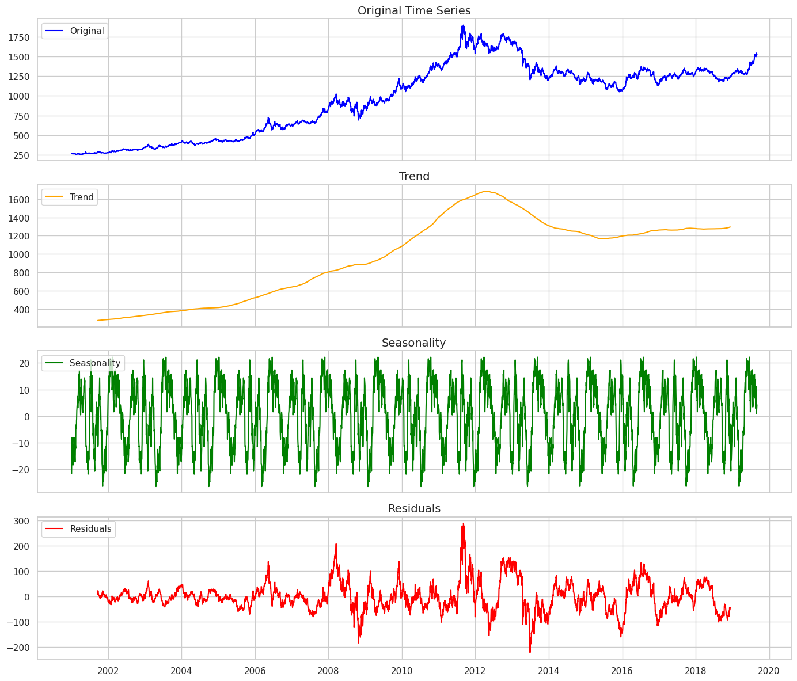

**Result:**

Thus the Program for decomposing time series data into trend and seasonality has been executed successfully.