**Exp:8**

**17.04.2025**

**Create an ARIMA model for time series forecasting**

**Aim:**

To develop a python program for creating an ARIMA model for time series forecasting

**1. Importing Required Libraries**

pip install statsmodels matplotlib scikit-learn

**Explanation:**

We import numpy (np) is used for numerical operations, pandas (pd) for data manipulation, matplotlib.pyplot (plt) for plotting.

Adfuller for stationary check

**2. Loading the Dataset**

file_path = "/mnt/data/gold.csv"

df = pd.read_csv(file_path)

**Explanation:**

We use pd.read_csv() to load a CSV file containing Gold data.

**3. Display the first few rows to understand the structure**

print(data.head())

print(data.info())

**4.** **Preprocessing the data**

data['Date'] = pd.to_datetime(data['Date'])

data.set_index('Date', inplace=True)

time_series = data['USD (AM)'].fillna(method='ffill')

plt.figure(figsize=(12, 6))

plt.plot(time_series, label='USD (AM) Price')

plt.title('Gold Price (USD AM) Over Time')

plt.xlabel('Date')

plt.ylabel('Price (USD)')

plt.legend()

plt.grid()

plt.show()

### 5. Split the Data

### train_size = int(len(time_series) * 0.8)

### train, test = time_series[:train_size], time_series[train_size:]

**6.Model fitting**

from statsmodels.tsa.arima.model import ARIMA

model = ARIMA(train, order=(5, 1, 0)) # Replace (5, 1, 0) with optimal (p, d, q)

model_fit = model.fit()

print(model_fit.summary())

**7.** **Forecasting**

from sklearn.metrics import mean_squared_error

forecast = model_fit.forecast(steps=len(test))

mse = mean_squared_error(test, forecast)

print(f"Mean Squared Error (MSE): {mse}")

plt.figure(figsize=(12, 6))

plt.plot(test.index, test, label='Actual')

plt.plot(test.index, forecast, label='Forecast', color='red')

plt.title('ARIMA Forecast vs Actual')

plt.xlabel('Date')

plt.ylabel('Price (USD)')

plt.legend()

plt.grid()

plt.show()

**Outputs:**

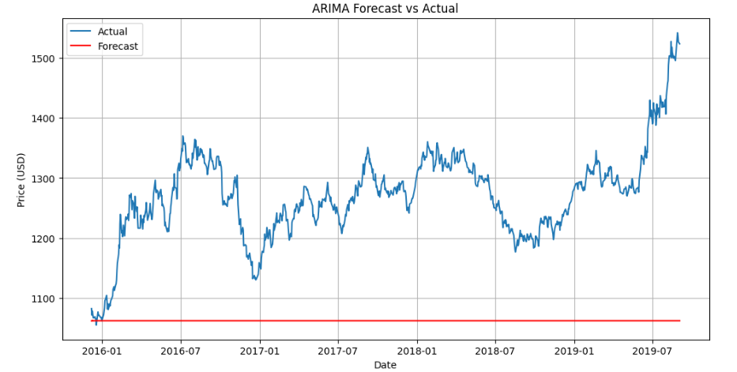

**Result:**

Thus the Program for creating an ARIMA model for forecasting has been implemented successfully.