# 2qqqA PROJECT REPORT ON

Comprehensive Digital Marketing For Maruti Suzuki India Ltd

***Submitted in partial fulfilment of the requirements for the award of the certificate of***

# LONG TERM INTERNSHIP COMPELETION

**IN**

# DIGITAL MARKTETING



**Submitted By:**

# M.Navven Reddy

**B.Prathyusha**

# K.Chaitanya

**D.Ajay Kumar**

**P.Ragu Ram Reddy**

Abstract

Digital marketing has become a pivotal strategy for companies in the automotive industry, and Maruti Suzuki, one of India's leading automobile manufacturers, is no exception. This abstract explores how Maruti Suzuki has leveraged digital marketing to enhance its brand presence, engage customers, and drive sales.

Maruti Suzuki's digital marketing approach encompasses a wide array of strategies. They have harnessed the power of social media platforms, search engine optimization, content marketing, email marketing, and online advertising to reach their target audience effectively.

The company's robust online presence enables it to engage with customers in real-time, fostering brand loyalty and trust.

One notable success is Maruti's use of social media platforms, where they share engaging content, run interactive campaigns, and address customer queries promptly. These efforts have allowed the company to establish a strong online community, providing a direct channel for communication with their customers.

In the digital age, data-driven decision-making is imperative. Maruti Suzuki utilizes data analytics to understand consumer behavior, preferences, and market trends. This valuable insight informs their marketing strategies, helping them tailor their products and campaigns to meet customer demands.

Moreover, Maruti Suzuki's digital marketing initiatives have expanded its customer base. Online advertising in particular has allowed the company to target potential buyers more precisely, leading to increased conversions and sales.

In conclusion, Maruti Suzuki's adoption of digital marketing strategies has been instrumental in its continued success. By embracing various online channels, harnessing data analytics, and engaging with customers in a personalized manner, the company has strengthened its market position and achieved significant growth in the competitive automotive sector.

# CONTENTS

**CHAPTER 1**

* 1. INTRODUCTION
  2. WHAT IS DIGITAL MARKETING?

# CHAPTER 2

* 1. BRAND STUDY
  2. COMPETITOR ANALYSIS
  3. BUYER’S/AUDIENCE’S PERSONA

# CHAPTER 3

* 1. SEO
  2. KEYWORD RESEARCH

# CHAPTER 4

* 1. CONTENT IDEAS
  2. MARKETING STRATEGIES

# CHAPTER 5

5.1 CONTENT CREATION AND CURATION

# CHAPTER 6

6.1Conclusion

# CHAPTER 1

* 1. **Introduction to Digital Marketing**

Digital marketing is the use of digital technologies and platforms to promote products and services, as well as to connect with potential customers. It is an incredibly versatile and powerful tool that can be used in various ways to reach people worldwide. Digital marketing utilizes multiple digital technologies to deliver promotional messages, such as mobile phones, computers, and other digital media and platforms. It can be used for B2B (Business to Business) and B2C (Business to Consumer) marketing, depending on the goal and objectives of the campaign. Digital marketing offers unique advantages such as greater reach, improved targeting, personalized messaging, and better ROI (Return on Investment). It also allows businesses to stay up-to-date with marketing trends and technologies. With the right strategies and tactics, companies can leverage digital marketing to increase their visibility and reach a larger audience.

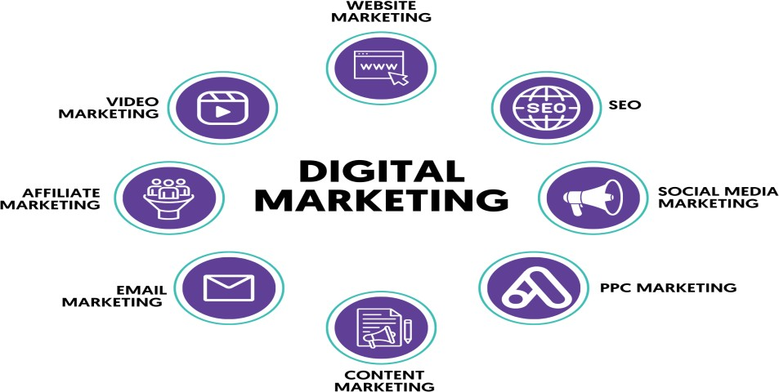

# Digital marketing includes:

* Email
* Social media
* Web-based advertising
* Text and multimedia messages
* Desktop computers
* Mobile phones
* Other digital media and platforms

Digital marketing differs from traditional marketing in that it uses online channels and methods. It allows you to:

Identify and target a highly-specific audience

Use personalized and high-converting marketing messages

Show ads to a certain audience based on variables like age, gender, location, interests, networks, or behaviours

# The 7 Cs of digital marketing are:

* Customer
* Content
* Context
* Community
* Convenience
* Cohesion
* Conversion.

Digital marketing originated in India in 1995 when CSNL launched its internet services.

It did not perform well initially, as only 0.5% of the population used the internet till 2020.

# WHAT IS DIGITAL MARKETING

Digital marketing is a transformative approach to marketing that has revolutionized how businesses and organizations connect with their target audience, promote products or services, and achieve their marketing objectives. In today's digitally-driven world, where people are increasingly connected through the internet, digital marketing has emerged as a critical component of any successful marketing strategy.

Digital marketing leverages a diverse set of online tools and strategies to reach, engage, and convert customers more effectively than traditional marketing methods. Unlike traditional marketing, which relies on physical channels like print media and billboards, digital marketing operates in the virtual realm of websites, search engines, social media, email, and various other online platforms.

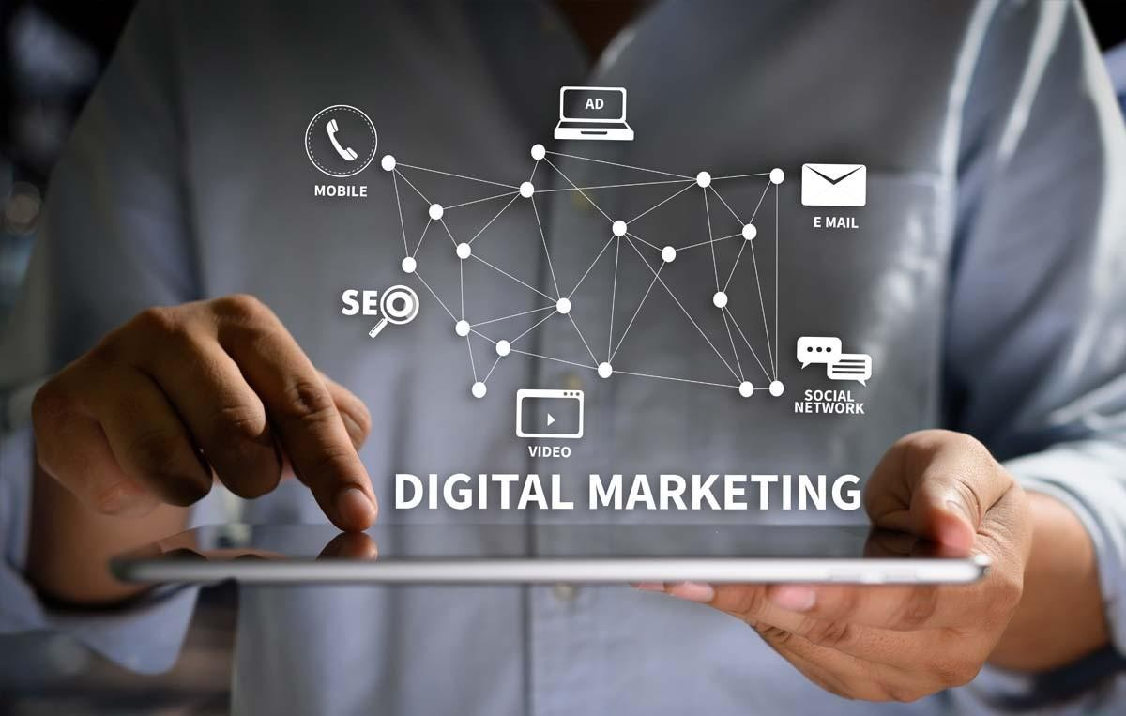

* **Key Components of Digital Marketing:**

1. Search Engine Optimization (SEO): This involves optimizing a website's content to rank higher in search engine results, making it more likely to be discovered by users searching for relevant information.
2. Content Marketing: Creating and distributing valuable and relevant content to attract and engage a target audience. This can include blog posts, articles, videos,

infographics, and more.

1. Social Media Marketing: Leveraging social media platforms to connect with

audiences, build brand awareness, and drive engagement. Social media allows for direct interaction with customers.

1. Email Marketing: Using email to communicate with potential and existing customers. Email campaigns can include newsletters, product announcements, and personalized offers.
2. Pay-Per-Click Advertising (PPC): A form of online advertising where advertisers pay a fee each time their ad is clicked. Google Ads is a popular PPC platform.
3. Affiliate Marketing: Partnering with other businesses or individuals to promote products or services, often in exchange for a commission on sales generated.
4. Analytics and Data Analysis: Utilizing data to measure the effectiveness of marketing campaigns, gain insights into customer behavior, and make data-driven decisions.
5. Mobile Marketing: Targeting audiences on mobile devices through mobile-optimized websites, apps, and SMS marketing.
6. Video Marketing: Creating and sharing video content on platforms like YouTube and social media to engage and inform the audience.
7. Web Analytics and Conversion Rate Optimization: Analyzing website traffic and user behavior to improve website performance, user experience, and conversion rates.

The Importance of Digital Marketing:

The significance of digital marketing lies in its ability to adapt to the changing digital landscape and consumer behavior. It provides businesses with the means to connect with global audiences, precisely target their marketing efforts, and measure results with unprecedented accuracy. Moreover, the dynamic nature of digital marketing encourages constant innovation and the pursuit of more effective strategies. In an era defined by online interactions and data-driven decision-making, digital marketing is an essential tool for businesses looking to thrive in the modern age.

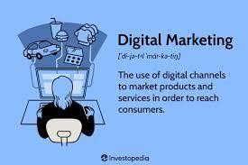

# CHAPTER 2

* 1. **MARUTI SUZUKI INDIA LTD BRAND STUDY**



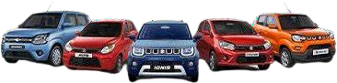

* Maruti Suzuki was established in 1981 as a collaboration between the Indian government and Suzuki Motor Corporation of Japan. It was initially named Maruti Udyog Limited.
* **Key Milestones**: Mention significant milestones in the company's history, such as the launch of the Maruti 800, India's first affordable small car, in 1983. This car played a pivotal role in making car ownership more accessible to the Indian middle class.
* **Suzuki's Involvement**: Emphasize the role of Suzuki Motor Corporation in providing technical expertise and know-how, which helped Maruti Suzuki develop a strong foothold in the Indian automotive market.
* **Joint Venture**: Discuss the nature of the joint venture between the Indian government and Suzuki, including details of shareholding and its evolution over the years.
* **Privatization**: Mention the privatization of Maruti Suzuki in 2003, when the Indian government sold its remaining stake to Suzuki, making it a wholly-owned subsidiary of Suzuki.
* Maruti Suzuki India Limited is an Indian auto giant based in New Delhi, India. The company has a market share of 47% in the passenger car segment.
* India’s most famous cars which include the likes of Maruti 800, Omni, Maruti Zen, the still popular Swift Dzire, and Maruti Gypsy, all have been born out of this company.

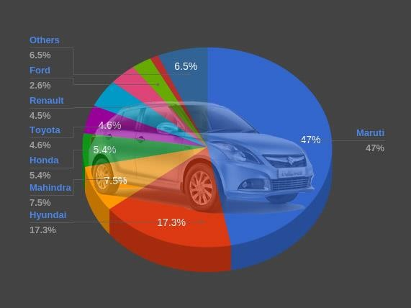

* It has two manufacturing plants in Haryana (Gurgaon and Manesar) and one manufacturing complex in Gujarat which is wholly owned by its parent company Suzuki, which supplies the entire production to Maruti Suzuki. They have a combined manufacturing capacity of 2,250,000 vehicle units annually.

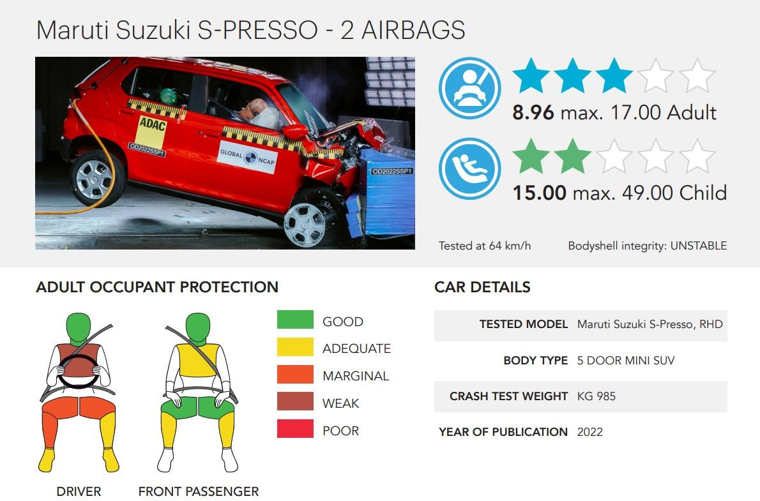

* The company’s success secret lies in its ability to cater to the needs of the price- sensitive Indian middle-class consumers by delivering at low initials accompanied by economical maintenance costs.
* The brand has a vast network of service stations and customer points across the nation which serve a huge number of cars daily. However, very few offerings from Maruti Suzuki have been able to score a rating exceeding 3.0 at any NCAP. Is this how the company is able to keep its costs low by compromising on safety aspects.

# Products by Maruti Suzuki

deals in the following products:

* Automobiles
* Commercial vehicles
* Automotive parts
* Manufacturing hatchbacks
* Motor vehicles, components and spare parts

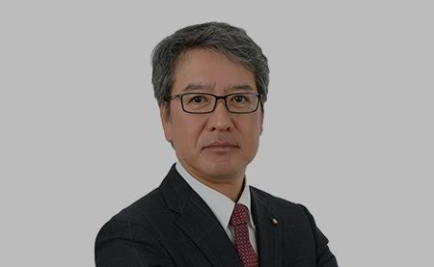

MR. HISASHI TAKEUCHI

|  |  |
| --- | --- |
| **CEO** | MR. HISASHI TAKEUCHI |
| CMO | Shashank Srivastava |
| Area Served | India |
| Industry | Automobile |
| Market Share/ Revenue | INR 81,844 million |

* The present CEO officer in India for Maruti Suzuki is **Mr. Hisashi Takeuchi**. He was appointed as the Managing Director and Chief Executive Officer of Maruti Suzuki India Limited (MSIL) with effect from **April 1, 2022**
* **Shashank Srivastava**, the senior executive officer of marketing and sales at Maruti Suzuki India Limited, the largest automobile manufacturer in India. He is responsible for leading Maruti Suzuki into the future with exciting cars that are good for the customers, environment and society.
  1. COMPETITOR ANALYSIS

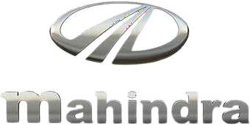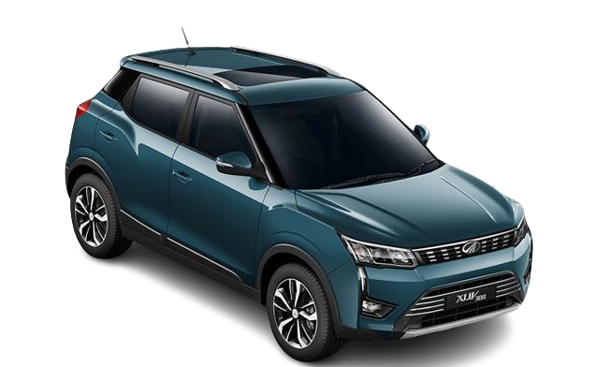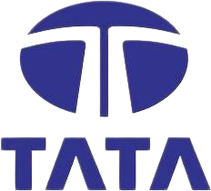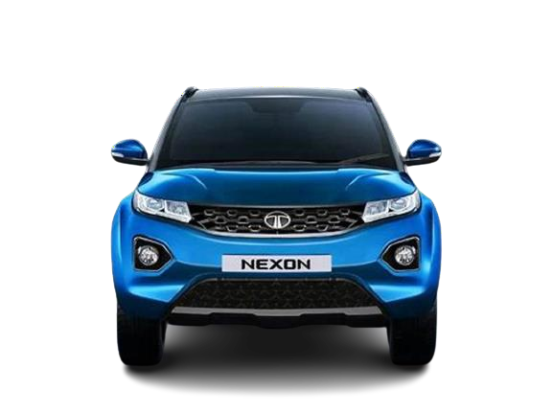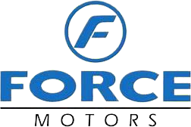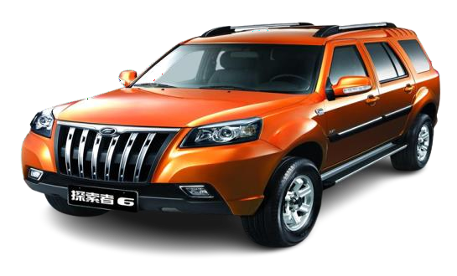

# Competitors of Maruti Suzuki

Among all the competitors, close competitors of Maruti Suzuki are listed the below:

* Force
* Hyundai
* Tata
* Mahindra

Now that we understand the company’s key business, let’s look after the SWOT Analysis of Maruti Suzuki.

# SWOT Analysis of Maruti Suzuki

SWOT Analysis of Maruti Suzuki can show how a well-established company uses its opportunities to ensure its growth. It can show how the company takes advantage of its strengths to use the opportunities while working on its weaknesses. SWOT Analysis of Maruti Suzuki will also reveal its expansion plans.

To better understand the SWOT analysis of Maruti Suzuki, refer to the infographic below:

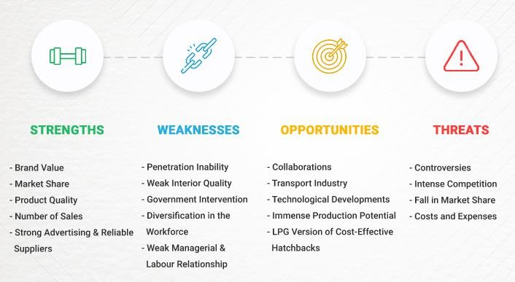

Now first let’s begin with the strengths of the company from the SWOT analysis of Maruti Suzuki.

# Strengths of Maruti Suzuki

The strengths of a company are the unique qualities that provide it with an advantage in acquiring more market share, attracting more customers, and maximizing profitability. Maruti Suzuki’s strengths are as follows:

* **Market Share:** Maruti Suzuki has a large market share with a share value of 45 percent which is comparatively more if compared to its competitors and this is one of the biggest strengths of Maruti Suzuki.
* **Number of Sales:** Maruti Suzuki registered the highest number of domestic sales in the previous fiscal year, with 9,66,447 units. This has recently surpassed the national sales mark of 10 million.
* **Brand Value:** Maruti Suzuki has high brand recognition and a large consumer base. Also earned a good reputation for selling second-hand vehicles of good quality through its true value chain.
* **Strong Advertising & Reliable Suppliers:** Effective approaches of advertising, good product range, and largest dealers network to attract people. It has a strong base of reliable suppliers of raw material thus enabling the company to overcome any supply chain bottlenecks.
* **Product Quality:** Maruti Suzuki engine capacity is supreme which provides more mileage as compared to its competitors, their cars require less maintenance and service

cost is the lowest in the market. These advantages give Maruti Suzuki a complete edge over its competitors in terms of capturing the market of the lower and middle class whose percentage is more as compared to the rich class.

* **Cost Optimization:** Maruti’s cost optimization strategies have benefitted the company in the long run, for example during Covid-19 the brand localized its imports and re- structured its way of functioning.

# Weaknesses of Maruti Suzuki

Weaknesses are elements of a company or brand that can be strengthened.

The following are Maruti Suzuki’s flaws:

* **Weak Interior Quality:** Maruti Suzuki’s interior quality is weak in comparison with the high-quality interior of Hyundai, Maruti Suzuki, Volkswagen etc. Also, the build quality of Maruti Suzuki cars is a little bit low compared to these competitors.
* **Government Intervention:** Government intervenes because of having a share in Maruti Suzuki as it’s owned by the government and a public company. Strategic decisions are dependent upon government approvals.
* **Penetration Inability:** Maruti Suzuki’s one of biggest inabilities is not being able to penetrate the world market. The company is only popular in India and some of the Asian regions other than this Maruti Suzuki’s presence in Europe and the North American market is not that fascinating.
* **Weak Managerial & labour Relationship:** The relationship between management and labour unions is not good. Employee strikes, worker’s wages strikes have declined the reputation of Maruti Suzuki in terms of being the best working place.
* **Diversification in the Workforce:** The workforce at Maruti Suzuki Motors is analyzed with mostly local workers, and low amounts of workers from other ethnical backgrounds. Lack of diversification makes it difficult for employees from different ethnical backgrounds to adapt at the workplace, leading to loss of talent.

# Opportunities for Maruti Suzuki

Potential areas of attention for a corporation to enhance results, expand sales, and, ultimately, profit are known as opportunities. Maruti Suzuki’s opportunities are

* **LPG Version of Cost-Effective Hatchbacks:** Maruti Suzuki is popular in the taxi sector and most of the taxis are connected with LPG. A recently positive move by Maruti Suzuki is that it introduced its LPG version of Wagon R which is a smart move taken by the company.
* **Collaborations:** Maruti Suzuki can jointly work with big car manufacturers to bring innovations to the market by improving relations. Just like recently, Maruti Suzuki is working with Toyota on a project to launch small electric SUVs in the market.
* **Technological Developments:** Technology succeeds with numerous advantages among many departments. Operations can be automated to diminish costs. Technology enables better data to be obtained from customers and improves trading accomplishments.
* **Immense Production Potential:** Maruti Suzuki has immense potential in foreign markets and it is a rapidly growing market for automobiles. It can tap into European and other untouched markets where growth potential is even more.
* **Transport Industry:** The transportation industry has been thriving in recent years and has significant growth potential in the future. This has reduced transportation costs, which benefits Maruti Suzuki by lowering its overall costs.

# Threats to Maruti Suzuki

Environmental variables that can damage a company’s growth are known as threats. Maruti Suzuki’s threats include the following:

* **Fall in Market Share:** Maruti Suzuki has experienced a great fall in its market share because of the higher increment in market share of other brands, such as Figo, Ford, and Volkswagen. Also, Maruti Suzuki registered a sales drop in January 2022.
* **Intense Competition:** China intends to join the Indian car market which can create immense competition. Also, Maruti Suzuki has other competitors from global automotive brands.
* **Controversies:** Maruti Suzuki is facing certain controversies such as its cars failing accident tests and safety benchmarks which is one of the most important aspects customers look into before purchasing any car.
* **Costs and Expenses:** Higher fuel costs including demonetization expenses and economic recession has caused decreasing purchases by customers.

# BUYER’S/AUDIENCE’S PERSONA

* Customer profile for the brand includes middle to high-income groups ranging from the ones.
* Who are looking to switch from 2-wheeler to 4- wheeler to those.
* Who are planning to buy the second car or a luxury car for their family.
* It includes customers in the age bracket of 22-60 year and also high business

professionals

* Who are looking for low maintenance or innovative and trending world-class vehicles with advanced safety features.
* Go back a few decades and the car-buying landscape couldn’t be more different – if you needed a car, you’d simply head to your local automotive dealer.
* Nowadays the internet has not only given automotive customers the opportunity to shop further afield but it’s also provided car buyers with a whole host of easily accessible knowledge.
* In fact, it’s believed that more than 90 percent of automotive customers now research their next car online before actually buying one, making it more and more common for car buyers to have an idea of what they want. With this in mind, it’s never been more essential for car dealerships to have a good understanding of who their customers are and how they can reach them.
* Ultimately, car buyer personas are effectively a guide to who their clients are – and without them, you basically risk wasting valuable time and money simply hoping a prospective customer will shop with you.
* Buyer personas are fictional representations of your ideal customers, that you, as a dealership, create. They generally include personality, attitude, values, interests and lifestyle, as well as thinking about why the customer would be interested in buying one of your cars.

•

* Most dealerships will have more than one persona, in fact, most automotive businesses have around three main personas that they work with.

# CHAPTER 3

* 1. SEO (SEARCH ENGINE OPTIMISATION)
* Maruti is one of the most successful automobile companies in India has worked immensely on optimizing its platform to rank on the search engine.
* Whenever someone searches for Keywords like “Cars”, Best Cars or anything related to Car and vehicles” the chances of results showing Maruti’s article are very high. And this is all possible because Maruti has put a lot of effort into SEO.
* As per Uber suggest, a keyword tool by Neil Patel, Maruti has a search volume of 135000 while 55837 people click on SEO results in India.
* The average web page that ranks in the top 10 has 290 backlinks and a domain score of

75. These stats are really amazing.

Maruti Suzuki Marketing Case Study - Target Audience - Search Engine Optimisation

* The graph below shows the monthly search volume of Maruti. As per the latest results in the month of August, Maruti had a total of 135000 searches, out of which 54726 were mobile searches while 80274 desktop searches.

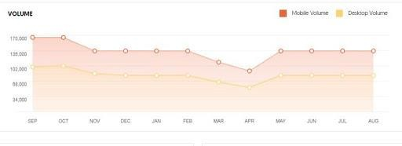

* Uber suggest gives an overall idea of keywords for which Maruti is being searched over the internet. The graph below shows different keywords and their search volume.

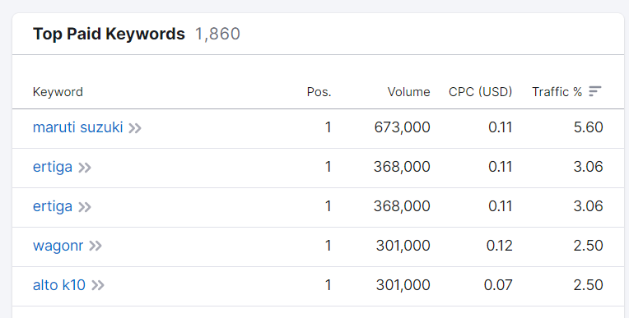

# KEYWORD RESEARCH

* The organic keywords for which Maruti ranks are 330,580, which is simply amazing. This shows how much effort Maruti has put forward for its SEO. The website gets a monthly traffic of 5,108,171, which is again brilliant.
* 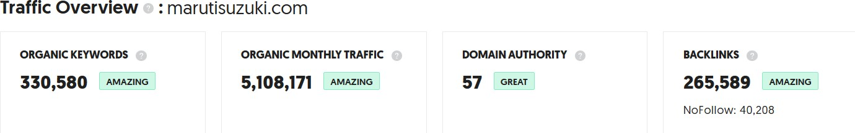It also gets 265,589 backlinks from other websites, which works as a backbone for Maruti in ranking no.1 on google search.

Below is the list of keywords for which marutisuzuki.com ranks.



# CHAPTER 4

* 1. CONTENT IDEAS

# Marketing Strategy of Maruti Suzuki

Maruti Suzuki was among the first in the industry to study consumer behaviour and effectively respond to it. The company primarily adopted a market segmentation policy to meet the needs and demands of different sections of society.

# Segmentation, Targeting and Positioning

Maruti Suzuki has a wide variety of models which meets every segment of the automobile market. It offers over 16 brands and about 150 variants spanning all segments which include Maruti 800, Maruti Omni, Maruti Alto, Maruti Gypsy, Maruti Wagon R, Maruti Swift, Maruti SX4, Maruti Ertiga, and Maruti Grand Vitara.

The brand has cars available for clients with an income of over 4 LPA. They cover the middle class, upper-middle-class, high class, and the affluent class which is its target customer base. MSIL positions its 16 brands effectively by serving customers according to their specific needs and desires. From Alto and Wagon R to the premium Ertiga, everyone is covered!

# Marketing Campaigns

**Kitna Deti Hai?**



The campaign sums up the Indian obsession with the value for money received from a product/service which in the case of auto refers to the mileage of a car. This was the advertisement video on their youtube channel with the success of 24k+ views.

# Tarakki Apki, Saath Humara

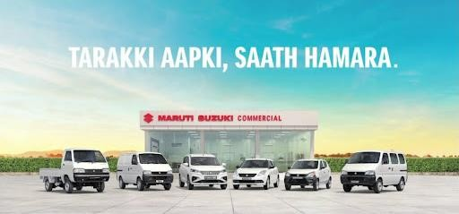

This campaign commemorates the channel’s success as a herald of growth, trust, transparency, and prosperity in meeting the customer’s business needs. The advertisement was successful on account that it helped instil in Maruti Suzuki being a trusted partner rather than a place to buy.

# Monsoon Care Campaign

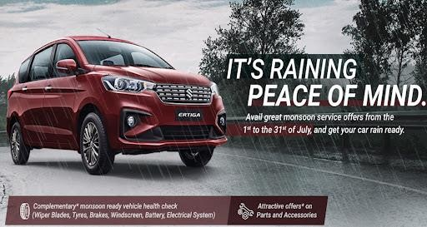

Through this campaign, the company offers complimentary checkups for their vehicles. Inspected by trained technicians to ensure safe monsoon driving. The advert will go a long way in showcasing the company as a responsible brand. Many customers showed interest in the offers to live a luxurious life.

# Social Media Marketing

Maruti Suzuki is very active in the social media space and has a good fan base across all major platforms like Twitter, Instagram, and Facebook. It has the highest number of followers on Facebook followed by Twitter and Instagram respectively. The marketing campaigns, brand offers, happy customer stories and many more are posted on their social media accounts.

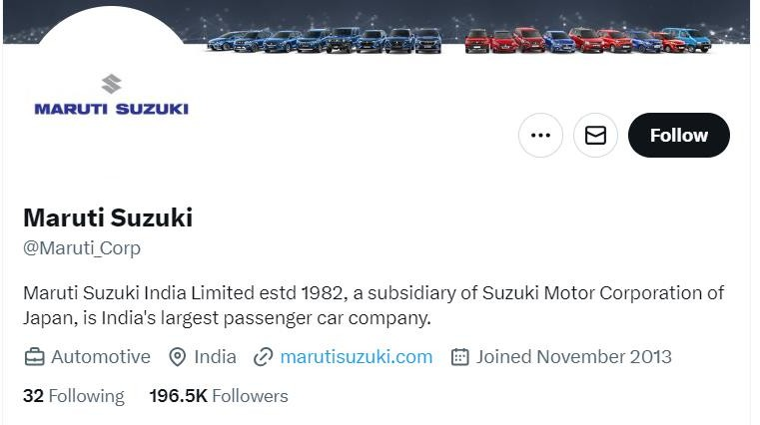

It has two divisions as well Maruti Suzuki Arena which focuses on the showroom experience through technology, design, and Connected Experience, and the other which is Nexa which solely focuses on the premium segment of the brand i.e Nexa models.

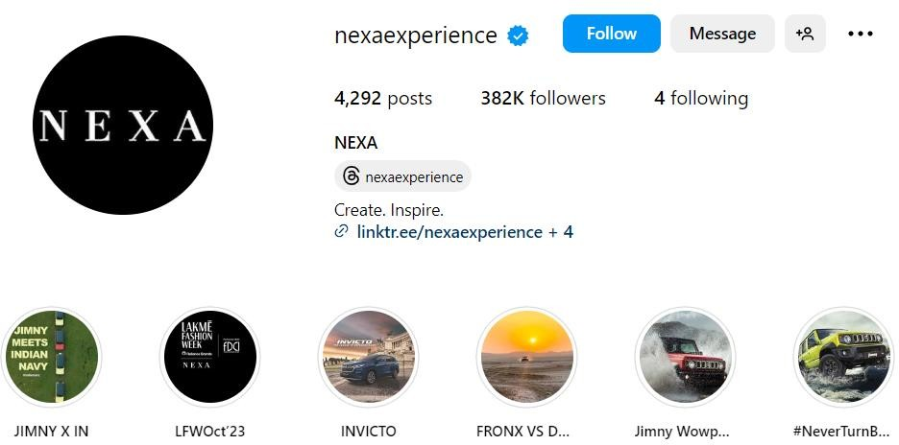

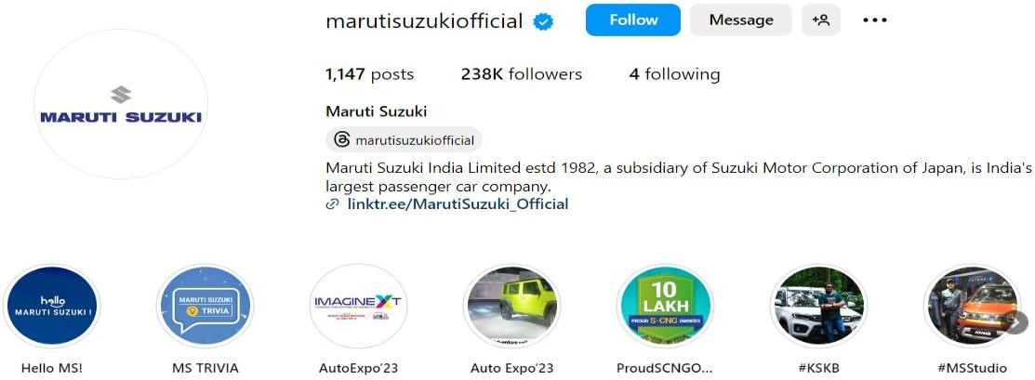

# SEO Strategies

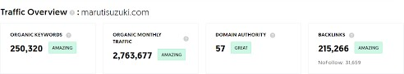

Maruti Suzuki has an organic keyword exceeding 30,000 which is impeccable and monthly traffic exceeding the 30 lakh mark shows the huge popularity and familiarity of the brand such that it is constantly growing with every passing calendar month. The brand has visits from

other sources also i.e hyperlinks from other websites to this domain. This figure is also mind- wobbling which shows the vast outreach and visibility it enjoys. The company is well versed to make full use of SEO strategies to the best extent.

# Influencer Marketing

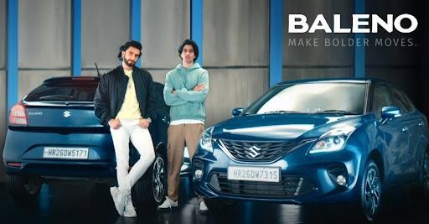

Maruti Suzuki signed a 2-year sponsorship deal with Ten Sports for the latter’s cricket rating property which is titled ‘Maruti Suzuki Cricket Ratings”. The company has roped in renowned Bollywood actor Ranveer Singh as its Nexa brand ambassador. It also has Varun Dhawan for Arena’s products in a move to connect with the younger audiences.

The marketing team at MSIL also came up with a campaign #BeLimitless through collaboration with individuals who have overcome great hardships in their life journey and including the likes of Olympic and World Champion Mary Kom, Para-athlete Bhupendra Sharma, and corporate banker Vikas Dimri, who conquered Mt. Everest and the Ironman Race.

**Ecommerce Strategies**

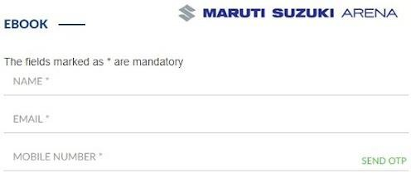

The company began taking online bookings in 2017. In fact, in 2020, the company says it sold more than 2lakh cars through its online channel. Recently it introduced an end-to-end online real-time car financing program. The smart finance campaign has truly refined the modern car buying experience. The platform has addressed the issues regarding lack of proper information, lack of transparency, and lack of convenience and thereby helped stimulate sales for the company.

# Mobile Application

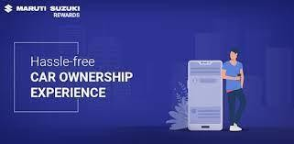

Maruti Suzuki Rewards app refines the automotive experience for customers. It offers complete ease in getting any help or data you want for your Maruti Suzuki vehicles. With the usefulness to book arrangements at the closest Maruti Suzuki Arena or NEXA service centre, you can likewise monitor your vehicle’s Maruti Insurance strategy, deal with your compensations under the Maruti Suzuki loyalty program, screen your vehicle’s servicing schedule, and many more.

5.1 CONTENT CREATION AND CURATION

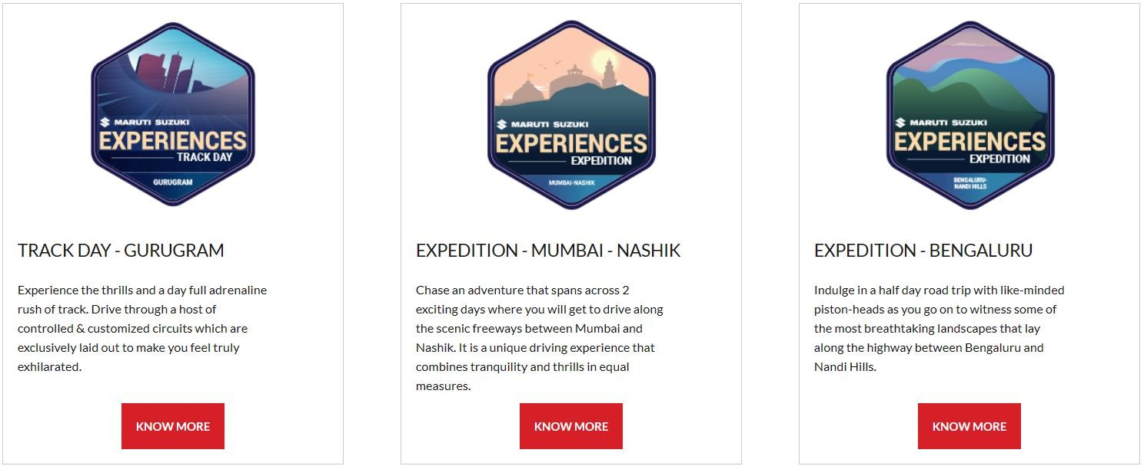

The brand uses effective content marketing strategies to engage audiences by increasing their knowledge in the auto field to make rational buying decisions and thereby in the process portray the superiority and the value brought forward by MSIL cars. Multiple blogs and posts on both the company website and platforms like Twitter to educate users and show the added privilege of being their customer are showcased.

# 6.1Conclusion

Maruti Suzuki has enjoyed brand loyalty and trust of Indians for decades now on account of the emotion it shares with its target consumers (Indians) as a whole generally. The company has a great and zestful marketing team that frequently engages the audience and also at times brings about the required developments in society.

We believe that considering the brand value it already enjoys, the uphill task for it would be to maintain the same for ages to come since reaching a position like this is possible in the short term but staying at the same place for years is what showcases the influence it commands.

The company has all resources to ensure it stays with time and advances as and when new innovations enter the industry like digital marketing.