NAME: Pasupula naveen reddy

ROLL NO:RA2111003020013

TITLE : ***ATM TRANSACTION IN C LANGUAGE***

.

***ABSTRARCT:***

It can be defined as actually simple code structure of ATM transaction process to be understood by a user. For implementing this project, we may have to use function but in the meantime for easy coding, we may have to switch cause statement.

Syntax:

The c program excutes in three forms of the coding syntax:

1)Account balance checking

2)ATM cash withdrawl

3)Deposition of cash

Initially we need to set the ATM pin along the amount including few random numbers.

Taking the ATM pin as a input

If the provided input pin is identical to pin which is adjusted by user , by the we can use to perform various additional operations.

We will implement the switch case for executing the additional operations such as checking balance,

Cash withdrawl, deposit and so on.

We use a while loop to resume the procedure.

Working procedure:

The ATM program follows three processes for proper transaction logically that includes cash withdrawing, depositing, and checking balance. This three-program sections are executed using the switch cases in C with initialized variables and functions with conditions. The conditions provide results accurately only if they are satisfied.

Features of the program:

The c program is able to show the ATM transaction.

For logging to the ATM it holds or needs a pin verification system.

Using this ATM program , a user can view their balance in the account.

This ATM program in assits in the withdrawl of cash also.

ATM enables switch case allowing multiple feature the user may exit which is done by a program to terminate.

***CODE :***

#include<stdio.h>

unsigned long amount=25000, deposit, withdraw;

int choice, pin, i;

char transaction ='y';

void main()

{

while (pin != 1097) //using while loop we are checking whether the pin is matching or not

{

printf("ENTER YOUR PIN NUMBER: ");

scanf("%d", &pin);

if (pin != 1097)

printf("PLEASE ENTER VALID PIN NUMBER \n");

}

do

{

printf(" Welcome to ATM Service \n");

printf("1. Check Balance\n");

printf("2. Withdraw Cash\n");

printf("3. Deposit Cash\n");

printf("4. Quit\n");

printf("\n\n");

printf("Enter your choice: ");

scanf("%d", &choice);

switch (choice)

{

case 1:

printf("\n YOUR BALANCE =Rs.%lu ", amount);

break;

case 2:

printf("\n ENTER THE AMOUNT: ");

scanf("%lu", &withdraw);

if (withdraw % 100 != 0)

{

printf("\n PLEASE ENTER THE AMOUNT IN MULTIPLES OF 100");

}

else if (withdraw >(amount - 1000))

{

printf("\n INSUFFICENT BALANCE");

}

else

{

amount = amount - withdraw;

printf("\n\n PLEASE COLLECT YOUR CASH"); //if you have sufficient amount in your account ATM will give the cash

printf("\n YOUR CURRENT BALANCE =RS.%lu", amount);

}

break;

case 3:

printf("\n ENTER THE AMOUNT: ");

scanf("%lu", &deposit);

amount = amount + deposit;

printf(" YOUR BALANCE =RS.%lu", amount);

break;

case 4:

printf("\n*********************** THANK YOU USING OUR ATM SERVICES***********************");

break;

default:

printf("\n INVALID CHOICE");

}

printf("\n\n\n DO U WISH TO HAVE ANOTHER TRANSCATION?(y/n): ");

fflush(stdin);

scanf("%c", &transaction);

if (transaction == 'n'|| transaction == 'N')

i = 1; }

while (!i);

printf("\n\n ********************THANKS FOR USING OUR ATM SERVICE********************");

}

***OUTPUT:***

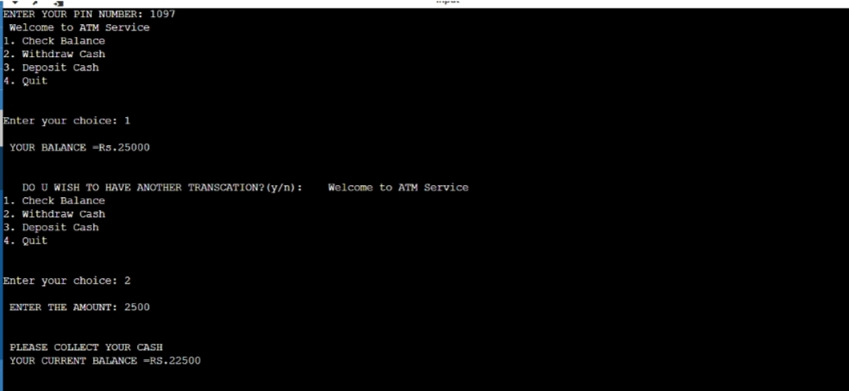

When we compile run the code we will view result as follows in the above figure.

This ATM program will perform the real time ATM transaction where initially we can check if the working effectively or not. 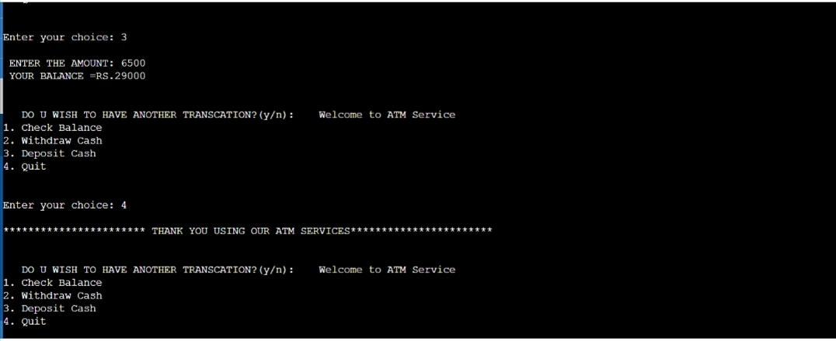 .

***CONCLUSION:*** ATM machine program using C, we need to implement the four fundamental concepts of each ATM system that exists, it includes cash withdraw, cash deposit and to check account balance .