Task 1

Name and Registration number: Naveen Kumar (22BKT0003)

1.Write an assembly language program for multiplication of two 8bit BCD numbers using the repeated addition logic.

# Flowchart and Algorithm

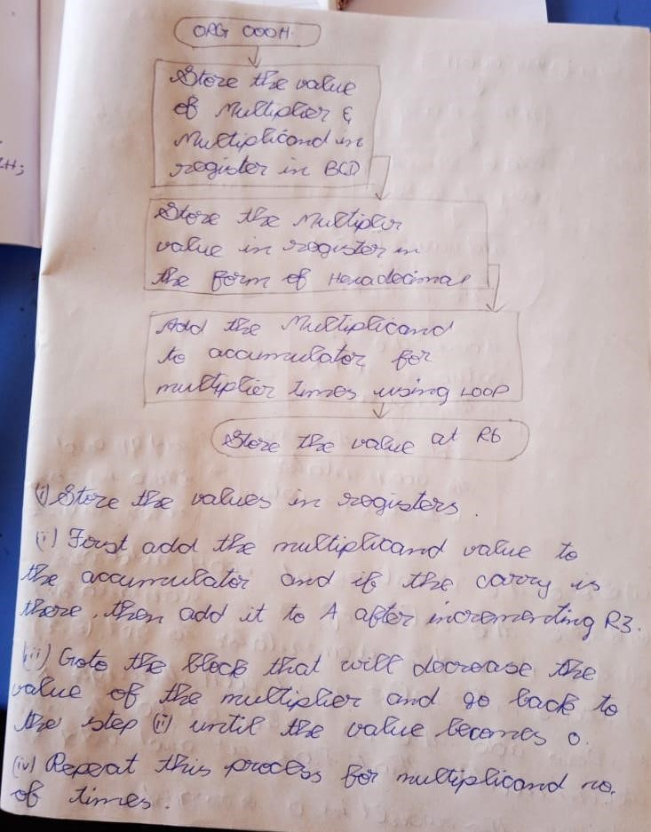

# Code

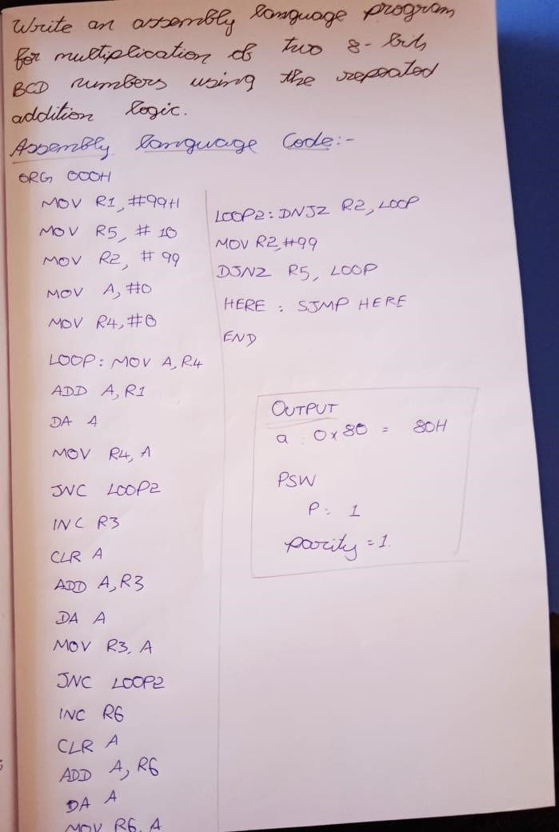

# Assembly language code and Output

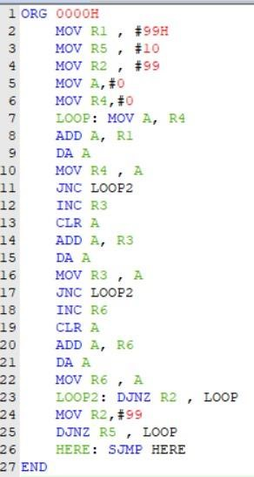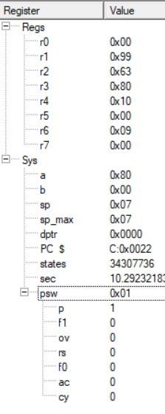

2. Write a program to calculate y where y = x2 + 2x + 9. x is between 0 and 9 and the look-up table for x2 is located at the address (code space) of 200H. Register R0 has the x, and at the end of the program R2 should have y. Use the simulator to change the x value and single-step through the program, examining the registers as you go.

# Flowchart and Algorithm

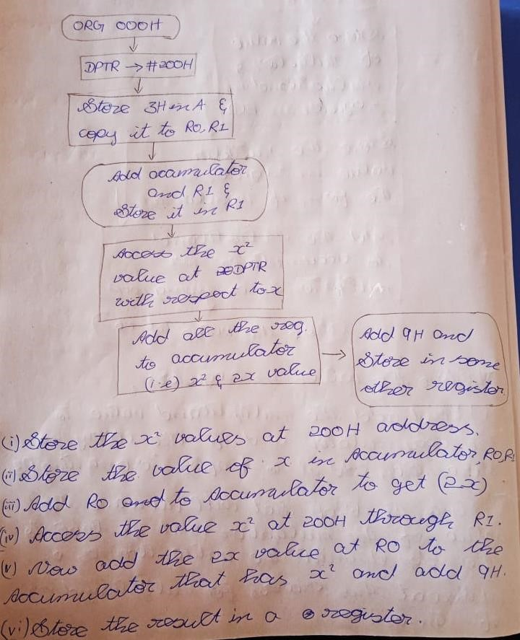

# Code

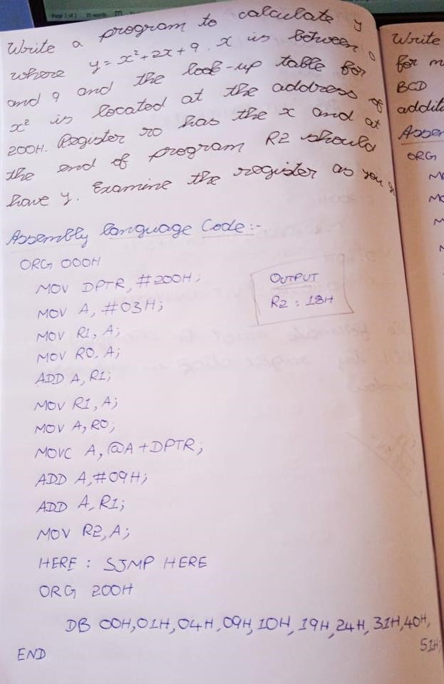

# Assembly language code and Output

