**7. CRM MANAGEMENT USING SALESFORCE CLOUD PLATFORM**

**Aim:**

To create a Customer Relationship Management System(CRM) using Salesforce.com portal.

**Algorithm:**

**Step 1:** Open the browser and search login Salesforce.com.

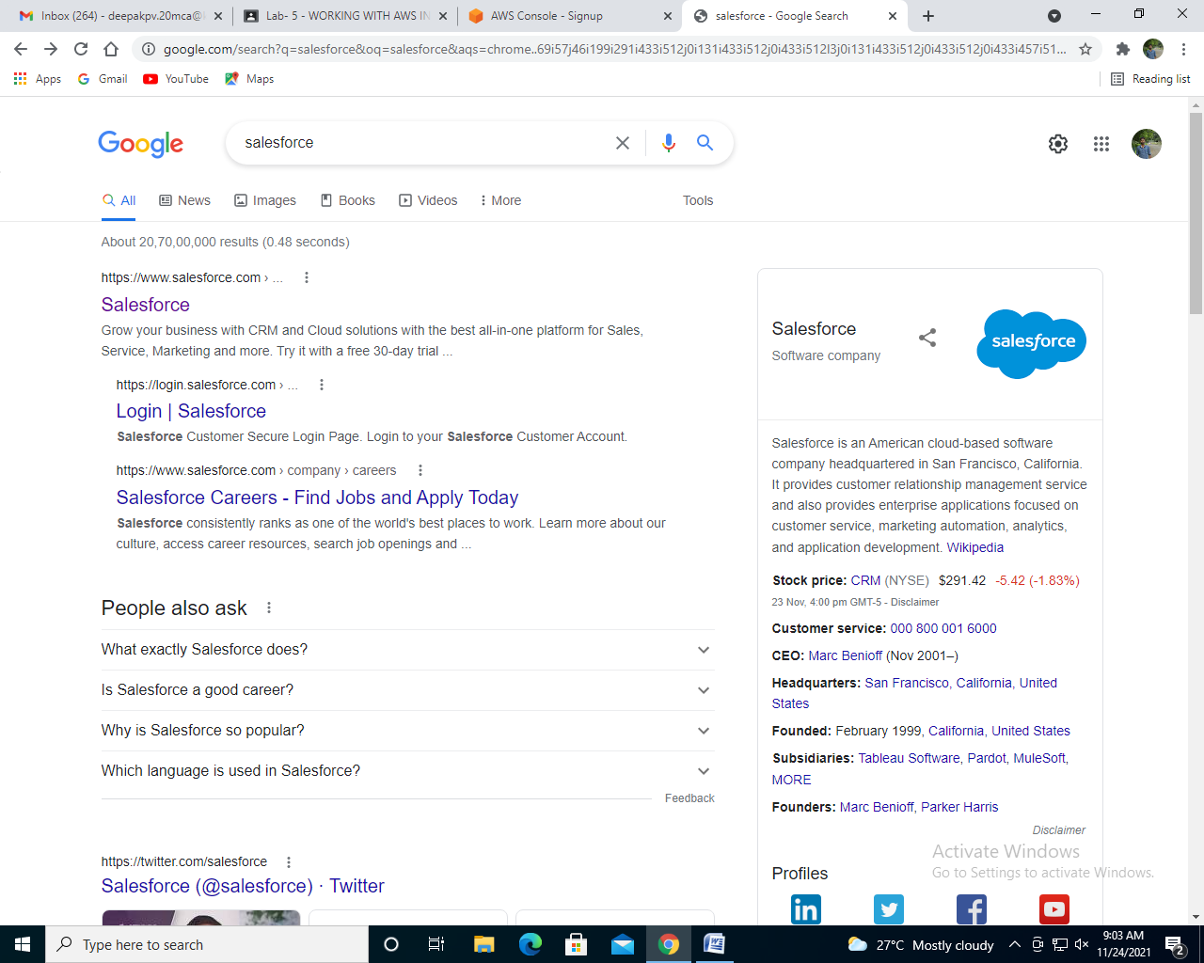

**Step 2:** Click the button try for free.

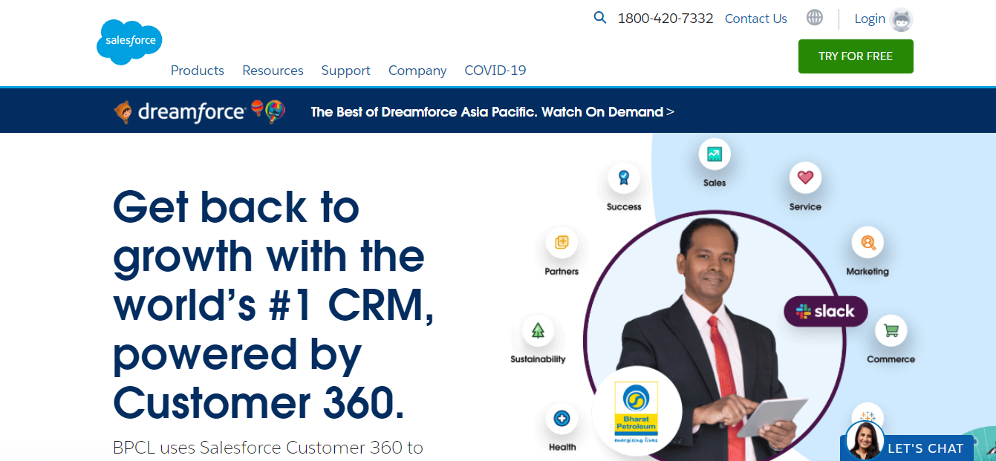

**Step 3:** Fill the all sign-up details.

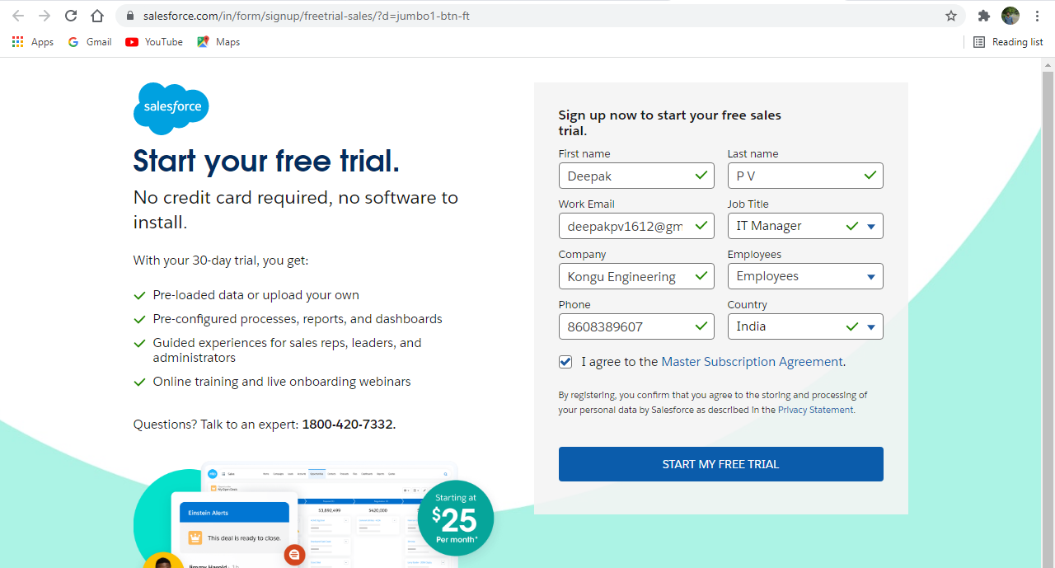

**Step 4:** Next, it enters into new window in that, click the contents.

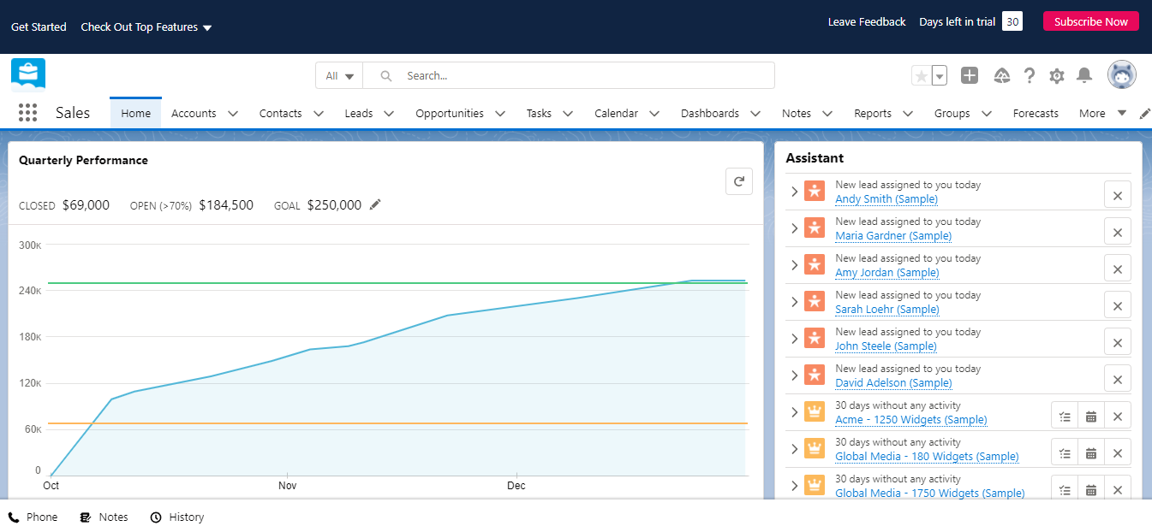

**Step 5:** From the contact, click new.

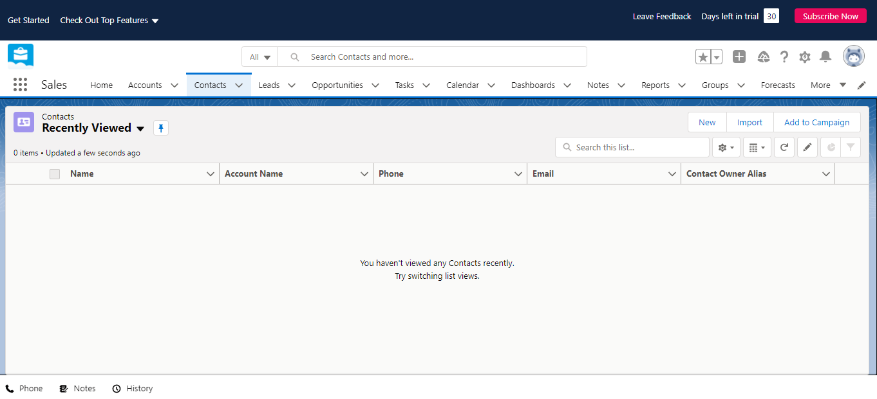

**Step 6:** One dialog box pops up and enter the contact details.

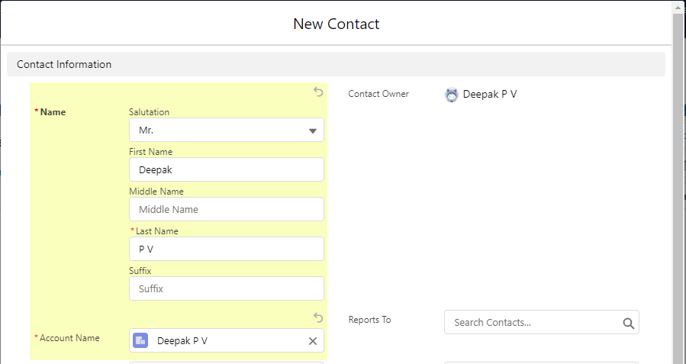

**Step 7:** Choose new account.

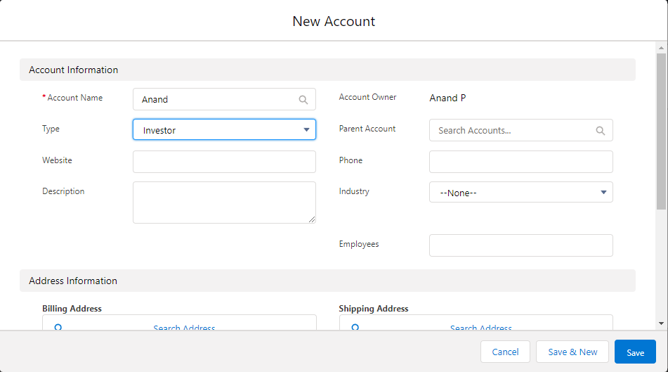

**Step 8:** Fill the account details.

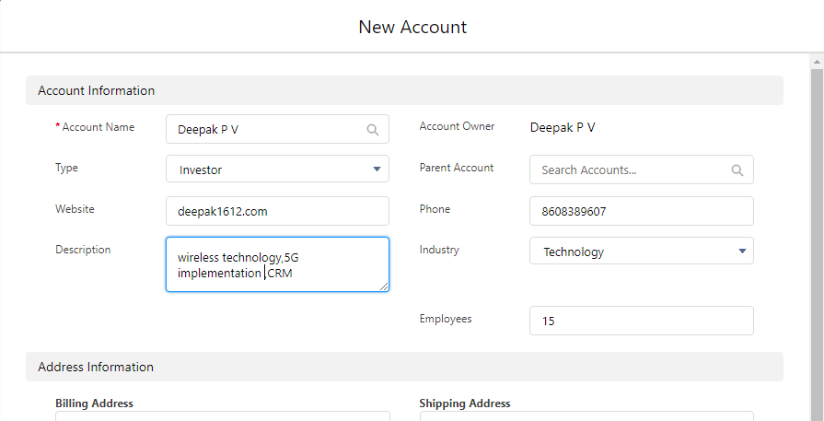

**Step 9:** The account will be created.

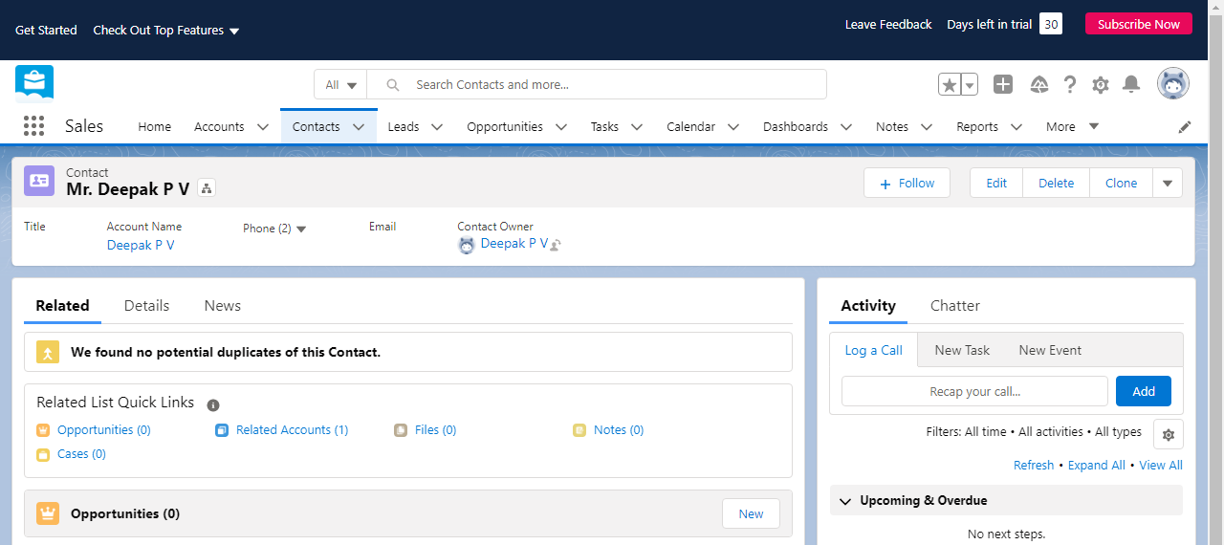

**Step 10:** Click the calendar and give the event details.

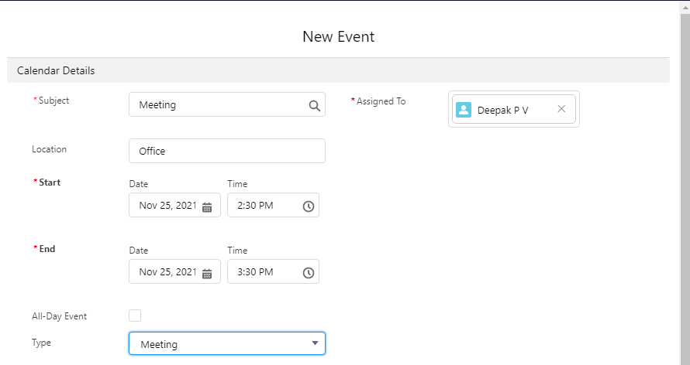

**Step 11:** Click the lead and give the new task.

