**B.Tech IoT Programming**  
**Project Report**  
**On**

Ultrasonic Blind Stick with Object Detector,  
Real-Time GPS Location System  
and  
Memory Navigation

By

**Group Leader:**

Naveen Beniwal (123102131) Email: naveenbeniwal00001@gmail.com No: 9728752191

**Other Team Members:**

1. **Ayush Bansal (123102138)**  
   Email: ayushbansal05dlp@gmail.com   
   Phone Number: 8955236226
2. **Ayush Antil (123102140)**  
   Email: ayushantil2023@gmail.com  
   Phone Number: 9518800364
3. **Rajat (123102132)**  
   Email: Rajatparashar456@gmail.com   
   Phone Number: 9467233860

**Branch:** CS/B  
**Subject:** IoT Programming (CSPC 209)

**Abstract**

This Project focus on making a Ultrasonic blind Stick that involves an **Object Detection System** , **GPS Location Tracking and Sharing** , and a **Memory-Navigation** feature to help the blind people. The stick will detect objects based on ultrasonic sensor data and alert the user by vibration or voice command A GPS system will enable users to share their current location with relatives whenever they perceive themselves in danger orlost. The path remembering feature will guide the users to travel to a preloaded location in database easily by guiding via voice commands. Additionally, this project will allow use of Machine learning, AI for further enhancement in future.

This system will be both affordable and user-friendly and help the visually impaired person in many problems they face on daily basis. During testing phase, the stick provides almost accurate results for object detection and guidance in recorded paths, making it reliable and safe for use.

**Keywords:** GPS Tracking, Ultrasonic sensors, Memory Navigation, Obstacle detection, IOT

**1. Introduction**

The main motivation behind making the project is to solve the problems that visually impaired people face in their day-to-day life. According to the World Health Organisation (WHO), approximately 285 million people worldwide are visually impaired ,39 million are classified as blind. In the developing countries there is less care/awareness about this topic. It is estimated that around 70% of visually impaired individuals have experienced accidents while trying to navigate public spaces, emphasizing the need of some solution/innovation for this.

Inspired by these statistics, our project’s aim is to develop the **Ultrasonic Blind Stick**. The stick provides several features: an ultrasonic object detection system, a real-time GPS location tracker, and a memory navigation feature that remembers familiar paths and many other basic features like water detection, light detection etc. The combination of these features will improve the difficult lifestyle of blind/visually impaired people.

Our ultrasonic blind stick includes an ultrasonic sensor, to enhance user safety. The ultrasonic sensor detects obstacles without physical contact by emitting ultrasonic waves. When an obstacle is detected, the sensor will inform the microcontroller, which will process the data to detect whether the obstacle is dangerous or not according to its distance from user. If an obstacle is detected nearby, the microcontroller will activate a buzzer to alert the user.

Additionally, the blind stick includes a water sensor that emits a distinct sound to warn the user of wet surfaces. There is also a light sensor which will tell the user about the surrounding environment light level to identify it is day or night.

There will be a GPS module system that will access the users current location and share it with the relatives of the user if the user command it to do so by pressing a emergency button it can be made voice operated.

Another component of our system will help the user to locate their stick if it is misplaced. By using an wireless remote, the user can activate a buzzer on the stick, helping in its recovery.

**Unique Functionality of the project:**

**Memory Navigation:**

This feature will enhance the functionality and accuracy of the stick as this feature will enable the stick to learn/remember the familiar locations so that the stick does not need to depend on GPS modules, which generally performs bad inside the house, office or any building , through this the user will be guided by voice commands to safely travel in house office or any buildings or any other route that has been saved in the database by the user’s relatives/user.

**2.Related work in Project**

Most of the previous work in technologies for the visually impaired has been done in the development of independent and safe devices. Many such inventions have utilized sensor-based systems to detect obstacles. Ultrasonic sensors, which emit sound waves that bounce off obstacles to alert the user, are a crucial part of the technologies in previous designs. The previous solutions, however, were lacking support for much more developed features including GPS tracking as well as memory navigation.

Previous research work in these projects developed walking sticks integrated with ultrasonic sensors. Yet most were only designed to be basic obstacle detectors with very few other capabilities. One major limitation of the earlier ideas is that they are unable to offer indoor navigation, as GPS technology usually fails within buildings. Many cause problems from the viewpoint of accuracy and usability in challenging indoor and outdoor environments.

Another approach focused on integrating sensor-based detection with GPS modules, providing users with the ability to send their current location in real time to caretakers. Some projects also integrated GSM modules in order to ensure emergency communication capabilities. However, memory navigation is a relatively new innovation; it allows a user to be guided through a familiar indoor environment that are lack in previous projects.

Additionally, while numerous previous studies successfully demonstrated the work of different sensors, fewer projects combined multiple sensors into one system to enhance end user detection of water and light condition status.

|  |  |  |  |  |  |  |
| --- | --- | --- | --- | --- | --- | --- |
| **Author(s)** | **Link** | **Year** | **Features** | **Sensors** | **Results** | **Drawbacks** |
| Raghu N et al (1) | <https://www.researchgate.net/publication/379844237_Design_and_Implementation_of_Smart_Blind_Stick_for_Obstacle_Detection_and_Navigation_System> | 2024 | 1.Environmentalawareness using PIR and IR sensors.  2.GPSnavigation for route guidance.  3.Emergencycommunication via GSM module. | 1.Ultrasonicsensors  2.GPSmodule  3. PIRsensors.  4. IRsensors  5.Vibrationmotor  6. Audiomodule  7.GSMmodule  8.Accelerometer | 1.Improvedmobility for visually impaired users.  2.Enhancedsafety during navigation.  3.Greaterindependence in unfamiliar environments. | 1.Environmentallimitations affect sensor accuracy.  2.Highcost of advanced technology.  3.Falsealerts from non-obstacles. |
| S. Sharmila et al (6) | <https://www.ijert.org/smart-blind-stick-3> | 2023 | 1.Detects obstacles, water  2.GPS tracking  3. SOS button | 1.Ultrasonic  2. IR Sensor  3.water, Sensor  4.GSM  5.GPS | 1.Effectively  aids  2.navigation  3. alerts  contacts in  emergencies | 1.Limited sensor range  2. relies on GSM  3.power dependency |
| Akshara et al (5) | <https://www.mdpi.com/2673-4605/10/1/12> | 2022 | |  | | --- | | 1.Smart blind  stick for obstacle detection |  |  |  | | --- | --- | |  | 2.Alerts users via buzzer |  |  |  | | --- | --- | |  | 3. Infrared  sensors for  stair detection | | |  | | --- | | 1.Ultrasonic  (HC-SR04) |  |  |  | | --- | --- | |  | 2.IR (A215/  450) |  |  |  | | --- | --- | |  | 3.Water  Sensor | | 1. Detects obstacles up to 4 meters.  2.Audio alerts via buzzer.  3.Affordable for visually impaired.  4.User-friendly and lightweight. | 1.Cannot detect holes or complex obstacles.  2. Limited detection range (up to 4 meters).  3. Lacks advanced features like GPS initially. |
| R.Dhanuja  et al (2) | <https://www.irjet.net/archives/V8/i5/IRJET-V8I588.pdf> | 2018 | 1.Obstacle Detection,  2.Real-Time Feedback,  3.Voice Alerts. | 1. Ultrasonic Sensor (HC-SR04)  2. IR Sensor  3. Voice Playback Module | 1. Assists visually impaired individuals.  2. Provides immediate alerts.  3. Enhances user confidence and safety. | 1. Limited IR sensor range.  2. No water detection  3.No GPS navigation. |
| Amira.A. Elsonbaty (3) | <https://www.ijeat.org/wp-content/uploads/papers/v10i5/D25350410421.pdf> | 2021 | |  | | --- | | 1.Development of a smart stick 2.Assists blind individual 3. Uses ultrasonic and water sensors  4.User feedback from |  |  | | --- | |  | | 1.Ultrasonic sensor 2.Water sensor 3.Fire sensor 4.ESP8266 microcontroller | 1.Reduced risk of accidents 2.Enhanced independence for users | 1.Limited range of motion 2. Requires technical knowledge for setup and maintenance |
| Sameer Grover et al (9) | <https://www.internationaljournalssrg.org/IJECE/paper-details?Id=347> | 2020 | 1.Obstacle detection, 2. navigation via GPS,  3. panic button, 4. moisture detection | 1.Ultrasonic sensors,  2.soil moisture detector, 3.GPS,  4. Bluetooth, 5. Atmega328 microcontroller | 1.Enhances user independence.  2. Voice navigation instructions.  3. Bluetooth-enabled.  4.Obstacle alerts.  5.Panic switch for emergencies. | 1. Requires prior user training.  2. Cannot differentiate objects or people.  3. Limited to detecting obstacles below head level. |
| Vishal Solanki et al (8) | <https://ieeexplore.ieee.org/document/9028921> | 2020 | 1.Smart blind stick for visually impaired  2. Ultrasonic, IR, water, and soil moisture sensors  3. Bluetooth connectivity  4. Panic button. | 1.Ultrasonic sensors  2.IR sensor  3. Water sensor  4. Soil moisture sensor  5.GPS sensor | - Detects obstacles with ultrasonic sensors  - Vibrates to alert user  - Sends GPS location in emergencies via GSM. | Cannot distinguish objects from people  - Requires training for use  - No detection of overhead or ground-level dangers |
| Amit Kumar Thakur et al (7) | <https://www.jetir.org/papers/JETIR2004105.pdf> | 2018 | |  | | --- | | 1.Development of a smart stick 2.Assists blind individual 3. Uses ultrasonic and water sensors |  |  | | --- | |  | | 1.Ultrasonic sensors  2.GPS | 1.Cost-effective 2.Alerts users via vibrations or sound for obstacle detection | 1.Complex design 2. Integrating GPS navigation is challenging |

**Drawbacks in these projects:**

**Short sensor range:** As limited range of obstacle detection system will affect the overall safety.

**Lack GPS:** Some projects unable to provide location-based guidance and assistance in outside environments.

**Weather sensitivity:** Sensors may poorly work in extreme weather conditions like rain or fog

**Requires training**: Users need proper training to effectively use and interprets the alerts.

**Inability to Differentiate Obstacles**: Cannot distinguish between objects and people.

**Unreliable for Indoors:** As GPS is not working properly inside home, offices and buildings so no accurate navigation.

**3.Project:**

The Ultrasonic Blind Stick is designed to enhance the freedom of movement and safety of visually impaired individuals by including multiple sensor technologies into a single, easy-to-use device. It helps in the secure movement of users around their surroundings, integrating its core features: obstacle detection, environmental awareness and GPS tracking. The project is being simulated using Proteus software as it allows virtually testing and designing.

The core functionality of stick is ultrasonic sensor, which detects the obstacle in path of the user. It sends ultrasonic waves (sound pulse) using transmitter which human beings cannot hear, and the receiver receive the reflected pulse. Using this time difference between the transmitted pulse and the received echo, the system calculates the distance to the obstacle using formula:

distance = (speed of sound * time)/2

In the situation that an obstacle is detected within a distance set (threshold distance), for this model about 50cm, the Arduino microcontroller activates a buzzer, which gives time to the user to withdraw from the way and avoid a possible collision. This process runs at faster speed and gives real-time feedback.

One of the most advanced features is the GPS module of the stick which enables the user to share his/her current location with the family or the caretaker. User's GPS is activated by simply clicking a button three times or through voice commands, sending real-time information as to his relatives. That makes this feature especially useful if individuals might get lost or require assistance.

This project code is based on cpp programming language which provider faster execution time.

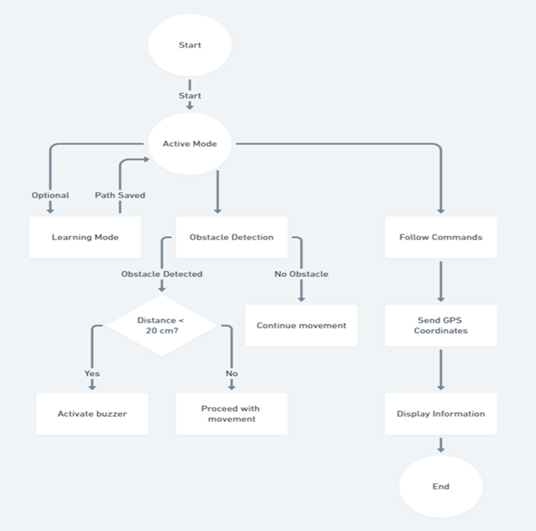

Fig-1: Flow Chart of Ultrasonic Blind Stick Project

The unique functionality of the system is memory navigation system which makes the blind stick more functional and provide accuracy. It can memorize the familiar places which can help the user navigate their route accurately. The places where GPS module fails due to weak signals like in indoors, this feature enables to navigate the visually impaired person. The system can store routes inside the house or office in the database. Such routes are pre-programmed by the user’s relatives to enable personalized guidance from the stick. For a familiar space, the stick utilizes voice commands to guide him or her along saved routes and therefore ensure safe and efficient movement without the use of GPS. The stick will tell through voice commands, the user how to navigate inside house, office’s corridors etc. step by step.

Fig-2 : Memory Navigation System

All these functionalities have been controlled using an Arduino microcontroller as the CPU for the system. All programs created for this project has been written in the Arduino IDE, ensuring that the sensors and components interact very well with each other. The whole project is currently being simulated using the Proteus software, which lets developers virtually test circuits and systems. This simulation phase simply ensures that the design works properly before going for the actual physical construction of the device.

**Working Example:**

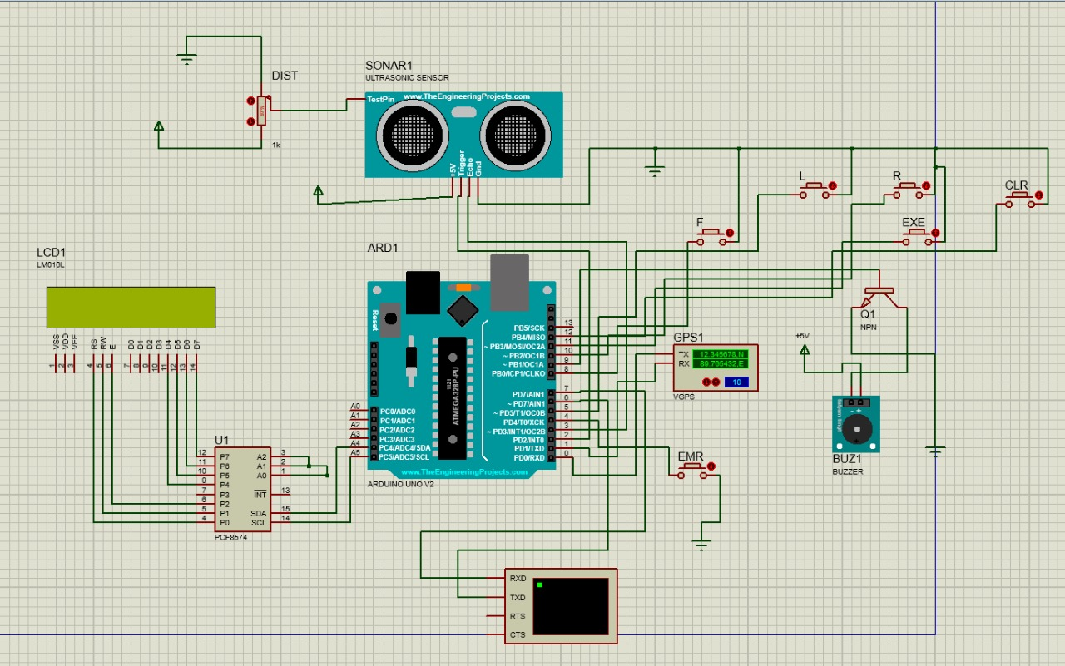

**4.Experimental Setup**

**4.1 Implementation Details**

**Arduino UNO**

The Arduino Uno is one of the most popular and widely used microcontroller boards based on ATmega328p.It operates on 5V voltage and having clock speed of 16MHz.It contains 6 analog pins and 15 digital I/O pins out of which 6 are PWM.

**SONAR1 Ultrasonic Sensor:**

SONAR1 Ultrasonic Sensor sends out ultrasonic sound waves that emit frequencies above human range, typically 40 kHz. It emulates real-world ultrasonic sensors such as HC-SR04. The distance from the object is calculated by determining how long it takes the wave to go out to the object and come back.

**GPS Module:**

A GPS module is a device that receives the signals transmitted by GPS satellites and gives out current location data.

**Table 1: Implementation Details**

|  |  |  |  |
| --- | --- | --- | --- |
| **Components** | **Input** | **Process** | **Result** |
| Arduino Pro Mini | Data from sensors (Ultrasonic, Light, Water, GPS) | Processes these data based on instructions which are programmed | Controls alerts (buzzer), manages GPS communications |
| Ultrasonic Sensor | Echo from the transmitted ultrasonic wave | Measures the differences of time between sent and received waves | Calculates distance and alerts(buzzer) the user if an obstacle is detected |
| GPS Module | GPS satellite signals | Receives satellite signals to determine the location | Gives real-time location coordinates |
| LCD I2C | Data to be shown | Process this data | Display |
| Buzzer | Commands | Process these commands | Produce alert sound |

**4.2 Experimental Results**

|  |  |  |  |
| --- | --- | --- | --- |
| **Components** | **Input Condition** | **Expected Result** | **Actual Result** |
| Ultrasonic Sensor | Obstacle at 2 meters | Buzzer should not sound | Buzzer remains silent |
| Ultrasonic Sensor | Obstacle at 25cm | Buzzer should sound | Buzzer sounds as expected |
| GPS Module | User presses emergency button | Accurate GPS location should send | GPS location sent with slight inaccuracy and delay |
| System response time | User encounters an obstacle | Immediately | Response time is of 7.50 seconds |

**5.Conclusion and Future Work**

The developed smart stick that is integrated with multiple sensors will help in navigating the way while walking and keep alerting the person if any sign of danger or inconvenience is detected. Also, for any emergency user can be able to send alert messages to its relatives with live location. Thus, the system is also allowing the user to move independently and securely both indoors and outside. The device’s design is adaptable and can be improved further with additional sensors or decision-making capabilities, making it suitable for a variety of environments and user needs. Furthermore, the system’s lightweight design, combined with its efficient performance, makes it an ideal tool for independent mobility.

The future scope of existing system is to guide and ensure full safety to visually impaired people. The further upgradation in this system is integrating a machine learning object detection system with voice navigation, as this advance technology will enable to provide more awareness about the environment and alert in case of danger. It will also feature the remote control, making the stick easier to find if lost by making a buzzer to sound. Also integrating some other advance technology will help to provide more accurate results which can lead to more comfort for visually impaired people. Further better database can also be added to store multiple maps and providing much better navigation.

**6.References:**

1. [Raghu N, Yogesh Kumaran , Rajeswari , Hemanth – Design and Implementation of Smart Blind Stick for Obstacle Detection and Navigation System](https://www.researchgate.net/publication/379844237_Design_and_Implementation_of_Smart_Blind_Stick_for_Obstacle_Detection_and_Navigation_System)
2. [Ronak Panchal, Sneha Sankhe, Saad Khan, Vishal Singh - Blind Stick for visually impaired people](https://www.irjet.net/archives/V8/i5/IRJET-V8I588.pdf)
3. [Amira. A. Elsonbaty- Smart Blind Stick Design and Implementation](https://www.ijeat.org/wp-content/uploads/papers/v10i5/D25350410421.pdf)
4. [Ashraf Anwar , Sultan Aljahdali- A Smart Stick For Assisting Blind People](https://www.iosrjournals.org/iosr-jce/papers/Vol19-issue3/Version-2/O1903028690.pdf)
5. [Premarajan Akhil ,Ramadas Akshara ,Sriniwasan Padmanaban-Smart Blind Walking Stick with Integrated Sensor](https://www.mdpi.com/2673-4605/10/1/12)
6. [S. Sharmila, P.Sai Teja, P. Shanmukh Sagar Kumar, Y. Bhaskara Rao, S. Venkata Ramanaji Kalla- Smart Blind Stick](https://www.ijert.org/smart-blind-stick-3)
7. [Aman Srinivas, Thrimadas Srikanth, Madhusudhan-Smart Blind Stick using Arduino](https://www.jetir.org/papers/JETIR2004105.pdf)
8. [Dheeraj Dhanvee, Sree Chandana, Harish-Blind Mate: A Friend to The Blind](https://ieeexplore.ieee.org/document/9028921)
9. [Sameer Grover, Ayesha Hasan, Kumar Yashawi- Smart Blind Stick](https://www.internationaljournalssrg.org/IJECE/paper-details?Id=347)