MID PROGRESS REVIEW
CPU Scheduling and Memory Management Visualization Tool
Operating Systems Lab (BCSE303P) | Review date: 24 September 2026

1. Project Title & Team Details
Project title | CPU Scheduling and Memory Management Visualization Tool (named OS Visualizer in the application)
Course | Operating Systems Lab, BCSE303P
Department / School | [Department / School]
Institution | [Institution name]
Guide / faculty | [Faculty guide name]
Semester / year | [Semester and academic year]
Review stage | Mid progress check, measured against the project proposal

# | Team member | Registration no.
1 | Boddepalli Naveen | 24BCE0512
2 | Rohan Anand CH | [Reg. no.]
3 | S Yeshwanth | [Reg. no.]

2. Introduction & Background

Project background
CPU scheduling and memory management are two of the most demanding topics in an introductory Operating Systems course. They are usually taught with static textbook diagrams and Gantt charts worked out by hand. This project is an interactive, browser-based tool: the student sets up a workload, picks an algorithm, and watches the result unfold. For scheduling, a Gantt chart builds tick by tick beside the ready queue and the running process. For memory, a frame table shows every page hit, page fault and eviction as it happens.

Context of the problem
- Students memorise the steps of FCFS, SJF, Priority, Round Robin, FIFO, LRU and Optimal without seeing how the decisions play out over time or under different workloads.
- The trade-offs the course cares about only appear when runs are compared: SJF gives a lower average wait but can starve long jobs; FIFO can fault more when it is given more frames, while LRU cannot.
- Existing simulators tend to be either too simple to show these effects, or too complex and code-heavy to use as a quick aid during a lab session.

Why the project is relevant to Operating Systems
Both halves of the project implement core OS mechanisms rather than merely illustrating them. The scheduler simulation reproduces what a kernel dispatcher does: it keeps a ready queue, picks the next process by a policy, preempts on a quantum or a better arrival, and accounts for idle time. The memory simulation reproduces demand paging: pages are loaded into a fixed set of frames, a miss raises a page fault, and a replacement policy chooses a victim. The tool also computes the criteria the course uses to judge these mechanisms (waiting, turnaround and response time, CPU utilization, page-fault rate). Section 5 maps each OS concept to the part of the code that implements it.

3. Problem Statement

Problem being addressed
Students can state what a scheduler or a page-replacement policy does, but find it hard to reason about how its decisions change over time and why one policy beats another on a given input. There is no quick way, during a lab session, to configure a workload, run it, and see the behaviour rather than only the final numbers.

Existing issue or limitation
- Static output. Textbook diagrams and hand-drawn Gantt charts show only the end result, not the moment a decision was made (for example, the tick at which SRTF preempts a running process).
- Manual comparison. Comparing two algorithms on the same input means redoing the work by hand, so the comparison is rarely made.
- Wrong level of detail. Many available simulators are either too simplistic to show the effects clearly, or too complex and code-heavy for quick use in a lab.

Scope of the project
In scope (version 1) | Planned next (version 1.1) | Out of scope
FCFS, SJF (non-preemptive), SRTF, Priority (non-preemptive and preemptive), Round Robin  FIFO, LRU and Optimal page replacement  Metrics for both areas  Custom input and random workloads  Side-by-side comparison of two algorithms | Internal and external fragmentation for fixed and variable partitions, with first-fit, best-fit and worst-fit placement  Built last because it is the most independent piece and the safest to defer | Segmentation: named in the proposal's problem statement but not in its objectives, so it was dropped to keep version 1 shippable  Context-switch cost (switches are counted but take zero time)  Multiple CPUs and I/O bursts (each process is a single CPU burst)

4. Objectives

Main objective
To build a lightweight, interactive, browser-based tool that lets a student configure a workload, run it through a chosen CPU scheduling or page-replacement algorithm, and see the behaviour animated together with its performance metrics, so that the trade-offs between algorithms become visible instead of memorised.

Specific objectives
- O1 Scheduling engines. Simulate FCFS, SJF (preemptive and non-preemptive), Priority and Round Robin.
- O2 Memory engines. Simulate paging with FIFO, LRU and Optimal replacement, and visualise internal and external fragmentation for fixed and variable partitions.
- O3 Animated Gantt chart. Update in real time as the simulation progresses, not only at the end.
- O4 Frame and page-table view. Highlight faults, hits and eviction decisions as they occur.
- O5 Metrics. Show average waiting, turnaround and response time, CPU utilization and page-fault rate for every run.
- O6 Comparison mode. Evaluate two algorithms side by side on an identical workload.
- O7 Flexible input. Accept custom process sets and memory configurations, or generate random workloads.
- O8 Decoupled engine. Keep the simulation engine separate from the visualisation so new algorithms need minimal UI changes.

Expected outcome
- A web application that runs from a plain folder (npm start) and, at the end of version 1, from a shareable GitHub Pages link.
- A CPU scheduling tab, a memory tab and a comparison mode, all driven by the same playback controls.
- Results verified against worked examples from the standard textbook (Silberschatz), so the numbers can be trusted in a demo.
- An engine that is easy to extend: a policy that orders processes by a key is one entry in the ALGORITHMS table.

5. Methodology / System Design

Proposed approach
- Precompute, then play back. The engine runs the whole simulation up front and returns an array of snapshots; the user interface only plays them back (play, pause, step, scrub, speed). This gives the live animation, makes comparison mode a matter of two runs on one clock, and keeps the engine free of UI code so it can be tested on its own.
- Unit-time ticks instead of an event queue. One tick per time unit keeps preemption (SRTF, preemptive priority, Round Robin) simple. The Gantt chart merges consecutive ticks into blocks.
- Test against known answers. Each algorithm is checked against worked textbook examples before its interface is built.
- Plain JavaScript modules and SVG. No framework, no build step and no runtime dependencies, so the project runs anywhere a browser does.

System architecture
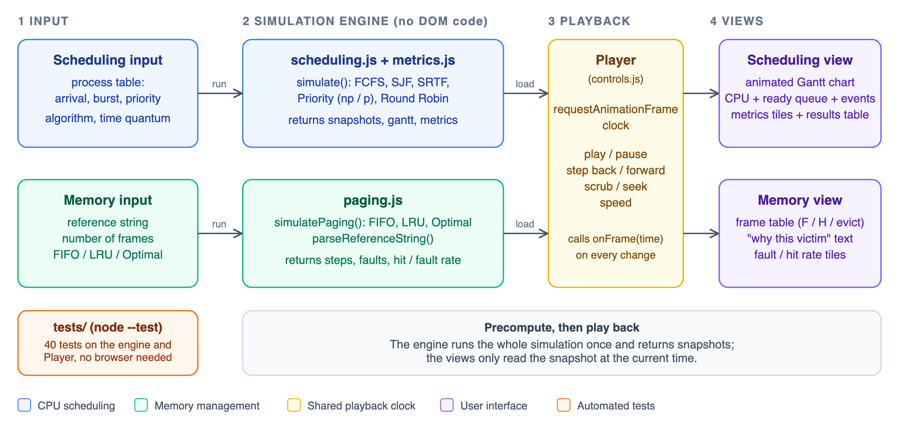
Figure 1. Architecture: input, simulation engine, shared playback clock and views.
simulate(processes, algorithm, { quantum }) returns the state at every tick (running process, ready queue, remaining time, events), the merged Gantt blocks, per-process results and the summary metrics. simulatePaging(refs, frames, algorithm) returns one step per page reference: the page, hit or fault, the frame touched, the evicted page with the reason it was chosen, and the frame contents.

Technologies and tools
Area | Choice | Purpose
Language | JavaScript (ES modules) | Engine and interface, no framework or build step
Rendering | HTML5, CSS3, SVG | Gantt chart and frame table; layout adapts to narrow screens; respects the reduced-motion setting
Animation | requestAnimationFrame | Playback clock that drives every view
Testing | Node.js 24, node --test | Automated tests with no external packages
Serving | Python http.server via npm start | ES modules need http, not file://
Version control | Git | Project history and later deployment to GitHub Pages

OS concepts implemented
OS concept | How it appears in the project
Ready queue, dispatch, context switch | Every snapshot lists the running process and the ready queue in the order the scheduler will pick from it; the context-switch count is a reported metric
Preemption and time quantum | SRTF and preemptive priority switch only for a strictly better process; Round Robin returns a process to the back of the queue when its quantum expires
Scheduling criteria | Waiting, turnaround and response time, CPU utilization, throughput, total time
Convoy effect and starvation | Presets and on-screen hints (FCFS convoy, SJF starvation risk)
Demand paging and page faults | A fixed set of frames; a reference is a hit if the page is resident, otherwise a fault
Page replacement | FIFO, LRU and Optimal, each with a plain-language explanation of why a victim was chosen
Belady's anomaly and locality | Presets show FIFO faulting more with more frames, LRU thrashing on a cyclic scan, and a hot working set
Internal / external fragmentation | Planned (milestone M7): fixed and variable partitions with first, best and worst fit

Rules the engine follows
These rules are fixed so that the results are deterministic and the tests can rely on them.
- Ties go to the earlier arrival, then to input order (P1 before P2). A tie never causes preemption.
- For Priority scheduling a lower number means higher priority.
- In Round Robin, a process arriving at the same tick a quantum expires joins the queue before the preempted one. A lone process simply keeps the CPU.
- CPU idle gaps are shown on the Gantt chart and count against utilization (busy ticks divided by elapsed ticks). Response time is first time on the CPU minus arrival.
- When several pages are never used again, Optimal evicts the one loaded first.

Major modules
Module | File | Responsibility | Status
Scheduling engine | src/engine/scheduling.js (221 lines) | Six algorithms, snapshots, Gantt blocks, input validation | Done
Metrics | src/engine/metrics.js (28) | Averages, CPU utilization, throughput, context switches | Done
Paging engine | src/engine/paging.js (124) | FIFO, LRU, Optimal; reference-string parser | Done
Playback clock | src/ui/controls.js (139) | Player plus transport bar: play, pause, step, scrub, speed, keyboard | Done
Gantt chart | src/ui/gantt.js (105) | SVG chart built once per run, cheap per-frame update | Done
Scheduling view | src/ui/schedulingView.js (239) | Process table, algorithm picker, Now panel, results table | Done
Frame table | src/ui/frames.js (62) | Fault, hit and eviction highlighting | Done
Memory view | src/ui/memoryView.js (141) | Reference-string input, eviction explanation, statistics | Done
Presets and shell | presets.js, main.js, index.html, css/style.css | 11 example workloads, tabs, layout | Done
Compare mode | src/ui/compare.js | Two algorithms, one input, one shared clock | Planned
Workload generator | src/engine/workload.js | Random processes and reference strings | Planned
Fragmentation | to be added | Fixed and variable partitions, first, best and worst fit | Planned

6. Work Completed / Current Progress

Activities completed so far
- Studied the proposal and fixed the scope: segmentation dropped, fragmentation deferred to a last milestone.
- Wrote a milestone plan (M0 to M7) with the engine interface and the tie-breaking rules agreed before coding.
- Built the scheduling engine with six algorithms and the metrics module.
- Built the paging engine with three replacement policies and its reference-string parser.
- Built both user interfaces on one shared playback clock: the CPU scheduling tab and the memory tab.
- Wrote 40 automated tests, including worked textbook examples and randomised checks, and ran both tabs in a browser.

Milestone status
# | Milestone | Done when | Plan | Status
M0 | Project scaffold | Page loads and npm test runs | 0.5 h | Done
M1 | Scheduling engine and metrics | Golden tests pass | 3 h | Done
M2 | Process input, animated Gantt, controls, metrics panel | Enter processes and watch a Gantt build | 4 h | Done
M3 | Paging engine (FIFO, LRU, Optimal) | Golden tests pass | 2.5 h | Done
M4 | Frame-table view and playback | Reference string animates step by step | 3 h | Done
M5 | Compare mode | Both modes work | 2.5 h | Planned
M6 | Random workloads, presets, polish, deployment | Shareable link | 2 h | Planned
M7 | Fragmentation (version 1.1) | Partition view and tests | 4 h | Planned

Overall: 5 of 8 milestones are complete. Version 1 (M0 to M6) is about 72% complete by planned effort (13 of 18 hours); including fragmentation the whole project is about 59% complete (13 of 22 hours). The hours are planning estimates, not measured time.

Progress against the proposal objectives
Objective | Status | Evidence
O1 Scheduling engines | Done | FCFS, SJF, SRTF, Priority (both kinds), Round Robin; all match textbook results
O2 Memory engines | Partial | FIFO, LRU, Optimal done; fragmentation is milestone M7
O3 Animated Gantt chart | Done | Chart builds as time advances; Figure 2
O4 Frame and page-table view | Done | F / H per reference, evicted page marked, reason explained; Figure 3
O5 Metrics | Done | All five requested metrics shown, plus context switches, hit rate and total time
O6 Comparison mode | Planned | Milestone M5; the engine already returns everything it needs
O7 Flexible input | Partial | Editable process table, reference string and frame count, 11 presets done; random generator is M6
O8 Decoupled engine | Done | Engine has no browser code and is tested directly in Node

Development and testing progress
The project has about 1,600 lines of application code and about 490 lines of tests. npm test runs 40 tests, all passing (last run on 24 September 2026):
Test file | Tests | What it checks
tests/scheduling.test.js | 18 | Textbook averages for every algorithm, tie-breaking, idle time, Round Robin edge cases, input errors, and rules that must hold on 200 random workloads for every algorithm
tests/paging.test.js | 16 | Fault counts for FIFO, LRU and Optimal, Belady's anomaly, the parser, input errors, and rules that must hold on 300 random reference strings
tests/player.test.js | 6 | Playback clock: clamping, stepping, seeking, end-of-run replay, backgrounded-tab jumps

The engine output was compared against the worked examples used in the tests:
Scenario | Expected | Engine result | Match
FCFS, bursts 24 / 3 / 3, all arrive at 0: average waiting time | 17 | 17 | Yes
SJF, bursts 6 / 8 / 7 / 3: average waiting time | 7 | 7 | Yes
SJF, arrivals 0 / 1 / 2 / 3, bursts 8 / 4 / 9 / 5: average waiting time | 7.75 | 7.75 | Yes
SRTF, same workload: average waiting time | 6.5 | 6.5 | Yes
Priority (non-preemptive), five processes: average waiting time | 8.2 | 8.2 | Yes
Round Robin, quantum 4, bursts 24 / 3 / 3: average waiting time | 5.66 | 5.667 | Yes
Reference string 7,0,1,2,0,3,0,4,2,3,0,3,2,1,2,0,1,7,0,1 with 3 frames: faults for FIFO / LRU / Optimal | 15 / 12 / 9 | 15 / 12 / 9 | Yes
Belady's anomaly string, FIFO: faults with 3 and 4 frames | 9 and 10 | 9 and 10 | Yes

Current project status
Both tabs work end to end. A student can edit the process table or the reference string, choose an algorithm, and play, pause, step, scrub or change the speed of the animation. Invalid input produces a message that names the problem instead of a blank screen. Comparison mode, the random workload generator and fragmentation are not started yet.
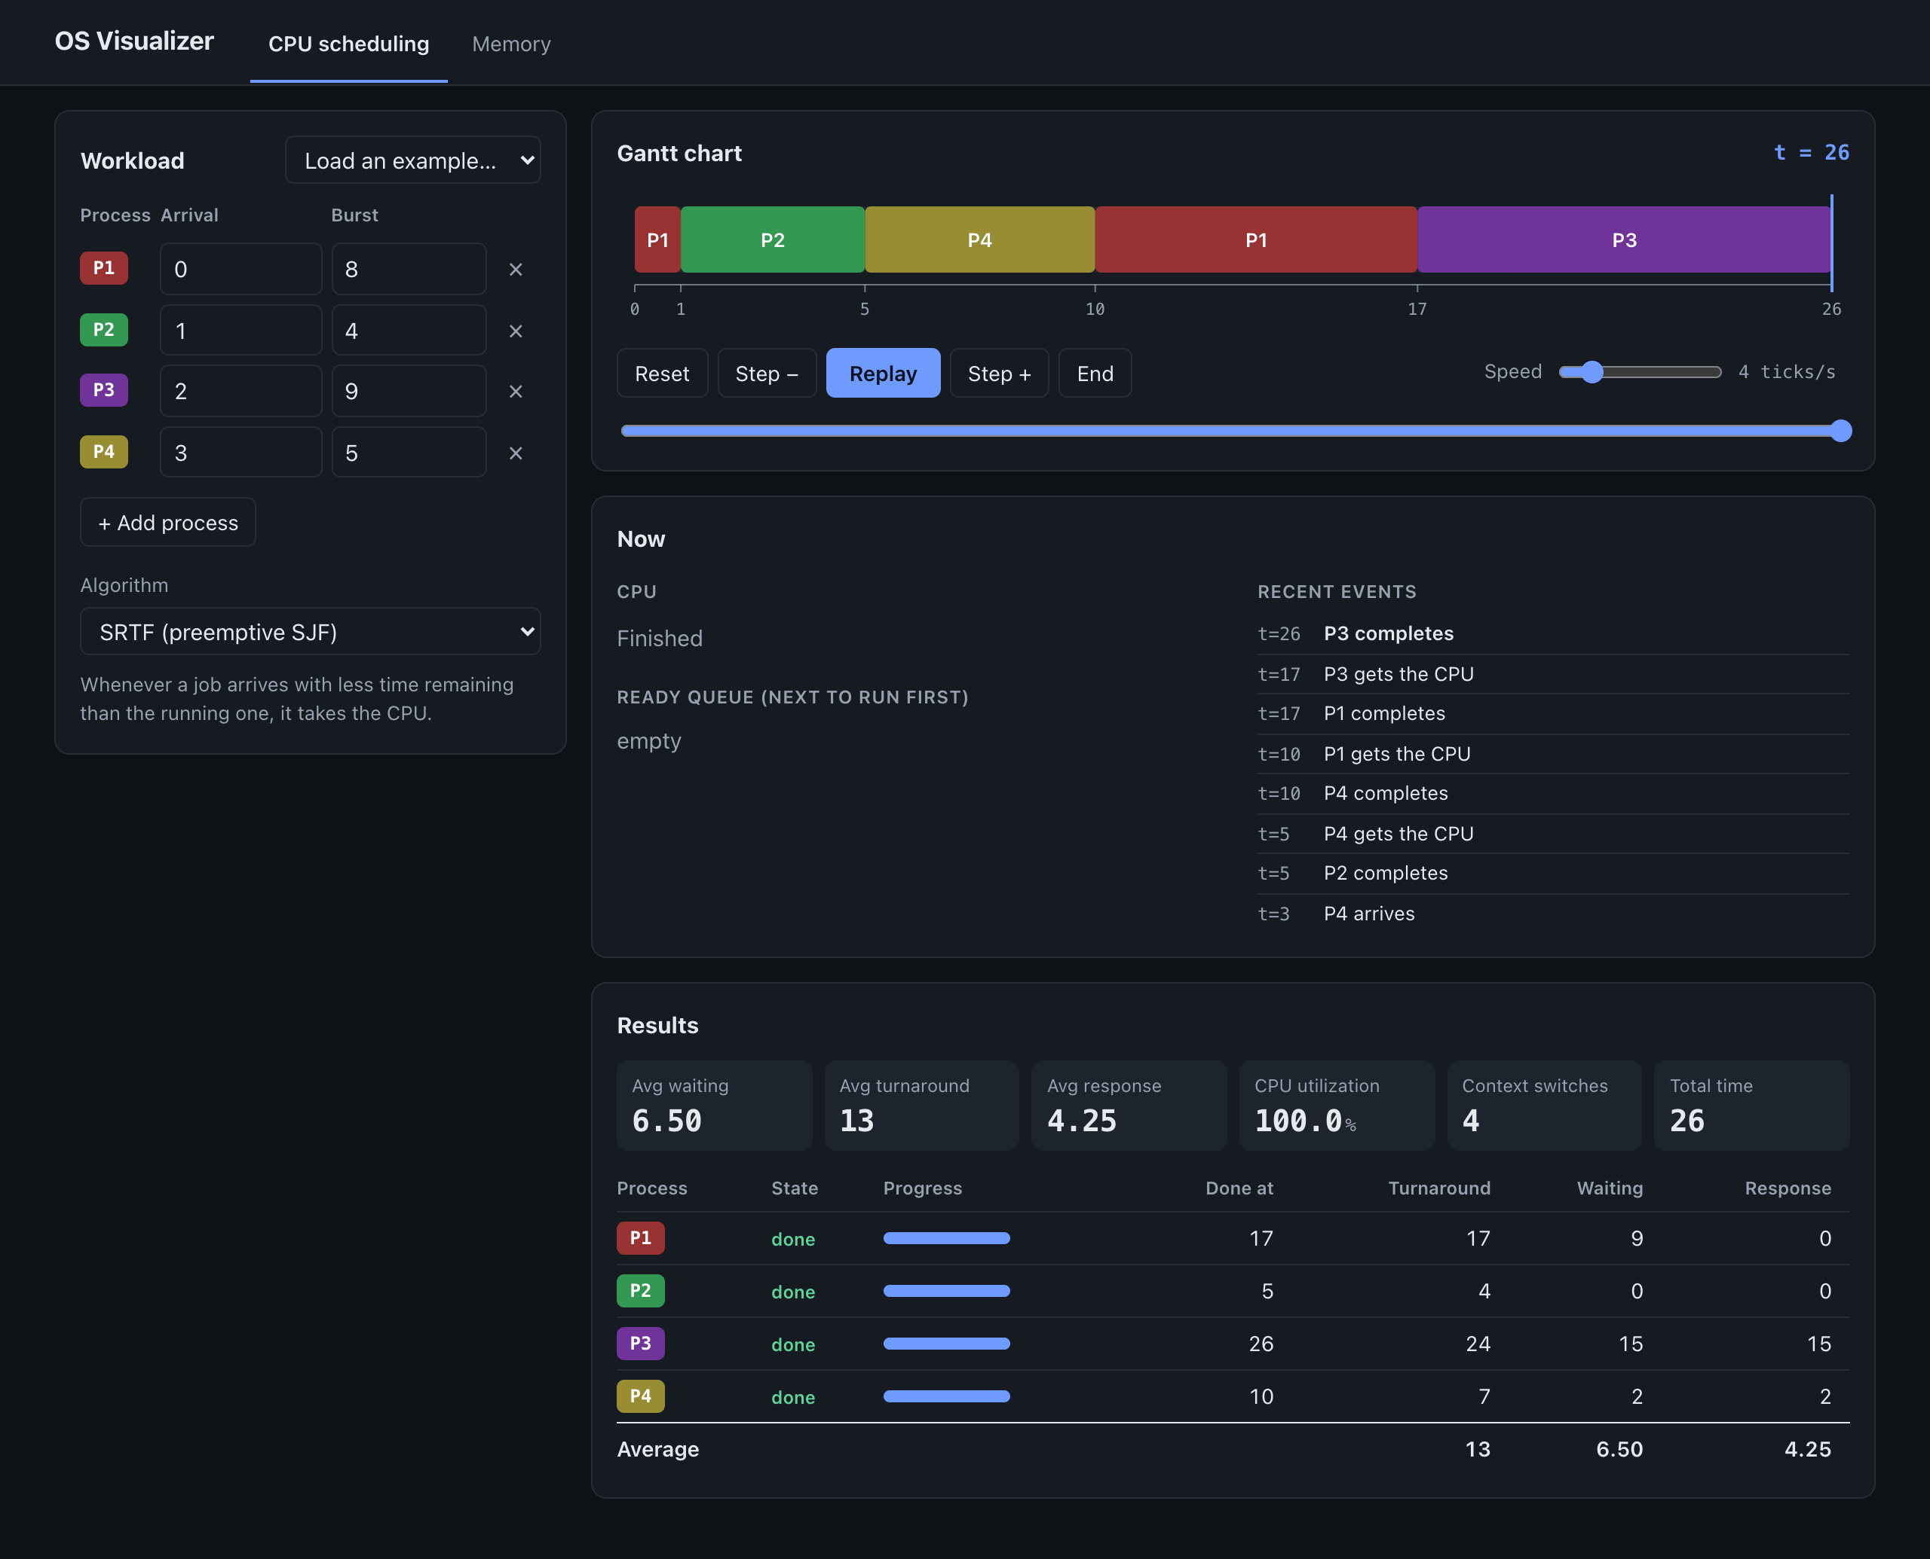
Figure 2. CPU scheduling tab: SRTF on four processes, shown at the end of the run (average waiting time 6.50).
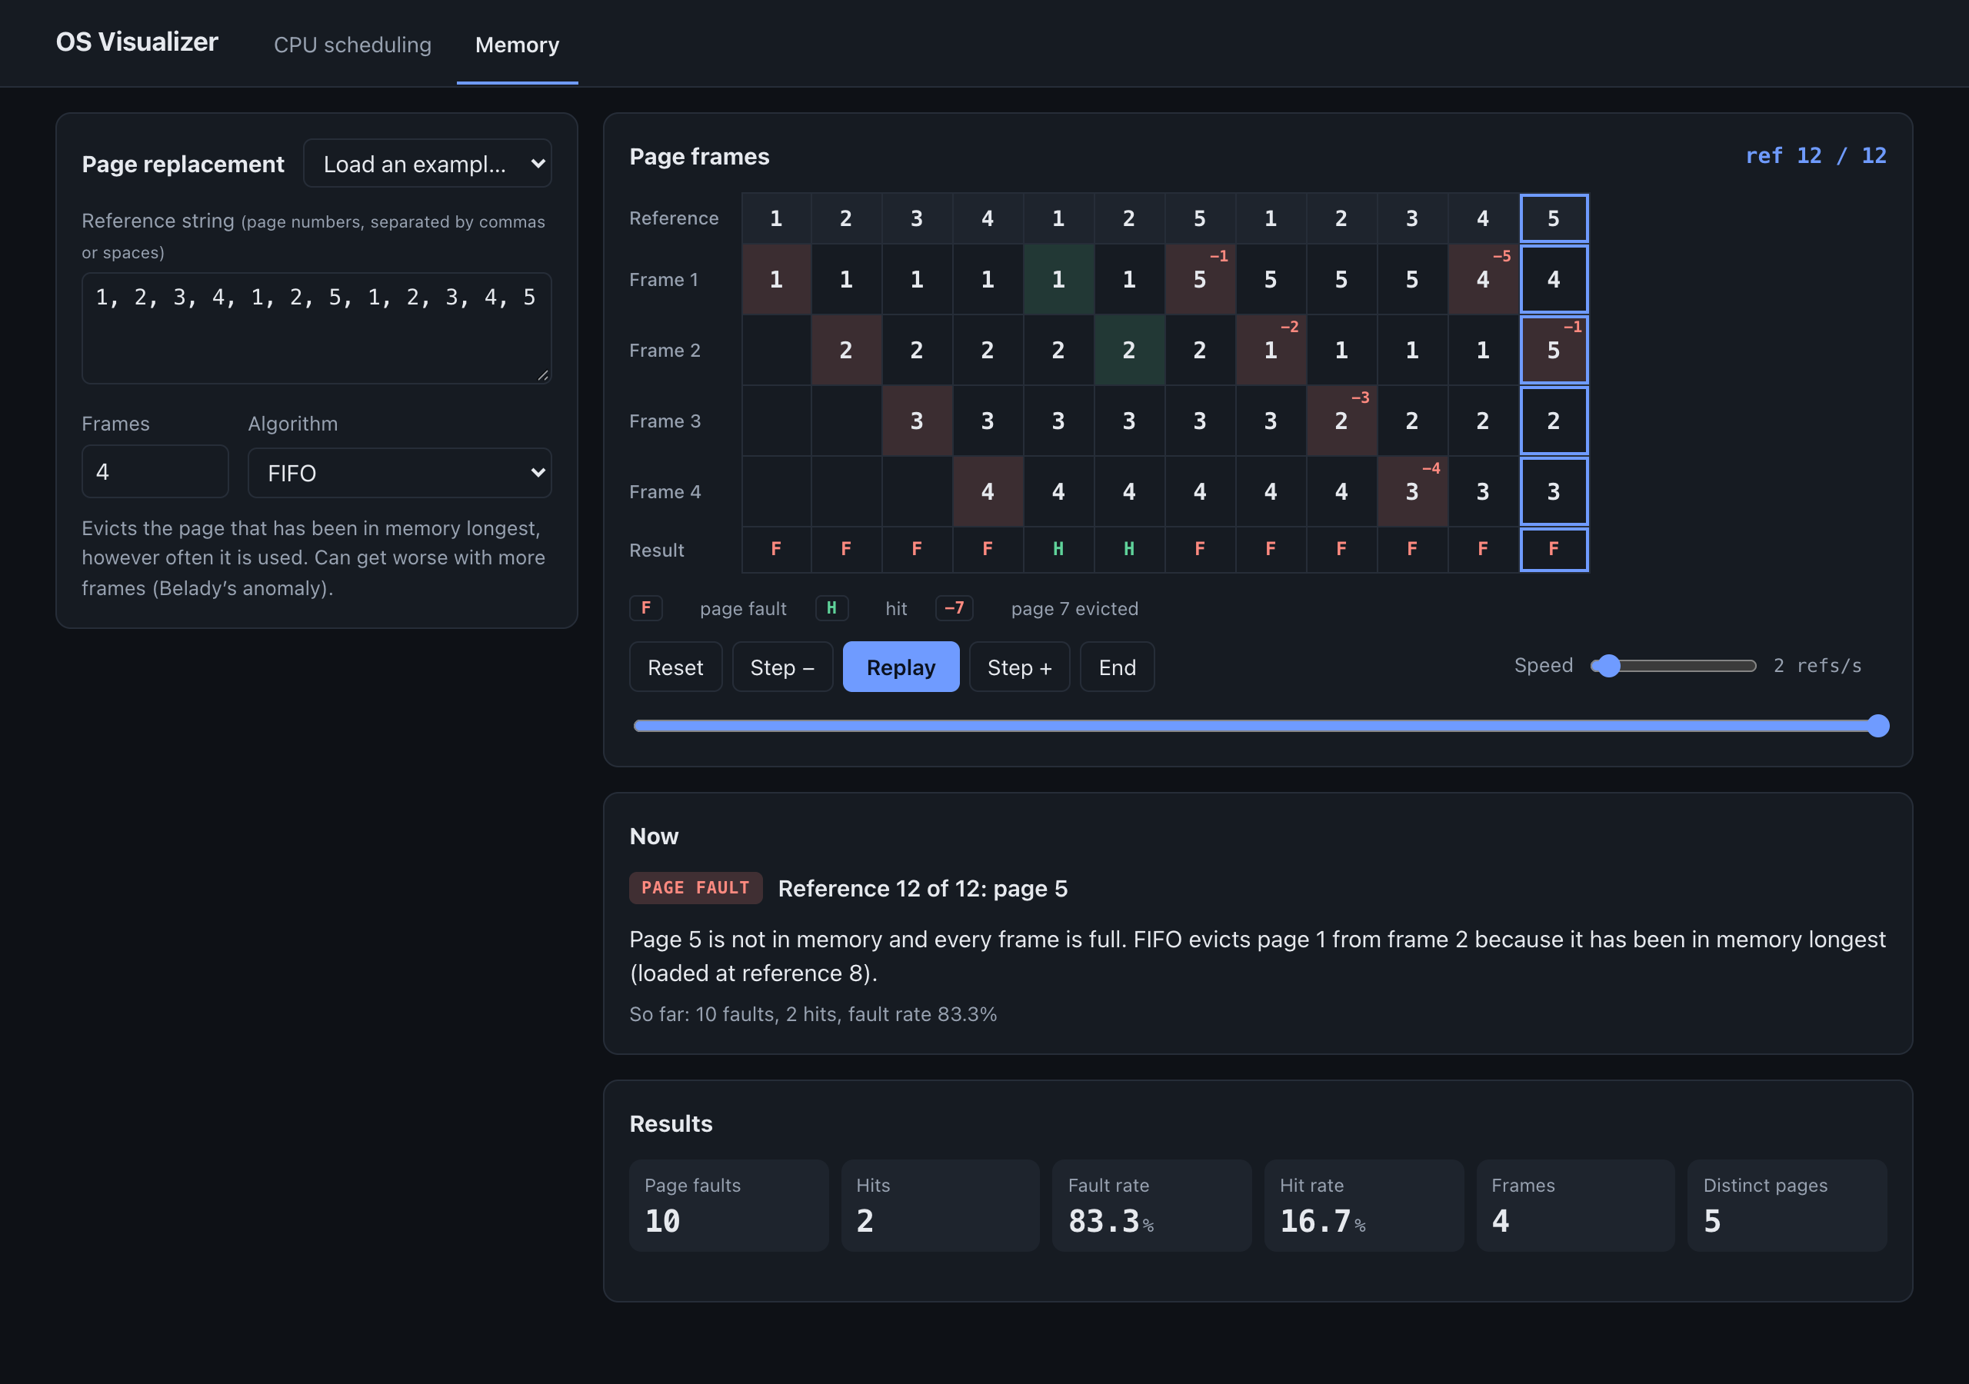
Figure 3. Memory tab: FIFO with 4 frames on the Belady string. Red cells mark evictions (−n is the page removed), green cells mark hits; 10 faults, one more than with 3 frames.

7. Last Contributions / Recent Progress

Most recent work completed
The two most recent milestones are M3 (paging engine) and M4 (frame-table view). With them, the memory tab is fully working and the project covers both areas named in the proposal, apart from fragmentation.

New functionality and improvements
Area | What was added
Paging engine | FIFO, LRU and Optimal replacement with hit and fault counts and rates; a reference-string parser that accepts commas, spaces and semicolons and reports the exact bad token
Frame-table view | One column per reference showing frame contents, F or H, the evicted page, and the current reference highlighted
"Now" explanation | Each eviction is explained in words, for example "FIFO evicts page 1 from frame 2 because it has been in memory longest (loaded at reference 8)"
Memory tab and navigation | Tabs with #scheduling and #memory addresses; the hidden tab's animation is paused
Playback clock | One clock for both tabs with play, pause, step, scrub, speed, and Space / arrow-key shortcuts; a backgrounded browser tab cannot make time jump ahead, and pressing Play at the end restarts the run
Robustness | Validation messages that name the offending process; a 100,000-tick limit so a typo cannot freeze the page; the Gantt chart rebuilds when the window is resized
Examples | 5 memory presets (textbook string, Belady's anomaly with 3 and 4 frames, cyclic scan, locality) alongside 6 scheduling presets
Tests | Grew to 40, adding paging tests and playback-clock tests

Contributions since the proposal
At proposal stage the project existed as a written problem statement, solution and objectives. It is now a running application with a tested simulation engine, two interactive views and a plan for what remains.

Current achievements and results
Scheduling. The same workload (arrivals 0, 1, 2, 3; bursts 8, 4, 9, 5) run through four algorithms shows the trade-offs the course describes. SRTF gives the lowest average waiting time. Round Robin gives a response time close to SRTF's but the highest waiting time and the most context switches.
Algorithm | Avg waiting | Avg turnaround | Avg response | Context switches
FCFS | 8.75 | 15.25 | 8.75 | 3
SJF (non-preemptive) | 7.75 | 14.25 | 7.75 | 3
SRTF (preemptive SJF) | 6.50 | 13.00 | 4.25 | 4
Round Robin, quantum 4 | 11.75 | 18.25 | 4.50 | 7

Memory. On the textbook reference string with 3 frames, Optimal faults least, LRU next and FIFO most. On the Belady string, FIFO with 4 frames faults more (10) than with 3 frames (9), which is the anomaly the course describes; LRU (10 to 8) and Optimal (7 to 6) improve with more frames.
Reference string | Frames | FIFO faults | LRU faults | Optimal faults
Textbook, 20 references | 3 | 15 | 12 | 9
Textbook, 20 references | 4 | 10 | 8 | 8
Belady, 12 references | 3 | 9 | 10 | 7
Belady, 12 references | 4 | 10 | 8 | 6

8. Remaining Work & Future Plan

Pending tasks
Milestone | Task | Plan
M5 Compare mode | Run two algorithms on one identical input, side by side, on one shared clock, for both CPU scheduling and page replacement | 2.5 h
M6 Workloads and release | Random workload generator for processes and reference strings; more presets; visual polish; deploy to GitHub Pages for a shareable link | 2 h
M7 Fragmentation | Fixed and variable partitions with first-fit, best-fit and worst-fit; a partition view showing internal and external fragmentation | 4 h
Course deliverables | Project report and demonstration; format and deadline still to be confirmed | not estimated

Remaining planned effort for the software is about 8.5 hours, plus the report and demonstration.

Testing and validation still required
- Compare mode: both runs share one clock, end together, and produce the same numbers as when run alone.
- Workload generator: results are reproducible from a seed and always within the allowed ranges.
- Fragmentation: golden tests from textbook first-fit, best-fit and worst-fit examples, in the same style as the existing tests.
- Browsers and screens: manual check in Chrome, Firefox and Safari and on a phone-width screen; keyboard-only walkthrough of both tabs.
- Usability: let a few classmates use the tool without instructions and note where they get stuck.

Expected final outcome
- A deployed, shareable web tool covering all eight objectives: six scheduling algorithms, three page-replacement policies, fragmentation for fixed and variable partitions, animated views, metrics, comparison mode and random workloads.
- A test suite that covers every algorithm against known answers.
- A short report and live demonstration built around the presets, such as the convoy effect, SRTF preemption and Belady's anomaly.

Timeline for completion
Weeks are counted from this review and will be aligned with the lab's final submission date once it is confirmed.
When | Target | Outcome
Week 1 | M5 Compare mode | Two algorithms compared side by side
Week 2 | M6 Workloads, polish, deployment | Random workloads and a live shareable link (version 1 complete)
Week 3 | M7 Fragmentation and its tests | Partition view working (version 1.1)
Week 4 | Full validation, report, demonstration rehearsal | Final submission ready

Risk | Mitigation
Fragmentation takes longer than planned | It is the last milestone and independent of the rest, so version 1 can be released without it
Compare mode makes the layout crowded | The engine already returns full results, so the work is layout only; use a stacked layout on narrow screens
Deadline or report format changes | Confirm with the faculty guide now; the milestone order lets the deliverable stop at any finished milestone

