Procedural Terrain Generation with Generative Adversarial Networks (GANs)

20PT17-Naveen Kumar A A 20PT19-Nikhilesh S P 20PT34-Srivatsan R 20PT37-Tejas Srinivas

This project explores the use of Generative Adversarial Networks (GANs) for procedural terrain generation, a technique traditionally reliant on handcrafted algorithms. We leverage recent advancements in deep generative modelling to learn and synthesize realistic terrains based on real-world data.

The project utilizes openly available satellite imagery from NASA to train two GANs:

* **DCGAN (Deep Convolutional Generative Adversarial Network):** Learns the underlying distribution of terrain heights.
* **pix2pix GAN:** Translates a low-resolution "altitude image" (representing desired terrain features) into a high-resolution, photorealistic terrain image.

By combining these networks, the project aims to achieve:

* **Automatic Terrain Creation:** Generate realistic terrains with minimal user input, reducing the need for manual design.
* **Data-Driven Approach:** Leverage real-world data to create terrains that are statistically similar to real-world landscapes.
* **Increased Realism:** Produce high-resolution, photorealistic terrains that enhance the visual quality of games or simulations.

This project represents a preliminary step towards GAN-based procedural terrain generation. Future work could involve:

* Joint training of DCGAN and pix2pix GAN for potentially better results.
* Integration of segmentation pipelines to classify different terrain types (e.g., forests, mountains).

This project holds promise for automating terrain creation and improving the realism of virtual environments in games, simulations, and other applications.

# Generated textures from DCGAN (training):

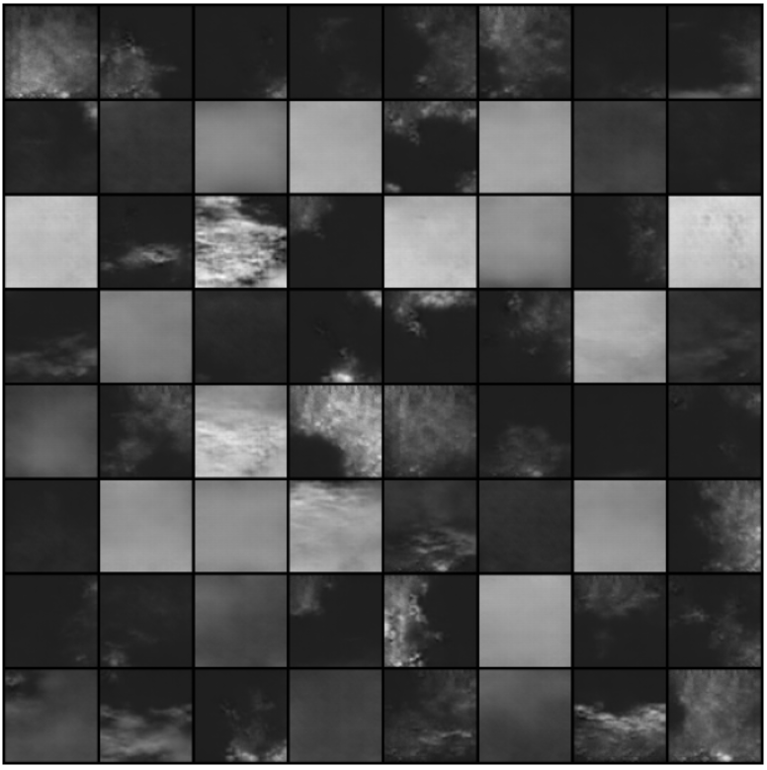

# Generated textures from DCGAN (testing):

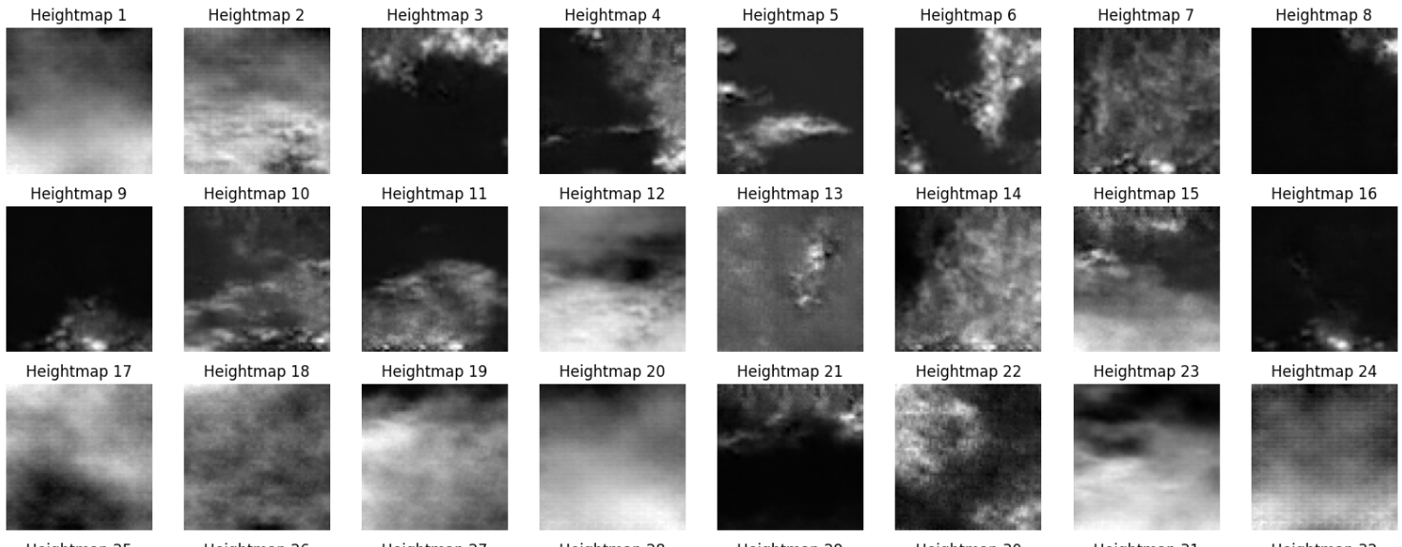

# Generated textures from pix2pix GAN (training):

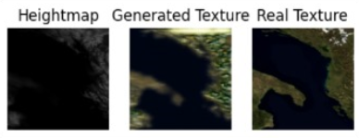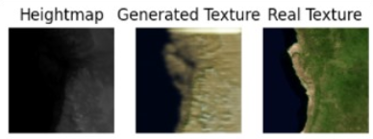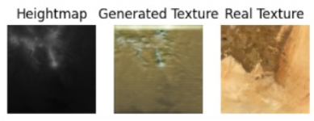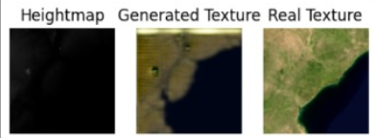

# Generated textures from pix2pix GAN (testing):

