JVM ARCHITECTURE

Vitual Machine: It is a software simulation of a machine which can perform opertions like a physical machine.
There are two types of virtural machines.
1. Hardware based/ System based virtual machines.
2. Application based/ Process based virtual machines.
1. Hardware based/ System based virtual machines:
These provide several logical systems on the same machine with strong isolation from each other i.e., on one physical machine we are defining multiple logical machines.
The main advantage of this kinda jvm is, hardware resource sharing and improves the utilization of
hardware resources.
Examples: KVM(Kernal based virtual machines for linux systems), vmware, xen, cloud computing

2. Application based/Process based virtual machines:
These virtual machines act as runtime engine to execute particular programming language
applications.
Examples: JVM, PVM(Parrot Virtual Machine) for perl, CLR(Common Language Runtime) for .Net applications

JVM:
Jvm is part of JRE and it is responsible to load and run java class files. Below is the architectural diagram of JVM.

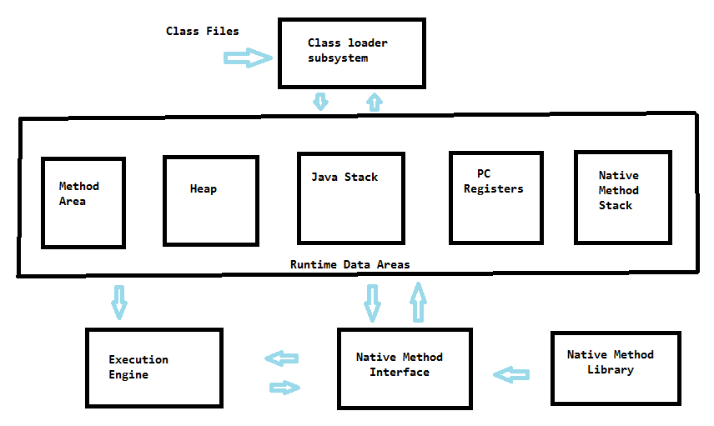

Class Loader Subsystem:
It is responisble for following three activities.
- Loading
- Linking
- Initialization
Loading:
Reads all the class files and stores the corresponding binary data in method area. For each and every class file jvm stores corresponding information in method area. That information includes
- Fully qualified name of class
- Fully qualified name of immediate parent class
- Methods information
- Variable information
- Constructor information
- Modifiers information
- Constant pool information
After loading .class files, immediately jvm creates a java.lang.class object for the loaded classes on the method area. A java.lang.class represents any loaded class which contains information of
methods, constructors, variables etc.
Note: For every loaded class only one java.lang.class object is created even if any object is used multiple times in a program. And this happens only once that is during class loading time.
Refer below program to understand this concept:

package org.mnr.jvm_29;
import java.lang.reflect.Method;
import java.util.Arrays;

public class JavaLangClassExample {
public static void main(String[] args) throws ClassNotFoundException
{
Class c1 = Class.forName("org.mnr.jvm_29.Student");
Method[] m= c1.getDeclaredMethods();
System.out.println(Arrays.toString(m));
// below is the output
//[public int org.mnr.jvm_29.Student.getId(), public //java.lang.String org.mnr.jvm_29.Student.getSchool()]
Student s1 = new Student();
Student s2 = new Student();

Class c2 = s1.getClass();
Class c3 = s2.getClass();
System.out.println(c2==c3);//true
// means both refs are pointing to same object
System.out.println(c2.hashCode());//364465875
System.out.println(c3.hashCode());//364465875
}
}
class Student{
public Student() {
}
public String getSchool(){
return "AITS";
}
public int getId(){
return 13123;
}
}
As you can observe from the above code, two different objects of Student class created but both
object references have same java.lang.class object.

Linking: Linking consists of three phases.
- Verify
- Prepare
- Resolve
Verify: It is the process of ensuring that binary coe of a .class file is structurally correct or not.
Byte Code Verifier is responsible to perform this activity. It is part of class loader subsystem.
If verification of a .class file fails then ByteCodeVerifier will throw java.lang.VerifyError.
Prepare: In this phase, memory is allocated for class level static variables and default values are
assigned to them.
Note: Original values are assigned only in initialization phase
Resolve: It is the process of replacing symbolic names in our program with original memory
references from method area.
Note: If there is any error occurs during linking, java.lang.LinkageError is thrown.

public class TestClass
{
public static void main(String[] args) {
String s = new String("naveen");
Student s1 = new Student();
}
}

For the above class, class loader loads TestClass.class, String.class, Student.class and Object.class files.

Note: The names of these classes are stored in constant pool of the TestClass in Resolve phase. These names are replaced with original memory references from method area.

Follwing is the byte code TestClass

package org.mnr.jvm_29;

public class org/mnr/jvm_29/TestClass {

public TestClass() { // <init> //()V
<localVar:index=0 , name=this , desc=Lorg/mnr/jvm_29/TestClass;, sig=null, start=L1, end=L2>

L1 {
aload0 // reference to self
invokespecial java/lang/Object <init>(()V);
return
}
L2 {
}
}

public static main(java.lang.String[] arg0) { //([Ljava/lang/String;)V
<localVar:index=0 , name=args , desc=[Ljava/lang/String;, sig=null, start=L1, end=L2>
<localVar:index=1 , name=s , desc=Ljava/lang/String;, sig=null, start=L3, end=L2>
<localVar:index=2 , name=s1 , desc=Lorg/mnr/jvm_29/Student;, sig=null, start=L4, end=L2>

L1 {
new java/lang/String
dup
ldc "naveen" (java.lang.String)
invokespecial java/lang/String <init>((Ljava/lang/String;)V);
astore1
}
L3 {
new org/mnr/jvm_29/Student
dup
invokespecial org/mnr/jvm_29/Student <init>(()V);
astore2
}
L4 {
return
}
L2 {
}
}
}

Initialization: In this phase all the static variables are assigned with original values and static blocks will be executed from parent to child and from top to bottom. If any error is occured
during the initialization phase java.lang.ExceptionInInitializerError is thrown.
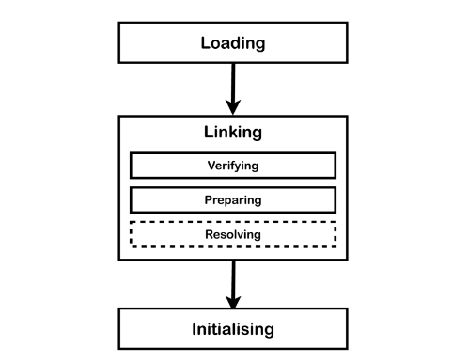

Types of Class Loaders:
There are three types of class loaders in JVM.
1. Bootstrap Classloader/Primeordial class loader
2.Extenstion Classloader
3. Application Classloader/System class loader

1. Bootstrap Class Loader:
It is responsible to load core java api classes present in rt.jar
Path: JDK\JRE\lib\rt.jar
The above location is called Bootstrap class path. Hence this class loader is called Bootstrap class loader.It is available with every JVM. It is implemented in native languages like c/c++ but not in java.
2. Extension Class Loader:
It is the child class of Bootstrap Class Loader. It is responsible to load classes from the following path. JDK/JRE/lib/ext/
It is implemented in java and it's corresponding .class file is sun.misc.Launcher$ExtClassLoader.
3. Application Class Loader/System Class Loader:
Application class loader is child class of extension class loader. It is responsible to load class files
from application class path. It internally uses environment variable class path. It is implemented in
java and its class file name is sun.misc.Launcher$AppClassLoader.

Working of Class Loader:

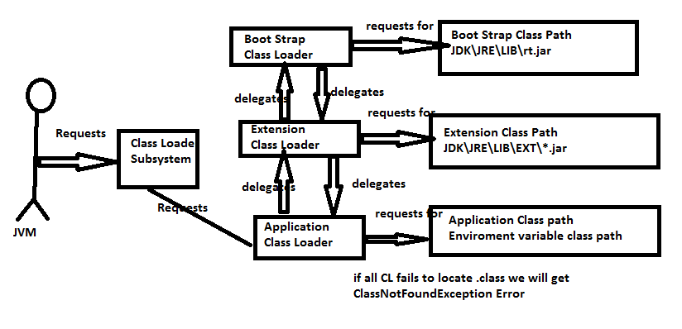
Whenever JVM comes across a class file which is not loaded during loading phase, it will request the class loader to load that class. Now this request directly goes to Application Class Loader. It
directly delegates to Extension class loader. Then extension class loader will delegate to bootstrap
class loader. Now bootstrap class loader searches in its designatd area. If the class in question is found then it is loaded by Bootstrap class loader else it wil again delegate it to the Extension class
loader. This loop continues till Application class loader. If Application class loader couldn't find the
said class, it'll throw java.lang.NoClassDefFoundError orjava.lang.ClassNotFoundException.
Note: Highest priority is given to Bootstrap class loader then Extension class loader and then Application class loader.

Refer following program to understan more.

public class ClassLoadersExample {
public static void main(String[] args) {
System.out.println(String.class.getClassLoader());
// this is to return Bootstrap class loader
// but returns null because Bootstrap class
// loader is not java implementation

System.out.println(ClassLoadersExample.class.getClassLoader());
//this is to return App class loader
//returns sun.misc.Launcher$AppClassLoader@756a7c99
System.out.println(Student.class.getClassLoader());
//this is to return App class loader
//returns sun.misc.Launcher$AppClassLoader@756a7c99
}
}

Note: There is one problem with default class loader. Once a class is loaded, it can't loaded again during jvm life time. This is where we need customized class loaders. Customized class loaders are generally designed to controll the class loading mechanism based on requirement. Let's say a class is needed to be loaded everytime it is updatd. This can be achieved using custom class loader.
Refer following snippet of custom class loader. Custom Class loader can be implemented by extending the abstract class java.lang.ClassLoader

public class CustomClassLoader extends ClassLoader {

public Class<?> loadClass(String name) throws ClassNotFoundException {

//custom loading mechanism

return Class;
}
}

Custom class loaders are designed for web and application servers.

JVM Memory Areas:
There are five memory areas in runtime data area of JVM as follows
- Method Area
- Heap
- Java Stack
- PC registers
- Native method stacks

Method Area: Every JVM will have one Method Area. It is created at the time of JVM startup. It stores class level binary data, static variables and constant pools of each class. It is shared among all the threads. Hence it is not thread safe.

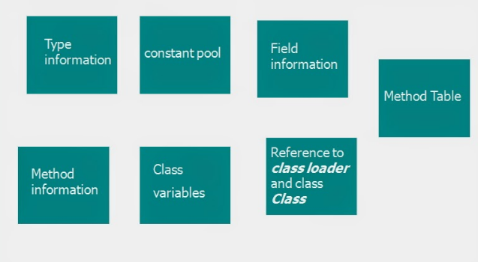

Heap Area: Every JVM will have one Heap. It is created at the time of JVM startup. Objects and
coreesponding instance variables are stored in this area. Heap also shared among all the threads.
Hence it is not thread safe. Heap need not to be continuous in storage. It can be scattered.

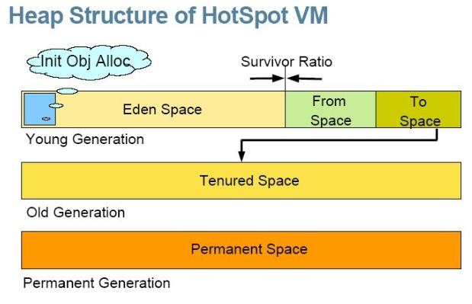

- Eden Space (heap): The pool from which memory is initially allocated for most objects.
- Survivor Space (heap): The pool containing objects that have survived the garbage collection of the Eden space.
- Tenured Generation (heap): The pool containing objects that have existed for some time in the survivor space.
- Permanent Generation (non-heap): The pool containing all the reflective data of the virtual machine itself, such as class and method objects. With Java VMs that use class data sharing, this generation is divided into read-only and read-write areas.
- Code Cache (non-heap): The HotSpot Java VM also includes a code cache, containing memory that is used for compilation and storage of native code.
Note:
- In Oracle's JVM, the permanent generation is not part of the heap. It's a separate space for class definitions and related data. In Java 6 and earlier, interned strings were also stored in the permanent generation. In Java 7, interned strings are stored in the main object heap.
- String pool is created in PermGen area of Heap, garbage collection can occur in perm space but depends upon JVM to JVM. By the way from JDK 1.7 update, String pool is moved to heap area where objects are created.
- Since Java8, there is no longer a PermGen space.
- Since arrays are also objects, they are stored in the heap itself.

We can obtain heap memory stats programatically. Refer the following snippet.

public class HeapStats {
public static void main(String[] args) {
long mb=1024*1024;
Runtime r = Runtime.getRuntime();
System.out.println("Max Memory"+(r.maxMemory()/mb));
System.out.println("Total Memory:"+(r.totalMemory()/mb));
System.out.println("Free Memory:"+(r.freeMemory()/mb));
System.out.println("Consumed Memory:"+
(r.totalMemory()- r.freeMemory())/mb);
}
}
Heap sizes can be altered using following jvm options.
-Xmx[size] and -Xms[size]
Ex: java -Xmx512m -Xms64m

Java Stack Memory:
For every thread, JVM will create a runtime stack during thread creation. Each and every method called by the thread and their corresponding local variables are stored on stack memory.
For every method call, a seperate entry is added to to stack which is called Stack Frame.

Stack Frame Structure: Each stack frame in Java Stack contains three parts.
- Local variable array
- Operand Stack
- Frame Data

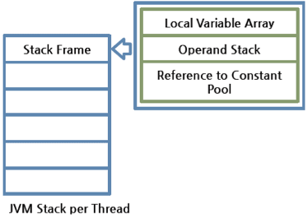

Local variable array: It contains the all the method parameters and local variables.
Each slot in the array is four bytes. Values of type int, float and reference occupies first slot in the
array. Values of type double and logn occupy second consecutive slot in the array. byte, short, char
values are converted to int type before storing and occupy first slot.
The way of storing boolean values is varied from jvm to jvm but most of the jvms use slot one .

Operand Stack:
Jvm uses operand stack as a workspace. Some instructions push the values to the operand stack and
some instructions perform required operations and some instructions share the results.

Reference to Constant Pool/ Frame Data:
It contains all the symbolic references related to the method. It also contains a reference to exception
table which provides corresponding catch block information incase of exception.

PC (Program Counter) Registers:
For every thread, a seperate pc register is created at the time of it's creation.
PC Register contains the address of current executing instruction. Once instruction execution
completes automatically pc register is incremented to hold address of next instruction.

Native Method Stacks:
For every thread, jvm creates a seperate native method stack. All native method calls invoked by the
thread are stored in the corresponding native method stack.
Note:
1. Method Area, Heap Area and Stack area are considered as important memory areas with respect to programmer.
2. Method Area and Heap are are per JVM where as Stack area, PC registers and native method stacks are per thread
Execution Engine:
This is the central component of JVM. Execution engine is responsible to execute java class files.
It contains two components
1. Interpreter
2. JIT Compiler
Interpreter:
It interpretes byte code into machine code and starts executing it line by line.
Problem: It interprets each every line/ method even if it is called repeatedly. This impacts the performance of JVM.
To overcome this , JIT compiler was introduced in java 1.1

JIT Compiler:
It improves the performance of JVM drastically. Internally JIT maintains a seperate count for every
method. Whenever JVM comes across any method call, first JIT will interpret it and increment the corresponding counter variable. This process is follwed for each and every method and block.
If any method count reaches threshold value then JIT compiler identifies that method is repeatedly
used and immediately JIT compiler compiles that method and generates corresponding native code.
Next time jvm comes across that method call then it directly uses native code and executes it instead
of interpreting once again.
Threshold count is varied from JVM to JVM.
Note:
JVM interprets total program line by line atleast once
JIT compiler is applicable only for repeatedly invoked methods but not for every method

