**What is Amazons EC2?**

* Amazons Elastic Compute Cloud (EC2) is a virtual server for running applications.
* It provides virtual computing environments, known as instances.
* Using Amazon EC2 eliminates your need to invest in hardware up front, so you can develop and deploy applications faster.

**How to Get Started with Amazon EC2?**

The first thing needed to use Amazon EC2 is signing up with Amazon Web Service (AWS). Below steps will guide on how to complete the signing process.

**1. Creating an AWS Account.**

Open <https://aws.amazon.com/> and then choose **Create an AWS Account.**

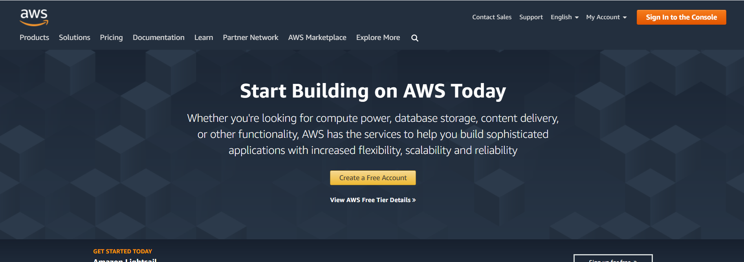

Enter Username, E-mail Address and Password to create a new AWS account. Sign up using SJSU email address to receive student credit.

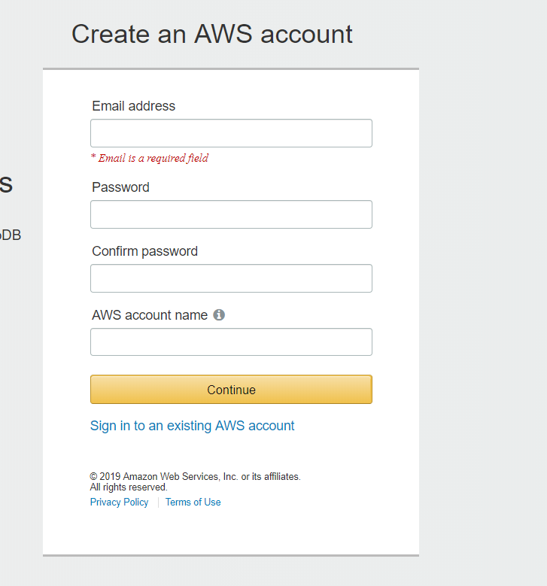

Enter Payment Information and Identify Verification details and complete the registration process.

**2. Launching an EC2 instance.**

Sign in to AWS Management Console using your AWS credentials.

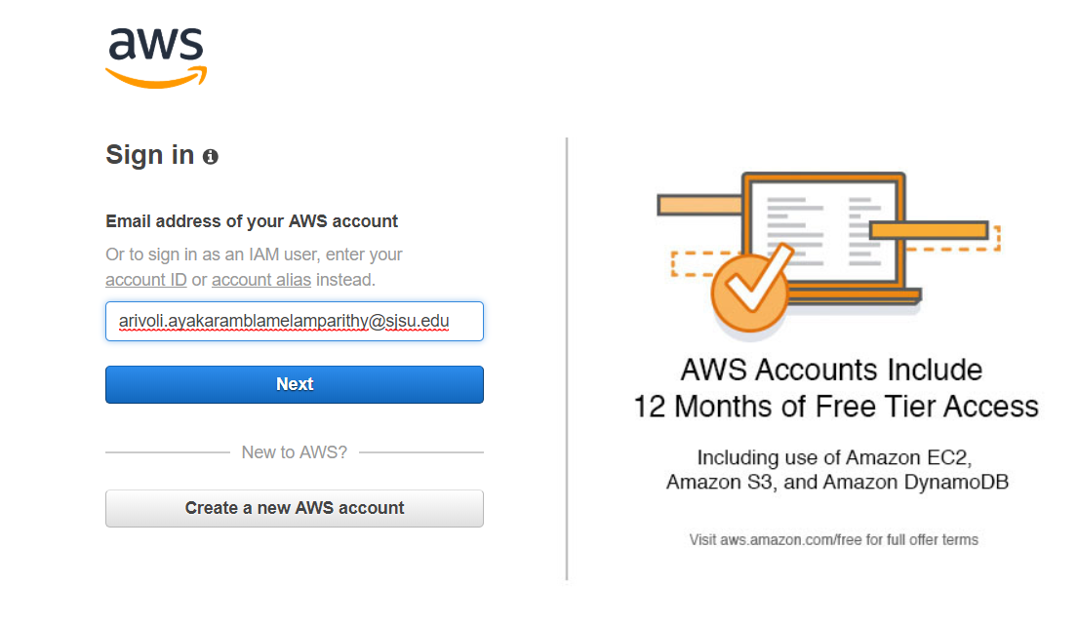

Go to Service->Compute -> And click on EC2. Then Click on “Launch Instance”.

Now Choose an Amazon Machine Image (AMI).

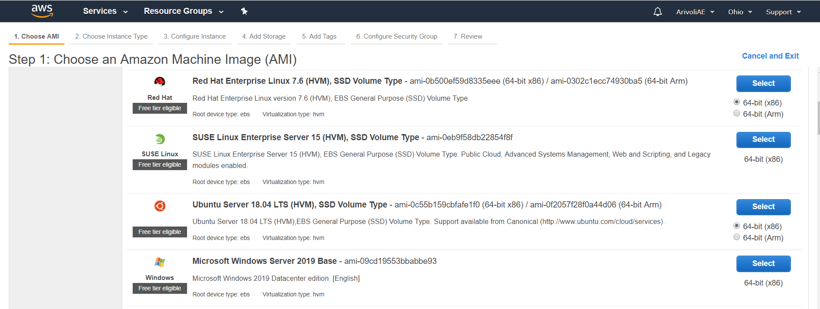

Choose an Instance Type. Amazon EC2 provides a wide selection of instance types optimized to fit different use cases. They have varying combinations of CPU, memory, storage, and networking capacity, and give you the flexibility to choose the appropriate mix of resources for your applications.

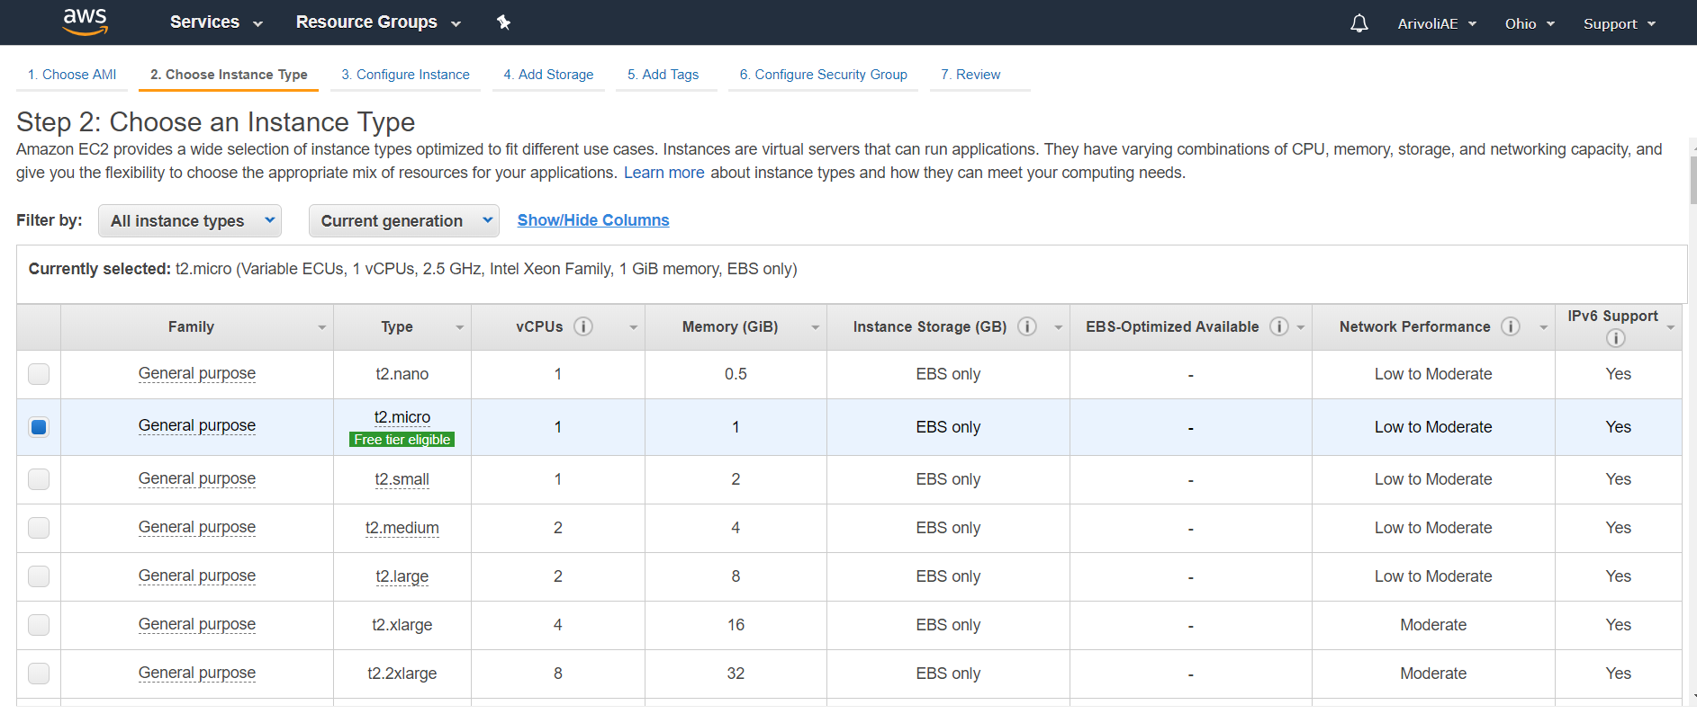

Configure Instance Details. These include launching multiple instances, subnet, Auto-assign Public IP, IAM role, etc.

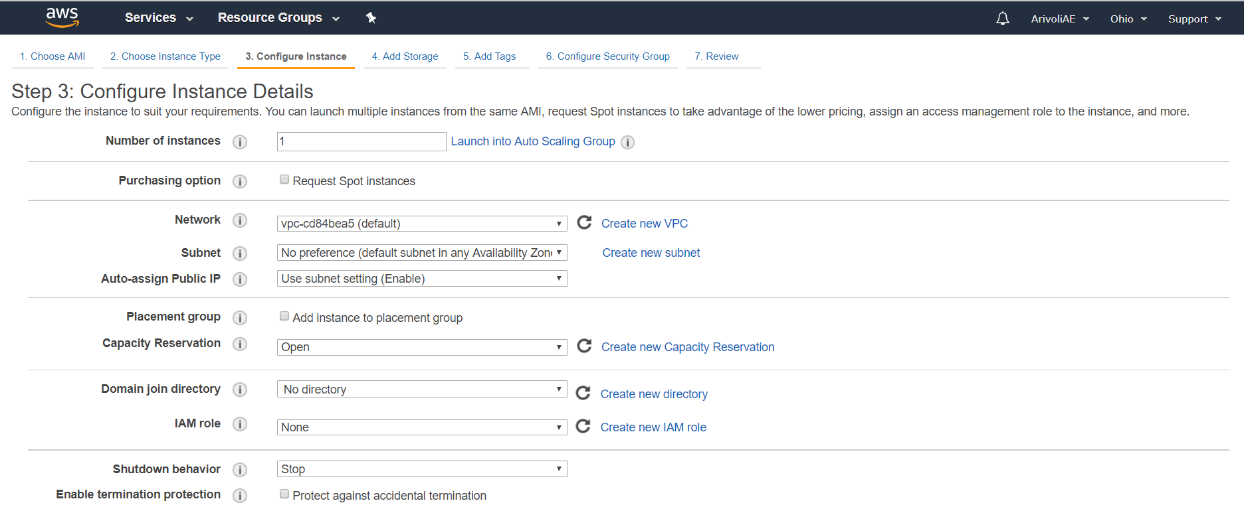

Add Storage. By default, t2. micro will be launched with 8GB(Linux) or 30GB(Windows) size. You can attach additional EBS storage to your instance.

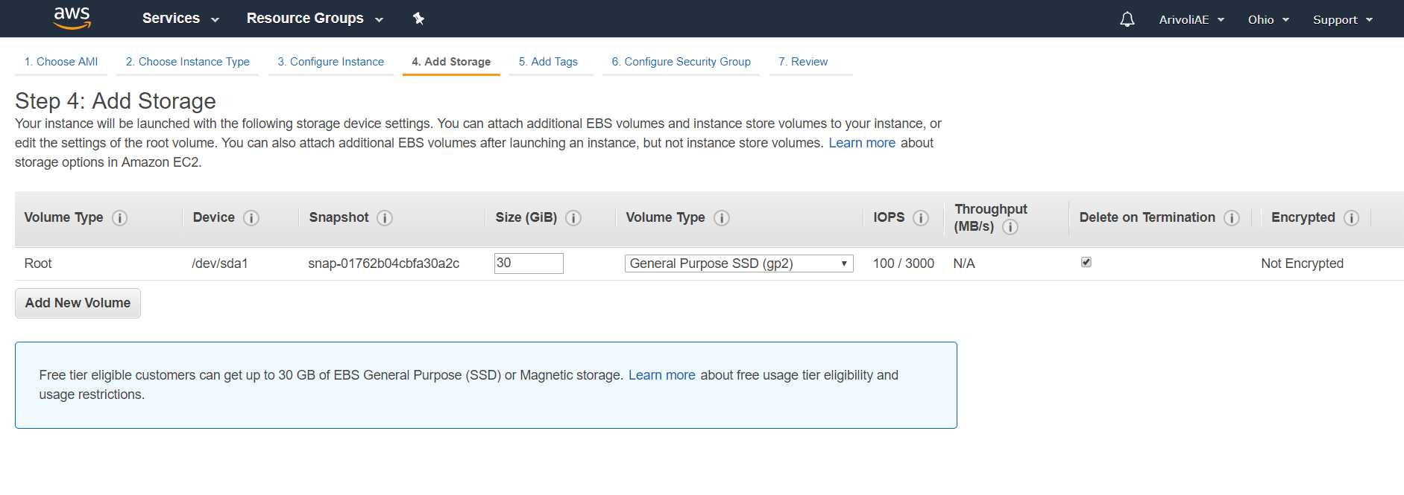

Add Tags. A tag is a key value pair with cn be applied to both Instance as well as Volume.

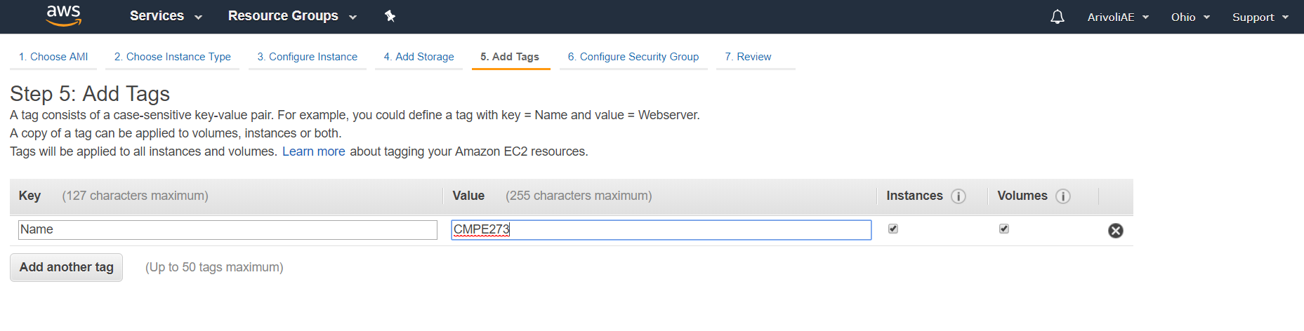

Configure Security Groups. Security groups are set of firewall rules that allow traffic to your instance.

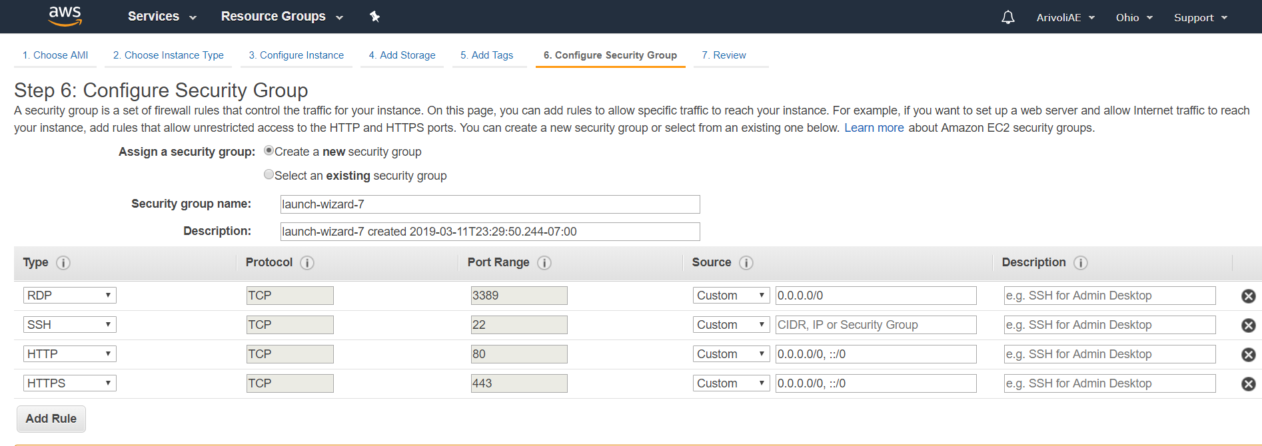

Review and Launch. Review your instance details before proceeding to launch. You can edit any sections. After reviewing Click launch.

* Select an existing key pair or create a new key pair. A key Pair is a combination of public and private key which is used to connect to the instance. The private key is stored at the end user side whereas the public key is stored at AWS end.

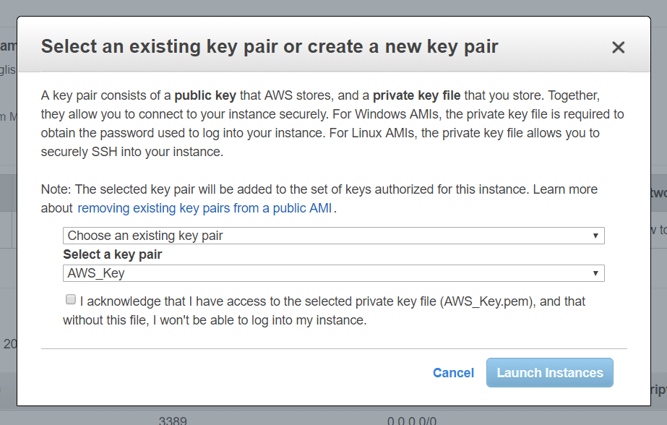

* You can view the instance details after the launch by clicking on running instances

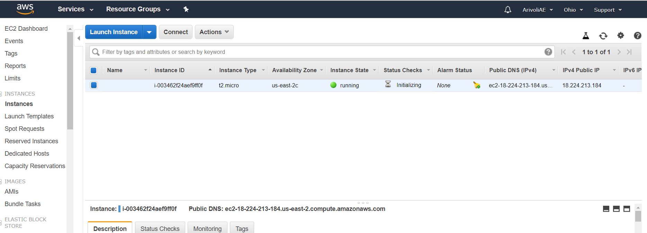

**3. Connecting to your EC2 Instance using PUTTY.**

* Since I am using Windows machine, we need PUTTY to connect with the EC2 instance. Linux users can directly connect to EC2 instance using ssh command in terminal. You can download PUTTY from http://www.putty.org/
* Open puttygen and convert the key pair for your instance from .pem to .ppk. Click on “Load” and browse the .pem file which was downloaded while generating the key pair for the instance.

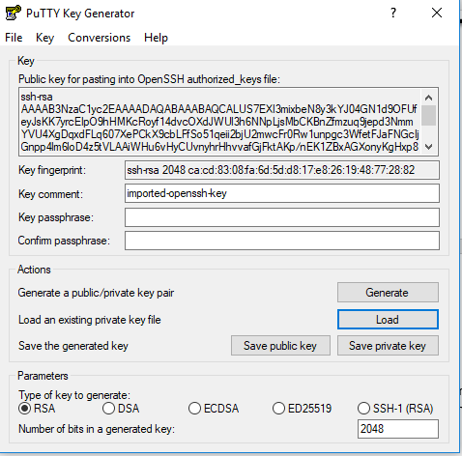

* Save the private key by clicking on “Save Private Key”.
  + Open Putty and follow below instructions to connect to EC2 instance. o In the Host Name field give ec2-user@Public DNS name of the ec2 instance. The Public DNS name can be obtained in the details pane.
  1. 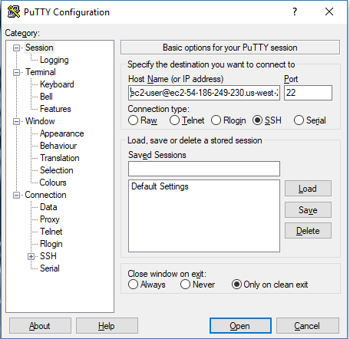
  + Expand the SSH tab in the navigation pane and go to Authentication. Browse the private key pair file.
* Click open.
  + Now you are connected to your ec2 instance. Below is the PUTTY’s terminal that will appear after the connection.

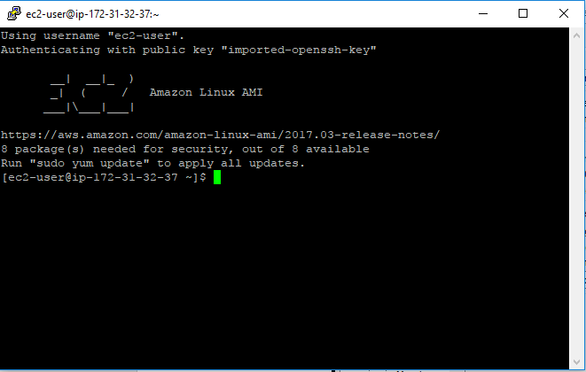

**4. Deploying a Web application on EC2 Instance.**

* We will download a software called WINSCP to transfer the .war file of our application on to the ec2 instance machine. You can download WINSCP from below website https://winscp.net/eng/download.php
  + Open WinSCP and follow below steps to transfer your deployment file.
  + In the Host Name field enter the Public DNS name of the EC2 instance.
  + In the user Name field enter ec2-user.

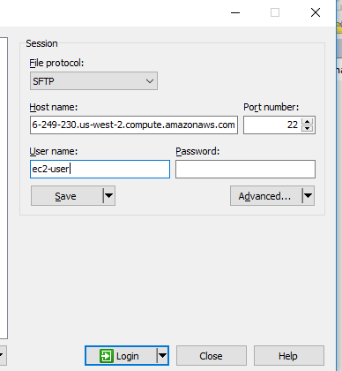

* Click on Advanced button and go to Authentication from the left navigation menu. Browse the key pair file from your local machine.
  1. Now click on OK. You will be connected to ec2 instance. Below screen will appear on successful connection



* Now you can drag and drop you files from local machine to EC2 instance. Transfer your war file from local machine to EC2 instance.
* • Now to run the application just run the Web application on browser using below URL

Public DNS of EC Instance:8080/ApplicationName

