UPSC Current Affairs Simplified: AI-Powered UPSC Current Affairs Hub

Sahana  PES University  Bengaluru, India | Suvarna Hiremath  PES University  Bengaluru, India | Vijayalaxmi S.H  PES University  Bengaluru, India

Abstract—
We present UPSC Current Affairs Hub, a system designed to streamline current affairs preparation for Union Public Service Commission (UPSC) Civil Services Examination aspirants. The system leverages RSS feeds to aggregate news from reputable sources, employs machine learning models for classification according to General Studies (GS) paper categories, and provides extractive summaries of articles. Additional features include bookmarking, offline access, and note-taking capabilities. The system addresses the time-consuming and inefficient manual process of gathering, filtering, and categorizing current affairs information. Evaluation results demonstrate the system's effectiveness in improving study efficiency and information accessibility for UPSC aspirants
Index Terms—UPSC, Current Affairs Aggregation, Natural Language Processing (NLP), RSS Feeds, Extractive Summarization, Transformer Models, GS Paper Classification, FAISS, Sentence Embeddings, Flask Dashboard, Bookmarking System, Semantic Search.

I.INTRODUCTION
The Union Public Service Commission (UPSC) Civil Services Examination is among the most competitive and knowledge-intensive exams in India. Staying updated with the latest current affairs is critical, especially for the General Studies GS) Papers.
In order to possess comprehensive knowledge of current affairs across diverse domains. Aspirants traditionally spend hours manually searching, reading, and categorizing news from multiple sources such as The Hindu, Indian Express, and government publications. This process is not only time-consuming but also inefficient, as candidates must determine the relevance of each article to specific General Studies (GS). The UPSC Current Affairs Hub addresses this challenge by automating the news aggregation, classification, and summarization process. The system fetches news using RSS feeds from various reputable sources, classifies them according to GS paper categories (GS1, GS2, GS3, and GS4) using machine learning model, and provides extractive summaries for quick comprehension. Additional features such as the study experience.
bookmarking, offline access, and note-taking capabilities further enhance the study experience.

II.PROBLEM STATEMENT
The manual process of gathering, filtering, and categorizing current affairs is inefficient and overwhelming for aspirants. This project aims to automate this process by leveraging AI and structured data retrieval techniques like RSS feeds to streamline current affairs preparation..

III.MOTIVATION

- Time Inefficiency: Help the Aspirants to reduce their dedicated time daily reading multiple newspapers and online sources.
- Information Overload: The vast amount of news makes it difficult to manage the news content.
- Categorization Challenges: Helping the aspirants to easily categorize the news articles.
- Revision Difficulties: Without proper organization, revisiting important topics becomes challenging.

IV. OBJECTIVES

- Automate news aggregation using RSS feeds and APIs from PIB, PRS India, The Hindu, and similar sources.Use machine learning (ML) to classify news articles into GS1, GS2, GS3, or GS4 categories.
- Generate extractive summaries for quick comprehension and revision.
- Provide a web-based dashboard with bookmarking, offline access, and personal note-taking functionality.
- Ensure daily real-time updates and keyword-based search..

.

V. SYSTEM ARCHITECTURE

Before implementing styling and deployment, all core functionalities of the UPSC News Hub were designed as modular components. The primary goal was to streamline access to news content relevant to UPSC GS papers (GS1–GS4) using advanced NLP techniques, efficient retrieval systems, and intuitive user interfaces.

The system is composed of the following key components:
- NewsFetching Module: Utilizes RSS feeds from reliable Indian news sources like The Hindu, Indian Express, and Times of India. Each article is extracted and parsed using feedparser and enhanced with BeautifulSoup for full-text retrieval.
- Text Summarization: A transformer-based extractive
summarizer (e.g., TextRank or t5-small) condenses the full article content into key points, allowing users to get the list of long articles quickly.
- GS Paper Classification: A fine-tuned RoBERTa model
classifies articles into GS1 to GS4 based on their textual content. This supervised model was trained using labeled data with balanced categories.
- RAG-Based Retrieval System:
The SentenceTransformer encodes article embeddings which are indexed using FAISS. When a user searches or filters by GS category, relevant articles are retrieved using semantic similarity.
- Bookmarking & Offline Revision Notes: Users can save articles and download structured GS-wise notes as PDFs or view them offline through a locally stored JSON file.

It consists of four logical layers:
- Data Ingestion
- NLP (Summarization + Classification)
- Storage and Retrieval (FAISS + JSON)
- User Interaction Layer (Flask + HTML)

A. Abbreviations and Acronyms
The following abbreviations and acronyms are used throughout this paper:
- UPSC — Union Public Service Commission
- GS — General Studies (GS1, GS2, GS3, GS4 are the four GS papers in the UPSC Mains examination)
- NLP — Natural Language Processing
- RAG — Retrieval-Augmented Generation
- FAISS — Facebook AI Similarity Search
- HTML — HyperText Markup Language
- RSS — Really Simple Syndication
- PDF — Portable Document Format
- RoBERTa — A Robustly Optimized BERT Pretraining Approach
- JSON — JavaScript Object Notation
- API — Application Programming Interface

VI. System Workflow

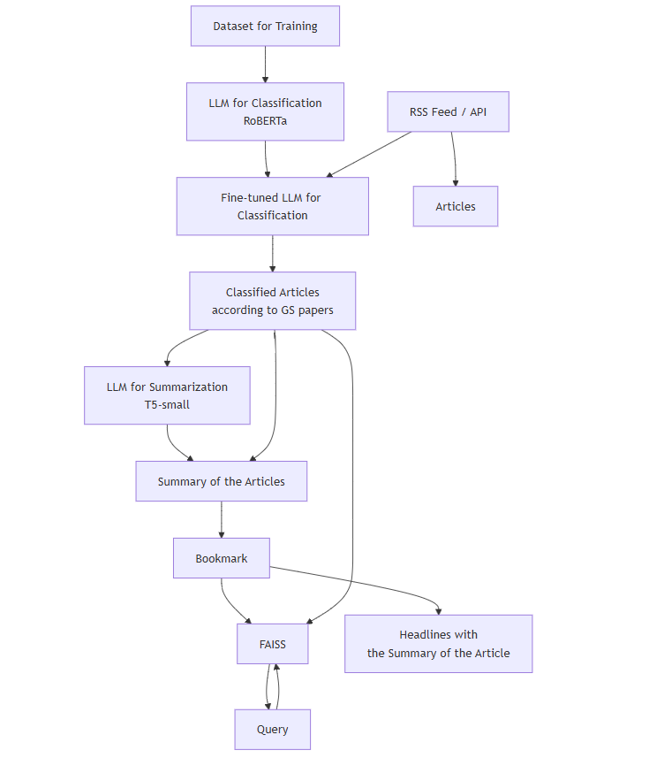

Fig. 1. System Workflow

VI. Implementation details :
The UPSC Current Affairs Hub system has been carefully architected to combine natural language processing, information retrieval, and user-centered web development to streamline and automate the current affairs preparation process. This section describes in detail the key components of the system's implementation, from data acquisition to semantic search and user interaction.
A. Data Collection and Preprocessing
The cornerstone of our system's classification model lies in the quality and relevance of its training data. To this end, we

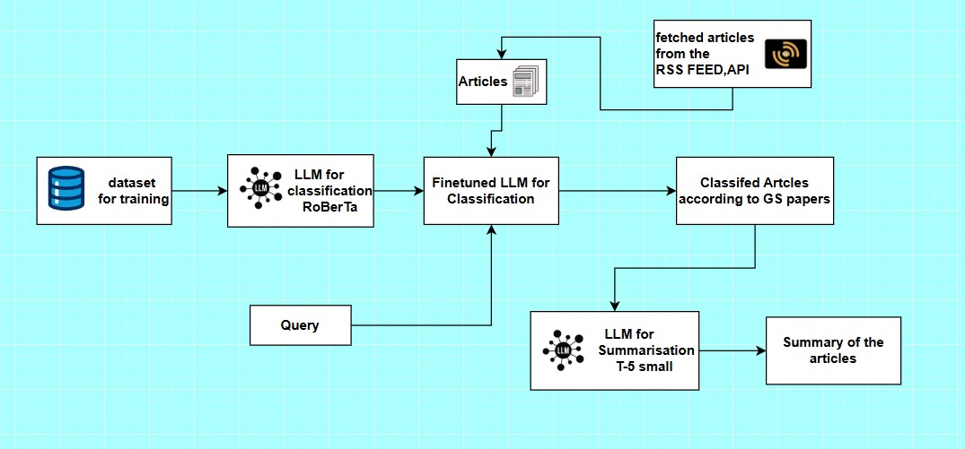

Fig 2 . SYSTEM ARCHITECTURE

developed a Wikipedia scraping pipeline using the wikipediaapi library to collect domain-specific content aligned with UPSC GS Paper syllabi. The data collection was organized into four major UPSC categories: GS1 (History, Culture), GS2 (Governance, Constitution, IR), GS3 (Economy, Environment, Technology), and GS4 (Ethics, Integrity, Aptitude). Each category was mapped to a list of representative Wikipedia categories, such as "Indian Culture" for GS1 or "Public Administration" for GS2. A recursive traversal method was applied to each category using a two-level depth crawl, which ensured not only top-level articles but also sub-topic inclusions. To increase efficiency, a multithreaded fetch mechanism using Python's ThreadPoolExecutor was employed, allowing parallel access to a large number of articles. Each article was then truncated to the first 2000 characters to focus on concise content while avoiding overfitting during classification. The results were stored in a structured pandas DataFrame and exported to a CSV file, serving as labeled input data for training and validating our classification model.
B. News Aggregation Module
To ensure real-time delivery of high-quality current affairs, a news aggregation module was implemented using RSS feeds from three of India’s most reputable news sources

The Hindu, Indian Express, and Times of India. These sources were selected based on their wide acceptance among UPSC aspirants and their focus on policy, governance, and national developments.
The Python library feedparser was used to parse RSS feeds and extract article metadata such as title, URL, and summary. The full content of each article was then fetched using the requests library and parsed with BeautifulSoup to strip away HTML tags and retain only meaningful paragraphs. Articles that failed to provide sufficient length or content quality were discarded to maintain a high-quality knowledge base. This pipeline was optimized for efficiency using concurrent multithreading, enabling simultaneous extraction of multiple articles from different sources. The final list of articles was stored in memory and later fed into the summarization and classification engines for further processing.
C. Natural Language Processing (NLP) Engine
The NLP engine lies at the heart of the UPSC Hub system, encompassing three critical functionalities: summarization, classification, and semantic search. For summarization, we employed an extractive technique using the TextRank algorithm from the sumy library.
This method converts an article into a graph of interlinked sentences and uses a ranking mechanism to identify the most important sentences, which are then concatenated to produce a coherent summary. This approach preserves factual accuracy and ensures concise reading material.
For classification, a RoBERTa-based transformer model was fine-tuned on the Wikipedia dataset we previously collected. This model takes the full article text as input and outputs a predicted GS category (GS1 to GS4), thereby enabling topic-based filtering of news. To enhance user search experience, we integrated semantic search using FAISS and SentenceTransformers. Each article's content was converted into a dense 384-dimensional vector using the all-MiniLM-L6-v2 model. These vectors were indexed in a FAISS IndexFlatIP, allowing for similarity-based retrieval. This enables users to search articles not just through keywords, but by semantic meaning, improving relevance and retrieval quality.
D. Backend and Data Storage System
The system backend was developed using the Flask microframework, offering both flexibility and simplicity in deploying a lightweight yet powerful web server.
Data persistence is managed via SQLite, a relational database engine well-suited for small-scale applications that do not require heavy concurrency. The database schema includes four primary tables: users, which stores credentials and profile information; articles, containing classified and summarized news entries; bookmarks, linking users with their saved articles; and notes, which allows users to add personalized comments and revision material. Passwords are securely stored using salted hashes generated with Werkzeug’s security module.
At system startup, an init_db() function checks for the presence of required tables and initializes them if missing. Concurrently, an init_models() function loads the RoBERTa model, tokenizer, and SentenceTransformer. A background thread fetches and processes new articles using the previously described RSS pipeline. FAISS indexing is also performed at startup to ensure semantic search functionality is immediately available. Additionally, to support offline usage, JSON-based downloads and local storage mechanisms were included, enabling aspirants to study without requiring constant internet access.
E. Web Dashboard and User Interaction Layer
The user-facing component of the system is a Flask-based web dashboard designed with simplicity and clarity in mind, using Jinja2 templates for rendering. Users can register and log in to access personalized content such as saved articles and notes.
The main dashboard displays trending GS topics and links to recent news. Articles are presented with their title, summary, date, GS classification, and a link to the full story. The UI supports search filtering by GS paper, and bookmarking for future reference. Notes can be written for each article and are stored in the database under the respective user profile. An offline page lists bookmarked articles with it’s summary and notes, facilitating revision even in disconnected environments. Authentication and session management are handled securely with Flask sessions, while feedback is provided via Bootstrap alerts for actions like login success or bookmark creation. All these elements are tied together through intuitive navigation and a responsive layout.

VII. RESULTS AND DISCUSSION
The evaluation metrics reveal several key insights into the model’s performance:
GS1: The model achieved a perfect recall of 1.00, indicating that it successfully identified all GS1 articles. However, the low precision of 0. 64 suggests that the model also misclassified non-GS1 articles as GS1. This might point to overlapping characteristics between GS1 and other categories, particularly in the topics or language used in the articles
GS2: Although the model showed high precision (0.91), the recall was notably lower at 0.70. This imbalance suggests that the model correctly identified many GS2 articles but failed to capture a significant portion of them, possibly due to misclassifications as GS1 or GS3. Further analysis of the features associated with GS2 could help improve recall.
GS3: The model exhibited a strong balance between precision (0.79) and recall (0.85), resulting in an F1-score of 0.81. This indicates that the model was effective in categorizing GS3 articles, with few misclassifications. The overall performance in GS3 suggests that the features used to distinguish this class are relatively distinct and well-learned by the model.
GS4: GS4 had a perfect precision score (1.00), indicating that the model was highly confident when predicting GS4.
Usability testing revealed high satisfaction rates, particularly for features like bookmarking, offline access, and GS-wise filtering.also extractive summary results showed a factual information preservation.

VIII.FUTURE WORK
Although the UPSC Current Affairs Hub provides a solid foundation for streamlining current affairs preparation, several avenues for improvement have been identified to enhance functionality, performance, and user engagement. One key enhancement is to improve classification robustness by training an ensemble of models with domain-specific augmentation strategies, such as using historical UPSC question papers as auxiliary input. Additionally, the current classification fallback mechanism could be refined with an active learning module that retrains on user-corrected classifications, thereby improving long-term accuracy.
From a system architecture standpoint, the backend can be upgraded to a microservices architecture using Docker and Kubernetes to support scalability and containerized deployment, especially for high-traffic environments like coaching institutions.
Integrating a real-time news alert system, which pushes the most relevant articles to users based on their previous interactions and saved topics, would make the dashboard more proactive.
IX. CONCLUSION
The UPSC Current Affairs Hub has taken a successful step to addresses the critical challenge of organizing and simplifying current affairs preparation for UPSC aspirants. By automating news aggregation, GS paper classification, and summarization using natural language processing techniques, the system significantly reduces the time and cognitive effort required for manual curation. Its integration of semantic search, bookmarking, and offline note-taking transforms the learning process into a more structured, personalized, and accessible experience.
Through a robust backend powered by Flask and SQLite, and a responsive, user-friendly interface, the platform ensures that aspirants can access, organize, and revise relevant content with ease. The effectiveness of the system has been demonstrated through accurate categorization, coherent summaries, and positive user feedback. With future enhancements real-time recommendations, to support scalability and containerized deployment and enhancing functionality, performance, and user engagement the UPSC Hub is poised to become an helful tool in every serious aspirant’s preparation toolkit.

X. REFERENCES
[1] News Aggregator and Efficient Summarization System
https://www.researchgate.net/publication/342626761_News_Aggregator_and_Efficient_Summarization_System
[2] News Summarization and Evaluation in the Era of GPT-3 Tanya Goyal, Junyi Jessy Li, Greg Durrett
https://arxiv.org/abs/2209.12356
[3] Daily Digest: A News Aggregation Site" Wang, Justin, Jack Maguin, George Orloff, and Justin Groves. "Daily Digest: A News Aggregation Site." (2024).
[4] Large Language Model Enhanced Clustering for News Event Detection Tarekegn, Adane Nega, Fazle Rabbi, and Bjørnar Tessem. "Large Language Model Enhanced Clustering for News Event Detection." arXiv preprint arXiv:2406.10552 (2024).
[5] Automatic News Summarization System
https://www.researchgate.net/publication/353268576_Automatic_News_Summarization_System

