**DOCUMENTATION FOR TASK1**

**COLUMN_GENERATION BASED ON SALRY COLUMN:**

Condition for column generation:

If Salary column in Table have value less than 30,000 then we need to add 5000 to the bonus column in table

If value is more than 30000 then No Bonus i.e, 0.

Csv file path: "C:\\Users\\donep\\OneDrive\\Desktop\\TASK_DAILY\\source\\surplus.csv"

Sample data:

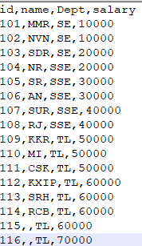

Python script :

The script which will read a csv file and generate a data frame

It will generate a bonus column based on salary column with respect condition for column generation

Condition

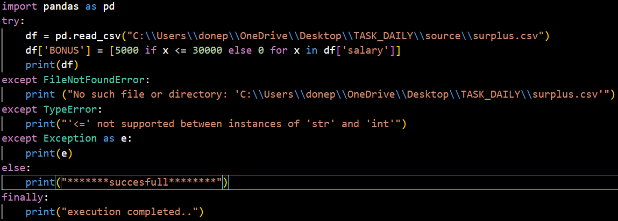

OUTPUT After execution:

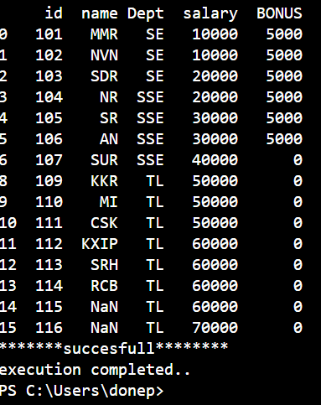

Implimented exceptions handling:

1. File not found exception
2. Type error exception

