ANGULAR

Pre-requisite:

1. NodeJs
2. NPM(Node Package Manager)

Installation & Running:

1.open terminal and check nodejs version `node –v`

2. If you have nodejs perfectly installed and npm, Enter the following command

`npm install -g @angular/cli`

This installs everything needed for us to run Angular

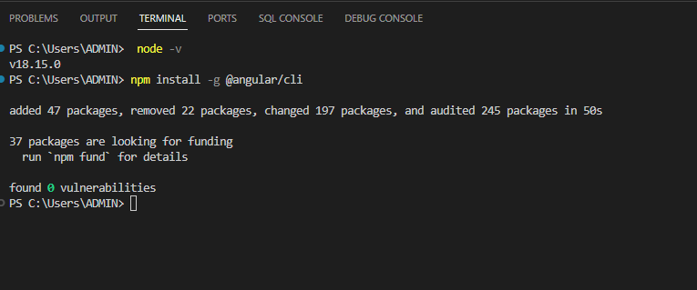

1. Creating a New Angular Project- (Enter the command in terminal)

`ng new my-app`

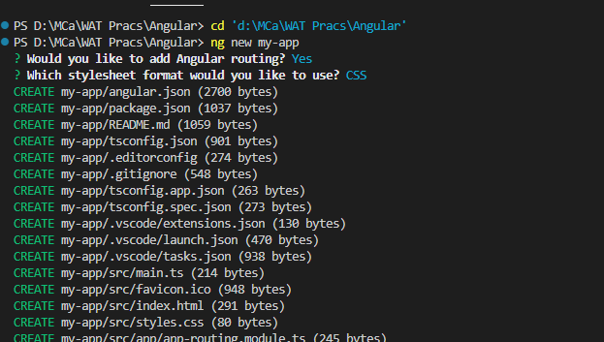

1. Then we will `cd`(change-directory) to our app and run your Application with command

`ng serve --open`

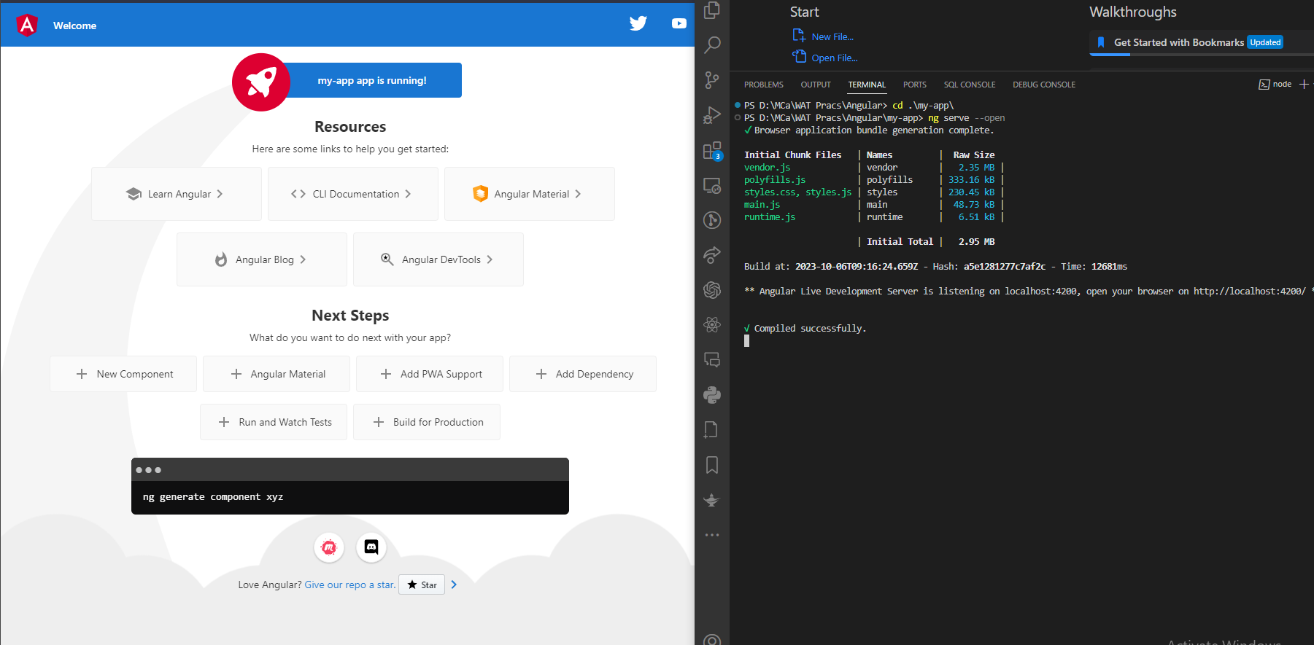

1. This will compile the Application and starts the server at `http://localhost:4200/`
2. Start Coding in `src/app` directory in TypeScript