Create an application to demonstrate Node.js Modules

Built in module-

i) Write a program to print information about the computer's operating system using the OS module.

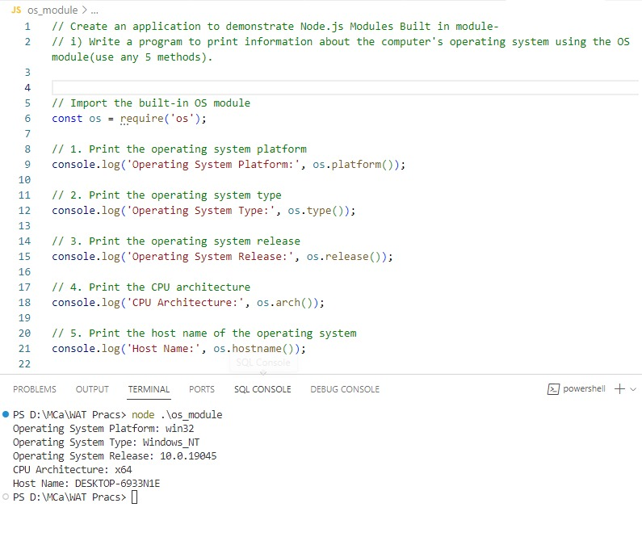

ii) Print "Hello" every 500 milliseconds using the Timer Module. The message should be printed exactly 10 times. Use SetInterval ,ClearInterval and SetTimeout methods.

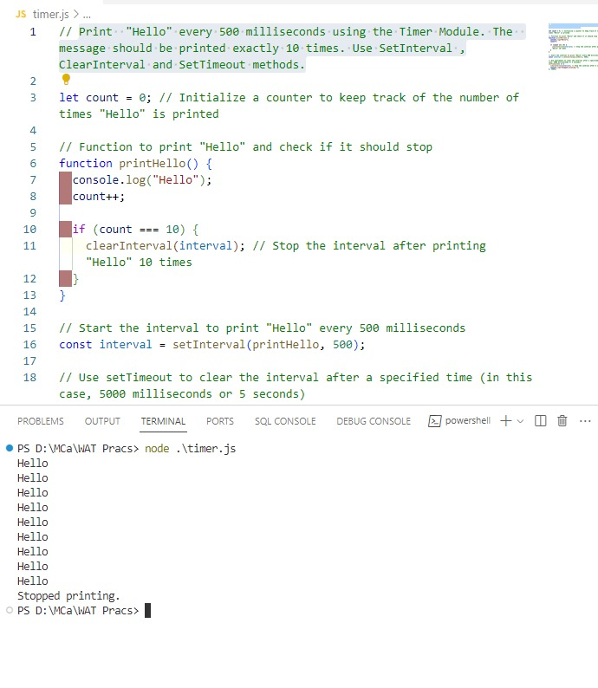

Custom module-

i) create a Calculator Node.js Module with functions add, subtract and multiply,Divide. And use the Calculator module in another Node.js file.

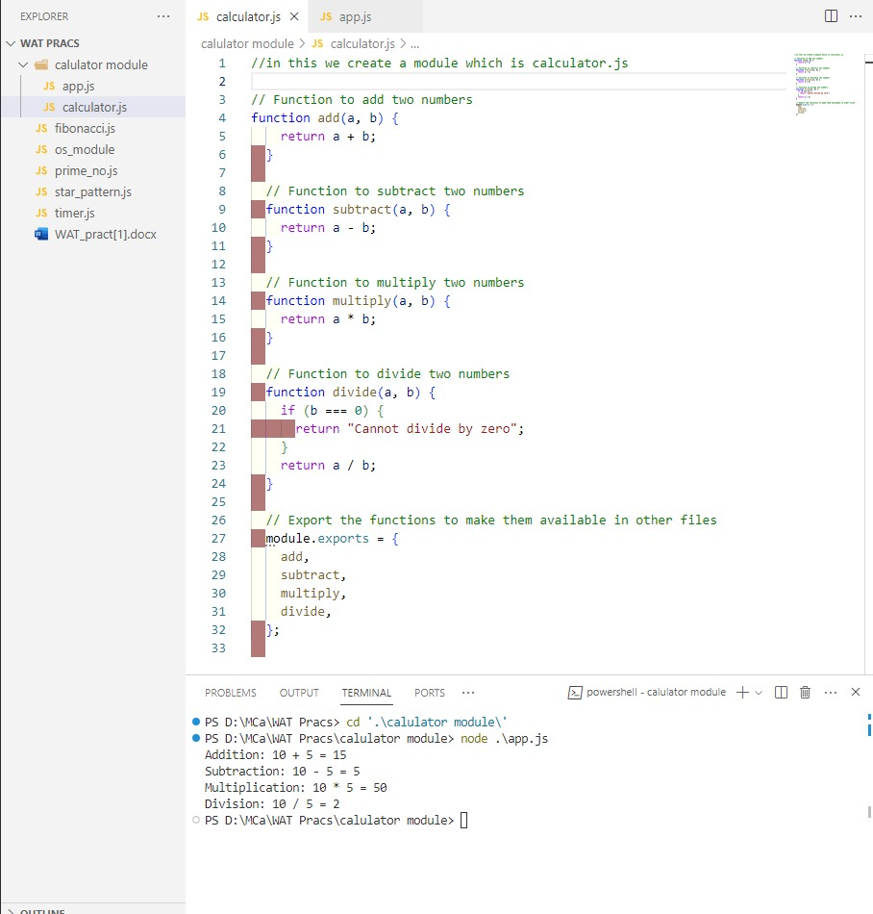

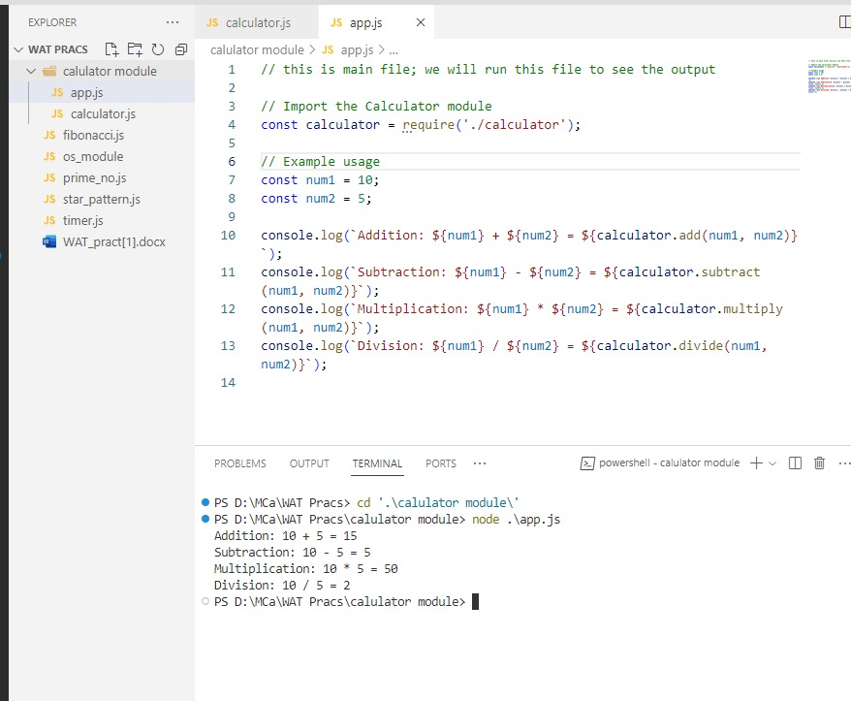

* ii) Create a circle module with functions to find the area and perimeter of a circle and use it.

