522.95 Test Program
The 522.95 Test Program can be used to communicate with a 522.95 IC or FPGA.
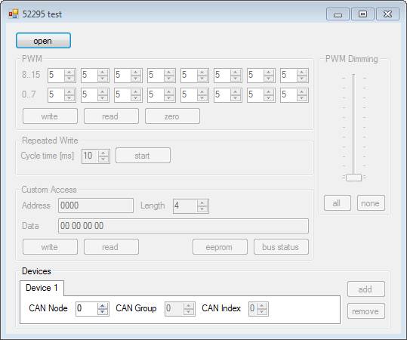1. Drawing: GUI after start-up

Communication properties
- CAN nominal bitrate: 500 kBit/s
- CAN data bitrate: 1MBit/s
- Secure Byte Master Frames: 0x42
- Secure Byte Slave Frames: 0x23
- CAN type identifier for slave response: 0x00
- CAN type identifier for master request: 0x04
- CAN type identifier for master write: 0x06
- CAN type identifier for master write_3: 0x02

Setup with FPGA
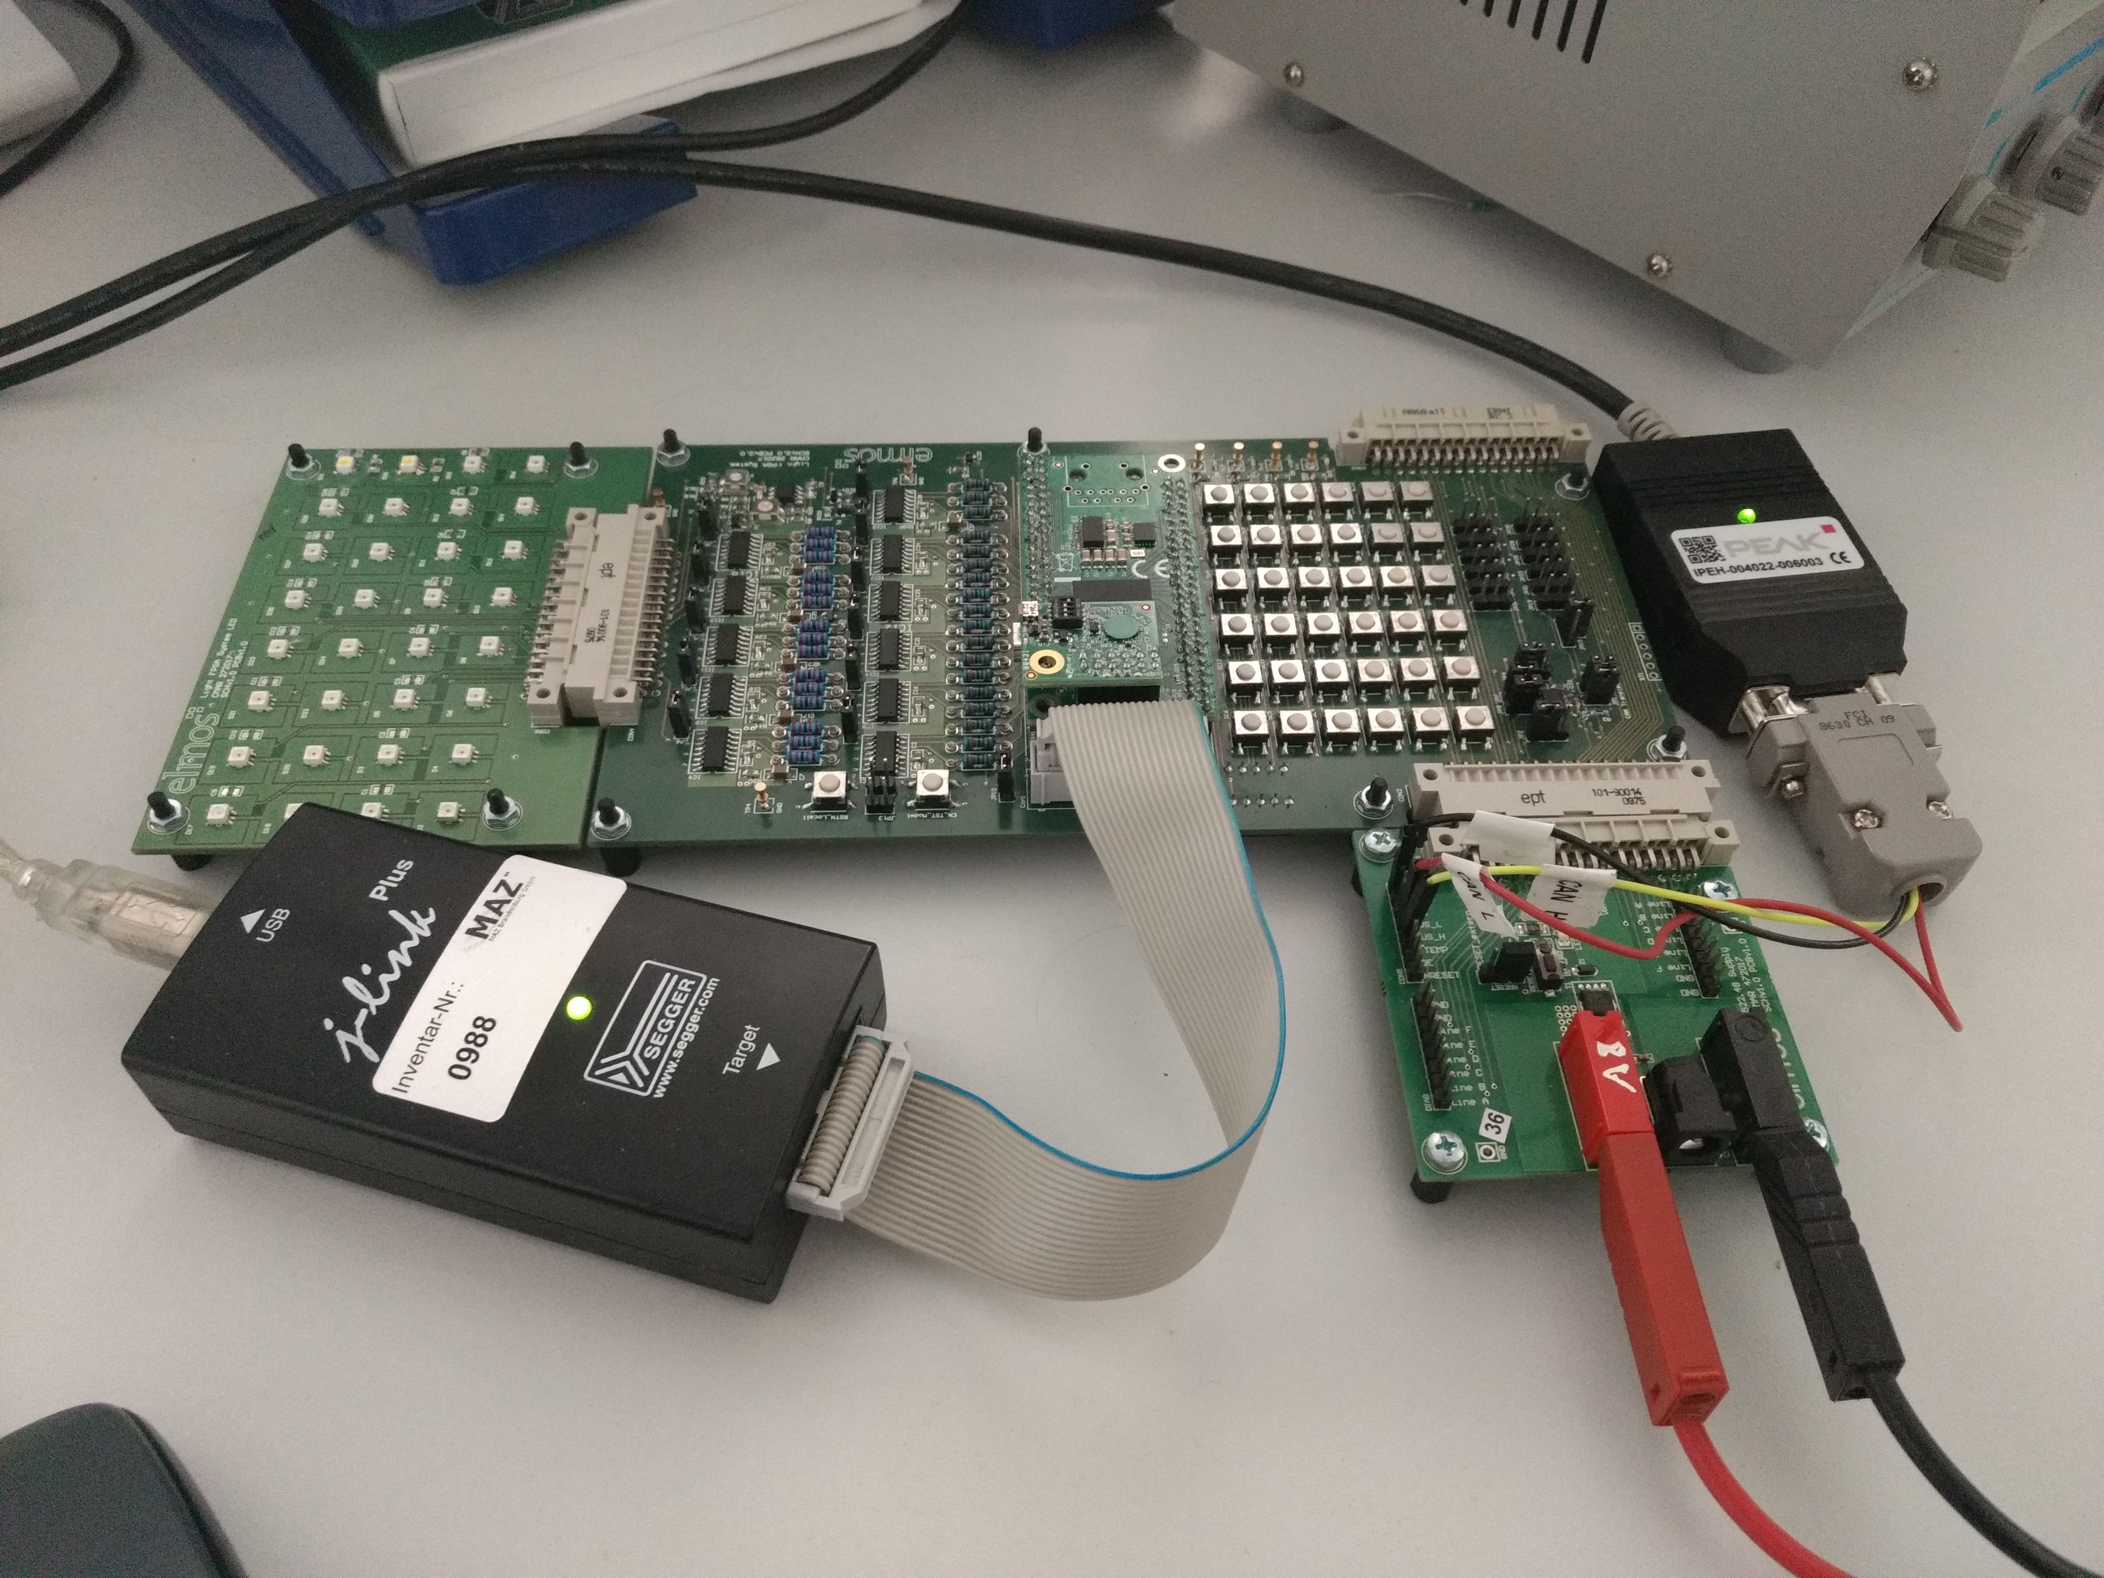2. Drawing: FPGA board setup
Necessary Parts:
- Peak Device
- Supply board
- 522.95 FPGA base board
- FPGA board

Board supply: 8V
The current limit of the supply source must be high enough, that all LED channels can be supplied at the highest light level. Otherwise the communication will be interrupted and the device will be fall back to save mode.
When running the FPGA with firmware inside, the EN_TST_Mode Jumper 10 must be open (also effects the device PROG pin). Otherwise the CAN interface will be set to the default programming settings and the application is not supporting this.
The CAN Node ID can be configured with DIP switches on the backside of the board (see table 1). Note that the order of the DIP switches are reverted and DIP 1 is used for a different purpose.
Node | DIP 2 | DIP 3 | DIP 4 | DIP5
0 | 0 | 0 | 0 | 0
1 | 0 | 0 | 0 | 1
2 | 0 | 0 | 1 | 0
3 | 0 | 0 | 1 | 1
4 | 0 | 1 | 0 | 0
5 | 0 | 1 | 0 | 1
6 | 0 | 1 | 1 | 0
7 | 0 | 1 | 1 | 1
8 | 1 | 0 | 0 | 0
9 | 1 | 0 | 0 | 1
10 | 1 | 0 | 1 | 0
11 | 1 | 0 | 1 | 1
12 | 1 | 1 | 0 | 0
13 | 1 | 1 | 0 | 1
14 | 1 | 1 | 1 | 0
15 | 1 | 1 | 1 | 1
1. Table: Node DIP Switch Code
Note

Usage

Connection
First the connection to the IC via Peak Device must be established by clicking on the "open" button.

PWM
Afterwards it is possible read and write the PWM pulse length values within the BUS_CONFIG area by using the "PWM" group box. For each channel the pulse length can be defined in a range 0..255.
Double clicking on the values of each channel will mark the corresponding channel to be affected by the dimming slider.
Note that writing the configuration to the BUS_CONFIG area will only taken into account by the firmware, if the basis protection is switched off or W3 are cyclically send by the bus master.

PWM Dimming
The dimming slider is only availble, when the repeated write process is running (W3 frames are send). The slider will effect the marked LED channels only.
The are short-cut button to mark all channels or none.

Repeated Write
To send W3 frames (leaving the safe state) click "start" in the "Repeated Write" group box. The time between sending the frames can be changed if the send process is stopped. Note that 10 ms is the lowest value which can be achieved using standard timer within this program.
Microsoft Docs Note:
The Windows Forms Timer component is single-threaded, and is limited to an accuracy of 55 milliseconds. If you require a multithreaded timer with greater accuracy, use the Timer class in the System.Timers namespace.

Custom Access
Within the "Custom Access" group box the complete BUS memory area can be accessed.
For read access the start address and length must be defined. When successfully read, the result will be presented in HEX format in the “Date” text box. The length is limited to 20 bytes, which is the maximum amount of payload handled in one frame.
For write access additionally the “Data” text box must be filled.
There are short-cut button to read out EEPROM data and BUS_STATUS information. Note that more than one frame will be send when reading out this information.

Devices
It was planed to support more than one device within this program. But this feature was not finished. The only possibility is to switch between the different devices and use the read and write access. The W3 frames are only valid for the notes 0 to 2.

