Machine Vision Based Water Bottling Plant for Impurity Detection

A FIELD VISIT REPORT
Submitted by
NAVEEN KUMAR. S
SRI KAVIN. S
SABARISH. M
RITHIK. P
in partial fulfillment for the award of the degree
of

BACHELOR OF ENGINEERING

IN

MECHANICAL ENGINEERING

KNOWLEDGE INSTITUTE OF TECHNOLOGY

ANNA UNIVERSITY:: CHENNAI 600 025

DEC 2025

1. Date & Place of Visit
Date: 15 October 2025
Place: Lingam Aqua Industries, Omalur, Salem District

2. Purpose of the Visit
The visit aimed at:
• Understand complete bottling plant workflow
• Study purification and filtration methods
• Observe bottle manufacturing and filling operations
• Identify real-world defects for Machine Vision inspection
• Compare manual and automated quality control
• Gather practical insights to improve our project design

3. Overview of the Industry
Lingam Aqua Industries is a packaged drinking water processing unit with:
• Production capacity above 1000 LPH
• Multiple product ranges: 300 ml, 500 ml, 1 L, 2 L, and 20 L cans
• Semi-automatic bottle blowing and packaging machines
• Local distribution network supplying retail, shops and hotels

4. Processes Observed
a) Water Purification Line
• Raw water pumped through sand filter for particle removal
• Carbon filter eliminates odor, chlorine, and color
• RO membrane separates impurities and saline content
• UV and ozone used for microbial purification
• TDS monitored regularly to maintain 70–120 ppm range
• pH adjusted between 8.0 to 8.5 for ideal drinking conditions
• Stainless steel tanks prevent corrosion and contamination

b) Ozonator Disinfection
• Ozone gas injected into treated water for sterilization
• Ensures elimination of bacteria, viruses, and microorganisms
• Water stored for 24 hours to stabilize before bottling

c) Bottle Manufacturing (PET Blowing)
• PET preforms heated using eight 200 W bulbs.
• Pre-blow low-pressure (2–4 bar) shapes the bottle base
• High-pressure (20 bar) final blow forms the bottle
• Cooling stage helps maintain bottle strength and shape
• Operators check for uneven thickness, dents, or deformities

d) Filling and Capping Section
• Bottles washed using high-pressure cleaning system
• Level-controlled filling ensures uniform water height
• Caps sealed tightly to avoid leakage or contamination
• Sensors detect improperly placed bottles
• Defective bottles removed manually by workers

e) Labeling and Packaging
• Heat-shrink labels used for branding and information
• Carton packing:
- 300 ml – 35/box
- 500 ml – 24/box
- 1 L – 15/box
• Boxes stacked and sealed for distribution
• Workers ensure label alignment and print accuracy

5. Observations & Learning Outcomes
Technical Learning
• Understood complete purification and RO membrane operations
• Observed role of physical, chemical, and microbial purification
• Learned how pressure and temperature influence bottle shaping
• Understood influence of lighting in defect visibility
• Noted real defects: under-fill, label shrink error, cap loose, impurities
Industrial Operation Learning
• Observed workflow management and worker coordination
• Learned importance of hygiene and contamination prevention
• Understood equipment maintenance and cleaning cycles
• Studied how small-scale industries balance cost and efficiency
• Identified bottlenecks during peak production hours

Project-Relevant Learning
• Understood real bottling line speed for camera triggering
• Observed how defects occur in natural environment
• Understood requirement for stable lighting for image processing
• Learned limitations of manual inspection in fast-moving lines
• Improved clarity on dataset collection for training YOLO model

Additional Insights
• Packaging cost and material impact total production cost
• Minor machine misalignment leads to significant defect rate
• Sensors and pneumatic systems require periodic calibration
• Human error is a major cause of wrong labeling or under-fill
• Automated systems can drastically improve consistency

6. Conclusion
The field visit provided extensive practical exposure to purification, bottle blowing, filling, capping, and packaging processes. The insights gained strongly supported the design of our Machine Vision Inspection System by showing real defects and bottling conditions. This visit enhanced our technical understanding, improved our project direction, and prepared us for industrial-level implementation.

FIELD VISIT IMAGES
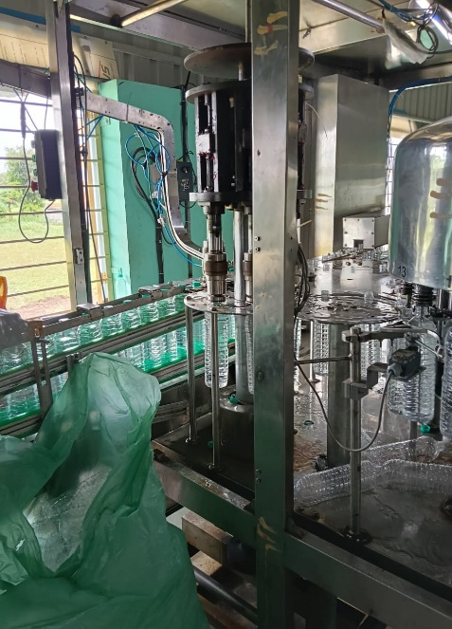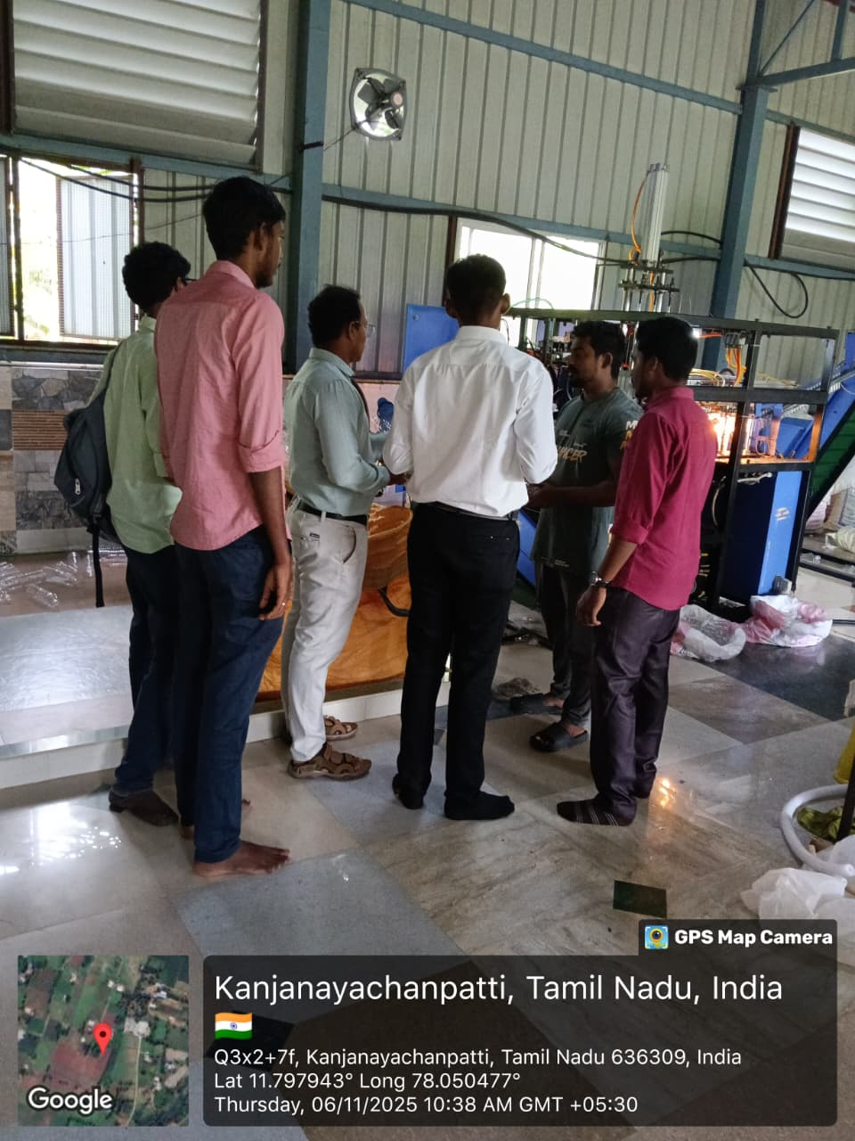

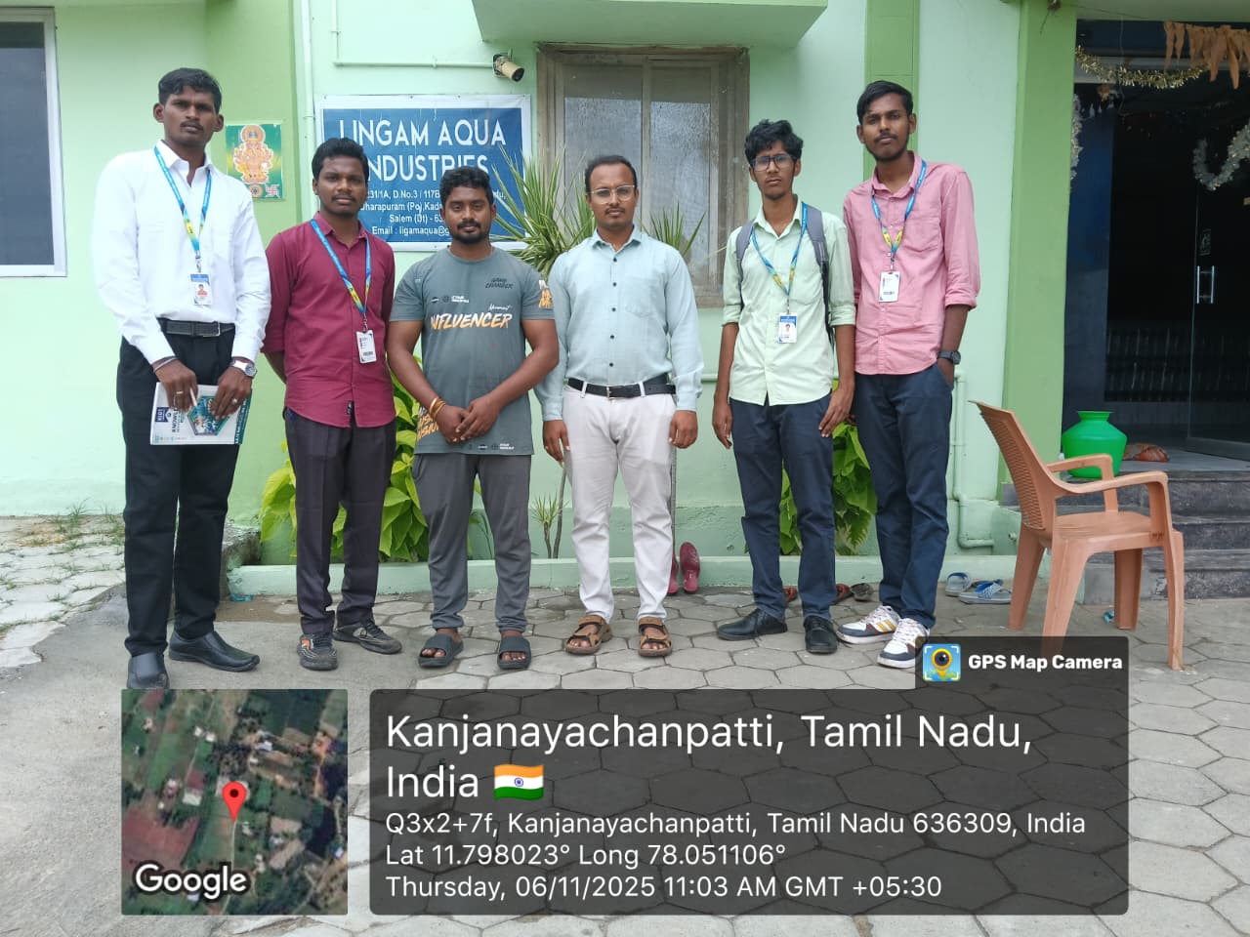
Figure 9.1 – Field visits images.

