**FINAL DOCUMENTATION**

**TOPIC:**

SENTIMENTAL ANALYSIS OF COVID 19 TWEETS – INDIA

**SUBMITTED BY:**

NAVEEN KUMAR K  
                   NISHOK  N J

RAGUL R

SOWMITHRA M

**INDEX**

|  |  |  |  |  |  |  |  |
| --- | --- | --- | --- | --- | --- | --- | --- |
| **1** | |  | **INTRODUCTION** | |  |  |  |
|  | |  | 1.1 Overview | |  |  |  |
|  | |  | 1.2 Purpose | |  |  |  |
| **2** | |  | **LITERATURE SURVEY** | |  |  |  |
|  | |  | 2.1 Existing problem | | |  |  |
|  | |  | 2.2 Proposed solution | | |  |  |
| **3** | |  | **THEORITICAL ANALYSIS** | |  |  |  |
|  | |  | 3.1 Block diagram | |  |  |  |
|  | |  | 3.2 Hardware / Software designing | | |  |  |
| **4** | |  | **EXPERIMENTAL INVESTIGATIONS** | | |  |  |
| **5** | |  | **FLOWCHART** | |  |  |  |
| **6** | |  | **RESULT** |  |  |  |  |
| **7** | |  | **ADVANTAGES & DISADVANTAGES** | | |  |  |
| **8** | |  | **APPLICATIONS** | |  |  |  |
| **9** | |  | **CONCLUSION** | |  |  |  |
| **10** | |  | **FUTURE SCOPE** | | **`** |  |  |
| **11** | |  | **BIBILOGRAPHY** | |  |  |  |
|  | |  | **APPENDIX** | |  |  |  |
|  |  | | A. Source code | |  |  |  |
|  |  | |  |  |  |  |  |

**INTRODUCTION**

**1.1 Overview**

We live in a world where 3.5 billion people are active social media users; that’s 45% of the world’s population! Every single minute of the day, people write more than 500,000 Tweets. Hence Sentimental analysis of twitter data may give us many meaningful conclusions, particularly during this tough covid 19 situation. Sentiment analysis allow us to mine the data various social medias and extract the feelings that underlie social media conversation, to understand how people are talking about a given product or topic. In this project, I build a web application using NodeRed, Javascript, HTML, CSS, Bootstrap and Watson assistant. I have followed the following steps:

* Use code that is written in Node.js (Node Red), with the twitter credentials we build a live tweet analysis dashboard.
* Using python and stream lit framework we build a simple sentimental analysis dashboard for past tweets and hosted it on heroku platform.
* Using IBM assistant we build a custom chatbot which can answer queries related to covid 19 tweets and about our website.
* Using Nodered to integrate all the three modules.
* Host the entire app on IBM Cloud.

**1.2 Purpose**

The main purpose is to create a user interface where the sentiments of the people of the country are analysed over a period of time mainly India. The tweets that are posted currently are also analysed and the sentimental score is calculated.

The approach of the people towards this lockdown is not stable and it’s a oscillating one. During each phase of the lockdown the people approach towards the pandemic was different.

At the beginning the people were more composed and motivation of coming out of the situation was high but now as the count increases there is lack of movitation.

All these change in sentiments of the people are analysed through the tweets that are posted in twitter..

**LITERATURE SURVEY**

**2.1 Existing problem**

* To Analyse the sentiments of Indians during this lockdown extensions with help of tweets from twitter.
* Understand the sentiments of people regarding  government decision to extend the lockdown.
* Analysing people tweets not only based on General and Lockdown events related to corona but also in various segments like medical announcements, identifying proper influencers who can help governments in awareness campaign, COVID-19 relief measures.
* To create a visualization dashboard to know about the sentiments of the people based on different attributes.

**2.2 Proposed solution**

By using IBM Cloud, Node Red and Watson Assisstant it makes the application development much easy and reduces the complexity of the application.

This project solution is drafted mainly in following 3 modules.

🡪The live page analysis shows us the current tweets that are posted online along with their sentimental score. The new feature of image vise analysis will display the picture posted along with the tweet and the ibm visual recognition predicts the image.And also the location of the tweet is also shown on the map of India with respective bird symbol(Green-positive,Red-Negative,Grey-Neutral)

🡪 The past data analysis shows us the word cloud the sentimental distrubuton of the period of time. To Analyse the past tweets from India right from the beginning of lockdown till june end and performing sentimental analysis and plotting beautiful bar graphs , word clouds etc.,. (Lock down 1.0,Lockdown 2.0 …….. ) Now, here for our current scope we only analysed tweets on April 16.

🡪The chatbot explains the features of the project and also answers few general questions about covid 19 FAQs and about covid 19 tweets. It is also trained to explain the features that are included in this project..

**THEORITICAL ANALYSIS**

**3.1 Block diagram**

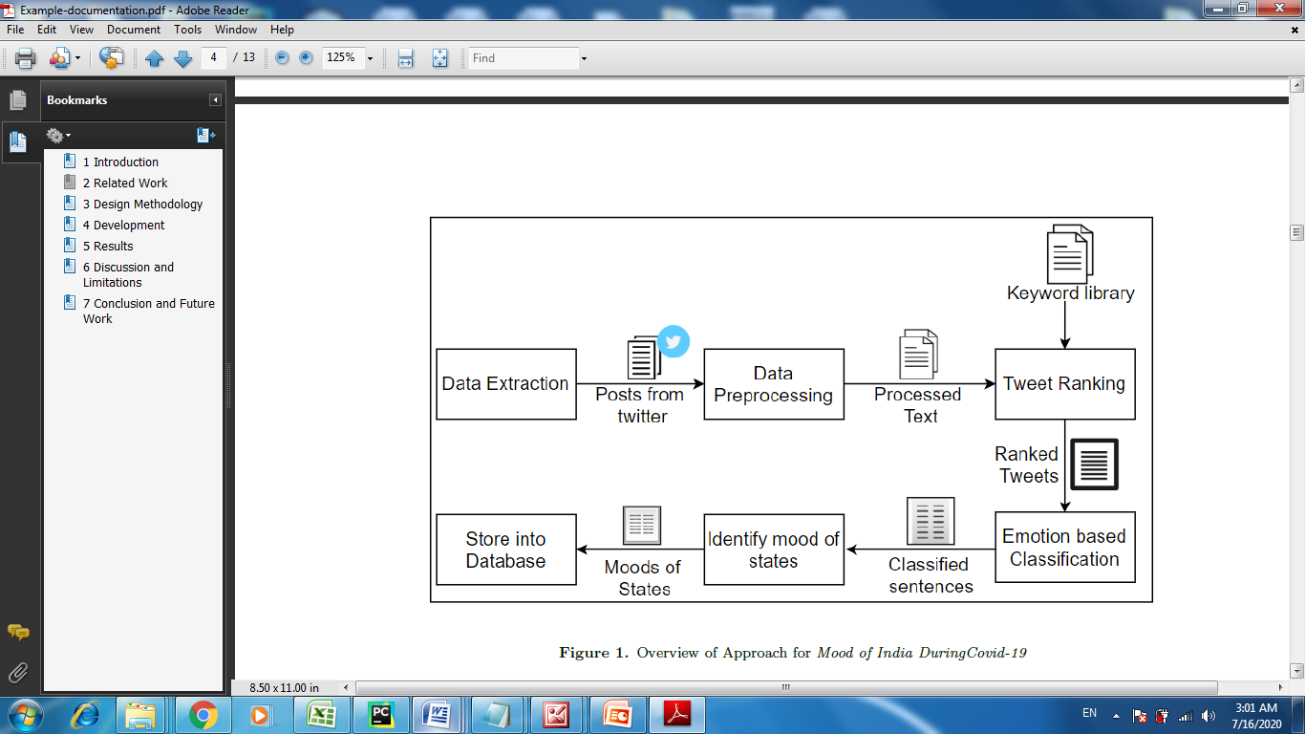

**3.2 Hardware / Software designing**

Live-data Analysis:

1. Node-red

2. Twitter credentials

Past data analysis

1. Ibm-watson studio – notebook & Kaggle notebook(finally used)

2. cloud object storage

3. cloudant

4.Python-Sreamlit(finally used)

5.Hosted on Heroku(finally used)

6. twarc (dehydartion and hydration of tweets)

7.IBM cognos dash board

Chat bot

1. ibm-watson assistant.

2. Node red

Module Integration:

1.HTML,CSS,Bootstrap

2.Node-Red

**EXPERIMENTAL INVESTIGATIONS**

In this process of developing the project we have undergone many investigation processes to learn and understand new concepts so that we can build the visualization dashboard successfully. For we had to learn and investigate following:

* IBM Cloud.
* Node Red.
* Basic HTML, CSS, Bootstrap.
* Watson studio.
* Watson assistant.
* Twitter Objects.
* GIT Hub.
* ZOHO Writer.

**FLOWCHART**

**RESULT**

**UI Interface:**

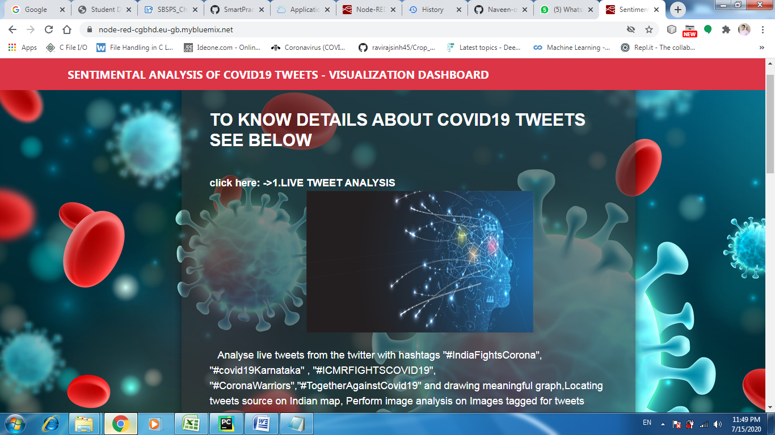

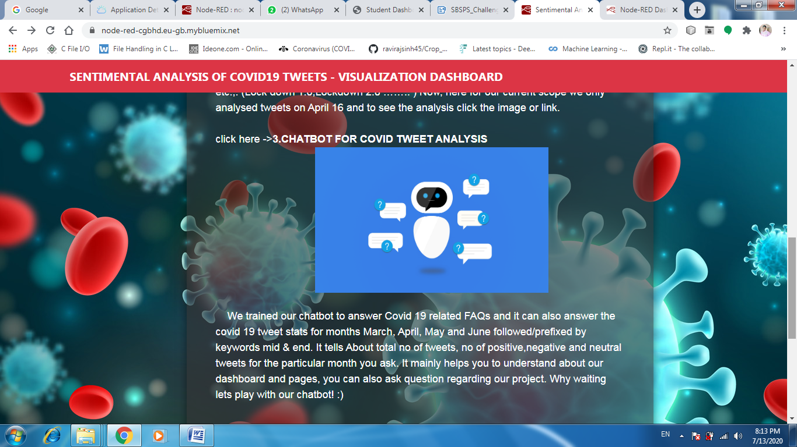

**Live tweet analysis:**

**1)Tweet analysis**

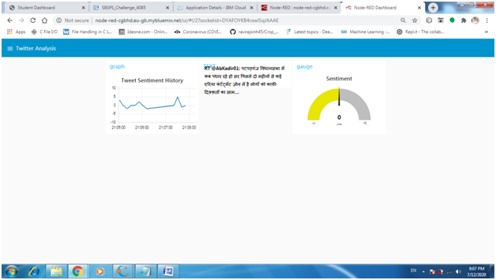

**2)Tweet Image Analysis**

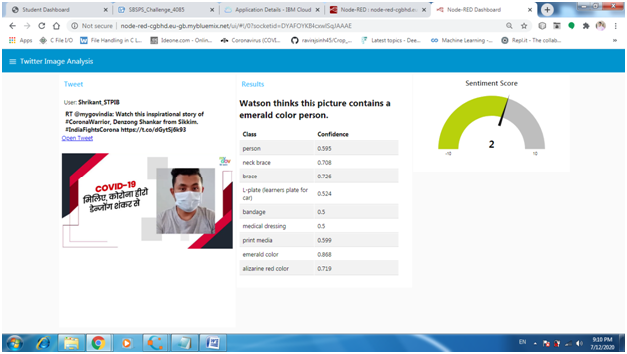

**3)Map tweet analysis:**

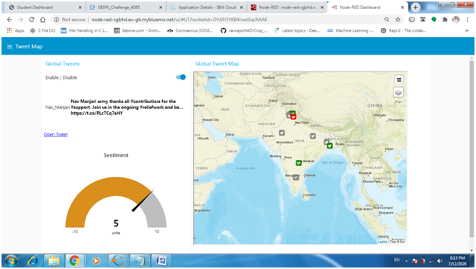

**Past Tweet Analysis:**

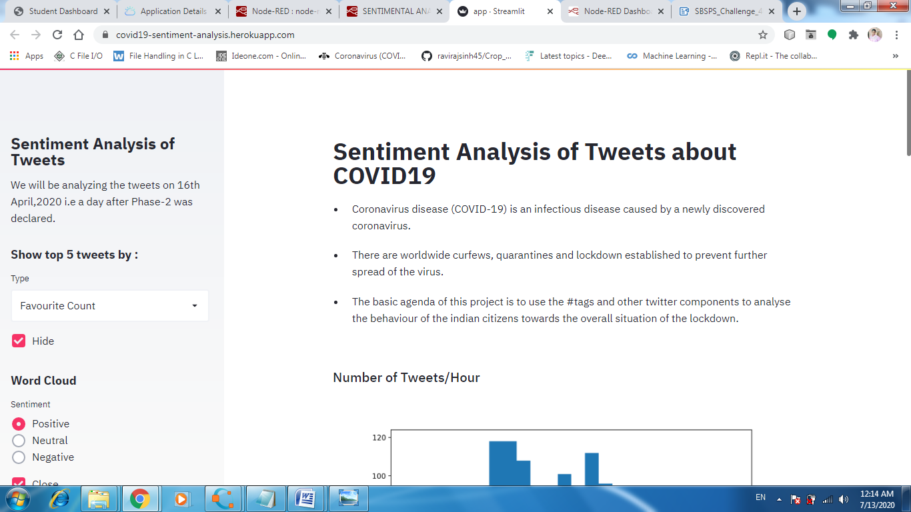

**Chatbot:**

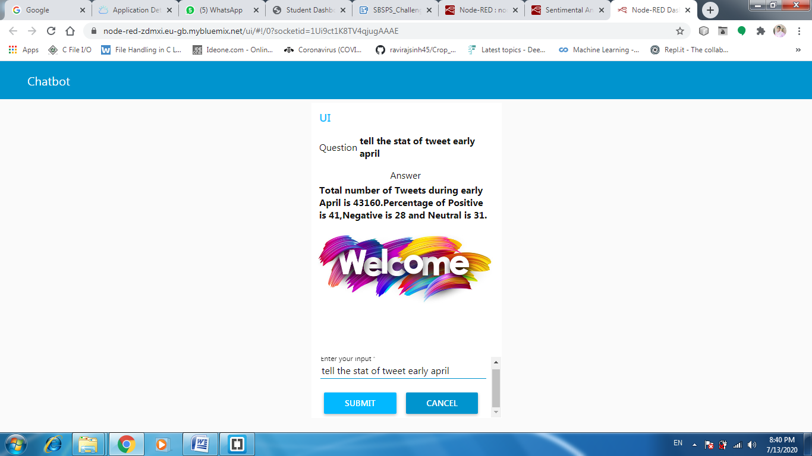

**Location wise analysis**

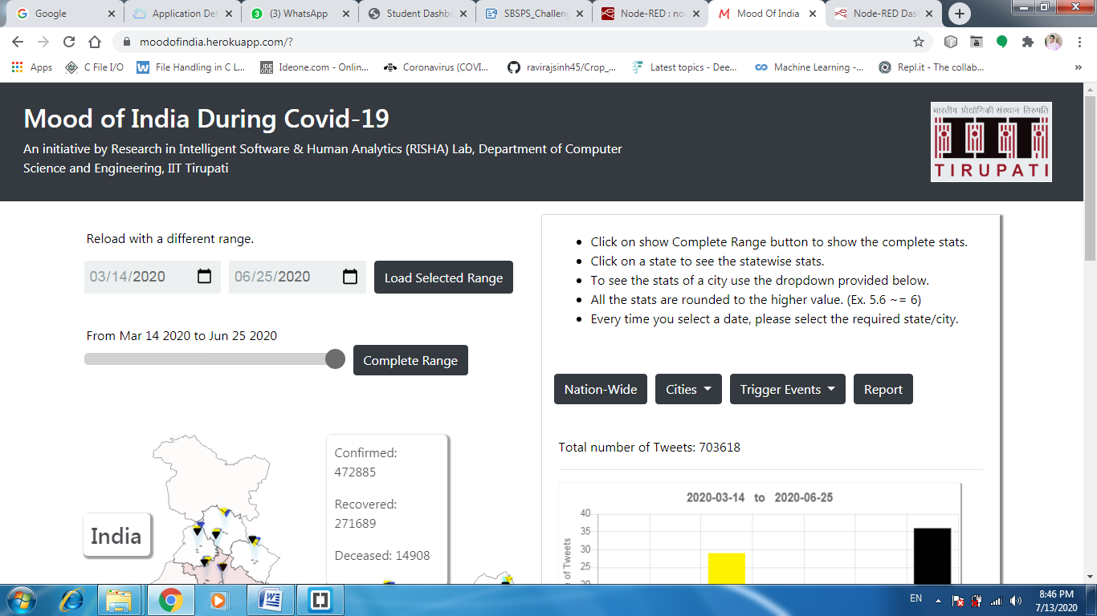

**ADVANTAGES**

1. Overview of the entire COVID -19 situation can be obtained

2. No need to go for different locations for knowing various facts.

3. Interaction of the user interface with the user is enhanced with the help of chatbot.

4.Awareness and also the precautions that are needed to taken are also displayed..

**DISADVANTAGES:**

1. Only limited amount of tweets are processed and graphs are constructed
2. Since the amounts of tweets processed is low the accuracy of the graph are a little bit less.

**APPLICATIONS**

1. People’s mindset about the lockdown and its extension can be understood.

2. By understanding the sentiments government can construct the ideas of how to eliminate the pandemic either through the extensions of lockdown or through any other means of implementing strict laws.

3. The chatbot provides a bit more user friendly touch to the proposed solution because always interactive means are always efficient

4. People not only  get information about the pandemic but also get awareness about the ongoing situation.

5.By knowing the issues of the people in a particular region through their sentiments government can take necessary actions to make sure that those people come out of their hardships.

**CONCLUSION**

* Thus the projection of the people sentiments towards the pandemic is potrayed in this project. The sentiments of the people are analysed under different criteria and over different time period and the analysis result is showcased.
* The greater the positivity that prevails among the people the fatser we can get rid of this COVID 19.
* Let us all conform to the government policies and rules and thereby prevent the further spread of the disease.
* Let us pray for the deceased and  all hope that the pandemic ends soon and the people get back to their normal routine life.

**FUTURE SCOPE**

* To design a predictive model which would predict the sentiments of the people if any further lock down or impositions are made on the people.
* To develop the chatbot to answer a still  more wider range of questions related to COVID -19.
* Increase the accuracy of the chatbots response with relation to number(counts).
* To take the complete set of past tweets and process it to get a higher accuracy about the sentiments predicted since as of now only few amount of tweets were processed and for sample single day april 16 the analysis is shown now but in future we try to add the analysis for every day from the mid march to present month of the year. And if we continue ,we will update the analysis on a daily basis so that instant change in emotion for a day can be observed more clearly by means of special graphs such as word cloud, Frequency plot for words used mostly.
* In Live tweet analysis also, we will add tone of tweets in live using IBM tone analyzer service.

**BIBILOGRAPHY**

**References:**

IBM Cloud: <https://www.ibm.com/cloud/get-started>

Node red tutorial: <https://developer.ibm.com/tutorials/how-to-create-a-node-red-starter-application/>

Watson services and product: <https://www.ibm.com/watson/products-services>

Demo application: <https://node-red-cgbhd.eu-gb.mybluemix.net/>

**Articles on TextBlob**

1. <https://medium.com/@rahulvaish/textblob-and-sentiment-analysis-python-a687e9fabe96>

2. <https://textblob.readthedocs.io/en/dev/quickstart.html>

3. <https://textblob.readthedocs.io/en/dev/>

4. <https://towardsdatascience.com/having-fun-with-textblob-7e9eed783d3f>

**Kaggle  Notebook References**

1. <https://www.kaggle.com/satanizer/covid-19-tweets-analysis>

2. <https://www.kaggle.com/gayatris/coronatweetanalysisandsummarization>

3. <https://www.kaggle.com/maianz/data-wrangling-eda-text-classification>

**Datasets**

1. <https://github.com/Rrishik/COVID-19-tweets/>

**Articles on Sentimental  analysis**

1. <https://towardsdatascience.com/twitter-sentiment-analysis-based-on-news-topics-during-covid-19-c3d738005b55>

**Sentiment Node:**

1. <https://github.com/thisandagain/sentiment/blob/master/README.md>

**MultilangSentiment Node:**

1. <https://github.com/marcellobarile/multilang-sentiment/blob/develop/README.md>

**Node-RED-Dashboard Charts**

1. <https://github.com/node-red/node-red-dashboard/blob/master/Charts.md>

2. <https://flows.nodered.org/node/node-red-node-ui-vega>

**WORLD MAP**

1. <https://www.npmjs.com/package/node-red-contrib-web-worldmap>

**Twitter API official documentation**

1. <https://developer.twitter.com/en/docs/tweets/data-dictionary/overview/intro-to-tweet-json>

2. <https://developer.twitter.com/en/docs/tweets/data-dictionary/overview/tweet-object>

**Function node**

1. <https://nodered.org/docs/user-guide/writing-functions>

**APPENDIX**

**Link to Node Red work space:**

<https://node-red-cgbhd.eu-gb.mybluemix.net/red/#flow/6fb8140d.8d4d1c>

**Link to all codes:** <https://github.com/SmartPracticeschool/SBSPS-Challenge-4085-Sentimental-Analysis-of-COVID-19-tweets---Visualization-Dashboard>

­­