Combined Authentication-Based Multi-access Social Networking (CAML)

INTRODUCTION

INTRODUCTION

About the Project

The system entitled “Combined Authentication Based Multilevel Access Social Networking” is web application software. This aims at the development of Multilevel Access Control to communicate and share information and ideas. CAML is based on Bioinformatics. The authentication is done using the finger print/face scanned image.

A common biometric authentication is to capture the biometric features of all users at the enrollment phase and to store the generated templates in a reference database. During the authentication phase, new measurements are matched against the original template in the reference database

Biometric data are noisy. Because of variable presentation, a matching test is inexact and inaccurate. The ability of authentication depends on technologies such as False Acceptance Rate (FAR) or False Rejection Rate (FRR).

The fact that biometric templates are stored in a database can cause a number of security and privacy risks. One of the most serious problems is impersonation. An attacker steals templates in a database and constructs artificial biometrics that pass authentication. It can make the exposure of sensitive personal information much easier. The using frequency of a biometric has influence on its security. The more frequently a biometric is used, the lessee cure it is. This is because people may leave fingerprints anywhere, and iris images may be captured by a hidden camera, so that biometrics can be found and copied easily. Biometric features are inherent and unique, and it means that they cannot be changed. The unchanging biometric features are hard to be updated, reissued, or destroyed when the biometric is compromised. Therefore, once compromised, it may cause some problems as well as verification.

Countermeasure:
A multimodal system such as a combination of fingerprint verification, face recognition, voice verification, and SIM card, or any other combination of biometrics can be a countermeasure to take advantage of the proficiency of each individual biometric and can be used to overcome some of the limitations of a single biometric. For instance, it is estimated that 5 percent of the population does not have legible fingerprints, a voice could be altered by a cold, and face recognition systems are susceptible to changes in ambient light and the pose of the subject’s head. A multimodal system, which combines the conclusions made by a number of unrelated biometrics indicators, can overcome many of these restrictions. As we mentioned in Section 2, the FRR of the integrated system on the test set with different values of FAR can be much less than face recognition systems and fingerprint verification systems, respectively.

Objective:

A CAML Access is a platform that focuses largely on building and reflecting social network(s) or social relations among people, e.g., who share interests and/or activities. A social network service essentially consists of a representation of each user (often a profile), his/her social links, and a variety of additional services.

A CAML Access is a social structure made up of individuals (or organizations) called "nodes", which are tied (connected) by one or more specific types of interdependency, such as friendship, kinship, common interest, financial exchange, dislike or relationships of beliefs, knowledge or prestige.

Feasibility Analysis:

After problem is clearly understood and solutions proposed, the next step is to conduct the feasibility study. This is high-level capsule version of the entire system. Feasibility study is carried out to describe and evaluate candidate systems and provide for the selection of the best system that meets the system performance requirements.

Feasibility is the determination of whether or not a project is worth doing. The process followed in making this determination is called a Feasibility Study. Once it has been determined that the project is feasible keeping the benefit of the Organization in mind, the analyst can go ahead and prepare the project specification, which finalizes the project requirements. Different tests of feasibility are studied during the investigation. The main of them are –

- Technical feasibility

- Economical feasibility

- Operational feasibility

Technical feasibility:

This is concerned with specifying equipment and software that will successfully satisfy the user requirement. It involves determining whether or not a system can actually be constructed or upgraded to solve the problem at hand. The technical needs of a system may vary considerably, but might include the following:
The necessary technology of both hardware and software existed and also could be acquired for the new system.

As the improvement in storage technology has developed over the recent years, data storage is becoming easier and safer.

The new system with powerful database technology has the capacity to hold the proposed data.

Technically, the system is designed in such a way that it provides accuracy, reliability, easy access, data security and integrity.

Operational Feasibility:

Operational feasibility deals with the human aspect of the organization. Proposed projects are beneficial only if they can be turned into information systems that will meet the organization’s operating requirements. This feasibility test asks whether the system will work when developed and installed. The users need to be convinced about the advantages of the new system. The user-friendly interface makes all the search of information easy.

Unless this is done effectively, the system would not be implemented even after its development and the old system would continue to be used. Some Key findings from the study are as follows.

It has been found to be well supportive by both the Management and the Users. If changes are needed, it has been notified and comprehensive solution has been designed.

At present stage all the work is done by manual. So, throughput and response time is too much. Finding out the detail regarding any information manually was very difficult. I have not changed the structure of organization. I deliver a system that will look like a current structure of organization. But the system, which is delivered by me, removes all the overheads. The Response time while searching the information is very quick.

Economical Feasibility:

Economic feasibility involves estimating benefits and costs. These benefits and costs may be tangible or intangible. It is seen whether the expenditure incurred for developing the new system will be cost effective or not. Because of the confusion between the types of costs, it is sometimes very difficult to decide if the benefits outweigh the costs. This basically involves top-level management of the company who are the decision makers. Some Key findings from the study are listed below.

There was no extra cost burden to conduct a full systems investigation.

Basic Hardware and Software would ensure the smooth run of the application, as the necessary tools were easily available.

The benefits are in the form of reduced costs with merely any errors, thus reducing the manual work. If the system were used without any major changes to it, no extra costs would be incurred.

Data Flow Diagram:

Most organization does not have documentation of the function performed by the users in enough detail to the use of the analyst. Usually all the analyst starts documenting the process using Data Flow Diagram. Views the process from the point of view of the data. As data progressed through the system process transform them.
The analysis stage is actually a learning process in which the analyst tries to gain. An understanding of what the user does. The Data Flow Diagram is an intermediate product that allows the analyst & the user to communicate unambiguously. Data Flow Diagram has a notation for each of the components of the system. They also have a notation for representing different levels in hierarchy of the detail used to describe the system. This notation makes it possible to represent an overall view of large complex system & a detailed view of part of the system using same notation.

Data Flow Diagrams are constructed from 4 basic building blocks:

Terminator Data Flows Process File

Terminators:

A terminator is an external source of information or an external sink for information. A terminator is a person or an organization that interacts with the system with the system being built, but is beyond the boundaries of the system being designed. A characteristic of a terminator are taken as given & cannot be influenced by design process.

Files
Stores data for use at later time by another process or in different place. Files normally correspond to table or views.

Data Flow
Data Flow arrow carries data in the direction of arrow. It can carry data from a terminal on file to a process & from a process to a file, a terminator or to another process.

Process:
The process box transforms one or more incoming data flows into one or more outgoing data flows. The process can be thought of as a machine or a transformer, that transforms input data into output data.

First Level Diagram:

Password Table
User
Sign In

CAML
Sign UP

Sign Up Module:
Registering

User

Sign In

User Module:
Registered
User
Message
News feed
Friend
Profile
Privacy

DETAILED DESIGN

Detailed design covers the study of the major entities involved in the system, their attributes and relationships, how they can be transformed into normalized tables and what is the dependency among the tables. While system definition is design oriented, detailed design is implementation oriented. By defining logical and physical structure of the database, detailed design guides the implementation phase.

Use Case Diagram for Registration
Registration

Sign In
New User

Use Case Diagram for Registered User:

Message
News feed
Friend
Profile
Privacy

Registered User

E-R Diagram

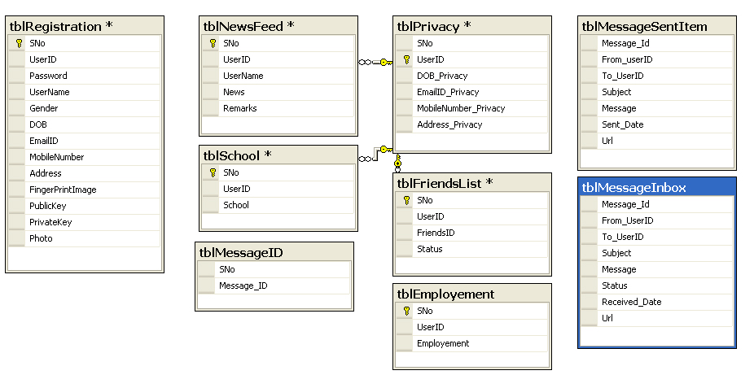

Overall system architectural definition:

User

ADO.NET

SQL

Asp.net
System Architecture

2.3 Tools & Environment

2.3.1 HARDWARE SPECIFICATION

Processor : Pentium III, 600MHz
RAM : 125 MB
HDD : 10GB
FDD : 1.44 MB
Pointing device : Two-Button Mouse
Keyboard : 104 Keys.

2.3.2 SOFTWARE SPECIFICATION:

A software requirement specification (SRS) is a document that clearly and precisely specifies each and every essential requirement for the software product, as well as the external interfaces to hardware and firmware. Each requirement should be defined so that it can be verified by a method such as inspection, demonstration, analysis and testing. There are number of desirable properties that SRS should possess. In particular, the requirement document should be

Correct
Complete
Consistent
Unambiguous
Functional
Verifiable
Traceable
Easy changed

An incorrect or incomplete set of requirements can result in software product that satisfies but does not satisfy customer needs. SRS should be functional in nature; i.e., they should describe what is required without implying how the system will need its requirements

Software Requirements:

Operating System : Windows XP
Client side Programming : C# (language), ASP.NET
Data base : SQL Server

System Design

ASP.NET is a web application framework developed and marketed by Microsoft to allow programmers to build dynamic web sites, web applications and web services. It was first released in January 2002 with version 1.0 of the .NET Framework, and is the successor to Microsoft's Active Server Pages (ASP) technology. ASP.NET is built on the Common Language Runtime (CLR), allowing programmers to write ASP.NET code using any supported .NET language. The ASP.NET SOAP extension framework allows ASP.NET components to process SOAP messages.

History
After the release of Internet Information Services 4.0 in 1997, Microsoft began researching possibilities for a new web application model that would solve common complaints about ASP, especially with regard to separation of presentation and content and being able to write "clean" code.^{[1]} Mark Anders, a manager on the IIS team, and Scott Guthrie, who had joined Microsoft in 1997 after graduating from Duke University, were tasked with determining what that model would look like. The initial design was developed over the course of two months by Anders and Guthrie, and Guthrie coded the initial prototypes during the Christmas holidays in 1997.^{[2]}
The initial prototype was called "XSP"; Guthrie explained in a 2007 interview that, "People would always ask what the X stood for. At the time it really didn't stand for anything. XML started with that; XSLT started with that. Everything cool seemed to start with an X, so that's what we originally named it."^{[1]} The initial prototype of XSP was done using Java,^{[3]} but it was soon decided to build the new platform on top of the Common Language Runtime (CLR), as it offered an object-oriented programming environment, garbage collection and other features that were seen as desirable features that Microsoft's Component Object Model platform didn't support. Guthrie described this decision as a "huge risk", as the success of their new web development platform would be tied to the success of the CLR, which, like XSP, was still in the early stages of development, so much so that the XSP team was the first team at Microsoft to target the CLR.
With the move to the Common Language Runtime, XSP was re-implemented in C# (known internally as "Project Cool" but kept secret from the public), and the name changed to ASP+, as by this point the new platform was seen as being the successor to Active Server Pages, and the intention was to provide an easy migration path for ASP developers.^{[4]}
Mark Anders first demonstrated ASP+ at the ASP Connections conference in Phoenix, Arizona on May 2, 2000. Demonstrations to the wide public and initial beta release of ASP+ (and the rest of the .NET Framework) came at the 2000 Professional Developers Conference on July 11, 2000 in Orlando, Florida. During Bill Gates' keynote presentation, Fujitsu demonstrated ASP+ being used in conjunction with COBOL,^{[5]} and support for a variety of other languages was announced, including Microsoft's new Visual Basic .NET and C# languages, as well as Python and Perl support by way of interoperability tools created by ActiveState.^{[6]}
Once the ".NET" branding was decided on in the second half of 2000, it was decided to rename ASP+ to ASP.NET. Mark Anders explained on an appearance on The MSDN Show that year that, "The .NET initiative is really about a number of factors, it's about delivering software as a service, it's about XML and web services and really enhancing the Internet in terms of what it can do ... we really wanted to bring its name more in line with the rest of the platform pieces that make up the .NET framework."^{[4]}
After four years of development, and a series of beta releases in 2000 and 2001, ASP.NET 1.0 was released on January 5, 2002 as part of version 1.0 of the .NET Framework. Even prior to the release, dozens of books had been written about ASP.NET,^{[7]} and Microsoft promoted it heavily as part of their platform for web services. Guthrie became the product unit manager for ASP.NET, and development continued apace, with version 1.1 being released on April 24, 2003 as a part of Windows Server 2003. This release focused on improving ASP.NET's support for mobile devices.
Characteristics

Pages
ASP.NET web pages or webpage, known officially as "web forms", are the main building block for application development.^{[8]} Web forms are contained in files with an ".aspx" extension; these files typically contain static (X)HTML markup, as well as markup defining server-side Web Controls and User Controls where the developers place all the required static and dynamic content for the web page. Additionally, dynamic code which runs on the server can be placed in a page within a block <% -- dynamic code -- %>, which is similar to other web development technologies such as PHP, JSP, and ASP. With ASP.NET Framework 2.0, Microsoft introduced a new code-behind model which allows static text to remain on the .aspx page, while dynamic code remains in an .aspx.vb or .aspx.cs file (depending on the programming language used).

Code-behind model
Microsoft recommends dealing with dynamic program code by using the code-behind model, which places this code in a separate file or in a specially designated script tag. Code-behind files typically have names like MyPage.aspx.cs or MyPage.aspx.vb while the page file is MyPage.aspx (same filename as the page file (ASPX), but with the final extension denoting the page language). This practice is automatic in Microsoft Visual Studio and other IDEs. When using this style of programming, the developer writes code to respond to different events, like the page being loaded, or a control being clicked, rather than a procedural walk through of the document.
ASP.NET's code-behind model marks a departure from Classic ASP in that it encourages developers to build applications with separation of presentation and content in mind. In theory, this would allow a web designer, for example, to focus on the design markup with less potential for disturbing the programming code that drives it. This is similar to the separation of the controller from the view in Model–View–Controller (MVC) frameworks.

Directives
A directive is special instructions on how ASP.NET should process the page.^{[10]} The most common directive is <%@ Page %> which can specify many things, such as which programming language is used for the server-side code.

Examples

[edit] Note that this sample uses code "inline", as opposed to code-behind.
<%@ Page Language="C#" %>
<!DOCTYPE html PUBLIC "---//W3C//DTD XHTML 1.0 Transitional//EN"
"http://www.w3.org/TR/xhtml1/DTD/xhtml1-transitional.dtd">
<script runat="server">
protected void Page_Load(object sender, EventArgs e)
{
lbl1.Text = DateTime.Now.ToLongTimeString();
}
</script>

<html xmlns="http://www.w3.org/1999/xhtml">
<head runat="server">
<title>Sample page</title>
</head>
<body>
<form id="form1" runat="server">
<div>
The current time is: <asp:Label runat="server" id="lbl1" />
</div>
</form>
</body>
</html>
The above page renders with the Text "The current time is: " and the <asp:Label> Text is set with the current time, upon render.

[edit] Code-behind solutions
<%@ Page Language="C#" CodeFile="SampleCodeBehind.aspx.cs" Inherits="Website.SampleCodeBehind"
AutoEventWireup="true" %>
The above tag is placed at the beginning of the ASPX file. The CodeFile property of the @ Page directive specifies the file (.cs or .vb) acting as the code-behind while the Inherits property specifies the Class the Page derives from. In this example, the @ Page directive is included in SampleCodeBehind.aspx, then SampleCodeBehind.aspx.cs acts as the code-behind for this page:
using System;
namespace Website
{
public partial class SampleCodeBehind : System.Web.UI.Page
{
protected void Page_Load(object sender, EventArgs e)
{
Response.Write("Hello, world");
}
}
}
Imports System
Namespace Website
Public Partial Class SampleCodeBehind
Inherits System.Web.UI.Page
Protected Sub Page_Load(ByVal sender As Object, ByVal e As EventArgs)
Response.Write("Hello, world")
End Sub
End Class
End Namespace
In this case, the Page_Load() method is called every time the ASPX page is requested. The programmer can implement event handlers at several stages of the page execution process to perform processing.

User controls
User controls are encapsulations of sections of pages which are registered and used as controls in ASP.NET. User controls are created as ASCX markup files. These files usually contain static (X)HTML markup, as well as markup defining server-side web controls. These are the locations where the developer can place the required static and dynamic content. A user control is compiled when its containing page is requested and is stored in memory for subsequent requests. User controls have their own events which are handled during the life of ASP.NET requests. An event bubbling mechanism provides the ability to pass an event fired by a user control up to its containing page. Unlike an ASP.NET page, a user control cannot be requested independently; one of its containing pages is requested instead.

Custom controls
Programmers can also build custom controls for ASP.NET applications. Unlike user controls, these controls don't have an ASCX markup file, having all their code compiled into a dynamic link library (DLL) file. Such custom controls can be used across multiple web applications and Visual Studio projects

Rendering technique
ASP.NET uses a visited composites rendering technique. During compilation, the template (.aspx) file is compiled into initialization code which builds a control tree (the composite) representing the original template. Literal text goes into instances of the Literal control class, and server controls are represented by instances of a specific control class. The initialization code is combined with user-written code (usually by the assembly of multiple partial classes) and results in a class specific for the page. The page doubles as the root of the control tree.
Actual requests for the page are processed through a number of steps. First, during the initialization steps, an instance of the page class is created and the initialization code is executed. This produces the initial control tree which is now typically manipulated by the methods of the page in the following steps. As each node in the tree is a control represented as an instance of a class, the code may change the tree structure as well as manipulate the properties/methods of the individual nodes. Finally, during the rendering step a visitor is used to visit every node in the tree, asking each node to render itself using the methods of the visitor. The resulting HTML output is sent to the client.
After the request has been processed, the instance of the page class is discarded and with it the entire control tree. This is a source of confusion among novice ASP.NET programmers who rely on class instance members that are lost with every page request/response cycle.

State management
ASP.NET applications are hosted by a web server and are accessed using the stateless HTTP protocol. As such, if an application uses stateful interaction, it has to implement state management on its own. ASP.NET provides various functions for state management. Conceptually, Microsoft treats "state" as GUI state. Problems may arise if an application needs to keep track of "data state"; for example, a finite state machine which may be in a transient state between requests (lazy evaluation) or which takes a long time to initialize. State management in ASP.NET pages with authentication can make Web scraping difficult or impossible.

Application State
Application state is held by a collection of shared user-defined variables. These are set and initialized when the Application_OnStart event fires on the loading of the first instance of the application and are available until the last instance exits. Application state variables are accessed using the Applications collection, which provides a wrapper for the application state variables. Application state variables are identified by name.^{[11]}

Session state
Server-side session state is held by a collection of user-defined session variables that are persistent during a user session. These variables, accessed using the Session collection, are unique to each session instance. The variables can be set to be automatically destroyed after a defined time of inactivity even if the session does not end. Client-side user session is maintained by either a cookie or by encoding the session ID in the URL itself.^{[11]}
ASP.NET supports three modes of persistence for server-side session variables:^{[11]}
In-Process Mode
The session variables are maintained within the ASP.NET process. This is the fastest way; however, in this mode the variables are destroyed when the ASP.NET process is recycled or shut down.
ASPState Mode
ASP.NET runs a separate Windows service that maintains the state variables. Because state management happens outside the ASP.NET process, and because the ASP.NET engine accesses data using .NET Remoting, ASPState is slower than In-Process. This mode allows an ASP.NET application to be load-balanced and scaled across multiple servers. Because the state management service runs independently of ASP.NET, the session variables can persist across ASP.NET process shutdowns. However, since session state server runs as one instance, it is still one point of failure for session state. The session-state service cannot be load-balanced, and there are restrictions on types that can be stored in a session variable.

SqlServer Mode
State variables are stored in a database, allowing session variables to be persisted across ASP.NET process shutdowns. The main advantage of this mode is that it allows the application to balance load on a server cluster, sharing sessions between servers. This is the slowest method of session state management in ASP.NET.

View state
View state refers to the page-level state management mechanism, utilized by the HTML pages emitted by ASP.NET applications to maintain the state of the web form controls and widgets. The state of the controls is encoded and sent to the server at every form submission in a hidden field known as __VIEWSTATE. The server sends back the variable so that when the page is re-rendered, the controls render at their last state. At the server side, the application may change the viewstate, if the processing requires a change of state of any control. The states of individual controls are decoded at the server, and are available for use in ASP.NET pages using the ViewState collection.^{[12]} ^{[13]}
The main use for this is to preserve form information across postbacks. View state is turned on by default and normally serializes the data in every control on the page regardless of whether it is actually used during a postback. This behavior can (and should) be modified, however, as View state can be disabled on a per-control, per-page, or server-wide basis.
Developers need to be wary of storing sensitive or private information in the View state of a page or control, as the base64 string containing the view state data can easily be de-serialized. By default, View state does not encrypt the __VIEWSTATE value. Encryption can be enabled on a server-wide (and server-specific) basis, allowing for a certain level of security to be maintained.^{[14]}

Server-side caching
ASP.NET offers a "Cache" object that is shared across the application and can also be used to store various objects. The "Cache" object holds the data only for a specified amount of time and is automatically cleaned after the session time-limit elapses.

Other
Other means of state management that are supported by ASP.NET are cookies, caching, and using the query string.

Template engine
When first released, ASP.NET lacked a template engine. Because the .NET Framework is object-oriented and allows for inheritance, many developers would define a new base class that inherits from "System.Web.UI.Page", write methods there that render HTML, and then make the pages in their application inherit from this new class. While this allows for common elements to be reused across a site, it adds complexity and mixes source code with markup. Furthermore, this method can only be visually tested by running the application - not while designing it. Other developers have used include files and other tricks to avoid having to implement the same navigation and other elements in every page.
ASP.NET 2.0 introduced the concept of "master pages", which allow for template-based page development. A web application can have one or more master pages, which, beginning with ASP.NET 2.0, can be nested.^{[15]} Master templates have place-holder controls, called ContentPlaceHolders to denote where the dynamic content goes, as well as HTML and JavaScript shared across child pages.
Child pages use those ContentPlaceHolder controls, which must be mapped to the place-holder of the master page that the content page is populating. The rest of the page is defined by the shared parts of the master page, much like a mail merge in a word processor. All markup and server controls in the content page must be placed within the ContentPlaceHolder control.
When a request is made for a content page, ASP.NET merges the output of the content page with the output of the master page, and sends the output to the user.
The master page remains fully accessible to the content page. This means that the content page may still manipulate headers, change title, configure caching etc. If the master page exposes public properties or methods (e.g. for setting copyright notices) the content page can use these as well.

Directory structure
In general, the ASP.NET directory structure can be determined by the developer's preferences. Apart from a few reserved directory names, the site can span any number of directories. The structure is typically reflected directly in the URLs. Although ASP.NET provides means for intercepting the request at any point during processing, the developer is not forced to funnel requests through a central application or front controller.
The special directory names (from ASP.NET 2.0 on) are:
App_Code
This is the "raw code" directory. The ASP.NET server automatically compiles files (and subdirectories) in this folder into an assembly which is accessible in the code of every page of the site. App_Code will typically be used for data access abstraction code, model code and business code. Also any site-specific http handlers and modules and web service implementation go in this directory. As an alternative to using App_Code the developer may opt to provide a separate assembly with precompiled code.
App_Data
default directory for databases, such as Access mdb files and SQL Server mdf files. This directory is usually the only one with write access for the application.
App_LocalResources
E.g. a file called CheckOut.aspx.fr-FR.resx holds localized resources for the French version of the CheckOut.aspx page. When the UI culture is set to french, ASP.NET will automatically find and use this file for localization.
App_GlobalResources
Holds resx files with localized resources available to every page of the site. This is where the ASP.NET developer will typically store localized messages etc. which are used on more than one page.
App_Themes
Adds a folder that holds files related to themes which is a new ASP.NET feature that helps ensure a consistent appearance throughout a Web site and makes it easier to change the Web site’s appearance when necessary.
App_WebReferences
holds discovery files and WSDL files for references to web services to be consumed in the site.
Bin
Contains compiled code (.dll files) for controls, components, or other code that you want to reference in your application. Any classes represented by code in the Bin folder are automatically referenced in your application.

Performance
ASP.NET aims for performance benefits over other script-based technologies (including Classic ASP) by compiling the server-side code to one or more DLL files on the web server.^{[18]} This compilation happens automatically the first time a page is requested (which means the developer need not perform a separate compilation step for pages). This feature provides the ease of development offered by scripting languages with the performance benefits of a compiled binary. However, the compilation might cause a noticeable but short delay to the web user when the newly-edited page is first requested from the web server, but won't again unless the page requested is updated further.
The ASPX and other resource files are placed in a virtual host on an Internet Information Services server (or other compatible ASP.NET servers; see Other implementations, below). The first time a client requests a page, the .NET Framework parses and compiles the file(s) into a .NET assembly and sends the response; subsequent requests are served from the DLL files. By default ASP.NET will compile the entire site in batches of 1000 files upon first request. If the compilation delay is causing problems, the batch size or the compilation strategy may be tweaked.
Developers can also choose to pre-compile their "codebehind" files before deployment, using MS Visual Studio, eliminating the need for just-in-time compilation in a production environment. This also eliminates the need of having the source code on the web server.

Modules in the Project:

Message Module:

The Message has the privilege to view new messages send by a members.
Message will store in inbox, option have provided to delete and forward same message to a friend. By this model we can send a communication node each other.

News feed Module:

In this module is act as a wall paper we can share the news / current event / interested/ hot topics with the members of CAML access; we can also receive the response for the news feed. By this mode we can analysis the statistic data, member likes and dislike can be take in record

Friend Module:

We have option to find a friend those who are the member of the CAML Access we can see the profile of the friend by this module we can get contact with the.

Profile Module:

By this module we can see our profile and any editorial factor is required we can update. During the time of registration if any mistake was happen that we can edit in this module

Privacy Module:

This module is the most important module by this module we can display our details like telephone number, date of birth, address and other details if we would like to share with other member otherwise our details is not display until we gave the privacy access.

Database Design:

SQL often referred to as Structured Query Language, is a database computer language designed for managing data in relational database management systems (RDBMS), and originally based upon relational algebra and calculus.^{[2]} Its scope includes data insert, query, update and delete, schema creation and modification, and data access control. SQL was one of the first commercial languages for Edgar F. Codd's relational model, as described in his influential 1970 paper, "A Relational Model of Data for Large Shared Data Banks".^{[3]} Despite not adhering to the relational model as described by Codd, it became the most widely used database language.
SQL was developed at IBM by Donald D. Chamberlin and Raymond F. Boyce in the early 1970s. This version, initially called SEQUEL (Structured English Query Language), was designed to manipulate and retrieve data stored in IBM's original quasi-relational database management system, System R, which a group at IBM San Jose Research Laboratory had developed during the 1970s. The acronym SEQUEL was later changed to SQL because "SEQUEL" was a trademark of the UK-based Hawker Siddeley aircraft company.
The first Relational Database Management System (RDBMS) was RDMS, developed at MIT in the early 1970s, soon followed by Ingres, developed in 1974 at U.C. Berkeley. Ingres implemented a query language known as QUEL, which was later supplanted in the marketplace by SQL.
In the late 1970s, Relational Software, Inc. (now Oracle Corporation) saw the potential of the concepts described by Codd, Chamberlin, and Boyce and developed their own SQL-based RDBMS with aspirations of selling it to the U.S. Navy, Central Intelligence Agency, and other U.S. government agencies. In June 1979, Relational Software, Inc. introduced the first commercially available implementation of SQL, Oracle V2 (Version2) for VAX computers. Oracle V2 beat IBM's August release of the System/38 RDBMS to market by a few weeks
After testing SQL at customer test sites to determine the usefulness and practicality of the system, IBM began developing commercial products based on their System R prototype including System/38, SQL/DS, and DB2, which were commercially available in 1979, 1981, and 1983, respectively.

Language elements
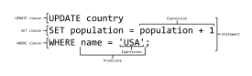
This chart shows several of the SQL language elements that compose a single statement.
The SQL language is sub-divided into several language elements, including:
- Clauses, which are constituent components of statements and queries. (In some cases, these are optional.)^{[9]}
- Expressions, which can produce either scalar values or tables consisting of columns and rows of data.
- Predicates, which specify conditions that can be evaluated to SQL three-valued logic (3VL) or Boolean (true/false/unknown) truth values and which are used to limit the effects of statements and queries, or to change program flow.
- Queries, which retrieve the data based on specific criteria. This is the most important element of SQL.
- Statements, which may have a persistent effect on schemas and data, or which may control transactions, program flow, connections, sessions, or diagnostics.
- SQL statements also include the semicolon (";") statement terminator. Though not required on every platform, it is defined as a standard part of the SQL grammar.
- Insignificant whitespace is generally ignored in SQL statements and queries, making it easier to format SQL code for readability.

Queries
The most common operation in SQL is the query, which is performed with the declarative SELECT statement. SELECT retrieves data from one or more tables, or expressions. Standard SELECT statements have no persistent effects on the database. Some non-standard implementations of SELECT can have persistent effects, such as the SELECT INTO syntax that exists in some databases.^{[10]}
Queries allow the user to describe desired data, leaving the database management system (DBMS) responsible for planning, optimizing, and performing the physical operations necessary to produce that result as it chooses.
A query includes a list of columns to be included in the final result immediately following the SELECT keyword. An asterisk ("*") can also be used to specify that the query should return all columns of the queried tables. SELECT is the most complex statement in SQL, with optional keywords and clauses that include:
- The FROM clause which indicates the table(s) from which data is to be retrieved. The FROM clause can include optional JOIN subclauses to specify the rules for joining tables.
- The WHERE clause includes a comparison predicate, which restricts the rows returned by the query. The WHERE clause eliminates all rows from the result set for which the comparison predicate does not evaluate to True.
- The GROUP BY clause is used to project rows having common values into a smaller set of rows. GROUP BY is often used in conjunction with SQL aggregation functions or to eliminate duplicate rows from a result set. The WHERE clause is applied before the GROUP BY clause.
- The HAVING clause includes a predicate used to filter rows resulting from the GROUP BY clause. Because it acts on the results of the GROUP BY clause, aggregation functions can be used in the HAVING clause predicate.
- The ORDER BY clause identifies which columns are used to sort the resulting data, and in which direction they should be sorted (options are ascending or descending). Without an ORDER BY clause, the order of rows returned by an SQL query is undefined.
The following is an example of a SELECT query that returns a list of expensive books. The query retrieves all rows from the Book table in which the price column contains a value greater than 100.00. The result is sorted in ascending order by title. The asterisk (*) in the select list indicates that all columns of the Book table should be included in the result set.
SELECT *
FROM Book
WHERE price > 100.00
ORDER BY title;
The example below demonstrates a query of multiple tables, grouping, and aggregation, by returning a list of books and the number of authors associated with each book.
SELECT Book.title,
count(*) AS Authors
FROM Book JOIN Book_author
ON Book.isbn = Book_author.isbn
GROUP BY Book.title;
Example output might resemble the following:
Title Authors
---------------------- -------
SQL Examples and Guide 4
The Joy of SQL 1
An Introduction to SQL 2
Pitfalls of SQL 1
Under the precondition that isbn is the only common column name of the two tables and that a column named title only exists in the Books table, the above query could be rewritten in the following form:
SELECT title,
count(*) AS Authors
FROM Book NATURAL JOIN Book_author
GROUP BY title;
However, many vendors either do not support this approach, or require certain column naming conventions in order for natural joins to work effectively.
SQL includes operators and functions for calculating values on stored values. SQL allows the use of expressions in the select list to project data, as in the following example which returns a list of books that cost more than 100.00 with an additional sales_tax column containing a sales tax figure calculated at 6% of the price.
SELECT isbn,
title,
price,
price * 0.06 AS sales_tax
FROM Book
WHERE price > 100.00
ORDER BY title;

Null and three-valued logic (3VL)
The idea of Null was introduced into SQL to handle missing information in the relational model. The introduction of Null (or Unknown) along with True and False is the foundation of three-valued logic. Null does not have a value (and is not a member of any data domain) but is rather a placeholder or "mark" for missing information. Therefore comparisons with Null can never result in either True or False but always in the third logical result.
SQL uses Null to handle missing information. It supports three-valued logic (3VL) and the rules governing SQL three-valued logic are shown below (p and q represent logical states).^{[12]} The word NULL is also a reserved keyword in SQL, used to identify the Null special marker.
Additionally, since SQL operators return Unknown when comparing anything with Null, SQL provides two Null-specific comparison predicates: IS NULL and IS NOT NULL test whether data is or is not Null.
Universal quantification is not explicitly supported by SQL, and must be worked out as a negated existential quantification.^{[13][14][15]}
There is also the "<row value expression> IS DISTINCT FROM <row value expression>" infixed comparison operator which returns TRUE unless both operands are equal or both are NULL. Likewise, IS NOT DISTINCT FROM is defined as "NOT (<row value expression> IS DISTINCT FROM <row value expression>)".

Data manipulation
The Data Manipulation Language (DML) is the subset of SQL used to add, update and delete data:
- INSERT adds rows (formally tuples) to an existing table, e.g.,:
INSERT INTO My_table
(field1, field2, field3)
VALUES
('test', 'N', NULL);
- UPDATE modifies a set of existing table rows, e.g.,:
UPDATE My_table
SET field1 = 'updated value'
WHERE field2 = 'N';
- DELETE removes existing rows from a table, e.g.,:
DELETE FROM My_table
WHERE field2 = 'N';
- MERGE is used to combine the data of multiple tables. It combines the INSERT and UPDATE elements. It is defined in the SQL:2003 standard; prior to that, some databases provided similar functionality via different syntax, sometimes called "upsert".

Transaction controls
Transactions, if available, wrap DML operations:
- START TRANSACTION (or BEGIN WORK, or BEGIN TRANSACTION, depending on SQL dialect) mark the start of a database transaction, which either completes entirely or not at all.
- SAVE TRANSACTION (or SAVEPOINT ) save the state of the database at the current point in transaction
CREATE TABLE tbl_1(id int);
INSERT INTO tbl_1(id) value(1);
INSERT INTO tbl_1(id) value(2);
COMMIT;
UPDATE tbl_1 SET id=200 WHERE id=1;
SAVEPOINT id_1upd;
UPDATE tbl_1 SET id=1000 WHERE id=2;
ROLLBACK TO id_1upd;
SELECT id FROM tbl_1;
- COMMIT causes all data changes in a transaction to be made permanent.
- ROLLBACK causes all data changes since the last COMMIT or ROLLBACK to be discarded, leaving the state of the data as it was prior to those changes.
Once the COMMIT statement completes, the transaction's changes cannot be rolled back.
COMMIT and ROLLBACK terminate the current transaction and release data locks. In the absence of a START TRANSACTION or similar statement, the semantics of SQL are implementation-dependent. Example: A classic bank transfer of funds transaction.
START TRANSACTION;
UPDATE Account SET amount=amount-200 WHERE account_number=1234;
UPDATE Account SET amount=amount+200 WHERE account_number=2345;
IF ERRORS=0 COMMIT;
IF ERRORS<>0 ROLLBACK;

Data definition
The Data Definition Language (DDL) manages table and index structure. The most basic items of DDL are the CREATE, ALTER, RENAME, DROP and TRUNCATE statements:
- CREATE creates an object (a table, for example) in the database, e.g.,:
CREATE TABLE My_table(
my_field1 INT,
my_field2 VARCHAR(50),
my_field3 DATE NOT NULL,
PRIMARY KEY (my_field1, my_field2)
);
- ALTER modifies the structure of an existing object in various ways, for example, adding a column to an existing table or a constraint, e.g.,:
ALTER TABLE My_table ADD my_field4 NUMBER(3) NOT NULL;
- TRUNCATE deletes all data from a table in a very fast way, deleting the data inside the table and not the table itself. It usually implies a subsequent COMMIT operation, i.e., it cannot be rolled back.
TRUNCATE TABLE My_table;
- DROP deletes an object in the database, usually irretrievably, i.e., it cannot be rolled back, e.g.,:
DROP TABLE My_table;

Data types
Each column in an SQL table declares the type(s) that column may contain. ANSI SQL includes the following datatypes.

Character strings
- CHARACTER(n) or CHAR(n) — fixed-width n-character string, padded with spaces as needed
- CHARACTER VARYING(n) or VARCHAR(n) — variable-width string with a maximum size of n characters
- NATIONAL CHARACTER(n) or NCHAR(n) — fixed width string supporting an international character set
- NATIONAL CHARACTER VARYING(n) or NVARCHAR(n) — variable-width NCHAR string

Bit strings
- BIT(n) — an array of n bits
- BIT VARYING(n) — an array of up to n bits

Numbers
- INTEGER and SMALLINT
- FLOAT, REAL and DOUBLE PRECISION
- NUMERIC(precision, scale) or DECIMAL(precision, scale)
SQL provides a function to round numerics or dates, called TRUNC (in Informix, DB2, PostgreSQL, Oracle and MySQL) or ROUND (in Informix, Sybase, Oracle, PostgreSQL and Microsoft SQL Server)

Date and time
- DATE — for date values (e.g., 2010-05-30)
- TIME — for time values (e.g., 14:55:37). The granularity of the time value is usually a tick (100 nanoseconds).
- TIME WITH TIME ZONE or TIMESTAMP — the same as TIME, but including details about the time zone in question.
- TIMESTAMP — This is a DATE and a TIME put together in one variable (e.g., 2010-05-30 14:55:37).
- TIMESTAMP WITH TIME ZONE or TIMESTAMPTZ — the same as TIMESTAMP, but including details about the time zone in question.
SQL provides several functions for generating a date / time variable out of a date / time string (TO_DATE, TO_TIME, TO_TIMESTAMP), as well as for extracting the respective members (seconds, for instance) of such variables. The current system date / time of the database server can be called by using functions like NOW.

Data control
The Data Control Language (DCL) authorizes users and groups of users to access and manipulate data. Its two main statements are:
- GRANT authorizes one or more users to perform an operation or a set of operations on an object.
- REVOKE eliminates a grant, which may be the default grant.
Example:
GRANT SELECT, UPDATE
ON My_table
TO some_user, another_user;

REVOKE SELECT, UPDATE
ON My_table
FROM some_user, another_user;

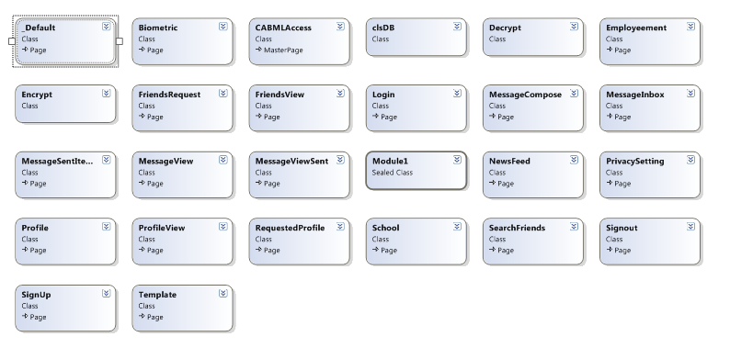

Database Tables:
tblEmployee
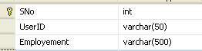

tblFriendList

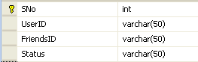

tblMessageId

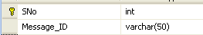

tblMessageInbox

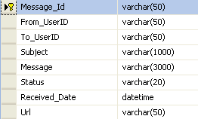
tblSentItems

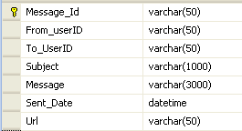

tblNewsFeed

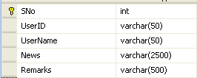

tblPrivacy

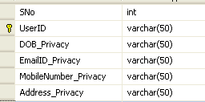

tblRegistration

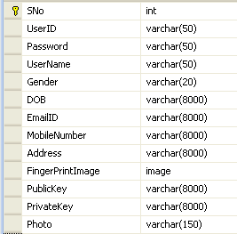

tblSchoolDetails

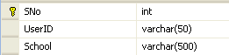

Screen Layout

Login Page
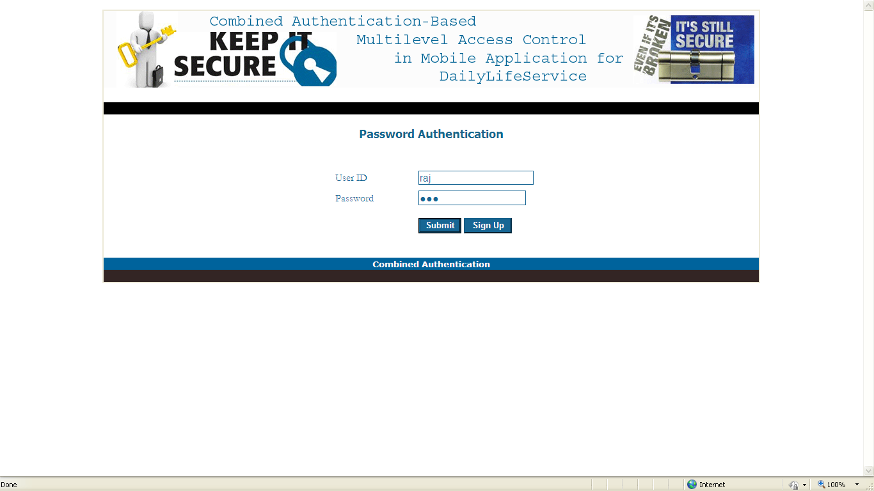
SignUp Page

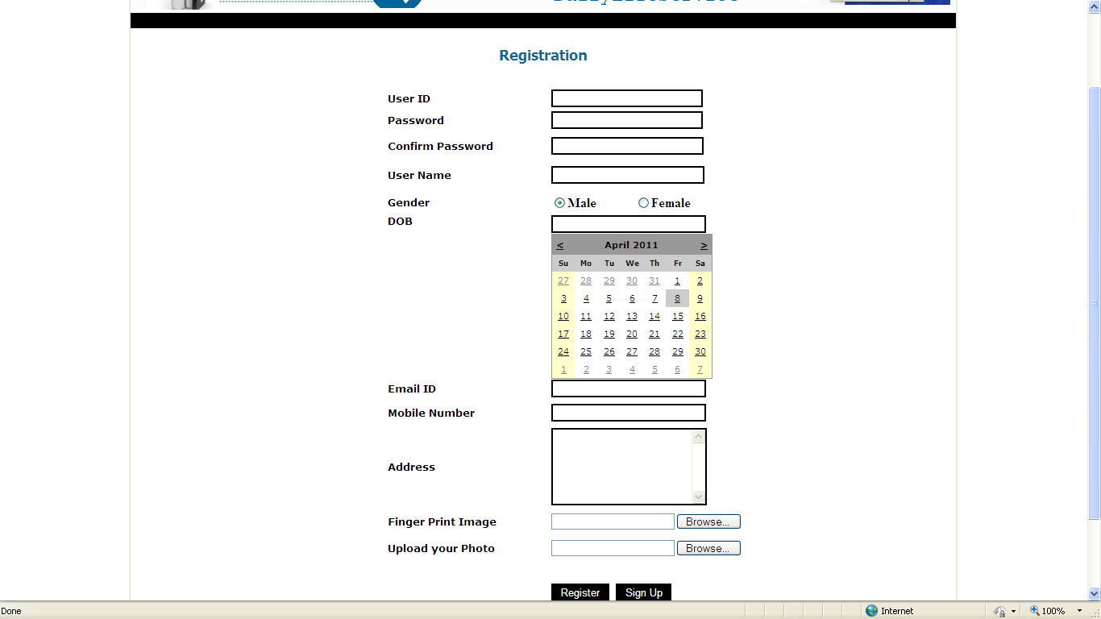
Biometric – Authentication Page
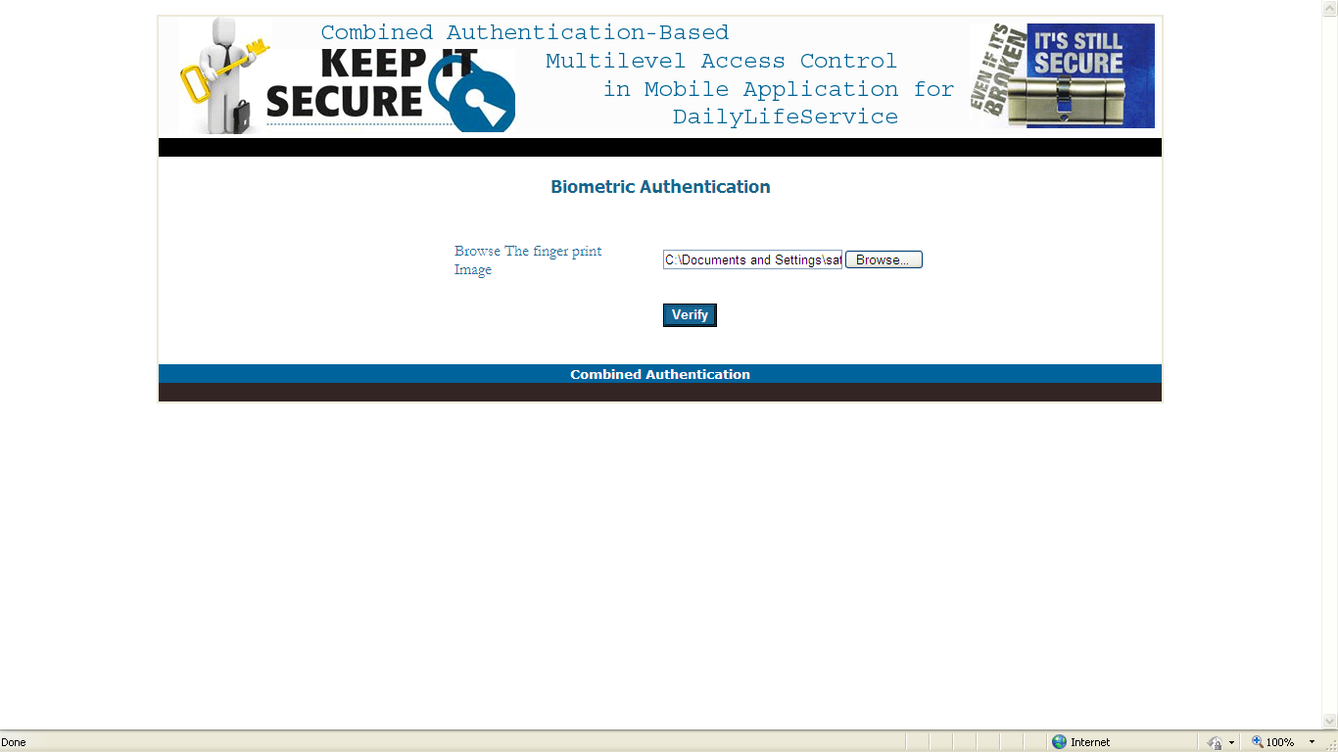

Login – Registered User

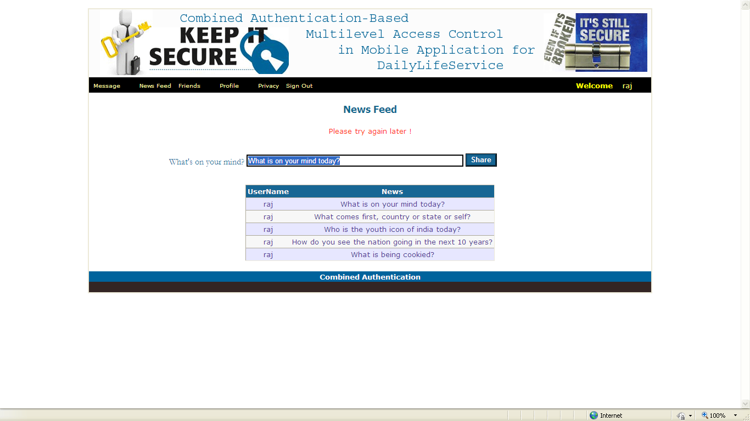

Message Module - Inbox

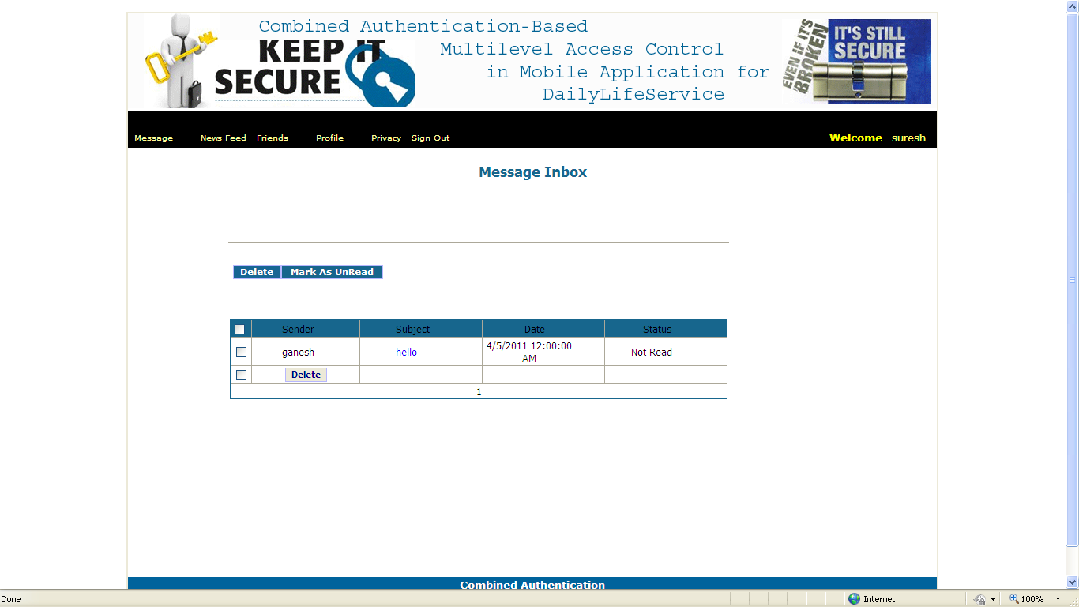

Message Module – Compose new message

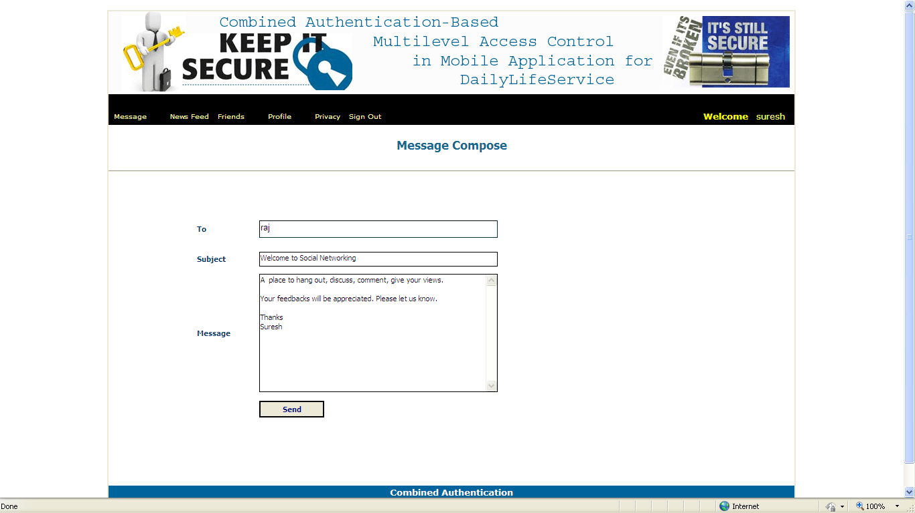
Message Module – Sent Items

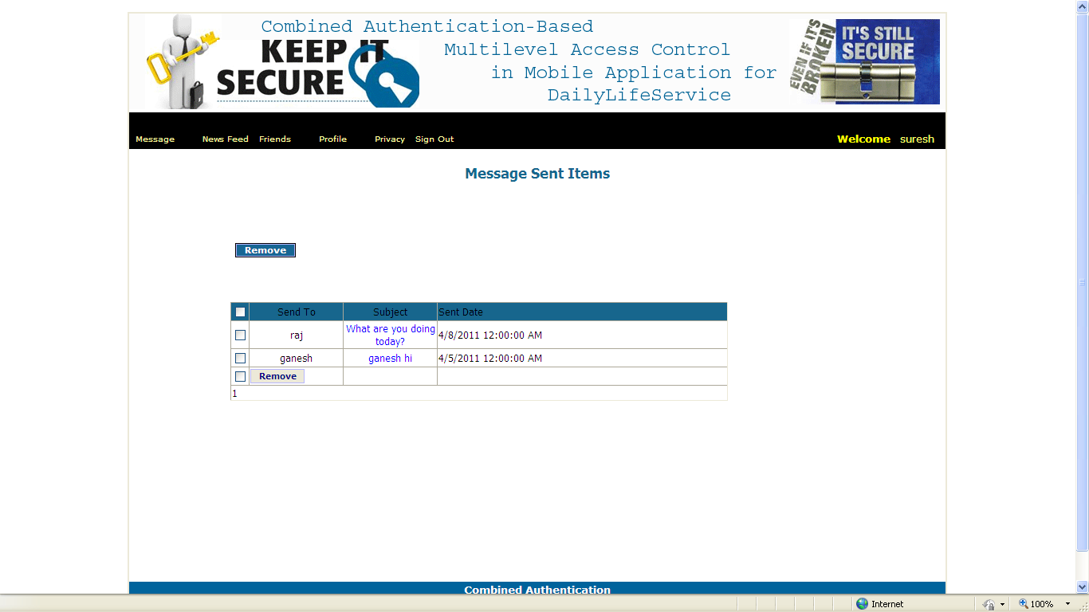

News feed Module:

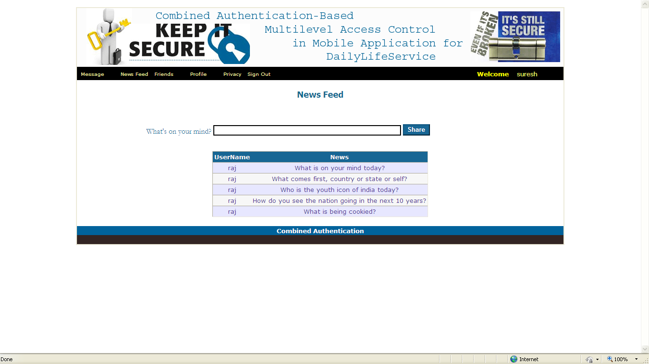
Friend Module:
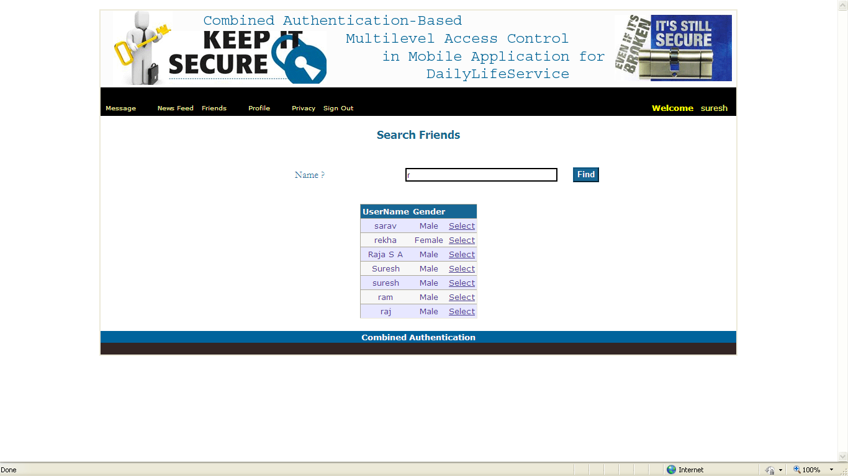

Profile Module:
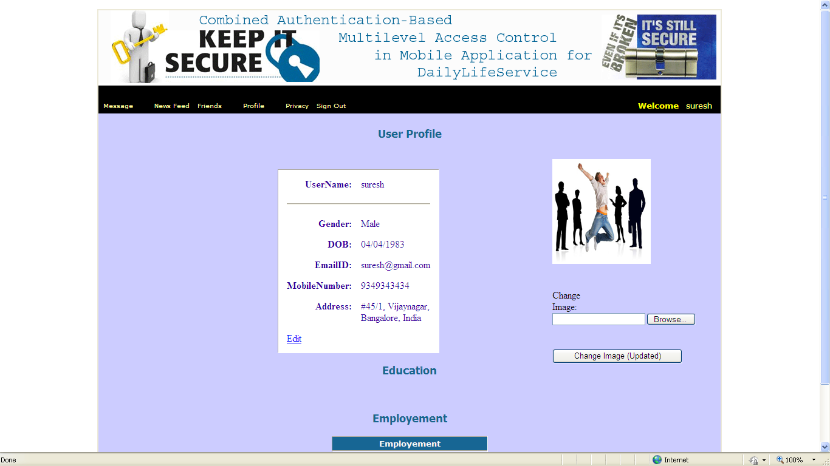

Education Details
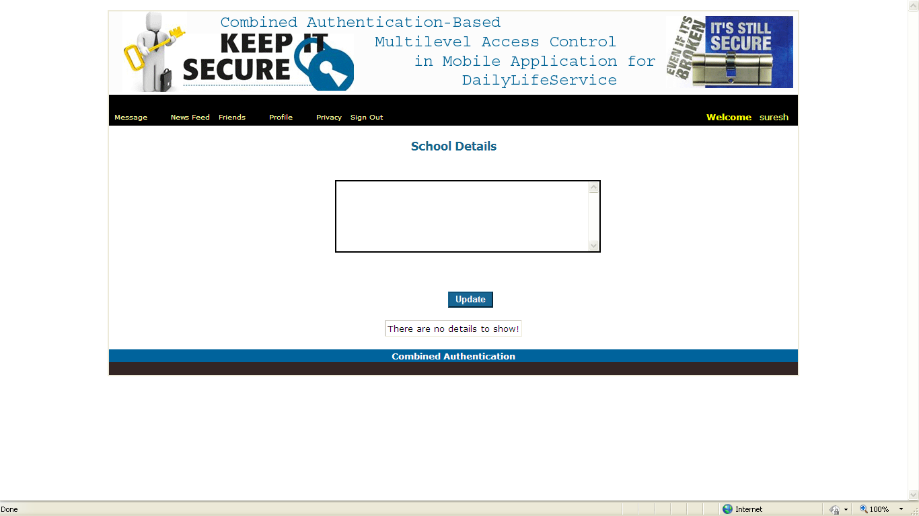

Employment Details
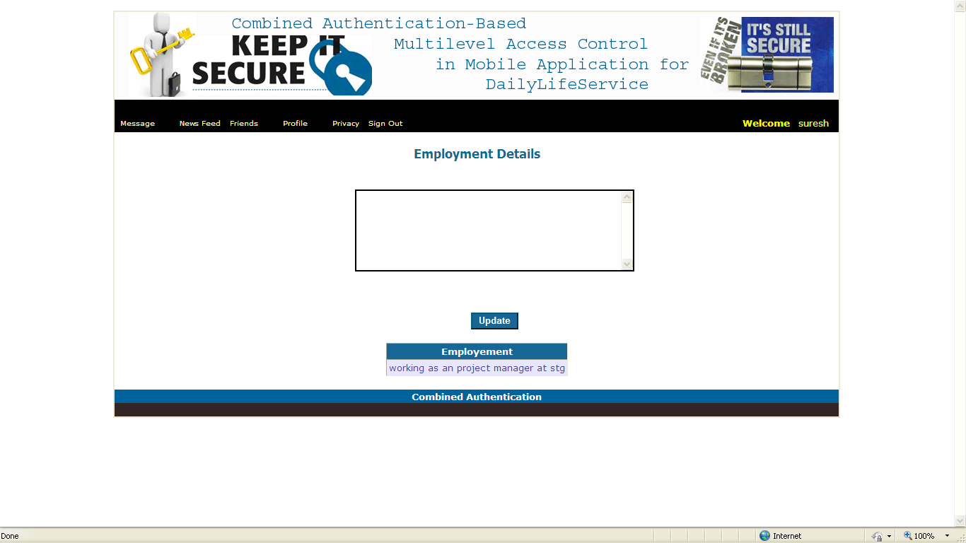

Privacy Module:
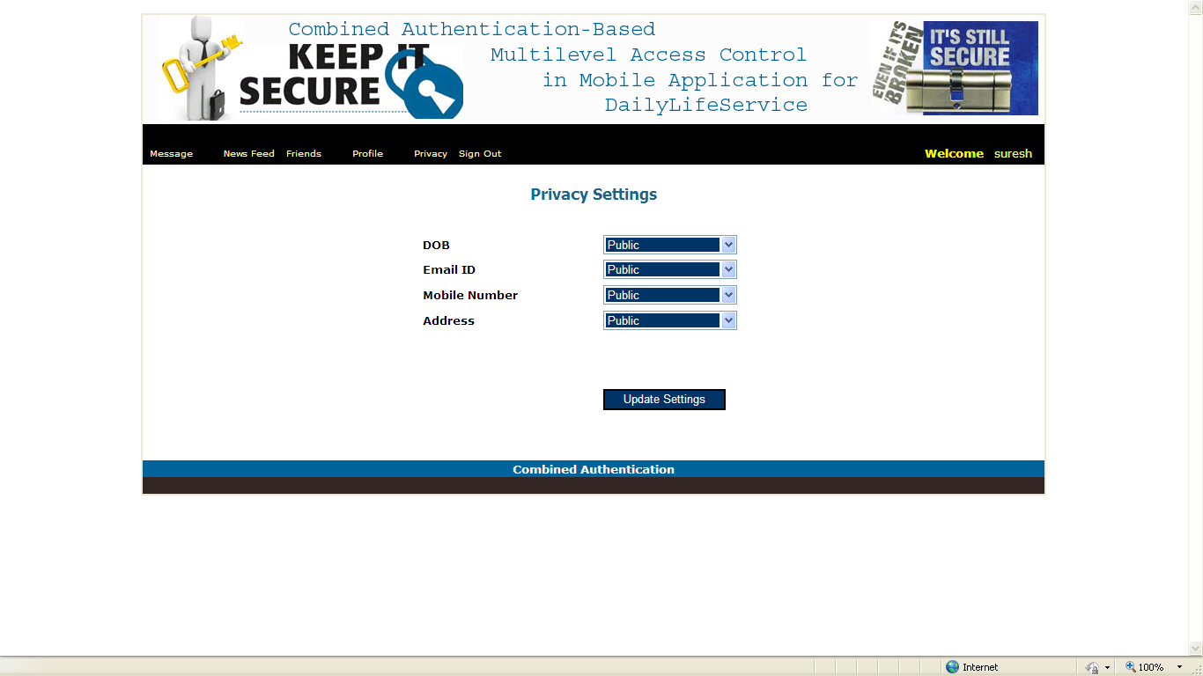

3.5 CODING & IMPLEMENTATION

CODING Definition
Definition
The process of converting information obtained on a subject or unit into coded values for the purpose of data storage, and analysis.

Coding Standards
This document requires or recommends certain practice for developing programs in the any language. The objective of this coding standard is to have a positive effect on
Avoidance of errors/bugs, especially the hard-to-find ones.
Maintainability, by promoting some proven design principle.
Maintainability, by requiring or recommending a certain unity of style.
Performance, by dissuading wasteful practices.

General Rules
Every time a recommendation is not followed, this must have a good reason. Good reasons do not include personal preferences of style.
Do not mix code from different providers in one file.

Comments and Embedded documentation
Each file shall contain a header block.
Use ‘ for comments.
All comments shall be written in US English.

Object Life Cycle
Declare and initialize variables close to where they are used.
If possible, initialize variables at the point of declaration.
Use a const field to define constant values.
Do not ‘shadow’ a name in an outer scope.

Control Flow
Do not change a loop variable inside a for loop block.
Update loop variables close to where the loop condition is specified.
All flow controls primitives (if, else, while, for, do, switch) shall be followed by a block, even if it is empty.
All switch statements shall have a difficult label as the last case label.
Avoid multiple or conditional return statements.

Object Oriented Programming
Declare all fields (data members) private.
Provide a difficult private constructor if they are only static methods and properties on a class.
If you must provide the ability to override a method, make only the most complete overload virtual and define the other operations in terms of it.
Use a property rather than a method when the member is a logical data member.
Use a method rather than a property when this is more appropriate.

Exceptions
Only throw exceptions in exceptional situations.
List the explicit exceptions a method or property can through.
Use standard exceptions.
Throw informational exceptions.
Throw the most specific exception possible.

Biometric Code
using System;
using System.Collections;
using System.Configuration;
using System.Data;
using System.Linq;
using System.Web;
using System.Web.Security;
using System.Web.UI;
using System.Web.UI.WebControls;
using System.Web.UI.WebControls.WebParts;
using System.Web.UI.HtmlControls;
using System.Xml.Linq;
using CABMLAccess.Helper;

namespace CABMLAccess
{
public partial class Biometric : System.Web.UI.Page
{
String strCon;

protected void Page_Load(object sender, EventArgs e)
{
strCon = System.Configuration.ConfigurationManager.ConnectionStrings["strcon"].ToString();

}

protected void btnSubmit_Click(object sender, EventArgs e)
{

try
{

string strUserID = "", strUserName = "";
string strQuery;
DataSet dsImage;
Object b1, b2;

byte[] Image1;
byte[] Image2;
byte[] Image3;
byte[] Image4;

int intLength1, intLength2, intLength3, intLength4;

if (Session["UserID"] != null)
{
strUserID = Session["UserID"].ToString();
strUserName = Session["UserName"].ToString();
}

strQuery = "select FingerPrintImage from tblRegistration where UserID='" + strUserID + "'";

dsImage = clsDB.fnAdapterFill(strCon, CommandType.Text, strQuery);

b1 = dsImage.Tables[0].Rows[0]["FingerPrintImage"];

Image1 = (System.Byte[])b1; //finger print

intLength1 = Image1.Length;

intLength4 = File3.PostedFile.ContentLength;

Image4 = new byte[intLength4];

File3.PostedFile.InputStream.Read(Image4, 0, intLength4); //finger print

bool flag = true;

if (intLength1 == intLength4)
{

for (int intI = 0; intI < intLength1; intI++)
{

if (Image1[intI] != Image4[intI])
{
flag = false;
break;
}
}

if (flag == true)
{

string strFile, strFileName, FolderPath, outputfile;
int intIndex;

strFile = File3.PostedFile.FileName;
intIndex = strFile.LastIndexOf("\\");
strFileName = strFile.Substring(intIndex + 1);
//strPath = clsHelper.FilePath();
FolderPath = clsDB.getRootDirectory();
outputfile = FolderPath + "Upload/";
Module1.strPath3 = outputfile + strFileName;

File3.PostedFile.SaveAs(Module1.strPath3);

lblMessage.Text = "success";
Response.Redirect("NewsFeed.aspx", false);

}
else
{
lblMessage.Text = "Please try again later";

}

}
else
{

lblMessage.Text = "Fail";

}

}
catch (Exception ex)
{
lblMessage.Text = ex.Message.ToString();

}

}
}
}

using Microsoft.VisualBasic;
using System.Data;
using System;
using System.IO;
using System.Collections;
using System.Diagnostics;
using System.Drawing;
using System.Runtime.InteropServices;

namespace CABMLAccess
{
sealed class Module1
{
public static string HiddenText;
public static short HiddenTextCharCount;
public static string strPath1,strPath2,strPath3,strTextData;

public static Bitmap RetriveLogoImage;
public static Bitmap RetriveFPImage;
public static string text;

public static int vt1;
public static int vt2;
public static int vt3;

public struct BinaryData
{
public byte[] BineryText;

//UPGRADE_TODO: "Initialize" must be called to initialize instances of this structure. Click for more: 'ms-help://MS.VSCC.2003/commoner/redir/redirect.htm?keyword="vbup1026"'
public void Initialize()
{
BineryText = new byte[801];
}
}
public static short ImageWidth;
public static short ImageHeight;
public static short TextWidth;

public static int LogoImageHeight;
public static int LogoImageWidth;

public struct RECT
{
//UPGRADE_NOTE: Left was upgraded to Left_Renamed. Click for more: 'ms-help://MS.VSCC.2003/commoner/redir/redirect.htm?keyword="vbup1061"'
public int Left_Renamed;
public int Top;
//UPGRADE_NOTE: Right was upgraded to Right_Renamed. Click for more: 'ms-help://MS.VSCC.2003/commoner/redir/redirect.htm?keyword="vbup1061"'
public int Right_Renamed;
public int Bottom;
}

public struct BITMAPINFOHEADER //40 bytes
{
public int biSize;
public int biWidth;
public int biHeight;
public short biPlanes;
public short biBitCount;
public int biCompression;
public int biSizeImage;
public int biXPelsPerMeter;
public int biYPelsPerMeter;
public int biClrUsed;
public int biClrImportant;
}

//Dim RGBQUAD As RGBQUAD
public struct RGBQUAD
{
public byte rgbBlue;
public byte rgbGreen;
public byte rgbRed;
public byte rgbReserved;
}

public struct BITMAPINFO
{
public BITMAPINFOHEADER bmiHeader;
public RGBQUAD[] bmiColors;

//UPGRADE_TODO: "Initialize" must be called to initialize instances of this structure. Click for more: 'ms-help://MS.VSCC.2003/commoner/redir/redirect.htm?keyword="vbup1026"'
public void Initialize()
{
bmiColors = new Module1.RGBQUAD[256];
}
}

public struct BITMAPFILEHEADER
{
public short bfType;
public int bfSize;
public short bfReserved1;
public short bfReserved2;
public int bfOffBits;
}

public struct COLORAMP
{
public int lo;
public int hi;
public int lored;
public int logrn;
public int loblu;
public int hired;
public int higrn;
public int hiblu;
}

public struct POINTAPI
{
public int X;
public int Y;
}
public static short[,] testimagearray = new short[257, 257];

public static int[] RetriveData = new int[1001];
public static long Retrive_Data_Counter;

public static short[] BinaryLogoImageData = new short[(250*250)*8*3 + 1];
public static short[] BinaryFPImageData = new short[(250*250)*8*3 + 1];

public static short[] tempimgdata = new short[(250*250)*8*3 + 1];

public static double TotalBitToRetrive;

static int[] BineryTextData = new int[1001];
//Dim BinaryLogoImageData(1000) As Integer
public static int[] BinaryInfoData = new int[25];

static short[] TotalDataToEmbed = new short[101];

public static BITMAPFILEHEADER BmBitmapFileHeader;
public static BITMAPINFO BmBitmapInfo;

public static BITMAPFILEHEADER LogoBitmapFileHeader;
public static BITMAPINFO LogoBitmapInfo;

public static byte[] BitmapPixelData;
public static BITMAPFILEHEADER SaveAsBmBitmapFileHeader;
public static BITMAPINFO SaveAsBmBitmapInfo;
public static byte[] SaveAsBitmapPixelData;

public static string StrCurFileName;
public static short pictureloaded;
public static Bitmap OriginalImage;
public static Bitmap LogoImage;
public static Bitmap FingerPrintImage;
public static Bitmap RangeBmp;
public static Bitmap ResultBmp;

public const short DIB_RGB_COLORS = 0; // color table in RGBs
public static int lTotSize;

//UPGRADE_WARNING: Structure BITMAPINFO may require marshalling attributes to be passed as an argument in this Declare statement. Click for more: 'ms-help://MS.VSCC.2003/commoner/redir/redirect.htm?keyword="vbup1050"'
//UPGRADE_ISSUE: Declaring a parameter 'As Any' is not supported. Click for more: 'ms-help://MS.VSCC.2003/commoner/redir/redirect.htm?keyword="vbup1016"'
[DllImport("gdi32", ExactSpelling=true, CharSet=CharSet.Ansi, SetLastError=true)]
public static extern long GetPixel(long hdc, long x, long y);
public static void ReadBitmapFile(string StrFileName, BITMAPFILEHEADER BmFileHeader, BITMAPINFO BmInfo, byte[] BtArPixelData)
{
if (StrFileName.Length <= 0)
{
//MessageBox.Show("please select a file");
return;
}

//'Open the bmp file in Binary format
//FileOpen(1, StrFileName, OpenMode.Binary)
//'Get the header structures
//'UPGRADE_WARNING: Get was upgraded to FileGet and has a new behavior. Click for more: 'ms-help://MS.VSCC.2003/commoner/redir/redirect.htm?keyword="vbup1041"'
//FileGet(1, BmFileHeader, 1)
//'UPGRADE_WARNING: Get was upgraded to FileGet and has a new behavior. Click for more: 'ms-help://MS.VSCC.2003/commoner/redir/redirect.htm?keyword="vbup1041"'
//FileGet(1, BmInfo.bmiHeader)
//If BmInfo.bmiHeader.biBitCount = 8 Then
// 'UPGRADE_WARNING: Get was upgraded to FileGet and has a new behavior. Click for more: 'ms-help://MS.VSCC.2003/commoner/redir/redirect.htm?keyword="vbup1041"'
// FileGet(1, BmInfo.bmiColors)
//End If
//If BmInfo.bmiHeader.biCompression = 1 Then
// ReDim BtArPixelData(BmInfo.bmiHeader.biSizeImage)
//Else
// ReDim BtArPixelData(BmFileHeader.bfSize - BmFileHeader.bfOffBits)
//End If
//'UPGRADE_WARNING: Get was upgraded to FileGet and has a new behavior. Click for more: 'ms-help://MS.VSCC.2003/commoner/redir/redirect.htm?keyword="vbup1041"'
//FileGet(1, BtArPixelData)
//FileClose(1)

}

public static void saveBitmapFile(string filename, BITMAPFILEHEADER BmFileHeader, BITMAPINFO BmInfo, byte[] pixeldata)
{
if (filename.Length <= 0)
{
//MessageBox.Show("select a file");
return;
}

// FileSystem.FileOpen(1, filename, OpenMode.Binary,OpenAccess.Default,OpenShare.Default,1000000 );
// //UPGRADE_WARNING: Put was upgraded to FilePut and has a new behavior. Click for more: 'ms-help://MS.VSCC.2003/commoner/redir/redirect.htm?keyword="vbup1041"'
// FileSystem.FilePut(1, BmFileHeader, 1);
// //UPGRADE_WARNING: Put was upgraded to FilePut and has a new behavior. Click for more: 'ms-help://MS.VSCC.2003/commoner/redir/redirect.htm?keyword="vbup1041"'
// FileSystem.FilePut(1, BmInfo, -1);
// //write the pixel data
// //UPGRADE_WARNING: Put was upgraded to FilePut and has a new behavior. Click for more: 'ms-help://MS.VSCC.2003/commoner/redir/redirect.htm?keyword="vbup1041"'
// FileSystem.FilePut(1, pixeldata, -1);
// FileSystem.FileClose(1);
}

public static void createramp(COLORAMP ramp)
{
int j;
int lowr;
int lowg;
int lowb;
int highr;
int highg;
int highb;
double deltared;
double deltagrn;
double deltablu;
double deltapal;
double mr;
double mg;
double mb;
double br;
double bg;
double bb;
double temp;

lowr = ramp.lored;
lowg = ramp.logrn;
lowb = ramp.loblu;
highr = ramp.hired;
highg = ramp.higrn;
highb = ramp.hiblu;

deltapal = ramp.hi - ramp.lo;

if (deltapal == 0)
{
goto xit;
}

deltared = highr - lowr;
deltagrn = highg - lowg;
deltablu = highb - lowb;

mr = deltared / deltapal;
mg = deltagrn / deltapal;
mb = deltablu / deltapal;

br = lowr - (ramp.lo * mr);
bg = lowg - (ramp.lo * mg);
bb = lowb - (ramp.lo * mb);

for (j = ramp.lo; j <= ramp.hi; j++)
{
temp = j * mr + br;
SaveAsBmBitmapInfo.bmiColors[j].rgbRed = Convert.ToByte(temp + 0.5); // Add 0.5 for precision rounding

temp = j * mg + bg;
SaveAsBmBitmapInfo.bmiColors[j].rgbGreen = Convert.ToByte(temp + 0.5);

temp = j * mb + bb;
SaveAsBmBitmapInfo.bmiColors[j].rgbBlue = Convert.ToByte(temp + 0.5);
}
}
}

Helper class
using System;
using System.Data.SqlClient;
using System.Data;
using System.Data.OleDb;
using System.Web.Mail;
using System.Collections;

namespace CABMLAccess.Helper
{
/// <summary>
/// Summary description for clsDB.
/// </summary>
public class clsDB
{
public clsDB()
{

//
// TODO: Add constructor logic here
//
}
public static int fnExecuteNonQuery(string strConnection, CommandType cmdType,string strCMDText)
{

SqlCommand cmdCommand;
SqlConnection cnConnection;
string ss,sss;
int result;
try
{

cnConnection = new SqlConnection(strConnection);
cmdCommand = new SqlCommand();

if (cnConnection.State != ConnectionState.Open )
{
cnConnection.Open();
}
cmdCommand.Connection = cnConnection;
cmdCommand.CommandText = strCMDText;
cmdCommand.CommandType = cmdType;

result = cmdCommand.ExecuteNonQuery();
cmdCommand.Parameters.Clear();
cnConnection.Close();

return result;

}
catch(Exception e)
{
ss=e.Message.ToString();
sss=ss;
return -1;

}

}

public static int fnExecuteNonQuery(string strConnection, CommandType cmdType,string strCMDText,Hashtable htParam)
{

SqlCommand cmdCommand;
SqlConnection cnConnection;
string ss,sss;
int result;
try
{

cnConnection = new SqlConnection(strConnection);
cmdCommand = new SqlCommand();

if (cnConnection.State != ConnectionState.Open )
{
cnConnection.Open();
}
cmdCommand.Connection = cnConnection;
cmdCommand.CommandText = strCMDText;
cmdCommand.CommandType = cmdType;

// If (htParam != null)
//{

int intInc=1;
foreach (object paramItem in htParam)
{
SqlParameter sqlParam = (SqlParameter)htParam[intInc];
intInc++;

cmdCommand.Parameters.Add(sqlParam);

// }

} result = cmdCommand.ExecuteNonQuery();
cmdCommand.Parameters.Clear();
cnConnection.Close();

return result;

}
catch(Exception e)
{
ss=e.Message.ToString();
sss=ss;
return -1;

}

}

public static int fnExecuteNonQueryOLE(string strConnection, CommandType cmdType,string strCMDText)
{

OleDbCommand cmdCommand;
OleDbConnection cnConnection;
string ss,sss;
int result;
try
{

//strConnection = "Provider=Microsoft.Jet.OLEDB.4.0;Data Source=D:\Project\DotNet\JPP\DataBase\Access.mdb;Persist Security Info=False"

cnConnection = new OleDbConnection(strConnection);
cmdCommand = new OleDbCommand();

if (cnConnection.State != ConnectionState.Open )
{
cnConnection.Open();
}
cmdCommand.Connection = cnConnection;
cmdCommand.CommandText = strCMDText;
cmdCommand.CommandType = cmdType;

result = cmdCommand.ExecuteNonQuery();
cmdCommand.Parameters.Clear();
cnConnection.Close();

return result;

}
catch(Exception e)
{
ss=e.Message.ToString();
sss=ss;
return -1;

}

}
public static string getRootDirectory()
{

string strRootPath;
strRootPath = System.AppDomain.CurrentDomain.BaseDirectory.ToString();
return strRootPath;

}

public static string FilePath()
{

string strFileName = "";

string strFolder;
string strFilePath;

strFilePath = getRootDirectory();
if (!strFilePath.Equals(""))
{

strFolder = System.Configuration.ConfigurationSettings.AppSettings.Get("strFolder");
strFileName = strFilePath + strFolder;

}
return strFileName;

}

public static DataSet fnAdapterFill(string strConnection, CommandType cmdType, string strCMDText)
{
string ss,sss;
SqlConnection cnConnection;
DataSet DSMessage = new DataSet ();

try
{

cnConnection = new SqlConnection(strConnection);

SqlDataAdapter adpAdadpter = new SqlDataAdapter(strCMDText, cnConnection);

adpAdadpter.Fill(DSMessage);
return DSMessage;

}
catch(Exception e)
{
ss=e.Message.ToString();
sss=ss;
return DSMessage;

}

}

public static int fnfnMailSend( string strSMTPServer, string strMailTo , string strMailFrom, string strSubject, string strMessage)
{
try
{
MailMessage mailmessage = new MailMessage();
string strSample;
strSample = SmtpMail.SmtpServer.Insert(0, strSMTPServer);
mailmessage.BodyFormat = System.Web.Mail.MailFormat.Text;
mailmessage.Body = strMessage;
mailmessage.Fields.Add("http://schemas.microsoft.com/cdo/configuration/smtpauthenticate", "1"); //basic authentication
mailmessage.Fields.Add("http://schemas.microsoft.com/cdo/configuration/sendusername", strMailFrom) ; //set your username here")
mailmessage.Fields.Add("http://schemas.microsoft.com/cdo/configuration/sendpassword", "password"); //set your password here")

System.Web.Mail.SmtpMail.Send(mailmessage);

return 1;
}
catch
{
return -1;
}

}

public static string getNextId(string strCurrentId)
{
string strSuffix, strNewID, strPrefix;
int intID;
strSuffix = strCurrentId.Substring(3);
strPrefix = strCurrentId.Substring(0, 3);
intID = Convert.ToInt32(strSuffix);
intID = intID + 1;
strNewID = strPrefix + intID.ToString();
return strNewID;
}

}
}

Login Code
using System;
using System.Collections;
using System.Configuration;
using System.Data;
using System.Linq;
using System.Web;
using System.Web.Security;
using System.Web.UI;
using System.Web.UI.WebControls;
using System.Web.UI.WebControls.WebParts;
using System.Web.UI.HtmlControls;
using System.Xml.Linq;
using CABMLAccess.Helper;

namespace CABMLAccess
{
public partial class Login : System.Web.UI.Page
{
String strCon;

protected void Page_Load(object sender, EventArgs e)
{
strCon = System.Configuration.ConfigurationManager.ConnectionStrings["strcon"].ToString();

}

protected void btnSubmit_Click(object sender, EventArgs e)
{
try
{
string strUserID, strPassword;
string strQuery1;
DataSet dsUserID;
strUserID = txtUserID.Text;
strPassword = txtPassword.Text;

if (strUserID.Equals("") || strPassword.Equals(""))
{
lblMessage.Text = "Please enter all details.";
}

else
{

strQuery1 = "select UserID,UserName from tblRegistration where ";
strQuery1 = strQuery1 + "UserID='" + strUserID + "'";
strQuery1 = strQuery1 + "and Password='" + strPassword + "'";

dsUserID = clsDB.fnAdapterFill(strCon, CommandType.Text, strQuery1);

if (dsUserID.Tables[0].Rows.Count <= 0)
{

lblMessage.Text = "Wrong UserID or Password!";
}
else
{
//strUserName = dsUserID.Tables[0].Rows[0]["UserName"].ToString() ;
Session["UserID"] = dsUserID.Tables[0].Rows[0]["UserID"].ToString();
Session["UserName"] = dsUserID.Tables[0].Rows[0]["UserName"].ToString();

//Response.Redirect("MessageCompose.aspx", false);

Response.Redirect("Biometric.aspx", false);

}

}

}
catch (Exception ex)
{
string ss = ex.Message.ToString();
string sss = ss;
}

}

protected void btnSubmit1_Click(object sender, EventArgs e)
{
try
{

Response.Redirect("SignUp.aspx", false);
}
catch (Exception ex)
{
string ss = ex.Message.ToString();
string sss = ss;
}

}
}
}

Sign Up Code
using System;
using System.Collections;
using System.Configuration;
using System.Data;
using System.Linq;
using System.Web;
using System.Web.Security;
using System.Web.UI;
using System.Web.UI.WebControls;
using System.Web.UI.WebControls.WebParts;
using System.Web.UI.HtmlControls;
using System.Xml.Linq;
using System.Data.SqlClient;
using System.IO;
using CABMLAccess.Helper;
using System.Security.Cryptography;

namespace CABMLAccess
{
public partial class SignUp : System.Web.UI.Page
{
String strCon;

protected void Page_Load(object sender, EventArgs e)
{
strCon = System.Configuration.ConfigurationManager.ConnectionStrings["strcon"].ToString();

}

protected void btnRegister_Click(object sender, EventArgs e)
{

try
{
string strUserID, strPassword, strUserName, strGender, strDOB;
string strEmailID, strMobileNumber, strAddress, strPublicKey, strPrivateKey;
byte[] byteFingerPrintImage;
string strQuery;
int intResult;

DataSet dsUser;

strUserID = txtUserID.Text;

strQuery = "select * from tblRegistration where UserID='" + strUserID + "'";

dsUser = clsDB.fnAdapterFill(strCon, CommandType.Text, strQuery);

intResult = dsUser.Tables[0].Rows.Count;

if (intResult <= 0)
{
strPassword = txtPassword.Text;
strUserName = txtUserName.Text;

if (rbtnMale.Checked == true)
{
strGender = "Male";
}
else
{
strGender = "Female";
}

strDOB = txtDOB.Text;
strEmailID = txtEmailID.Text;
strMobileNumber = txtMobileNumber.Text;
strAddress = txtAddress.Text;

RSACryptoServiceProvider RSA = new RSACryptoServiceProvider();

strPublicKey = RSA.ToXmlString(false);
strPrivateKey = RSA.ToXmlString(true);

int intLength1 = fFingerPrintImage.PostedFile.ContentLength;

byteFingerPrintImage = new byte[intLength1];

fFingerPrintImage.PostedFile.InputStream.Read(byteFingerPrintImage, 0, intLength1);
try
{
string strFileNameOnServer = System.IO.Path.GetFileName(fyPhoto.PostedFile.FileName);
string strBaseLocation = Server.MapPath("~/photos/");
if (fyPhoto.PostedFile != null)
{
fyPhoto.PostedFile.SaveAs(strBaseLocation + strFileNameOnServer);
}
}
catch
{
}
strQuery = "insert into tblRegistration(";
strQuery = strQuery + "UserID,Password,UserName,Gender,DOB,EmailID,";
strQuery = strQuery + "MobileNumber,Address,FingerPrintImage,PublicKey,PrivateKey,Photo) values(";
strQuery = strQuery + "@UserID,@Password,@UserName,@Gender,@DOB,@EmailID,@MobileNumber,";
strQuery = strQuery + "@Address,@FingerPrintImage,@PublicKey,@PrivateKey,";
strQuery = strQuery + "@Photo)";

Hashtable htReigstration = new Hashtable();
SqlParameter Param;

SqlConnection connection = new
SqlConnection(strCon);

connection.Open();
SqlCommand cmd = new SqlCommand(strQuery, connection);

Param = new SqlParameter();
Param.ParameterName = "@UserID";
Param.DbType = DbType.String;
Param.SqlDbType = SqlDbType.VarChar;
Param.Direction = ParameterDirection.Input;
Param.Value = strUserID;
//cmd.Parameters.Add(Param);
htReigstration.Add(1, Param);

Param = new SqlParameter();
Param.ParameterName = "@Password";
Param.DbType = DbType.String;
Param.SqlDbType = SqlDbType.VarChar;
Param.Direction = ParameterDirection.Input;
Param.Value = strPassword;
htReigstration.Add(2, Param);
//cmd.Parameters.Add(Param);

Param = new SqlParameter();
Param.ParameterName = "@UserName";
Param.DbType = DbType.String;
Param.SqlDbType = SqlDbType.VarChar;
Param.Direction = ParameterDirection.Input;
Param.Value = strUserName;
htReigstration.Add(3, Param);
//cmd.Parameters.Add(Param);
Param = new SqlParameter();
Param.ParameterName = "@Gender";
Param.DbType = DbType.String;
Param.SqlDbType = SqlDbType.VarChar;
Param.Direction = ParameterDirection.Input;
Param.Value = strGender;
htReigstration.Add(4, Param);
//cmd.Parameters.Add(Param);

Param = new SqlParameter();
Param.ParameterName = "@DOB";
Param.DbType = DbType.String;
Param.SqlDbType = SqlDbType.VarChar;
Param.Direction = ParameterDirection.Input;
Param.Value = strDOB;
htReigstration.Add(5, Param);
//cmd.Parameters.Add(Param);

Param = new SqlParameter();
Param.ParameterName = "@EmailID";
Param.DbType = DbType.String;
Param.SqlDbType = SqlDbType.VarChar;
Param.Direction = ParameterDirection.Input;
Param.Value = strEmailID;
htReigstration.Add(6, Param);
//cmd.Parameters.Add(Param);

Param = new SqlParameter();
Param.ParameterName = "@MobileNumber";
Param.DbType = DbType.String;
Param.SqlDbType = SqlDbType.VarChar;
Param.Direction = ParameterDirection.Input;
Param.Value = strMobileNumber;
htReigstration.Add(7, Param);
//cmd.Parameters.Add(Param);
Param = new SqlParameter();
Param.ParameterName = "@Address";
Param.DbType = DbType.String;
Param.SqlDbType = SqlDbType.VarChar;
Param.Direction = ParameterDirection.Input;
Param.Value = strAddress;
htReigstration.Add(8, Param);
//cmd.Parameters.Add(Param);

Param = new SqlParameter();
Param.ParameterName = "@FingerPrintImage";
Param.DbType = DbType.Byte;
Param.SqlDbType = SqlDbType.Image;
Param.Direction = ParameterDirection.Input;
Param.Value = byteFingerPrintImage;
htReigstration.Add(9, Param);
//cmd.Parameters.Add(Param);

Param = new SqlParameter();
Param.ParameterName = "@PublicKey";
Param.DbType = DbType.String;
Param.SqlDbType = SqlDbType.VarChar;
Param.Direction = ParameterDirection.Input;
Param.Value = strPublicKey;
htReigstration.Add(10, Param);
//cmd.Parameters.Add(Param);

Param = new SqlParameter();
Param.ParameterName = "@PrivateKey";
Param.DbType = DbType.String;
Param.SqlDbType = SqlDbType.VarChar;
Param.Direction = ParameterDirection.Input;
Param.Value = strPrivateKey;
htReigstration.Add(11, Param);
//cmd.Parameters.Add(Param);

Param = new SqlParameter();
Param.ParameterName = "@Photo";
Param.DbType = DbType.String;
Param.SqlDbType = SqlDbType.VarChar;
Param.Direction = ParameterDirection.Input;
Param.Value = "photos/" + fyPhoto.PostedFile.FileName;
htReigstration.Add(12, Param);
//cmd.Parameters.Add(Param);

intResult = clsDB.fnExecuteNonQuery(strCon, CommandType.Text, strQuery, htReigstration);

String strPrivacy = "Public";
strQuery = "insert into tblPrivacy values(";
strQuery = strQuery + "'" + strUserID + "',";
strQuery = strQuery + "'" + strPrivacy + "',";
strQuery = strQuery + "'" + strPrivacy + "',";
strQuery = strQuery + "'" + strPrivacy + "',";
strQuery = strQuery + "'" + strPrivacy + "')";

intResult = clsDB.fnExecuteNonQuery(strCon, CommandType.Text, strQuery, htReigstration);

if (intResult > 0)
{

string strFolder = strUserID;
string FolderPath = clsDB.getRootDirectory();
string outputfile = FolderPath + "inbox/" + strFolder;

try
{
if (!Directory.Exists(outputfile))
{
// Create the directory it does not exist.
Directory.CreateDirectory(outputfile);
}

}
catch (Exception ex)
{

Console.WriteLine(ex.Message.ToString());
}

Response.Redirect("Login.aspx", false);

}
}
else
{
lblMessage.Text = "User with this ID already registered";

}

}
catch (Exception ex)
{

lblMessage.Text = ex.ToString();

}

}

protected void btnSignUp_Click(object sender, EventArgs e)
{
try
{

Response.Redirect("Login.aspx", false);
}
catch (Exception ex)
{
lblMessage.Text = ex.ToString();

}

}

protected void Calendar1_SelectionChanged(object sender, EventArgs e)
{
txtDOB.Text = Calendar1.SelectedDate.ToShortDateString();
}
}
}

View Profile Code
using System;
using System.Collections;
using System.Configuration;
using System.Data;
using System.Linq;
using System.Web;
using System.Web.Security;
using System.Web.UI;
using System.Web.UI.WebControls;
using System.Web.UI.WebControls.WebParts;
using System.Web.UI.HtmlControls;
using System.Xml.Linq;
using CABMLAccess.Helper;
using System.Data.SqlClient;

namespace CABMLAccess
{
public partial class Profile : System.Web.UI.Page
{
string strCon;
protected void Page_Load(object sender, EventArgs e)
{
strCon = System.Configuration.ConfigurationManager.ConnectionStrings["strcon"].ToString();

if (Session["UserID"] != null)
{
lblName.Text = Session["UserName"].ToString();

}
else
{

Response.Redirect("login.aspx", false);
}

loadProfile();

}

protected void loadProfile()
{

string strQuery;
int intResult;
DataSet dsProfile, dsPrivacy;
Object[] Data;
Object[] Datas;
string strUserName, strGender, strDOB, strEMailID, strMobileNumber, strAddress, strPublicKey, strPrivateKey;
string strDOB_Privacy, strEMailID_Privacy, strMobileNumber_Privacy, strAddress_Privacy;
string strUserID = Session["UserID"].ToString();

try
{
strQuery = "select DOB_Privacy,EmailID_Privacy,MobileNumber_Privacy,Address_Privacy from tblPrivacy where UserID='" + strUserID + "'";

dsPrivacy = clsDB.fnAdapterFill(strCon, CommandType.Text, strQuery);

intResult = dsPrivacy.Tables[0].Rows.Count;

if (intResult > 0)
{
Datas = dsPrivacy.Tables[0].Rows[0].ItemArray;

strDOB_Privacy = Datas[0].ToString();
strEMailID_Privacy = Datas[1].ToString();
strMobileNumber_Privacy = Datas[2].ToString();
strAddress_Privacy = Datas[3].ToString();

strQuery = "select UserName,Gender,DOB,EMailID,MobileNumber,Address,PublicKey,PrivateKey,Photo from tblRegistration where UserID='" + strUserID + "'";
dsProfile = clsDB.fnAdapterFill(strCon, CommandType.Text, strQuery);

intResult = dsProfile.Tables[0].Rows.Count;

if (intResult > 0)
{
Data = dsProfile.Tables[0].Rows[0].ItemArray;
strUserName = Data[0].ToString();
strGender = Data[1].ToString();
strDOB = Data[2].ToString();
strEMailID = Data[3].ToString();
strMobileNumber = Data[4].ToString();
strAddress = Data[5].ToString();
strPrivateKey = Data[6].ToString();
strPublicKey = Data[7].ToString();
string photoPath = Data[8].ToString();

imgPhoto.ImageUrl = "~/" + photoPath;

//txtUserName.Text = strUserName;
//if (strGender.Equals("Male"))
//{
// rbtnMale.Checked = true;
//}
//else
//{
// rbtnFemale.Checked = true;
//}

if (strDOB_Privacy.Equals("Private Shareable"))
{
strDOB = Decrypt.DecryptString(strDOB, 1024, strPublicKey);

}
else if (strDOB_Privacy.Equals("Private Not Shareable"))
{
strDOB = Decrypt.DecryptString(strDOB, 1024, strPublicKey);
strDOB = Decrypt.DecryptString(strDOB, 1024, strPublicKey);

}
else if (strDOB_Privacy.Equals("Public"))
{
//strDOB = strDOB;

}

if (strEMailID_Privacy.Equals("Private Shareable"))
{

strEMailID = Decrypt.DecryptString(strEMailID, 1024, strPublicKey);

}
else if (strEMailID_Privacy.Equals("Private Not Shareable"))
{
strEMailID = Decrypt.DecryptString(strEMailID, 1024, strPublicKey);
strEMailID = Decrypt.DecryptString(strEMailID, 1024, strPublicKey);

}
else if (strEMailID_Privacy.Equals("Public"))
{
//strEMailID = strEMailID;

}

if (strMobileNumber_Privacy.Equals("Private Shareable"))
{

strMobileNumber = Decrypt.DecryptString(strMobileNumber, 1024, strPublicKey);

}
else if (strMobileNumber_Privacy.Equals("Private Not Shareable"))
{
strMobileNumber = Decrypt.DecryptString(strMobileNumber, 1024, strPublicKey);
strMobileNumber = Decrypt.DecryptString(strMobileNumber, 1024, strPublicKey);

}
else if (strMobileNumber_Privacy.Equals("Public"))
{
//strMobileNumber = strMobileNumber;

}

if (strAddress_Privacy.Equals("Private Shareable"))
{
strAddress = Decrypt.DecryptString(strAddress, 1024, strPublicKey);

}
else if (strAddress_Privacy.Equals("Private Not Shareable"))
{
strAddress = Decrypt.DecryptString(strAddress, 1024, strPublicKey);
strAddress = Decrypt.DecryptString(strAddress, 1024, strPublicKey);

}
else if (strAddress_Privacy.Equals("Public"))
{
//strAddress = strAddress;

}

//txtDOB.Text = strDOB;
//txtEmailID.Text = strEMailID;
//txtMobileNumber.Text = strMobileNumber;
//txtAddress.Text = strAddress;

}
else
{

lblMessage.Text = "There is no profile data available";
}
}
else
{
lblMessage.Text = "There is no profile data available";

}

}
catch (Exception ex)
{

}

}

protected void btnChangeImg_Click(object sender, EventArgs e)
{

try
{
string strFileNameOnServer = System.IO.Path.GetFileName(fyPhoto.PostedFile.FileName);
string strBaseLocation = Server.MapPath("~/photos/");
if (fyPhoto.PostedFile != null)
{
fyPhoto.PostedFile.SaveAs(strBaseLocation + strFileNameOnServer);
}

string strQuery = "UPDATE tblRegistration SET Photo=@Photo WHERE UserId=@UserID";

Hashtable htReigstration = new Hashtable();
SqlParameter Param;

SqlConnection connection = new SqlConnection(strCon);

connection.Open();
SqlCommand cmd = new SqlCommand(strQuery, connection);
Param = new SqlParameter();
Param.ParameterName = "@Photo";
Param.DbType = DbType.String;
Param.SqlDbType = SqlDbType.VarChar;
Param.Direction = ParameterDirection.Input;
Param.Value = "photos/" + fyPhoto.PostedFile.FileName;
string filePath= "~/photos/" + fyPhoto.PostedFile.FileName;
htReigstration.Add(1, Param);

Param = new SqlParameter();
Param.ParameterName = "@UserID";
Param.DbType = DbType.String;
Param.SqlDbType = SqlDbType.VarChar;
Param.Direction = ParameterDirection.Input;
Param.Value = Session["UserId"].ToString();
htReigstration.Add(2, Param);

btnChangeImg.Text = "Change Image" + " (Updating...)";

int Result = clsDB.fnExecuteNonQuery(strCon, CommandType.Text, strQuery, htReigstration);

if (Result > 0)
{
btnChangeImg.Text = "Change Image" + " (Updated)";
imgPhoto.ImageUrl = filePath;
}
else
{
btnChangeImg.Text = "Change Image" + " (Not Updated)";
}
}
catch
{
btnChangeImg.Text = "Change Image" + " (Not Updated)";
}

}

}
}

Privacy module code
using System;
using System.Collections;
using System.Configuration;
using System.Data;
using System.Linq;
using System.Web;
using System.Web.Security;
using System.Web.UI;
using System.Web.UI.WebControls;
using System.Web.UI.WebControls.WebParts;
using System.Web.UI.HtmlControls;
using System.Xml.Linq;
using CABMLAccess.Helper;

namespace CABMLAccess
{
public partial class PrivacySetting : System.Web.UI.Page
{
string strCon;

protected void Page_Load(object sender, EventArgs e)
{
strCon = System.Configuration.ConfigurationManager.ConnectionStrings["strcon"].ToString();
if (Session["UserID"] != null)
{
lblName.Text = Session["UserName"].ToString();

}
else
{

Response.Redirect("login.aspx", false);
}

}
protected void btnRegister_Click(object sender, EventArgs e)
{

String strQuery;
string strUserID, strDOB_Privacy, strEMailID_Privacy;
String strMobileNumber_Privacy, strAddress_Privacy;
string strDOB="", strEmailID="", strMobileNumber="", strAddress="";
string strPrivateKey="", strPublicKey="";

int intResult;
strUserID = Session["UserID"].ToString();

DataSet dsUser, dsPrivacy;

Object[] Datas;

try
{
strQuery = "select DOB_Privacy,EmailID_Privacy,MobileNumber_Privacy,Address_Privacy from tblPrivacy where UserID='" + strUserID + "'";

dsPrivacy = clsDB.fnAdapterFill(strCon, CommandType.Text, strQuery);

intResult = dsPrivacy.Tables[0].Rows.Count;

if (intResult > 0)
{
Datas = dsPrivacy.Tables[0].Rows[0].ItemArray;

strDOB_Privacy = Datas[0].ToString();
strEMailID_Privacy = Datas[1].ToString();
strMobileNumber_Privacy = Datas[2].ToString();
strAddress_Privacy = Datas[3].ToString();

strQuery = "select DOB,EmailID,MobileNumber,Address,PublicKey,PrivateKey from tblRegistration where UserID='" + strUserID + "'";

dsUser = clsDB.fnAdapterFill(strCon, CommandType.Text, strQuery);

intResult = dsUser.Tables[0].Rows.Count;

if (intResult > 0)
{
Datas = dsUser.Tables[0].Rows[0].ItemArray;
strDOB = Datas[0].ToString();
strEmailID = Datas[1].ToString();
strMobileNumber = Datas[2].ToString();
strAddress = Datas[3].ToString();
strPublicKey = Datas[5].ToString();
strPrivateKey = Datas[4].ToString();

if (strDOB_Privacy.Equals("Private Shareable"))
{
strDOB = Decrypt.DecryptString(strDOB, 1024, strPublicKey);

}
else if (strDOB_Privacy.Equals("Private Not Shareable"))
{
strDOB = Decrypt.DecryptString(strDOB, 1024, strPublicKey);
strDOB = Decrypt.DecryptString(strDOB, 1024, strPublicKey);

}
else if (strDOB_Privacy.Equals("Public"))
{
strDOB = strDOB;

}

if (strEMailID_Privacy.Equals("Private Shareable"))
{

strEmailID = Decrypt.DecryptString(strEmailID, 1024, strPublicKey);

}
else if (strEMailID_Privacy.Equals("Private Not Shareable"))
{
strEmailID = Decrypt.DecryptString(strEmailID, 1024, strPublicKey);
strEmailID = Decrypt.DecryptString(strEmailID, 1024, strPublicKey);

}
else if (strEMailID_Privacy.Equals("Public"))
{
strEmailID = strEmailID;

}

if (strMobileNumber_Privacy.Equals("Private Shareable"))

{

strMobileNumber = Decrypt.DecryptString(strMobileNumber, 1024, strPublicKey);

}
else if (strMobileNumber_Privacy.Equals("Private Not Shareable"))
{
strMobileNumber = Decrypt.DecryptString(strMobileNumber, 1024, strPublicKey);
strMobileNumber = Decrypt.DecryptString(strMobileNumber, 1024, strPublicKey);

}
else if (strMobileNumber_Privacy.Equals("Public"))
{
strMobileNumber = strMobileNumber;

}

if (strAddress_Privacy.Equals("Private Shareable"))
{
strAddress = Decrypt.DecryptString(strAddress, 1024, strPublicKey);

}
else if (strAddress_Privacy.Equals("Private Not Shareable"))
{
strAddress = Decrypt.DecryptString(strAddress, 1024, strPublicKey);
strAddress = Decrypt.DecryptString(strAddress, 1024, strPublicKey);

}
else if (strAddress_Privacy.Equals("Public"))
{
strAddress = strAddress;

}

}

}
else {
lblMessage.Text = "There is no privacy settings available for this user";
}

strDOB_Privacy = ddlDOB.SelectedItem.Text;
strEMailID_Privacy = ddlEmailID.SelectedItem.Text;
strMobileNumber_Privacy = ddlMobileNumber.SelectedItem.Text;
strAddress_Privacy = ddlAddress.SelectedItem.Text;

strQuery="update tblPrivacy set ";
strQuery = strQuery + "DOB_Privacy='" + strDOB_Privacy + "',";
strQuery = strQuery + "EMailID_Privacy='" + strEMailID_Privacy + "',";
strQuery = strQuery + "MobileNumber_Privacy='" + strMobileNumber_Privacy + "',";
strQuery = strQuery + "Address_Privacy='" + strAddress_Privacy + "'";
strQuery = strQuery + " Where UserID ='" + strUserID + "'";

intResult = clsDB.fnExecuteNonQuery(strCon, CommandType.Text, strQuery);

if (intResult > 0)
{

if (strDOB_Privacy.Equals("Private Shareable")){

strDOB = Encrypt.EncryptString(strDOB, 1024, strPrivateKey);

}
else if(strDOB_Privacy.Equals("Private Not Shareable"))
{
strDOB = Encrypt.EncryptString(strDOB, 1024, strPrivateKey);
strDOB = Encrypt.EncryptString(strDOB, 1024, strPrivateKey);

}
else if(strDOB_Privacy.Equals("Public"))
{
strDOB = strDOB;

}

if (strEMailID_Privacy.Equals("Private Shareable"))
{

strEmailID = Encrypt.EncryptString(strEmailID, 1024, strPrivateKey);

}
else if (strEMailID_Privacy.Equals("Private Not Shareable"))
{
strEmailID = Encrypt.EncryptString(strEmailID, 1024, strPrivateKey);
strEmailID = Encrypt.EncryptString(strEmailID, 1024, strPrivateKey);

}
else if (strEMailID_Privacy.Equals("Public"))
{
strEmailID = strEmailID;

}

if (strMobileNumber_Privacy.Equals("Private Shareable"))
{

strMobileNumber = Encrypt.EncryptString(strMobileNumber, 1024, strPrivateKey);

}
else if (strMobileNumber_Privacy.Equals("Private Not Shareable"))
{
strMobileNumber = Encrypt.EncryptString(strMobileNumber, 1024, strPrivateKey);
strMobileNumber = Encrypt.EncryptString(strMobileNumber, 1024, strPrivateKey);

}
else if (strMobileNumber_Privacy.Equals("Public"))
{
strMobileNumber = strMobileNumber;

}

if (strAddress_Privacy.Equals("Private Shareable"))
{

strAddress = Encrypt.EncryptString(strAddress, 1024, strPrivateKey);

}
else if (strAddress_Privacy.Equals("Private Not Shareable"))
{
strAddress = Encrypt.EncryptString(strAddress, 1024, strPrivateKey);
strAddress = Encrypt.EncryptString(strAddress, 1024, strPrivateKey);

}
else if (strAddress_Privacy.Equals("Public"))
{
strAddress = strAddress;

}

strQuery = "update tblRegistration set ";
strQuery = strQuery + "DOB ='" + strDOB + "',";
strQuery = strQuery + "EmailID ='" + strEmailID + "',";
strQuery = strQuery + "MobileNumber ='" + strMobileNumber + "',";
strQuery = strQuery + "Address ='" + strAddress + "' ";
strQuery = strQuery + "Where UserID='" + strUserID + "'";

intResult = clsDB.fnExecuteNonQuery(strCon, CommandType.Text, strQuery);

if (intResult > 0)
{
lblMessage.Text = "Success";
}
else
{
lblMessage.Text = "Fail";
}

}
else
{
lblMessage.Text = "There is no data availabe for the user";

}

if (intResult > 0)
{
lblMessage.Text = "Success";
}
else
{

lblMessage.Text = "Fail";
}

}
catch (Exception ex)
{

lblMessage.Text = ex.ToString();

}

}
}
}

News Feed Code
using System;
using System.Collections;
using System.Configuration;
using System.Data;
using System.Linq;
using System.Web;
using System.Web.Security;
using System.Web.UI;
using System.Web.UI.WebControls;
using System.Web.UI.WebControls.WebParts;
using System.Web.UI.HtmlControls;
using System.Xml.Linq;
using CABMLAccess.Helper;

namespace CABMLAccess
{
public partial class NewsFeed : System.Web.UI.Page
{
String strCon;

protected void Page_Load(object sender, EventArgs e)
{
strCon = System.Configuration.ConfigurationManager.ConnectionStrings["strcon"].ToString();
if (Session["UserID"] != null)
{
lblName.Text = Session["UserName"].ToString();

}
else
{

Response.Redirect("login.aspx", false);
}

loadNews();
}

protected void loadNews()
{
DataSet dsNews;
string strQuery,strUserID;
DataSet dsFriends;
int intResult;
Object []Datas;

strUserID = Session["UserID"].ToString();
string strCondition;

strCondition = "where UserID='";

strQuery = "select FriendsID from tblFriendsList where userID='" + strUserID + "'";

dsFriends = clsDB.fnAdapterFill(strCon, CommandType.Text, strQuery);

intResult = dsFriends.Tables[0].Rows.Count;

if (intResult > 0)
{
for (int intI = 0; intI < intResult; intI++)
{
Datas = dsFriends.Tables[0].Rows[intI].ItemArray;

strCondition = strCondition + Datas[0].ToString() + "' OR UserID='";

}

}
strCondition = strCondition + strUserID + "'";

strQuery = "select UserName,News from tblNewsFeed " + strCondition + " order by SNo desc";

dsNews = clsDB.fnAdapterFill(strCon, CommandType.Text, strQuery);

gvNewsFeed.DataSource = dsNews;
gvNewsFeed.DataBind();

}

protected void btnSubmit_Click(object sender, EventArgs e)
{
String strQuery, strUserID, strUserName, strNews, strRemarks;

int intResult;

try
{
strUserID = Session["UserID"].ToString();
strUserName = Session["UserName"].ToString();
strNews = txtNews.Text;
strRemarks = "Remarks";

strQuery = "insert into tblNewsFeed values(";
strQuery = strQuery + "'" + strUserID + "',";
strQuery = strQuery + "'" + strUserName + "',";
strQuery = strQuery + "'" + strNews + "',";
strQuery = strQuery + "'" + strRemarks + "')";

intResult = clsDB.fnExecuteNonQuery(strCon, CommandType.Text, strQuery);

if (intResult > 0)
{

loadNews();

}
else
{
lblMessage.Text = "Please try again later !";

}

}
catch (Exception ex)
{

lblMessage.Text = ex.Message.ToString();

}

}
}
}

Inbox module
using System;
using System.Collections;
using System.Configuration;
using System.Data;
using System.Linq;
using System.Web;
using System.Web.Security;
using System.Web.UI;
using System.Web.UI.WebControls;
using System.Web.UI.WebControls.WebParts;
using System.Web.UI.HtmlControls;
using System.Xml.Linq;
using CABMLAccess.Helper;

namespace CABMLAccess
{
public partial class MessageInbox : System.Web.UI.Page
{
String strCon;

protected void Page_Load(object sender, EventArgs e)
{
strCon = System.Configuration.ConfigurationManager.ConnectionStrings["strcon"].ToString();
if (Session["UserID"] != null)
{
lblName.Text = Session["UserName"].ToString();

}
else
{

Response.Redirect("login.aspx", false);
}

if (!IsPostBack)
{
loadMessageInbox();
}

}
protected void btnDelete_Click(object sender, EventArgs e)
{
try
{
fnDelete(sender, e);

}
catch (Exception ex)
{
lblMessage.Text = ex.Message;

}

}
public void fnDelete(object sender, EventArgs e)
{

try
{
String strMessage_ID = "";
foreach (DataGridItem ob in DgMessageInbox.Items)
{
if (ob.ItemType != ListItemType.Header && ob.ItemType != ListItemType.Footer && ob.ItemType != ListItemType.Pager)
{
bool ChkSelected1;
CheckBox chkBox;
chkBox = (CheckBox)(ob.Cells[0].FindControl("cbSelected"));
ChkSelected1 = chkBox.Checked;

if (ChkSelected1 == true)
{
strMessage_ID = strMessage_ID + DgMessageInbox.DataKeys[ob.ItemIndex].ToString() + ",";
}
}

}
bool boolContains;
char[] ch = { ',' };
String[] strIDS = { "" };

boolContains = strMessage_ID.Contains(",");

if (boolContains)
{
strMessage_ID = strMessage_ID.Substring(0, strMessage_ID.Length - 1);
strIDS = strMessage_ID.Split(ch);

}

try
{
int intI, intL;
intL = strIDS.Length;
String strMessageID;
String strQuery;

int intResult = 0;

for (intI = 0; intI < intL; intI++)
{

strMessageID = strIDS[intI];
strQuery = "delete from tblMessageInbox where Message_Id='" + strMessageID + "'";

intResult = clsDB.fnExecuteNonQuery(strCon, CommandType.Text, strQuery);

}
if (intResult > 0)
{
Session["Message"] = "Message Deleted Succssfully!";
Response.Redirect("MessageInbox.aspx", false);

}
else
{
lblMessage.Text = "Please try again later!";

}

}
catch (Exception ex)
{
lblMessage.Text = ex.Message;

}

}

catch (Exception ex)
{
lblMessage.Text = ex.Message;

}

}

protected void loadMessageInbox()
{
try
{

string strQuery, strUserID = "";
DataSet dsMessageInbox;

int intCount;

strUserID = Session["UserID"].ToString();

//strRouteID = ddlRouteID.SelectedItem.Text;
strQuery = "select * from tblMessageInbox where To_UserID='" + strUserID + "' order by Message_Id desc";
dsMessageInbox = clsDB.fnAdapterFill(strCon, CommandType.Text, strQuery);
intCount = dsMessageInbox.Tables[0].Rows.Count;
DgMessageInbox.DataSource = dsMessageInbox;
DgMessageInbox.DataBind();

}
catch (Exception ex)
{
lblMessage.Text = ex.Message;

}

}

protected void DgMessageInbox_SelectedIndexChanged(object sender, EventArgs e)
{

}

}
}

using System;
using System.Collections;
using System.Configuration;
using System.Data;
using System.Linq;
using System.Web;
using System.Web.Security;
using System.Web.UI;
using System.Web.UI.WebControls;
using System.Web.UI.WebControls.WebParts;
using System.Web.UI.HtmlControls;
using System.Xml.Linq;
using CABMLAccess.Helper;

namespace CABMLAccess
{
public partial class MessageCompose : System.Web.UI.Page
{
String strCon;
static string strMessageID;

protected void Page_Load(object sender, EventArgs e)
{
strCon = System.Configuration.ConfigurationManager.ConnectionStrings["strcon"].ToString();

if (Session["UserID"] != null)
{
lblName.Text = Session["UserName"].ToString();

}
else
{

Response.Redirect("login.aspx", false);
}
if (Session["To"] != null && Session["From"] != null && Session["Subject"] != null && Session["Message"] != null)
{

txtTo.Value = Session["To"].ToString();
txtSubject.Text = Session["Subject"].ToString();
txtMessage.Text = Session["Message"].ToString();

Session["To"] = null;
Session["Subject"] = null;
Session["Message"] = null;
}

generateNewID();
}

protected void generateNewID()
{
try
{

// to generate BusID

string strQuery;
string strCurrentID;
DataSet dsMessageID;
int intCount;
object[] Datas;
strQuery = "select Message_id from tblMessageID order by SNo desc";
dsMessageID = clsDB.fnAdapterFill(strCon, CommandType.Text, strQuery);
intCount = dsMessageID.Tables[0].Rows.Count;
if (intCount > 0)
{

Datas = dsMessageID.Tables[0].Rows[0].ItemArray;
strCurrentID = Datas[0].ToString();
strMessageID = clsDB.getNextId(strCurrentID);
}
else
{
strMessageID = "MSG10001";

}

}
catch (Exception ex)
{
lblMessage.Text = ex.Message;

}
}

protected void btnSend_Click(object sender, EventArgs e)
{
try
{
String strMessage_Id, strFrom_UserID, strTo_UserID, strSubject;
String strMessage, strStatus, strReceived_Date, strUrl;
String strQuery1, strQuery2, strQuery3;

int intResult1, intResult2, intResult3;

strMessage_Id = strMessageID;

strTo_UserID = txtTo.Value;
strSubject = txtSubject.Text;
strMessage = txtMessage.Text;

strFrom_UserID = Session["UserID"].ToString();

strStatus = "Not Read";
strReceived_Date = System.DateTime.Today.ToShortDateString();
strUrl = "MessageView.aspx?MessageID=" + strMessageID;

strQuery1 = "insert into tblMessageInbox values(";
strQuery1 = strQuery1 + "'" + strMessageID + "',";
strQuery1 = strQuery1 + "'" + strFrom_UserID + "',";
strQuery1 = strQuery1 + "'" + strTo_UserID + "',";
strQuery1 = strQuery1 + "'" + strSubject + "',";
strQuery1 = strQuery1 + "'" + strMessage + "',";
strQuery1 = strQuery1 + "'" + strStatus + "',";
strQuery1 = strQuery1 + "'" + strReceived_Date + "',";
strQuery1 = strQuery1 + "'" + strUrl + "')";

intResult1 = clsDB.fnExecuteNonQuery(strCon, CommandType.Text, strQuery1);

strUrl = "MessageViewSent.aspx?MessageID=" + strMessageID;

strQuery2 = "insert into tblMessageSentItem values(";
strQuery2 = strQuery2 + "'" + strMessageID + "',";
strQuery2 = strQuery2 + "'" + strFrom_UserID + "',";
strQuery2 = strQuery2 + "'" + strTo_UserID + "',";
strQuery2 = strQuery2 + "'" + strSubject + "',";
strQuery2 = strQuery2 + "'" + strMessage + "',";
strQuery2 = strQuery2 + "'" + strReceived_Date + "',";
strQuery2 = strQuery2 + "'" + strUrl + "')";

intResult2 = clsDB.fnExecuteNonQuery(strCon, CommandType.Text, strQuery2);

strQuery3 = "insert into tblMessageID values(";
strQuery3 = strQuery3 + "'" + strMessage_Id + "')";

intResult3 = clsDB.fnExecuteNonQuery(strCon, CommandType.Text, strQuery3);

if (intResult1 > 0 && intResult2 > 0 && intResult3 > 0)
{

// lblMessage.Text = "success";
Session["Message"] = "Message Sent...";
Response.Redirect("MessageSentItems.aspx", false);
}
else
{
lblMessage.Text = "Please try again later";
}

}
catch (Exception ex)
{
lblMessage.Text = ex.Message;

}

}
}
}

using System;
using System.Collections;
using System.Configuration;
using System.Data;
using System.Linq;
using System.Web;
using System.Web.Security;
using System.Web.UI;
using System.Web.UI.WebControls;
using System.Web.UI.WebControls.WebParts;
using System.Web.UI.HtmlControls;
using System.Xml.Linq;
using CABMLAccess.Helper;

namespace CABMLAccess
{
public partial class MessageSentItems : System.Web.UI.Page
{
String strCon;

protected void Page_Load(object sender, EventArgs e)
{
strCon = System.Configuration.ConfigurationManager.ConnectionStrings["strcon"].ToString();

if (!IsPostBack)
{

if (Session["UserID"] != null)
{
lblName.Text = Session["UserName"].ToString();

}
else
{

Response.Redirect("login.aspx", false);
}

if (Session["Message"] != null)
{
lblMessage.Text = Session["Message"].ToString();
Session["Message"] = null;

}

loadMessageSentItem();
}

}

public void fnDeleteMessage(object sender, EventArgs e)
{
try
{
String strMessage_ID = "";
foreach (DataGridItem ob in dgMessageSentItem.Items)
{
if (ob.ItemType != ListItemType.Header && ob.ItemType != ListItemType.Footer && ob.ItemType != ListItemType.Pager)
{
bool ChkSelected1;
CheckBox chkBox;
chkBox = (CheckBox)(ob.Cells[0].FindControl("cbSelected"));
ChkSelected1 = chkBox.Checked;

if (ChkSelected1 == true)
{
strMessage_ID = strMessage_ID + dgMessageSentItem.DataKeys[ob.ItemIndex].ToString() + ",";
}
}

}
bool boolContains;
char[] ch = { ',' };
String[] strIDS = { "" };

boolContains = strMessage_ID.Contains(",");

if (boolContains)
{
strMessage_ID = strMessage_ID.Substring(0, strMessage_ID.Length - 1);
strIDS = strMessage_ID.Split(ch);

}

try
{
int intI, intL;
intL = strIDS.Length;
String strMessageID;
String strQuery;

int intResult = 0;

for (intI = 0; intI < intL; intI++)
{

strMessageID = strIDS[intI];
strQuery = "delete from tblMessageSentItem where Message_Id='" + strMessageID + "'";

intResult = clsDB.fnExecuteNonQuery(strCon, CommandType.Text, strQuery);

}
if (intResult > 0)
{
Session["Message"] = "Message Deleted Succssfully!";
Response.Redirect("MessageSentItems.aspx", false);

}
else
{
lblMessage.Text = "Please try again later!";

}

}
catch (Exception ex)
{
lblMessage.Text = ex.Message;

}

}

catch (Exception ex)
{
lblMessage.Text = ex.Message;

}

}

protected void loadMessageSentItem()
{
try
{

string strQuery, strUserID = "";
DataSet dsMessageInbox;

int intCount;

// if (Session["UserID"] != null)
// {
// strUserID = Session["UserID"].ToString();

strUserID = Session["UserID"].ToString();

//}

//strRouteID = ddlRouteID.SelectedItem.Text;
strQuery = "select * from tblMessageSentItem where From_UserID='" + strUserID + "' order by Message_Id desc";
dsMessageInbox = clsDB.fnAdapterFill(strCon, CommandType.Text, strQuery);
intCount = dsMessageInbox.Tables[0].Rows.Count;
dgMessageSentItem.DataSource = dsMessageInbox;
dgMessageSentItem.DataBind();

}
catch (Exception ex)
{
lblMessage.Text = ex.Message;

}

}

protected void btnRemove_Click(object sender, EventArgs e)
{

}

protected void dgMessageSentItem_SelectedIndexChanged(object sender, EventArgs e)
{

}
}
}

using System;
using System.Collections;
using System.Configuration;
using System.Data;
using System.Linq;
using System.Web;
using System.Web.Security;
using System.Web.UI;
using System.Web.UI.WebControls;
using System.Web.UI.WebControls.WebParts;
using System.Web.UI.HtmlControls;
using System.Xml.Linq;
using CABMLAccess.Helper;

namespace CABMLAccess
{
public partial class MessageView : System.Web.UI.Page
{
String strCon;
String strMessageID;

protected void Page_Load(object sender, EventArgs e)
{
strCon = System.Configuration.ConfigurationManager.ConnectionStrings["strcon"].ToString();

strMessageID = Request.QueryString.Get("MessageID");

if (!IsPostBack)
{
if (Session["UserID"] != null)
{
lblName.Text = Session["UserName"].ToString();

}
else
{

Response.Redirect("login.aspx", false);
}

loadMessage();

}

}
public void loadMessage()
{
try
{

string strQuery, strFrom_UserID, strTo_UserID, strSubject, strStatus, strReceived_Date, strUrl, strMessage;
DataSet dsMessage;
int intResult;
object[] Datas;
strQuery = "select * from tblMessageInbox where Message_Id='" + strMessageID + "'";
dsMessage = clsDB.fnAdapterFill(strCon, CommandType.Text, strQuery);
intResult = dsMessage.Tables[0].Rows.Count;
if (intResult > 0)
{

Datas = dsMessage.Tables[0].Rows[0].ItemArray;

strFrom_UserID = Datas[1].ToString();
strTo_UserID = Datas[2].ToString();
strSubject = Datas[3].ToString();
strMessage = Datas[4].ToString();
strStatus = Datas[5].ToString();
strReceived_Date = Datas[6].ToString();
strUrl = Datas[7].ToString();

Session["MessageDetails"] = strMessage;

Char[] strSplit = { '~' };
String[] strMsgSig;

strMsgSig = strMessage.Split(strSplit);

lblFromProfileId.Text = strFrom_UserID;
lblToProfileId.Text = strTo_UserID;
lblSubject.Text = strSubject;
txtMessage.Text = strMsgSig[0];
lblDate.Text = strReceived_Date;

}
}
catch (Exception ex)
{
lblMessage.Text = ex.Message;

}

}
protected void btnReplay_Click(object sender, EventArgs e)
{
try
{
Session["To"] = lblFromProfileId.Text;
Session["From"] = lblToProfileId.Text;
Session["Subject"] = "Re:" + lblSubject.Text;
Session["Message"] = "\n\n\n\n\n\n\n\n\n Wrote...." + txtMessage.Text;
Response.Redirect("MessageCompose.aspx", false);

}
catch (Exception ex)
{
lblMessage.Text = ex.Message;

}

}

protected void btnForward_Click(object sender, EventArgs e)
{
try
{
Session["To"] = "";
Session["From"] = lblToProfileId.Text;
Session["Subject"] = "Forward:" + lblSubject.Text;
Session["Message"] = "Forward...\n" + txtMessage.Text;
Response.Redirect("MessageCompose.aspx", false);

}
catch (Exception ex)
{
lblMessage.Text = ex.Message;

}

}

protected void btnDelete_Click(object sender, EventArgs e)
{
try
{

String strQuery;

int intResult;

strQuery = "delete from tblMessageInbox where Message_Id='" + strMessageID + "'";

intResult = clsDB.fnExecuteNonQuery(strCon, CommandType.Text, strQuery);
if (intResult > 0)
{
Session["Message"] = "Message Deleted Succssfully!";
Response.Redirect("MessageInbox.aspx", false);

}
else
{ }

}
catch (Exception ex)
{
lblMessage.Text = ex.Message;

}

}

protected void btnAddToAddressBook_Click(object sender, EventArgs e)
{

}
}
}

using System;
using System.Collections;
using System.Configuration;
using System.Data;
using System.Linq;
using System.Web;
using System.Web.Security;
using System.Web.UI;
using System.Web.UI.WebControls;
using System.Web.UI.WebControls.WebParts;
using System.Web.UI.HtmlControls;
using System.Xml.Linq;
using CABMLAccess.Helper;

namespace CABMLAccess
{
public partial class MessageViewSent : System.Web.UI.Page
{
String strCon;
String strMessageID;

protected void Page_Load(object sender, EventArgs e)
{
strCon = System.Configuration.ConfigurationManager.ConnectionStrings["strcon"].ToString();

strMessageID = Request.QueryString.Get("MessageID");
if (Session["UserID"] != null)
{
lblName.Text = Session["UserName"].ToString();

}
else
{

Response.Redirect("login.aspx", false);
}

if (!IsPostBack)
{

loadMessage();

}

}
public void loadMessage()
{
try
{

string strQuery, strFrom_UserID, strTo_UserID, strSubject, strMessage, strStatus, strSent_Date, strUrl;
DataSet dsMessage;
int intResult;
object[] Datas;
strQuery = "select * from tblMessageSentItem where Message_Id='" + strMessageID + "'";
dsMessage = clsDB.fnAdapterFill(strCon, CommandType.Text, strQuery);
intResult = dsMessage.Tables[0].Rows.Count;
if (intResult > 0)
{

Datas = dsMessage.Tables[0].Rows[0].ItemArray;

strFrom_UserID = Datas[1].ToString();
strTo_UserID = Datas[2].ToString();
strSubject = Datas[3].ToString();
strMessage = Datas[4].ToString();

strSent_Date = Datas[5].ToString();
strUrl = Datas[6].ToString();

lblFromUserID.Text = strFrom_UserID;
lblToUserID.Text = strTo_UserID;
lblSubject.Text = strSubject;

Char[] strSplit = { '~' };
String[] strMsgSig;

strMsgSig = strMessage.Split(strSplit);

txtMessage.Text = strMsgSig[0];
lblDate.Text = strSent_Date;
}
}
catch (Exception ex)
{
lblMessage.Text = ex.Message;

}

}

protected void btnReplay_Click(object sender, EventArgs e)
{
try
{
Session["To"] = lblToUserID.Text;
Session["From"] = lblFromUserID.Text;
Session["Subject"] = "Re:" + lblSubject.Text;
Session["Message"] = "\n\n\n\n\n\n\n\n\n Wrote...." + txtMessage.Text;
Response.Redirect("MessageCompose.aspx", false);

}
catch (Exception ex)
{
lblMessage.Text = ex.Message;
}
}

protected void btnForward_Click(object sender, EventArgs e)
{

}

protected void btnDelete_Click(object sender, EventArgs e)
{

}

protected void btnAddToAddressBook_Click(object sender, EventArgs e)
{

}
}
}

Friends module
using System;
using System.Collections;
using System.Configuration;
using System.Data;
using System.Linq;
using System.Web;
using System.Web.Security;
using System.Web.UI;
using System.Web.UI.WebControls;
using System.Web.UI.WebControls.WebParts;
using System.Web.UI.HtmlControls;
using System.Xml.Linq;

namespace CABMLAccess
{
public partial class FriendsRequest : System.Web.UI.Page
{
string strCon;
protected void Page_Load(object sender, EventArgs e)
{
strCon = System.Configuration.ConfigurationManager.ConnectionStrings["strcon"].ToString();

Session["Status"] = "Request";

if (Session["UserID"] != null)
{
lblName.Text = Session["UserName"].ToString();

}
else
{

Response.Redirect("login.aspx", false);
}
}

protected void gvFriends_SelectedIndexChanging(object sender, GridViewSelectEventArgs e)
{
try
{
String strUserID;

strUserID = gvFriends.DataKeys[e.NewSelectedIndex].Values[0].ToString();

Session["FriendID"] = strUserID;

Response.Redirect("RequestedProfile.aspx", false);
}
catch (Exception ex)
{
lblMessage.Text = ex.Message.ToString();
}
}

protected void gvFriends_SelectedIndexChanged(object sender, EventArgs e)
{

}
}
}

using System;
using System.Collections;
using System.Configuration;
using System.Data;
using System.Linq;
using System.Web;
using System.Web.Security;
using System.Web.UI;
using System.Web.UI.WebControls;
using System.Web.UI.WebControls.WebParts;
using System.Web.UI.HtmlControls;
using System.Xml.Linq;

namespace CABMLAccess
{
public partial class FriendsView : System.Web.UI.Page
{
protected void Page_Load(object sender, EventArgs e)
{
if (Session["UserID"] != null)
{
lblName.Text = Session["UserName"].ToString();

}
else
{

Response.Redirect("login.aspx", false);
}

Session["Control"] = "Friend";
Session["Status"] = "Confirmed";

if (Session["Message"] != null)
{
lblMessage.Text = Session["Message"].ToString();

Session["Message"] = null;
}
}

protected void gvFriends_SelectedIndexChanging(object sender, GridViewSelectEventArgs e)
{

try
{
String strUserID;

strUserID = gvFriends.DataKeys[e.NewSelectedIndex].Values[0].ToString();

Session["ProfileID"] = strUserID;
Session["Status"] = "Confirmed";

Response.Redirect("ProfileView.aspx", false);
}
catch (Exception ex)
{
lblMessage.Text = ex.Message.ToString();
}

}

protected void gvFriends_SelectedIndexChanged(object sender, EventArgs e)
{

}
}
}

Encrypt & Decrypt module
using System;
using System.Collections.Generic;
using System.Text;
using System.Collections;
using System.Security.Cryptography;

namespace CABMLAccess
{
class Encrypt
{
public static string EncryptString(string inputString, int dwKeySize,
string xmlString)
{
// TODO: Add Proper Exception Handlers
RSACryptoServiceProvider rsaCryptoServiceProvider =
new RSACryptoServiceProvider(dwKeySize);
rsaCryptoServiceProvider.FromXmlString(xmlString);
int keySize = dwKeySize / 8;
byte[] bytes = Encoding.UTF32.GetBytes(inputString);
// The hash function in use by the .NET RSACryptoServiceProvider here
// is SHA1
// int maxLength = ( keySize ) - 2 -
// ( 2 * SHA1.Create().ComputeHash( rawBytes ).Length );
int maxLength = keySize - 42;
int dataLength = bytes.Length;
int iterations = dataLength / maxLength;
StringBuilder stringBuilder = new StringBuilder();
for (int i = 0; i <= iterations; i++)
{
byte[] tempBytes = new byte[
(dataLength - maxLength * i > maxLength) ? maxLength :
dataLength - maxLength * i];
Buffer.BlockCopy(bytes, maxLength * i, tempBytes, 0,
tempBytes.Length);
byte[] encryptedBytes = rsaCryptoServiceProvider.Encrypt(tempBytes,
true);
// Be aware the RSACryptoServiceProvider reverses the order of
// encrypted bytes. It does this after encryption and before
// decryption. If you do not require compatibility with Microsoft
// Cryptographic API (CAPI) and/or other vendors. Comment out the
// next line and the corresponding one in the DecryptString function.
Array.Reverse(encryptedBytes);
// Why convert to base 64?
// Because it is the largest power-of-two base printable using only
// ASCII characters
stringBuilder.Append(Convert.ToBase64String(encryptedBytes));
}
return stringBuilder.ToString();
}

}
}

using System;
using System.Collections.Generic;
using System.Text;
using System.Collections;
using System.Security.Cryptography;

namespace CABMLAccess
{
class Decrypt
{
public static string DecryptString(string inputString, int dwKeySize,
string xmlString)
{
// TODO: Add Proper Exception Handlers
RSACryptoServiceProvider rsaCryptoServiceProvider
= new RSACryptoServiceProvider(dwKeySize);
rsaCryptoServiceProvider.FromXmlString(xmlString);
int base64BlockSize = ((dwKeySize / 8) % 3 != 0) ?
(((dwKeySize / 8) / 3) * 4) + 4 : ((dwKeySize / 8) / 3) * 4;
int iterations = inputString.Length / base64BlockSize;
ArrayList arrayList = new ArrayList();
for (int i = 0; i < iterations; i++)
{
byte[] encryptedBytes = Convert.FromBase64String(
inputString.Substring(base64BlockSize * i, base64BlockSize));
// Be aware the RSACryptoServiceProvider reverses the order of
// encrypted bytes after encryption and before decryption.
// If you do not require compatibility with Microsoft Cryptographic
// API (CAPI) and/or other vendors.
// Comment out the next line and the corresponding one in the
// EncryptString function.
Array.Reverse(encryptedBytes);
arrayList.AddRange(rsaCryptoServiceProvider.Decrypt(
encryptedBytes, true));
}
return Encoding.UTF32.GetString(arrayList.ToArray(
Type.GetType("System.Byte")) as byte[]);
}

}
}

Web configuration
<?xml version="1.0"?>
<configuration>
<configSections>
<sectionGroup name="system.web.extensions" type="System.Web.Configuration.SystemWebExtensionsSectionGroup, System.Web.Extensions, Version=3.5.0.0, Culture=neutral, PublicKeyToken=31BF3856AD364E35">
<sectionGroup name="scripting" type="System.Web.Configuration.ScriptingSectionGroup, System.Web.Extensions, Version=3.5.0.0, Culture=neutral, PublicKeyToken=31BF3856AD364E35">
<section name="scriptResourceHandler" type="System.Web.Configuration.ScriptingScriptResourceHandlerSection, System.Web.Extensions, Version=3.5.0.0, Culture=neutral, PublicKeyToken=31BF3856AD364E35" requirePermission="false" allowDefinition="MachineToApplication"/>
<sectionGroup name="webServices" type="System.Web.Configuration.ScriptingWebServicesSectionGroup, System.Web.Extensions, Version=3.5.0.0, Culture=neutral, PublicKeyToken=31BF3856AD364E35">
<section name="jsonSerialization" type="System.Web.Configuration.ScriptingJsonSerializationSection, System.Web.Extensions, Version=3.5.0.0, Culture=neutral, PublicKeyToken=31BF3856AD364E35" requirePermission="false" allowDefinition="Everywhere"/>
<section name="profileService" type="System.Web.Configuration.ScriptingProfileServiceSection, System.Web.Extensions, Version=3.5.0.0, Culture=neutral, PublicKeyToken=31BF3856AD364E35" requirePermission="false" allowDefinition="MachineToApplication"/>
<section name="authenticationService" type="System.Web.Configuration.ScriptingAuthenticationServiceSection, System.Web.Extensions, Version=3.5.0.0, Culture=neutral, PublicKeyToken=31BF3856AD364E35" requirePermission="false" allowDefinition="MachineToApplication"/>
<section name="roleService" type="System.Web.Configuration.ScriptingRoleServiceSection, System.Web.Extensions, Version=3.5.0.0, Culture=neutral, PublicKeyToken=31BF3856AD364E35" requirePermission="false" allowDefinition="MachineToApplication"/>
</sectionGroup>
</sectionGroup>
</sectionGroup>
</configSections>
<appSettings/>
<connectionStrings>
<add name="strcon" connectionString="Data Source=.\SQLEXPRESS;AttachDbFilename=|DataDirectory|\CABMLAccess.mdf;Integrated Security=True;User Instance=True"
providerName="System.Data.SqlClient" />
</connectionStrings>
<system.web>
<!--
Set compilation debug="true" to insert debugging
symbols into the compiled page. Because this
affects performance, set this value to true only
during development.
-->
<compilation debug="true">
<assemblies>
<add assembly="System.Core, Version=3.5.0.0, Culture=neutral, PublicKeyToken=B77A5C561934E089"/>
<add assembly="System.Data.DataSetExtensions, Version=3.5.0.0, Culture=neutral, PublicKeyToken=B77A5C561934E089"/>
<add assembly="System.Web.Extensions, Version=3.5.0.0, Culture=neutral, PublicKeyToken=31BF3856AD364E35"/>
<add assembly="System.Xml.Linq, Version=3.5.0.0, Culture=neutral, PublicKeyToken=B77A5C561934E089"/>
</assemblies>
</compilation>
<!--
The <authentication> section enables configuration
of the security authentication mode used by
ASP.NET to identify an incoming user.
-->
<authentication mode="Windows"/>
<!--
The <customErrors> section enables configuration
of what to do if/when an unhandled error occurs
during the execution of a request. Specifically,
it enables developers to configure html error pages
to be displayed in place of a error stack trace.

<customErrors mode="RemoteOnly" defaultRedirect="GenericErrorPage.htm">
<error statusCode="403" redirect="NoAccess.htm" />
<error statusCode="404" redirect="FileNotFound.htm" />
</customErrors>
-->
<pages>
<controls>
<add tagPrefix="asp" namespace="System.Web.UI" assembly="System.Web.Extensions, Version=3.5.0.0, Culture=neutral, PublicKeyToken=31BF3856AD364E35"/>
<add tagPrefix="asp" namespace="System.Web.UI.WebControls" assembly="System.Web.Extensions, Version=3.5.0.0, Culture=neutral, PublicKeyToken=31BF3856AD364E35"/>
</controls>
</pages>
<httpHandlers>
<remove verb="*" path="*.asmx"/>
<add verb="*" path="*.asmx" validate="false" type="System.Web.Script.Services.ScriptHandlerFactory, System.Web.Extensions, Version=3.5.0.0, Culture=neutral, PublicKeyToken=31BF3856AD364E35"/>
<add verb="*" path="*_AppService.axd" validate="false" type="System.Web.Script.Services.ScriptHandlerFactory, System.Web.Extensions, Version=3.5.0.0, Culture=neutral, PublicKeyToken=31BF3856AD364E35"/>
<add verb="GET,HEAD" path="ScriptResource.axd" type="System.Web.Handlers.ScriptResourceHandler, System.Web.Extensions, Version=3.5.0.0, Culture=neutral, PublicKeyToken=31BF3856AD364E35" validate="false"/>
</httpHandlers>
<httpModules>
<add name="ScriptModule" type="System.Web.Handlers.ScriptModule, System.Web.Extensions, Version=3.5.0.0, Culture=neutral, PublicKeyToken=31BF3856AD364E35"/>
</httpModules>
</system.web>
<system.codedom>
<compilers>
<compiler language="c#;cs;csharp" extension=".cs" warningLevel="4" type="Microsoft.CSharp.CSharpCodeProvider, System, Version=2.0.0.0, Culture=neutral, PublicKeyToken=b77a5c561934e089">
<providerOption name="CompilerVersion" value="v3.5"/>
<providerOption name="WarnAsError" value="false"/>
</compiler>
</compilers>
</system.codedom>
<!--
The system.webServer section is required for running ASP.NET AJAX under Internet
Information Services 7.0. It is not necessary for previous version of IIS.
-->
<system.webServer>
<validation validateIntegratedModeConfiguration="false"/>
<modules>
<remove name="ScriptModule"/>
<add name="ScriptModule" preCondition="managedHandler" type="System.Web.Handlers.ScriptModule, System.Web.Extensions, Version=3.5.0.0, Culture=neutral, PublicKeyToken=31BF3856AD364E35"/>
</modules>
<handlers>
<remove name="WebServiceHandlerFactory-Integrated"/>
<remove name="ScriptHandlerFactory"/>
<remove name="ScriptHandlerFactoryAppServices"/>
<remove name="ScriptResource"/>
<add name="ScriptHandlerFactory" verb="*" path="*.asmx" preCondition="integratedMode" type="System.Web.Script.Services.ScriptHandlerFactory, System.Web.Extensions, Version=3.5.0.0, Culture=neutral, PublicKeyToken=31BF3856AD364E35"/>
<add name="ScriptHandlerFactoryAppServices" verb="*" path="*_AppService.axd" preCondition="integratedMode" type="System.Web.Script.Services.ScriptHandlerFactory, System.Web.Extensions, Version=3.5.0.0, Culture=neutral, PublicKeyToken=31BF3856AD364E35"/>
<add name="ScriptResource" preCondition="integratedMode" verb="GET,HEAD" path="ScriptResource.axd" type="System.Web.Handlers.ScriptResourceHandler, System.Web.Extensions, Version=3.5.0.0, Culture=neutral, PublicKeyToken=31BF3856AD364E35"/>
</handlers>
</system.webServer>
<runtime>
<assemblyBinding xmlns="urn:schemas-microsoft-com:asm.v1">
<dependentAssembly>
<assemblyIdentity name="System.Web.Extensions" publicKeyToken="31bf3856ad364e35"/>
<bindingRedirect oldVersion="1.0.0.0-1.1.0.0" newVersion="3.5.0.0"/>
</dependentAssembly>
<dependentAssembly>
<assemblyIdentity name="System.Web.Extensions.Design" publicKeyToken="31bf3856ad364e35"/>
<bindingRedirect oldVersion="1.0.0.0-1.1.0.0" newVersion="3.5.0.0"/>
</dependentAssembly>
</assemblyBinding>
</runtime>
</configuration>

Testing

Testing Process
Software Testing:

As the coding is completed according to the requirement we have to test the quality of the software. Software testing is a critical element of software quality assurance and represents the ultimate review of specification, design and coding. Although testing is to uncover the errors in the software but is also demonstrates that software functions appear to be working as per the specification, those performance requirements appear top have been met. In addition, data collected as testing is conducted provide a good indication of software reliability and some indications of software quality as a whole. To assure the software quality we conduct both White Box Testing and Black Box Testing.

White Box Testing:

White Box Testing is a test case design method that uses the control structure of the procedural designs to derive test cases. As we are using a non procedural language, there is very small scope for the white Box Testing. Whenever it is necessary, there the control structures are tested and successfully passed all the control structures with a very minimum error.

Black Box Testing:

Black Box Testing focuses on the functional requirement of the software. It enables to derive sets of input conditions that will fully exercise all functional requirements for a program.
The Black Box Testing finds almost all errors. If finds some interface errors and errors in accessing the database and some performance errors. In Black Box Testing we use mainly two techniques: Equivalence Partitioning the Boundary Volume Analysis Technique.

Equivalence Partitioning:
In this method we divide input domain of program into classes of data from which test cases are derived. An Equivalence class represents a set of valid or invalid or a set of related values or a Boolean condition. The equivalence for these is:

Input condition requires specific, value-specific or non-specific two classes.
Input condition requires a range- in the range or out of range two classes.
Input condition specifies a member of a set- belongs to a set or not belongs to the set two classes.
Input condition is Boolean- valid or invalid Boolean condition two classes.

By these types of equivalent classes, we can test for many cases.

Boundary Values Analysis:
Number of errors usually occurs at the boundaries of the input domain generally. In this technique a selection of test cases is exercised using boundary values i.e. around boundaries.
By the above two techniques, we eliminated almost all errors from the software and checked for numerous test values for each and every input value. The results were satisfactory.

System Testing:
System testing is designated to uncover weakness that was not detected in the earlier tests. The total system is tested for recovery and fallback after various major failures to ensure that no data are lost. An acceptance test is done to validity and reliability of the system. The philosophy behind the testing is to find error in project. There are many test cases designed with this in mind. The flow of testing is as follows:
The next level of testing is system testing and acceptance testing. This testing is done to check if the system has met its requirements and to find the external behavior of the system.
System testing involves two kinds of activities:
Integration testing
Acceptance testing.

Integration Testing:

The next level of testing is called the Integration Testing. In this many tested modules are combined into subsystems, which were then tested. Test case data is prepared to check the control flow of all the modules and to exhaust all possible inputs to the program. Situations like treating the modules when there is no data entered in the test box is also tested.

This testing strategy dictates the order in which modules must be available, and exerts strong influence on the order in which the modules must be written. Debugged and unit tested. In integration testing, all the modules/units on which unit testing is performed are integrated together and tested.

Acceptance Testing:

This testing is performed finally by the user to demonstrate that the implemented system satisfies its requirements. The user gives various inputs to get required outputs.

Code Testing:

Specification testing is done to check if the program does with it should do and how it should behave under various condition or combinations and submitted for processing in the system and it s checked if any overlaps occur during the processing.

This strategy examines the logic of the program. Here only syntax of the code is tested. In code testing syntax error are corrected, to ensure that the code is perfect.

Unit Testing:

The first level of testing is called unit testing. Here different modules are tested against the specifications produced during the design of the modules. Unit testing is done to test the working of individual modules with test oracles.

Unit testing comprises a set of tests performed by an individual programmer prior to integration of the units into a large system. A program unit is usually small enough that the programmer who developed it can test it in a great detail. Unit testing focuses first in the modules to locate errors. These errors are verified and corrected so that the unit perfectly fits to the project.
Specification Testing:
Specification testing is done to check if the program does what it should do and how it should behave under various conditions or combination and submitted for processing in the system and it is checked if any overlaps occur during the processing.
Performance Time Testing:
Performance time testing is done to determine how long it takes to accept and respond i.e., the total time for processing when it has to handle quite a large number of records. It is essential to check the exception speed of the system, which runs well with
only a handful of test transactions. Such systems might be slow when fully loaded. So, testing is done by providing large number of data for processing. A system testing is designed to uncover weaknesses that were not detected in the earlier tests.

The total system is tested for recovery and fallback after various major failures to ensure that no data are lost during an emergency. An acceptance test is done to ensure the user about the validity and reliability of the system.

Future Scope & CONCLUSION

Future Scope:

Today the technology is fast advancing and in social or shared networking website it is possible that you are by now entirely conscious of their fame and the cause for fame. There is now amazing concerning these websites that illustrate in millions of Internet users. With an extensive diversity of unlike social networking websites accessible, there is a broad diversity of unlike reasons for their fame. One those reasons being no difficulty of exercise.
CAML Access for the mainly part, simple to make use of. Nearly CAML Access are simple to steer. In fact, a lot of necessitate slight information of the Access. In accumulation to being simple to steer, CAML Access as well make it easier to meet up new groups online. There is a lot of Internet users who would love to make new contacts online; on the other hand, that can occasionally be not easy to do.
Security mainly supports Authentication and Authorization.

Authentication involves a login with username and password to ascertain identity. Authentication can be administered via the Security pane, User Information link where new user can be added, and their membership within groups administered. Authentication information can be stored on the client as a cookie to enable the user to bypass the manual login process when they visit the application.

CONCLUSION
Converging technology with collaborative computing has been a central concern for the community of researchers and practitioners in network systems and its environments.
In this kind of computing era, users also have been center of considerations in social computing development processes because they are expanding their requirements to take seamless collaborative supporting services in their life.
Although collaborative computing technologies have been rapidly developed and it has provided diverse social services to users, there are ongoing issues for users in safety
and some scholars already have studied on security issues. However, they only highlighted partly approaches with separate concentrations in applications and independent technologies for collaborative computing. Hence, there are limitations and huge challenges to prevent higher risks for users’ security and privacy in collaborative computing applications and technologies. Moreover, we believe that the identified problems and approaches between collaborative computing and security also should be managed as an integrated system.

Reference

Text-Books:
Systems Analysis and Design Gary B. Shelly, Thomas J. Cashman, Harry J. Rosenblatt
A.P. McAfee, “Enterprise 2.0: The Dawn of Emergent Collaboration,”
MIT Sloan Management Rev., vol. 47, no. 3, pp. 21-28, 2006.
M. Klemettinen, “Enabling Technologies for Mobile Services,”
The MobiLife Book, Wiley, 2007.
J. Gemmell, G. Bell, and R. Lueder, “MyLifeBits: A Personal
Database for Everything,” Comm. ACM, vol. 49, no. 1, pp. 88-95,
2006.
L. Pearlman, V. Welch, I. Foster, C. Kesselman, and S. Tuecke, “A
Community Authorization Service for Group Collaboration,” Proc.
Third Int’l Workshop Policies for Distributed Systems and Networks,
pp. 50-59, 2002.
D. Argarwal, M. Thompson, M. Perry, and M. Lorch, “A New
Security Model for Collaborative Environments,” Paper LBNL-
52894, Lawrence Berkeley Nat’l Laboratory, Univ. of California,
2003.
A. Al Qayedi, W. Adi, A. Zahro, and A. Mabrouk, “Combined
Web/Mobile Authentication for Secure Web Access Control,”
Proc. Wireless Comm. and Networking Conf., vol. 2, pp. 677-681, 2004.

Websites:
www.CSharpStation.com
www.aspnet.com
www.microsoft.com
www.codeproject.com

