AI-Powered-Support-Request-Automation-Workflow

Automation Features:
1.Robust-handles new request categories along with the existing request categories through AI Agent.
2.Integrated Slack to send the messages to the respective team.
3.Sends organization themed acknowledgement mail to the customers.
4.No manual effort required, fully automated.

The N8N Workflow:
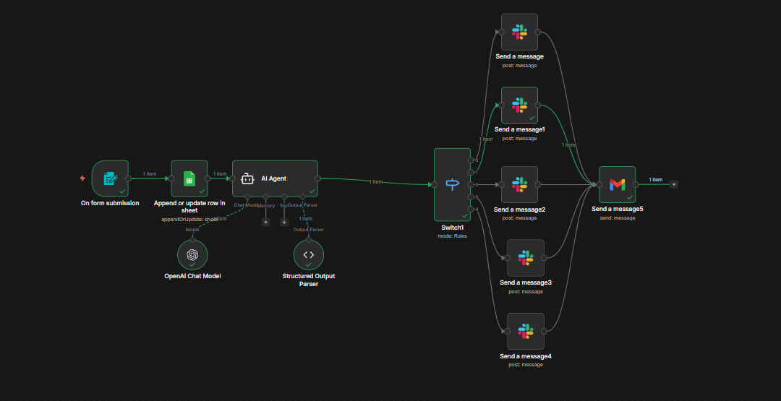

Request Form:
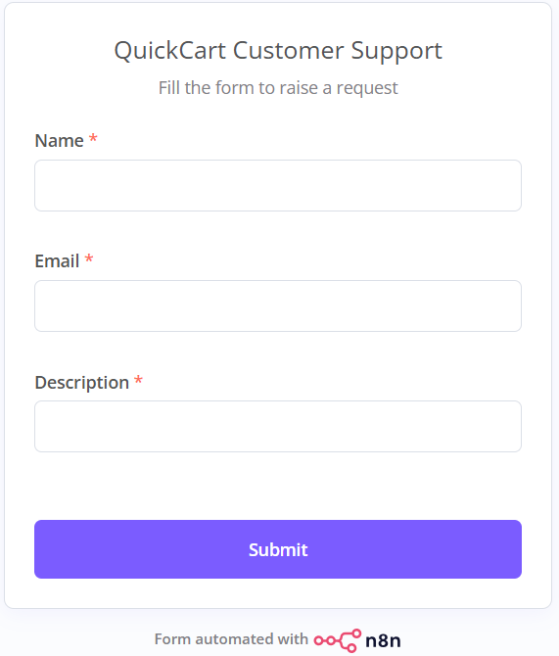
Updated Spreadsheet:
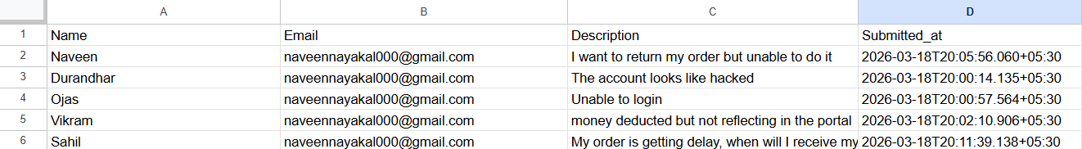
Channels for teams in slack:
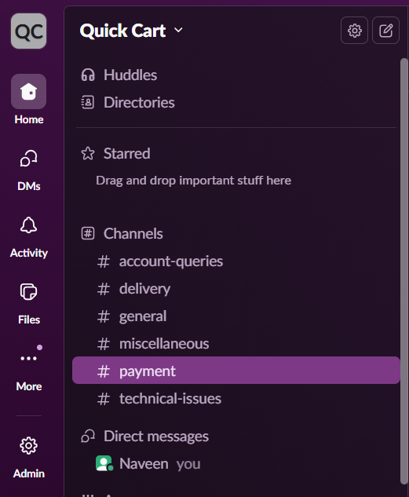
Messages sent to the Teams:

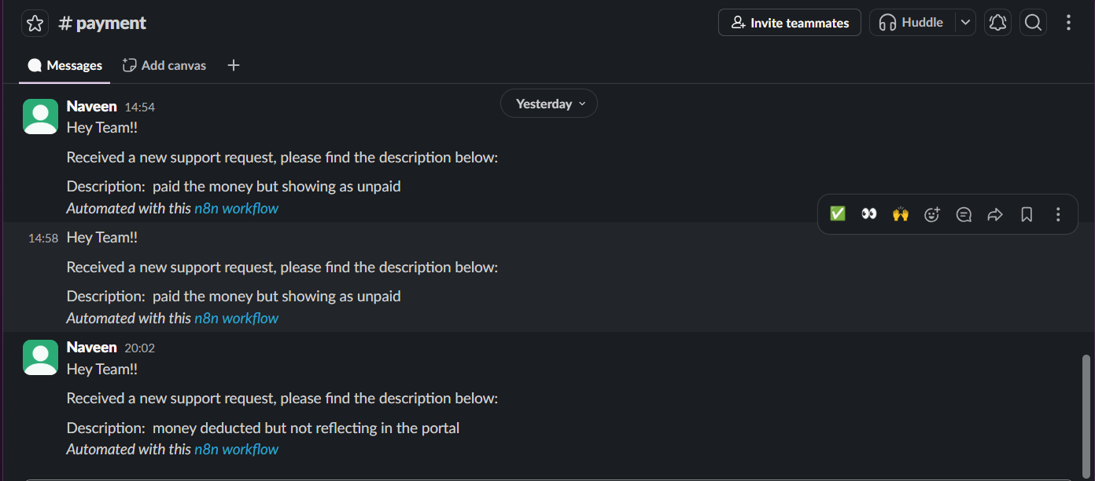
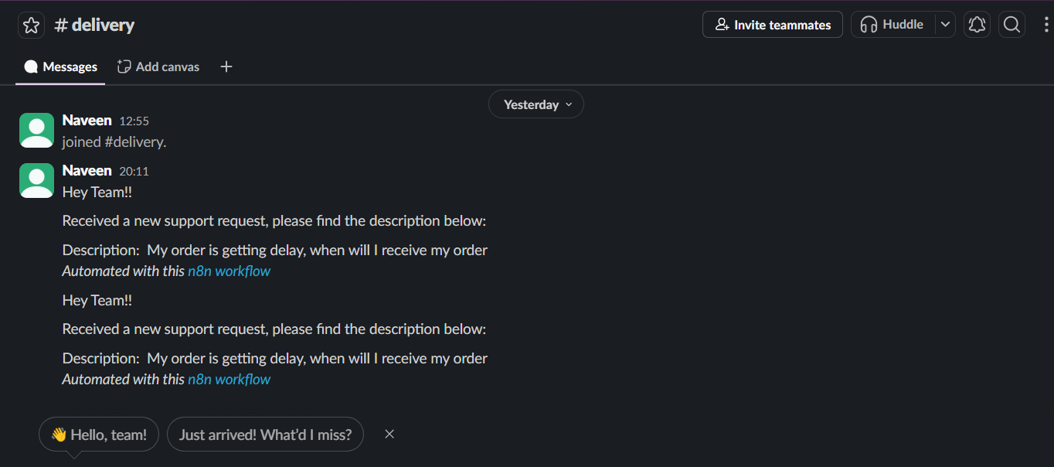
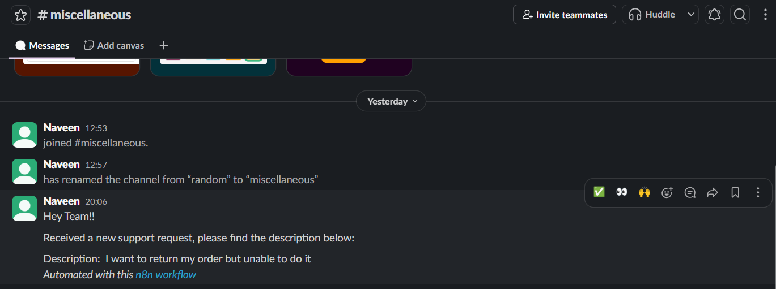

Acknowledgement sent to the Customer :
