ALLIANCE COLLEGE OF ENGINEERING AND DESIGN



Topic: configuring intranet connection using switches and routers

By:

Nandan kumar(16030141IT029)   
Naveen kumar(16030141IT030)  
Varun kumar(16030141IT048)  
Omer zabhi(16030141IT032)  
Sinan bin muhammad(16030141IT040)

Referred:  
**Dr.Rathnakar Achary**

Contents:

1. Introduction
2. Requirements
3. Configurations model
4. Physical configuration
5. Summary

1.Introduction

A computer network is a set of computers connected together for the purpose of sharing resources. The most common resource shared today is connection to the Internet. Other shared resources can include a printer or a file server. The Internet itself can be considered a computer network. Network configuration is the process of setting a network's controls, flow and operation to support the network communication of an organization and/or network owner. This broad term incorporates multiple configuration and setup processes on network hardware, software and other supporting devices and components. Here we are going to create a simple intranet connection by configuring DHCP, DNS, HTTP and a MAIL SERVER.

* Dynamic Host Configuration Protocol(DHCP):

The Dynamic Host Configuration Protocol is a network management protocol used on UDP/IP networks whereby a DHCP server dynamically assigns an IP address and other network configuration parameters to each device on a network so they can communicate with other IP networks.

* Domain Name System(DNS):

The Internet is really based on IP addresses. A DNS service must translate the name into the corresponding IP address. For example, the domain name www.example.com might translate to 198.105.232.4.

* Hyper Text Transfer Protocol(HTTP):

It is the underlying protocol used by the World Wide Web and this protocol defines how messages are formatted and transmitted, and what actions Web servers and browsers should take in response to various commands.

* Mail Server:

It is an application that receives incoming e-mail from local users (people within the same domain) and remote senders and forwards outgoing e-mail for delivery. The following protocols are responsible for the sending and receiving mails.

* Simple mail transfer protocol(SMTP):

Simple Mail Transfer Protocol (SMTP) is the standard protocol for **sending emails** across the Internet.

By default, the SMTP protocol works on three ports:

* **Port 25** - this is the default SMTP non-encrypted port
* **Port 2525** - this port is opened on all SiteGround servers in case port 25 is filtered (by your ISP for example) and you want to send non-encrypted emails with SMTP
* **Port 465** - this is the port used if you want to send messages using SMTP securely
* Post office protocol(POP):

Post Office Protocol version 3 (POP3) is a standard mail protocol used to **receive emails** from a remote server to a local email client. POP3 allows you to download email messages on your local computer and read them even when you are offline. POP3 Is the latest version of POP.

By default, the POP3 protocol works on two ports:

* **Port 110** - this is the default POP3 non-encrypted port
* **Port 995** - this is the port you need to use if you want to connect using POP3 securely
* Internet Mail Access Protocol(IMAP):

It is a mail protocol used for accessing email on a remote web server from a local client. IMAP allows simultaneous access by multiple clients. This is why IMAP is more suitable for you if you're going to access your email from different locations or if your messages are managed by multiple users..

By default, the IMAP protocol works on two ports:

* **Port 143** - this is the default IMAP non-encrypted port
* **Port 993** - this is the port you need to use if you want to connect using IMAP securely

2.Requirement

* Hardware used:  
   Switch(Catalyst 2960)

Router 2800 series

RJ 45 cable

Console cable

End system(PC, Laptop)

* Software used:
* Tera term
* Hmail server
* Wamp server
* Squirell mail
* Operating system used:

Windows 10(laptop and service)

3. Configuration model

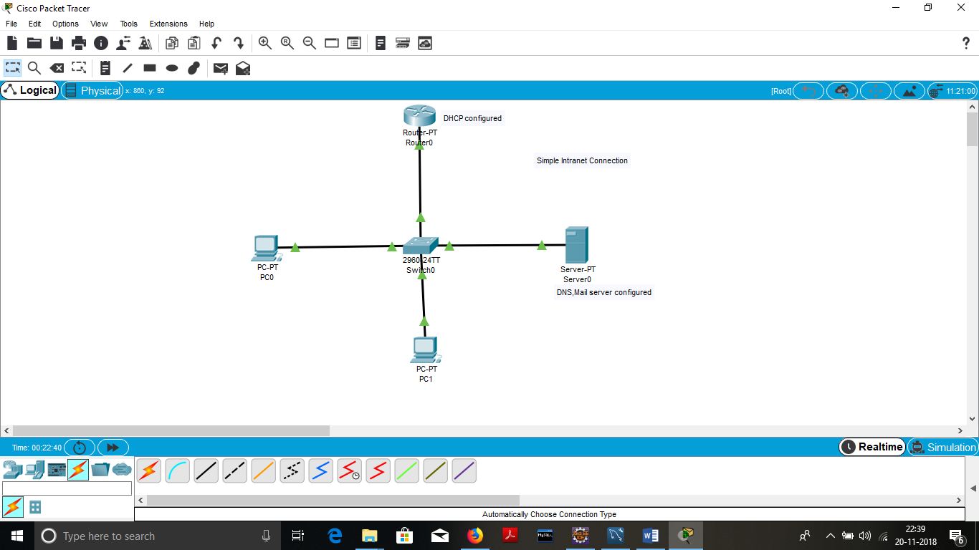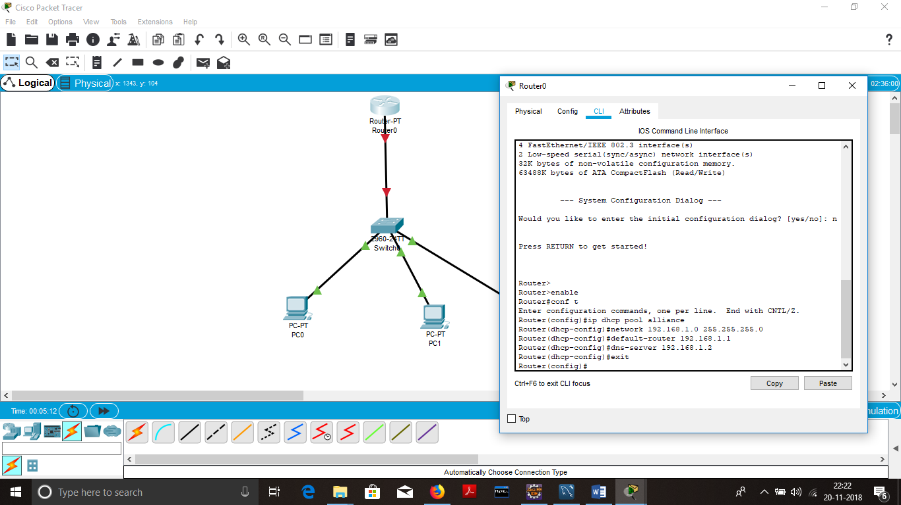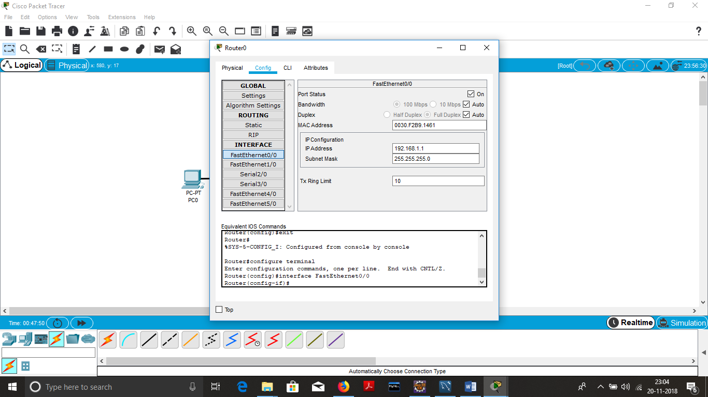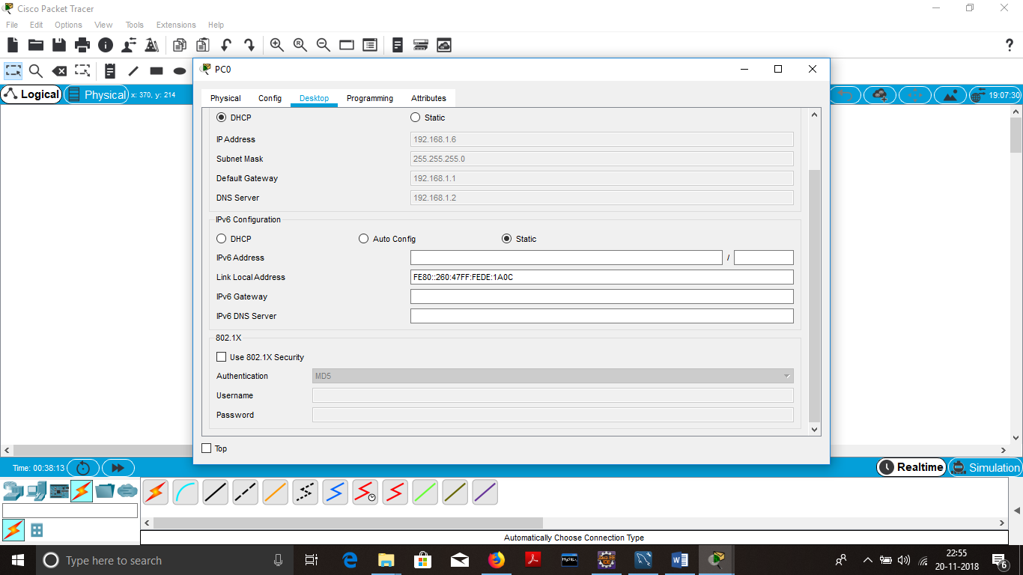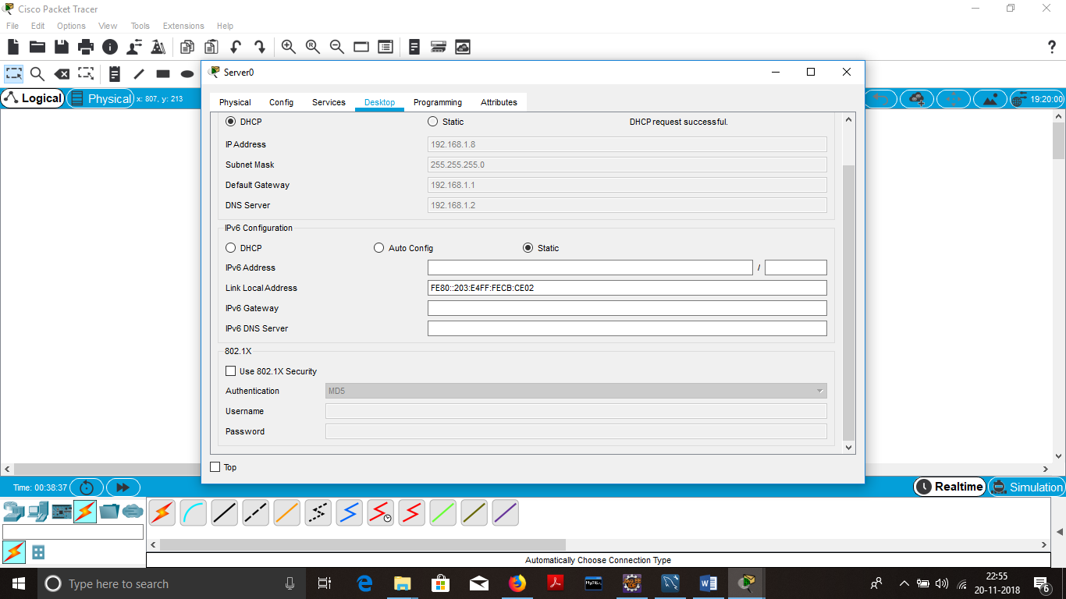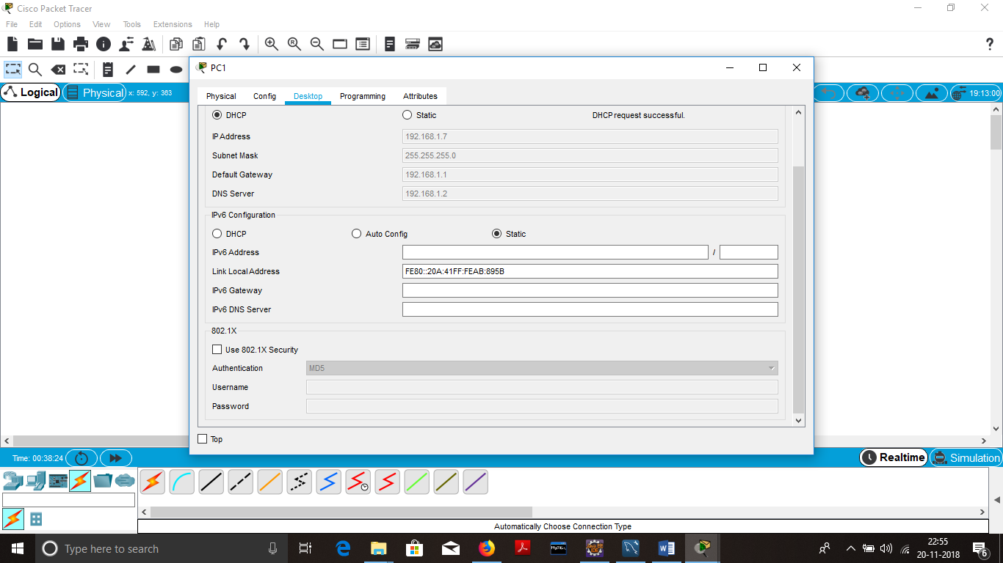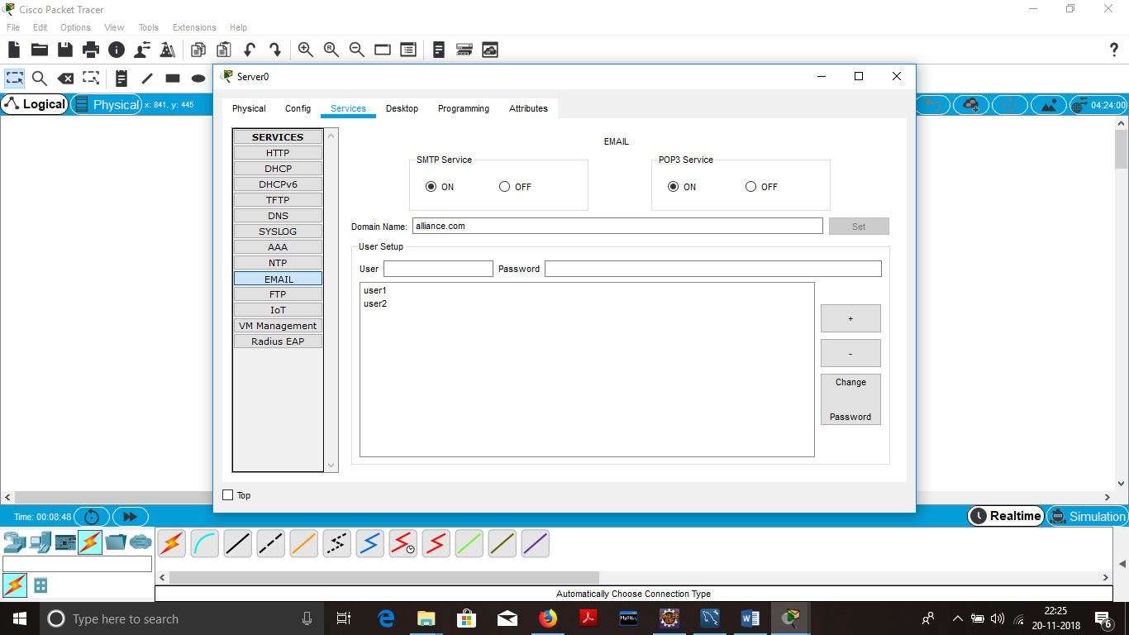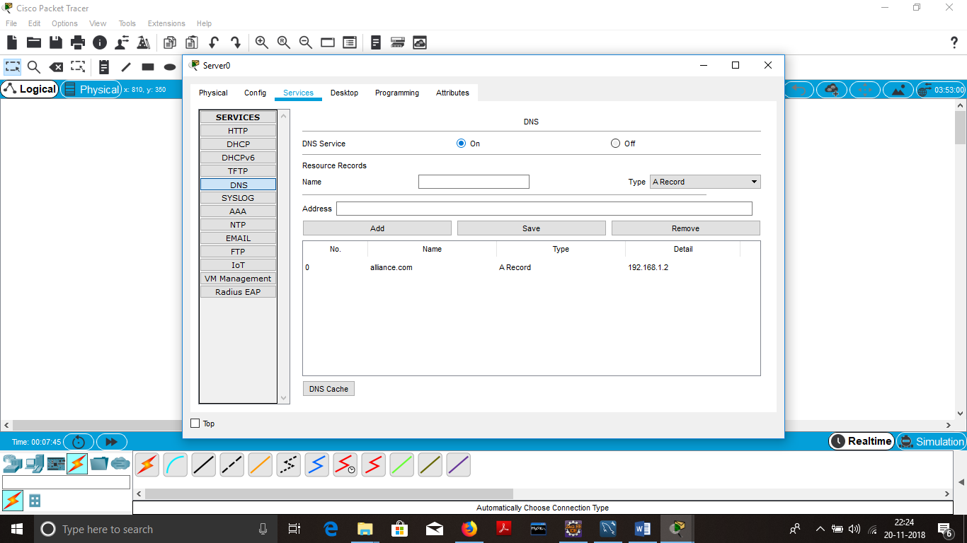

4.physical implementation

The model shown above was implemented using cisco 2960 switch and 2800 series router. The router was configured to act as dhcp server for the connected devices through interface fa0/0.

The following commands were used to configure the router for dhcp

R0> enable

R0#conf t

R0(config)#ip dhcp pool alliance

R0(dhcp-config)#network 192.168.1.0 255.255.255.0

R0(dhcp-config)#default-router 192.168.1.1

R0(dhcp-config)#dns-server 192.168.1.2

R0(dhcp-config)#exit

R0(config)#ip dhcp excluded 192.168.1.1

R0(config)#ip dhcp excluded 192.168.1.2 192.168.1.5

R0(config)#exit

R0(config)# interface fastEthernet 0/0

R0(if-config)# ip address 192.168.1.1 255.255.255.0

R0(if-config)#exit

R0(config)# no shut

R0(config)#exit

The server was configured for

* http and https service
* DNS service
* Email service

Connect the end devices to the switch.  
then click on each pc or server  
Desktop> ip configuration> change the ipv4 to dynamic  
the pc automatically retrieves an ip-address from the router

Server configuration:

In the real scenario we did use the server instead we used squirell mail, wampserver and hmailserver

* Configure the hmailserver with domainname
* With respect to domain name create to user mail accounts
* Close the hmailserver
* Migrate to C:\Windows\System32\drivers\etc\hosts
* Add next to 127.0.0.1 with one tab space domain name.
* Extract the squirrel mail to disk c:/
* Migrate to C:\squirrelmail-webmail-1.4.22\config folder
* rename config_default.php to config.php
* edit config.php in notepad++.
* Set the domain name, sending mail protocol(smtp), receiving mail protocol(pop), and snmp for the domainname

And server for wamp server

* Now run the wampserver, once the wamp server turns green in taskbar left click on it > choose apache>alias>add new alias. A command prompt will be displayed.
* Type the name as mail and copy the squirrel mail location to the command prompt and press enter.
* Finally type the system ip in your browser.
* Login to your account.

5.summary

The above connections where made and the services was established successfully. The mail service and server was configured using hmailserver and squirel mail application and was made to run wamp server. The mail service was established successfully but the main problem was

The mail was accessing within the configured pc but not accessible out of that pc due to the wamp server restriction.

