ALLIANCE COLLEGE OF ENGINEERING AND DESIGN



Topic: Street light automation and power saving

**Table of contents:**

1. **Introduction**
2. **Material and software used**
3. **Circuit diagram**
4. **Program**
5. **Procedure**
6. **Application**

**1.Introduction**

**Arduino:**

**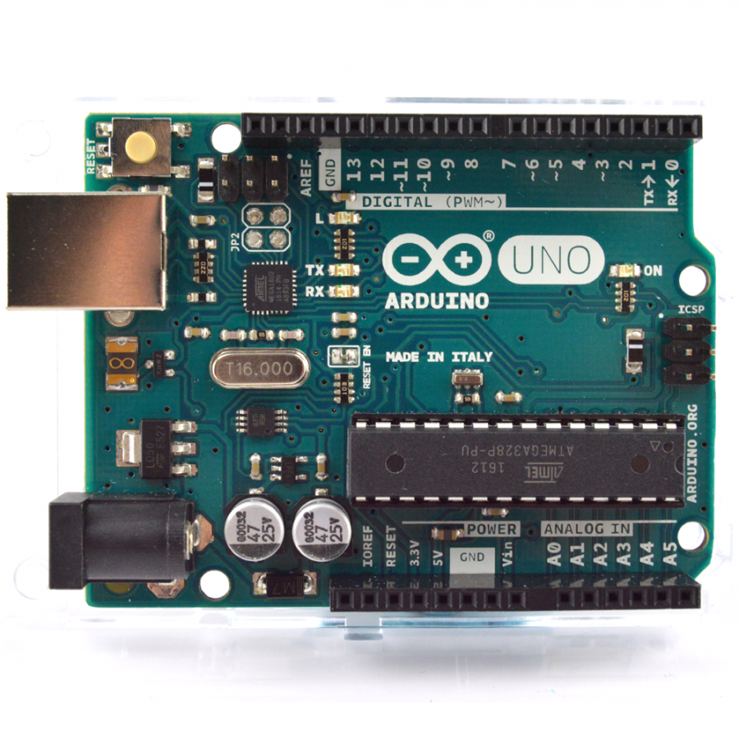  
  
 Arduino Uno** is a microcontroller board based on the ATmega328P ([datasheet](http://www.atmel.com/Images/doc8161.pdf)). It has 14 digital input/output pins (of which 6 can be used as PWM outputs), 6 analog inputs, a 16 MHz quartz crystal, a USB connection, a power jack, an ICSP header and a reset button. It contains everything needed to support the microcontroller; simply connect it to a computer with a USB cable or power it with a AC-to-DC adapter or battery to get started.. You can tinker with your UNO without worring too much about doing something wrong, worst case scenario you can replace the chip for a few dollars and start over again.

"Uno" means one in Italian and was chosen to mark the release of Arduino Software (IDE) 1.0. The Uno board and version 1.0 of Arduino Software (IDE) were the reference versions of Arduino, now evolved to newer releases. The Uno board is the first in a series of USB Arduino boards, and the reference model for the Arduino platform; for an extensive list of current, past or outdated boards see the Arduino index of boards.

**Reference:**

1)pwm:Pulse Width Modulation, or PWM, is a technique for getting analog results with digital means. Digital control is used to create a square wave, a signal switched between on and off.

2)clock speed:  
 clock speed refers to the number of pulses per second generated by an oscillator that sets the tempo for the processor.

3)UWART:  
 It is a computer hardware device for asynchronous serial communication in which the data format and transmission speeds are configurable

4)ATmega16u2:  
 The high-performance, low-power Microchip 8-bit AVR RISC-based microcontroller combines 16KB ISP flash memory with read-while-write capabilities, 512B EEPROM, 512-Byte SRAM, 22 general purpose I/O lines, 32 general purpose working registers, two flexible timer/counters with compare modes and PWM, USART, programmable watchdog timer with internal oscillator, SPI serial port, debugWIRE interface for on-chip debugging and programming, and five software selectable power saving modes. The device operates betweeen 2.7-5.5 volts

**Ir sensor:**

An **infrared sensor** is an electronic instrument which is used to sense certain characteristics of its surroundings by either emitting and/or detecting **infrared** radiation. **Infrared sensors** are also capable of measuring the heat being emitted by an object and detecting motion.

**LDR:** An LDR is a component that has a (variable) resistance that changes with the light intensity that falls upon it.

**2. Requirements**

Materials used:

1. Arduino Uno R3.
2. Breadboard.
3. Resistor(4.7kΩ).
4. Jumper Wires.
5. LED.
6. LDR.
7. Infrared sensor.

**Software used:**

-Arduino IDE.

**3. Circuit Diagram**

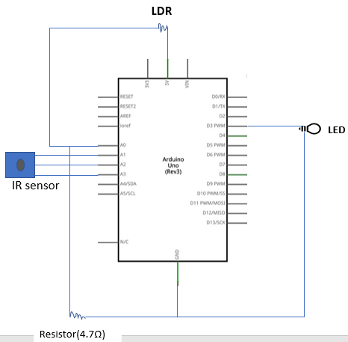

**4.Program**

#include <SoftwareSerial.h>

int sensorPin = A0; // select the input pin for the LDR

int sensorValue = 0; // variable to store the value coming from the sensor

int led = 3;

void setup() { // declare the ledPin as an OUTPUT:

pinMode(led, OUTPUT);

Serial.begin(9600);

pinMode(A3,INPUT);

pinMode(A2,OUTPUT);

pinMode(A1,OUTPUT);

digitalWrite(A1,HIGH);

digitalWrite(A2,LOW);

}

void loop()

{

Serial.println("Darkness");

sensorValue = analogRead(sensorPin);

Serial.println(sensorValue);

if (sensorValue < 100)

{

Serial.println("LED Dim");

analogWrite(led,5);

}

if(sensorValue<100 && analogRead(A2)<500)

{

Serial.println("LED bright");

for(int i=0;i<255;i++){

analogWrite(led,i);

analogWrite(5,i);

}

delay(10000);

}

else if(sensorValue < 100)

{

Serial.println("LED Dim");

analogWrite(led,5);

analogWrite(5,5);

}

else

{

digitalWrite(led,LOW);

digitalWrite(5,LOW);

}

}

**5.Procedure**

1. Connect the circuit as shown in the diagram using arduino, Led, LDR, IR sensor and wires.
2. Use an A to B cable to connect Arduino and pc.
3. Upload the program as given.

(Note: Connect the circuit as in terms of pin initialized in the program. The block diagram given should be modified according to the program.).

1. After successful upload of program. Check the output in your device.

**6.Application**

1. Automation of technology is one of the leading technology.
2. Implementing this technology reduces the power consumption nearly 70%, when no vehicle is travelling in street.
3. Advanced IR sensors in combination with detectors can identify the difference between vehicle and other obstacles, where street light glows only when vehicles are detected.