**AMAZON**

What is amazon?

Amazon.comom, Inc., is an American multinational technology company based in Seattle, Washington. Amazon focuses on e-commerce, cloud computing, digital streaming, and artificial intelligence. It is considered one of the Big Four technology companies, along with Google, Apple, and Facebook.

**History**:

Amazon was founded by [Jeff Bezos](https://en.m.wikipedia.org/wiki/Jeff_Bezos) in [Bellevue](https://en.m.wikipedia.org/wiki/Bellevue,_Washington), Washington, on July 5, 1994. The company started as an online marketplace for books but expanded to sell electronics, software, video games, apparel, furniture, food, toys, and jewelry

The **Amazon logo** was created to represent the message that it sells everything from A to Z (the arrow connects the two letters) and also represents the smile that customers would experience by shopping on the **Amazon**.com Web site (the arrow becomes a smile).

**Amazon Platform:**

**Stacks:**

A stack is a collection of AWS resources that you can manage as a single unit. In other words, you can create, update, or delete a collection of resources by creating, updating, or deleting stacks. All the resources in a stack are defined by the stack's AWS CloudFormation template. A stack, for instance, can include all the resources required to run a web application, such as a web server, a database, and networking rules. If you no longer require that web application, you can simply delete the stack, and all of its related resources are deleted.

AWS CloudFormation ensures all stack resources are created or deleted as appropriate. Because AWS CloudFormation treats the stack resources as a single unit, they must all be created or deleted successfully for the stack to be created or deleted. If a resource cannot be created, AWS CloudFormation rolls the stack back and automatically deletes any resources that were created. If a resource cannot be deleted, any remaining resources are retained until the stack can be successfully deleted.

**Used of Technology**:

* Java(backend)
* Mysql

DynamoDB

* GWT
* Angular.js

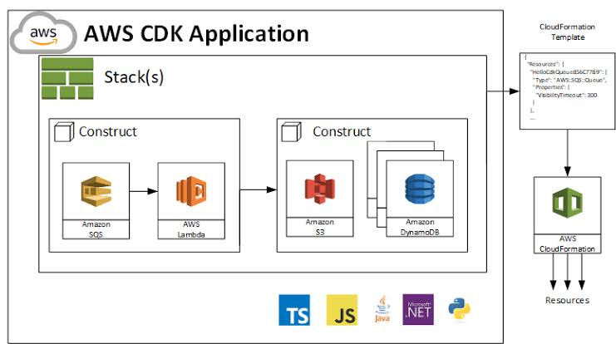

**Amazon S3:**

****Store and retrieve any amount of data, at any time, from anywhere on the web.

Amazon Simple Storage Service provides a fully redundant data storage infrastructure for storing and retrieving any amount of data, at any time, from anywhere on the web

Amazon S3 is a tool in the **Cloud Storage** category of a tech stack.

## Who uses Amazon S3?

**COMPANIES**

**5711** companies reportedly use **Amazon S3** in their tech stacks, including **Airbnb, Pinterest,**and **Netflix**

## **Amazon S3 Integrations**

**Travis CI, Gatsby, Auth0, Fastly,**and **Papertrail** are some of the popular tools that integrate with Amazon S3. Here's a list of all **139** tools that integrate with Amazon S3.

## **Amazon EC2:**



## **What is Amazon EC2?**

It is a web service that provides resizable compute capacity in the cloud. It is designed to make web-scale computing easier for developers.

Amazon EC2 is a tool in the **Cloud Hosting** category of a tech stack.

## **Who uses Amazon EC2?**

**COMPANIES**

**6092** companies reportedly use **Amazon EC2** in their tech stacks, including **Uber, Airbnb,**and Pinter.

## **Amazon EC2 Integrations**

**New Relic, Ansible, Vagrant, Amazon EC2 Container Service,**and **Terraform** are some of the popular tools that integrate with Amazon EC2. Here's a list of all **108** tools that integrate with Amazon EC2.

**Amazon RDS:**



Set up, operate, and scale a relational database in the cloud

## **What is Amazon RDS?**

Amazon RDS gives you access to the capabilities of a familiar MySQL, Oracle or Microsoft SQL Server database engine. This means that the code, applications, and tools you already use today with your existing databases can be used with Amazon RDS. Amazon RDS automatically patches the database software and backs up your database, storing the backups for a user-defined retention period and enabling point-in-time recovery. You benefit from the flexibility of being able to scale the compute resources or storage capacity associated with your Database Instance (DB Instance) via a single API call.

Amazon RDS is a tool in the **SQL Database as a Service** category of a tech stack.

## **Who uses Amazon RDS?**

**COMPANIES**

**2183** companies reportedly use **Amazon RDS** in their tech stacks, including **Airbnb, Netflix,**and **Amazon**

## **Amazon RDS Integrations**

**Paper trail, AWS Glue, Redash, OpsGenie,**and **Amazon Quicksight** are some of the popular tools that integrate with Amazon RDS. Here's a list of all **34** tools that integrate with Amazon RDS.