HOUSEHUNT**Top of Form**

**INTRODUCTION**

**House Hunt** is a modern real estate platform designed to simplify the process of buying, selling, and renting properties. With the rise of digital technology, HouseHunt aims to provide a seamless, user-friendly experience for individuals and families looking to navigate the complexities of the housing market.

House Hunt offers a comprehensive range of services, including property listings, detailed descriptions, high-quality images, and interactive features like virtual tours. It also includes search filters to help users find homes based on various criteria such as location, price, size, and amenities.

**TEAM MEMBERS**

* **Bottom of Form**
* K. NANAJI NAVEEN KUMAR : TEAM LEADER, CODING
* Y. MANIKANTA : CODING
* G. DEVIKA : DOCUMENTATION
* S.S.D.M.MADHAVI : DOCUMENTATION

**PROJECT REVIEW**

**Purpose Of House Hunt :**

The purpose of HouseHunt is to streamline the real estate journey by providing a comprehensive, user-friendly platform that connects home buyers, sellers, renters, and real estate professionals. It aims to simplify the often complex and time-consuming process of searching for or listing a property, offering tools and resources that enhance the experience for all parties involved.

1. **Empowering Users with Information:** HouseHunt provides detailed listings, market insights, and property data, helping users make informed decisions about buying, selling, or renting homes.
2. **Simplifying the Property Search:** With advanced search filters and features like virtual tours, HouseHunt makes it easy to find properties that match specific preferences such as location, price, and amenities.
3. **Facilitating Transactions:** By connecting buyers with sellers, renters with landlords, and users with real estate professionals, HouseHunt streamlines the entire transaction process, from browsing listings to negotiating deals and finalizing paperwork.
4. **Supporting Real Estate Professionals:** HouseHunt serves as a marketing tool for real estate agents and brokers, offering them a platform to reach potential clients and showcase properties.
5. **Creating a Transparent Marketplace:** By providing clear, accurate property information, HouseHunt fosters transparency, ensuring that users have access to reliable data to make confident real estate decisions. Offering a Convenient, 24/7 Platform: HouseHunt is accessible anytime, anywhere, offering user

**Features Of House Hunt :**

HTop of Form

ouseHunt offers a variety of features designed to enhance the real estate experience for buyers, sellers, renters, and professionals. These features aim to simplify property searches, provide valuable insights, and streamline the transaction process. Below are some of the key features of HouseHunt:

**1. Advanced Property Search**

* Filters: Users can filter properties based on location, price range, property type, size, number of bedrooms, and specific amenities (e.g., pet-friendly, pool, garage).
* Saved Searches: Allows users to save their search criteria for easy access to new listings that match their preferences.

**2. Interactive Property Listings**

* High-Quality Photos & Videos: Properties are showcased with professional images and video tours to give users a detailed view of the home.
* 360° Virtual Tours: Users can take interactive virtual tours of properties to get a feel for the space before scheduling an in-person visit.
* Floor Plans: Many listings include detailed floor plans to help users visualize the layout of a property.

**3. Market Insights and Trends**

* Price Trends: Displays information on how property prices are trending in specific areas, allowing buyers and sellers to make informed decisions.
* Neighbourhood Insights: Information on local amenities, schools, crime rates, and transport options, giving users a deeper understanding of the area they are considering.
* Investment Potential: Provides data on property value appreciation and investment opportunities for users looking to invest in real estate.

**4. Property Alerts**

* New Listings Alerts: Users can set up email or push notifications to be alerted when new properties matching their criteria are listed.
* Price Drop Alerts: Users are notified when a property they are interested in has a price reduction.

**5. Professional Connections**

* Real Estate Agents and Brokers: HouseHunt connects users with certified real estate professionals who can guide them through the buying, selling, or renting process.
* Legal and Financial Experts: The platform offers connections to legal advisors, mortgage brokers, and financial planners to assist with the paperwork and financial aspects of the transaction.

**ARCHITECTURE**

FRONTEND:

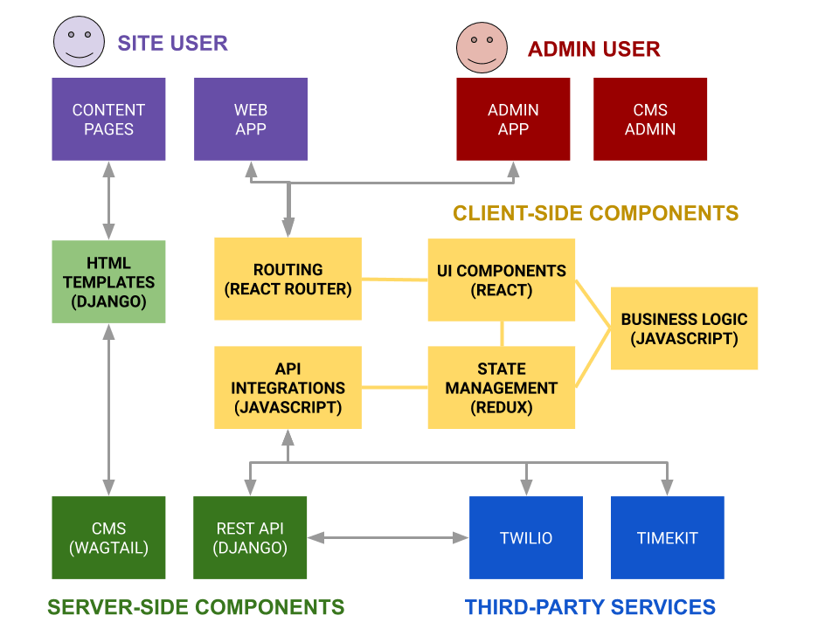

BACKEND:

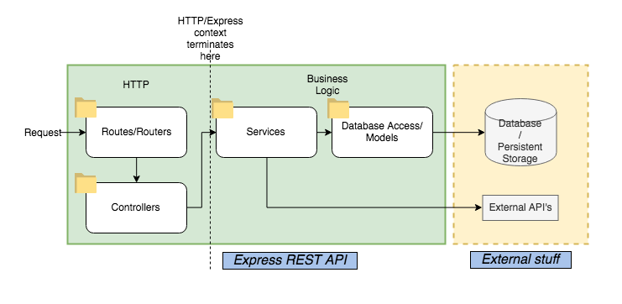

DATABASE:

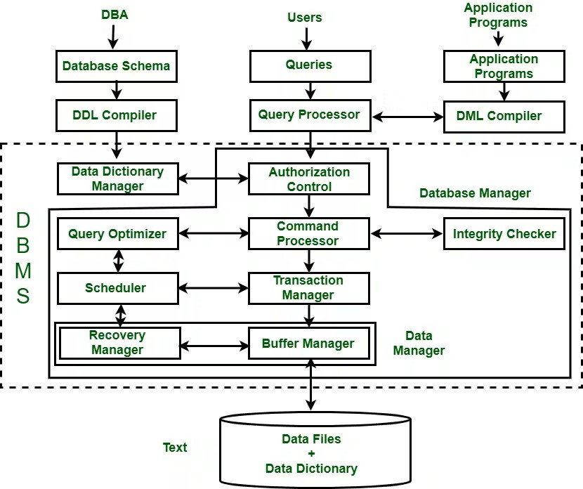

**SETUP INSTRUCTIONS**

**PREREQUISITES**:

For a project like HouseHunt, which is typically a real estate listing platform, here is a list of possible software dependencies based on a common tech stack. If your project is built with specific technologies, you can adjust the list accordingly. Below is a general overview:

**Node.js and npm:** Install Node.js, which includes npm (Node Package Manager), on your

development machine. Node.js is required to run JavaScript on the server side.

* Download: <https://nodejs.org/en/download/>
* Installation instructions: <https://nodejs.org/en/download/package-manager/>

**MongoDB:** Set up a MongoDB database for house hunt information. Install

MongoDB locally using a cloud-based MongoDB service.

* Download: <https://www.mongodb.com/try/download/community>
* Installation instructions: <https://docs.mongodb.com/manual/installation/>

**Express.js:** Express.js is a web application framework for Node.js. Install Express.js to handle server-side routing ,middleware, and API development.

* Installation: Open your command prompt or terminal and run the following command:

npm install express

**React.js:** React.js is a popular JavaScript library for building user interfaces. It enables developers to create interactive and reusable UI components, making it easier to build dynamic and responsive web applications. To install React.js, a JavaScript library for building user interfaces, follow the installation guide: <https://reactjs.org/docs/create-a-new-react-app.html>

**HTML,CSS**, and **JavaScript:** Basic knowledge of HTML for creating the structure of your app, CSS for styling, and JavaScript for client-side interactivity is essential. Database Connectivity: Use a MongoDB driver or an Object-Document Mapping (ODM) librarylike Mongoose to connect your Node.js server with the MongoDB database and perform CRUD(Create, Read, Update, Delete) operations.

**Database Connectivity:** Use a MongoDB driver or an Object-Document Mapping (ODM) library like Mongoose to connect your Node.js server with the MongoDB database and perform CRUD (Create, Read, Update, Delete) operations.

**Front-end Framework:** Utilize Angular to build the user-facing part of the application, including product listings, booking forms, and user interfaces for the admin dashboard.

**Version Control:** Use Git for version control, enabling collaboration and tracking changes throughout the development process. Platforms like GitHub or Bitbucket can host your repository.

Git: Download and installation instructions can be found at: <https://git-scm.com/downloads>

**Development Environment:** Choose a code editor or Integrated Development Environment (IDE) that suits your preferences, such as Visual Studio Code, Sublime Text, or WebStorm.

• Visual Studio Code: Download from <https://code.visualstudio.com/download>

**Start the development Server:**

* To start the development server, execute the following command:

npm run dev or npm run start

* The e-commerce app will be accessible at http://localhost:3000 by default. You can change the port configuration in the .env file if needed.

**Access the App:**

* Open your web browser and navigate to http://localhost:3000
* You should see the flight booking app's homepage, indicating that the installation and the setup was successful.

You have successfully installed and set up the house hunt app on your local machine. You can now proceed with further customization, development, and testing as needed.

**INSTALLATION OF REQUIRED TOOLS:**

FOLDER SETUP:

* Create Frontend and
* Backend folders

1. Open the frontend folder to install necessary tools .For frontend, we use:

* React Js
* Bootstrap
* Material UI

2. Open the backend folder to install necessary tools .For backend, we use:

* Cors
* Crypt
* Express
* Doten
* Mongoose
* Nodemon
* Json web token

3.BACKEND DEVELOPMENT

* Setup express server

1. Create index.js file in the server (backend folder).

2. define port number, MongoDB connection string and JWT key in env file to access it.

3. Configure the server by adding cors, body-parser.

* Configure MongoDB

1. Import mongoose.

2. Add database connection from config.js file present in config folder

3. Create a model folder to store all the DB schemas like user, jobs and applications

properties schemas.

* Add authentication:

For authentication, need to define URL for login and register processes in the backend by getting the data from request from the client, we need to perform Required operations.

**FOLDER STRUCTURE:**

The first part shows the whole structure of the project that includes both the client and server folders.

The second images show the internal content of the component section in the client’s app folder.

**RUNNING THE APPLICATIONS**

**User:**

* Users can create their account or get register.
* Users can search for available properties based on various criteria like location, price range, etc.
* Users can directly communicate with sellers or agents for further inquiries about listings.
* Users may be able to complete transactions for rentals or purchases, including making payments.

**Admin:**

* Manages all bookings for the users.
* Adds and manages available houses and services
* Tracks user interactions, property interest, and monitor user activity.

**API DOCUMENTATION:**

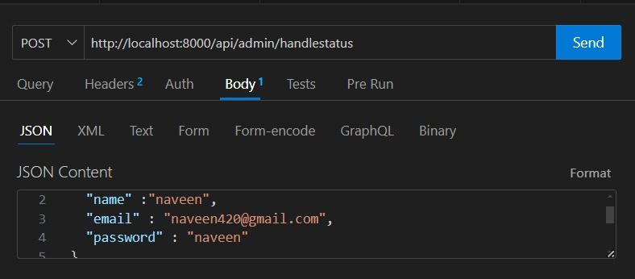

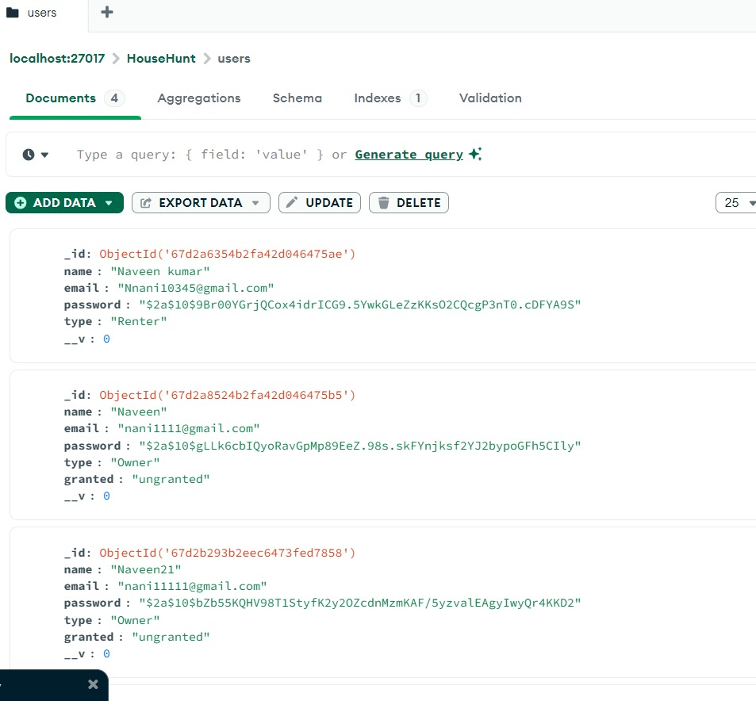

It shows the document of all endpoints exposed by the backend, and Include request methods and parameters of the backend in the thunder client.

**AUTHENTICATION**

* Create routes and middleware for user registration, login, and logout.
* Set up authentication middleware to protect routes that require user authentication.
* It shows the data to get register and to choose the type of houses.

**SCREENSHOTS OR DEMO**

* **Register or Sign Up:**

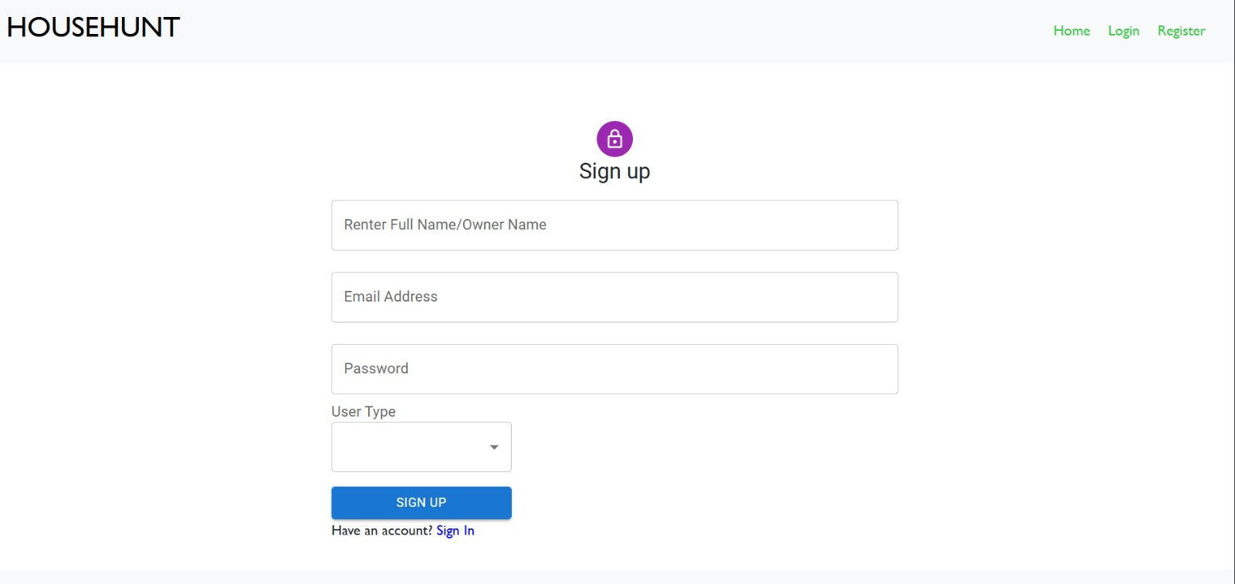

* **Login:**

**Properties:**

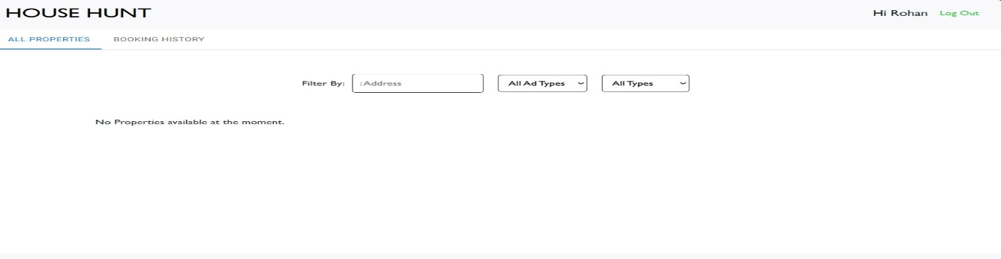

* **Booking History:**

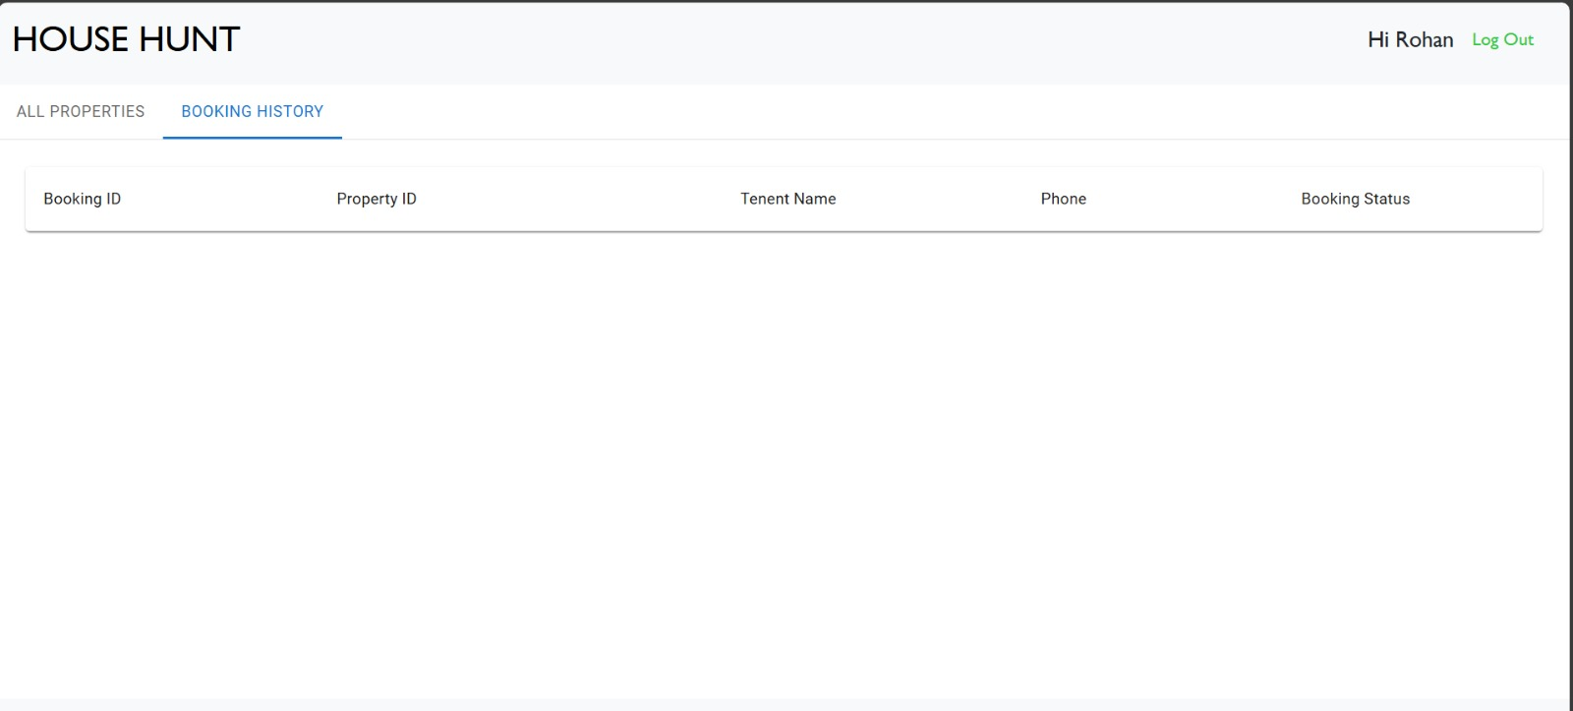

**FUTURE ENHANCEMENTS**

This House hunt can be further updated by adding features like:

* **Smart Recommendations**: Homes suggested to you based on your preferences.
* **Virtual Tours**: You can explore homes online without leaving your house.
* **Faster Process**: Using technology to make buying a home quicker and easier.
* **Easy Loans**: Fast access to loan options and help finding a lender.

In short, house hunting will become much easier, faster, and more personalized!