SheHealth
AI-Powered Women's Health Companion
Full-Stack Serverless Application on AWS
Built entirely using Kiro — Amazon's AI-powered IDE
Powered by AWS | Groq AI | React
Live Demo: https://d3dczdioqgaqqt.cloudfront.net
GitHub: https://github.com/Naveen15github/SheHealth-AI-Powered-Womens-Health-Companion

1. About the Project
SheHealth is a full-stack serverless health application designed to address a critical gap in women's health technology. Most health apps are generic, lack context, and don't help users articulate what they're experiencing to a doctor. SheHealth solves three specific problems:

- Structured Symptom Tracking: Symptom tracking is fragmented — SheHealth provides a structured log with severity ratings, timestamps, and 30-day history.
- AI Health Assistant: No accessible first-response health guidance — The AI chat assistant understands health profiles and prior context to give relevant responses.
- Medical Report Generation: Doctor visits are inefficient without documentation — The report generation feature produces structured PDF-ready medical reports from logged symptoms.

The entire backend is serverless — no servers to manage, no databases to patch, auto-scales automatically, and costs essentially nothing at low traffic.

2. Architecture Overview
SheHealth uses a fully serverless AWS architecture where the React frontend is served via CloudFront from S3, API calls go through API Gateway with Cognito JWT authorization, and business logic runs in three Lambda functions connected to DynamoDB and S3.

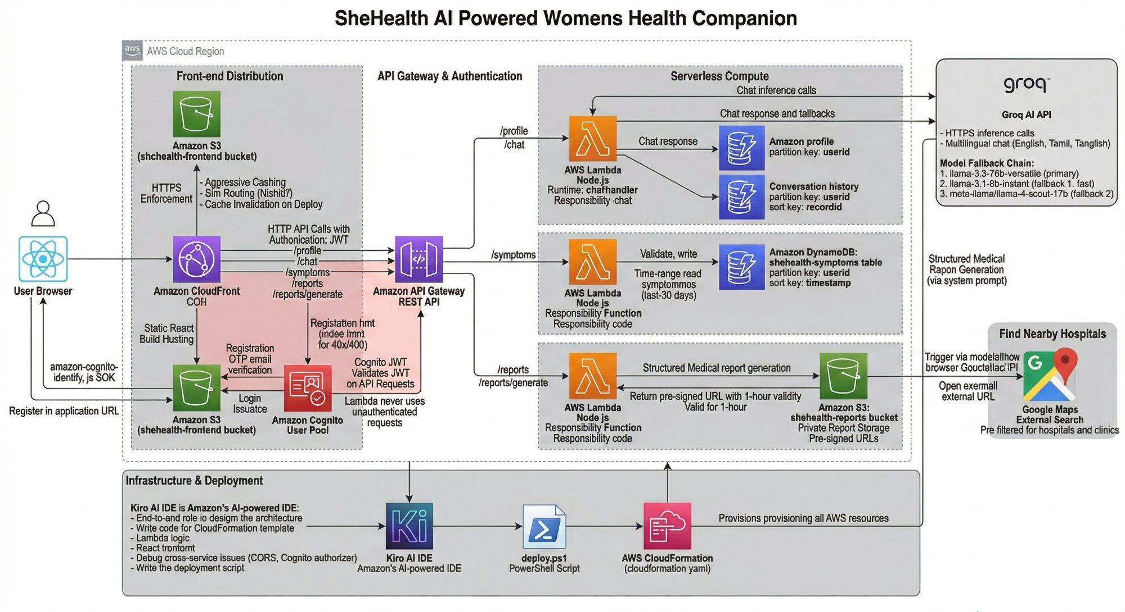
Figure 1: SheHealth AWS Architecture Diagram

High-Level Flow
User Browser → Amazon CloudFront (CDN) → Amazon S3 (React build) → API Gateway (REST, JWT auth) → AWS Lambda → DynamoDB / S3 / Groq AI

Authentication Flow
- User enters credentials via amazon-cognito-identity-js SDK in the frontend
- Amazon Cognito User Pool validates credentials and issues a JWT token
- ID Token stored in localStorage and attached to every API request as Authorization header
- API Gateway Cognito Authorizer validates token — Lambda only executes with verified userId

3. Tech Stack

Layer | Technology
IDE / Dev Tool | Kiro (AI-powered IDE by Amazon)
Frontend | React, amazon-cognito-identity-js
Hosting | Amazon S3 + CloudFront
Auth | Amazon Cognito (User Pools)
API | Amazon API Gateway (REST)
Backend | AWS Lambda (Node.js)
Database | Amazon DynamoDB
File Storage | Amazon S3
AI Inference | Groq API (Llama 3.3 70B / Llama 3.1 8B / Llama 4 Scout)
Infrastructure | AWS CloudFormation
Deployment | PowerShell deploy script (deploy.ps1)

4. AWS Services — What, How & Why

Amazon Cognito
Handles the entire authentication flow — user registration with email, OTP email verification, login, JWT token issuance, and refresh. The frontend communicates directly with Cognito via the amazon-cognito-identity-js SDK without routing auth requests through the backend. Cognito is HIPAA-eligible and integrates natively with API Gateway as a JWT authorizer, meaning invalid/expired tokens are rejected at the gateway layer before Lambda is ever invoked.

AWS Lambda
Backend logic is split across three Lambda functions:
- chatHandler — handles GET /profile, POST /profile, and POST /chat. Reads/writes user health profiles to DynamoDB and calls Groq AI for contextual chat responses.
- symptomHandler — handles GET /symptoms and POST /symptoms. Validates incoming symptom data and stores it in DynamoDB.
- reportHandler — handles GET /reports and POST /reports/generate. Fetches symptom data, sends to Groq AI with a structured medical prompt, saves to S3, and returns a pre-signed URL.

Amazon DynamoDB
Three tables designed for per-user data isolation:
- shehealth-users — stores user health profiles. Partition key: userId (Cognito sub).
- shehealth-symptoms — stores symptom logs. Composite key: userId + timestamp for efficient time-range queries.
- shehealth-conversations — stores chat history and report metadata. Composite key: userId + recordId.

Amazon S3
Two buckets serve different purposes:
- shehealth-reports-{accountId} — stores generated health reports as .txt files with no public access; users access via 1-hour pre-signed URLs.
- shehealth-frontend-{accountId} — hosts the compiled React application as a static website.

Amazon API Gateway
Single REST API with five resource paths: /profile, /chat, /symptoms, /reports, /reports/generate. Every route (except CORS OPTIONS) is protected by a Cognito JWT authorizer. API Gateway handles authentication enforcement, rate limiting, CORS configuration, and request routing without custom code.

Amazon CloudFront
Global CDN with 400+ edge locations serving the React app. Configuration includes: HTTPS enforcement, SPA routing support (404/403 → index.html), aggressive caching for JS/CSS with immutable headers, no-cache for index.html, and automatic cache invalidation on every deployment.

Groq AI
Lambda functions call Groq's OpenAI-compatible API with a three-model fallback chain: (1) llama-3.3-70b-versatile as primary, (2) llama-3.1-8b-instant as first fallback, (3) meta-llama/llama-4-scout-17b as second fallback. Groq's inference speed of 280–750 tokens/second (vs OpenAI's ~50) makes the chat experience genuinely responsive. Llama models handle Tamil script and Tanglish phonetics without any special configuration.

5. Features
- User Authentication — Register, verify email via OTP, login, logout using Amazon Cognito. Sessions persist across reloads.
- Health Profile Setup — On first login, users fill in age and existing conditions; the AI uses this as context in every conversation.
- AI Chat Assistant — Powered by Llama 3.3 70B. Supports English, Tamil, and Tanglish in the same session.
- Symptom Logging — Log symptoms with type, severity (1–10), date, and notes, stored per-user in DynamoDB.
- Symptom History — View the last 30 days of logged symptoms with timestamps and severity ratings.
- Medical Report Generation — One-click report generation producing structured PDFs downloadable via secure pre-signed URLs.
- Report History — View and re-download all previously generated reports.
- Find Nearby Hospitals — Browser Geolocation or city-name search, opens Google Maps pre-loaded with hospital results.
- Fully Serverless — Auto-scales to any traffic level with near-zero idle cost.
- Multi-model Fallback — Automatic fallback through three AI models with no visible disruption to the user.

6. Application Walkthrough

6.1 Landing Page
The public-facing landing page showcases the app's multilingual AI capabilities and key features — AI Assistant, Symptom Tracking, and Health Reports. The hero section includes trust indicators and a "Get Started" CTA.

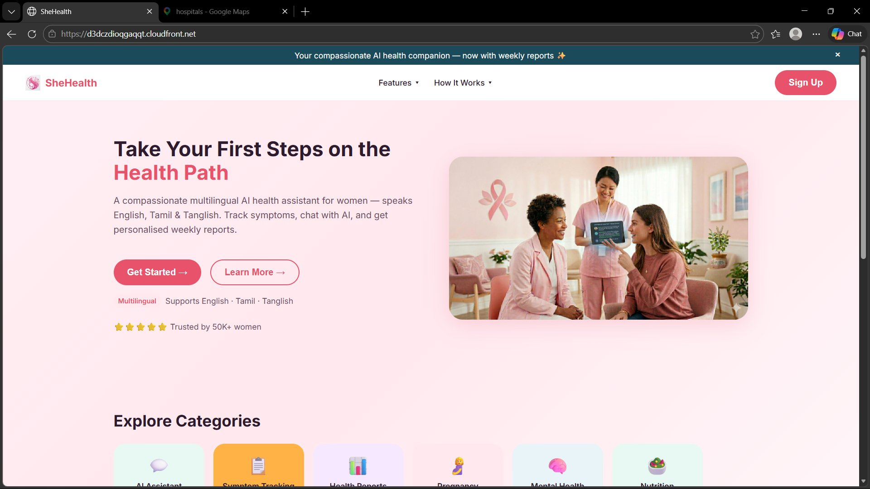
Figure 2: SheHealth Landing Page — Hero Section

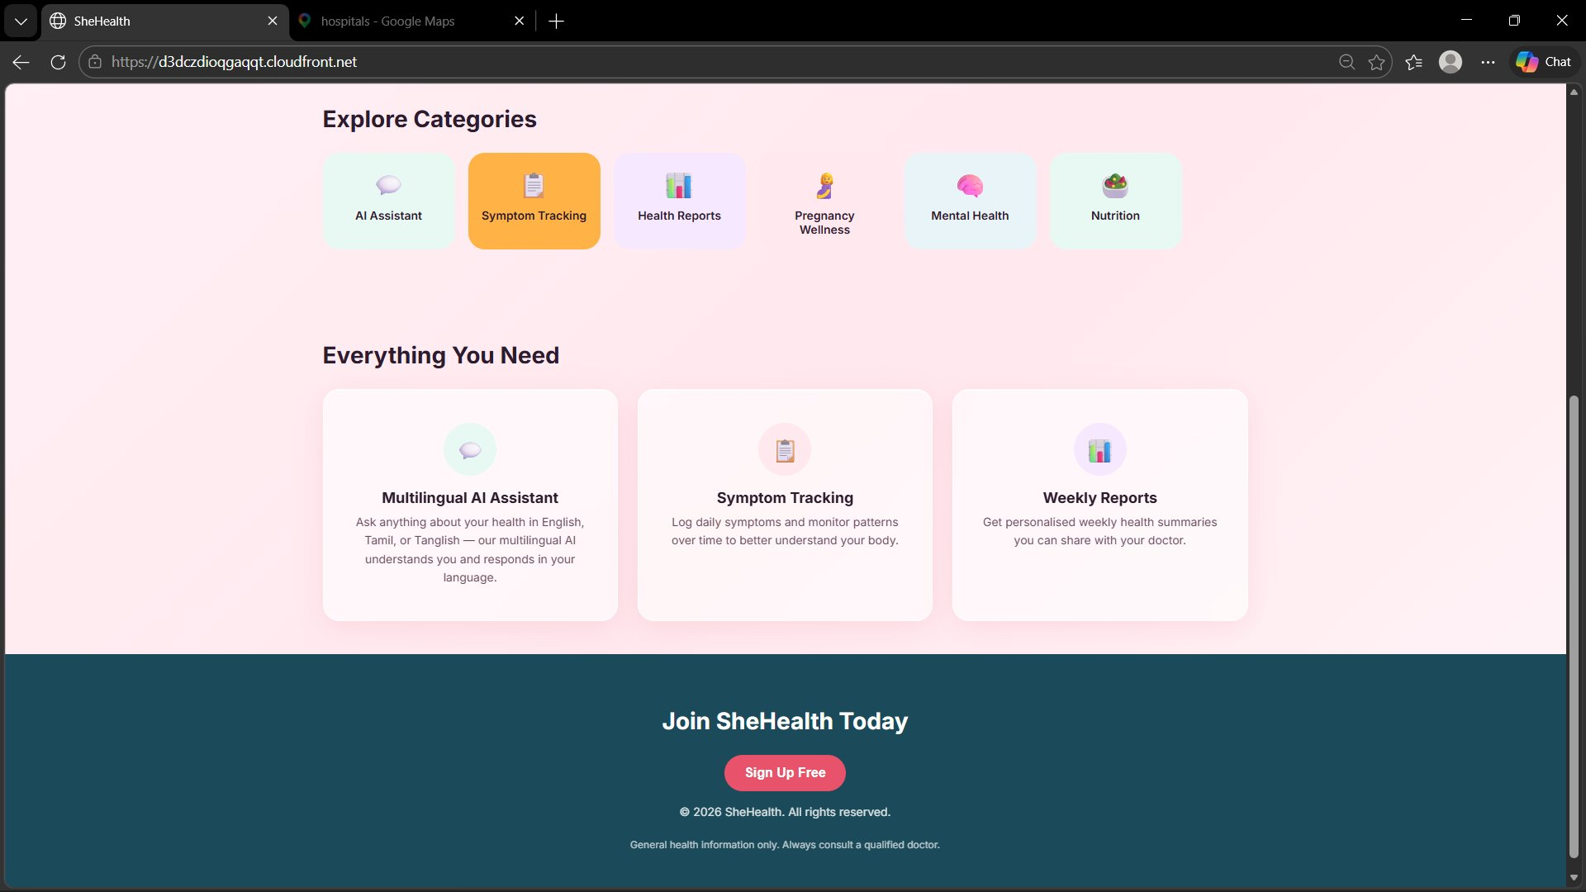
Figure 3: Landing Page — Features Section (Explore Categories & Everything You Need)

6.2 Registration & Login
New users click Sign Up, enter their email and password, and receive a 6-digit OTP from Amazon Cognito for email verification. After verifying, they are redirected to the Dashboard. Returning users log in at /login and their session persists across browser reloads.

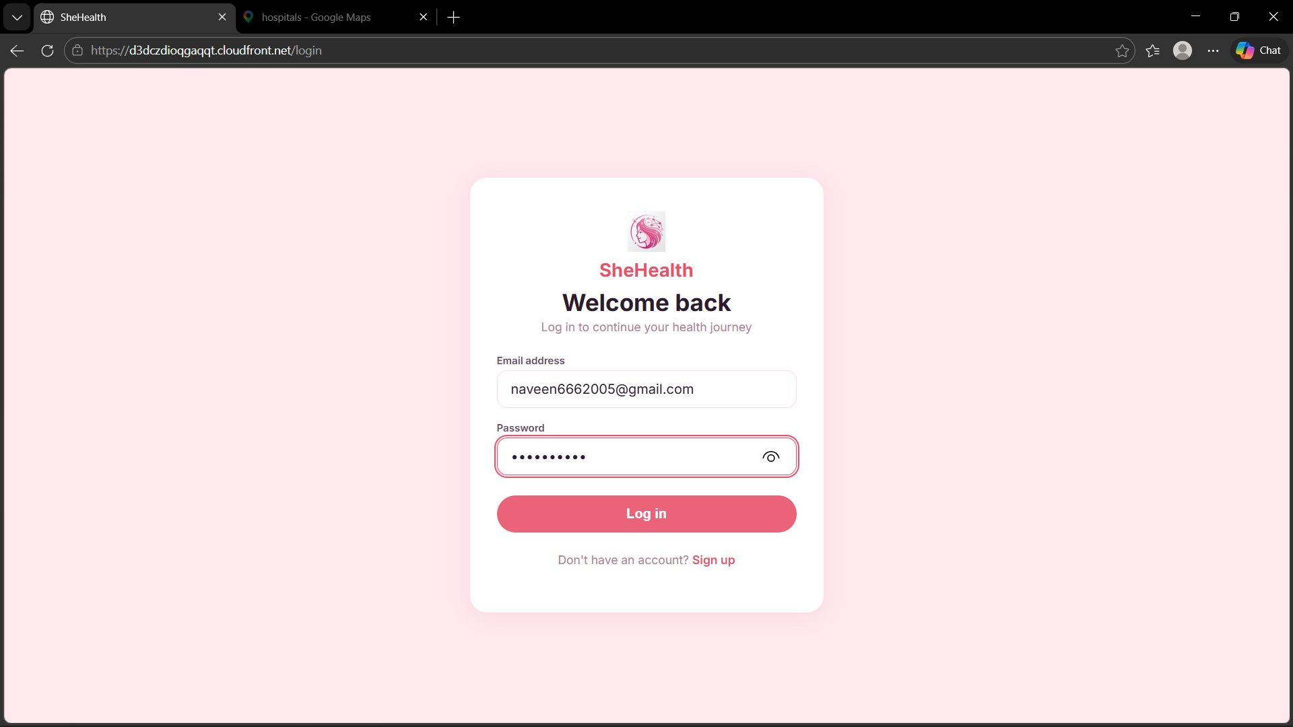
Figure 4: Login Page — Secure Authentication via Amazon Cognito

6.3 Dashboard
After login, users land on the Dashboard which displays: a daily health tip with a Multilingual AI banner, quick-action cards for AI Assistant / Log Symptoms / View Reports, a Schedule an Appointment CTA with hospital finder, and Health Topic categories (Fitness, Wellness, Cycle, Nutrition, Mental Health, Community).

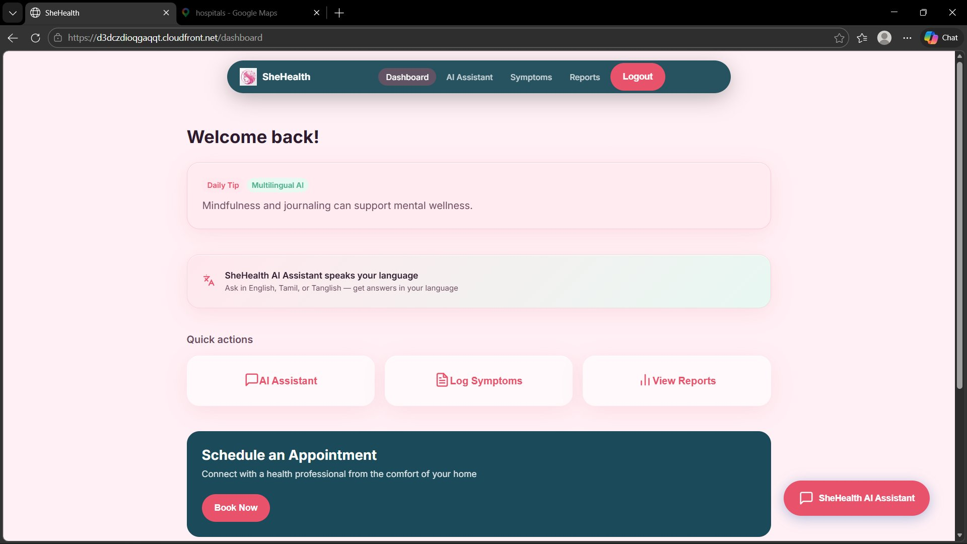
Figure 5: Dashboard — Welcome Screen, Daily Tip & Quick Actions

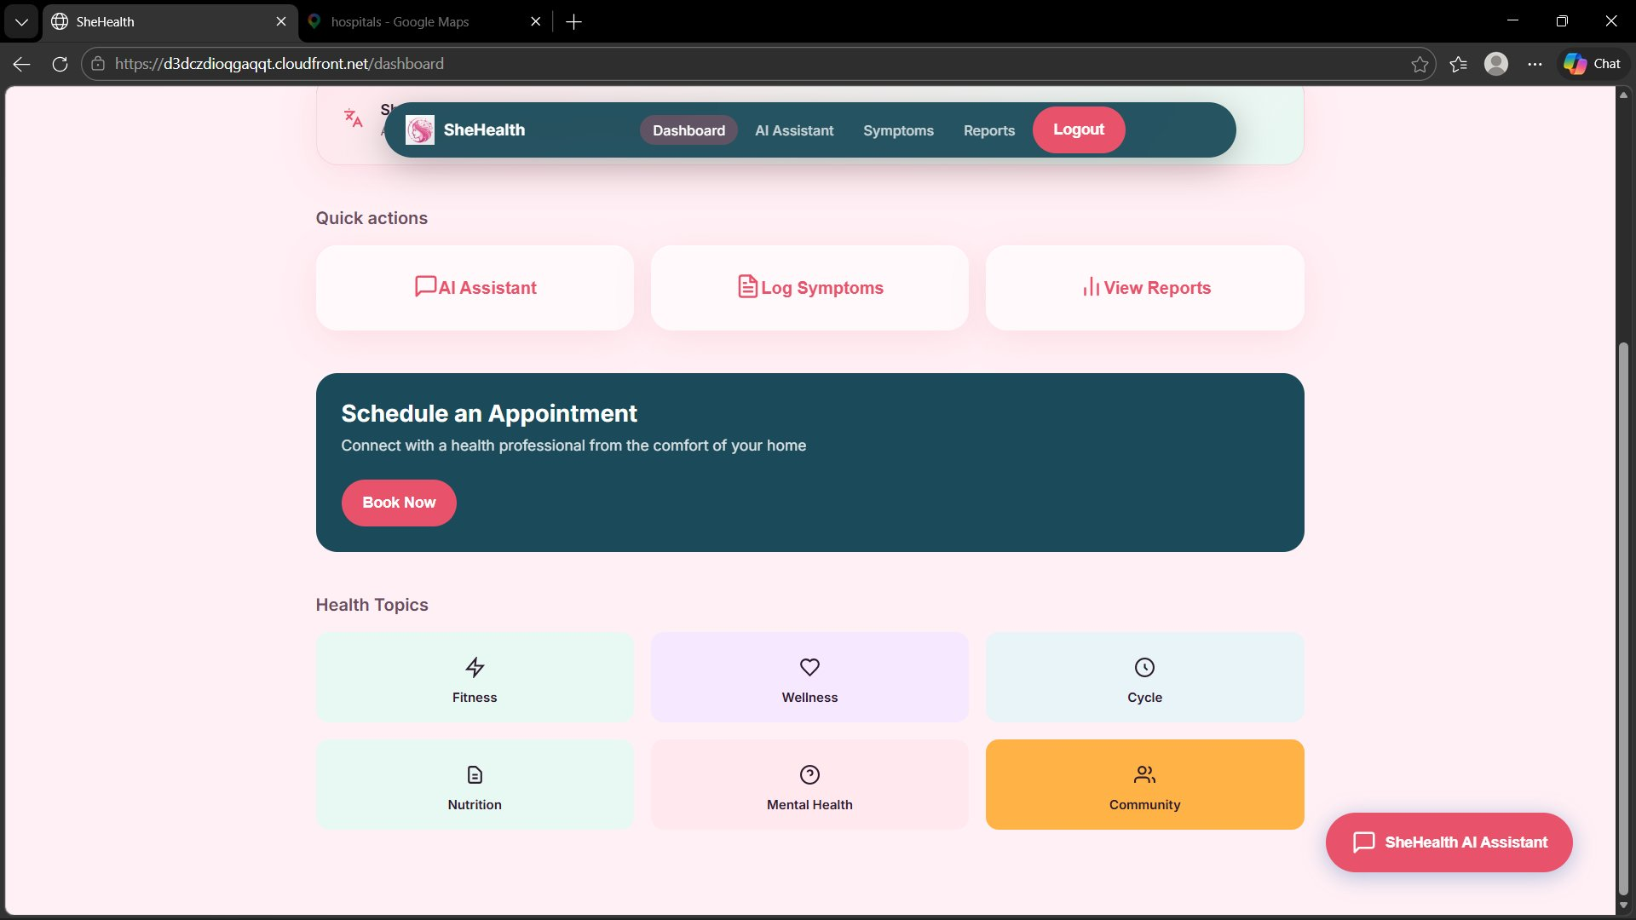
Figure 6: Dashboard — Health Topics Grid

6.4 Symptom Logger
Users log symptoms by selecting a type (Cramps, Fatigue, Mood Swings, Fever, etc.), picking a date, dragging the severity slider (1–10), and optionally adding notes. POST /symptoms validates and stores the entry in DynamoDB. Recent entries appear immediately below the form.

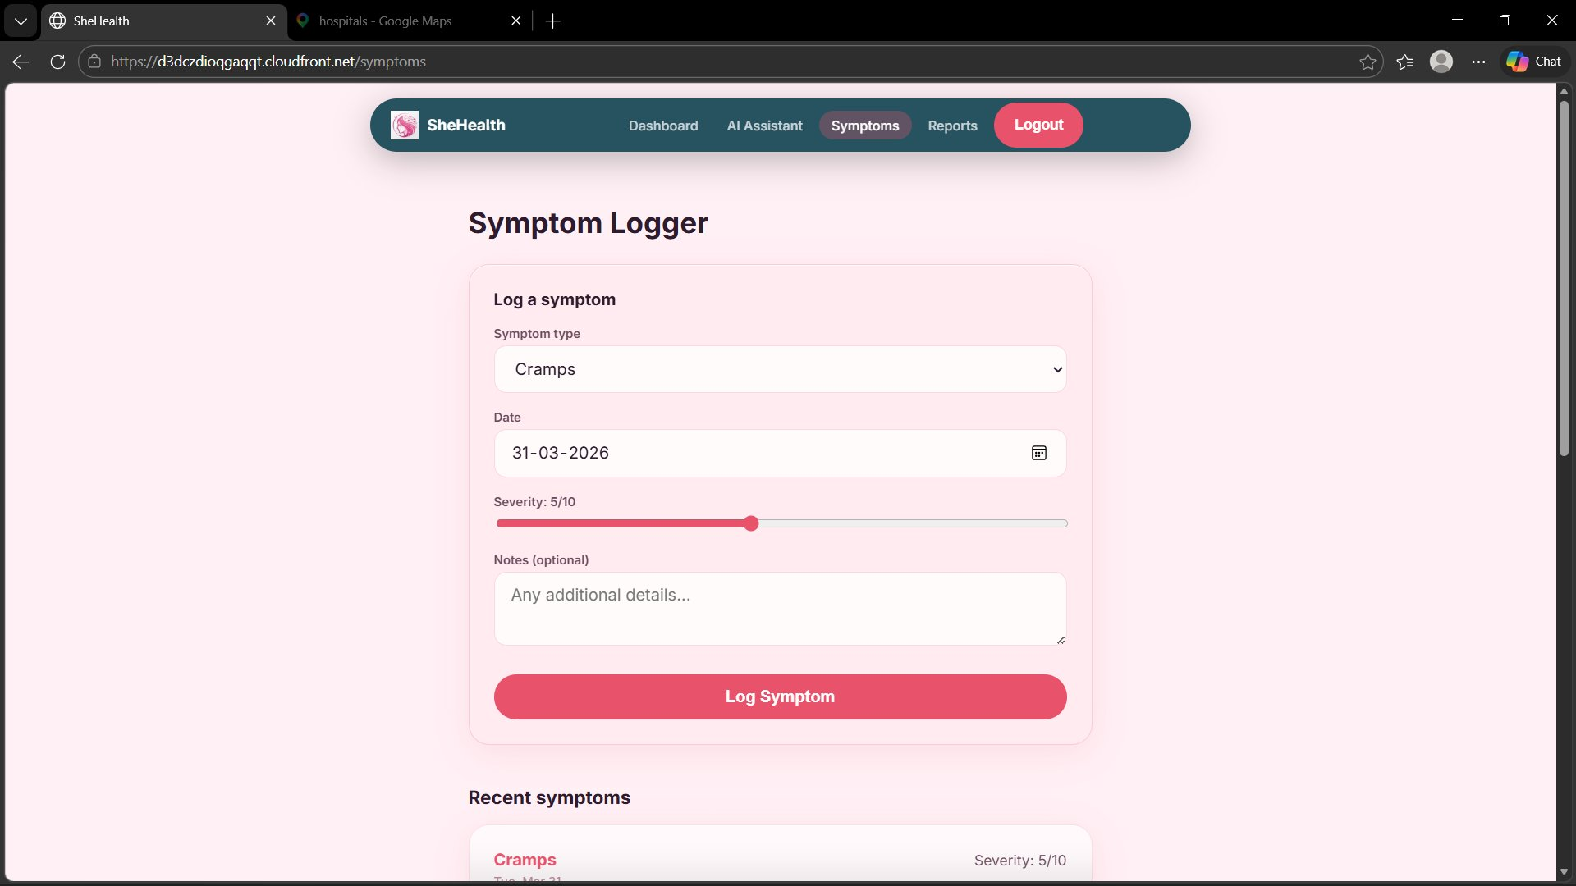
Figure 7: Symptom Logger Form

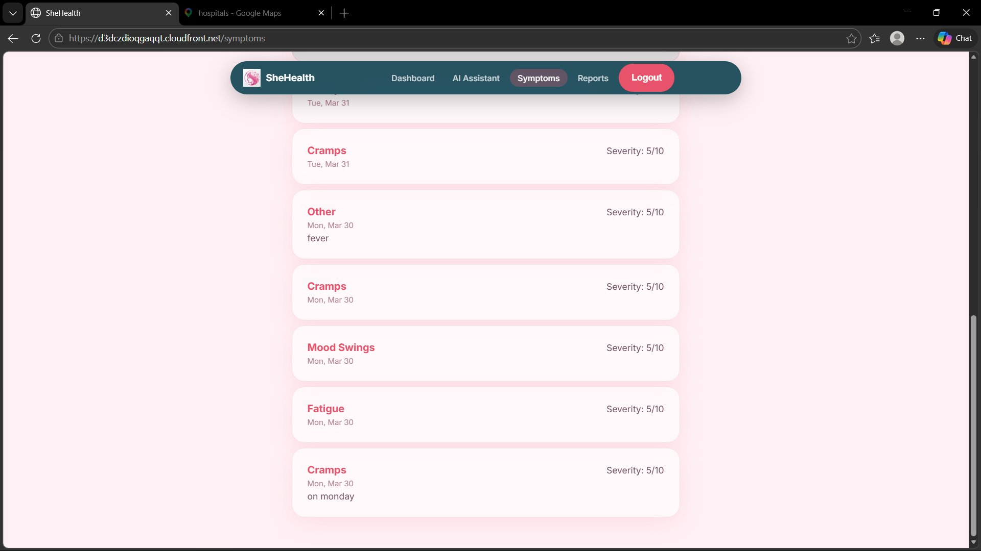
Figure 8: Recent Symptoms History (Last 30 Days)

6.5 Health Report Generation
Users select a date range and click Generate Report. The reportHandler Lambda fetches all symptom data for that period from DynamoDB, constructs a structured medical prompt, and sends it to Groq AI. The output is saved to a private S3 bucket and a pre-signed URL valid for 1 hour is returned for download.

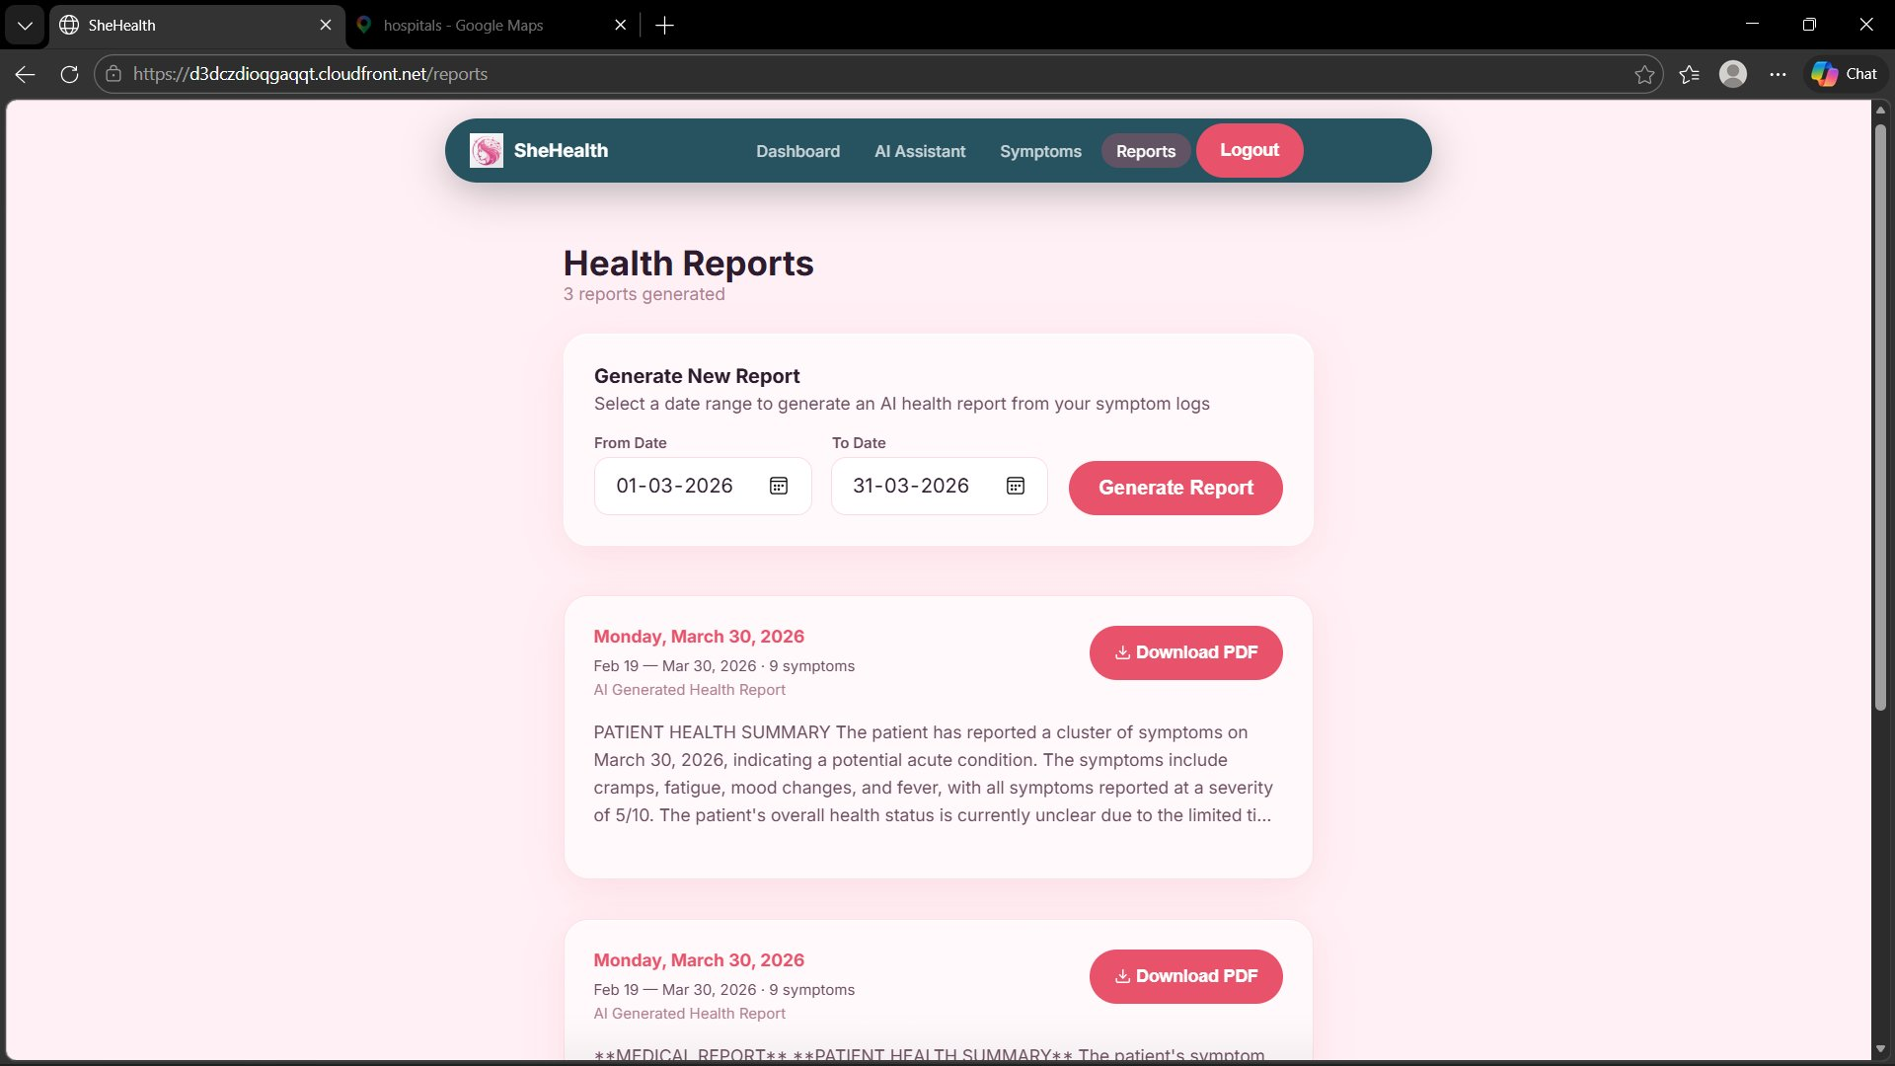
Figure 9: Health Reports Page — Generate New Report & Past Reports List

6.6 Generated Medical Report (PDF)
The downloaded report is formatted with clearly defined sections: Patient Health Summary, Symptom Analysis, Clinical Observations, and Recommendations — structured to be useful in a clinical setting. A disclaimer footer clarifies it is AI-generated and intended to assist, not replace, a doctor's diagnosis.

Note: A sample generated PDF report is also included in the GitHub repository for reference. Users can also ask their own questions — the AI chat and report system are fully personalised based on each user's logged symptoms and health profile.

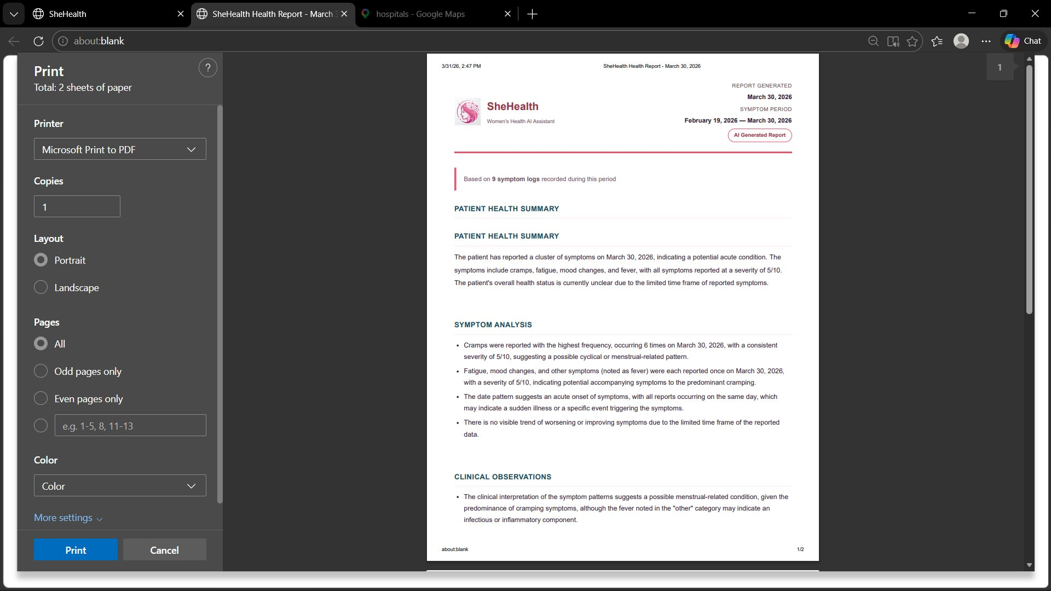
Figure 10: Generated Report — Page 1 (Patient Health Summary & Symptom Analysis)

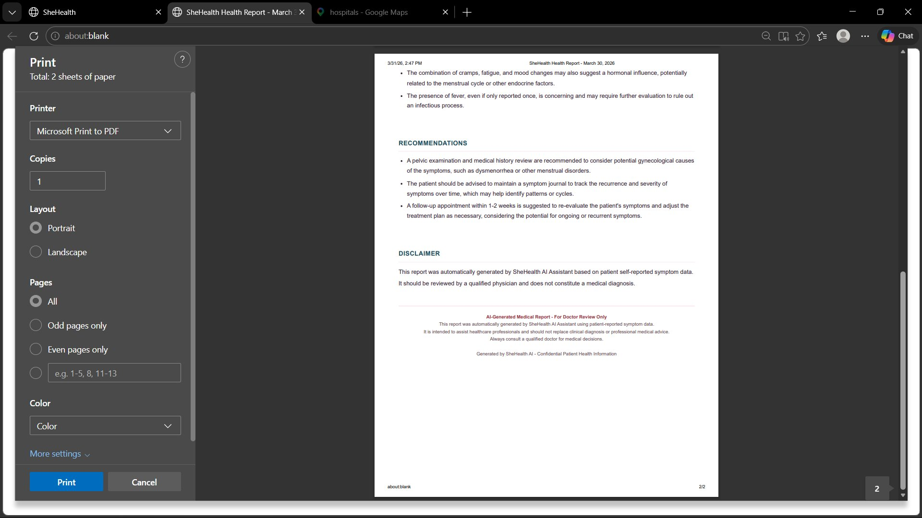
Figure 11: Generated Report — Page 2 (Clinical Observations, Recommendations & Disclaimer)

6.7 AI Chat Assistant — Multilingual Support
The chat interface sends messages to POST /chat. Lambda passes the full conversation history, the user's health profile, and the current message to Groq API. Responses from Llama 3.3 70B typically arrive within 1–2 seconds. The left sidebar stores all past conversations. The AI seamlessly handles English, Tanglish (Tamil-English mix), and pure Tamil in the same session.

Tip: The sample PDF report in the GitHub repository demonstrates queries made in English. You can also ask in Tamil or Tanglish — the AI detects the language automatically and responds in kind.

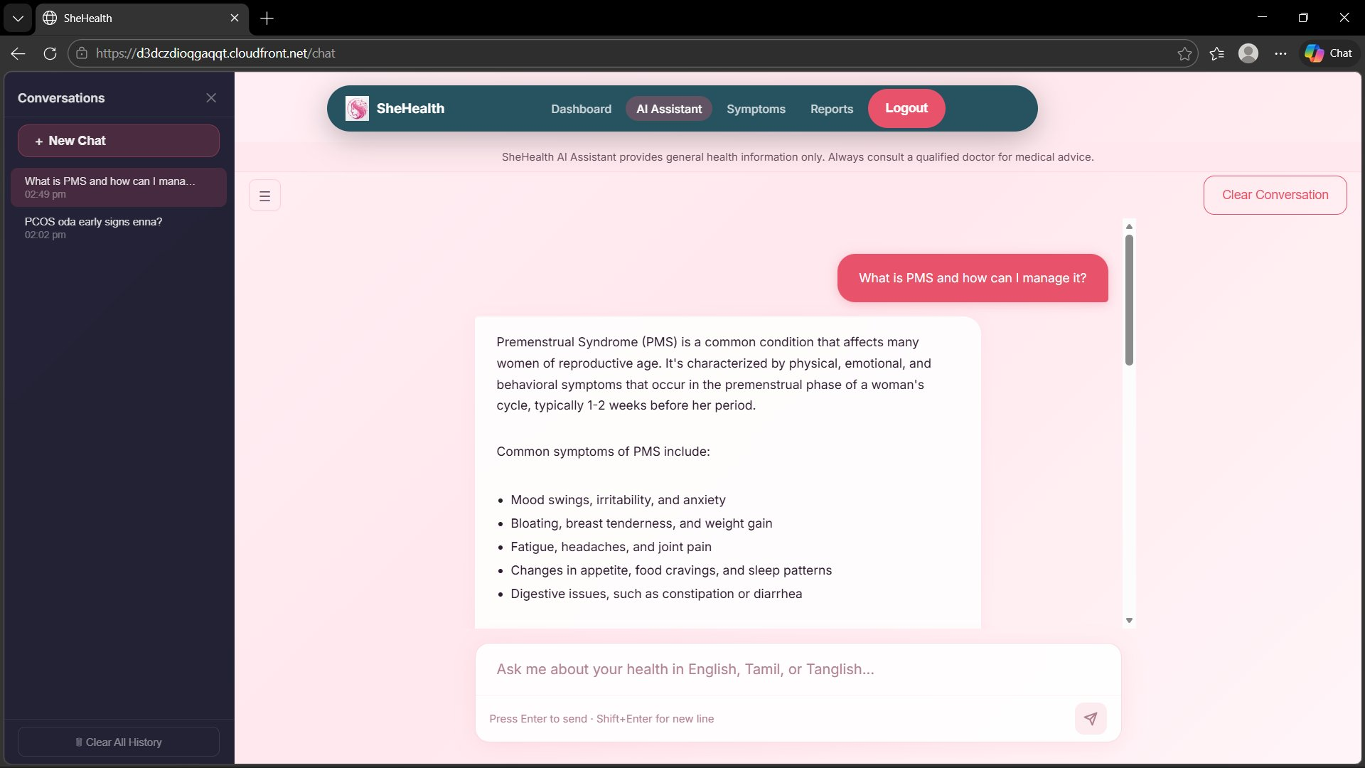
Figure 12: AI Chat — English Query (PMS information)

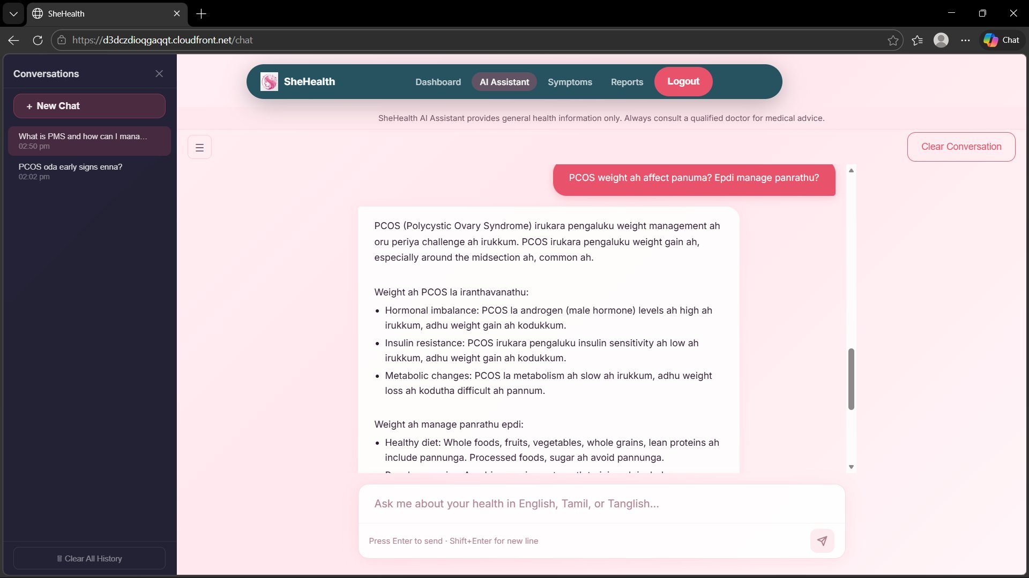
Figure 13: AI Chat — Tanglish Query (PCOS weight management)

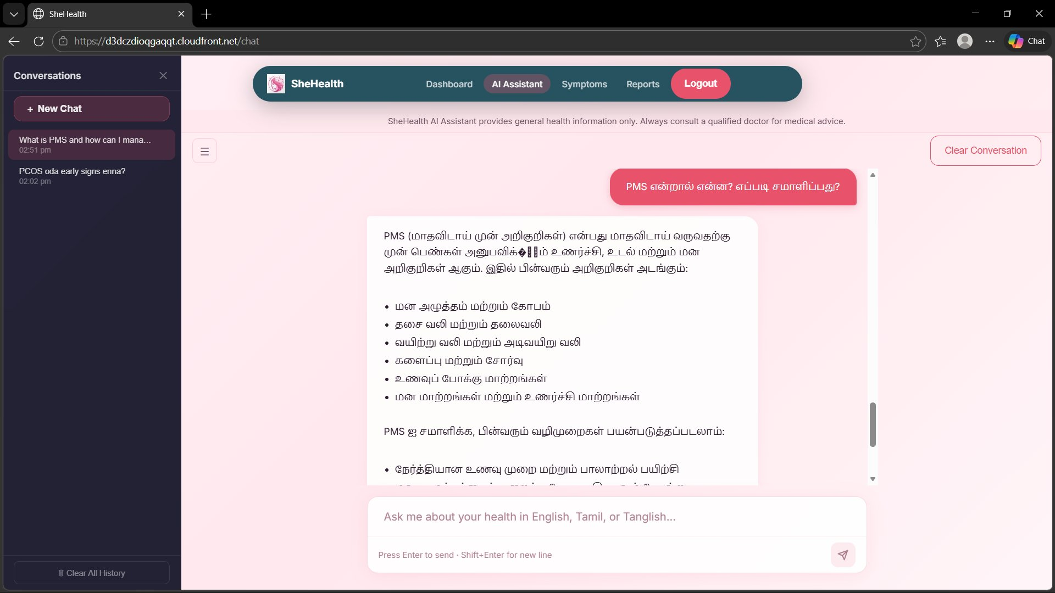
Figure 14: AI Chat — Pure Tamil Query (PMS in Tamil)

6.8 Find Nearby Hospitals
Clicking Book Now on the Dashboard triggers a modal with two options: use the browser's Geolocation API to detect the user's current position, or manually enter a city name. Either path opens Google Maps in a new tab pre-queried for hospitals and clinics in that area.

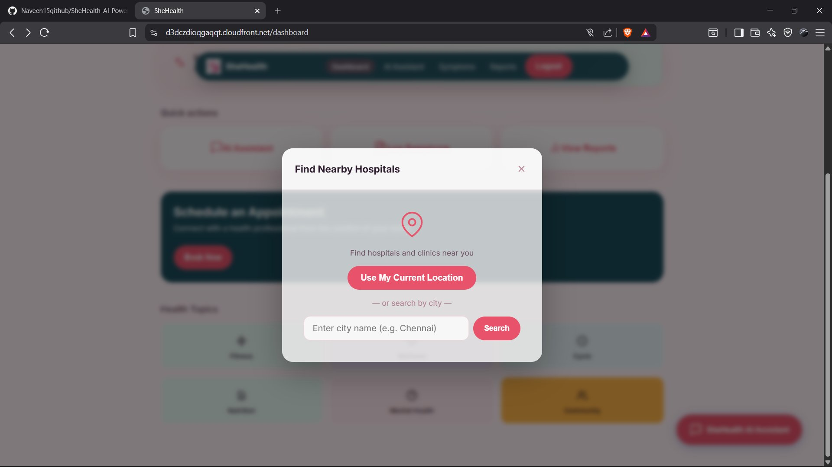
Figure 15: Find Nearby Hospitals Modal

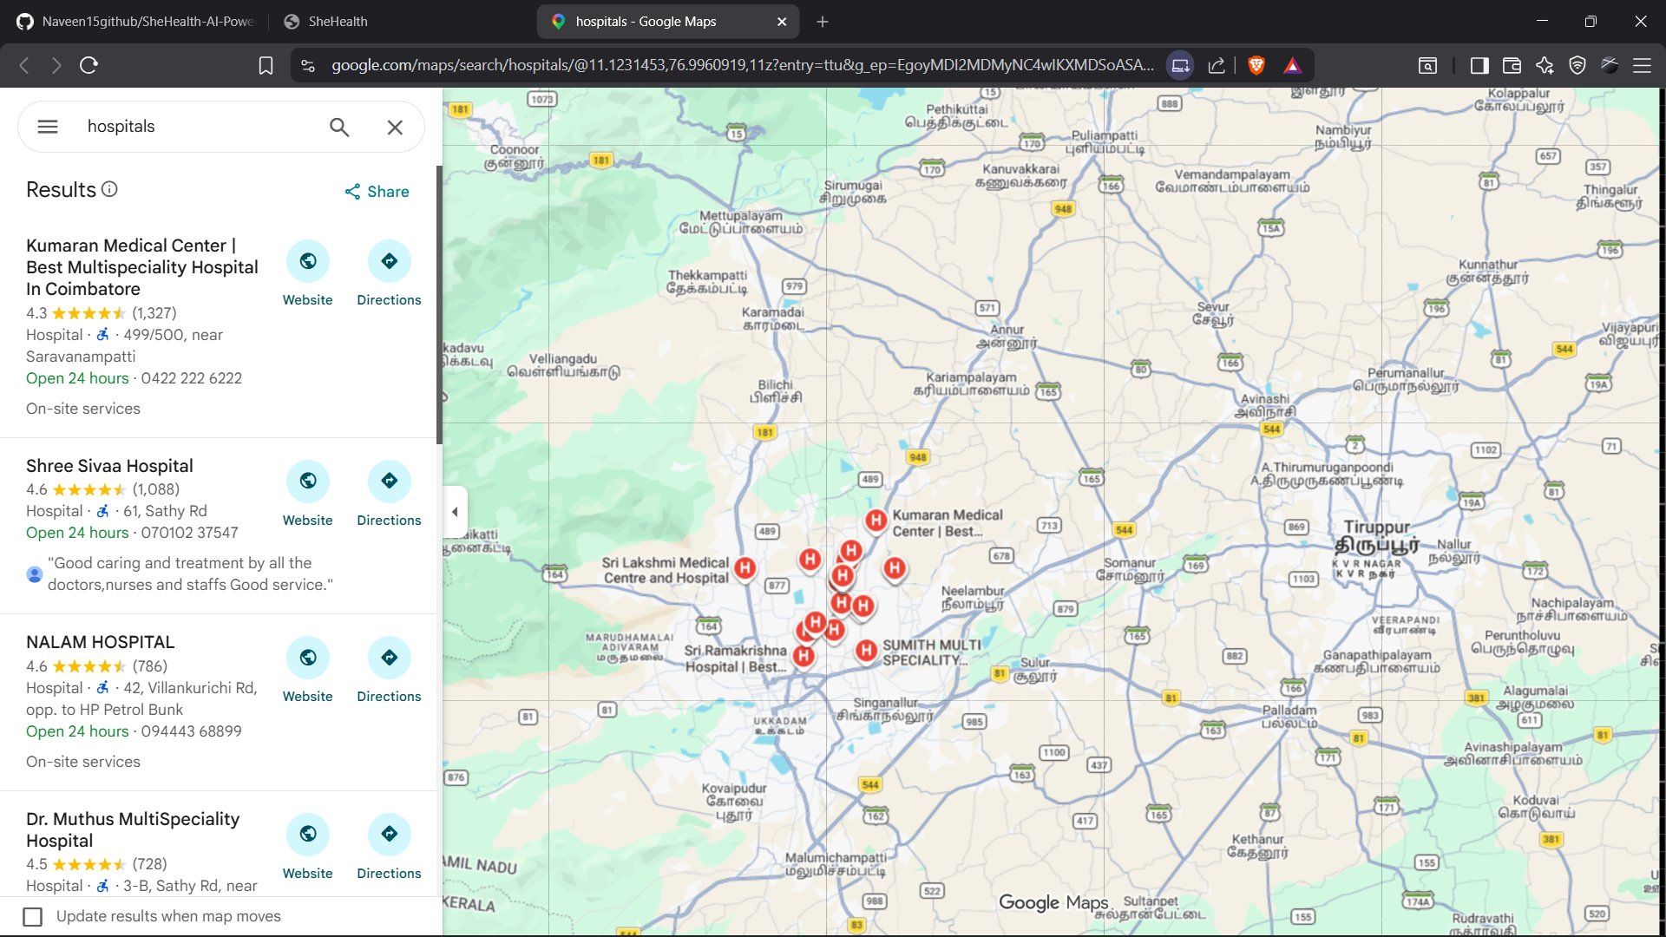
Figure 16: Google Maps — Hospitals near Coimbatore, Tamil Nadu

7. API Reference
All endpoints require an Authorization: <Cognito ID Token> header. The Cognito JWT authorizer on API Gateway validates the token before any Lambda is invoked.

Method | Endpoint | Lambda | Description
GET | /profile | chatHandler | Retrieve the authenticated user's health profile
POST | /profile | chatHandler | Create or update the user's health profile
POST | /chat | chatHandler | Send a chat message, receive AI response
GET | /symptoms | symptomHandler | Get last 30 days of symptom logs
POST | /symptoms | symptomHandler | Log a new symptom entry
GET | /reports | reportHandler | List all previously generated reports
POST | /reports/generate | reportHandler | Generate a new medical report from symptom data

8. Built with Kiro
This entire project was built using Kiro (kiro.dev), Amazon's AI-powered IDE designed for spec-driven, agent-assisted development. Kiro compressed what would have been days of documentation-reading and trial-and-error into a focused build session.

Specifically, Kiro helped:
- Design the architecture — suggesting the right AWS services and how they should connect
- Write the CloudFormation template — the entire cloudformation.yaml with all DynamoDB tables, S3 buckets, Cognito, Lambda, IAM roles, API Gateway routes, and CloudFront
- Implement Lambda handlers — all three Lambda functions (chatHandler, symptomHandler, reportHandler)
- Build the React frontend — component scaffolding, Cognito SDK integration, API wiring, and routing
- Debug cross-service issues — CORS errors, Cognito JWT authorizer misconfigurations, pre-signed URL expiry
- Write the deployment script — the deploy.ps1 PowerShell script for build, sync, and CloudFront invalidation

9. Known Issues & Future Improvements

Known Issues
- Report format — Reports are generated as plain .txt files; PDF formatting with proper sections and styling is planned.
- Groq rate limits — Free tier has per-minute token limits; high-volume sessions may fall back to the smaller model (handled silently).
- No real-time chat streaming — Responses return as a complete message; WebSocket/SSE streaming is on the roadmap.
- Single AWS region — No multi-region DynamoDB replication configured.
- No data export — Users can download individual reports but cannot bulk-export all symptom data.

Future Improvements
- Streaming AI responses using Server-Sent Events or WebSocket API
- PDF report generation using a Lambda layer with a headless PDF library
- Push notifications via SNS for daily symptom logging reminders
- Symptom visualizations — severity trend charts using Recharts
- Full Tamil language support in the UI (not just AI chat)
- Doctor sharing — generate shareable report links accessible without a SheHealth account
- Wearable integration — pull data from Apple Health or Google Fit

10. Deployment Guide
Prerequisites: Node.js 18+, AWS CLI with IAM permissions, PowerShell, and a Groq API key (free at console.groq.com).

Step 1 — Deploy AWS Infrastructure
Run the CloudFormation template from the project root:
aws cloudformation deploy --template-file infrastructure/cloudformation.yaml --stack-name shehealth --capabilities CAPABILITY_NAMED_IAM --parameter-overrides GroqApiKey=<your_key>
Step 2 — Configure Frontend .env
Set REACT_APP_USER_POOL_ID, REACT_APP_CLIENT_ID, and REACT_APP_API_URL from CloudFormation outputs.
Step 3 — Build & Deploy Frontend
Run npm run build in the frontend/ directory, then sync to S3 and invalidate CloudFront. Or run the all-in-one script:
./deploy.ps1

11. Acknowledgements
- Kiro (kiro.dev) — the AI-powered IDE that made building this entire project possible
- Groq — for fast, free AI inference accessible to indie developers
- Meta AI — for open-sourcing the Llama model family
- AWS — for the free tier that made building and hosting this project essentially free
- The women who gave feedback during early testing and pushed for Tamil language support

Built with ☁️ Kiro, a lot of CloudFormation YAML, and one too many IAM policy debugging sessions.

