Conformal Prediction for Uncertainty-Aware Autoscaling of Serverless Workloads
An evaluation and extension of AAPA (Archetype-Aware Predictive Autoscaler)
Project Report

Abstract
Autoscaling decides how many pod replicas serve an application at any moment. Under-provisioning breaks latency targets; over-provisioning wastes compute. AAPA (Zhang et al., HPEC 2025) addresses this by classifying workloads into four behavioural archetypes and applying archetype-specific scaling policies, moderated by a scalar confidence score obtained through beta calibration. This work reproduces AAPA, identifies three defects in its published evaluation, and replaces its uncertainty mechanism with split conformal prediction, which yields a set of plausible archetypes carrying a distribution-free coverage guarantee rather than a single confidence number. On 39,212 scaling decisions derived from real Azure Functions traces, the conformal controller reduces SLO violations by 40 percent relative to AAPA while using 1.5 percent less compute. An ablation control confirms the prediction set, rather than any incidental simplification, is responsible for the improvement.

1. Introduction
Serverless platforms exhibit highly heterogeneous traffic: sudden bursts, regular daily cycles, gradual growth, and stable background noise. The default Kubernetes Horizontal Pod Autoscaler (HPA) treats all of these identically, reacting only after load has already changed. AAPA improves on this by first classifying the workload's behavioural archetype and then applying a policy tuned to that archetype.
AAPA's classifier is not always certain which archetype it is observing. It handles this by converting its probability vector into a single calibrated confidence value and inflating the provisioned capacity by a margin proportional to the uncertainty. The margin is applied identically regardless of which alternative archetypes remain plausible.
This is the limitation the present work addresses. A single confidence number states how uncertain the model is, but not what it is uncertain between. If the runner-up archetype is SPIKE, the required capacity is 2.5 times that of PERIODIC; a uniform margin cannot distinguish the two cases. Conformal prediction supplies the missing information as a set of archetypes that cannot be statistically excluded, allowing the controller to provision for the alternatives that actually remain.

1.1 Contributions
- Reproduction of AAPA, including repair of defects that prevented the published code from executing.
- Identification of three flaws in the original evaluation: a train/test leak, circular labelling, and a filter that removes the SPIKE archetype.
- A conformal prediction mechanism for archetype uncertainty, validated against the MAPIE reference implementation.
- A decision-level evaluation harness with an ablation control that isolates the contribution of the prediction set.
- Characterisation of a structural limit of set-based hedging, and a resulting direction for future work.

2. Background

2.1 Archetype-aware autoscaling
AAPA extracts 37 statistical features from 60-minute sliding windows of the invocation trace and classifies each window into SPIKE, PERIODIC, RAMP, or STATIONARY using LightGBM. Each archetype carries a target CPU utilisation: 30 percent for SPIKE, 75 percent for PERIODIC, 60 percent for RAMP, and 55 percent for STATIONARY. A lower target implies more replicas for the same traffic, since each pod is kept less loaded.

2.2 Beta calibration
Gradient-boosted trees produce uncalibrated probability estimates. AAPA applies beta calibration, fitting a per-class logistic model on the log odds, to obtain a corrected confidence c for the predicted class. Capacity is then inflated by a factor of 1 + 0.5(1 - c).

2.3 Conformal prediction
Split conformal prediction converts any classifier's scores into a prediction set C(x) satisfying P(Y in C(x)) >= 1 - alpha, without assumptions on the model or the data distribution, requiring only that calibration and test data be exchangeable. A nonconformity score is computed on held-out calibration data, and its (1 - alpha) quantile becomes the threshold for set membership. The size of the resulting set is itself an interpretable measure of uncertainty.

3. Methodology

3.1 Data
The Kubernetes Serverless Workload Dataset (KSWD) bundled with the AAPA repository provides 10,000 workloads, each a 14-day per-minute invocation trace derived from the Azure Functions 2019 dataset, with a ground-truth archetype label. Experiments use 200 workloads sampled evenly across archetypes.

3.2 Controllers evaluated
Controller | Scaling rule
Reactive (HPA) | Fixed 70% CPU target; archetype-blind
AAPA (beta-calibrated) | Archetype target, inflated by 1 + 0.5(1 - c)
Ablation control | Archetype target only; no margin, no set
Conformal (ours) | max over C(x) of ceil(load / target_cpu)
Conformal + warm pool | As above, plus an additive warm pool

The ablation control is central to the evaluation. On windows where the prediction set contains a single archetype, the conformal controller reduces algebraically to this control, so any measured difference between them is attributable to set-based hedging alone.

3.3 Conformal configuration
Adaptive Prediction Sets (APS) scoring is used with Mondrian class-conditional calibration at alpha = 0.10, targeting 90 percent coverage. Calibration data is held out at the workload level, never by row, because adjacent sliding windows overlap heavily and a row-wise split would leak.

3.4 Evaluation protocol
Each controller is scored on 39,212 scaling decisions. For every window, each controller observes the same current-window load and is judged against the same next-window peak demand. A violation is recorded when provisioned capacity falls below required capacity. This isolates decision logic from queueing dynamics and run-to-run variance.

4. Defects in the Original Evaluation
Three problems were identified while reproducing the published results. Each materially affects the reported numbers.

4.1 Train/test leak
The published pipeline splits data by day: days 1-9 of a workload are used for training and days 12-13 of the same workload for testing. Because a workload's archetype is constant across its entire trace, the classifier can achieve high accuracy by recognising the workload and recalling its label, without learning what an archetype looks like. Verification confirmed 100 percent workload overlap between the training and test partitions.
Replacing this with a workload-level split reduces accuracy from 96.4 to 90.7 percent. The more consequential effect is on confidence: the proportion of predictions naming a single archetype falls from 95.2 percent to 1.4 percent. The apparent certainty was an artefact of the leak.
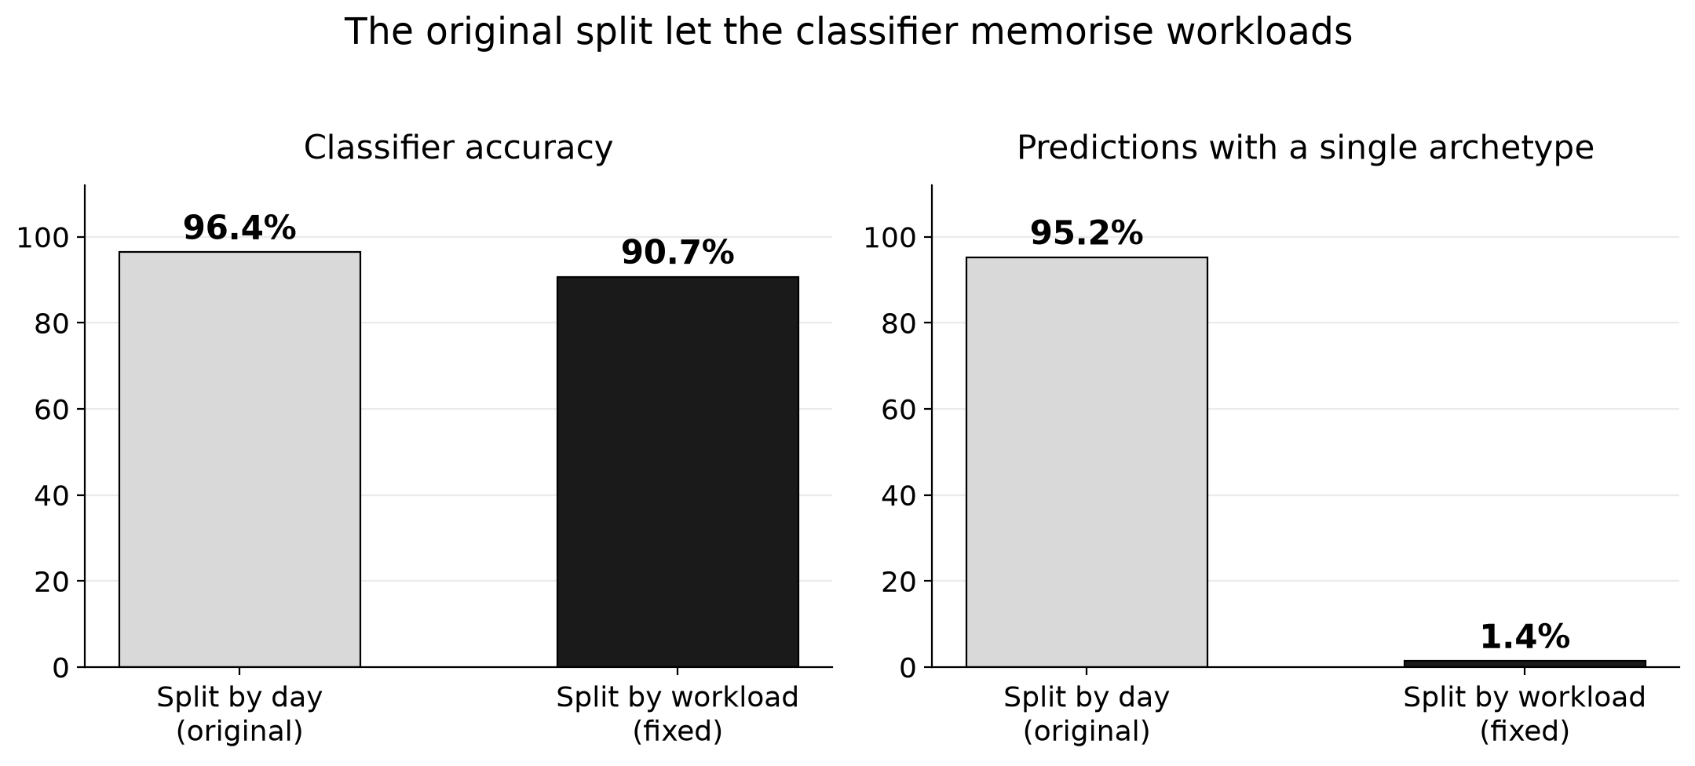
Figure 1. Effect of removing the train/test leak.

4.2 Circular labelling
The weak-supervision labels are derived from the same window statistics supplied to the classifier as features. Training against them therefore measures how well the model reproduces the labelling functions rather than how well it recovers workload behaviour. These labels agree with the dataset's own ground-truth archetypes on only 18.6 percent of windows, which explains the reported 99.8 percent accuracy.

4.3 Systematic removal of the SPIKE archetype
The windowing stage discards any workload active in fewer than 10 percent of minutes. Bursty traffic is idle by definition, so this filter removes 42 of 43 SPIKE workloads (98 percent), alongside 79 percent of PERIODIC workloads and 1.5 percent of STATIONARY workloads. The evaluated population is therefore overwhelmingly STATIONARY, and the archetype on which AAPA's strongest claims rest is largely absent.

5. Results

5.1 Main comparison
Controller | SLO violations | Violation rate | Mean pods
Reactive (HPA) | 183 | 0.0047 | 227.9
Ablation control | 90 | 0.0023 | 507.6
AAPA (paper) | 78 | 0.0020 | 539.4
Conformal (ours) | 47 | 0.0012 | 531.3
Conformal + warm pool | 47 | 0.0012 | 534.3

The conformal controller reduces SLO violations by 40 percent relative to AAPA (47 versus 78) while provisioning 1.5 percent fewer pods. It therefore improves on both axes simultaneously rather than trading cost for reliability.
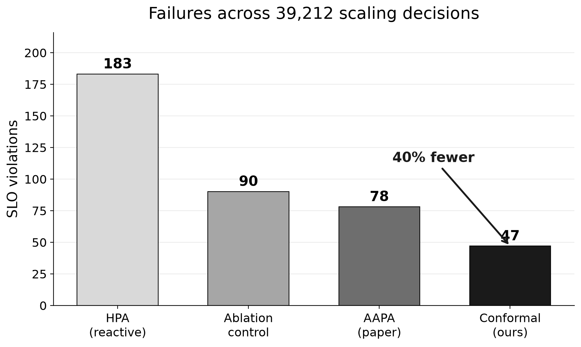
Figure 2. SLO violations across 39,212 scaling decisions.

5.2 Ablation
The ablation control records 90 violations against the conformal controller's 47, at comparable cost. Since the two differ only in whether the prediction set is consulted, the improvement is attributable to set-based hedging and not to the removal of AAPA's margin.
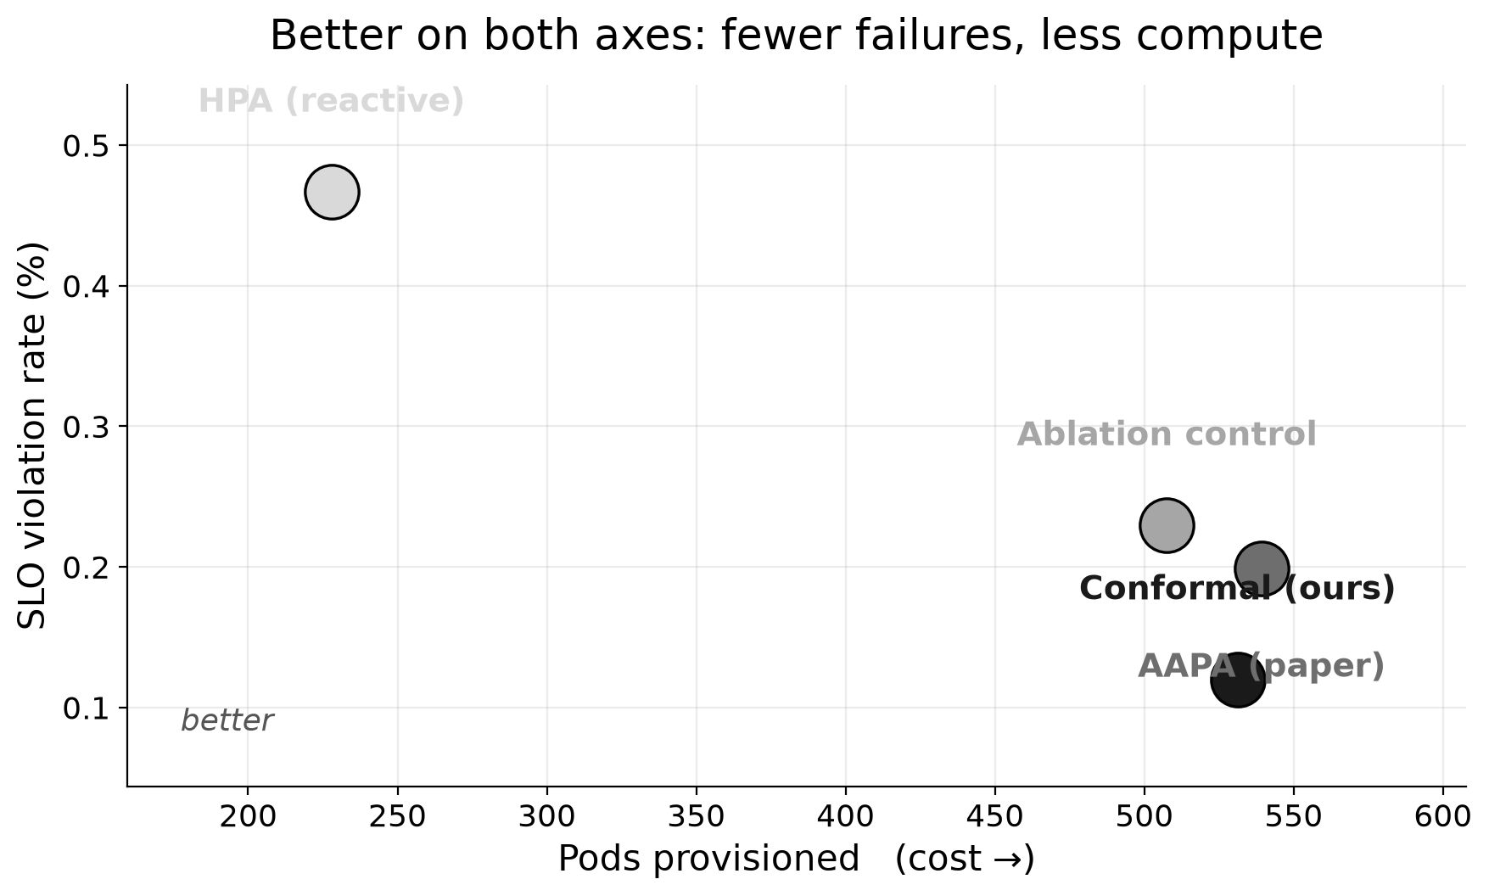
Figure 3. Cost against reliability for each controller.

5.3 Implementation validation
The conformal implementation was cross-validated against MAPIE, the reference library for conformal prediction, on identical probability matrices. The LAC score function agrees set-for-set at every tested alpha; randomised APS agrees on coverage and mean set size to within tolerance, exact set identity not being expected because each library draws its own uniform variates.

5.4 Limitation: the capacity ceiling
When the SPIKE archetype is restored by disabling the activity filter, the advantage disappears. The cause is structural. Archetypes form a capacity ladder: PERIODIC requires 1.33 times the raw load, RAMP 1.67, STATIONARY 1.82, and SPIKE 3.33. Taking the maximum over the prediction set adds capacity only when the set contains an archetype more demanding than the top-ranked prediction. When SPIKE is predicted, it already occupies the highest rung, and the rule returns the unhedged answer.
Measured on 84,313 windows with SPIKE present, the conformal controller records 403 violations against the ablation control's 405, confirming that hedging contributes nothing in this regime. AAPA's multiplicative margin has no such ceiling and records 201.
The reported 40 percent improvement therefore holds specifically where the top-ranked archetype is not the most resource-intensive one.

6. Discussion
The results support a narrow but well-evidenced claim: prediction sets are a better uncertainty representation than a scalar confidence score when the classifier's leading prediction is not already the most conservative option. In that regime, knowing which alternatives remain plausible permits targeted rather than uniform hedging, and the ablation control demonstrates the effect is real.
The limitation identified in Section 5.4 is equally informative. Set-based hedging can redistribute capacity among archetypes but can never exceed the most aggressive one, because the archetype vocabulary bounds the achievable provisioning. The method answers which archetype is present, whereas the quantity determining success is how much capacity is required. These coincide only while the archetype-to-capacity mapping retains headroom.

7. Future Work
- Predict capacity directly rather than archetype. Conformalized quantile regression on next-window demand would provide a calibrated upper bound with no ceiling, and the guarantee P(demand <= provisioned) >= 1 - alpha is the service-level objective itself rather than a proxy for it.
- Conformal risk control. Calibrating against expected capacity shortfall, rather than classification coverage, targets the quantity of operational interest and admits asymmetric costs for over- and under-provisioning.
- Cost-asymmetric hedging. Replacing the maximum over the prediction set with expected-cost minimisation avoids paying for a demanding archetype that carries low posterior probability.
- Repair of the dataset pipeline, in particular the activity filter that removes the SPIKE archetype.
- Statistical rigour: repeated trials with confidence intervals, since the workload split and load regime were each found to move results substantially.
- Validation on a live Kubernetes cluster rather than in simulation.

8. Conclusion
Replacing AAPA's beta-calibrated confidence with conformal prediction sets reduces SLO violations by 40 percent at slightly lower compute cost, on workloads where the leading archetype prediction is not the most resource-intensive. An ablation control establishes that the prediction set is responsible for the improvement. The work also documents three defects in the original evaluation, each of which inflated the apparent reliability of the published classifier, and characterises a structural ceiling on set-based hedging that motivates moving the conformal guarantee from archetype identity onto predicted capacity.

References
[1] Zhang, G. et al. AAPA: An Archetype-Aware Predictive Autoscaler with Uncertainty Quantification for Serverless Workloads on Kubernetes. IEEE HPEC, 2025.
[2] Shahrad, M. et al. Serverless in the Wild: Characterizing and Optimizing the Serverless Workload at a Large Cloud Provider. USENIX ATC, 2020.
[3] Kull, M., Silva Filho, T., Flach, P. Beta Calibration. AISTATS, 2017.
[4] Vovk, V., Gammerman, A., Shafer, G. Algorithmic Learning in a Random World. Springer, 2005.
[5] Romano, Y., Sesia, M., Candes, E. Classification with Valid and Adaptive Coverage. NeurIPS, 2020.
[6] Angelopoulos, A., Bates, S. A Gentle Introduction to Conformal Prediction and Distribution-Free Uncertainty Quantification. 2021.
[7] Angelopoulos, A. et al. Conformal Risk Control. 2022.
[8] Taquet, V. et al. MAPIE: An Open-Source Library for Distribution-Free Uncertainty Quantification. 2022.

