Requirements Gathering from Restaurant (BRD-Business Requirement Document)

Process-1:

Business Analyst:

After the Business Requirements Document (BRD), the Business Analyst is providing the functional requirements to the Platform Architect.

Process-2:

Platform Architect:

After the Business Analyst provides the functional requirements, the Platform Architect uses them to design the system architecture.

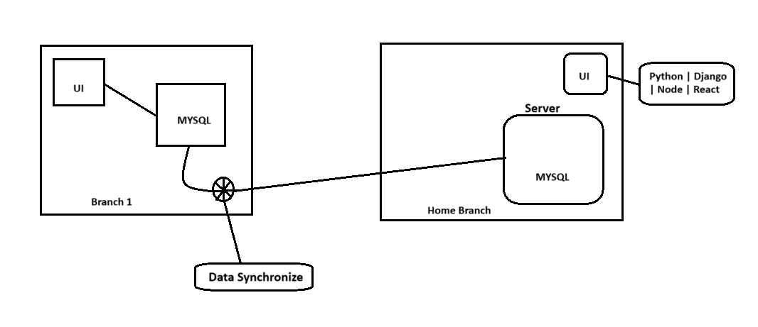

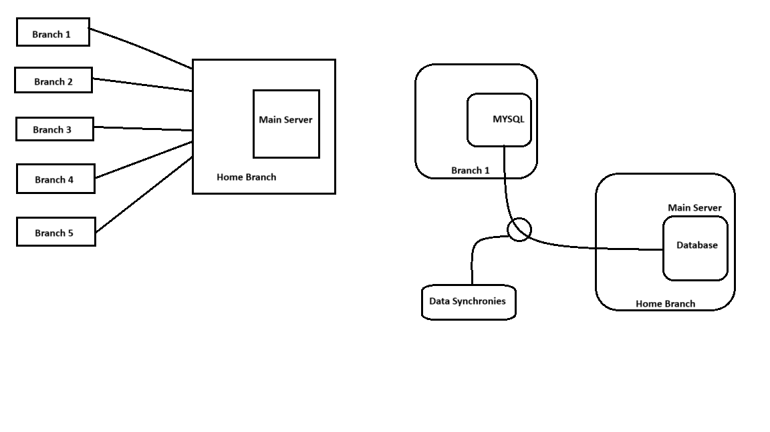

**Branch’s (Offline Branch’s)**

* **UI**: The user interface is hosted locally at the branch, allowing users to interact with the system even without internet connectivity.
* **MySQL**: The local database where all data entries and transactions are stored.
* **Status**: This branch operates **offline**, meaning it functions independently without an active internet connection.
* **Function**: Users input data via the UI, and the data is stored in the local MySQL database.

**Data Synchronize Component**

* **Role**: Acts as a middle layer that handles the **synchronization of data** from offline branches to the central home branch once an internet connection becomes available.
* **Mechanism**:
  + Monitors for internet availability.
  + When online, pulls data from the local MySQL.
  + Pushes/syncs the data to the **Home Branch Server**.
* **Use Case**: Ideal for remote or rural locations where continuous internet is not available.

**Home Branch (Central Server)**

* **Server**:
  + Hosts the **main MySQL database**, which acts as the central repository.
  + Receives and stores synchronized data from all branches.
* **UI**: This is the centralized user interface accessible via internet.
* **Tech Stack**: Powered by **Python, Django, Node.js, and React**, indicating:
  + **Python/Django** for backend APIs and server-side logic.
  + **Node.js** possibly for middleware, services, or real-time functions.
  + **React** for a dynamic and responsive frontend.

**Data Syncretization:**

Data synchronization is the process of ensuring that data in two or more locations remains consistent, accurate, and up-to-date. It involves the continuous or scheduled alignment of data between systems, devices, or databases, so that any change made in one location is reflected in the others.

**Example:**  
If a user updates their contact information on a mobile app, data synchronization ensures that the same update appears on the web application and the backend database.