**Ganadipathy Tulsi's Jain Engineering College**

Kaniyambadi - Vellore - 632102

**IBM – PROJECT**

**Project Title: PRODUCT SALES ANALYIS**

Phase 5(Final Submission)

### Submitted By,

Team Leader NaveenRaj. C

Team Member 1 - Santhosh. D

Team Member 2 - Hemalatha. N

Team Member 3 - Harish. K

# Project Mentor Project Evaluator

## Mrs. K. Durga Priyanka Mrs. K. Durga Priyanka

## **INDEX**

**1. INTRODUCTION**

1.1 PROBLEM OBJECTIVE

**2. DESIGN THINKING PROCESS**

2.1 FLOW CHART

**3. DEVELOPMENT PHRASES**

**4. ANALYSIS OBJECTIVES**

**4.1** TYPES OF MACHINE LEARNING ALGORITHM

4.2 IMPLEMENTING MACHINE LEARNING ALGORITHMS

4.3EVALUATING AND REFINING PREDICTION

**5. DATA COLLECTION**

**6. DATA VISUALIZATION**

**6.1 IBM COGNOS**

**7. DERIVED ACTIONABLE INSIGHTS**

**8. INSIGHTS FROM THE ANALYSIS GUIDES**

8.1 INVNTORY MANAGEMENT

8.2 MARKETING STRATEGIES

**9. FUTURE SCOPE**

**10. ADVANTAGES**

**11.DISADVANTAGES**

**12.CONCLUSION**

**1 INTRODUCTION**

* In this part you will begin building your project by loading and preprocessing the dataset.
* Start building the product sales analysis using IBM Cognos for visualization.
* Define the analysis objectives and collect sales data from source shared.
* Process and clean the collected data to ensure its accuracy and reliability

**1.1 PROJECT OBJECTIVE**

* The primary objective of this project is to conduct a comprehensive analysis of product sales data to gain valuable insights
* This analysis can help businesses make informed decisions, optimize strategies, and improve profitability.
* Some specific objectives for a product sales analysis project:
  + - Identifying products with the highest sales
    - Peak sales Periods
    - Customer preference for specific products

**2.DESIGN THINKING PROCESS**

* **ANALYSIS OBJECTIVES**

Define the specific insights you want to extract from the sale data, such as identifying top-selling products, analyzing sales trends, and understanding customer preferences

* **DATA COLLECTION**

Determine the sources and methods for collecting sales data, including transaction records, product information and customer demographics

* **VISUALIZATION STRATEGY**

Plan how to visualize the insights using IBM cognos to create interactive dashboards and reports

* **ACTIONABLE INSIGHTS**

Identify how the derived insights can guide inventory management and marketing strategies

**2.1 FLOWCHART**

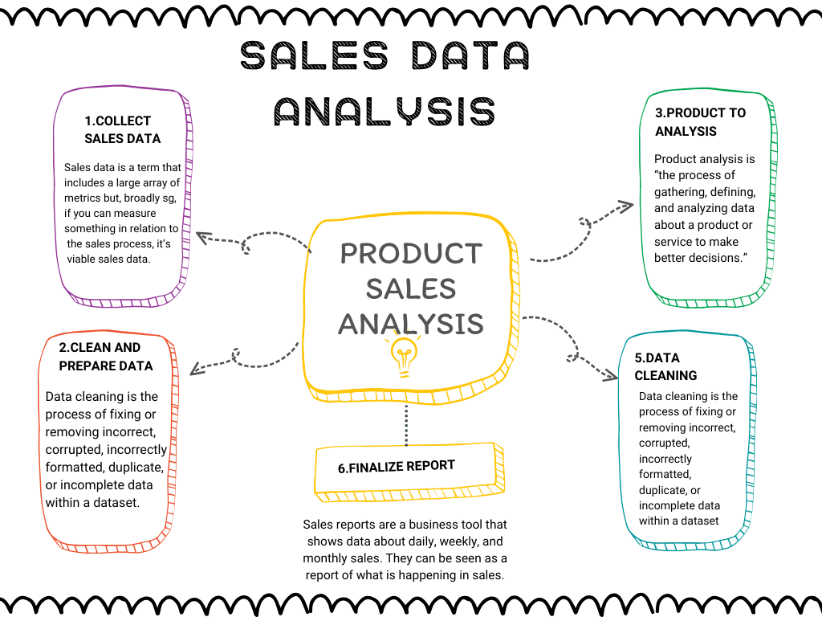

**3.DEVELOPMENT PHASES**

* Product sales analysis typically involves several key phases or steps to gather, process, and derive insights from sales data.
* These phases are crucial for a comprehensive analysis of product sales performance.
* Here are the typical development phases in product sales analysis:
* Define your Goals and Objectives
* Data Collection
* Data Cleaning and Preprocessing
* Data Transformation and Feature Engineering
* Exploratory Data Analysis
* Predictive Modeling
* Visualization and Reporting

**4.ANALYSIS OBJECTIVES**

* The analysis objective in product sales analysis is to gain a comprehensive understanding of how a company's products are performing in the market.
* This type of analysis involves examining sales data to extract valuable insights, make informed decisions, and optimize strategies.
* The specific objectives of product sales analysis typically include:
* Sales Performance Evaluation
* Trends and Patterns
* Customer Segmentation
* Inventory Management
* Pricing Strategy
* Product Life Cycle Analysis
* By thoroughly understanding how products are performing in the market and what factors influence sales
* businesses can make informed decisions about marketing strategies, inventory management, product development, and pricing to optimize their sales and profitability.

**4.1 TYPES OF MACHINE LEARNING ALGORITHM**

**FOR PREDICT SALES AND TRENDS:**

**1.SUPERVISED LEARNING ALGORITHM:**

* + Train model using labelled data to prediction or classification.

**2.UNSUPERVISED LEARNING ALGORITHM:**

* + Discover patterns and structure in unlabelled data without predefined categories.

**3.REINFORCEMENT LEARNING ALGORITHM:**

* + Learn through interaction with an environment to maximize reward and minimize penalties.

**4.2 IMPLEMENTING MACHINE LEARNING ALGORITHMS:**

**1.CHOOSE THE RIGHT ALGORITHM:**

* Based on your specific needs, choose an algorithm that can efficiently analysis.

**2.TRAIN THE MODEL:**

Feed the algorithm to your data to train the model and

analysis the predictions.

**3)MAKE PREDICTION:**

* finally use your trained data to predict the future for sales trends.

**4.3 EVALUATING AND REFINING PREDICTION:**

**CONFUSION MATRIX:**

* A table that helps to determine the accuracy of model predictions.

**CROSS VALIDATIONS:**

* A technique for testing a model efficiently divides the data to testing and training.

**FEATURE IMPORTANCE:**

* A feature importance that determines the feature in which data is most important for data set.

**5.DATA COLLECTION**

* The dataset for the above mentioned project was obtained from kaggle website
* Kaggle is one of the popular dataset providing source where obtained datasets are with high quality and less errors.

**Imported Dataset**

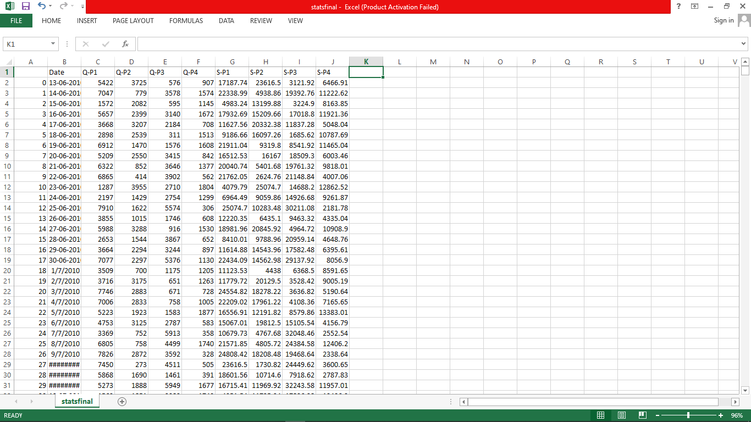

**5.1 DATA CLEANING**

* Filling missing value
* Identify and decide how to deal with missing data points

(eg. imputation, removal, or interpolation).

* Removing Duplicate Records:
* Identify and remove identical or redundant rows in the dataset.
* Handling Outliers:
* Identify and decide whether to remove, transform, or keep outliers based on their impact on the analysis.
* Standardizing Formats:
* Ensure consistent formats for data (e.g., date formats, units of measurement) to avoid discrepancies**.**

**5.2 DATA CLEANING USING JUPTER NOTEBOOK**

* To make a clean dataset by using Jupiter Notebook
* Jupiter Notebook is one of the platform to clean the data and used for make data visualization
* **Import the Necessary Libraries**

Start by importing the required libraries.

**Program:**

import pandas as pd

import numpy as np

import mathplotlib .pyplot as plt

mport seaborn as sns

* **Load the Dataset:**

Read the dataset such as a CSV file, into a Pandas

Dataframe.

Replace ‘statsfinal.csv' with the actual filename of your dataset.

**Program:**

data=pd.read_csv(‘'C:/Users/Public/Documents/statsfinal.csv’)

* **Load and Preprocess the Dataset Using Python:**

To clean a Dataset by preprocessing steps

You can load and preprocess your dataset using Python

Save the preprocessed data to a CSV file

* **Explore the Data:**

Before preprocessing, it's essential to get an overview of the dataset.

**Program:**

# Display the first few rows of the dataset

print(data.head())

# Get basic information about the dataset

print(data.info())

# Check for missing values

print(data.isnull().sum())

# Summary statistics

print(data.describe())

* **FEATURE ENGINEERING:**

Create new features or modify existing ones if needed for your analysis. This step depends on the specifics of your analysis.

**Program:**

data['year'] = pd.to_datetime(data['date']).dt.year

data['month'] pd.to_datetime(data['date']).dt.month

* **DATA TRANSFORMATION:**

Transform data to make it suitable for analysis. You might need to encode categorical variables, normalize or scale numerical features, and perform other transformations.

* if you want Data preprocessing steps go and check my github account

**IMPORTANCE OF LOADING AND PROCESSING DATASET:**

* Loading and preprocessing the dataset is an important first step in building any machine learning model. However, it is especially important for product sales analysis models, as product price datasets are often complex and noisy.
* By loading and preprocessing the dataset, we can ensure that the machine learning algorithm is able to learn from the data effectively and accurately

**6.DATA VISUALIZATION**

* Visualizing and preprocessing data are crucial steps in product sales analysis.
* Let's start with data visualization using Python
* But this project we use IBM Cognos for visualization

**6.1 IBM COGNOS FOR VISUALIZATION**

* Cognos is a business intelligence performance management tools for IBM
* It allows technical and non-technical employees in any company to analyse, extract and create interactive dashboards that enable the company to take relevant decisions.
* The Cognos tool combines a multitude of products which enables communication with different third parties
* **We have to make analyze and report using dataset**
* perform the three analyze and report
* top selling products
* customer preferences
* sales trend
* And we design interactive dashboards
* Dashboards are a type of data visualization, and often use common visualization tools such as graphs, charts, tables.

**THE FIND OUTS USING IBM COGNOS:**

* Top Selling Product
* Sales Trend
* 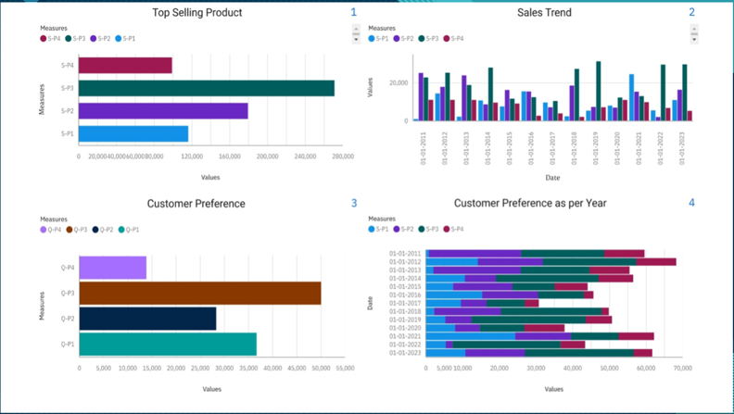Customer Preference
* Now in the dashboard we have three analysis top selling products , sales trend, customer preferences This visualization are done by using bar chart and filtering is applied in the all analysis. In filtering we using date column for filtering all the sales and quantities by Date.

In the Dashboard we Conclude,

* + Top selling product : S-P3 has highest selling product by Date
  + Sales Trend- S-P3 has the maximum sales in all year
  + Customer preference:Q-P3 has high Quantity and S-P3 has highest sales

**IDENTIFYING PRODUCTS WITH THE HIGHEST SALES:**

* The top-selling product can vary significantly depending on various factors such as time, location, and industry.
* It's important to note that the top-selling product in one category or market may not be the same in another.
* In this dataset has 4 products S-P1, S-P2, S-P3, S-P4 then we find the highest sales through the 4 products**.**

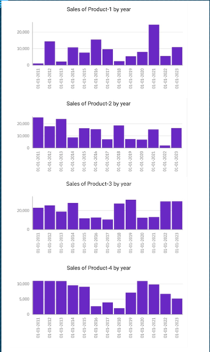

* In this graphical represent the year wise sales
* we have a 4 column charts (Product 1,product 2,product 3, product 4)
* In this case we apply the date on x-axis
* Products are apply in y-axis
* Dates are filtered as 2011 – 2023

**PEAK SALES PERIODS:**

* In the context of business and data analysis, refers to the long-term movement or direction in which a company's sales figures are changing.
* It involves analyzing historical sales data to identify patterns or tendencies in sales performance over a specific period of time.
* Understanding sales trends is crucial for businesses because it can help them make informed decisions

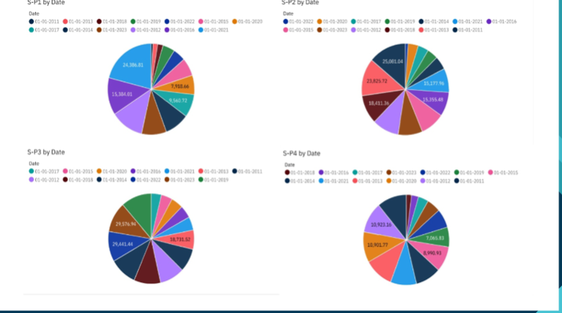

**CUSTOMER PREFERENCE:**

* Customer preferences refer to the specific choices, tastes, and desires of individual customers or groups of customers when it comes to products, services, or experiences offered by a business.
* Understanding customer preferences is crucial for businesses because it enables them to tailor their offerings and marketing strategies to better meet customer needs and increase customer satisfaction.

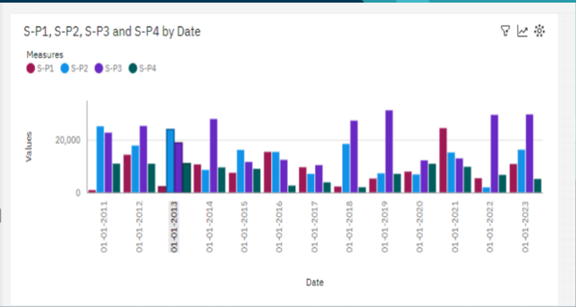

**DERIVED ACTIONABLE INSIGHT**

Here are some more examples of actionable insights that can be derived from product sales analysis:

**Identify which products are frequently purchased together:**

* This information can be used to create product bundles and cross-sell products to customers.

**Identify which products are often returned:**

* This information can be used to improve product quality, reduce customer churn, and develop better return policies.

**Identify which products are sold best in which regions or channels:**

* This information can be used to optimize inventory levels and allocate marketing resources more effectively.

**Identify which products are most seasonal:**

* This information can be used to develop seasonal promotions and sales strategies.

**Identify which products are trending:**

* This information can be used to develop new products or improve existing products to meet customer demand.

**Example:**

* how to use product sales analysis to derive an actionable insight for a software company:
* The software company analyzes its product sales data and finds that customers who purchase its customer relationship management (CRM) software also frequently purchase its marketing automation software. Based on this information, the software company can develop a bundled product offering that includes its CRM software and its marketing automation software. The software company can also promote its marketing automation software to customers who have purchased its CRM software in the past.
* By using product sales analysis to derive actionable insights, businesses can increase sales, improve profitability, and reduce customer churn.

**HOW THE INSIGHTS FORM THE ANALYSIS CAN GUIDE INVENTORY MANAGEMENT AND MARKETING STRATEGIES**

The insights from product sales analysis can guide inventory management and marketing strategies in a number of ways.

**INVENTORY MANAGEMENT:**

**Identifying the most popular products:**

* This information can be used to ensure that adequate inventory levels are maintained for popular products to avoid stockouts and lost sales.

**Identifying the least popular products:**

* This information can be used to reduce inventory levels for unpopular products to reduce costs and free up space for more popular products.

**Identifying seasonal trends:**

* This information can be used to adjust inventory levels based on seasonal demand to avoid overstocking and understocking.

**Identifying slow-moving products:**

* This information can be used to develop strategies to sell slow-moving products, such as discounts, promotions, and bundling with other products.

**MARKETING STRATEGIES:**

**Identifying the most profitable products:**

* This information can be used to focus marketing efforts on the most profitable products.

**Identifying the most valuable customer segments:**

* This information can be used to target marketing campaigns to the most likely customers.

**Identifying the key drivers of product sales:**

* This information can be used to develop marketing messages that focus on the benefits that are most important to customers.

**Identifying sales opportunities and threats:**

* This information can be used to develop marketing strategies to capitalize on sales opportunities and mitigate sales threats.

**FUTURE SCOPE**

**Increased use of artificial intelligence (AI) and machine learning (ML):**

* AI and ML will play an increasingly important role in product sales analysis. AI and ML algorithms can be used to automate tasks such as data collection, cleaning, and analysis.

**Real-time analytics:**

* This will enable them to make faster and more informed decisions about pricing, marketing, and inventory management.

**More granular analytics:**

* Businesses will require more granular analytics that can provide insights into specific product categories, customer segments, and geographic regions.
* This will enable them to better understand their customers and develop more targeted marketing and sales strategies.

**Integration with other data sources:**

* Product sales analysis will be increasingly integrated with other data sources, such as customer data, marketing data, and financial data.
* This will provide businesses with a more holistic view of their business and enable them to make better decisions

**ADVANTAGES**

**Identify the most profitable products and customer segments:**

* Product sales analysis can help businesses identify their most profitable products and customer segments.
* This information can be used to make better decisions about pricing, marketing, product development, and inventory management.

**Improve marketing campaigns:**

* Product sales analysis can help businesses identify which marketing campaigns are most effective.
* This information can be used to improve future marketing campaigns and increase sales.

**Identify sales opportunities and threats:**

* Product sales analysis can help businesses identify sales opportunities and threats.
* This information can be used to develop strategies to capitalize on sales opportunities and mitigate sales threats.

**Make better business decisions:**

* Product sales analysis can help businesses make better decisions about all aspects of their business, from pricing to marketing to product development.

**DISADVANTAGES**

**Cost and time:**

* Product sales analysis can be costly and time-consuming.

* Businesses need to invest in the necessary tools and resources to collect, clean, and analyze their sales data.

**Complexity:**

* Product sales analysis can be complex, especially for businesses with large amounts of data.
* Businesses need to have the expertise to analyze their sales data and interpret the results.

**Data quality:**

* The accuracy of the insights from product sales analysis depends on the quality of the data.
* Businesses need to ensure that their sales data is accurate and complete before analyzing it.

**Misinterpretation:**

* It is important to interpret the results of product sales analysis carefully.
* It is possible to misinterpret the results and draw incorrect conclusions.

**CONCLUSION**

Product Sales Analysis empowers businesses to make informed decisions, optimize their operations, and achieve greater profitability. By leveraging data, visualizations, and insights, companies can adapt to market dynamics and stay competitive in a constantly evolving business environment.