INSTRUCTIONS FOR REPLICATE ANALYSIS AND GENERATE VISUALIZATON

* First get a data set from anywhere but in this project

we use Kaggle website to get a dataset

* And next we need to clean and preprocessing the dataset using

Jupiter Notebook

* we already explain how to clean the dataset and provides a code for this

process

* if you want that codes go and check my github repository then find

data preprocessing steps file

* and next you want to make analysis by using dataset for product sales
* if you want know how to make analysis please go and check the Phase 1,

Phase 2, Phase 3, Phase 4, Phase 5 files you will get a better understanding about analysis and use to replicate it

* Next visualization we use IBM cognos to make Visualization
* IBM cognos is a platform to make analysis easily and make interactive dashboards graphs etc.
* First go and sign up on cognos then get a free trial
* After getting free trial we use the platform to make visualization

EXAMPLE OUTPUT OF VISUALIZATION:

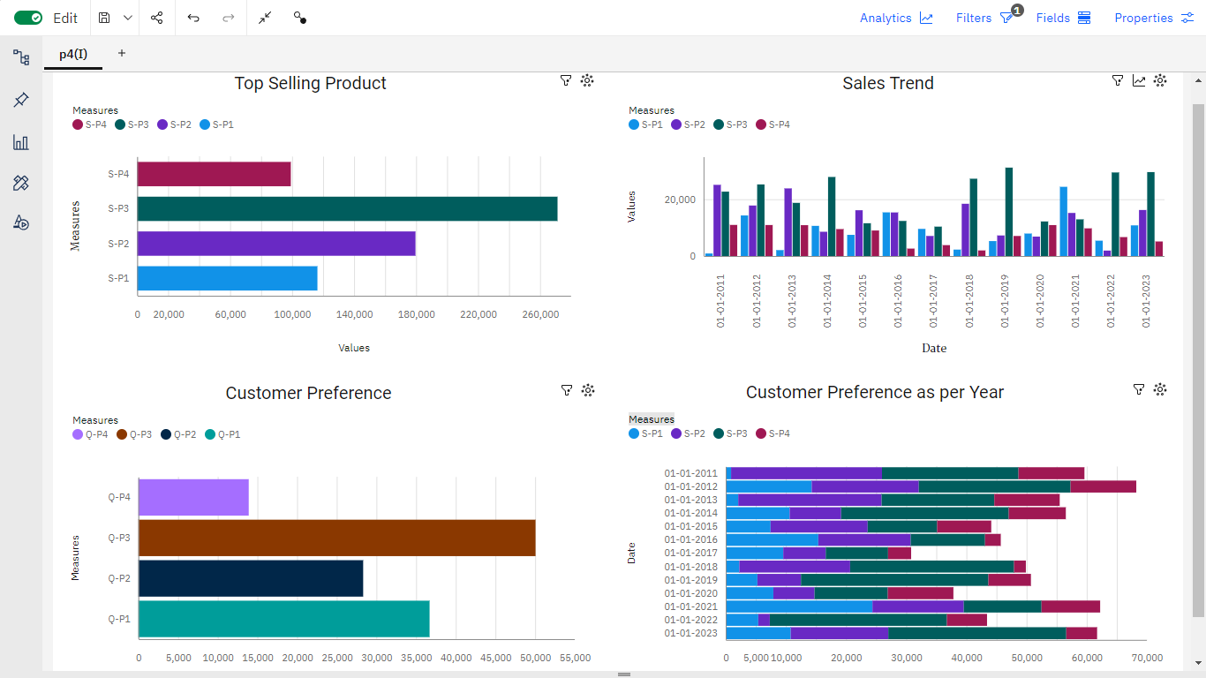

(THIS IS INTERACTIVE DASHBOARDS)

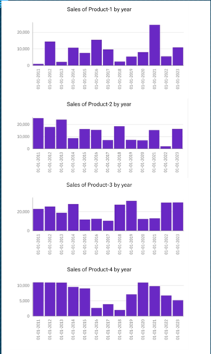

(THIS IS PREDICT SALES AT EVERY YEAR)

(THIS IS CUSTOMER PREFERRNCE THROUGH YEAR)

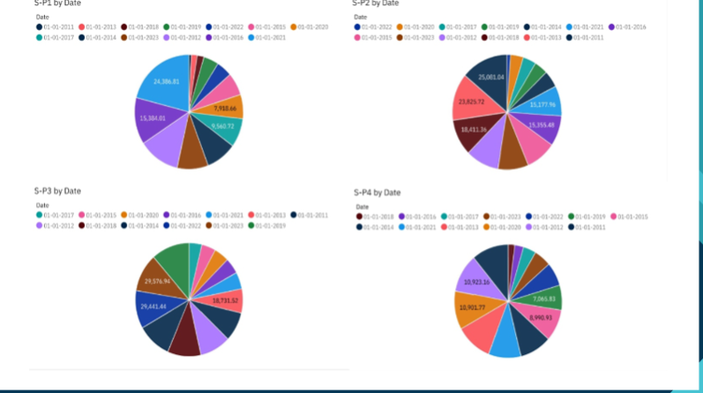

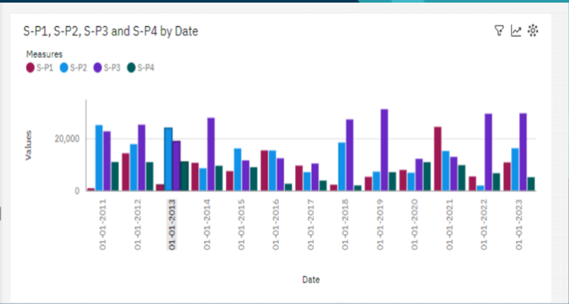

(THIS IS SALES PEEK PERIOD)

* And we explain about derived insights and prediction in above files